**Dyeing of Woven Yarn Using Areca Fruit Extract**

**at IKM Nari-Nari Bima City**

A Wiraningtyas1, Ruslan1,a), A Sandi2, M Nasir3

*1Departement of Chemistry Education, STKIP Bima, West Nusa Tenggara, Indonesia*

*2Departement of Economy Education, STKIP Bima, West Nusa Tenggara, Indonesia*

*3Departement of Biology Education, STKIP Bima, West Nusa Tenggara, Indonesia*

a)Corresponding author: [ruslan_kim@stkipbima.ac.id](mailto:ruslan_kim@stkipbima.ac.id)

**Abstract**. The raw material for yarn used in the manufacture of Bima woven fabric is yarn that has been colored using synthetic dyes. Synthetic dyes have more diverse colors, do not fade easily, are easy to produce, the fabric dyeing process is easier and the cost is cheap. However, synthetic dyes are carcinogenic and harmful to the environment, thereby reducing their artistic value and exotic side. Synthetic dyes contain compounds that are not easily degraded by the environment. The activities of woven yarn coloring using areca fruit can improve the quality of woven fabrics. natural dye woven yarn products from areca fruit extract have a bright red color on alum fixation, black color on tunjung fixation, and pale red color on lime fixation. There is a change in the behavior of partner groups in the use of science and technology to produce woven fabrics based on natural dyes.

**INTRODUCTION**

Bima woven fabric as a regional superior product is increasingly recognized and favored by various groups of people, both local, national and international. This is due to the thickness and the colors are bright and beautiful with a motif that has a symbolic meaning from its shape. In addition, Bima woven fabric is very suitable for use in all seasons, both summer and winter. Because it is widely known, the demand for Bima woven fabrics is increasing. To compensate for the increasing demand, the Bima City Government has conducted data collection and grouping of weaving craftsmen. Weaving groups or centers in Bima City are divided into eight groups and each group or center supervises at least 200 traditional weavers. The total production for one weaver is about two to four mesrai woven fabrics within a month, while for nggoli woven fabrics it reaches ten pieces of cloth. The selling price for one piece of cloth varies greatly depending on the motif and color of the cloth. The more complex the motifs and the complex colors, the more expensive the price. To further advance this superior product, weavers are also required to be more creative, both in making motifs and patterns. Currently, there are more than 200 types of Bima woven fabric motifs that use three types of thread, namely nggoli, glendo and mesrai. Natural dyes are dyes obtained from natural materials such as plants, bacteria, fungi and algae, both micro and macroalgae. Natural dyes have a beautiful and distinctive color effect that is difficult to imitate synthetic dyes, so there are still many people who like and are supporters of exclusive products and high artistic value [1]. Each plant can be a source of natural dyes, because they contain natural pigments. This potential is determined by the intensity of the color produced and is highly dependent on the type of coloring matter present. Coloring matter is a substance that determines the color direction of natural dyes, an organic compound that contains more than one type of coloring matter. Based on the type of coloring matter, natural dyes are divided into 4 groups, namely mordant dyes, direct dyes, acid/base dyes and vessel dyes [2]. Sources of natural dyes commonly used for coloring such as banana stems are brown; noni roots are red, yellow and brown; blue tilapia/tarum leaves; brown betel leaf; dark red betel nut; green mango leaves; brown mahogany leather; light brown teak leaves; red pineapple; yellow turmeric rhizome; brown seaweed [3]. Traditionally, natural dyes are obtained by extracting or boiling the surrounding plants. The extraction method commonly used to obtain pigments from plants depends on the nature of the pigment using water as a solvent [4]. This method is very easy and anyone can do it. In addition, the solvent used in this method is cheap and easy to obtain [5]. However, the weakness of extraction using water solvent is that the extract obtained is easily moldy if the extract does not use preservatives and proper storage. If natural dyes are to be stored as pastes, the solvent must first be evaporated using a certain technique. One of the evaporation techniques that can be used is the oven [6]. Although the presence of natural dyes is very abundant, natural dyes have several disadvantages such as easy to fade, less uniform color, and the production process time to produce dyes is longer [7]. In addition, certain methods are needed to obtain natural dyes. considering that fabrics dyed with natural dyes will produce more exotic, elegant and environmentally friendly colors, it is necessary to find a way to popularize natural dyes in small and medium enterprises, especially Bima woven fabrics [8]. Yarn materials are generally difficult to bond with dyes. Therefore, before dyeing the yarn, a mordanting process is carried out to remove impurities attached to the yarn. To obtain dyes that have good fastness, it is necessary to carry out a dye fixation process. Fixation can function to strengthen the color and change natural dyes according to the type of metal that binds them and locks the dyes that have entered the fiber. Materials commonly used for fixation are alum [K2SO4.Al2 (SO4)3.24H2O], lime (CaCO3) and tunjung (FeSO4) [9].

**EXPERIMENTAL PROCEDURE**

**Extraction of Natural Dyes**

The dyestuff is made by heating. Dried areca fruit is boiled with water for 1 hour then cooled and filtered. The filtrate obtained is used as a dye and can be directly used in the yarn dyeing process.

**Mordanting of Woven Yarn**

Prior to the dyeing process, the threads were first mordanted using a solution of alum at a temperature of 60 oC for 1 hour, then dried for a day.

**Dyeing of Woven Yarn**

The mordanted yarn is then dipped in dye for 10 minutes and then dried in the sun for 30 minutes. Then the yarn is dyed again for 10 minutes and dried in the sun to dry.

**Fixation of Woven Yarn**

The dyed threads were then fixed with tunjung, alum and quicklime by immersion for 5 minutes, then dried in the sun for 30 minutes, then soaked again for 5 minutes and dried in the sun to dry.

**RESULT AND DISCUSSIONS**

**Extraction of Natural Dyes**

In this activity, the coloring of woven threads uses natural dyes of areca fruit. The areca fruit is washed thoroughly to remove the adhering dirt, then the extraction process is carried out by inserting a sample of the dye into a pan and adding water in a ratio of 1:10 (w/v).

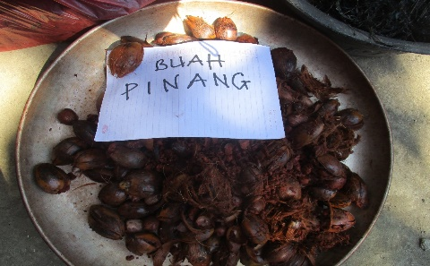

**FIGURE 1**. Areca fruit as Raw Material

The mixture was heated for 1 hour and cooled, then filtered and the filtrate obtained was further concentrated by evaporating the solvent so that the extract volume was halved as shown in Figure 2. The extract obtained is then cooled and ready for use in yarn dyeing. The dye from areca fruit extract produces a red color.

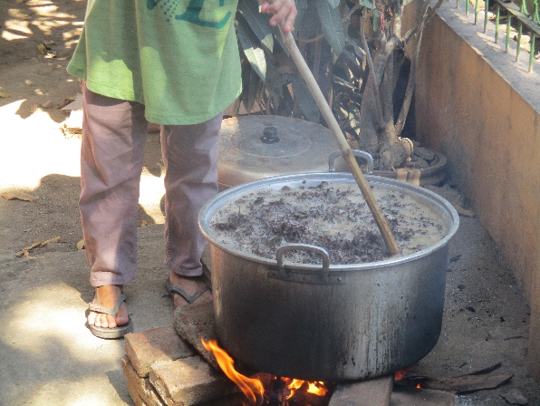

**FIGURE 2**. Extraction of Natural Dye

**Mordanting of Woven Yarn**

Before the coloring process is carried out, the thread is mordanted using alum. White cotton thread was put into a pot filled with alum solution and heated for 30 minutes then drained for 1 hour. Mordanting is done to remove dirt in the form of fat and other impurities that are not soluble in water and to strengthen the bond between the yarn fibers and the dye. The thread mordanting process is as shown in Figure 3. The mordanted yarn is then put into a container filled with extracts of natural dyes.

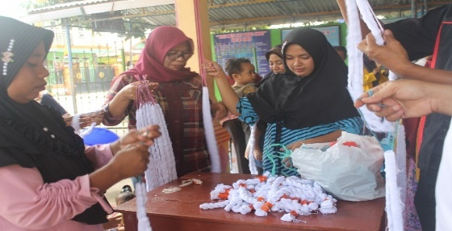 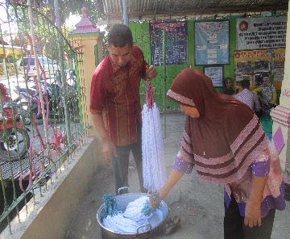 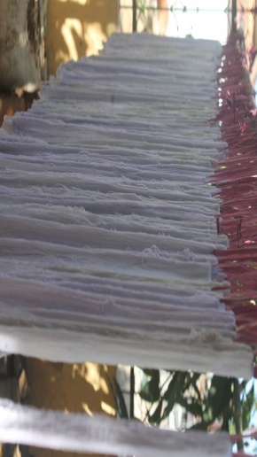

**FIGURE 3**. Mordanting of Woven Yarn

**Dyeing of Woven Yarn**

The dyeing process was carried out for 24 hours and then drained to reduce the water content. Then dipped again for 30 minutes 2 times. This is done to obtain a homogeneous color on the surface of the yarn. The color on the yarn will easily fade when washed with water. Then the next process is to bind the dye to the thread which is called the fixation process. The materials commonly used in the fixation process are alum, tunjung and lime.

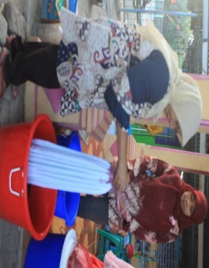 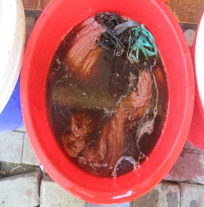 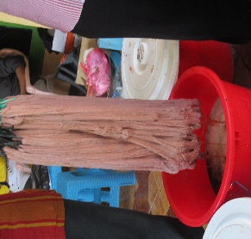 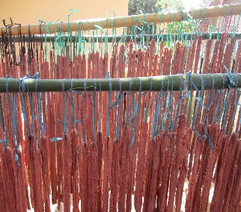

**FIGURE 4.** Dyeing of Woven Yarn

The fixation process can improve the quality of the dye on the yarn and the resulting color will vary depending on the binding agent even from the same dye source. The threads that have been fixed are then dried in the sun to dry and then washed with water to obtain threads with a stable color. The process of drying the yarn as shown in Figure 4. After drying, the dry yarn is then trimmed and rolled up and then packaged. The packaged yarn is then distributed to members of the IKM Nari-Nari Rabadompu Timur weaving craftsmen, Bima City.

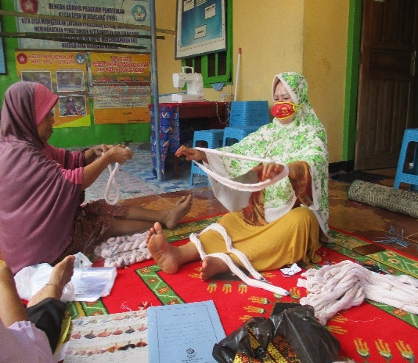 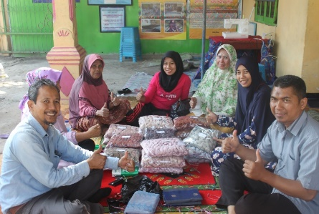

**FIGURE 5**. Packaging of woven Yarn

Based on these results, the yarn product dipped in dye from yellow bark initially produced a maroon color. However, after fixation, the color changed to bright red on alum fixation, black on tunjung fixation and became cream on lime fixation.

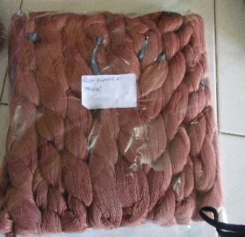 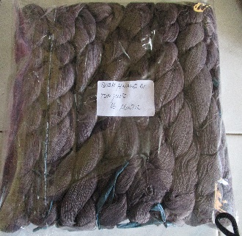 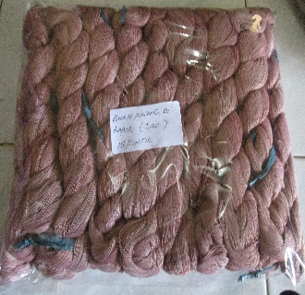

**FIGURE 6**. Woven Yarn using areca fruit extract

The next stage is the process of making woven fabrics from natural dyes. In the process of making woven cloth, it is carried out through steps such as winding the thread, handling, and the weaving process. The process of weaving Bima woven fabric still uses simple looms such as gedogan as shown in figure 7.

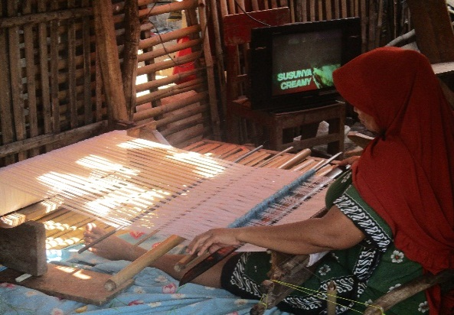 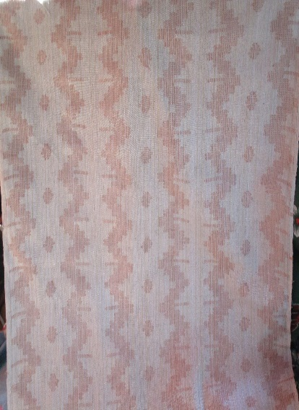

**FIGURE 7**. Weaving Craftsmen and Natural Dyed Woven Fabric Products

**CONCLUSIONS**

The activities of woven yarn coloring using areca fruit can improve the quality of woven fabrics. Natural dye woven yarn products from areca fruit extract have a bright red color on alum fixation, black color on tunjung fixation, and pale red color on lime fixation. There is a change in the behavior of partner groups in the use of science and technology to produce woven fabrics based on natural dyes.

**ACKNOLEDGMENTS**

The author would like to thank the Directorate of Research and Community Service, Directorate General of Research and Development Strengthening, Ministry of Research, Technology and Higher Education of the Republic of Indonesia who has funded this Community Service through the PPPUD scheme 2021.

**REFERENCES**

1. Inayat, A., Khan, S.R., Waheed, A., Deeba, F. *Proc. Pakistan Acad. Sci*. **47** (3): 131-135. (2010).
2. Paryanto, Kridyantoro, R., Prabowo, Y.S. *EKUILIBRIUM*. **14** (1); 13-16. (2015).
3. Wiraningtyas, A., Ruslan, Sandi, A., Nasir, A. *Journal of Physics: Conference Series*. **1833** 012061. 1-5. (2021).

doi :10.1088/1742-6596/1833/1/012061

1. Wiraningtyas, A. *Jurnal Redoks: Jurnal Pendidikan Kimia Dan Ilmu Kimia*, **2**1, 1-10.(2019).

<https://doi.org/10.33627/re.v2i01.72>

1. Wiraningtyas, A., Ruslan, Sandi, A., Nasir, A. *Jurnal Redoks: Jurnal Pendidikan Kimia Dan Ilmu Kimia*, **3**(1), 8-12. (2020). <https://doi.org/10.33627/re.v3i1.242>
2. Wiraningtyas, A., Ruslan, Sandi, A., Nasir, A. *JPM* (*Jurnal Pemberdayaan Masyarakat*). **5** 2. 446-452.  (2020).

<https://doi.org/10.21067/jpm.v5i2.3706>

1. Pujilestari, T. *Dinamika Kerajinan dan Batik*, **31** 1, 7-9. (2014).
2. Indrianingsih, A.W., Darsih, C., Maryana, R. *Prosiding Seminar Nasional Kimia dan Pendidikan Kimia V*. PKIM FKIP UNS. pp.682-691. (2013).
3. Hartanto, N.S., Watanabe, S. *Teknologi Tekstil*. (2003).