**THE MANIFEST APPLICATION OF PASSENGERS AND VEHICLES AT THE BATULICIN CROSSING PORT IN SOUTHERN KALIMANTAN .**

**Chairul I.Ilham1) - Bambang S.2) Atiqoh.AS3)**

*Inland Waterways and Ferries Transport of Palembang Polytechnic*

*(Poltek Trans SDP Palembang)*

*Jalan Sabar Jaya 116 Prajin Palembang.*

***ABSTRACT***

*Applying passenger and vehicles manifest aplication nowdays is a must. The function is to improve our service and safety of the passengers and vehicles that will load in to the ship. This aplication is an aplication made by using Visual Basic 6.0 which designed to make the process of making the manifest of passengers and vehicles easier and clustured by it’s type and function.*

*This aplication use the date of the passenger and vehicles in Batulicin Harbour using the computerization system by making the form to input the data of passenger and vehicles. The data are : 1) Identity of passenger and vehicles 2) identity of vehicles and the crews; by designing the program using Visual Basic 6.0 by two steps, which are makeing the database and the design of aplication page. They are Login page, Main page, User page, Data page, Class of passenger and vehicles page, Ticket amount page, and Ticket booking page.*

*The result from this program is to make the operator easier to archiving the document and monitoring the sold tickets and also to avoid the duplication of service.*

**Keywords** : *ticket,data, passenger,vehicles,booking*

**I. INTRODUCTION.**

Batulicin harbor crossing is one of the existing port in Tanah Bumbu regency which has an important role in promoting economic development, especially in developing economies in Batulicin District, Tanah Bumbu Regency. Batulicin harbor crossing is managed by PT. ASDP Indonesia Ferry (Persero) Branch of Batulicin and has two (2) path namely the path of commercial Batulicin - Tanjung Serdang served by 7 ferry boat to cross a distance of 2.5 miles and the track Pioneers Batulicin - Garongkong served by one ferry to cross the distance 473.58 miles.

In an effort to improve safety, comfort and security of crossing transport then the identity of the services users is needed both pedestrian or vehicle passengers and cargo were loaded in the vehicle. This identity will be used for charging the manifest list of passengers and vehicles at the Batulicin Crossing Port. In addition, the identity data of passengers and vehicles are also useful for PT. ASDP as the manager of the port's productivity data collection transport of passengers and crossing vehicle daily.

From the survey results and observations made during the activities in the field, it is known that the current state of service users Batulicin Seaport Crossing not be asked to fill manifest data at the time of ticket purchase, because the distance of crossing a relatively short and is considered no need for the list because crossing Batulicin cross - Tanjung Serdang not use SPB, but Bandar Movement Permit which is valid for 7 days. This is contrary to the Transportation Minister Regulation No. PM 25 Year 2016 about the List of Passengers and Crossing Tranport Vehicles that every Fery transport ship that will sail are required to have an Sailing Approval Letter, and to obtain the Sailing Approval Letter then the port must attach a list of passengers and vehicles aboard the ferry transport ship. In addition Batulicin crossing harbor has only one (1) counter service to serve pedestrians and vehicle class I to class IX. It is very dangerous to the users of services especially those of services pedestrians users.

Under the existing conditions, we felt it necessary to make an application design plan manifest of passengers and crossing transport vehicles that the data collection activities can be done with a well organized results and the data of passengers and vehicles can be grouped automatically by the application.

Based on the observation that has been done in the research area, then in this writing there are a number of issues which in our opinion has not met some of the expectations and needs to be studied and given settlement solutions, namely:

1. Service user safety conditions at the time of ticket purchase at the Batulicin Crossing Port
2. Passenger manifest data collection systems and vehicles in the Batulicin Crossing Port in accordance with the Regulation of the Repubic Indonesia Transportation Minister No. 25 Year 2016 about the list of passengers and crossing transport vehicles
3. Need to making the passengers manifest application and vehicles at the Batulicin Crossing Port

**II. Theoretical basis**

Regulation of the Minister of Transportation No. 25 2016 PM about the List of Passengers and Crossing transport vehicles

1. Article 3

List of passengers and vehicles on board ferry transport ship consists of:

1. Passengers pedestrians;
2. Passengers in the vehicle;
3. Vehicle class I s / d IX.
4. Article 4, paragraph (3)

Passenger identity data at least contain:

1. Name;
2. Gender;
3. Age;
4. Domicile address; and
5. Passport number of foreign passengers.
6. Article 6

The driver of a vehicle shall disclose information to passengers regarding the prohibition of passengers in vehicles during shipping, before entering the port.

1. Article 7

The driver of the vehicle which uses crossing transport vehicle services consisting of individual vehicle drivers to passengers transportation and for freight transportation.

1. Article 12 paragraph (1), (2) and (3)
2. Driver before buying tickets shall submit the manifest to the clerk as a requirement to buy a ticket,
3. A driver who does not submit the manifest will not be served buying tickets,
4. The Manifest at least consist of :

- Passenger name

- Gender

- Age

- Address (city domicile)

- Number of motor vehicles

- type / class

To support the existing legal basis, then it is need for related theory in this paper:

* + 1. *Visual basic*

According to (Jubilee 2017) *Visual Basic* is a programming language that is easy to learn and practice. The Resulting program is in the form of application that works on *windows* operating system. This program was developed in an IDE (Integrated Development Environtment) so users do not bother to write the code to program. This application is also an application-based *Graphical User* *Interface* so have an interface with buttons, windows, menus and toolbars such as Microsoft Word.

* + 1. Programming language

According to (Jubilee, 2017) programming language or computer language is a standard to govern computer instruction. This programming language is a set of rules of syntax and systematically used to define a computer program. This language allows a programmer can specify exactly which data will be processed by a computer, as this data will be stored / transmitted, and precisely what kind of measures to be taken in various situations.

* + 1. *Form designer*

According to (Eri et al, 2017) *form designer* is a *window* that can be used to manage the applications display that are going to make, or in other words as a place to design a form. In designing a *form*, we also need to know the terms that are used in *Visual Basic 6.0*, such as:

*Event* which is an activity that occurs while using the application. *Event* occurs because of user action, such as *mouse* clicks or *keyboard* use. However, the *event* may also occur because of the arrangement by a timer or by the application itself.

*Property* which is part building an object. These properties determine the object that is being created. We can equate an object with a man, while the other properties can we equate with the name, height, weight, gender and so on.

The procedure is a set of routine code that is written in a separate block. The block is only executed if the title or name was called.

* + 1. *Microsoft access*

According to (Junindar 2010) *Microsoft Access* 2010 is a database processing software running under the *Windows operating system*. *Microsoft Access* is part of the *Microsoft Office* program package which is devoted to processing the data base. *Microsoft Access* 2010 has some of the latest features are:

*Quick Start Fields*

*Menu and Ribbon*

*Application Parts*

*Office Themes*

*Calculate Fields*

*Data Bars and Conditional Formatting*

*Navigation Form*

*Macro*

***III. Flow Chart System Design***

The design of this flow chart system serves to determine how work systems themselves planned application, and what data needed to be loaded into the application and what data can be obtained from the application. The following flow chart drawing application system manifest of passengers and vehicles are planned:

Passenger ticket and Vehicles

1. Passengers Biodata
2. The data of Vehicles and Passengers in vehicles also vehicles cargo

Passenger

prospective passengers

Leader

Transaction reports 

Operator

1. Ticket Booking transaction data
2. Passengers Biodata
3. The Data of Vehicles and Passengers in vehicles also vehicles cargo

**PASSENGER’ TICKETS RESERVATION SYSTEM AND CROSSING TRANSPORT VEHICLE**

*Source: Analysis Report, 2018*

**Flow Chart of the Crossing Transport Ticket Booking System**

From the diagram above, we can know that to get tickets for crossing transport, prospective passengers pedestrians and vehicles must provide information such as biographical data of passengers are then recorded by the operator in an manifest application of the passenger and freight crossing vehicles then the data is used to report to the leaders port and used accordingly.

***IV. Planning System***

The design system is a picture of the flow process of making application to be made. The purpose of this design is for purposes of ticket purchasing process passengers and vehicles at the Batulicin Crossing Port. Starting with the design system. General overview of the design can be shown in the following figure:

Preparing *Visual Basic 6.0* Applications

*Database* Design

Creating a Flow System Chart

Result

Testing Menu on Application

Applications Design

*Source: Analysis Report, 2018*

Application System Design Of The Passengers And Vehicles Manifest

**V. *Flowchart Program***

In the flowchart created will explain the flow of the application manifest, passenger and crossing transport vehicles at the Batulicin Crossing Port, South Kalimantan province. In the *flowchart* will be explained the configuration of the *input/output* of data generated each menu and then be *input* into the *database*. The following *flowchart* application manifest of passengers and vehicles made:

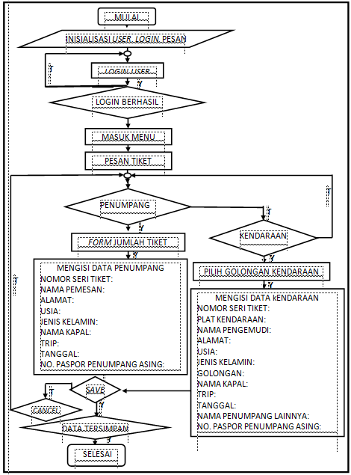

*Source: Analysis Report, 2018*

***FLOW CHART* PROGRAM**

V.1 Application Usage Diagram

This application usage Diagram include operation of the passenger and crossing transport vehicle application manifest so that it can be used as guidance for the application on users using this application. The following diagram passenger manifest application usage and crossing transport vehicles :

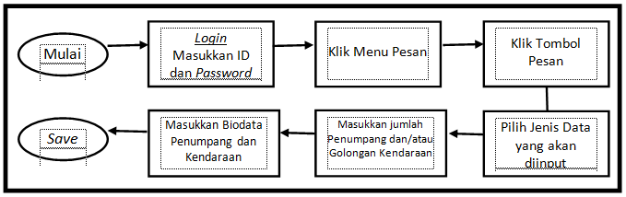

*Source: Analysis Report, 2018*

**App Usage Diagram**

**VI. Solution to problem**

VI.1 *Database* Creation

*Database* design includes creating tables that will be used in the application manifest of passengers and vehicles. The *database* used is *Microsoft Access*. Here's how to create a *database* in *visual basic*:

1. Install *Visual Basic* application.
2. Open *Visual Basic* program.
3. Click the *Add-Ins* menu.

Click visual data manager, and the image will appear as below.

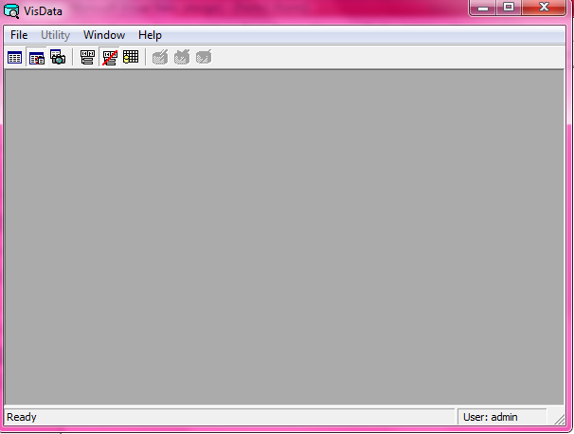

*Source: Analysis Report, 2018*

**Visual Data**

1. Select *file* and then *New*.
2. Select *Microsoft Access* and select the 7.0 mdb version.
3. Give the *file* name and storage location of the data, the *file* name is saved with Dbase.mdb name, then select *save*.

Then allows us to create a database that will be designed to the application manifest of passengers and vehicles as follows:

1. *Database user*

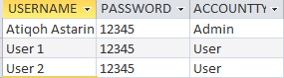

*Source: Analysis Report, 2018*

***Database User***

*Database User* onthe manifest application of passengers and vehicles used for adding an account to the clerk, so that each officer have thedata each other.

1. Pedestrian Passengers *Database*

**

*Source: Analysis Report, 2018*

***Pedestrian Passengers Database***

passengers *database* on the manifest of passengers and vehicle applications are used as the recapitulation of pedestrian passenger’s data that has been inputted before.

1. *database* Vehicle



*Source: Analysis Report, 2018*

**Vehicle *Database***

*database* vehicles on passenger and vehicle application manifest is used as the recapitulation of vehicle data that has been previously inputted.

V.2 Making Design

Making *Design* includes the manufacture of views on the manifest application of passengers and vehicles. Applications used to make a *design* that is *Visual Basic 6.0*. For stages be done in manufacture of *design* in the manifest application of passengers and vehicles in Attachment II.

Here design has been created for the manifest application of passengers and vehicles:

1. Homepage *Design*



*Source: Analysis Report, 2018*

**Homepage *Design***

The homepage *Design* in the manifest application of passengers and vehicles is an initial view that will appear when the application is run.

1. *Login* Page *Design*

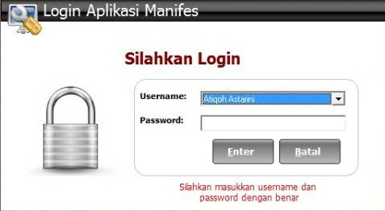

*Source: Analysis Report, 2018*

**Login Page *Design***

Login page *design* in the manifest application of passengers and vehicles is a view that is used to access the menus there is by way of entering a username and password.

1. Main Page *Design*

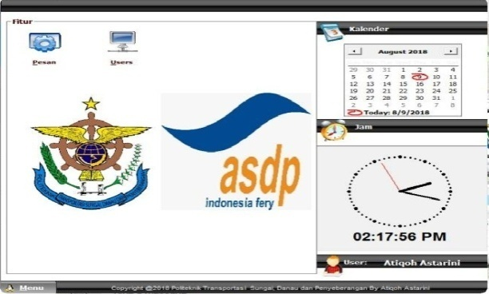

*Source: Analysis Report, 2018*

**Main Page *Design***

The main page *design* in the manifest application of passengers and vehicles is an initial view that contains menus that can be used as a ticket reservation or setting menu *user*/user account.

1. *Users Page Design*

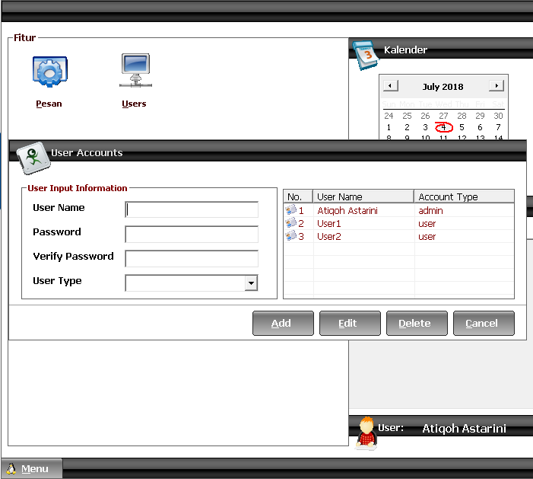

*Source: Analysis Report, 2018*

***User Page Design***

*User* page *design* in the manifest application of passengers and vehicles is a view of the user menu that serves to set a password or username operator or to create a new account.

1. Passenger And Vehicle List Page *Design*

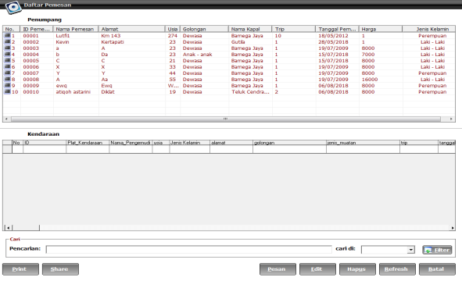

*Source: Analysis Report, 2018*

**Passenger and Vehicle List page *Design***

Passenger and vehicle list page *design* in the manifest application of passengers and vehicles is a message menu display function to display a list of passengers and vehicles already bought a ticket. This page also contains a button menu to delete data, refresh the data, or edit existing data. However, these menus can only be used by the admin, while *users* can not use these menus.

1. Group Page *Design*

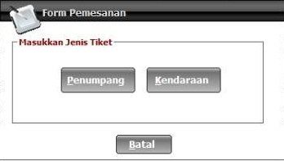

*Source: Analysis Report, 2018*

**Group Page Design**

Group page *design* in the manifest application of passengers and vehicles is a menu display function to display the data that will be entered.

1. Page Number of Pedestrian Passengers Tickets *Design*

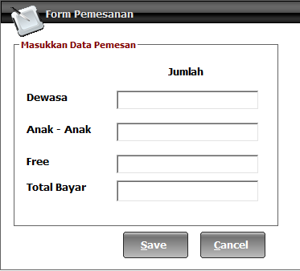

*Source: Analysis Report, 2018*

**Page Number of Pedestrian Passengers Tickets *Design***

Page number of pedestrian passengers *design* in the manifest application and vehicle is a display to enter how many tickets will be purchased by passengers who will then automatically calculated how much money is to be paid by the service user.

1. Vehicle Group Page *Design*

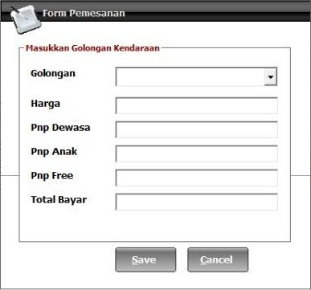

*Source: Analysis Report, 2018*

**Vehicle Group Page** *Design*

Vehicle grouppage *design* on the manifest applications is a display to enter the type of vehicle ticket to be purchased by passengers who will then display the prices that must be paid by the service user automatically.

1. Passengers Group Page *Design*

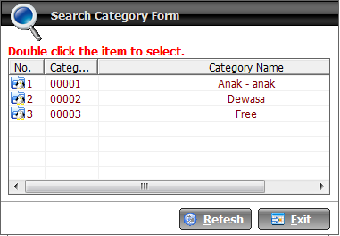

*Source: Analysis Report, 2018*

Passengers Group Page *Design*

Passengers group page *design* on passenger and vehicle manifest application is a display to enter the type of ticket will be purchased by the service user.

1. Passenger Booking Page *Design*

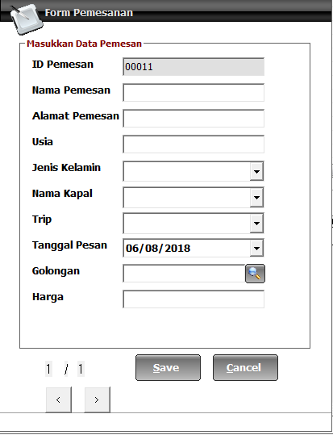

*Source: Analysis Report, 2018*

**Passenger Booking Page *Design***

Passenger booking page *design* in the manifest application of passengers and vehicles is a display to enter the biodata of pedestrians service users which is then stored into the database.

1. Vehicles Booking *Form Design*

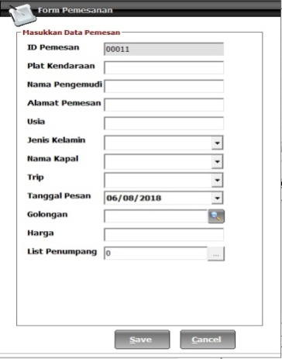

*Source: Analysis Report, 2018*

**Vehicles Booking *Form Design***

Vehicle booking page *design* in the manifest application of passengers and vehicles is a display for entering their vehicles’ data, passengers and cargo were transported which is then stored into the database.

1. Passengers Booking Page On Vehicles *Design*

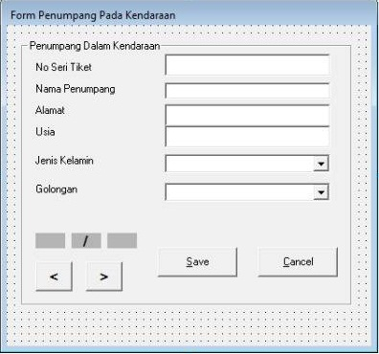

*Source: Analysis Report, 2018*

**Passengers Booking Page On Vehicles *Design***

Passengers booking page on vehicles *design*contained in the manifest application of passengers and vehicles is a display to enter the passengers’ biodata who were in the vehicle which is then stored into the database.

**V.3 Application Validation**

To ascertain whether the application has been made to run properly, it is necessary to do the tests on the existing menus on the application. In conducting these experiments it can be done with methods *whitebox* and *blackbox*.

In *whitebox* testing method is a test application that can be seen from the algorithm or *flowchart* applications that have been created, while the *blackbox* testing method that takes into account the menus or buttons are available in the application. To that end, here is a *blackbox* testing method on the manifest application of passengers and vehicles:

**Application Validation With Blackbox Method**

|  |  |  |  |  |
| --- | --- | --- | --- | --- |
| **No.** | **Trial** | **Experiment Page** | **Aim** | **Result** |
| **(1)** | **(2)** | **(3)** | **(4)** | **(5)** |
| 1 | Press the button on the *keyboard* | Homepage | *Login* page | Succeed |
| 2 | Click *Enter* | *Login* Page | *Main* page | Succeed |
| 3 | Click Cancel | *Login* Page | Homepage | Succeed |
| 4 | Click Message | Main Page | Page List Of Passengers And Vehicles | Succeed |
| 5 | Click *Users* | Main Page | *Users* Page | Succeed |
| 6 | Click *Add* | *Users* Page | Adding *User* | Succeed |
| 7 | Click Edit | *Users* Page | Editing Existing *User* | Succeed |
| 8 | Click *Cancle* | *Users* Page | Main Page | Succeed |
| 9 | Click *Delete* | *Users* Page | Deleting *User* | Succeed |
| 10 | Click Message | Page List Of Passengers And Vehicles | Group Page | Succeed |
| 11 | Click Delete | Page List Of Passengers And Vehicles | Deleting Data | Succeed |
| 12 | Click *Refresh* | Page List Of Passengers And Vehicles | Reloading Data | Succeed |
| 13 | Click Edit | Page List Of Passengers And Vehicles | Editing Data | Succeed |
| 14 | Click Cancel | Page List Of Passengers And Vehicles | Main Page | Succeed |
| **(1)** | **(2)** | **(3)** | **(4)** | **(5)** |
| 15 | Click Filter | Page List Of Passengers And Vehicles | Sorting Data | Succeed |
| 16 | Click Passengers | Group Page | Page Number Of Pedestrian Passengers Tickets | Succeed |
| 17 | Click Vehicle | Group Page | Vehicles Group Page | Succeed |
| 18 | Click Cancel | Group Page | Page List Of Passengers And Vehicles | Succeed |
| 19 | Click *Save* | Page Number Of Pedestrian Passengers Tickets | Passenger Booking Page | Succeed |
| 20 | Click *Cancle* | Page Number Of Pedestrian Passengers Tickets | Page List Of Passengers And Vehicles | Succeed |
| 21 | Click *Save* | Vehicle Group Page | Vehicles Booking Page | Succeed |
| 22 | Click *Cancle* | Vehicle Group Page | Page List Of Passengers And Vehicles | Succeed |
| 23 | Click *Refresh* | Passengers Group Page | Reloading Passengers Group | Succeed |
| 24 | Click *Exit* | Passengers Group Page | Passenger Booking Page | Succeed |
| 25 | Click *Save* | Passenger Booking Page | Page List Of Passengers And Vehicles | Succeed |
| 26 | Click *Cancle* | Passenger Booking Page | Page List Of Passengers And Vehicles | Succeed |
| 27 | Click > | Passenger Booking Page | Passenger Booking Page 1 | Succeed |
| 28 | Click < | Passenger Booking Page | Passenger Booking Page 2 | Succeed |
| 29 | Click *Save* | Vehicles Booking Page | Page List Of Passengers And Vehicles | Succeed |
| 30 | Click *Cancle* | Vehicles Booking Page | Page List Of Passengers And Vehicles | Succeed |
| 31 | Click Menu | Main Page | Menu Exit And *Logout* | Succeed |
| 32 | Click *Logout* | Main Page | *Login* Page | Succeed |
| 33 | Click Exit | Main Page | Applications Closed | Succeed |

*Source: Analysis Report, 2018*

From these data, it can be seen that the manifest application of passengers and vehicles are planned to be operated in accordance with the plan.

**VI. CONCLUSION**

Before applying the manifest application of passengers and vehicles is planned, then we must consider the impact or benefit that would be obtained if the manifest application is applied at the Batulicin Crossing Port. The following comparison between the manifest data collection system manually with the data collection system using manifest application of passengers and vehicles:

**Comparison Between Manual System And Application System**

|  |  |  |
| --- | --- | --- |
| **NO** | **System Manual** | **System Using Application** |
| 1. | Did not record a list of passengers and crossing transport vehicles according to the Minister of Transportation Regulation No. 25 Year 2016 concerning the List of Passengers and Crossing Transport Vehicles, so that the Port Manager does not have definite data. | Contains data on passengers and vehicles in accordance with the provisions of the Minister of Transportation Regulation No. 25 Year 2016 concerning the List of Passengers and Crossing transport Vehicles, so that the port management have exact data on the number and the data of passengers and vehicles. |
| 2. | Ticket purchasing process faster because it does not charge the biodata of passengers and vehicles. | Ticket purchase process is slower because officers enter data of passengers and vehicles on the application. |
| 3. | Does not have an archive list of passengers and vehicles. | Ease in filing the list of passengers and vehicles. |
| 4. | Unable to monitor exactly the number of tickets sold and the remaining tickets at the counter. | Can monitor the number of tickets sold and the remaining tickets at the ticket counter with serial numbers recorded in the application. |
| 5. | Unable to ensure that tickets have already been sold can not be resold. | Can ensure that tickets have already been sold so it can not be resold. |

*Source: Analysis Report, 2018*

Based on the above table, it can be concluded that there are advantages and disadvantages to each passenger ticket purchasing system and vehicles at the Batulicin Crossing Port.

**References**

1. Direktorat Jendral Perhubungan darat, ***Pengembangan angkutan Sungai,Danau dan Penyeberangan*,** Jakarta 2006
2. Keputusan Menteri Perhubungan No KM 32 , Tahun 2001, **Tentang *Penyelenggaraan angkutan Penyeberangan***.
3. Keputusan Direktur Jendral Perhubungan Darat No: SK.73/AP005/DRJD/2003 Tahun 2003, **tentang *Persyaratan minimal Angkutan Penyeberangan****.*
4. International Maritime Organization, IMO and RO RO Safety, London 1997.
5. Undang Undang Republik Indonesia Nomor 17 Tahun 2008 **tentang *Pelayaran***
6. Nurgiyantoro, Burhan, Gunawan dan Marzuki, 2000,***Statistik Terapan Untuk Ilmu-Ilmu Sosial,*** Yogyakarta: Gadja Mada University Press.
7. Rakhmat, Jalaludin, 1999, ***Metode Penelitian Komunikasi, Bandung*** : PT Remaja Rosda Karya.
8. Sugiyono, 2001, ***Metode Penelitian Bisnis, Bandung*** : CV Alfabeta
9. Suharsimi, Arikanto, 2000, ***Manajemen Penelitian***, Jakrata : Rineka Cipta
10. Bruton M.J (1985); ***Introduction to Transportation Planning***,Hutchinson Melbourne
11. Kanafani,Adib,(1983);***Transportation Demand Analysis***, Mc GrawHill Book Company,New York.
12. Miro,Fidel (2005); ***Perencanaan Transportasi***, Erlangga,Jakarta