**Stability Of Yogyakarta International Airport Underpass Structure Based On Analytical And 3d Numerical Solutions**

D.N Mufti1, a), A. Rifa’i 1 & F. Faris1

*1Departement of Civil and Environmental Engineering, Universitas Gadjah Mada, Yogyakarta, Indonesia*

1. *Corresponding author: ahmad.rifai@ugm.ac.id*

**Abstract.** The Yogyakarta International Airport (YIA) was built to expand flight capacity due to limited capacity at Adisucipto Airport. The underpass structure is needed to anticipate traffic jams to YIA Airport due to the existing road above it. Underpass is a transverse road under another road that is built underground and in the form of a tunnel. The purpose of this study is to analyse the stability of the underpass structure based on analytical and 3D numerical solutions.

The stability analysis of the underpass retaining wall is performed by manual calculation based on static and dynamic loads. Underpass stability analysis was also conducted based on numeral simulations using Rockscience 3 (RS3) software. The data is based on drilling tests in three locations namely the BH 06, BH 10 and BH 11 drill points. BH 06 drill point is on the edge of underpass, precisely at the underpass entrance from Yogyakarta direction; BH 10 represents the zone in the middle of the underpass and BH 11 is on the edge of the underpass.

The results of the analysis of safety factor against shearing and turning forces due to static and dynamic loads at all points of view showed SF values above the criteria, making them safe for shearing and turning stabilities. Based on 3D numerical simulations on static and dynamic loadings, the result of the settlement occurred at the points of view in the range of 23-35 mm. This value is well under the required maximum limit of 51 – 76 mm.

Keyword: retaining wall, underpass stability, 3D numerical simulation, safety factor, displacement

# INTRODUCTION

The Special Region of Yogyakarta is an area that many domestic and international tourists choose as their vacation destination. To reach access to Yogyakarta, most people choose air transportation, thus making the condition on the airport increasingly crowded every holiday time. One of the attempts to fix this problem was the construction of new airport by the Yogyakarta Transportation Service, which then was named the Yogyakarta International Airport (YIA). The new airport is located on the western side of the Special Region of Yogyakarta, precisely in Kulon Progo District.

The construction of underpass is really needed to support the traffic in the YIA in order to reduce the congestion. Underpass is a traffic lane or could be referred as an underground-built lane that crosses under a different lane, in the form of tunnel, and has function to reduce the congestion in traffic. The underpass is constructed by digging the existing soil and replaces it with a U-shaped construction or empty box with various type of structure.

Based on the underpass project plan, the analysis on the construction stability is necessary in order to minimalize and anticipated the probability of problem that could arise during the execution and or after the construction is complete.

Several research on the stability of the underpass construction have been conducted, one of it was by Sianipar (2018) who analyse the construction plan of the underpass's retaining wall by using secant pile at the Brigjend Katamso – AH Nasution Street in Medan. Putera (2018) conducted the three-dimensional analysis on the slope stability of waste dump in Piyungan Landfill, Yogyakarta. The analysis on the slope stability was conducted by using Rocscience 3 (RS3). Sulardi and Prasetyo (2018) did a research on the box underpass design by using the ultimate design method, and Kalolo (2017) analysed the stability of the retaining wall on the area of PT. Trakindo, Maubi Village, Minahasa Utara District.

This research resulted in a safety factor analysis of the stability of the underpass's retaining wall against sliding and overturning, by using three-dimensional Rocscience 3 (RS 3). The final result was the displacement to stability of the underpass structure, which has never been done in previous researches.

## METHOD

*2.1* *Research Location*

The location of this study was on the Yogyakarta International Airport underpass, in the area of Glagah Beach, Daendles Street, Temon Sub-district, Kulon Progo District, Special Region of Yogyakarta. The distance between Yogyakarta International Airport and the centre of Yogyakarta is about 44.4 km. This study used the data of soil layers in three drill points, which are BH-11, BH-10, and BH-06.

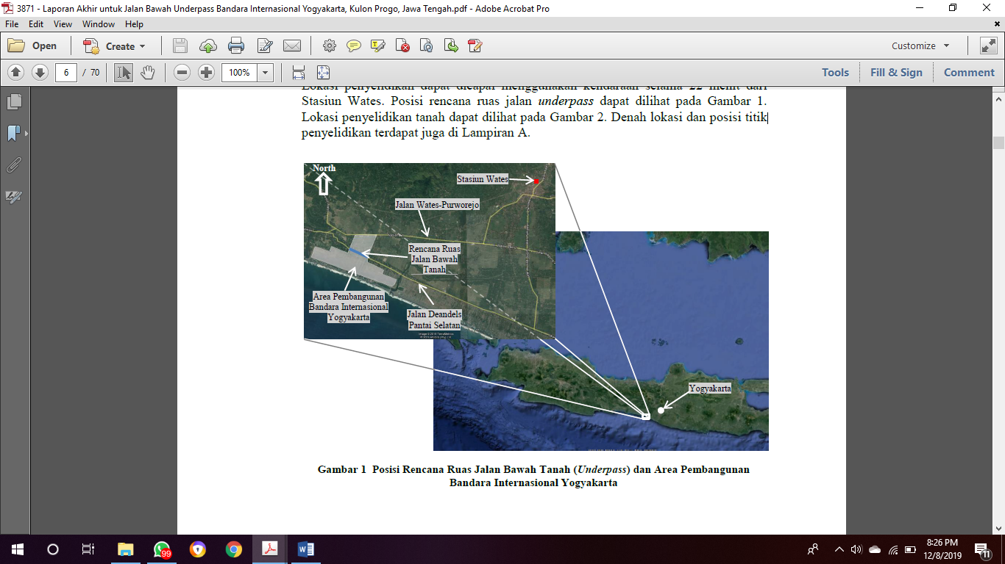

Figure 1. Research Location

## *2.2* *Lateral Earth Pressure on Static Condition*

Lateral earth pressure is the force caused by the soil pressure against the retaining wall structure. The amount of lateral soil is very influenced by the location changes of the retaining wall and the properties of the soil. The retaining wall construction planned for the underpass was used to hold the soil with vertical slope. The horizontal force that works between the retaining wall construction and the mass of the soil it held are needed to be known, in order to be able to distribute the working load. The retaining wall of the underpass only has active earth pressure, therefore stated in Equation (1):

*Pa = Ka x γ x H* (1)

In which Ka is active earth coefficient of earth pressure, γ is the volume weight of soil, and H is height. The Ka equation for flat ground is stated in Equation (2) and for sloped ground is stated in Equation (3); in which ϕ is the friction angle of the soil, and δ is soil slope.

*Ka = = tan2 (45-)* (2)

*Ka = ( )2* (3)

Cohesion (*c*) as the adhesiveness between the soil grains also has effect in reducing the active earth pressure, which is of 2*c $√$*Ka, stated in Equation (4).

*Pa = Ka x γ x H – 2 x c x $√$ Ka* (4)

## *Lateral Earth Pressure on Dynamic Condition*

Coulomb (1776) introduced the active earth pressure (Pa) for retaining wall on dry cohesionless backfill, as follows:

Pa = . H2 . Ka . γ (5)

In which Pa is active force per unit length of the wall, γ volume weight of the soil, H is the height of the retaining wall, and Ka= coefficient of ground water pressure. Whereas the Ka value is as follows:

Ka = (6)

In which, ϕ is the friction angle of the soil, δ is the friction angle of the wall, β is the wall slope on vertical field, and i is the wall slope on horizontal field.

As follows is the analysis on lateral earth pressure calculation at earthquake by Monokabe-Okabe.

1. Active Pressure (KAE)

PAE = . H2 . γ . (1 - kv) . KAE (7)

In which KAE is the active earth pressure coefficient with earthquake effect

KAE = (8)

θ = $\tan^{-1}[ \frac{Kh}{1-Kv} ]$ (9)

1. Passive Pressure (KPE)

PPE = . H2 . γ . (1 - kv) . KPE (10)

In which KPE is the passive earth pressure coefficient with earthquake effect

KPE = (11)

θ = $\tan^{-1}[ \frac{kh}{1-kv} ]$ (12)

## *2.4 Analysis on Underpass Stability*

Static stability analysis includes overturning stability, shear stability, eccentricity stability, and soil bearing stability.

* + - 1. Overturning Stability

The lateral earth pressure that caused by the soil around the construction tend to overturn with the rotation centre on the toe point with the foundation plate (Hardiyatmo, 2011). This overturning moment is resisted by the self-weight of the construction's foundation and the moment caused by the backfill weight above the foundation plate by using Equation (13).

$Fgl= \frac{Mw}{Mgl}$ (13)

In which *Fgl* is the safety factor for construction overturning, *Mw* is the moment resisting the overturning direction, Mgl is the moment that caused the overturning. *Fgl* > 1.5 comes under the safe and stable zone.

* + - 1. Sliding Stability

The safety factor against sliding (*Fgs*) is defined on Equation (14) as follows:

*Fgs = $\frac{Rh}{Ph}$*  (14)

In which Rh is the retaining wall resistance against sliding, Ph is the total of horizontal force. *Fgs* > 1.5 comes under the safe and stable zone.

## *2.5 Loading*

The load of the underpass structure is the traffic load caused by the action of the vehicles on the bridge, including its relations with dynamic effects, but not including the impact. The traffic load for the underpass planning consists of 'D' lane load and 'T' truck load. Loading was conducted according to Indonesian National Standard Design (*Rancangan Standar Nasional Indonesia — RSNI)* number T-02-2005.

## *Peak Ground Acceleration (PGA)*

Peak Ground Acceleration (PGA) analysis was based on Indonesian National Standard (*Standar Nasional Indonesia —* *SNI*) number 8460:2017 about the planning procedure for earthquake resistance on building and non-building construction structure has the design life (years) of 50 years with exceeding probability (%) equal with 2%. The return period (years) is equal with 2,500 years. The peak ground acceleration value then was determined by PGAM value on Equation 15.

PGAM = FPGA x PGA (15)

In which PGA*M* is the adjusted peak ground acceleration (g), *F*PGA is the site coefficient which is shown in Table 1, and PGA is the peak ground acceleration of the bedrock (g).

**Table 1**. Koefisien situs FPGA (AASHTO,2012)

|  |  |  |  |  |  |  |  |  |  |  |  |  |  |  |  |  |  |  |  |  |  |  |  |  |  |  |  |  |  |  |  |  |  |  |  |  |  |
| --- | --- | --- | --- | --- | --- | --- | --- | --- | --- | --- | --- | --- | --- | --- | --- | --- | --- | --- | --- | --- | --- | --- | --- | --- | --- | --- | --- | --- | --- | --- | --- | --- | --- | --- | --- | --- | --- |
| |  |  |  |  |  |  |  |  |  |  |  |  |  |  |  |  |  |  |  |  |  |  |  |  |  |  |  |  |  |  |  |  |  |  |  |  |  | | --- | --- | --- | --- | --- | --- | --- | --- | --- | --- | --- | --- | --- | --- | --- | --- | --- | --- | --- | --- | --- | --- | --- | --- | --- | --- | --- | --- | --- | --- | --- | --- | --- | --- | --- | --- | --- | | |  |  |  |  |  |  | | --- | --- | --- | --- | --- | --- | | Kelas Situs | PGA $≤$ 0,1 | PGA $=$ 0,2 | PGA $=$ 0,3 | PGA $=$ 0,4 | PGA $≥$ 0,5 | | *SA* | 0,8 | 0,8 | 0,8 | 0,8 | 0,8 | | *SB* | 1,0 | 1,0 | 1,0 | 1,0 | 1,0 | | *SC* | 1,2 | 1,2 | 1,1 | 1,0 | 1,0 | | *SD* | 1,6 | 1,4 | 1,2 | 1,1 | 1,0 | | *SE* | 2,5 | 1,7 | 1,2 | 0,9 | 0,9 | | |

## *Numerical Simulation with Rocscience 3 (RS3)*

Rocscience 3 (RS3) is 3D finite element analysis software used to apply soil and rock material in geotechnical field. RS3 is used in the scope of work consists of sub-surface excavation, surface excavation, tunnel construction, foundation reinforcement design, groundwater seepage, consolidation modelling and embankment design. On this RS3, there is an available main feature, which is the finite element from stability analysis by using shear strength reduction method. The programming could be run automatically or with adjustment from Mohr-Coulomb or Hoek-Brown strength parameter.

# RESULTS AND DISCUSSION

*3.1 Analysis on Retaining Wall*

1. Static Condition

Calculation on the retaining wall was conducted in order to obtain the safety factor against sliding and overturning. This calculation was conducted on three drill points: BH-06, BH-10, and BH-11. The diagram of earth pressure on the BH-06, BH-10, and BH-11 drill points are shown in Figure 2, Figure 3, and Figure 4.

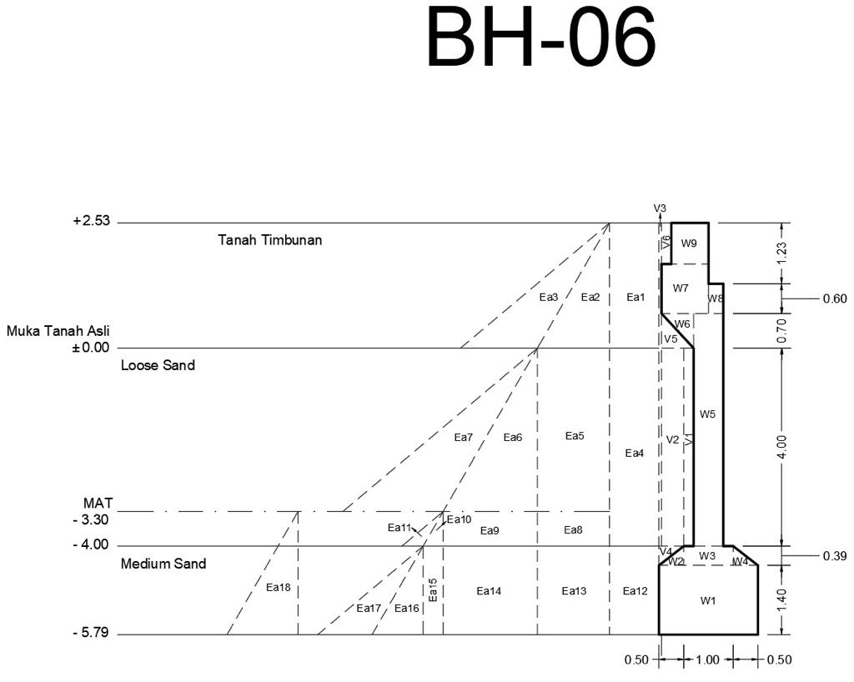

**Figure 1**. Diagram of the force working on drill point BH-06 of the retaining wall

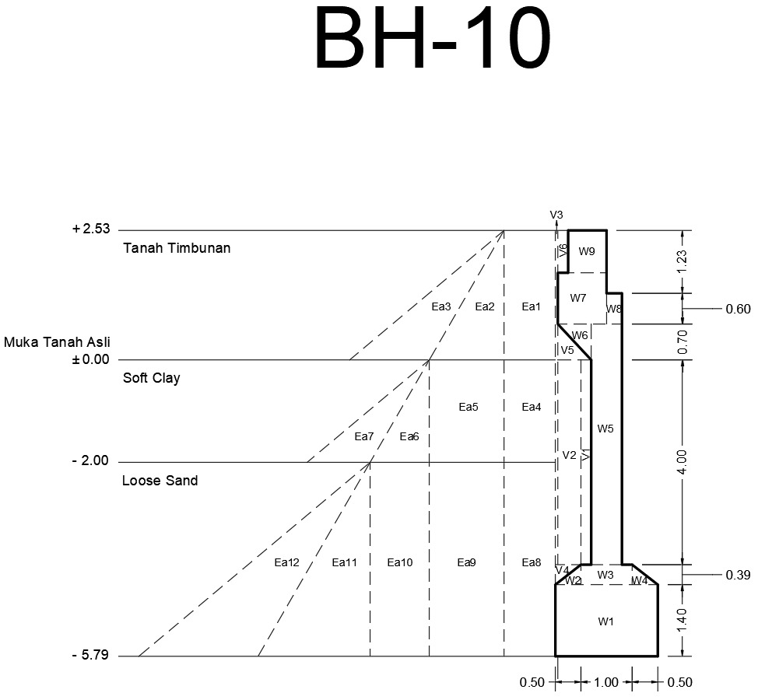

**Figure 2**. Diagram of the force working on drill point BH-10 of the retaining wall

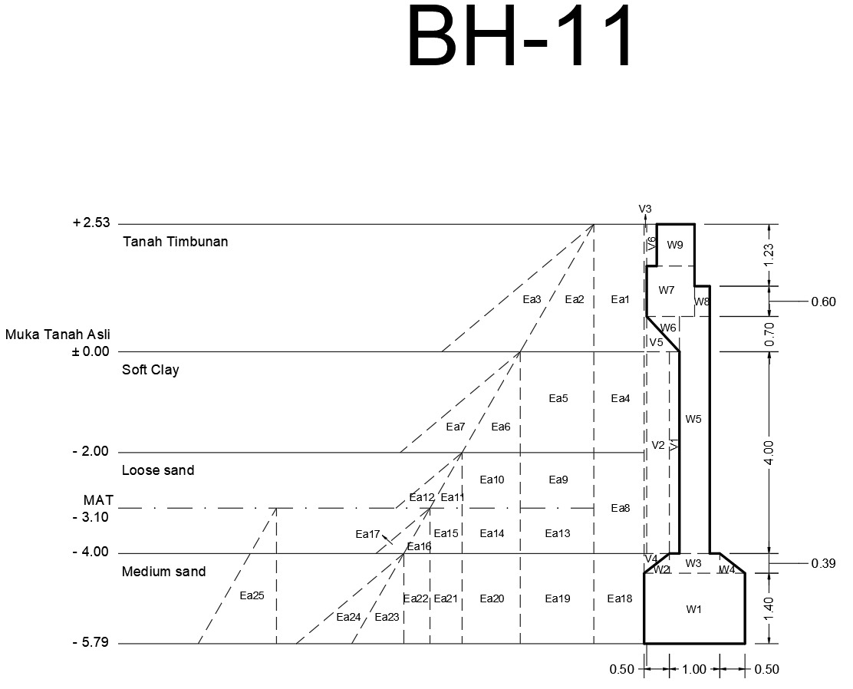

**Figure 3**. Diagram of the force working on drill point BH-11 of the retaining wall

The calculation result for SF (safety factor) due to static condition against sliding force and overturning force of each drill points could be seen in Table 2.

**Table 2**. SF result of each drill points due to static condition

|  |  |  |  |  |
| --- | --- | --- | --- | --- |
| No | Drill Point | SF (*safety factor*) | | Note |
| Sliding Force | Overturning Force |
| 1 | BH 06 | 1.662 | 2.179 | Safe |
| 2 | BH 10 | 3.653 | 5.522 | Safe |
| 3 | BH 11 | 1.515 | 2.266 | Safe |

## 2. Dynamic condition

The calculation result for SF (safety factor) due to dynamic condition against sliding force and overturning force of each drill points could be seen in Table 3.

**Table 3**. SF result of each drill points due to dynamic condition

|  |  |  |  |  |
| --- | --- | --- | --- | --- |
| No | Drill Point | SF (*safety factor*) | | Note |
| Sliding Force | Overturning Force |
| 1 | BH 06 | 1.133 | 1.683 | Safes |
| 2 | BH 10 | 2.391 | 3.614 | Safe |
| 3 | BH 11 | 1.125 | 1.895 | Safe |

*3.2* *Analysis on the Underpass Structure Stability with Rocsience 3 (RS3)*

The stability analysis on the Yogyakarta International Airport underpass structure by using Rocscience 3 (RS3) numerical simulation showed a *safe* result when the required maximum settlement is 51 – 76 mm or 0.51 – 0.76 m. The loading value inserted in the static analysis was 18.58 kN/m2, and the earthquake load on the peak ground acceleration (PGA) analysis according to SNI 8460:1726 is 0.472 g. The underpass geometry is shown in Figure 5. The modelling result has review point with transverse direction and longitudinal direction which could be seen in Figure 6. The analysis result of the overall settlement on each drill points are shown in Table 4.

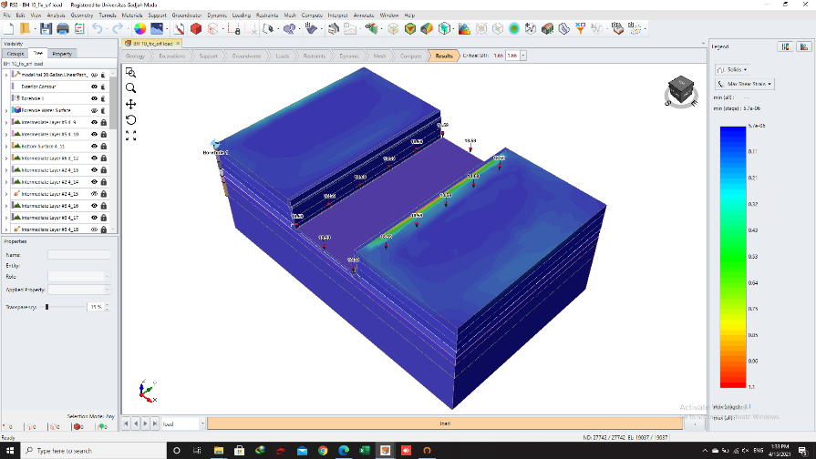

**Figure 4**. Geometry of Yogyakarta International Airport underpass

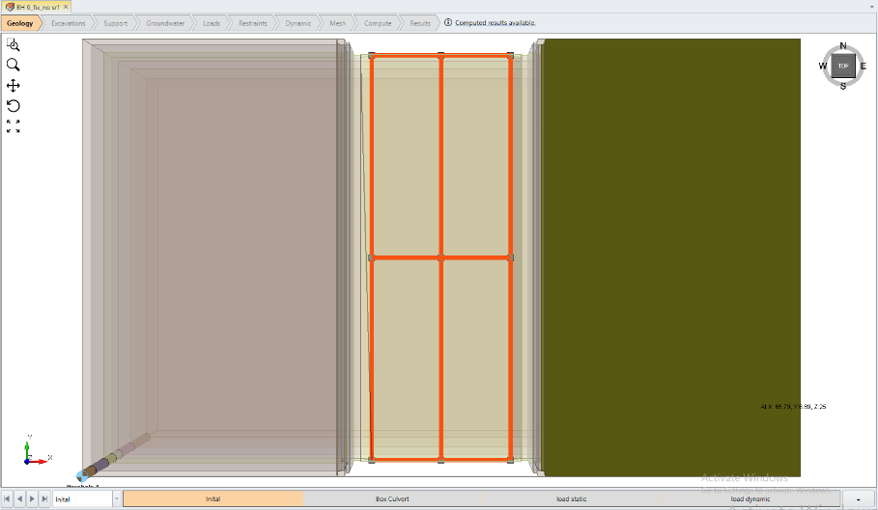

**Figure 5**. Review points in transverse direction and longitudinal direction

**Table 4**. Analysis result of the overall settlement on each drill points

|  |  |  |  |  |  |  |  |  |  |  |
| --- | --- | --- | --- | --- | --- | --- | --- | --- | --- | --- |
| No | Drill Points | Calculation | Settlement (m) | | | | | | | |
| Distance | Transverse Direction | | | Distance | Longitudinal Direction | | |
| Front | Middle | Back | Left | Middle | Right |
| 1 | BH 06 | Static | 14.720 | 0.0236 | 0.0249 | 0.0236 | 43.007 | 0.0237 | 0.0252 | 0.0236 |
|  |  | Dynamic | 14.720 | 0.0318 | 0.0331 | 0.0317 | 43.007 | 0.0277 | 0.0306 | 0.0317 |
| 2 | BH 10 | Static | 14.720 | 0.0225 | 0.0249 | 0.0224 | 43.007 | 0.0224 | 0.0243 | 0.0225 |
|  |  | Dynamic | 14.720 | 0.0282 | 0.0315 | 0.0282 | 43.007 | 0.0211 | 0.0263 | 0.0282 |
| 3 | BH 11 | Static | 14.720 | 0.0256 | 0.0271 | 0.0256 | 43.007 | 0.0255 | 0.0277 | 0.0256 |
|  |  | Dynamic | 14.720 | 0.0350 | 0.0367 | 0.0350 | 43.007 | 0.0277 | 0.0327 | 0.0350 |

The numerical simulation analysis result based by the allowed requirement for the underpass structure showed that it is safe against the occurring settlement.

## CONCLUSION

Based on the result of the conducted analysis, it could be concluded that the analysis of safety factor against shearing and turning forces due to static and dynamic loads at all points of view showed SF values above the criteria, making them safe for shearing and turning stabilities. Based on 3D numerical simulations on static and dynamic loadings, the result of the settlement occurred at the points of view in the range of 23-35 mm. This value is well under the required maximum limit of 51 – 76 mm. which means the YIA underpass structure is *safe* against the settlement.

## ACKNOWLEDGEMENT

Thank you to the Department of Public Works and Spatial Planning (PUPR) DI. Yogyakarta and the National Road Planning and Supervision Work Unit (P2JN) DI Yogyakarta. The management, consultants and contractors of YIA underpass buildings, PT. WIKA, PT. PP Persero and PT. Perentjana Djaja, who has provided access and data for this research. Thanks are also conveyed to the colleagues of this research team for the discussions that enrich the research discussion.

# REFERENCE

1. Coulomb, C. A. (1776). "Essai sur une Application des Regles de Maximis et Minimis a quelques Problemes de Statique, relatifs ai' Architecture," Mem. Roy. Des Sciences, Paris, Vol 3, pp. 38
2. Hardiyatmo, Hary C., 2011. *Analisis dan Perancangan Fondasi II*, Gajah Mada University Press, Jogjakarta
3. Kalolo, M., 2017. *Analisis Stabilitas Dinding Penahan Tanah (Studi kasus: Areal PT. Trakindo, Desa Maubi, Kabupaten Minahasa Utara*. Jurnal Sipil Statik Vol. No 5 Juli 2017 hal. 285-294. Manado : Universitas Sam Ratulangi Manado..
4. Mononobe, N. (1929). "Earthquake-Proof Construction ofMasonry Dams," Proceedings, World Engineering Conference, Vol. 9, pp. 274-280
5. 0kabe, S. (1926). "General Theory of Earth pressure," Journal of the Japanase Society ofCivil Engineers, Vol. 12, No.1.
6. Putera, A. M., 2018. Analisis 3 Dimensi Stabilitas Lereng Timbunan Sampah Padat pada TPST Piyungan Yogyakarta. Tesis. Yogyakarta : UGM.
7. RSNI T-02-2005., Standar Pembebanan
8. Sianipar, A. B., 2018*. Perencanaan Kontruksi Dinding Penahan Tanah pada Underpass dengan menggunakan Secantpile di Jalan Brigjend. Katamso - AH Nasution Medan*. Tugas Akhir. Medan : USU.
9. Sulardi., Prasetyo, D. P., 2018. *Perancangan Box Underpass dengan Menggunakan Metode Kekuatan Batas (Ultimate Design)*. Jurnal Desain Kontruksi. Depok: Universitas Gunadarma.