**Paradigm Shift E-Learning and Technology Transformation UP-CYCLE Rustic Wood During the Covid-19 Pandemic**

**Moh. Rusnoto Susanto1, a), Anselmus Sudirman 2, Shafa’ Selimanorita3,,**

**Siti Mariah4, Abdul Rahim5, A. Sudjud Dartanto6, M. Dwi Marianto7, Andrik Musfalri8, b)**

*1,8Art Education Program-FKIP UST Yogyakarta, 2English Education Department, UST Yogyakarta, Indonesia, 3International Communication Studies Program, FISIPOL-Universitas Muhammadiyah Yogyakarta-Indonesia,4 PVPKK, UST Yogyakarta, Indonesia, 5PGSD UST Yogyakarta, Indonesia, 6Program Studi Tata Kelola, Institut Seni Indonesia Yogyakarta, 7Jurusan Seni Murni, Institut Seni Indonesia Yogyakarta.*

*a) corresponding author:* [*rusnoto@ustjogja.ac.id*](mailto:rusnoto@ustjogja.ac.id)

*b) shafa.s.isip20@mail.umy.ac.id*

*Abstract, The outbreak of the Covid-19 pandemic in mid-February 2020, the Indonesian government called for solutions to its spread, including the Ministry of Education and Culture which ordered education authorities or providers to carry out online learning from home so that the online learning system has become a policy in Indonesia. This also has an impact on changes in the creative industry, UP_CYCLE Rustic Wood, which carries out technological transformation in the aspects of design innovation and E-Commerce. This study aims to (1) describe the phenomenon of the e-learning paradigm shift in the world of education and design innovation strategies on Rustic Wood UP-CYCLE Products in Indonesia, (2) describe how to implement an e-learning-based self-learning system, (3) how the process technological transformation on UP-CYCLE Rustic Wood Products during the Covid-19 pandemic. As a qualitative research with a phenomenological approach, data were collected from various events, participants, findings in the field, literacy, coding process, analysis and representation, criteria of trust and authenticity, and reflection of researchers with several perspectives. The results of the study show that (1) the Covid-19 pandemic phenomenon has shifted the paradigm of an independent e-learning system in Indonesia, (2) an e-learning-based self-learning system that has been implemented as a strategic policy of the government in dealing with Covid-19 cases, and (3 ) Technology transformation process strategy for UP-CYCLE Rustic Wood Products during the Covid-19 pandemic.*

***Keywords****: paradigm shift, e-learning, technological transformation, UP-CYCLE rustic wood*

1. **Introduction**

The era of digitization is marked by the exploration of digital simulation technology which is manifested in all aspects of life and ultimately builds the paradigm and characteristics of the millennial generation currently celebrating the mainstream of cyberculture. The millennial generation is inevitably rolled up in the flow of digital communication technology that has provided a potential form of characteristics by uprooting identity at its cultural roots. The era of digital technology development in the new transformers of the 4.0 industrial revolution era emphasizes the pattern of digital economy, artificial intelligence, big data, and robotic platforms known as a disruptive innovation phenomenon. [1]. The Covid-19 pandemic is a phenomenon that urges the world to shift and even change almost all systems, including the massive response to changes in all-digital learning styles. This is the latest portrait of the face of the world of education.

Indonesia inevitably exposed the spread of the coronavirus until the end of March, 2020, recorded 1.465.928 cases, hospitals treated 1.290.000 patients, 39.000 patients died, 1.297.967 patients recovered, and the number will be dynamic anyhow. [1] Indonesia has experienced conditions where the community's concern about COVID-19 is quite large so that government policy is needed to conduct a lockdown regulation, to stop the spread of the corona Covid-19 virus. [2]. The public panic in face of the ongoing COVID-19 outbreak reminds us of the history of the 1918 inﬂuenza pandemic in London, United Kingdom. Furthermore, its characteristics of mild symptoms in most cases and short serial intervals (4-5 days) are similar to the pandemic inﬂuenza, rather than the other two coronaviruses (SARS-CoV and MERS-CoV).[3]. In 1918, a significant can’t proportion of the deaths were from pneumonia followed by inﬂuenza infection. Thus, it might be reasonable to revisit the modeling framework of the 1918 inﬂuenza pandemic, and in particular, to capture the effects of the 34 individual reactions (to the risk of infection) and government action.[4]

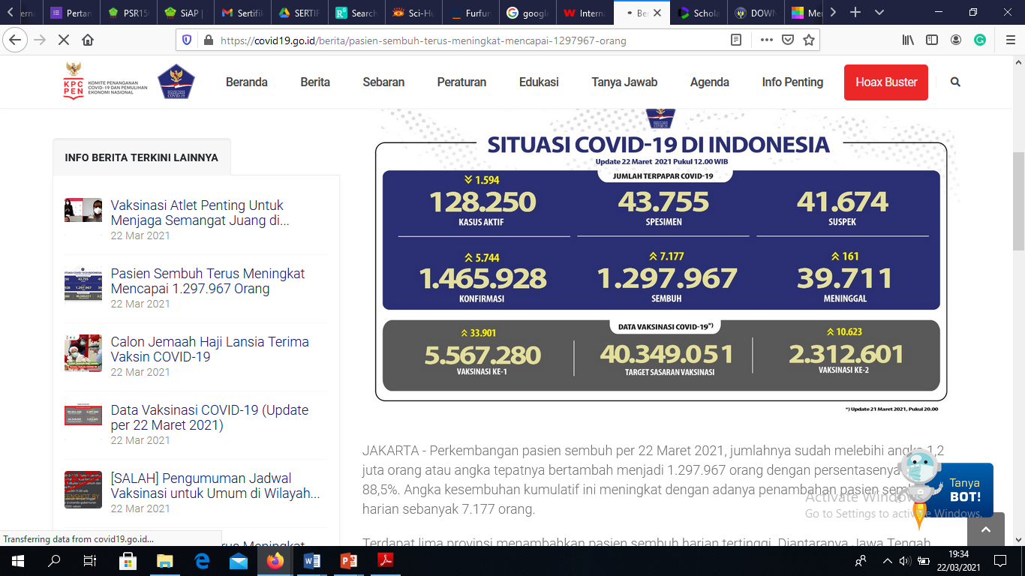

*Figure 1. Latest data on March 21, 2021 on the handling of the Covid-19 Pandemic in Indonesia*

Meanwhile, the Chinese Health Authority is concerned about a serious threat to public health at large. Notification of the WHO on 31 Dec 2019 by the Chinese Health Authorities has prompted health authorities in Hong Kong, Macau, and Taiwan to step up border surveillance, and generated concern and fears that it could mark the emergence of a novel and serious threat to public health. (Parr, 2020).[5] To control public panic over a deadly threat that impacts all social and security aspects, so that monitoring and control through quarantine are carried out strictly. However, at present, there is very limited clinical information about 2019-nCoV infection and missing data regarding age range, the animal source of the virus, incubation period, epidemic curve, viral kinetics, route of transmission, pathogenesis, autopsy findings, and any treatment response. against antivirals among severe cases. [6]

Transmission of the virus by respiratory and extra respiratory routes may help explant the rapid spread of disease. Besides, testing of specimens from multiple sites may improve the sensitivity and reduce false-negative test results. Two smaller studies reported the presence of SARS-CoV-2 in anal or oral swabs and blood from16 patients in Hubei Province. [7]

Furthermore, Zaharah stated that the current teaching and learning process has changed to adapt to the context of the Covid-19 pandemic through an e-learning system using technological devices, such as smartphones, computers, and notebooks through digital platforms. [8] Teaching and learning activities can then be carried out at their respective homes, controlled by teachers or lecturers as well as parents through distance learning policies. The current corona virus affects social, cultural, and economic and even political aspects. In these conditions, the government issues a public policy so that people reduce and do not carry out any activities outside the home such as conditions before the pandemic, all work is then carried out from home, including teaching and learning activities.

It is clear that the Covid-19 pandemic has had a serious impact on almost all sectors of life, including the economic, socio-political, cultural, and educational sectors. UNESCO in mid-year 2020 gave a public statement that the Covid-19 outbreak had a direct impact, especially on the education sector.

Nearly 300 million students have been completely disturbed by the opportunities for exploring the space of normal school activities and their educational rights are threatened in the future so that all countries then make the same decision to carry out the online learning process through various alternative applications of each country's policies. Likewise, Indonesia, through the Ministry of Education and Culture, has also aligned the pandemic situation which has lasted almost 2 years using an online learning system that must be adapted by teachers, lecturers, and students through virtual face-to-face activities in classical learning through zoom meetings or google meet or other platforms as learning facilities. virtual environment to ensure students learn at the same time in different places with virtual face-to-face patterns.

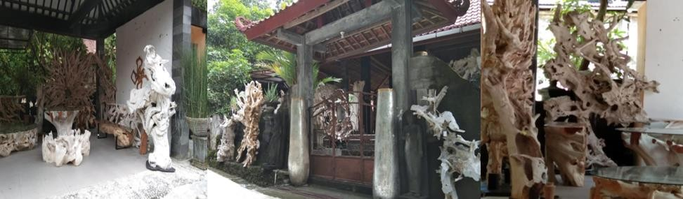

Figure 2. UP-CYCLE Rustic Wood Worshop

The development of innovative products based on the Up-Cycle is focused on design innovations for superior export products and through business pioneering activities and the dynamics of exporting rustic wood based on the Up-Cycle which provide prospective opportunities for the development of creative industry MSMEs in encouraging increased productivity and product quality. Government efforts and the role of researchers and community servants take a strategic role to intervene in the program. Various programs to strengthen the quality of human resources and the achievement of quality with design innovation is carried out solely as a form of creativity, aesthetic form innovation, but has a profane function. Marketing Strategy Based on E-Commerce, building an integrated financial management system, marketing, and online tax reporting system. E-Commerce needs to be strengthened by providing PIXEL links from the WEB to the business IG with up to date interconnections. This also has an impact on changes in the creative industry, UP_CYCLE Rustic Wood, which carries out technological transformation in the aspects of design innovation and E-Commerce. This article intends; (1) describe the phenomenon of the e-learning paradigm shift in the world of education and design innovation strategies on Rustic Wood UP-CYCLE Products in Indonesia, (2) describe how to implement an e-learning-based self-learning system, (3) how the process technological transformation on UP-CYCLE Rustic Wood Products during the Covid-19 pandemic.

1. Method

This type of research is a qualitative study using a phenomenological approach. The data were collected from various events, participant data, in-field findings, literacy, the coding process, analysis and representation, criteria for trust and authenticity, and researchers’ reflection with several perspectives. The reason for choosing this approach is based on problems studied, focusing on the daily experiences of participants and official sources of information, and reflections on experiences of learning activities currently recommended by the government with a learning policy from home by promoting online learning systems independently. The research methods included (1) the type of research and methodology approach, (2) time and place of research, (3) data sources, (4) data collection techniques and instruments used, (5) data analysis and representation (6) criteria for trust and authenticity, and (7) researchers' reflectivity. Zaharah [8] emphasizes that a qualitative method deals with a literature review (of documents) from several sources both print and electronic media, books, and e-journals. Journal searches are carried out through Google Scholar. The search results of selected data meet the criteria. The analysis of the literature review includes data collection, data reduction, data presentation, and concluding.

1. Results and Discussion

In the Covid-19 pandemic situation, conventional learning systems carried out in classrooms, laboratories, studios, and learning methods commonly practiced previously must now be adapted to the circumstances of the typical international world when handling outbreaks. Conventional learning systems are immediately converted into online learning systems that are carried out independently through different e-learning activities. The independent online learning system is carried out in a planned, managed, and systematic manner with the direction of the Ministry of Education and Culture's policy regarding the independent learning process through the online system. In the implementation, some agreements on the use of online facilities have been conducted between lecturers and students, teachers and students, and early childhood and elementary school students, guided by parents and other adults as guides for the online learning process.

Facing the Covid-19 pandemic, the Indonesian government called for solutions to its spread, including the Ministry of Education and Culture which ordered education authorities or providers to carry out online learning from home so that the online learning system has become a policy in Indonesia. Likewise, the productive sector in the creative industry is looking for various alternatives to deal with this difficult time with strategic steps through digital technology transformation to explore export product design innovations and optimize the use of E-Commerce platforms. This phenomenon has strengthened as a strategic step for the creative industry, UP-CYCLE Rustic Wood, which carried out technological transformation in the aspect of design innovation in empowering human resource qualifications and E-Commerce.

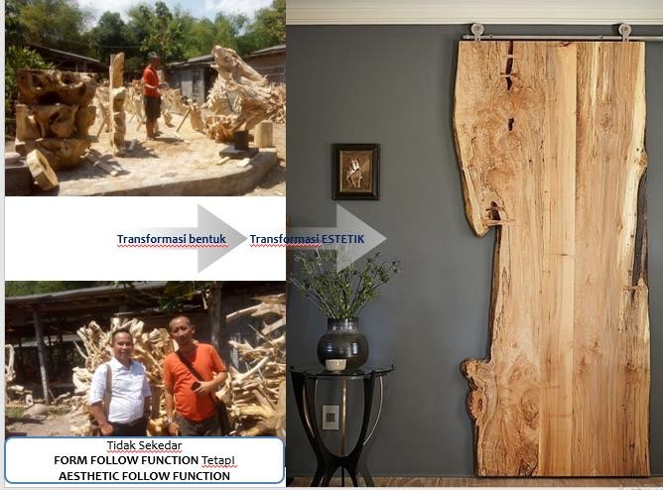 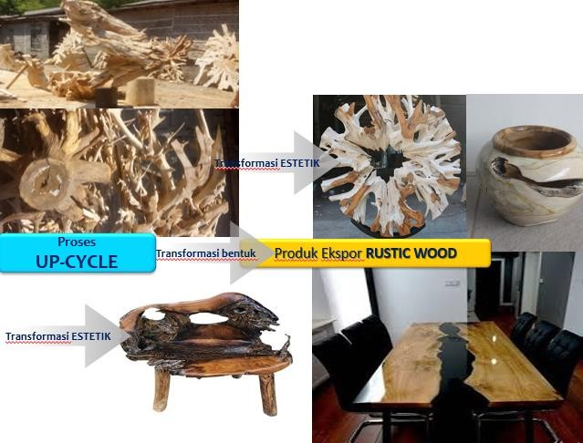

Figure 3. Up-Cycle Based Rustic Wood Products

Popular facilities in the implementation of independent online learning systems include google classroom, google zoom cloud, Edmundo, WA group, e-mail, and with an academic portal system designed by every Education provider institution such as Google Indonesia, Smart Class, Microsoft, Quipper, Ruangguru, Sekolahmu, and Zenius. The Ministry of Education and Culture itself has its learning portal, the Learning House, and even audio-visual facilities through learning programs on TVRI that regularly concoct a distance learning program. [9]. Audrey Azoulay, stated that UNESCO together with each country worked together to ensure the continuity of learning for all, especially children and disadvantaged youth who tended to be the hardest hit by school closures. The policy of closing schools in these countries has an impact on nearly 421.4 million children and adolescents in the world.[10]. Countries affected by Covid-19 place national responses in the form of learning platforms and other devices such as distance learning.

The impact of the coronavirus encouraged universities to stop lectures face to face, as well as using the distance method. Of course, this long-distance method must use information technology facilities and one of them is e-learning. E-learning is information and communication technology to enable students to learn whenever and wherever. [11]. Understanding e-learning has a lot of meaning because of the various uses of e-learning today. E-learning has two types, synchronous and asynchronous. First Synchronous means at the same time. The learning process occurs at the same time between lecturers and students. This allows direct interaction between educators and students on line.

In its implementation, synchronous training requires that lecturers and students access the internet simultaneously. Lecturers provide learning material in the form of papers or presentation slides and students can listen to presentations directly through the internet. Students can also submit questions or comments directly or via chat with the lecturer. Synchronous training is a picture of a real class but is virtual (virtual) and all students are connected via the internet.[12]. Synchronous training is often also referred to as a virtual classroom. This can also be combined with live videos that can be accessed by many students. In the online learning system, the role of lecturers or teachers is important to do motivational activities while strengthening learning innovation competencies, processing teaching materials, and strengthening school culture, and synergizing productive and meaningful learning.

Sarjiya states that there is a positive and significant correlation between Teacher Professional Competence, Teacher Work Motivation, and School Organization Culture together with Teacher Work Productivity. [13]. All three go hand in hand so supervision is needed to create a conducive school organizational culture that allows each teacher to be more motivated to work, accompanied by efforts to improve their professional competence. Both Asynchronous means not at the same time. Students can take different learning time from lecturers who provide material. Asynchronous training is popular in e-learning because students can access learning material wherever and whenever. Students can carry out learning and finish it at any time according to a predetermined schedule range. Learning can take the form of reading, animation, simulation, educational games, tests, quizzes, and task collection. Applications that can be used for online learning are of many types. For example for learning Synchronous training can use Zoom, a video conferencing device (video calls with many audiences). Lecturers/educators can also display what is on the laptop screen (screen sharing) to students. The free zoom is only 40 minutes long with a maximum of 100 participants. In addition to zooming, Google Meet and Webex can be an educational choice in delivering material to students' lives. [12].

As for Asynchronous training lecturers or education can use Screencastify and loom. Tere are still many other applications that can be used by educators in delivering teaching material to students in the form of recordings. To conduct tests, quizzes, or assessment lecturers can use Kahoot, quizizz, and Google form. The various applications above support e-learning as a way to prevent the spread of the Covid-19 virus. Educators and lecturers can use the Synchronous and Asynchronous methods and their various applications. Of course, this is intended to avoid direct contact between individuals and groups to reduce the spread of the COVID-19 virus. [12]. More important to pay attention to is students and students, using distance learning as well as possible because even though it can be said to be a holiday but learning activities must still be carried out and students are encouraged not to use the study time at home to travel.

**3.1 Change of Online Learning System as the Government's Strategic Policy**

Rahayu Retnaningsih states that one of the renewal efforts in the field of education is the renewal of learning methods. During the Covid-19 pandemic Indonesia, Indonesia could immediately adopt the online learning system through e-learning methods.[14]. Putsanra said that the availability of a list of e-learning from the Ministry of Education and Culture that can be used when schools are closed because the COVID-19 coronavirus is very helpful for online learning system activities.[15]. Minister of Education and Culture (Mendikbud) Nadiem Makarim explained that some regions closed schools for fear of spreading the new type of coronavirus or COVID-19 in their respective regions. [8]. Therefore, the Minister of Education and Culture cooperates with various parties for online learning. Some parties that focus on developing the education system online are Google Indonesia, Smart Class, Microsoft, Quipper, Ruangguru, Sekolahmu, and Zenius.

The Ministry of Education and Culture has its learning portal, the Rumah Belajar. Some partners, said Nadiem, expressed their willingness to contribute to implementing online learning systems. Each platform will provide facilities that are publicly accessible and free.[8]. According to him, Google is committed to helping improve learning for everyone. In connection with the COVID-19 situation, Google is helping students and teachers in Indonesia to be able to continue learning outside of school through G Suite for Education as a collaborative learning tool between teachers and students available free of charge from Google. Nadiem Makarim's dream is now realized by the presence of students and students who are almost 65% able to use or carry out virtual learning. Although the percentage of students using Online Learning is not very significant, at least it has shown that there is progress, development, and innovation in the education system in Indonesia by using this Online Learning. Indeed, many schools and universities previously used e-learning or online learning, but not all of them were able to use online learning, due to limited resources such as teachers who did not understand and understood the various online learning applications used in the process and teaching and learning activities in schools. In addition to the limitations of the internet network, the availability of smartphones or notebooks that not all students can have. [8]

The United Nations Educational, Scientific, and Cultural Organization (UNESCO) notes, COVID-19 has an impact on the education of around 290.5 million students worldwide. UNESCO Director-General Audrey Azoulay said disadvantaged children and adolescents were those who tended to be most affected by the closure of schools. Although the temporary closure of schools as a result of health problems and other crises is not new, however, the current global scale and speed of educational disruption are unmatched and if extended, could threaten the right to education. [10]

Minister of Education and Culture, Nadiem Anwar Makarim supports the policy of the regional government (Pemda) which dismiss schools and postpones the implementation of the National Examination (UN). That was as a step to prevent the spread of Coronavirus or Coronavirus disease 2019 (COVID-19). The impact of the spread of COVID-19 will differ from one region to another. The Ministry of Education and Culture is ready to support the policies adopted by the Regional Government. The safety and safety of students and teachers and education personnel are the main ones/ [16].

The United Nations Educational, Scientific, and Cultural Organization (UNESCO) notes, COVID-19 has an impact on the education of around 290.5 million students worldwide. UNESCO Director-General Audrey Azoulay said disadvantaged children and adolescents were those who were tended to be most affected by the closure of schools. Although the temporary closure of schools as a result of health problems and other crises is not new, however, the current global scale and speed of educational disruption are unmatched and if extended, could threaten the right to education. [10]. Minister of Education and Culture (Mendikbud) Nadiem Anwar Makarim supports the policy of the regional government (Pemda) which dismiss schools and postpones the implementation of the National Examination (UN). That was as a step to prevent the spread of Coronavirus or Coronavirus disease 2019 (COVID-19). The impact of the spread of COVID-19 will differ from one region to another.

The Ministry of Education and Culture is ready to support the policies adopted by the Regional Government. The safety and safety of students and teachers and education personnel are the main ones. [16]. Schools can use hangouts meet, video conferencing tools available to all G Suite users, and Google Classroom, to attend classes and continue distance learning from home. Until July 1, 2020, Google provided the most complete hangouts meet feature free of charge which included live streaming capabilities of up to 100,000 viewers in a domain and large gatherings of up to 250 participants per class until July 1, 2020, which could be recorded and stored on Google Drive for later access day. Likewise with the Education Leadership of PT Microsoft Indonesia, Benny Kusuma, explaining it provides Office 365 access for education. To take advantage of this facility, schools only need to provide an institutional domain as a digital identity of teachers and students. Then Ruangguru also announced the opening of the Ruangguru Free Online School. Through this program, students can take distance learning online (live teaching) every Monday to Friday, as school as usual. Starting on Monday, March 16, 2020, students can take free Ruangguru Online School lessons from 08.00 - 12.00 WIB, which will have 15 live teaching channels that cover all subjects according to the national curriculum starting from grade 1 elementary school to grade 12 high school (Natural Sciences and IPS), which was guided by Ruangguru Master Teachers.

Likewise, your school has also organized classroom and career learning by collaborating with hundreds of schools and organizations. Online learning is intended for all students, teachers, and even parents. The programs provided by your school have been very well designed by an experienced academic team in applying successful competency-based learning.[15]. The following is a list of E-Learning websites that students can use during the COVID-19 corona pandemic, including (1) Access to Learning Centers: https://belajar.kemdikbud.go.id (2). Access Google G Suite for Education: https://blog.google/outreach-initiatives/education/offline-access-covid19/ (3) Smart Class Access: https://kelaspintar.id (4) Access Microsoft Office 365: https : //microsoft.com/en-us/education/products/office (5) Access to Quipper School: https://quipper.com/id/school/teachers/ (6) Free Ruangguru Online School, (7) Free access to online learning for your school.[15].

Another focus of the government is also to balance the system of strengthening the economy through the resilience of the creative industry to face the global market during the Covid-19 pandemic. Various measures of strengthening in an integrated and systemic manner were also mobilized by the business world, researchers, community servants and all parties to jointly revive the Indonesian economic system.

It takes the participation of the government and researchers as well as community servants to carry out various assistance and program strengthening both in the aspects of design innovation and marketing strategies based on digital platforms. The extraordinary enthusiasm of the stakeholders to carry out various programs to strengthen the quality of human resources and achieve quality with design innovations to transform the aesthetic form as a product of creativity, innovation that not only fulfills a profane function but also an aesthetic function. E-Commerce-Based Marketing Strategy, building an integrated online financial management, marketing, and tax reporting system. E-Commerce needs to be strengthened by providing PIXEL links from the WEB to the business IG with up to date interconnections. Innovative designs need the support of a good and effective technology-based marketing system to support new ideas or findings of new processes and appropriate methods taken to give birth to new creative ideas that are fresh and up to date, requiring good imagination and visualization power. Practical needs-oriented creators (profanes) market superior export products through a marketplace that is supported by the completeness of an E-Commerce-based marketing system through various applications and patterns of continuous training assistance, helping Partners in strengthening the marketing system.

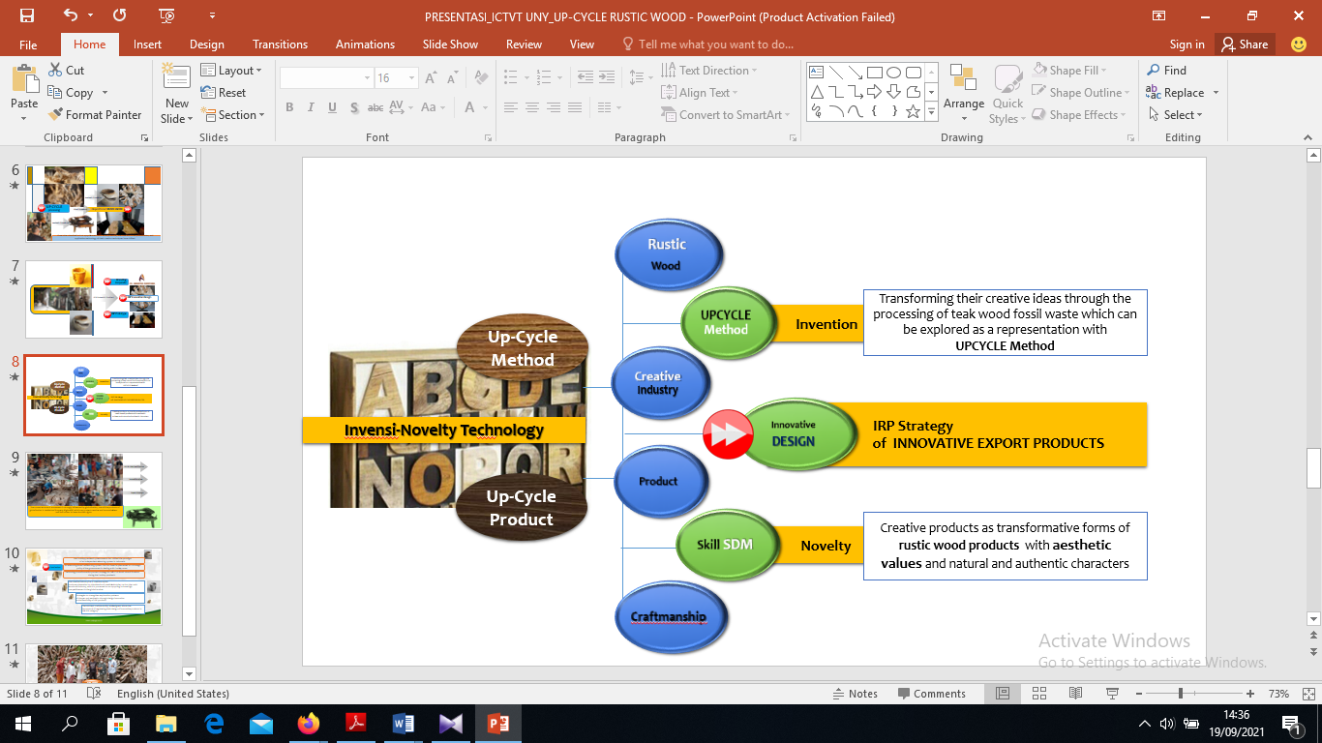

Figure 4. Technology Transformation of Up-Cycle Based Rustic Wood Products

**3.2 A Critical Review of Values and Problems**

It seems clear that a variety of provisions that are planted with students or students seem to need to adjust the various points of the concept that is instilled Ki Hajar Dewantara in the Among system which is supported by several important points that can be used as the basis for the implementation of an online learning system independently. That *Pamong* (educators) foster and instill trust in God with full confidence as a source of strength *(Ngandel).* The statement above certainly motivates all of us that we believe this situation will soon be overcome by believing the test that must be overcome together. In the context of an online learning system that is prioritized mutual trust with learning resources and the value of knowledge that is transformed through the e-learning process. The *pamong* (educator) can instill in students or students to have a brave attitude and character who dare to take an attitude and decision based on rules, norms, and truth values *​​(Kendel).*

This certainly can be part of students' attitudes in accepting the truth of the information that has scientific value as previously believed when doing regular face-to-face meetings. *Pamong* (educator) can also instill a strong attitude, resilient, and stand the test of various challenges, never give up (Stubborn). This recalcitrant attitude is the time to be prepared and implemented in facing the threat situation of the spread of Covid-19 which is increasingly whacking various joints of life both social, economic, cultural, and disruption of spiritual activities. At present social relations are arranged the distance of meetings including arrangements to study at home, work at home, and even religious activities carried out at home. This becomes a new challenge and requires an unyielding attitude so that learning activities are carried out using an online learning system as a non-negotiable alternative.

The *pamong* (educator) can instill a high mental attitude of confidence towards the ability and potential that is possessed of a thick mental *(Kandel).* In the process of independent learning is very much in line with the values ​​and teachings of the Tamansiswa Opor Bebek Mateng soko Awake Dewek, how the attitude of self-reliance in learning has been instilled with an attitude of confidence that is thick and resilient. Besides, *pamong* (educator) can stimulate and foster an attitude of observing carefully and deeply both in thought, attitude, and action *(Niteni)*. How *Pamong* (educator) can provide an overview of the process of imitating both the environment, self, and social both in thought, attitude, and action *(Nirokake).* How can *Pamong* (educators) be able to foster creative attitudes well after having the ability to observe, imitate both thoughts, attitudes, and actions *(Nambahi)?*

Rahayu Retnaningsih said that *Pamong* (educator) in the learning process must instill knowledge and observation steps so that students can know, and understand something (understand).[14]. *Pamong* (educator) in the learning process must instill awareness in processing the sensitivity of taste to understand something with the sensitivity of feeling *(Ngrasa).* *Pamong* (educator) after passing through the process of understanding and feeling, someone should be able to do something according to what is known, understood, and has been felt *(Ngelakoni). Pamong* (educator) can give a good example in the process of giving birth to ideas and thoughts that can provide stimulation to students in creating a way of thinking (copyright). *Pamong* (educators) have the competence to foster attitudes and have empathy for others to feel something (cultivate a sense) that other people feel (taste). Pamong (educator) can train students in having the will and ability to do something with the ability and all potential (intention). A Pamong (educator) must be able to set a good example for his students *(Tuladha).* A *Pamong* (educator) in the middle must be able to motivate students (*Madya* and *Karsa*). A *Pamong* (educator) must be able to encourage his students *(Handayani). Pamong* (educator) develops competence in applying good example-based learning processes with noble character according to Tamansiswa's life teachings. Pamong (educator) must provide various appropriate motivations according to the needs of the learning process in various contexts of the theme taught to his students.

Problems that arise in the field when using an online learning system are certainly many things that can be required to achieve the ideal KM process, problems include: (1) Requires Adequate Infrastructure, (2) Learning Outcomes to Be Obtained, (3) Learning Outcomes Depends on Students Who Follow, (4) e-Learning Cannot Adjust Everyone's Learning Styles, and (5) Real Teachers Still Need to Learn. [17]. In other words, learning is a process to help students to learn well. Also learning is a process of conscious effort made by individuals for a change from not knowing to know, from not having an attitude to being right, from being unskilled to being skilled at doing something. Learning is not merely mapping the knowledge or information conveyed. How to involve individuals actively make or revise the learning outcomes they receive into a personal experience that is beneficial to them. 18].

On the other hand the role and support of the government through various government policies (world education policies, work at home, learning from home, worship at home, extended periods of independent learning, travel restrictions, hospitalization, and quarantine and the prohibition of going home). So that it is expected to strengthen government synergy and strengthen community solidarity to remain calm, orderly, have awareness, be wise, and continue to work together to handle the COVID-19 case completely. 1) COVID-19 Pandemic Phenomenon and Online Learning System Paradigm An independent learning system based on e-learning has been implemented from PAUD, Kindergarten, Elementary, Middle, High School, and Higher Education levels as a strategic government policy obligation in undertaking efforts to handle the Coronavirus Disease 2019 (COVID-19) case.

Teachers as a source of learning can do learning using the E-Learning method, namely electronic learning that utilizes information and communication technology. The learning system is implemented through computer devices (PCs), laptops, smartphones, and gadgets that are connected to the internet network connection, teachers can do joint learning independently. E-learning is done at the same time using groups on social media such as Whats App (WA), telegram, Zoom applications, or other social media as a means of learning to ensure students learn at the same time even in different places.

The teacher or lecturer must be able to consider by giving measurable tasks and still ensure that each session describes the lesson plans, SAP, RPS that have been prepared with various adjustments to the material and interesting methods. So that the online learning process can replace the planned material essence like the quality of face-to-face learning. Various other innovations can be done by educators to provide access to knowledge by ensuring the quality of learning continues to run and students get knowledge according to the curriculum that has been prepared by the government. The Principal (Head of Study Program or Director) plans various innovations in carrying out the supervision or coaching function to the teacher and lecturer to ensure that the teaching and learning process has been carried out by teachers and students even though using the remote method (online). Principals (Head of Study Programs) can also provide solutions and motivation to teachers or lecturers so that teachers (lecturers) who are not ready to use online media can be supervised and given solutions.

Thus, the government synergy strengthens the community solidarity to stay calm, aware, and wise to continue fighting against the Covid-19 pandemic. The e-learning system that is applied to online learning activities, especially in vocational education (both fine arts and mechanical engineering and fashion design) actually encounters many obstacles considering that many technical matters related to practicum activities that take place in studios, laboratories and workshops cannot be facilitated and well accessed by students.

1. Conclusion

Analysis of online learning systems during the Covid-19 period through a Student Review from a phenomenological perspective. During the Covid-19 pandemic, the process of teaching and learning was transferred to a large extent and all online learning activities using the e-learning method, so that many things should be understood as part of the mental management of students in dealing with all situations. The conclusion of the study show that (1) the Covid-19 pandemic phenomenon has shifted the paradigm of an independent e-learning system in Indonesia, (2) an e-learning-based self-learning system that has been implemented as a strategic policy of the government in dealing with Covid-19 cases, and (3) Technology transformation process strategy for UP-CYCLE Rustic Wood Products during the Covid-19 pandemic. In the perspective of Tamansiswa's noble values, Ki Hajar Dewantara instilled the attitude of *Ngandel, Kendel, Bandel*, and *Kandel*. Pamong (educator) fosters and instills trust in God with confidence as a source of strength (Ngandel). The statement above certainly motivates all of us that we believe this situation will soon be overcome by believing the test that must be overcome together. I the context of an online learning system that is prioritized mutual trust with learning resources and the value of knowledge that is transformed through the e-learning process. Pamong (educator) can instill in students or students to have a brave attitude and character who dare to take an attitude and decision based on rules, norms, and truth values ​​(Kendel).

This certainly can be part of students' attitudes in accepting the truth of the information that has scientific value as previously believed when doing regular face-to-face meetings. Pamong (educator) can also instill a strong attitude, resilient, and stand the test of various challenges, never give up (Stubborn). This recalcitrant attitude is the time to be prepared and implemented in facing the threat situation of the spread of Covid-19 which is increasingly whacking various joints of life both social, economic, cultural, and disruption of spiritual activities. At present social relations are arranged the distance of meetings including arrangements to study at home, work at home, and even religious activities carried out at home. This becomes a new challenge and requires an unyielding attitude so that learning activities are carried out using an online learning system as a non-negotiable alternative. Problems that arise in the field when using an online learning system are certainly many things that can be required to achieve the ideal KM process, problems include: (1) Requires Adequate Infrastructure, (2) Learning Outcomes to Be Obtained, (3) Learning Outcomes Depends on Students who Follow, (4) e-Learning Cannot Adjust Everyone's Learning Style, and (5) Real Teachers Still Need to Learn. The online learning system, especially in vocational education, actually encounters many obstacles, considering that there are many technical issues related to practical activities that students are unable to facilitate and access properly.

**Acknowledgment**

The research team for applied research grants for higher education institutions (PTUPT) would like to thank the BRIN Research and Technology DRM, the Ministry of Education, Culture, Research and Technology of the Republic of Indonesia for providing funding for the implementation of multi-year research. Thank you to the research team and article writing teams from other universities who contributed to completing this article. Thank you to LP2M and Universitas Sarjanawiyata Tamansiswa Yogyakarta for providing various access and facilities for the research team.

**References**

# [1] Susanto, Moh. Rusnoto. 2019. Exploring Ki Hadjar Dewantara’s Avant Garde Principles Of National Education: A Philosophy Of Organism Perspective, *Proceeding : Intercultural Collaboration Indonesia – Malaysia "Implementation Of Tamansiswa Philosophy"* Https://Jurnal.Ustjogja.Ac.Id/Index.Php/ICIM/Article/View/5967/2683UST Yogyakarta, 2019, P. 98

[2] Yunus, Nur Rohim, Annissa Rezki. 2020. Kebijakan Pemberlakuan Lock Down Sebagai Antisipasi Penyebaran Corona Virus Covid-19, *SALAM; Jurnal Sosial & Budaya Syar-i FSH UIN Syarif Hidayatullah Jakarta Vol. 7 No. 3 (2020), pp.269-282, DOI: 10.15408/sjsbs.v7i3.15104*

[3] Nishiura H, Linton NM, Akhmetzhanov AR. 2019. The serial interval of novel coronavirus (2019-nCoV) infections. *medRxiv*.178 2020; p.179

[4] You C, Deng Y, Hu W, Sun J, Lin Q, Zhou F, et al. 2020. Estimation of the Time-Varying Reproduction Number of 180 COVID-19 Outbreak in China. *medRxiv.* 2020; Available *from:*[*https://www.medrxiv.org/content/early/1812020/02/17/2020.02.08.20021253.182*](https://www.medrxiv.org/content/early/1812020/02/17/2020.02.08.20021253.182), p. 180

[5] Parr, J. 2020. Pneumonia in China: Lack of Information Raises Concerns Among Hong Kong Health Workers. BMJ 2020; 368; m56, DOI: [http://dx.doi.org/10.1136/bmj.m56 Published 8 January 2020](http://dx.doi.org/10.1136/bmj.m56%20Published%208%20January%202020).

[6] *Hui, DS et al.* . 2020. The continuing 2019-nCoV epidemic threat of novel coronaviruses to global health-The latest 2019 novel coronavirus outbreak in Wuhan, China,  *International Journal of Infectious Diseases 91 (2020) 264*–*266* <http://doi.org/10.1016/j.ijid.2020.01.009>, 1201-9712/© 2020. Published by Elsevier Ltd on behalf of International Society for Infections Diseases. This is an open access article under the CC BY-NC-ND License (<http://creativecommons.org/licenses/by-nc-nd/4.0/>)

[7] Zhang W, Du RH, Li B, et al. 2019. Molecular and serological investigation of 2019-nCoV infected patients: implication of multiple shed doing routes. *Emerg Microbes Infect*. 2020; 9(1):386-389. DOI:10.1080/22221751.2020.1729071, p. 1

[8] Zaharah, Galia Ildusovna Kirilova, Anissa Windarti. 2020. Impact of Corona Virus Outbreak Towards Teaching and Learning Activities in Indonesia, *SALAM; Jurnal Sosial & Budaya Syar-i* , FSH UIN Syarif Hidayatullah Jakarta Vol. 7 No. 3 (2020), pp.269-282, DOI: 10.15408/sjsbs.v7i3.15104

[9] Irawan, Hendra. 2020. *Inovasi Pendidikan Sebagai Antisipasi Penyebaran Covid-19, Senin*, 23/03/2020 <https://ombudsman.go.id/artikel/r/artikel--inovasi-pendidikan-sebagai-antisipasi-penyebaran-covid-19>

[10] Azoulay, Audrey. 2020. *Dirjen UNESCO Director-General of the United Nations Educational, Scientific and Cultural Organization (UNESCO)* seen on 22 Maret 2020.

[11] Dahiya, S., Jaggi, S., Chaturvedi, KK., Bhardwaj, A., Goyal, RC., and Vrghese, C, 2016. An e-learning System for Agricultural Education. Indian Research Journal of Extention Education, 12 (3), pp. 132-135

[12] Fikri, Haidar, 2020. *E-Learning dan Covid-19*, diposting Rabu, 18 Maret 2020 - 13:33 | 263.35k, <https://www.timesindonesia.co.id/read/news/257426/elearning-dan-covid19>

[13] Sarjiya, Mulyoto. 2016. Korelasi Kompetensi Profesional, Motivasi Kerja, dan Budaya Organisasi Sekolah dengan Produktivitas Kerja Guru SMP/MTs Se-Kecamatan Temon, *WIYATA DHARMA, Jurnal Penelitian dan Evaluasi* Pendidikan, Vol 4 No. 2 (2016) DOI: <http://dx.doi.org/10.30738/wd.v4i2.2271.g1238.\>

[14] Retnaningsih, Rahayu. 2016. Upaya Meningkatkan Motivasi dan Prestasi Belajar Matematika Pada Operasi Bangun Ruang Melalui Pembelajaran Kooperatif Tipe STAD (Student Teams Achievement Division) Kelas IV di Sekolah Dasar Negeri Jombor Lor, *WIYATA DHARMA, Jurnal Penelitian dan Evaluasi Pendidikan*, [Vol 5, No 2 (2017)](https://jurnal.ustjogja.ac.id/index.php/wd/issue/view/280), DOI: <http://dx.doi.org/10.30738/wd.v5i2.3378>

[15] Putsanra, Dipna Videlia. 2020. *Daftar E-Learning Kemendikbud, Sekolah Online untuk Mencegah Corona,* diposting pada 16 Maret 2020 <https://tirto.id/daftar-e-learning-kemendikbud-sekolah-online-untuk-mencegah-corona-eFrR>

[16] Hendarti, Yuli. 2020. *Optimalisasi Pembelajaran Berbasis Online Selama COVID-19* ttps://www.rakyatpos.com/optimalisasi. (searching, 22 Maret 2020).

[17] [Pardi](https://koinworks.com/blog/author/devayanti/), Devayanti. 2020. 5 Alasan yang Menunjukkan Bahwa *e-Learning* Bukan Pilihan Untuk Anda, <https://koinworks.com/blog/e-learning-bukan-pilihan/>

[18] Hardianto, Deni. 2005. Media Sebagai sarana Pembelajaran Efektif. *Majalah Ilmiah Pembelajaran*. Vol. 1 Jakarta.