**Supplier Selection Problem for Multiple Items: an MCDM Approach**

Dyah Ari Susanti1,a), Wakhid Nur Hidayat2,b), Patrisius Edi Prasetyo3,c), V. Reza Bayu Kurniawan4,d)

1,2,3,4Department of Industrial Engineering, Universitas Sarjanawiyata Tamansiswa, Yogyakarta, Indonesia

a)Corresponding author: [dyah.as@ustjogja.ac.id](mailto:dyah.as@ustjogja.ac.id)

b)[wakhidnur567@gmail.com](mailto:wakhidnur567@gmail.com)

c)[patrisedi@ustjogja.ac.id](mailto:patrisedi@ustjogja.ac.id)

d)[reza.kurniawan@ustjogja.ac.id](mailto:reza.kurniawan@ustjogja.ac.id)

**Abstract.** Many studies on supplier selection decision making have been carried out with various multi-criteria decision-making (MCDM) approaches as the decision influences a company’s overall performance. However, an organization is still facing difficulty to find the right solution with regard to supplier selection problem (SSP) with multiple items due to fewer studies. Accordingly, the purpose of this study is to evaluate suppliers under a multi-item environment using the AHP method. The decision-making model is demonstrated in an Indonesian garment industry. There are six experts invited in this study to define 21 factors for selecting the best supplier for four items as parts of printing accessories materials. The factors are broken down from six criteria namely quality, price, delivery, flexibility, document, and relation. The result indicates that the second supplier is the most performing supplier to serve all items, while only one supplier (the first supplier) which has the closest production capability as the second supplier. This study brings some recommendations based on the suppliers’ scores obtained in order to apply a more effective improvement. Besides, this paper has also provided an initial model for further modified SSP cases.

**INTRODUCTION**

This study proposes a case study on supplier selection decision making under a multi-item environment demonstrasted in a garment manufacturing company in Indonesia. The company has currently been certified in quality management system which should take into account the control of processes, products, and services provided by external parties. In this case, supplier evaluation is essential for the fulfillment of production process standards in the company. Further, the supplier selection decision making in the compant is more complex as considering multiple suppliers for multiple items simultaneously [1]. Hence, a structured decision-making method for supplier selection needs to be applied.

Several studies solved SSP using the MCDM technique since the problem is often considered as a complex problem involving many considerations and evaluation factors as well as alternatives. Felice et al. [2] utilized analytic hierarchy process (AHP) to solve supplier selection process using seven criteria modified from previous studies. The decision model was validated in the SSP cases situated in Iranian and Swedish companies. Another SSP case based on AHP has also been conducted by Dweiri et al. [3] considering four main criteria (price, quality, delivery, and service). Furthermore, the sensitivity analysis was calculated in the study demonstrated in the automotive industry in Pakistan. The integrated and modified AHP into fuzzy environment have been carried out by some scholars [4,5,6]. Nazim [4] developed a supplier selection model using AHP and supply chain operation reference (SCOR), especially at the appraisal stage to obtain the weight of criteria and to aggregate the criteria scores at the selection stage. Then, fuzzy analytic hierarchy process (F-AHP) was utilized by Jain et al. [5] which was integrated with fuzzy technique for order of preference by similarity to ideal solution (F-TOPSIS) and Sivrikaya et al. [6] combining goal programming. Jain et al. [5] took a case study for the selection process of headlamp in an Indian automobile company where the F-AHP was assigned to determine the weights of criteria and F-TOPSIS was to rank the alternatives. In the study, the sensitivity analysis has also been calculated as [3]. Meanwhile, Sivrikaya et al. [6] did not only perform the supplier selection decision method, but also solved the ordering processes model to find the optimal order allocation using linear goal programming. Several scholars have also carried out the SSP study in the garment industry since the decision of supplier selection has a significant impact to the quality of the end products. In Vietnam, Wang et al. [7] evaluated the suppliers using MCDM considering the sustainability factors, while Wang et al. [8] proposed the integration between fuzzy analytic network process (F-ANP) and goal programming. In Indonesia, the study on supplier selection with green criteria has been conducted using AHP and VIKOR approaches [9], while DEMATEL and ANP were selected to determine the relationship between factors and the weight of supplier performance [10].

In this study, AHP is taken to address the typical SSP with multi-items since the method is capable to support strategic decisions in the fundamental step. Although the principles used in this research are adapted from previous studies, the SSP environment delivered is more complicated as it may not only comprise of multiple criteria and alternatives, but also multiple items. Meanwhile, a multi-item SSP is still rarely undertaken although Ayhan and Kilic [11] has introduced an integrated F-AHP and MILP model. Therefore, this study contributes twofold:

1. This paper provides an understandable initial model of SSP under a multi-item environment.
2. The evaluation factors (criteria and sub-criteria) are defined in a garment company that is often deemed to be a highly competitive industry in a developing country.

**METHOD**

In this study, the SSP model is solved using AHP which was firstly introduced by Saaty [12]. In addition to simplicity in computation, the method deploys a complex SSP into a hierarchical structure. To solve the SSP with multiple items, the first step is to define factors derived by the decision-makers (DMs), and then a decision-making structure can be drawn up by describing each level from goals to alternatives. Thirdly, the weights of factors are determined through the AHP pairwise comparisons. The weights indicate the score of suppliers that should be selected.

The main AHP step is initially to construct a positive reciprocal matrix *A* using the 9-scale of pairwise comparison between 1 representing equal importance and 9 representing extreme importance [2,3].

$A=\left(\begin{matrix}a_{11} & a_{12} & a_{13} \\ a_{21} & a_{22} & a_{23} \\ a_{31} & a_{32} & a_{33}\end{matrix}\right)$

$a_{ij}={\text{a}}_{ik}×{\text{a}}_{jk}$ (1)

${\text{a}}_{ij}=\frac{1}{{\text{a}}_{jk}}$ (2)

Where *i*, *j*, and *k* are any elements of the matrix A, a*ij* = 1 when *i* = *j*. Next, the weight of each factor (criterion or alternative) can be calculated using equation (3). The sum of weights is 1.

$\text{Weight of i}= w_{i}=\frac{\sum_{j=1}^{n}{w_{ij}}}{n}$ (3)

$w_{ij}=\frac{{\text{a}}_{ij}}{\sum_{i=1}^{n}{a_{ij}}}$ (4)

Where w*ij* = a*ij*. To check the consistency, the consistency ratio (*CR*) is computed using equation (5) where λmax of Aw = λmaxw is the largest eigenvalue of matrix *A*. If the *CR* value is less than or equal to 0.10, then the level of inconsistency is accepted; otherwise, the judgement matrix, the values of a*ij*, needs to be revised.

$CR=\frac{CI}{RI}=\frac{Consistency Index}{Random Consistency of A}$ (5)

$CI=\frac{λ_{max}-n}{n-1}$ (6)

$RI=\frac{1.98(n-2)}{n}$ (7)

**RESULTS AND DISCUSSION**

**The Case Study**

A case study of a multi-item SSP modeled on a garment manufacturing company located in Indonesia. The SSP decision making is very important since the company has adapted the good practice of quality management system, particularly to control process, product, and services. The complexity of the decision-making process is also described by a number of suppliers producing the four items required, namely label (*I*1), sticker (*I*2), papertag (*I*3), and polybag (*I*4), and there are many raw materials that have not been passed the quality testing based on the acceptable quality level testing system and 10% random testing. These four items addressed are fulfilled by local suppliers and categorized as printing accessories material. The number of suppliers currently serving the four items (*I*1 to *I*4) is respectively three suppliers, four suppliers, and two suppliers for *I*3 and *I*4. Due to the high percentage of defective materials as well as the number of suppliers supplying the items, a structured decision-making process needs to be developed.

**Criteria and The Hierarchical Structure of AHP**

The first step of defining criteria and producing the pairwise comparions matrices involves six DMs, namely general manager, factory manager, PPIC purchasing, PPIC planning, PPIC material control, and production manager. Table 1 presents the criteria and sub-criteria identified from the expert group discussion.

**TABLE 1**. The criteria and sub-criteria used to evaluate the supplier in the company [13]

|  |  |  |  |  |
| --- | --- | --- | --- | --- |
| **Criteria** | |  | **Sub-criteria** |  |
| Quality | *C*1 | | Specifications | *C*11 |
|  |  | | Consistency in quality | *C*12 |
|  |  | | Low defect quantity | *C*13 |
|  |  | | Acceptable rejection rate | *C*14 |
| Price | *C*2 | | Competitive price | *C*21 |
|  |  | | Reduced price | *C*22 |
|  |  | | Price fluctuation | *C*23 |
| Delivery | *C*3 | | On-time delivery | *C*31 |
|  |  | | Delivery on right quantity | *C*32 |
|  |  | | Delivery cost | *C*33 |
|  |  | | Packaging for delivery | *C*34 |
|  |  | | Lead time | *C*35 |
| Flexibility | *C*4 | | Payment flexibility | *C*41 |
|  |  | | Order flexibility | *C*42 |
|  |  | | Claim | *C*43 |
|  |  | | Negotiable supply schedule | *C*44 |
| Document | *C*5 | | Contract and purchase documents | *C*51 |
|  |  | | Shipping documents | *C*52 |
| Relation | *C*6 | | Communication channels | *C*61 |
|  |  | | Customer relationship management | *C*62 |
|  | |  | Accessibility | *C*63 |

As can be seen in Table 1 that there are six criteria and 21 sub-criteria for evaluating supplier. The 21 sub-criteria are adapted to evaluate the four items since the items are grouped into the same type of material served by the same local suppliers. The quality criteria (*C*11-*C*14) indicate the specifications and quality of materials as agreed, while the price criteria (*C*21-*C*23) describe how competitive the prices are given by suppliers including the fluctuation given external factors. The third criterion is delivery including the supplier’s capability to meet the delivery requirements in the form of on-time delivery and right-quantity delivery. Then, the flexibility criteria explain the acceptance level of suppliers to negotiate same crucial matters related to payment, order quantity, quality, and time. The fifth and sixth criteria are document and relation where the document factor represents the documented supply chain process, while the capability to response and follow-up are described as relation factors. The AHP hierarchical structure is illustrated in Figure 1.

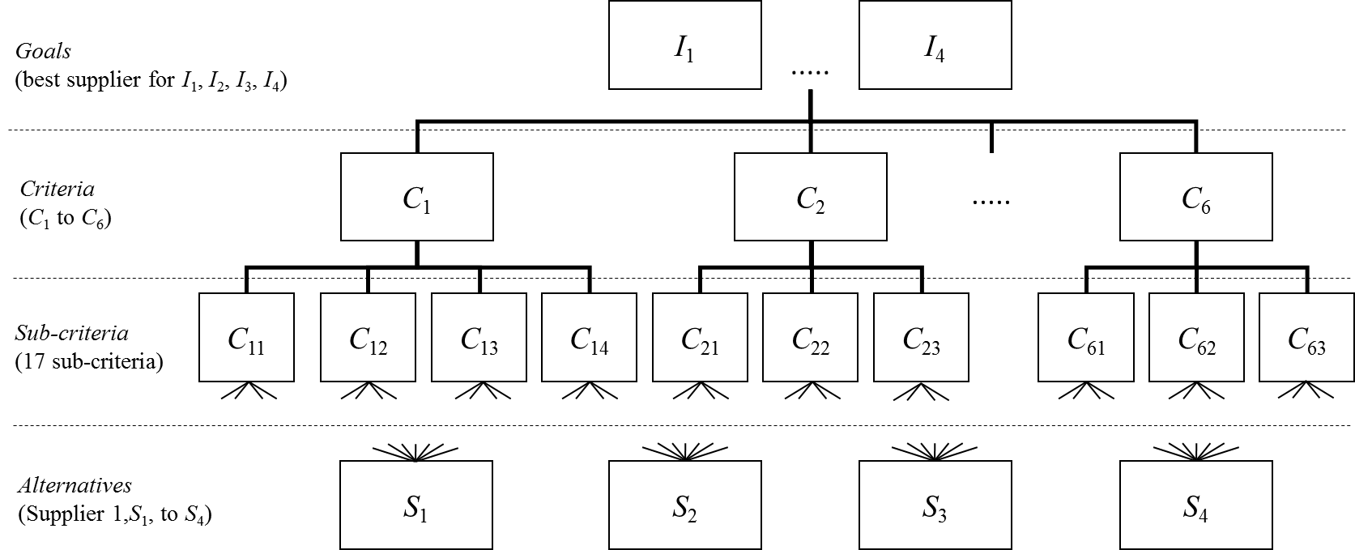

**FIGURE 1**. The AHP hierarchical structure for SSP with multiple items

Currently, the company has several types of material that should be fulfilled. The materials are classified into two types: imported and local materials. The imported materials are directly purchased by the buyer and the procurement mechanism also depends on the buyer’s decision. Meanwhile, the local materials are ordered by PPIC purchasing. There are nine suppliers procuring the different types of local materials such as fabric, elastic, sponge, box and yarn, whilst the printing accessories consist of four items served by different supplier composition. The accessories materials are selected in this study as they have a number of suppliers that have more performance on different criteria.

**Determining criteria’ weights**

The main step to evaluate suppliers is to determine the weight of criteria and alternatives using AHP. Firstly, pairwise comparison matrices for criteria, sub-criteria and alternatives are developed by inviting the DMs to bring the justification comparing two factors. Table 2 exemplifies the weights of criteria obtained. The DMs also determine the same matrices for all sub-criteria within the criterion and alternatives per sub-criterion.

**TABEL 2**. Aggregated pairwise comparison matrix and weights for criteria

|  |  |  |  |  |  |  |  |
| --- | --- | --- | --- | --- | --- | --- | --- |
| **Criteria** | ***C*1** | ***C*2** | ***C*3** | ***C*4** | ***C*5** | ***C*6** | **Weights** |
| *C*1 | 1 | 1.732 | 4.899 | 3.873 | 7.483 | 5.657 | 0.406 |
| *C*2 |  | 1 | 4.243 | 3.000 | 4.899 | 0.816 | 0.224 |
| *C*3 |  |  | 1 | 0.577 | 4.583 | 0.577 | 0.084 |
| *C*4 |  |  |  | 1 | 4.583 | 1.000 | 0.115 |
| *C*5 |  |  |  |  | 1 | 0.236 | 0.034 |
| *C*6 |  |  |  |  |  | 1 | 0.138 |

**TABEL 3**. Local weights and global weights for suppliers (example of *C*1)

|  |  |  |  |  |  |  |  |  |  |
| --- | --- | --- | --- | --- | --- | --- | --- | --- | --- |
| **Factors** | **Suppliers** | **Local weights** | | | | **Global weights** | | | |
| ***I*1** | ***I*2** | ***I*3** | ***I*4** | ***I*1** | ***I*2** | ***I*3** | ***I*4** |
| *C*1 (0.406) | | | | | | | | | |
| *C*11  (0.389) | *S*1 | 0.421 | 0.121 | 0.274 | 0.500 | 0.066 | 0.019 | 0.043 | 0.079 |
| *S*2 | 0.421 | 0.362 | 0.726 | 0.500 | 0.066 | 0.057 | 0.115 | 0.079 |
| *S*3 | 0.159 | 0.162 | - | - | 0.025 | 0.026 | - | - |
| *S*4 | - | 0.355 | - | - | - | 0.056 | - | - |
| *C*12  (0.192) | *S*1 | 0.415 | 0.082 | 0.366 | 0.274 | 0.032 | 0.006 | 0.029 | 0.021 |
| *S*2 | 0.333 | 0.504 | 0.634 | 0.726 | 0.026 | 0.039 | 0.050 | 0.057 |
| *S*3 | 0.170 | 0.133 | - | - | 0.013 | 0.010 | - | - |
| *S*4 | - | 0.281 | - | - | - | 0.022 | - | - |
| *C*13  (0.284) | *S*1 | 0.415 | 0.083 | 0.224 | 0.274 | 0.048 | 0.010 | 0.026 | 0.032 |
| *S*2 | 0.415 | 0.499 | 0.776 | 0.726 | 0.048 | 0.057 | 0.089 | 0.084 |
| *S*3 | 0.170 | 0.140 | - | - | 0.020 | 0.016 | - | - |
| *S*4 | - | 0.279 | - | - | - | 0.032 | - | - |
| *C*14  (0.135) | *S*1 | 0.421 | 0.060 | 0.333 | 0.500 | 0.023 | 0.003 | 0.018 | 0.027 |
| *S*2 | 0.421 | 0.488 | 0.667 | 0.500 | 0.023 | 0.027 | 0.036 | 0.027 |
| *S*3 | 0.159 | 0.172 | - | - | 0.009 | 0.009 | - | - |
| *S*4 | - | 0.280 | - | - | - | 0.015 | - | - |

The pairwise comparison elements in Table 2 is consistent as the *CI* value is 0.121 and the *CR* value is 0.097 (acceptable if *CR* < 0.10). Then, Table 3 provides the local weights and global weights of the four suppliers for the criterion *C*1. The total score of global weights for each supplier in each factor will produce the final score indicating supplier performances.

**Ranking the suppliers for all items**

Figure 2 descibes the overall supplier performances for the six criteria in each item. As illustrated that there are three suppliers, four suppliers, two suppliers and two suppliers for item *I*1, *I*2, *I*3, *I*4, respectively.

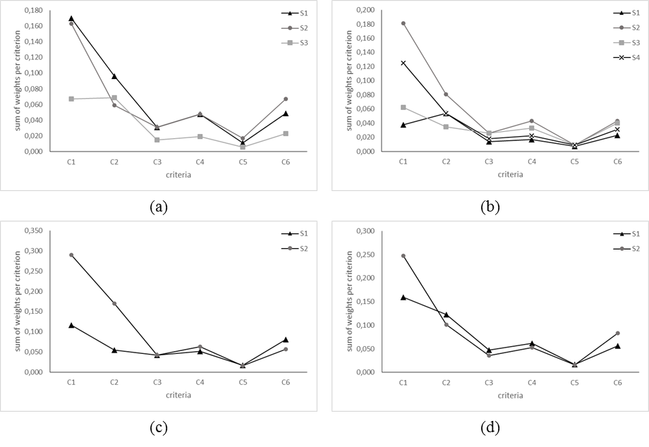

**FIGURE 2**. The supplier performances for the six criteria in each item

(a) = *I*1, (b) = *I*2, (c) = *I*3, (d) = *I*4

On *I*1, the two suppliers (*S*1 and *S*2) have the same performance for almost all criteria, especially for *C*1, *C*3, *C*4, and *C*5. These suppliers even have the same score of 0.031 and 0.048 for *C*3 and *C*4, respectively, whilst the scores for *C*1 and *C*5 are slightly different. Meanwhile, the *S*2 also has dominant scores for the remaining three items, although on *I*4, the *S*2 has almost the same value as *S*1 on *C*2, *C*3, *C*4, and *C*5. The four graphs shown in Figure 2 provide good views for the DMs in the company to assess the superiority of suppliers depending on the factors such as *S*2 that has consistent values on *C*1, *C*2, and *C*6 compared to the other three suppliers. The total performance score for all suppliers is presented in Figure 3.

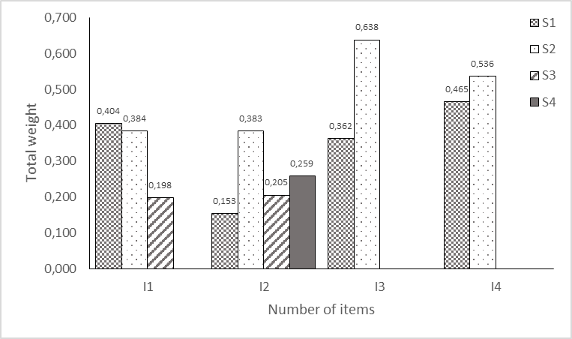

**FIGURE 3**. The suppliers’ total scores for all items

As clearly seen in Figure 3, the best supplier for label accessories is *S*1 (0.404), followed by *S*2 (0.384), and *S*3 (0.198). Although *S*1 becomes the best supplier for *I*1, it is required to improve the performance of *S*1 in terms of document factors. Then, *S*2 becomes the best supplier for *I*2 peaked at 0.383 followed by *S*4 (0.259), *S*3 (0.205), and *S*1 (0.153). The *S*2’ performance can be improved especially in terms of price and delivery aspects for the sticker material. Further, *S*2 also becomes the best supplier for the other two items of *I*3 and *I*4. On *I*3, *S*2 should consider the agreed specification and delivery aspects, while on *I*4, some aspects must be improved such as quality, the low number of defects, and negotiable price.

In general, the company should pay more attention to *S*2 since the supplier has the most consistent perormance for all types of items required. The *S*2’ scores shows the capability of quality as well as capacity to meet the company’s requirement. In contrast, there is only one supplier, *S*1, which has the same production capability for all items as *S*2, while *S*3 and *S*4 are only able to produce item *I*1 and *I*2. Despite *S*1’ range of items, the *S*1’ performance looks inconsistent. It is indicated by the *S*1’ score on *I*2 which is the lowest among the other three suppliers. With this AHP result, the DMs is finally able to make several decisions in order to ensure the sustainability of the material supplies taking into account suppliers’ values. For instance, *S*1 should be supervised to improve its performance to produce *I*3 and *I*4 as the company only has two suppliers producing these items. Alternatively, the company can assign *S*1 to focus on producing *I*1, *I*3 and *I*4 only and eliminating the line up from *I*2 so that the better performance can be achieved.

**CONCLUSION**

This study contributes to providing an initial model that can be applied to various SSP cases with multiple items. The AHP reports the evaluation results very well considering factors and items. By defining 21 factors to evaluate suppliers, the DMs can determine the best supplier, S2, to fulfill all items and also enable effective improvements for the other three suppliers. The improved performances of external partners certainly affect the sustainability of manufacturing process as well as the quality of finished goods. Finally, further study is strongly encougared to make more detailed assessment by adding sensitivity analysis and even combining with other MCDM techniques to obtain optimal weights with different ranking approaches so that the result in this study can be intensively compared.

**REFERENCES**

1. V.R.B. Kurniawan and F.H. Puspitasari, IOP Conf. Ser. Mater. Sci. Eng. **1071**, 012004 (2021).
2. F. De Felice, M.H. Deldoost, M. Faizollahi, and A. Petrillo, Int. J. Eng. Bus. Manag. **7**, 1 (2015).
3. F. Dweiri, S. Kumar, S.A. Khan, and V. Jain, Expert Syst. Appl. **62**, 273 (2016).
4. R. Nazim, Int. J. Recent Innov. Trends Comput. Commun. **3**, 338 (2015).
5. V. Jain, A.K. Sangaiah, S. Sakhuja, N. Thoduka, and R. Aggarwal, Neural Comput. Appl. **29**, 555 (2018).
6. B.T. Sivrikaya, A. Kaya, E. Dursun, and F. Çebi, Res. Logist. Prod. **Vol. 5**, 271 (2015).
7. C.N. Wang, V.T. Hoang Viet, T.P. Ho, V.T. Nguyen, and V.T. Nguyen, Symmetry (Basel). **12**, 1 (2020).
8. C.N. Wang, C.Y. Yang, and H.C. Cheng, Processes **7**, 1 (2019).
9. D.M. Utama, 31 (2020).
10. D.M. Utama, B. Maharani, and I. Amallynda, J. Ilm. Tek. Ind. **20**, 119 (2021).
11. M.B. Ayhan and H.S. Kilic, Comput. Ind. Eng. **85**, 1 (2015).
12. T. Saaty, *The Analytic Hierarchy Process* (McGraw-Hill, New York, 1980).
13. W.N. Hidayat, *EVALUASI SUPPLIER AKSESORIS PRINTING DENGAN MENGGUNAKAN METODE ANALYTICAL HIERARCHY PROCESS (AHP) (STUDI KASUS DI PT UDAKA INDONESIA)* (2020).