**ANTENNA DESIGN YAGI UDA 2,4 GHZ WITH MODULE NRF24L01 FOR RADIATION PATTERN DISTANCE OF 30 KM USING CST STUDIO SUITE SOFTWARE**

**Fredy Sidabutar1, Mukhidin1, Dendi Mochamad Jabar1**

1Departemen Pendidikan Teknik Elektro, Universitas Pendidikan Indonesia, Bandung, Indonesia

E-mail : fredysidabutar1@upi.edu, mukhidin@upi.edu, dendimj@gmail.com

**Abstract.** Delivery of information media in this growing age, driven by ease of implementation, performance, as well as the reach of the information media can be channeled, one of the ways that the media can be sent not through cable media is to use air media, information sent in the form of electromagnetic fields that propagate in the air, the electromagnetic field can be formulated, one way is to use antennas, Yagi Uda Antenna has a considerable gain characteristics, the recommended working frequency is to have a frequency at 2400 Mhz, Bandwidth is more than 1.3% with VSWR below 2 , input resistance of 50 Ohm. And has a working frequency of 2382.9Mhz – 2410.6Mhz, as well as a maximum reflection coefficient (S - Parameter) of 13.620377 dB located at a frequency of 2400Mhz and a gain of 14 dBi. In this research parameters produced from CST STUDIO SUITE software. And the NRF24L01 Module as an assistive medium in remote antenna experiments.

# Introduction

## Antenna Yagi Uda

Antennas are devices that are used to send and receive signals. Antenna is made in various forms according to its application function. One type of antenna that will be discussed is Yagi antenna or also known as Yagi Uda. Yagi Antenna is a type of radio antenna or television created by Hidetsugu Yagi and Dr. Shintaro Uda. Yagi antenna is widely used and is one of the antennas with the most successful design and is widely used for RF directive applications. AntenaYagi is used to receive or send radio signals. AntenaYagi is a directional antenna which means it can only receive signals in one direction (front direction), therefore this antenna is different from standard polished antennas that can pick up signals just as well in each direction (3600)[7]. Yagi antennas are used to receive or send radio signals. This antenna used to be widely used in World War 2 because it was easy to make and not too complicated. Yagi antenna is a directional antenna, meaning it can only pick up or receive signals in one direction (i.e. front), olek therefore this antenna is different from the standard polished antenna that can pick up signals just as well in each direction. Yagi antenna usually has a gain of about 3-20 dB. Each element receives energy and re-emits that energy. Neighboring trunks take back some of the energy that is radiated, if the stems are located within a good distance. This state shows a transmitter. Yagi antenna is a directional antenna that can only pick up or receive signals from one direction, namely the front because the antenna side behind the reflector has a smaller gain than in front of the director. Yagi antenna usually has a gain of about 3-20 dB.

## Module NRF24L01

The nRF24L01 module uses GFSK modulation. Users can configure parameters such as channel frequency, output and airborne transmission speed. NRF24L01 supports transmission speed of 250 kbps,1 Mbps & 2 Mbps.

Here are the specifications and features of nrf24L01 module:

1. Using a 2.4 GHz band
2. There are 126 RF channels
3. Using GFSK modulation
4. 250Kbps, 1Mbps, and 2Mbps data speeds
5. Interface using 4 SPI pins
6. Voltage 1.9 – 3.6 V

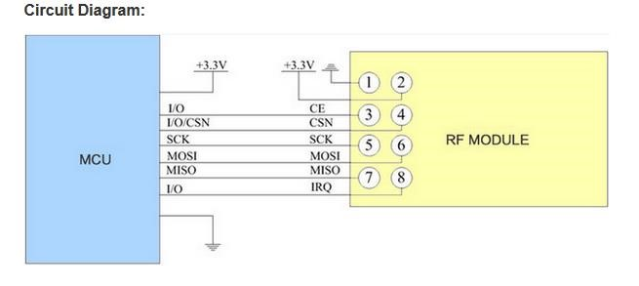

Figure 1. Foot Pin on NRF24L01 Module

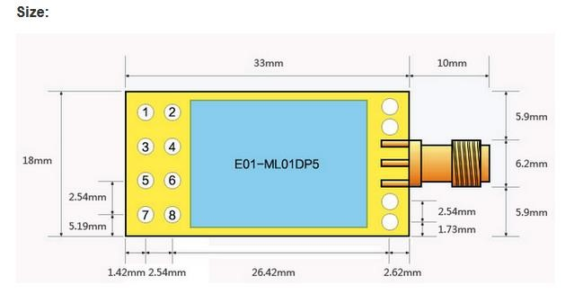

Figure 2. NRF24L01 Module Shape

## CST STUDIO SUITE

CST STUDIO SUITE is a software package that can simulate and solve all electromagnetic problems ranging from low frequencies to microwaves and optics as well as thermal and some mechanical problems. There are 7 working menus, among others:

1. Microwave Studio: for RF and Microwave problems such as antenna design.
2. EM Studio: for problems with low frequencies such as RFID, electrostatic, magnetostatic, etc.
3. Design Studio: schematic workflow to design luminous circuits and also join other studio results to design assembly system.
4. Particle Studio: for particles and simulation of radiance such as e-Gun, microwave tube, etc.
5. MPHYSISCS Studio: for some mechanical and thermal simulations.
6. Cable Studio: for cable design and simulation in bundles, harnesses, etc.
7. PCB Studio: for simulation of PI and SI on multi-layered PCB.2.

# Research Methodology

At this stage, the first thing the author did before designing the antenna, was to determine the specifications of the antenna and conduct a literature study to obtain the desired dimensions of the antenna. After the specifications and dimensions of antennas have been obtained, the second step is to design and simulate antennas using CST Studio Suite 2019 software. Antennas that have been designed can be simulated, but usually the results of the simulation may not be in accordance with the desired antenna specifications, so optimization is needed to get results according to the desired antenna specifications. The third step after the simulation results obtained is appropriate, is the realization / fabrication and measurement of antennas. After that, the last step is to compare the simulation results with the measurement results that have been done.

## Antenna Design

At the initial stage the author will determine the specification of antenna parameters. After recording the antenna specifications to be made, then make antenna design in CST STUDIO SUITE software such as gamba below.

* 16 – Elements of Yagi Uda Arrangement
* Frequency : 2400 MHz
* Bandwidth/ (VSWR < 2)
* Input Impendance (Zin) = 50 Ω
* Vertical Linear Polarization
* Gain > 10 dBi

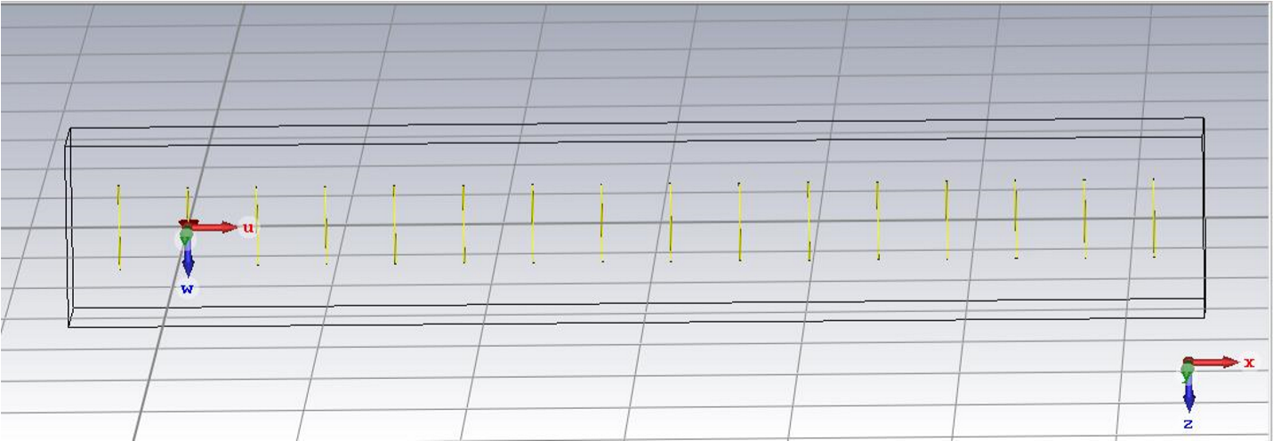

Figure 3. Initial Antenna Design

the desired middle frequency is 2400 Mhz then the wavelength, λ = 125 mm, as well as the diameter of each element by r, which in this report defines r is worth 0.531 mm. Then by defining the parameters in the picture above, we can see in the table below.

|  |  |  |
| --- | --- | --- |
| Parameters | Formula | Results |
| λ | 𝑐  λ= 𝑓 | 125 mm |
| dr | dr =  ; k (metal) = 0.95 | 56,375mm |
| gap | Gap = | 0,625 mm |
| r | d0 = 0,00425 | 0,531 mm |
| s | sr = | 31,25 mm |
| sd | sd = 0,35 | 43,75 mm |
| d | d = 0,442 | 55,25 mm |
| rl | r = 0,477 | 59,625 mm |

Table 1. Antenna Parameters

dr = Long Driven Polished

r = Reflector Length

s = Distance Driven – Reflector d = Director Length

r = Element Diameter

sd = Distance Between Director

These parameters can change according to the desired frequency of work but in general there are already some parameter requirements that have been met.

## Antenna Simulation

Antenna simulation is done using CST Studio Suite 2019 software. Modification of antenna size is done as a form of optimization if the simulated antenna is not in accordance with the specifications that have been determined.

# Results and Discussion

In this section, the results and discussions are explained at the stage of design, simulation, optimization,

## Simulation

After the calculation is done to get the large dimensions of the antenna, it begins to be simulated in CST Studio Suite 2019 software. . Simulation results on the initial design antenna looks the results have not met the desired specifications so optimization is required

The results of the simulation conducted in the CST Program are:

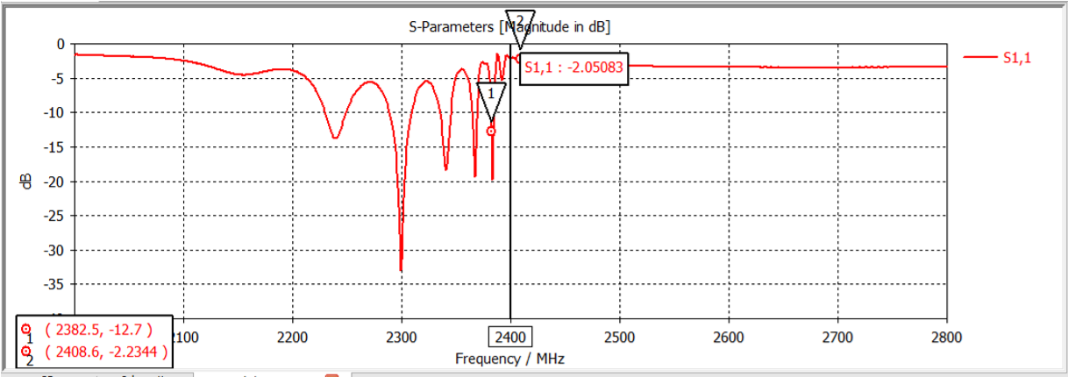

Figure 4. S- Antenna Parameters

From the result of S Bisi parameters can be seen the lower frequency of 2382.5Mhz and the upper frequency of 2408.6Mhz.

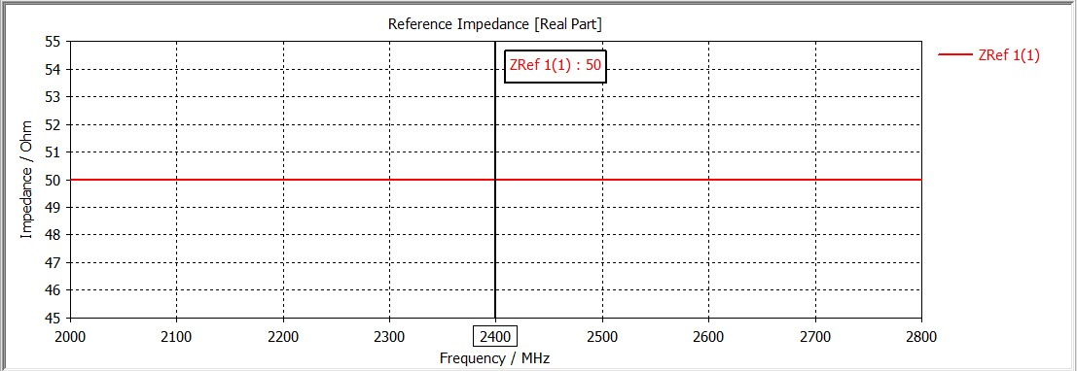

Figure 5. Reference Antenna Impedance

From here it looks the Impedance is 50 Ohm when the middle frequency is 2400Mhz

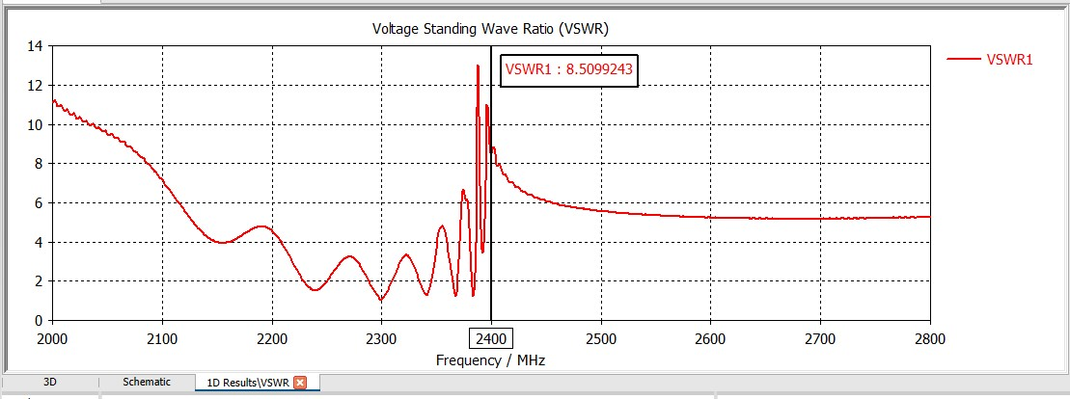

Figure 6. VSWR Value

When the initial design was made its VSWR value was still at 8.5099243 which should have been the requested specification was < 2 hence required optimization.

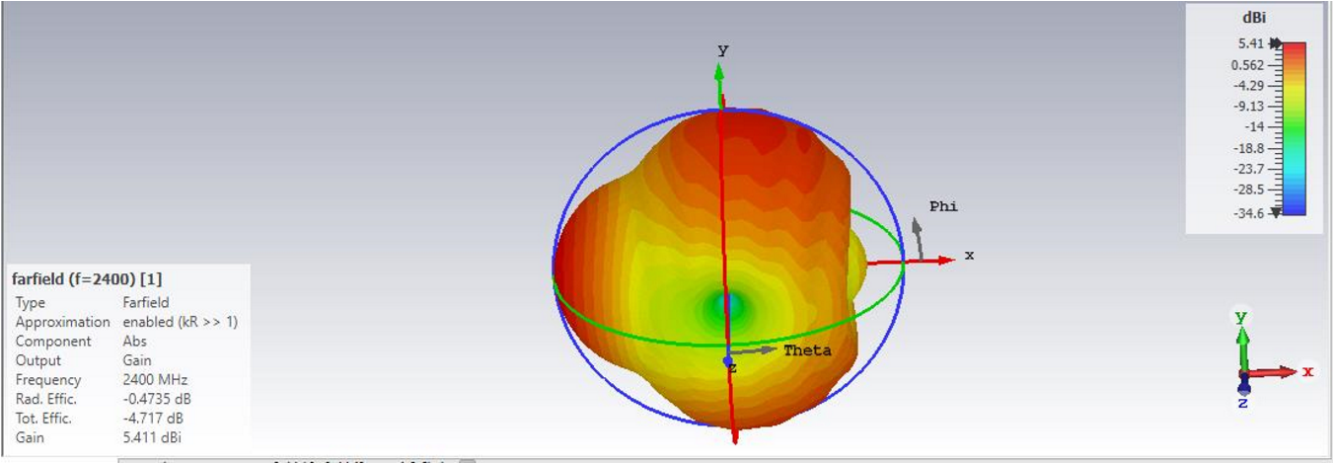

Figure 7. Antenna Farfield

In farfield results can be seen that the gain obtained is 5.41 dB while the requested on the specification is 25 dB, therefore it also requires optimization to get optimal results.

## Optimization

At the initial design not all the desired specifications are met. Then there are some parameters that must be changed so that the desired specifications can be met, and the antenna design in Figure 8.

accordance with what is expected.

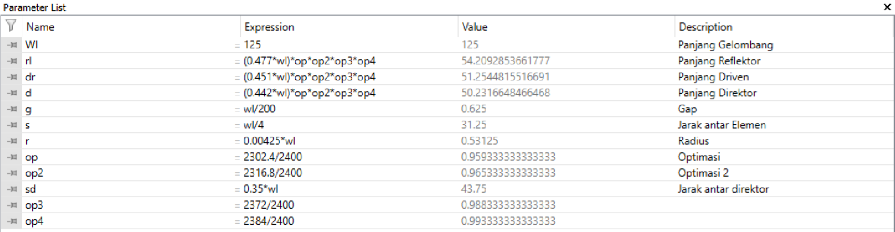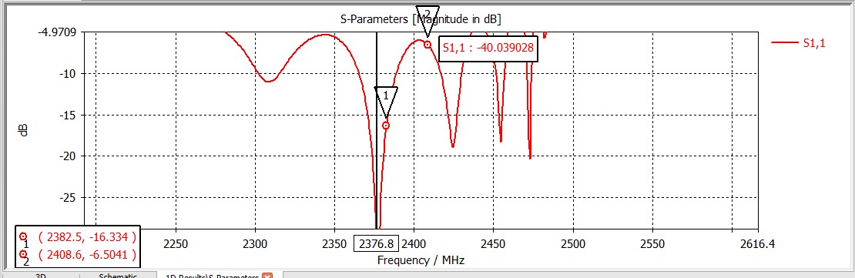

Figure .S – First Optimization Parameters

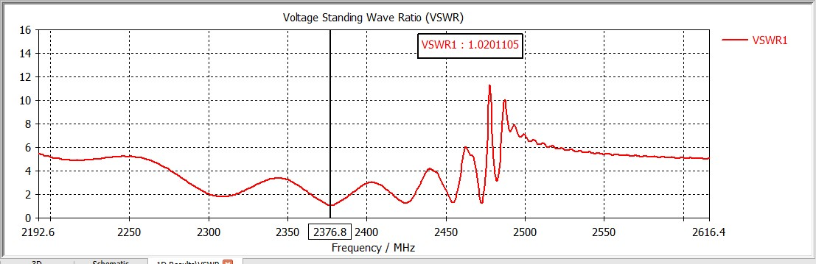

Figure 9. VSWR First Optimization

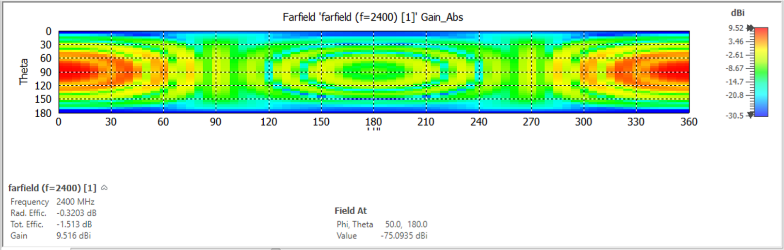

Figure 10. Farfield Optimization First

In this optimization s - parameters can not match the desired specifications on this optimization s - the parameter is at a working frequency of 2376.8 and still requires optimization while VSWR has met the specifications originally from 8.5099243 to 1.0201105 (VSWR < 2). Then gain that was originally 5.41 dB increased to 9,516 dB.

Since not all specifications are met, it is necessary to re-optimize.

## Final Result

After doing some optimization, the antenna results are obtained in accordance with the desired specifications. Starting from changing the Length of the reflector, Changing Reflector Length, Length Driven polished, Distance Driven – Reflector, Element Diameter, Distance Between The Director and other adjustment adjustments.

There are also parameter values used for the final design as follows:

|  |  |
| --- | --- |
| Parameters | Parameters  Value |
| r | 0,531 |
| rl | 59,625 |
| dr | 56,375 |
| s | 31,25 |
| sd | 43,75 |
| gap | 0,625 |
| d | 55,25 |
| wl | 125 |

The above results are the result of optimization to adjust the required specifications.

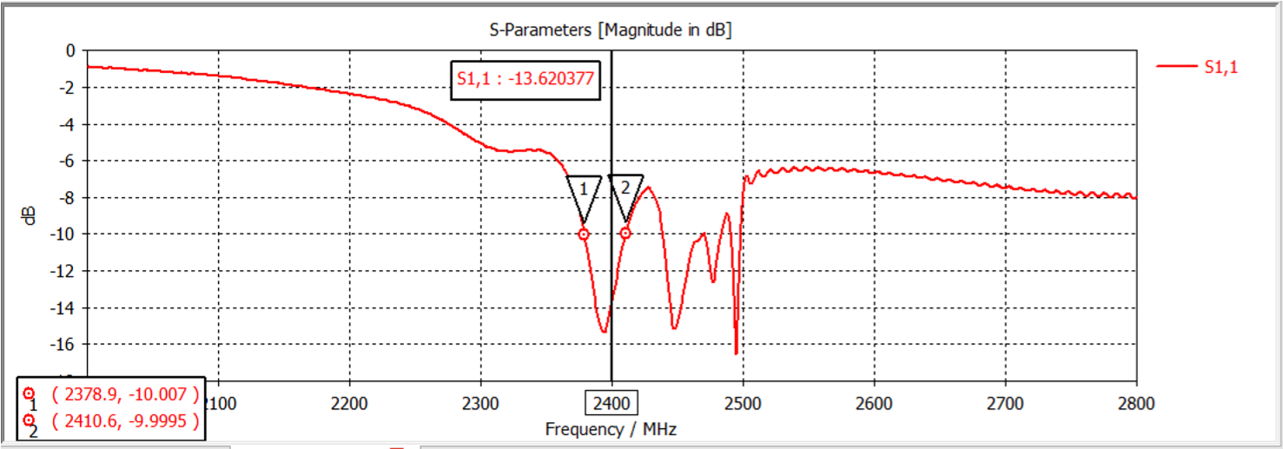

Figure 11. S – Final Design Parameters

In this final design, the value of S - The parameter is already in the number 2400Mhz. and its bandwidth can be calculated from the difference in minimum and maximum values (2410.6 - 2378.9) = 32 dB and if in percentage to (32/2400 x 100%) = 1.3%.

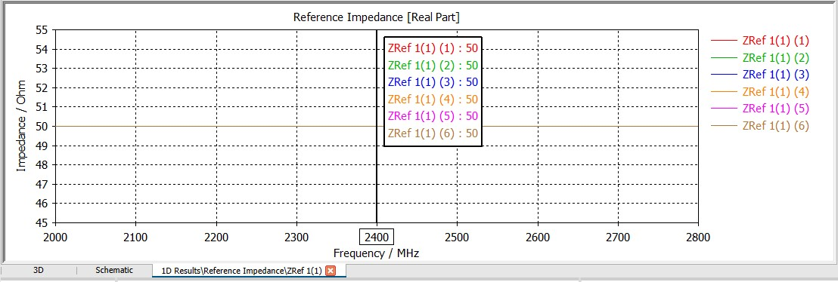

Figure 12. Reference Impedance (Real Part)

In the Impedance Reference this real part shows that the input resistance has met the specification of 50 Ohm.

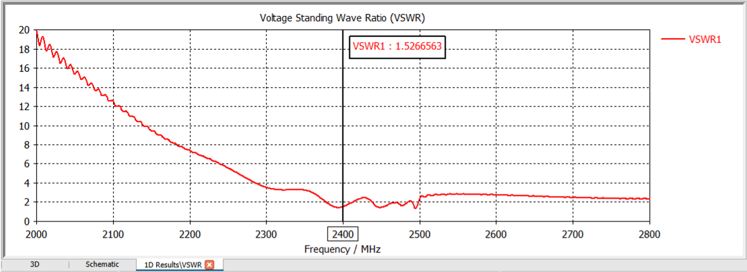

Figure 13. VSWR Antenna Final Design

In this final design the VSWR value is 1.52666563. So that value has met the requested specification of < 2.0.

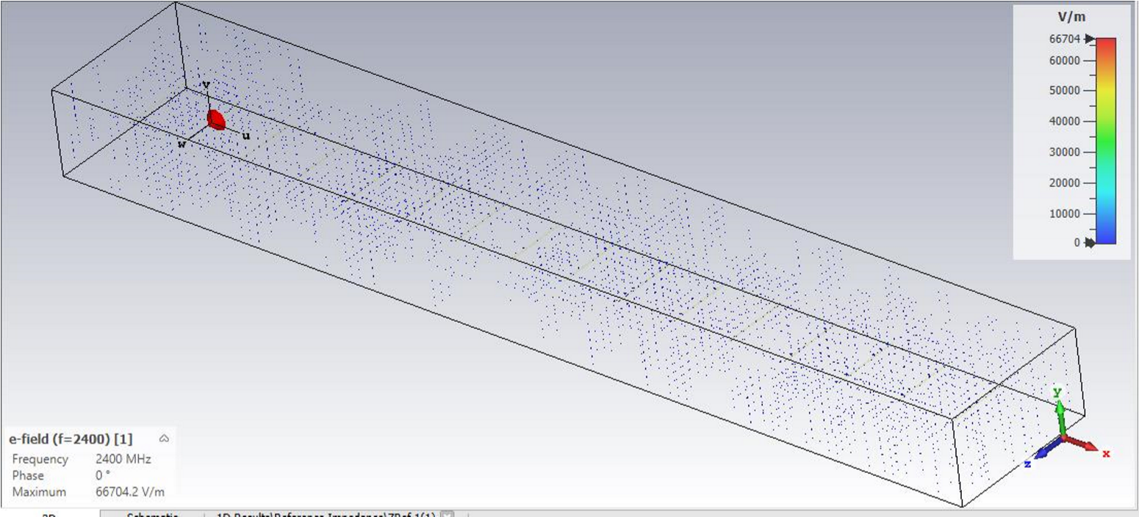

Figure 14. Polarization on the E-field

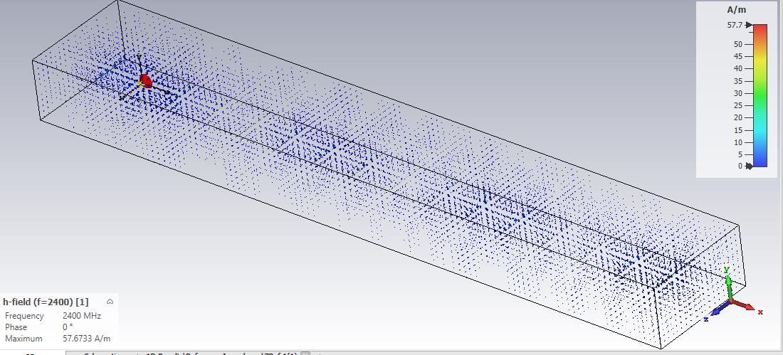

Figure 15. Polarization on h-field

The more visible the Polarization Pattern on this design is linear, and it already meets the desired specifications.

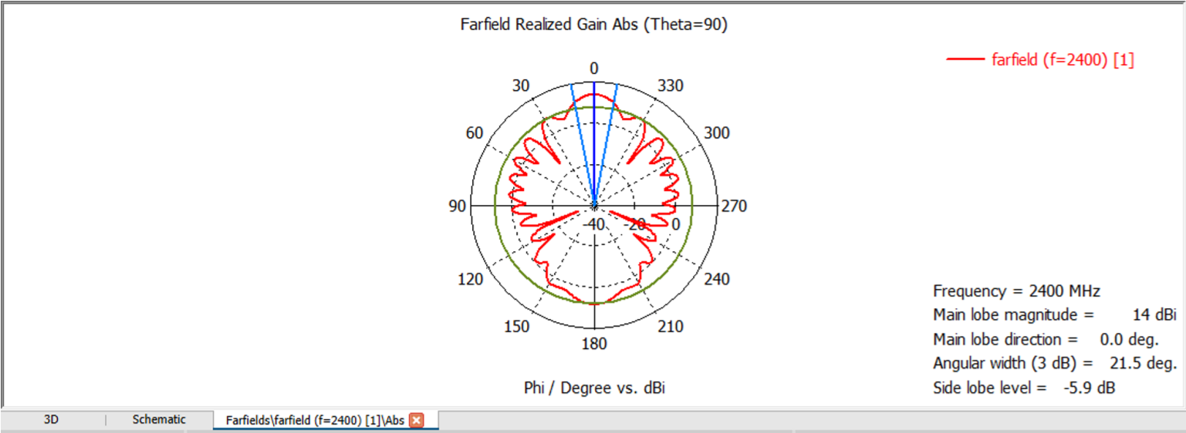

Figure 16. Farfield Final Design Results

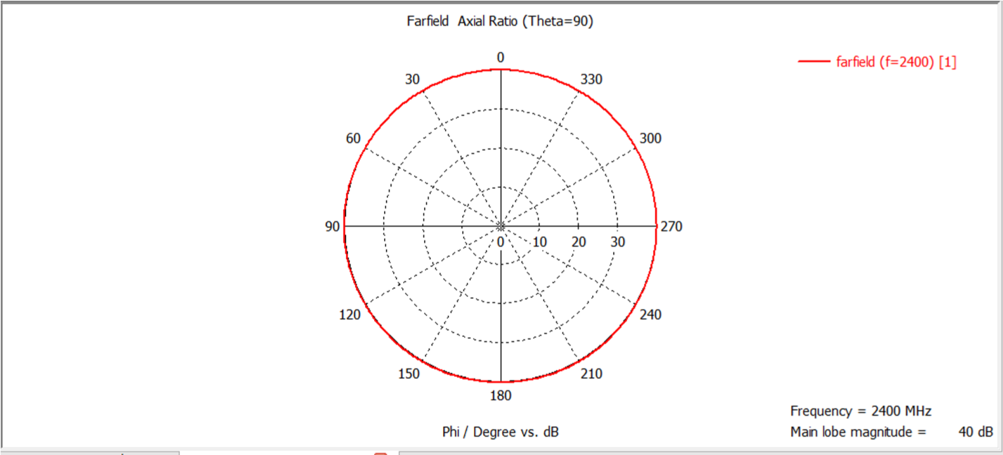

Figure 17. Polarization Results in Farfield

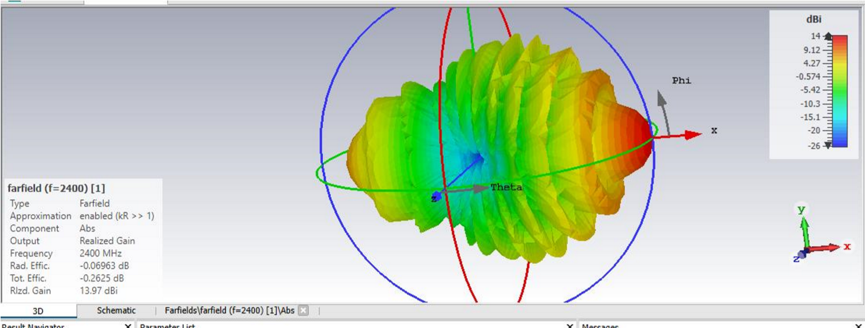

Figure 18. Final Design 3D Polarization Results

From farfield results that appear to be obtained that the polarization direction of the antenna made is directional. And the axtial ratio is polar in shape. Then when viewed from Farfield in the form of a stronger 3D gain towards the x symbolised by red. Also seen there is a gain of 13.97 dBi.

# Conclusion

Yagi Uda antenna has been designed by using CST STUDIO SUITE software with a working frequency of 2.4 GHz with vertical linear radiation pattern. Based on the results of the discussion in doing antenna design yagi uda 2.4 GHz for a distance of 30 km that is not yet as expected, in the design of the antenna that I designed to Gain antenna has not met the desired specifications, look for vswr specifications, S – Parameters, impendation input has met the specifications. NRF24L01 module as a wireless module to function properly when emitting electromagnetic waves from the receiver to the transmitter station.

## References

[1] International Journal of Antennas vol.2,no.1, Januari 2016 “Design of a Yagi-Uda Antenna with Gain and Bandwidth Enhancement for Wi-Fi and Wi-Maax Applications” oleh : Vinay Bankey, dan N. Anvesh Kumar.

[2] Jurnal Teknik Elektro Itenas Vol.1, No.1, Januari – Juni 2013 “ Perancangan dan Implementasi Antena Yagi 2.4 Ghz pada aplikasi Wi-Fi (Wireless Fidelity)” oleh : Budi Pratama, Lita Lidyawati, Arsyad Ramadhan D.

[3] Yagi Antenna Design NBS Technical Note 688, Oleh : Peter P.Viezbicke

[4] Muhammad Soleh; Tugas Akhir Teknik Elektro UNDIP : Perancangan Antena Yagi UDA Pada frekuensi 600Mhz, 2011.

[5] Pertanika Journal of Science & Techonology Vol. 25 (S) Nov. 2017 Hal.1 “Development of Ultra-Wideband Directional Microstrip Antenna” oleh : Mukhidin and Tuti Suartini.

[6] Majalah Ilmiah Teknik Elektro Universitas Udayana Vol. 16, No.1 January-April 2017 “Rancang Bangun Antena Yagi pada Frekuensi 1800MHZ untuk penguatan sinyal Model” oleh : I.G.N. Dharmayana, I.P. Ardana, Widyantara.