Usage Tests of Blended Learning Based on *TKP*-*Kelase* for Mathematics Lessons at Senior High Schools or Vocational Schools

I Putu Wisna Ariawan1,a) , Dewa Gede Hendra Divayana2 and P. Wayan Arta Suyasa2

1 Department of Mathematics Education, Universitas Pendidikan Ganesha, Singaraja-81116, Indonesia  
2 Department of IT Education, Universitas Pendidikan Ganesha, Singaraja-81116, Indonesia

a) Corresponding author: wisna.ariawan@undiksha.ac.id

**Abstract.** The main objective of this research was to show the effectiveness results of blended learning based on TKP-Kelase through usage tests. The concept of *TKP* (*Tri Kaya Parisudha*) is used as a basis for strengthening the cognitive, affective, and psychomotor domains in blended learning. Kelase is used as a platform to realize blended learning for Mathematics lessons of senior high schools or vocational schools in Bali. The method in this research was the development method. The development model used was Borg and Gall which focused on the stage of usage tests. The research location was conducted at several senior high schools or vocational schools in Bali. The subjects involved were 154 people, consisting of experts, teachers, and students. The data collection tools for usage test results were questionnaires consisting of 12 questions. The analysis of the collected data was carried out by comparing the effectiveness percentage of usage test results with the standard of effectiveness referring to the five's scale. The results showed that blended learning based on TKP-Kelase was in the effective category to be used as a supporting facility for Mathematics lessons at senior high schools or vocational schools in Bali.

# Keywords: Usage Tests, Blended Learning, *TKP* (*Tri Kaya Parisudha*), *Kelase*.

# INTRODUCTION

Blended learning is a learning model that is suitable for use by teachers and students of senior high schools or vocational schools during the *Covid-19* pandemic. This is because the implementation of blended learning can minimize the occurrence of crowded so that it can reduce the risk of transmission of the coronavirus. During the *Covid-19* pandemic, blended learning can be done fully online both for face-to-face learning and learning independently. Face-to-face learning can use *Webex*, *Zoom*, and *Meetgoogle* facilities. Learning independently can be done by students in their respective homes by searching for material sources on the internet.

Nevertheless, blended learning must still be able to facilitate an effective learning process. Effective learning must be able to achieve completeness of student learning outcomes in the cognitive, affective, and psychomotor domains. The reality that happens in the fields is not like we imagine. Not all platforms support blended learning automatically contain the material contents that can measure cognitive, affective, and psychomotor domains. Therefore, innovation and modification of platforms support blended learning is needed to facilitate the requirement of material contents from those three domains.

One of the efforts in the form of innovation and modification had been carried out previously in 2020 by Ariawan *et al*. through a modification of the *Kelase* platform which was integrated with the Tri Kaya Parisudha concept [1]. Through that innovation and modification, a blended learning platform had been successfully created which contains material contents to measure the three domains of completeness of learning outcomes based on the *TKP* (*Tri Kaya Parisudha*) concept. The *Manacika* (good thinking) in the concept of *Tri Kaya Parisudha* is used as a basis for measuring students’ cognitive abilities. The *Wacika* (speaking well) in the concept of *Tri Kaya Parisudha* is used as a basis for measuring students' affective abilities. The *Kayika* (good attitude) in the *Tri Kaya Parisudha* concept is used as a basis for measuring psychomotor abilities.

The research limitation found in 2020 was that the *Tri Kaya Parisudha*-based blended learning platform was only researched until field trials. Therefore, the overall level of effectiveness had not yet known. Based on that limitation, the question of this research is how are the usage test results to determine the effectiveness of the blended learning platform based on *TKP*-*Kelase* on mathematics lessons for students at senior high school or vocational school students, a case study in Bali?

This research was based on several previous research results. Muhtia *et al*.’s research [2] showed the use of *Schoology* as a support platform for the implementation of blended learning. The limitation of Muhtia *et al*.’s research was that it had not shown a container in the *Schoology* platform that was able to be used to package content and test forms in blended learning as a whole from the cognitive, affective and psychomotor domains. Research by Sulisworo *et al*. [3] showed the use of *Moodle* as a blended learning platform. The limitation of Sulisworo *et al*.’s research was the *Moodle* platform used in blended learning had not facilitated material contents and the forms of a test that refers to the cognitive, affective, and psychomotor domains as a whole. The research of Wijanayu *et al*. [4] showed the use of the quipper school platform to support blended learning. The limitation of Wijanayu *et al*.’s research was that it had not shown material contents and test forms that refer to the cognitive, affective, and psychomotor domains, but only focuses on the cognitive domains. Helsa and Kenedi’s research [5] showed the use of the Edmodo platform for blended learning implementation. The limitation of Helsa and Kenedi’s research was that it had not shown material contents and test forms that refer to the cognitive, affective, and psychomotor domains to obtain effective learning outcomes.

# Method

This research was development research that was conducted by the *Borg* and *Gall* development model. The focus of this research was on the usage tests stage to determine the effectiveness level of blended learning based on *TKP*-*Kelase* for Mathematics lessons. The subjects involved in the usage tests were four experts, 50 teachers, and 100 students spread across several senior high schools or vocational schools in Bali. The tools were used to collect the results of the usage tests were questionnaires that containing 12 questions.

The location of the research was conducted in senior high schools or vocational schools spread over six districts in Bali province, including Gianyar, Buleleng, Tabanan, Badung, Klungkung, and Denpasar. The technique was used to analyze the data from usage tests was quantitative descriptive. This technique was carried out by comparing the percentage results of usage tests with a predetermined standard of effectiveness. The percentage results of the usage tests were obtained using the formula for the effectiveness percentage, which can be seen completely in equation (1) [6-13]. The defined effectiveness standards can be seen in Table 1 [14-19].

**Percentage of Effectiveness= (f/N) × 100%** (1)

Notes:

F : the total of acquisition scores

N : the total of maximum scores

|  |  |
| --- | --- |
| **TABLE 1.** Effectiveness standards based on five’s scale | |
| **Range of Percentage** | **Category of Effectiveness** |
| 90 to 100 | Very High |
| 80 to 89 | High |
| 65 to 79 | Enough |
| 55 to 64 | Less |
| 0 to 54 | Poor |

# Results and discussion

Before seeing the usage test results of blended learning based on *TKP*-*Kelase* for Mathematics lessons, it is necessary to know about the important forms in blended learning based on *TKP*-*Kelase*. Some display of the important forms in blended learning based on *TKP*-*Kelase* can be seen in Figures 1 and 2.

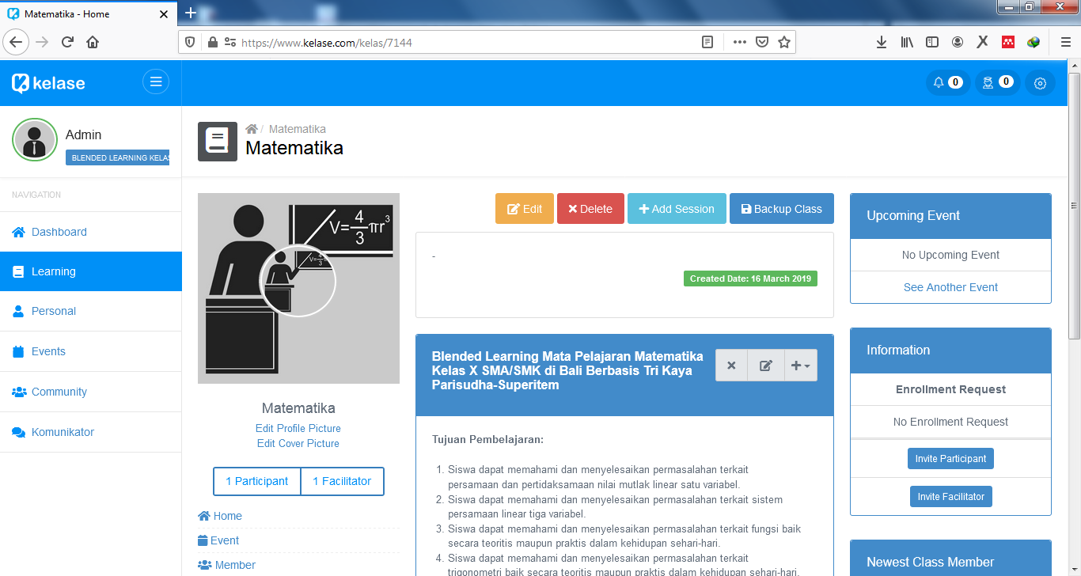

**FIGURE 1**. The design of main menu

Figure 1 shows the main menu display of blended learning based on *TKP*-*Kelase* to support Mathematics learning at the level of senior high schools or vocational schools. The main menu contains several navigations to other forms. These navigations included: dashboard, learning, personal, events, community, and communicators. The main menu form also displays lesson profiles and learning objectives.

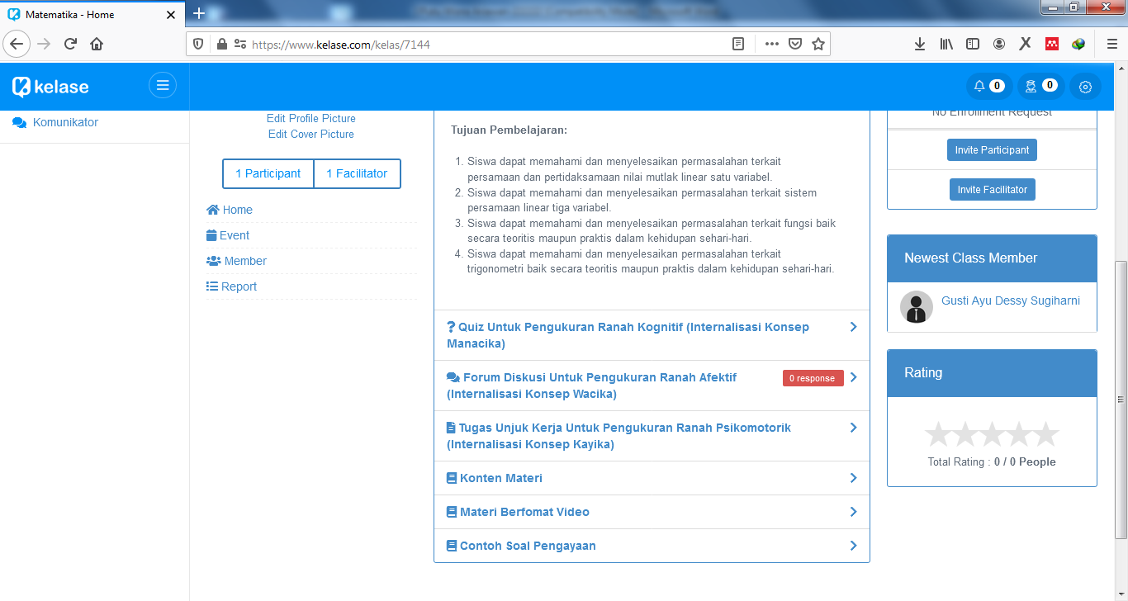

**FIGURE 2**. The design of form which contains the material contents and the test form

Figure 2 shows the display of the form which contains the material contents and the test form that measures learning outcomes in the cognitive, affective, and psychomotor domains. The cognitive domain is showed through quizzes which internalize the concept of *Manacika*. The affective domain is showed through discussion forums that internalize the concept of *Wacika*. The psychomotor domain is showed through performance tasks that internalize the concept of *Kayika*.

The results of usage tests of blended learning based on TKP-Kelase were conducted by four experts (two education experts and two informatics experts) can be seen in Table 2. The results of the usage tests were conducted by 50 Mathematics teachers from several senior high schools or vocational schools in Bali can be seen in Table 3. The results of the usage tests were conducted by 100 students from several senior high schools or vocational schools in Bali can be seen in Table 4.

| **TABLE 2.** Usage test results by experts toward blended learning based on *TKP*-*Kelase* | | | | | | | | | | | | | | |
| --- | --- | --- | --- | --- | --- | --- | --- | --- | --- | --- | --- | --- | --- | --- |
| **Respondents** | **Items** | | | | | | | | | | | | **Σ** | **Percentage of Effectiveness (%)** |
| **1** | **2** | **3** | **4** | **5** | **6** | **7** | **8** | **9** | **10** | **11** | **12** |
| Education Expert-1 | 4 | 4 | 5 | 4 | 4 | 4 | 5 | 5 | 4 | 5 | 4 | 4 | 52 | 86.67 |
| Informatics Expert-1 | 4 | 5 | 5 | 4 | 4 | 5 | 4 | 4 | 4 | 4 | 5 | 5 | 53 | 88.33 |
| Education Expert-2 | 4 | 4 | 4 | 5 | 4 | 4 | 5 | 5 | 5 | 5 | 5 | 4 | 54 | 90.00 |
| Informatics Expert-2 | 5 | 4 | 4 | 4 | 5 | 5 | 5 | 4 | 5 | 5 | 4 | 5 | 55 | 91.67 |
| **Average** | | | | | | | | | | | | | | **89.17** |

|  |  |  |  |  |  |  |  |  |  |  |  |  |  |  |
| --- | --- | --- | --- | --- | --- | --- | --- | --- | --- | --- | --- | --- | --- | --- |
| **TABLE 3.** Usage test results by teachers toward blended learning based on *TKP*-*Kelase* | | | | | | | | | | | | | | |
| **Respondents** | **Items** | | | | | | | | | | | | **Σ** | **Percentage of Effectiveness (%)** |
| **1** | **2** | **3** | **4** | **5** | **6** | **7** | **8** | **9** | **10** | **11** | **12** |
| Teacher-1 | 5 | 4 | 5 | 5 | 5 | 4 | 5 | 4 | 5 | 4 | 4 | 4 | 54 | 90.00 |
| Teacher-2 | 5 | 5 | 5 | 4 | 5 | 5 | 4 | 4 | 4 | 5 | 5 | 4 | 55 | 91.67 |
| Teacher-3 | 4 | 4 | 4 | 5 | 4 | 5 | 5 | 4 | 4 | 5 | 4 | 5 | 53 | 88.33 |
| Teacher-4 | 5 | 4 | 5 | 4 | 5 | 4 | 4 | 5 | 4 | 5 | 4 | 4 | 53 | 88.33 |
| Teacher-5 | 4 | 4 | 4 | 4 | 4 | 4 | 4 | 4 | 4 | 5 | 4 | 5 | 50 | 83.33 |
| Teacher-6 | 4 | 4 | 4 | 4 | 5 | 5 | 4 | 5 | 5 | 4 | 5 | 4 | 53 | 88.33 |
| Teacher-7 | 4 | 5 | 4 | 4 | 4 | 5 | 5 | 5 | 4 | 5 | 4 | 4 | 53 | 88.33 |
| Teacher-8 | 4 | 5 | 4 | 5 | 5 | 4 | 5 | 4 | 5 | 4 | 5 | 4 | 54 | 90.00 |
| Teacher-9 | 5 | 4 | 4 | 5 | 4 | 5 | 4 | 4 | 4 | 4 | 4 | 4 | 51 | 85.00 |
| Teacher-10 | 5 | 5 | 4 | 5 | 4 | 4 | 4 | 4 | 4 | 5 | 4 | 4 | 52 | 86.67 |
| Teacher-11 | 4 | 4 | 5 | 5 | 4 | 4 | 5 | 4 | 5 | 4 | 5 | 4 | 53 | 88.33 |
| Teacher-12 | 4 | 4 | 5 | 4 | 5 | 5 | 4 | 4 | 5 | 5 | 4 | 5 | 54 | 90.00 |
| Teacher-13 | 5 | 4 | 5 | 4 | 4 | 5 | 5 | 4 | 5 | 4 | 5 | 5 | 55 | 91.67 |
| Teacher-14 | 5 | 5 | 5 | 5 | 5 | 4 | 4 | 5 | 4 | 4 | 5 | 4 | 55 | 91.67 |
| Teacher-15 | 5 | 4 | 4 | 5 | 5 | 5 | 5 | 5 | 4 | 4 | 5 | 5 | 56 | 93.33 |
| Teacher-16 | 4 | 5 | 4 | 5 | 4 | 5 | 4 | 5 | 5 | 4 | 5 | 4 | 54 | 90.00 |
| Teacher-17 | 4 | 4 | 5 | 4 | 4 | 5 | 4 | 4 | 4 | 5 | 4 | 4 | 51 | 85.00 |
| Teacher-18 | 5 | 5 | 4 | 5 | 4 | 4 | 4 | 4 | 5 | 4 | 5 | 4 | 53 | 88.33 |
| Teacher-19 | 5 | 4 | 5 | 5 | 5 | 5 | 5 | 5 | 4 | 5 | 5 | 5 | 58 | 96.67 |
| Teacher-20 | 4 | 4 | 5 | 4 | 5 | 4 | 5 | 4 | 5 | 4 | 5 | 4 | 53 | 88.33 |
| Teacher-21 | 5 | 4 | 5 | 4 | 4 | 5 | 4 | 4 | 5 | 5 | 5 | 5 | 55 | 91.67 |
| Teacher-22 | 5 | 5 | 5 | 5 | 5 | 4 | 5 | 4 | 4 | 5 | 4 | 5 | 56 | 93.33 |
| Teacher-23 | 4 | 5 | 4 | 5 | 4 | 5 | 5 | 5 | 4 | 5 | 4 | 4 | 54 | 90.00 |
| Teacher-24 | 4 | 5 | 5 | 5 | 5 | 5 | 4 | 5 | 4 | 4 | 4 | 4 | 54 | 90.00 |
| Teacher-25 | 5 | 4 | 5 | 4 | 5 | 4 | 5 | 5 | 5 | 5 | 5 | 5 | 57 | 95.00 |
| Teacher-26 | 4 | 5 | 4 | 5 | 4 | 4 | 5 | 4 | 5 | 4 | 5 | 4 | 53 | 88.33 |
| Teacher-27 | 5 | 5 | 5 | 4 | 5 | 4 | 5 | 4 | 4 | 5 | 4 | 4 | 54 | 90.00 |
| Teacher-28 | 4 | 5 | 4 | 5 | 5 | 5 | 5 | 5 | 5 | 4 | 5 | 4 | 56 | 93.33 |
| Teacher-29 | 5 | 4 | 4 | 5 | 4 | 5 | 4 | 5 | 4 | 5 | 5 | 5 | 55 | 91.67 |
| Teacher-30 | 5 | 4 | 4 | 5 | 5 | 5 | 5 | 5 | 5 | 4 | 5 | 4 | 56 | 93.33 |
| Teacher-31 | 4 | 5 | 4 | 5 | 4 | 4 | 4 | 5 | 4 | 5 | 5 | 5 | 54 | 90.00 |
| Teacher-32 | 4 | 4 | 5 | 4 | 4 | 5 | 5 | 5 | 5 | 5 | 4 | 5 | 55 | 91.67 |
| Teacher-33 | 5 | 5 | 4 | 5 | 4 | 4 | 5 | 4 | 5 | 4 | 5 | 5 | 55 | 91.67 |
| Teacher-34 | 5 | 4 | 5 | 5 | 5 | 5 | 4 | 4 | 4 | 4 | 5 | 4 | 54 | 90.00 |
| Teacher-35 | 4 | 4 | 5 | 4 | 5 | 4 | 5 | 4 | 5 | 4 | 5 | 4 | 53 | 88.33 |
| Teacher-36 | 5 | 4 | 5 | 4 | 4 | 5 | 4 | 5 | 5 | 5 | 5 | 5 | 56 | 93.33 |
| Teacher-37 | 5 | 5 | 5 | 4 | 4 | 4 | 4 | 5 | 4 | 5 | 4 | 5 | 54 | 90.00 |
| Teacher-38 | 4 | 5 | 4 | 4 | 4 | 4 | 4 | 5 | 5 | 5 | 5 | 5 | 54 | 90.00 |
| Teacher-39 | 5 | 4 | 4 | 4 | 5 | 4 | 5 | 4 | 5 | 4 | 4 | 5 | 53 | 88.33 |
| Teacher-40 | 4 | 4 | 5 | 4 | 4 | 4 | 4 | 5 | 5 | 5 | 4 | 4 | 52 | 86.67 |
| Teacher-41 | 4 | 5 | 4 | 4 | 5 | 4 | 5 | 5 | 4 | 5 | 4 | 4 | 53 | 88.33 |
| Teacher-42 | 5 | 4 | 5 | 4 | 5 | 4 | 5 | 4 | 4 | 5 | 4 | 4 | 53 | 88.33 |
| Teacher-43 | 4 | 5 | 5 | 5 | 4 | 5 | 4 | 4 | 4 | 4 | 4 | 5 | 53 | 88.33 |
| Teacher-44 | 4 | 4 | 4 | 4 | 5 | 4 | 5 | 4 | 4 | 4 | 5 | 4 | 51 | 85.00 |
| Teacher-45 | 4 | 5 | 5 | 4 | 4 | 4 | 5 | 4 | 5 | 4 | 4 | 4 | 52 | 86.67 |
| Teacher-46 | 4 | 4 | 4 | 5 | 4 | 5 | 4 | 5 | 4 | 5 | 4 | 4 | 52 | 86.67 |
| Teacher-47 | 5 | 4 | 4 | 5 | 4 | 4 | 5 | 4 | 5 | 5 | 5 | 4 | 54 | 90.00 |
| Teacher-48 | 4 | 5 | 4 | 4 | 4 | 5 | 4 | 4 | 4 | 5 | 4 | 4 | 51 | 85.00 |
| Teacher-49 | 4 | 5 | 4 | 5 | 5 | 4 | 4 | 5 | 4 | 4 | 5 | 4 | 53 | 88.33 |
| Teacher-50 | 4 | 4 | 4 | 4 | 4 | 5 | 4 | 4 | 4 | 4 | 4 | 5 | 50 | 83.33 |
| **Average** | | | | | | | | | | | | | | **89.40** |

|  |  |  |  |  |  |  |  |  |  |  |  |  |  |  |
| --- | --- | --- | --- | --- | --- | --- | --- | --- | --- | --- | --- | --- | --- | --- |
| **TABLE 4.** Usage test results by students toward blended learning based on *TKP*-*Kelase* | | | | | | | | | | | | | | |
| **Respondents** | **Items** | | | | | | | | | | | | **Σ** | **Percentage of Effectiveness (%)** |
| **1** | **2** | **3** | **4** | **5** | **6** | **7** | **8** | **9** | **10** | **11** | **12** |
| Student-1 | 4 | 4 | 5 | 4 | 4 | 4 | 5 | 4 | 4 | 4 | 4 | 5 | 51 | 85.00 |
| Student-2 | 5 | 4 | 5 | 5 | 4 | 4 | 4 | 4 | 4 | 5 | 5 | 4 | 53 | 88.33 |
| Student-3 | 4 | 5 | 5 | 4 | 5 | 4 | 4 | 5 | 5 | 4 | 5 | 4 | 54 | 90.00 |
| Student-4 | 4 | 5 | 4 | 4 | 5 | 4 | 4 | 4 | 5 | 4 | 5 | 5 | 53 | 88.33 |
| Student-5 | 5 | 5 | 4 | 5 | 5 | 4 | 4 | 5 | 4 | 4 | 4 | 4 | 53 | 88.33 |
| Student-6 | 4 | 5 | 4 | 5 | 4 | 5 | 4 | 4 | 4 | 5 | 4 | 4 | 52 | 86.67 |
| Student-7 | 5 | 4 | 4 | 5 | 5 | 4 | 4 | 5 | 4 | 5 | 5 | 5 | 55 | 91.67 |
| Student-8 | 5 | 5 | 5 | 4 | 5 | 4 | 5 | 5 | 5 | 5 | 4 | 5 | 57 | 95.00 |
| Student-9 | 5 | 4 | 5 | 4 | 5 | 5 | 5 | 4 | 4 | 4 | 5 | 4 | 54 | 90.00 |
| Student-10 | 4 | 5 | 4 | 4 | 4 | 5 | 5 | 5 | 4 | 5 | 4 | 5 | 54 | 90.00 |
| Student-11 | 4 | 4 | 4 | 5 | 4 | 4 | 5 | 4 | 5 | 4 | 5 | 4 | 52 | 86.67 |
| Student-12 | 4 | 5 | 4 | 5 | 5 | 5 | 4 | 5 | 4 | 5 | 5 | 5 | 56 | 93.33 |
| Student-13 | 5 | 5 | 5 | 5 | 4 | 5 | 4 | 5 | 5 | 5 | 4 | 4 | 56 | 93.33 |
| Student-14 | 5 | 4 | 4 | 4 | 5 | 4 | 4 | 4 | 5 | 5 | 5 | 4 | 53 | 88.33 |
| Student-15 | 5 | 5 | 4 | 5 | 4 | 5 | 5 | 5 | 5 | 5 | 4 | 5 | 57 | 95.00 |
| Student-16 | 5 | 4 | 5 | 4 | 5 | 4 | 5 | 4 | 5 | 4 | 4 | 5 | 54 | 90.00 |
| Student-17 | 4 | 4 | 4 | 5 | 4 | 4 | 4 | 4 | 4 | 4 | 5 | 5 | 51 | 85.00 |
| Student-18 | 4 | 5 | 4 | 5 | 5 | 5 | 5 | 5 | 4 | 5 | 5 | 5 | 57 | 95.00 |
| Student-19 | 5 | 5 | 5 | 5 | 4 | 5 | 4 | 4 | 4 | 5 | 5 | 5 | 56 | 93.33 |
| Student-20 | 5 | 4 | 4 | 4 | 5 | 4 | 5 | 5 | 5 | 4 | 5 | 4 | 54 | 90.00 |
| Student-21 | 5 | 5 | 4 | 5 | 4 | 5 | 5 | 5 | 4 | 4 | 4 | 5 | 55 | 91.67 |
| Student-22 | 5 | 4 | 5 | 5 | 4 | 5 | 4 | 5 | 4 | 5 | 4 | 5 | 55 | 91.67 |
| Student-23 | 4 | 4 | 5 | 4 | 4 | 4 | 4 | 4 | 5 | 4 | 4 | 4 | 50 | 83.33 |
| Student-24 | 4 | 5 | 5 | 5 | 4 | 4 | 5 | 4 | 5 | 4 | 5 | 4 | 54 | 90.00 |
| Student-25 | 5 | 5 | 5 | 5 | 4 | 5 | 5 | 5 | 5 | 5 | 5 | 5 | 59 | 98.33 |
| Student-26 | 5 | 4 | 4 | 4 | 5 | 5 | 4 | 4 | 5 | 5 | 4 | 4 | 53 | 88.33 |
| Student-27 | 5 | 5 | 4 | 5 | 4 | 5 | 5 | 4 | 4 | 5 | 5 | 4 | 55 | 91.67 |
| Student-28 | 5 | 4 | 5 | 5 | 4 | 5 | 4 | 5 | 4 | 5 | 4 | 5 | 55 | 91.67 |
| Student-29 | 4 | 4 | 5 | 4 | 4 | 4 | 4 | 5 | 4 | 4 | 4 | 5 | 51 | 85.00 |
| Student-30 | 4 | 5 | 5 | 5 | 4 | 4 | 5 | 4 | 5 | 5 | 5 | 4 | 55 | 91.67 |
| Student-31 | 5 | 4 | 5 | 4 | 5 | 4 | 5 | 4 | 4 | 5 | 5 | 5 | 55 | 91.67 |
| Student-32 | 4 | 4 | 4 | 4 | 4 | 5 | 4 | 5 | 4 | 4 | 5 | 5 | 52 | 86.67 |
| Student-33 | 5 | 4 | 4 | 5 | 4 | 5 | 4 | 5 | 5 | 4 | 4 | 5 | 54 | 90.00 |
| Student-34 | 5 | 4 | 5 | 5 | 5 | 4 | 5 | 5 | 4 | 5 | 4 | 4 | 55 | 91.67 |
| Student-35 | 4 | 5 | 5 | 4 | 4 | 4 | 4 | 4 | 5 | 5 | 5 | 5 | 54 | 90.00 |
| Student-36 | 5 | 4 | 5 | 5 | 4 | 5 | 4 | 5 | 4 | 5 | 4 | 5 | 55 | 91.67 |
| Student-37 | 5 | 4 | 5 | 4 | 5 | 5 | 5 | 4 | 5 | 4 | 5 | 4 | 55 | 91.67 |
| Student-38 | 4 | 4 | 4 | 4 | 5 | 5 | 4 | 5 | 5 | 5 | 4 | 5 | 54 | 90.00 |
| Student-39 | 5 | 4 | 4 | 5 | 5 | 4 | 5 | 5 | 4 | 4 | 5 | 4 | 54 | 90.00 |
| Student-40 | 4 | 5 | 5 | 5 | 4 | 5 | 4 | 5 | 5 | 5 | 5 | 5 | 57 | 95.00 |
| Student-41 | 4 | 4 | 5 | 5 | 5 | 4 | 5 | 4 | 5 | 5 | 4 | 4 | 54 | 90.00 |
| Student-42 | 5 | 4 | 4 | 5 | 5 | 5 | 5 | 5 | 5 | 4 | 5 | 5 | 57 | 95.00 |
| Student-43 | 5 | 5 | 5 | 4 | 5 | 5 | 4 | 4 | 4 | 5 | 4 | 5 | 55 | 91.67 |
| Student-44 | 5 | 4 | 5 | 4 | 5 | 5 | 5 | 4 | 5 | 5 | 5 | 5 | 57 | 95.00 |
| Student-45 | 4 | 5 | 4 | 4 | 4 | 5 | 4 | 5 | 5 | 4 | 4 | 5 | 53 | 88.33 |
| Student-46 | 5 | 4 | 5 | 5 | 5 | 5 | 5 | 4 | 5 | 5 | 4 | 4 | 56 | 93.33 |
| Student-47 | 4 | 5 | 4 | 5 | 4 | 5 | 5 | 4 | 5 | 4 | 5 | 4 | 54 | 90.00 |
| Student-48 | 5 | 5 | 5 | 5 | 4 | 5 | 4 | 4 | 4 | 4 | 5 | 4 | 54 | 90.00 |
| Student-49 | 5 | 4 | 4 | 4 | 5 | 4 | 5 | 4 | 4 | 5 | 5 | 4 | 53 | 88.33 |
| Student-50 | 4 | 4 | 5 | 4 | 4 | 4 | 4 | 4 | 5 | 5 | 4 | 5 | 52 | 86.67 |
| Student-51 | 4 | 5 | 5 | 5 | 4 | 4 | 5 | 4 | 5 | 4 | 4 | 4 | 53 | 88.33 |
| Student-52 | 5 | 5 | 5 | 5 | 4 | 5 | 5 | 5 | 4 | 4 | 5 | 4 | 56 | 93.33 |
| Student-53 | 5 | 4 | 4 | 4 | 5 | 5 | 4 | 4 | 4 | 4 | 5 | 4 | 52 | 86.67 |
| Student-54 | 5 | 5 | 4 | 5 | 4 | 5 | 5 | 4 | 4 | 5 | 4 | 4 | 54 | 90.00 |
| Student-55 | 5 | 4 | 5 | 5 | 4 | 5 | 4 | 5 | 4 | 5 | 4 | 5 | 55 | 91.67 |
| Student-56 | 4 | 4 | 5 | 4 | 4 | 4 | 4 | 5 | 4 | 4 | 5 | 4 | 51 | 85.00 |
| Student-57 | 4 | 5 | 5 | 5 | 4 | 4 | 5 | 4 | 4 | 4 | 5 | 4 | 53 | 88.33 |
| Student-58 | 5 | 4 | 5 | 4 | 5 | 4 | 5 | 4 | 4 | 5 | 4 | 4 | 53 | 88.33 |
| Student-59 | 4 | 4 | 4 | 4 | 4 | 5 | 4 | 5 | 4 | 5 | 4 | 5 | 52 | 86.67 |
| Student-60 | 5 | 4 | 4 | 5 | 4 | 5 | 4 | 5 | 5 | 4 | 5 | 5 | 55 | 91.67 |
| Student-61 | 5 | 4 | 5 | 5 | 5 | 4 | 5 | 5 | 5 | 4 | 5 | 4 | 56 | 93.33 |
| Student-62 | 4 | 5 | 5 | 4 | 4 | 4 | 4 | 4 | 5 | 5 | 4 | 4 | 52 | 86.67 |
| Student-63 | 5 | 4 | 5 | 5 | 4 | 5 | 4 | 5 | 4 | 4 | 5 | 4 | 54 | 90.00 |
| Student-64 | 5 | 4 | 5 | 4 | 5 | 5 | 5 | 4 | 4 | 4 | 5 | 4 | 54 | 90.00 |
| Student-65 | 5 | 5 | 4 | 4 | 5 | 4 | 5 | 4 | 5 | 5 | 5 | 5 | 56 | 93.33 |
| Student-66 | 5 | 4 | 5 | 5 | 5 | 5 | 5 | 5 | 4 | 5 | 4 | 5 | 57 | 95.00 |
| Student-67 | 4 | 4 | 5 | 4 | 5 | 5 | 5 | 5 | 4 | 5 | 4 | 5 | 55 | 91.67 |
| Student-68 | 4 | 5 | 4 | 4 | 4 | 5 | 4 | 4 | 4 | 4 | 4 | 5 | 51 | 85.00 |
| Student-69 | 4 | 5 | 4 | 5 | 4 | 5 | 5 | 4 | 4 | 4 | 5 | 5 | 54 | 90.00 |
| Student-70 | 5 | 4 | 5 | 5 | 4 | 4 | 5 | 5 | 5 | 4 | 5 | 4 | 55 | 91.67 |
| Student-71 | 5 | 4 | 5 | 5 | 5 | 4 | 4 | 4 | 4 | 5 | 5 | 4 | 54 | 90.00 |
| Student-72 | 5 | 5 | 4 | 5 | 4 | 5 | 5 | 4 | 4 | 5 | 5 | 4 | 55 | 91.67 |
| Student-73 | 5 | 4 | 5 | 5 | 4 | 5 | 4 | 5 | 5 | 5 | 5 | 5 | 57 | 95.00 |
| Student-74 | 4 | 4 | 5 | 4 | 4 | 4 | 4 | 5 | 4 | 5 | 4 | 4 | 51 | 85.00 |
| Student-75 | 4 | 5 | 5 | 5 | 4 | 4 | 5 | 4 | 4 | 4 | 4 | 5 | 53 | 88.33 |
| Student-76 | 5 | 4 | 5 | 4 | 5 | 4 | 5 | 4 | 5 | 4 | 5 | 4 | 54 | 90.00 |
| Student-77 | 4 | 4 | 4 | 4 | 4 | 5 | 4 | 5 | 5 | 4 | 4 | 4 | 51 | 85.00 |
| Student-78 | 5 | 4 | 4 | 5 | 4 | 5 | 4 | 5 | 5 | 5 | 4 | 5 | 55 | 91.67 |
| Student-79 | 5 | 4 | 4 | 5 | 5 | 4 | 4 | 4 | 4 | 4 | 4 | 4 | 51 | 85.00 |
| Student-80 | 4 | 5 | 5 | 4 | 4 | 4 | 4 | 4 | 4 | 5 | 5 | 4 | 52 | 86.67 |
| Student-81 | 5 | 4 | 4 | 5 | 4 | 5 | 4 | 5 | 4 | 5 | 5 | 5 | 55 | 91.67 |
| Student-82 | 5 | 4 | 4 | 4 | 5 | 5 | 5 | 4 | 4 | 4 | 5 | 4 | 53 | 88.33 |
| Student-83 | 5 | 4 | 4 | 5 | 4 | 5 | 4 | 4 | 5 | 5 | 5 | 5 | 55 | 91.67 |
| Student-84 | 5 | 4 | 4 | 4 | 4 | 4 | 4 | 5 | 4 | 4 | 5 | 5 | 52 | 86.67 |
| Student-85 | 4 | 5 | 4 | 5 | 4 | 4 | 5 | 4 | 5 | 4 | 5 | 4 | 53 | 88.33 |
| Student-86 | 5 | 5 | 4 | 4 | 5 | 4 | 5 | 4 | 4 | 4 | 4 | 5 | 53 | 88.33 |
| Student-87 | 4 | 5 | 5 | 4 | 4 | 4 | 5 | 5 | 5 | 5 | 4 | 4 | 54 | 90.00 |
| Student-88 | 4 | 5 | 5 | 5 | 4 | 4 | 4 | 5 | 4 | 4 | 4 | 4 | 52 | 86.67 |
| Student-89 | 4 | 4 | 5 | 4 | 5 | 5 | 4 | 5 | 4 | 4 | 4 | 4 | 52 | 86.67 |
| Student-90 | 4 | 5 | 5 | 5 | 4 | 4 | 4 | 5 | 4 | 5 | 4 | 4 | 53 | 88.33 |
| Student-91 | 5 | 4 | 4 | 5 | 4 | 5 | 4 | 4 | 4 | 5 | 4 | 5 | 53 | 88.33 |
| Student-92 | 4 | 4 | 4 | 4 | 4 | 4 | 4 | 5 | 4 | 4 | 4 | 5 | 50 | 83.33 |
| Student-93 | 4 | 4 | 4 | 5 | 4 | 4 | 4 | 4 | 4 | 4 | 4 | 5 | 50 | 83.33 |
| Student-94 | 4 | 4 | 4 | 5 | 4 | 4 | 5 | 4 | 4 | 4 | 4 | 4 | 50 | 83.33 |
| Student-95 | 4 | 4 | 4 | 5 | 4 | 4 | 4 | 4 | 4 | 4 | 5 | 4 | 50 | 83.33 |
| Student-96 | 4 | 4 | 5 | 5 | 5 | 5 | 4 | 4 | 4 | 5 | 4 | 4 | 53 | 88.33 |
| Student-97 | 4 | 5 | 4 | 4 | 4 | 5 | 5 | 4 | 4 | 4 | 5 | 4 | 52 | 86.67 |
| Student-98 | 5 | 4 | 4 | 4 | 4 | 5 | 4 | 5 | 4 | 4 | 4 | 5 | 52 | 86.67 |
| Student-99 | 5 | 4 | 4 | 4 | 4 | 4 | 4 | 5 | 4 | 4 | 4 | 5 | 51 | 85.00 |
| Student-100 | 4 | 4 | 4 | 4 | 4 | 4 | 5 | 4 | 4 | 4 | 5 | 5 | 51 | 85.00 |
| **Average** | | | | | | | | | | | | | | **89.48** |

There were 12 questions used to collect data of the usage test results were conducted by experts, teachers, and students. Question-1 about the design display and navigation function on the main menu form. Question-2 about the clarity of the Manacika concept internalization in the material contents used in blended learning to measure the cognitive domain. Question-3 about the clarity of the Wacika concept internalization in the material contents used in blended learning to measure the affective domain. Question-4 about the clarity of the Kayika concept internalization in the material contents used in blended learning to measure the psychomotor domain. Question-5 about the quality of the quiz used in blended learning. Question-6 about the effectiveness of the discussion forum in blended learning. Question-7 about the quality of the performance task provided in blended learning. Question-8 about the ease of inputting video or audio format materials in blended learning. Question-9 about the ease of accessing blended learning based on TKP-Kelase. Question-10 about the ease of operating the Kelase platform. Question-11 about the security of data stored in the *Kelase* platform. Question-12 about the security of admin and user access rights to the *Kelase* platform.

Some suggestions were given by experts, teachers, and students when carrying out usage tests were very important to use as a basis for making improvements to blended learning based on *TKP*-Kelase. Some of those suggestions can be seen in Table 5.

| **TABLE 5.** Respondents’ suggestions when usage tests | |
| --- | --- |
| **Respondents** | **Suggestions** |
| Education Expert-2 | There need facilities to be added to remind important events so that students and teachers are on time in carrying out learning activities. |
| Informatics Expert-1 | There need facilities to make it easier for users to register independently. |
| Teacher-20 | You need to add facilities to be able to do your registration. |
| Teacher-30 | There needs to be a reminder facility for important events that must be carried out jointly between teachers and students. |
| Student-40 | Please provide the facilities to register independently. |
| Student-46 | Please prepare facilities to be able to register independently without admin assistance. |

Based on the suggestions shown in Table 5, there were several remedial efforts made to perfect blended learning based on *TKP*-*Kelase*. Suggestions from the Education Expert-2 and Teacher-30 regarding the need for reminder facilities for important events had been answered by presenting an add event form which can be seen in Figure 3. Suggestions from informatics expert-1, teacher-20, student-40, and student-46 had been answered by presenting the registration rights setting form which can be seen in Figure 4.

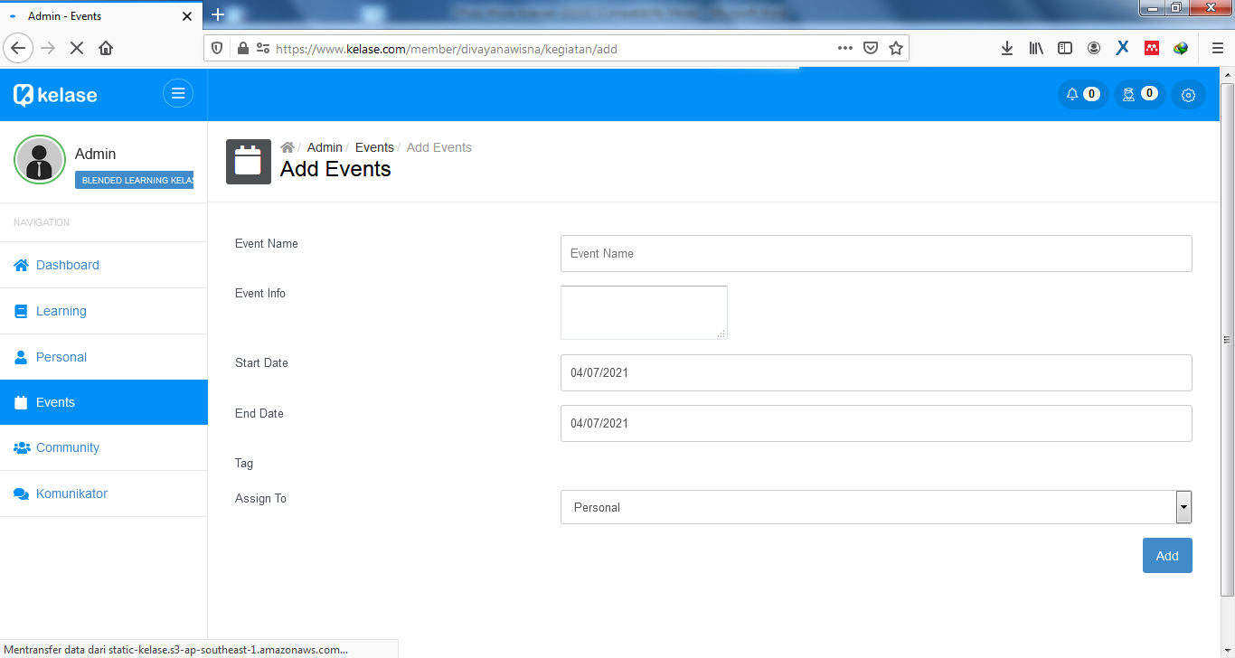

**FIGURE 3**. Form of add events

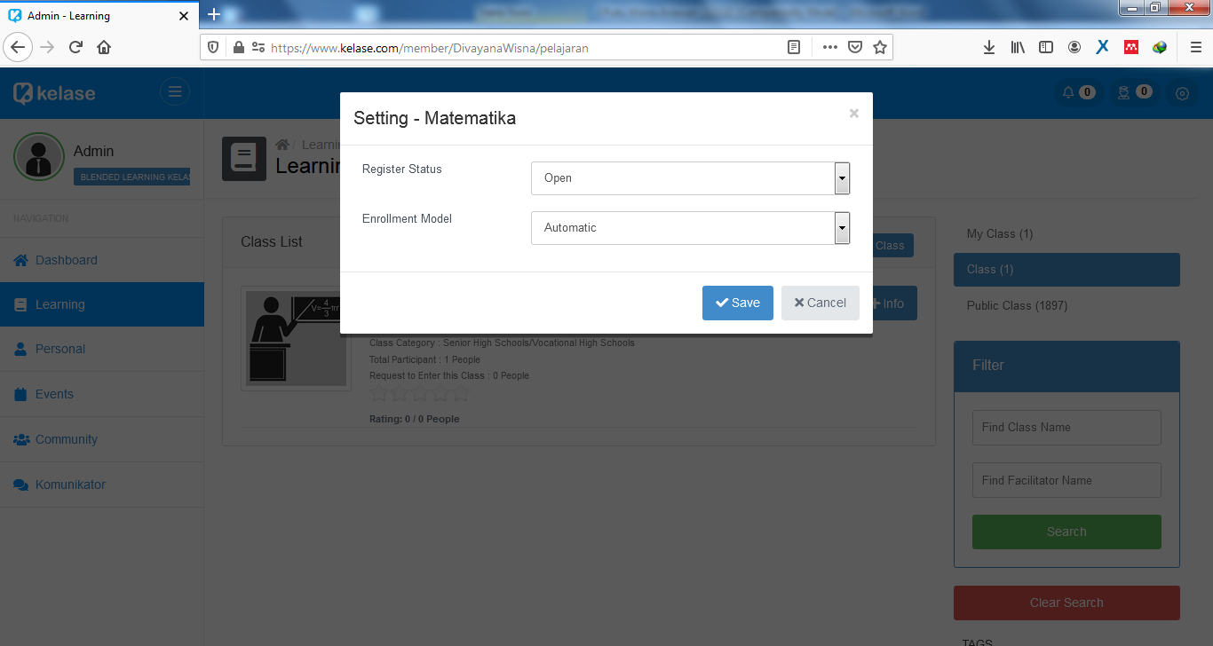

**FIGURE 4**. Form of setting the registration rights

If viewed from the average percentage of effectiveness shown in Table 2 to Table 4, in general, blended learning based on TKP-Kelase was classified as good. This was because the percentage of effectiveness obtained in the usage tests in the range of 80% to 89% based on the five’s scale of effectiveness standard.

This research succeeded in being an answer to several limitations of Muhtia et al.’s research [2], Sulisworo et al.’s research [3], Wijanayu et al.’s research [4], and Helsa and Kenedi’s research [5] by showing the material contents and tests form that refers to the cognitive, affective and psychomotor in blended learning based on *TKP*-*Kelase*. Although this research had contributed to overcoming the limitations of previous studies, this research also has obstacles. The obstacle found in this research is that it has not shown a ranking based on the results of student achievement assessments in the cognitive, affective, and psychomotor domains as a whole.

# Conclusions

The results of usage tests conducted by experts, teachers, and students showed that blended learning based on *TKP*-*Kelase* was good and effective to be used as a facility to support the mathematics learning process of senior high schools/vocational schools in Bali. Future work being carried out to overcome the constraint of this research is to prepare facilities to calculate the average of student achievement assessment for all cognitive, affective, and psychomotor domains.

# Acknowledgment

The authors would like thank to the Directorate General of Research and Development, Ministry of Education, Culture, Research and Technology of the Republic of Indonesia that providing opportunities and funding in carrying out the research at several senior high schools and vocational schools in Bali.

# references

1. Ariawan I P W and Divayana D G H 2020 Design of blended learning based on tri kaya parisudha using kelase platform in realizing hybrid-superitem learning in mathematics lessons *International Journal of Instruction*. 13(3), 679–698.
2. Muhtia A, Suparno and Sumardi 2018 Blended learning using schoology as an online learning platform *ELLiC Proceedings*. 2, 171–175.
3. Sulisworo D, Agustin S P and Sudarmiyati E 2016 Cooperative-blended learning using moodle as an open source learning platform *International Journal of Technology Enhanced Learning*. 8(2), 187–198.
4. Wijanayu A, Hardyanto W and Isnaeni W 2018 Blended learning method based on quipper school to improve concepts understanding and independence learning *Journal of Primary Education*. 7(1), 88–95.
5. Helsa Y and Kenedi A K 2019 Edmodo-based blended learning media in learning mathematics *Journal of Teaching and Learning in Elementary Education*. 2(2), 107–117.

Sujariati S 2020 Improving the students’ listening comprehension through aural-oral language approach *Linguistic, English Education and Art (LEEA) Journal.* 3(2), 486–505.

Sutirna 2019 Subject teachers’ perceptions of academic mentoring and counseling services *COUNS-EDU:* *The International Journal of Counseling and Education*. 4(4), 129–133.

Chandra J 2017 An analysis of grammatical errors in efl college students’ proposal thesis writing *International Conference on Language Teaching and Education (ICoLTE),* Jambi, Indonesia, 185–193.

Maryansyah Y 2016 An analysis on readability of english reading texts for grade IX students at MTSN 2 Kota Bengkulu *Premise Journal*. 5(1), 69–88.

Dalimunte M and Salmiah M 2019 Students’ ability at changing direct into indirect speech and indirect into direct speech *Budapest International Research and Critics Institute-Journal (BIRCI-Journal)*. 2(2), 178–185.

Clarissa S V, Yusuf Y Q and Zulfikar T 2018 Young children’s word awareness development at preschool *Proceedings of the International Conference on the Roles of Parents in Shaping Children‟s Characters (ICECED)*, Anjong Mon Mata, Banda Aceh, Indonesia, 374–385.

Sari S A and Rezeki Y S 2019 The development of an ingenious circuit based on chemo-edutainment learning *International Journal of Educational Research Review*. 4(1), 15–25.

Razak M R R, Dahong M, Ahmad J, Dema H and Mustanir A 2018 The effect of siri’s marriage on government administration *International Journal of Sciences: Basic and Applied Research (IJSBAR)*. 42(3), 171–184.

Sari L Y, Susanti D, Fitriani V, Supriatno B and Riandi R 2020 How to Validity Handbook in Introduction and Laboratory Techniques Oriented PBL *International Journal of Progressive Sciences and Technologies (IJPSAT).* 19(1), 250–254.

Yulina I K, Permanasari A, Hernani H and Setiawan W 2019 Analytical thinking skill profile and perception of pre service chemistry teachers in analytical chemistry learning *IOP Conf. Series: Journal of Physics: Conf. Series*, 1157, 1–7.

Sugiharni G A D 2018 The development of interactive instructional media oriented to creative problem solving model on function graphic subject *Journal of Educational Research and Evaluation*. 2(4), 183–189.

Dalimoenthe I, Clara E, Akmal Y, Alkhudri A T, Andhyni B P and Sarwestri I D 2020 Psycho-Social Education (PSE) model: conceptualisation and implementation of empowerment models for families evicted from cities *International Journal of Innovation, Creativity and Change*. 13(1), 1052–1072.

Nawawi S, Nizkon and Azhari A T 2020 Analysis of the level of critical thinking skills of students in biological materials at Muhammadiyah high school in Palembang city *Universal Journal of Educational Research*. 8(3D), 47–53.

Divayana D G H, Suyasa P W A, Ariawan I P W, Mahendra I W E and Sugiharni G A D 2019 The design of digital book content for assessment and evaluation courses by adopting superitem concept based on kvisoft flipbook maker in era of industry 4.0 *IOP Conf. Series: Journal of Physics: Conf. Series*. 1165, 1–6.