Usage Tests of the *CIPP* Model Evaluation Application Integrated with the *SAW* Method to Evaluate the Effectiveness of the E-Learning Implementation

I Putu Wisna Ariawan1 , Dewa Gede Hendra Divayana2 and Made Kurnia Widiastuti Giri3

1 Department of Mathematics Education, Universitas Pendidikan Ganesha, Singaraja-81116, Indonesia  
2 Department of IT Education, Universitas Pendidikan Ganesha, Singaraja-81116, Indonesia

3 Department of Medical, Universitas Pendidikan Ganesha, Singaraja-81116, Indonesia

a) Corresponding author: wisna.ariawan@undiksha.ac.id

**Abstract.** This research was able to aim to show the usage test results of the *CIPP* (*Context*-*Input*-*Process*-*Product*) evaluation application which was integrated with the *SAW* (*Simple Additive Weighting*) method. This research approach was development research. The development method was *R&D* (Research & Development) and the development model using *Borg and Gall* model. The development stage was focused on the stage of usage tests. These usage tests involved four experts, 20 lecturers, and 30 students. The tools were used to the usage tests related to the effectiveness of evaluation application were questionnaires consisting of 15 questions. The usage tests of application were carried out at six health universities in Bali. The analysis technique was used to analyze the data from the usage tests was the quantitative descriptive technique. This technique was carried out by interpreting the results of a comparison between the effectiveness percentage of usage test results with the effectiveness standard categorizations based on the eleven’s scale. The usage test results showed that the *CIPP* evaluation application integrated with *SAW* was in a good category. It was based on the usage test results of the *SAW* formula which showed an accurate calculation process. Besides, the results of the effectiveness tests toward the evaluation application by experts, lecturers, and students, respectively showed the effectiveness percentages were 90.67%, 90.47%, and 90.49%. Those indicated the effectiveness of the evaluation application was classified as a good category.

# Keywords: Usage Tests, *CIPP*, *SAW*, Effectiveness Evaluation, E-Learning.

# INTRODUCTION

The Covid-19 pandemic had caused changes in the learning model used in most health universities. E-learning as a learning model implemented in health universities is certainly very useful and important to support the smooth learning process since the appearance of the Covid-19 pandemic. The advantage of the e-learning model when compared to other learning models is that e-learning can be carried out fully online during the Covid-19 pandemic. Therefore, the e-learning model can reduce the occurrence of crowds and the learning process can still occur between lecturers and students from their respective homes through internet facilities. Although e-learning has several advantages, the implementation of e-learning in the fields also has obstacles. Some of the most common obstacles included: unstable internet access, the lack of supporting tools owned by students and lecturers in realizing e-learning, not all students and lecturers in health universities are accustomed to operating e-learning platforms.

Based on those obstacles, it is necessary to carry out an evaluation activity to obtain appropriate recommendations to increase the effectiveness of the e-learning implementation at health universities. Many evaluation tools can be used to support evaluation activities on the e-learning implementation at health universities. However, there are no evaluation tools that can be used to determine the dominant indicators that trigger the effectiveness of the e-learning implementation.

One of the efforts that had been conducted by the authors through research in 2020 to overcome those obstacles was to develop an evaluation application based on the *CIPP* model that was integrated with the *SAW* method **1**. The calculation simulation of determining the dominant indicators that trigger the effectiveness of the e-learning implementation using the *CIPP*-*SAW* evaluation application had been carried out on a limited scale. However, the usage tests to determine the effectiveness of the *CIPP*-*SAW* evaluation application had not been implemented in 2020. Therefore, it was necessary to conduct the usage tests of the *CIPP*-*SAW* evaluation application to evaluate the effectiveness level of the e-learning implementation.

Based on those needs, the question of this research was how the usage test results of the *CIPP*-*SAW* evaluation application to evaluate the effectiveness of the e-learning implementation? The purpose of this research was to determine the usage test results of the *CIPP*-*SAW* evaluation application.

This research was motivated by several results and limitations from previous researches. The research was conducted by Rasouli et al.**2** showed activity to evaluate the readiness of students in implementing e-learning. The limitations of Rasouli et al.’s research were that it had not explained in-depth about usage tests toward evaluation model used to determine the dominant aspects that trigger the effectiveness of e-learning implementation. The research of Setiawan and Munajah**3** showed evaluation toward the application used for the online learning implementation at universities in Indonesia. The limitations of Setiawan and Munajah’s research were that it had not shown the usage tests of evaluation application that was used to evaluate and showed the dominant aspects that caused the effectiveness of the online learning implementation. Eze et al.’s research**4** revealed the factors that influence the use of e-learning facilities in private universities. The limitations of Eze et al.’s research were that it had not shown usage tests viewed from the dimensions of formula and functionality of the evaluation application. Barteit et al.’s research**5** revealed the results of evaluating the e-learning effectiveness in medical education. The limitations of Barteit et al.’s research were that it had not shown the usage tests of the evaluation model used for evaluating and had not shown the most dominant aspect of evaluation as a trigger for the e-learning effectiveness. Chin et al.’s research**6** showed the evaluation results of the learning material sources used in e-learning. Limitations of Chin et al.’s research were that it had not shown effectiveness tests of the evaluation application and usage tests of the formula applied to that evaluation application.

# Method

This research used a development approach. The development method was *R&D* and the development model was the *Borg and Gall* model **7-10**. The focus of the development carried out in this 2021 research was the stage of usage tests. The usage tests were carried out in this research had not only testing the validity and reliability of instruments which had generally been done by previous studies. The testing method in previous studies used the quantitative method by using the tendency to calculate the content validity and reliability of instruments. However, the usage tests in this research were more in-depth in carrying out two testing activities. There were two activities carried out in the usage tests, included: 1) usage tests of the *SAW* method formula in determining the dominant aspects that need to be maintained and the dominant aspects that need to be improved to support the effectiveness of e-learning; 2) effectiveness tests of the *CIPP*-*SAW* evaluation application.

The *SAW* method formula consists of 2 equations. Equation (1) is used to determine data normalization. The formula for equation (1) can be shown as follows **11-15**.



(1)

Notes:

rij  = rating score of normalized performance

xij = attribute value of each criteria

Benefit = if highest value is the best

Cost = if lowest value is the best

Max xij  = the highest value of each criteria

Min xij = the lowest value of each criteria

Equation (2) is used to determine the rank. The rank is a basis for determining the dominant aspects that need to be maintained and improved. The formula for equation (2) can be shown as follows **16-20**.



(2)

Notes:

Vi = rank for each alternative

wj  = weighted value of each criteria

rij = rating score of normalized performance

The tools were used in testing the effectiveness of the *CIPP*-*SAW* evaluation application were instruments. The instruments consist of 15 questions. The location of usage tests was carried out in six health universities in Bali Province. The subjects involved in the usage tests were two informatics education experts, two educational evaluation experts, 20 lecturers, and 30 students.

The analysis technique was used to the data from the effectiveness tests of the *CIPP*-*SAW* evaluation application was a quantitative descriptive technique. The quantitative results in the form of percentage scores of effectiveness obtained through the analysis technique are calculated using a percentage descriptive formula. The formula for calculating the percentage descriptive can be seen in equation (3) **21-23**.

(3)

Notes:

EP = Effectiveness Percentage

∑ = Total

n = Total number of questionnaires item

Descriptions of the quantitative results that had been obtained then were interpreted descriptively by comparing the percentage scores of effectiveness with the categorization of effectiveness standards which refers to the eleven’s scale. The categorization of effectiveness standards based on the eleven’s scale can be seen in Table 1 **24-25**.

Table 1. Categorization of effectiveness standards based on the eleven’s scale.

| Percentage range (%) | Effectiveness categorization |
| --- | --- |
| 0 to 4 | Poor |
| 5 to 14 | Very bad |
| 15 to 24 | Bad |
| 25 to 34 | Very less |
| 35 to 44 | Less |
| 45 to 54 | Elementary |
| 55 to 64 | Enough |
| 65 to 74 | Intermediate |
| 75 to 84 | Advanced |
| 85 to 94 | Good |
| 95 to 100 | Excellent |

# Results and discussion

Before seeing the usage test results of the CIPP evaluation application integrated with SAW, it is necessary to know the forms available in the evaluation application. The forms intended can be seen in Figure 1 to Figure 6.

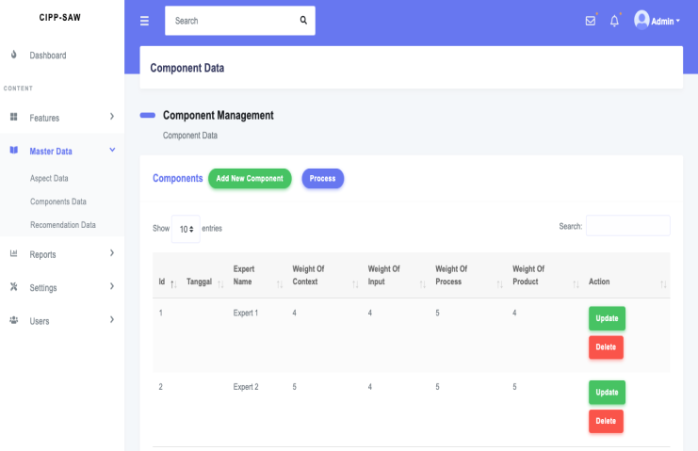

Fig.1. Main menu form Fig.2. Form of evaluation components’ management

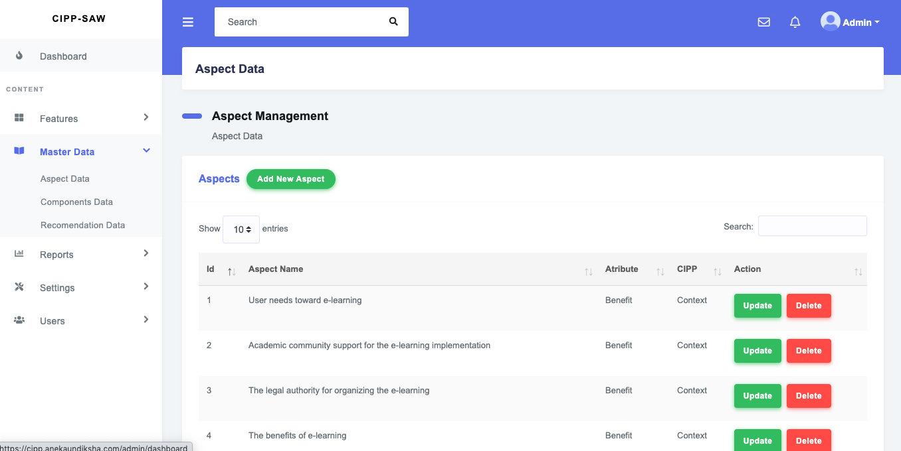

Fig. 3. Form of evaluation aspects’ management

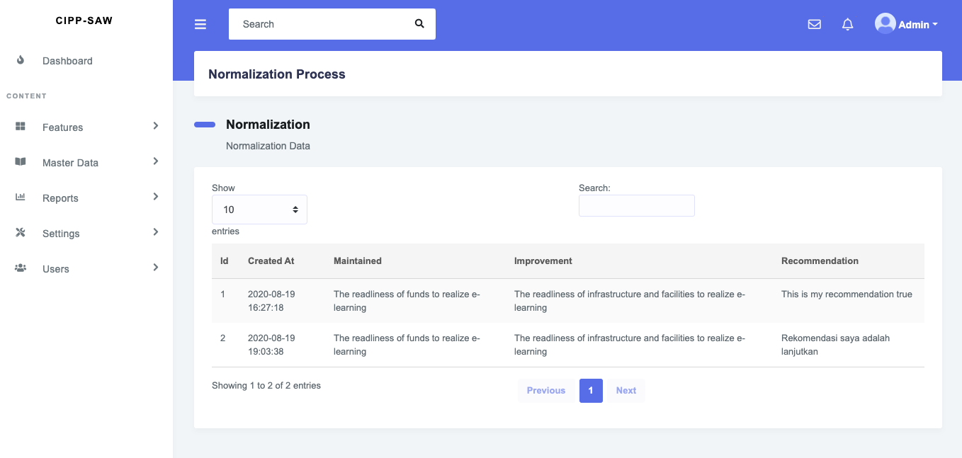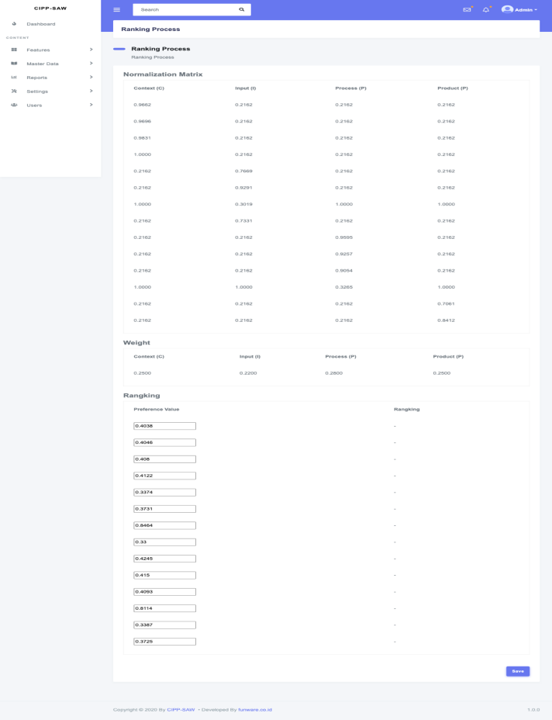

Fig. 4. Form of normalization process Fig. 5. Form of ranking process

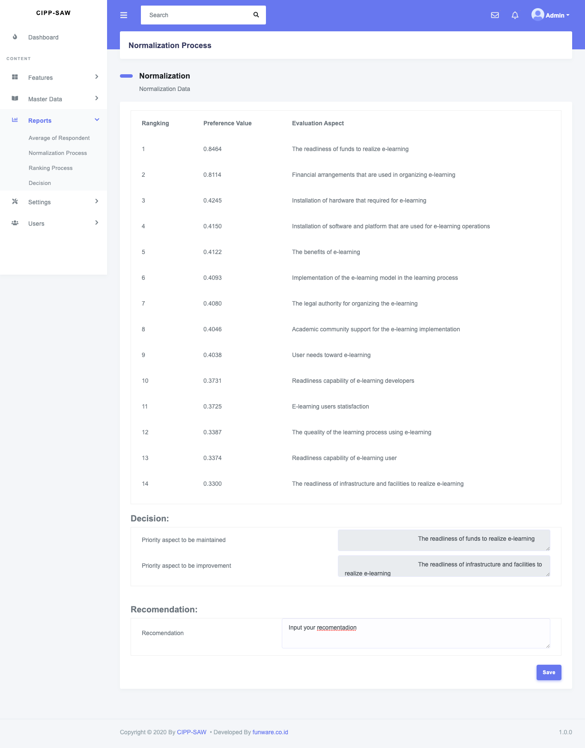

Fig. 6. Form of decisions

Figure 1 shows the main menu form which serves as a navigation to other forms. Some of the navigation on this main form included: features navigation, master data navigation, reports’ navigation, settings navigation, and users’ navigation. Figure 2 shows a form that functions to organize data of evaluation components. The settings in this form including input, update, and delete the evaluation components data. Figure 3 shows a form that functions to organize data of evaluation aspects. The settings in this form including input, update, and delete data of the evaluation aspects data. Figure 4 shows a form that functions to carry out the data normalization process. The normalized values are the values of the interest rating of the evaluation aspects given by the respondents. Figure 5 shows a form that functions to perform the ranking process. The values that are ranked are the preference values. The highest preference value gets the top ranking, while the lowest preference gets the bottom ranking. Figure 6 shows a form that serves to determine decisions and recommendations. The decisions contain information about the dominant aspects that need to be maintained to support the effectiveness of e-learning and the dominant aspects that need to be improved so that later it can support the effectiveness of e-learning. Recommendations contain suggestions for improvements to the dominant aspects that need to be improved.

The usage tests of the SAW method formula can be carried out based on the test data shown in Table 2, equation (1) and equation (2). The calculation process of the SAW method formula can be explained as follows.

Table 2. Data of SAW method formula test

| Respondents | Aspects | | | | | | | | | | | | | |
| --- | --- | --- | --- | --- | --- | --- | --- | --- | --- | --- | --- | --- | --- | --- |
| A1 | A2 | A3 | A4 | A5 | A6 | A7 | A8 | A9 | A10 | A11 | A12 | A13 | A14 |
| Context | 4.4688 | 4.4844 | 4.5469 | 4.6250 | 1.0000 | 1.0000 | 1.0000 | 1.0000 | 1.0000 | 1.0000 | 1.0000 | 1.0000 | 1.0000 | 1.0000 |
| Input | 1.0000 | 1.0000 | 1.0000 | 1.0000 | 3.5469 | 4.2969 | 3.3125 | 3.3906 | 1.0000 | 1.0000 | 1.0000 | 1.0000 | 1.0000 | 1.0000 |
| Process | 1.0000 | 1.0000 | 1.0000 | 1.0000 | 1.0000 | 1.0000 | 1.0000 | 1.0000 | 4.4375 | 4.2813 | 4.1875 | 3.0625 | 1.0000 | 1.0000 |
| Product | 1.0000 | 1.0000 | 1.0000 | 1.0000 | 1.0000 | 1.0000 | 1.0000 | 1.0000 | 1.0000 | 1.0000 | 1.0000 | 1.0000 | 3.2656 | 3.8906 |

Notes:

A1: user needs toward e-learning; A2: academic community support for the e-learning implementation; A3: the legal authority to organize the e-learning; A4: the e-learning’s benefits; A5: capability’s readiness of e-learning users; A6: capability’s readiness of e-learning developers; A7: the readiness of funds to realize e-learning; A8: the readiness of infrastructure and facilities to e-learning realization; A9: installation of hardware required for e-learning; A10: installation of software and platforms that are used for e-learning operations; A11: the e-learning model implementation in the learning process; A12: financial arrangements that are used in organizing e-learning; A13: the learning process quality using e-learning; A14: user’s satisfaction toward e-learning.

From those fourteen aspects, several aspects are categorized as benefit attributes and cost attributes. Aspects that include the cost attribute, including aspect-A7: the readiness of funds to realize e-learning; and aspect-A12: financial arrangements that are used in organizing e-learning. The other twelve aspects include the benefit attribute.

Referring to equation (1), the data in Table 2, the aspects classified as benefit attributes and cost attributes, then normalization calculations can be carried out. The results of normalization calculations can be seen as follows.

|  |  |  |  |  |  |  |  |  |  |  |  |
| --- | --- | --- | --- | --- | --- | --- | --- | --- | --- | --- | --- |
| r11 | = | 0.9662 | r12 | = | 0.2162 | r13 | = | 0.2162 | r14 | = | 0.2162 |
| r21 | = | 0.9696 | r22 | = | 0.2162 | r23 | = | 0.2162 | r24 | = | 0.2162 |
| r31 | = | 0.9831 | r32 | = | 0.2162 | r33 | = | 0.2162 | r34 | = | 0.2162 |
| r41 | = | 1.0000 | r42 | = | 0.2162 | r43 | = | 0.2162 | r44 | = | 0.2162 |
| r51 | = | 0.2162 | r52 | = | 0.7669 | r53 | = | 0.2162 | r54 | = | 0.2162 |
| r61 | = | 0.2162 | r62 | = | 0.9291 | r63 | = | 0.2162 | r64 | = | 0.2162 |
| r71 | = | 1.0000 | r72 | = | 0.3019 | r73 | = | 1.0000 | r74 | = | 1.0000 |
| r81 | = | 0.2162 | r82 | = | 0.7331 | r83 | = | 0.2162 | r84 | = | 0.2162 |
| r91 | = | 0.2162 | r92 | = | 0.2162 | r93 | = | 0.9595 | r94 | = | 0.2162 |
| r101 | = | 0.2162 | r102 | = | 0.2162 | r103 | = | 0.9257 | r104 | = | 0.2162 |
| r111 | = | 0.2162 | r112 | = | 0.2162 | r113 | = | 0.9054 | r114 | = | 0.2162 |
| r121 | = | 1.0000 | r122 | = | 1.0000 | r123 | = | 0.3265 | r124 | = | 1.0000 |
| r131 | = | 0.2162 | r132 | = | 0.2162 | r133 | = | 0.2162 | r134 | = | 0.7061 |
| r141 | = | 0.2162 | r142 | = | 0.2162 | r143 | = | 0.2162 | r144 | = | 0.8412 |

That normalization results were converted into matrix R. The display of matrix-R can be seen in Figure 7.

|  |  |  |  |  |  |
| --- | --- | --- | --- | --- | --- |
|  |  | 0.9662 | 0.2162 | 0.2162 | 0.2162 |
|  |  | 0.9696 | 0.2162 | 0.2162 | 0.2162 |
|  |  | 0.9831 | 0.2162 | 0.2162 | 0.2162 |
|  |  | 1.0000 | 0.2162 | 0.2162 | 0.2162 |
|  |  | 0.2162 | 0.7669 | 0.2162 | 0.2162 |
|  |  | 0.2162 | 0.9291 | 0.2162 | 0.2162 |
| R | = | 1.0000 | 0.3019 | 1.0000 | 1.0000 |
| 0.2162 | 0.7331 | 0.2162 | 0.2162 |
|  |  | 0.2162 | 0.2162 | 0.9595 | 0.2162 |
|  |  | 0.2162 | 0.2162 | 0.9257 | 0.2162 |
|  |  | 0.2162 | 0.2162 | 0.9054 | 0.2162 |
|  |  | 1.0000 | 1.0000 | 0.3265 | 1.0000 |
|  |  | 0.2162 | 0.2162 | 0.2162 | 0.7061 |
|  |  | 0.2162 | 0.2162 | 0.2162 | 0.8412 |

Fig. 7. Matrix-R

The ranking calculation process is largely determined by the weights given by the experts to each evaluation component. If the weights given by the experts to each component of the CIPP evaluation (Context = 25%, Input = 22%, Process = 28%, Product = 25%), then the ranking calculation process referring to equation (2) can be seen as follows.

V1 = (0.25)(0.9662) + (0.22)(0.2162) + (0.28)(0.2162) + (0.25)(0.2162) = 0.4038

V2 = (0.25)(0.9696) + (0.22)(0.2162) + (0.28)(0.2162) + (0.25)(0.2162) = 0.4046

V3 = (0.25)(0.9831) + (0.22)(0.2162) + (0.28)(0.2162) + (0.25)(0.2162) = 0.4080

V4 = (0.25)(1.0000) + (0.22)(0.2162) + (0.28)(0.2162) + (0.25)(0.2162) = 0.4122

V5 = (0.25)(0.2162) + (0.22)(0.7669) + (0.28)(0.2162) + (0.25)(0.2162) = 0.3374

V6 = (0.25)(0.2162) + (0.22)(0.9291) + (0.28)(0.2162) + (0.25)(0.2162) = 0.3731

V7 = (0.25)(1.0000) + (0.22)(0.3019) + (0.28)(1.0000) + (0.25)(1.0000) = 0.8464

V8 = (0.25)(0.2162) + (0.22)(0.7331) + (0.28)(0.2162) + (0.25)(0.2162) = 0.3300

V9 = (0.25)(0.2162) + (0.22)(0.2162) + (0.28)(0.9595) + (0.25)(0.2162) = 0.4245

V10 = (0.25)(0.2162) + (0.22)(0.2162) + (0.28)(0.9257) + (0.25)(0.2162) = 0.4150

V11 = (0.25)(0.2162) + (0.22)(0.2162) + (0.28)(0.9054) + (0.25)(0.2162) = 0.4093

V12 = (0.25)(1.0000) + (0.22)(1.0000) + (0.28)(0.3265) + (0.25)(1.0000) = 0.8114

V13 = (0.25)(0.2162) + (0.22)(0.2162) + (0.28)(0.2162) + (0.25)(0.7061) = 0.3387

V14= (0.25)(0.2162) + (0.22)(0.2162) + (0.28)(0.2162) + (0.25)(0.8412) = 0.3725

From the ranking results above, it is clear that the accuracy of the SAW method calculations in determining the dominant aspects that need to be maintained and the dominant aspects that need to be improved to support the e-learning effectiveness. The dominant aspect that needs to be maintained is aspect-A7 (the readiness of funds to realize e-learning) because the ranking value is the largest when compared to other aspects. The dominant aspect that needs improvement is aspect-A8 (the readiness of infrastructure and facilities to e-learning realization) because the ranking value is the smallest when compared to other aspects. The accuracy of the calculation results using the SAW method formula can also be seen from the consistency of the calculation results when viewed from manual calculations and calculations through evaluation application.

The results of effectiveness tests were conducted by four experts toward the CIPP evaluation application that integrated with the SAW method can be seen completely in Table 3. The results of effectiveness tests were conducted by 20 lecturers can be seen in Table 4. The results of effectiveness tests were conducted by 30 students can be seen in Table 5.

Table 3. Results of effectiveness tests were conducted by experts

| Respondents | Question items- | | | | | | | | | | | | | | | Σ | Average |
| --- | --- | --- | --- | --- | --- | --- | --- | --- | --- | --- | --- | --- | --- | --- | --- | --- | --- |
| 1 | 2 | 3 | 4 | 5 | 6 | 7 | 8 | 9 | 10 | 11 | 12 | 13 | 14 | 15 |
| Expert-1 | 5 | 4 | 4 | 5 | 5 | 4 | 5 | 4 | 4 | 5 | 4 | 5 | 4 | 5 | 4 | 67 | 89.33 |
| Expert-2 | 4 | 5 | 5 | 4 | 4 | 5 | 5 | 5 | 5 | 4 | 5 | 4 | 4 | 4 | 5 | 68 | 90.67 |
| Expert-3 | 5 | 5 | 4 | 5 | 5 | 4 | 4 | 5 | 4 | 5 | 5 | 4 | 5 | 5 | 5 | 70 | 93.33 |
| Expert-4 | 4 | 4 | 5 | 5 | 4 | 4 | 5 | 4 | 4 | 5 | 4 | 5 | 4 | 5 | 5 | 67 | 89.33 |
| Average | | | | | | | | | | | | | | | | | 90.67 |

Table 4. Results of effectiveness tests were conducted by lecturers

| Respondents | Question items- | | | | | | | | | | | | | | | Σ | Average |
| --- | --- | --- | --- | --- | --- | --- | --- | --- | --- | --- | --- | --- | --- | --- | --- | --- | --- |
| 1 | 2 | 3 | 4 | 5 | 6 | 7 | 8 | 9 | 10 | 11 | 12 | 13 | 14 | 15 |
| Lecturer-1 | 5 | 4 | 4 | 5 | 5 | 5 | 5 | 4 | 5 | 5 | 5 | 5 | 4 | 5 | 4 | 70 | 93.33 |
| Lecturer-2 | 4 | 5 | 5 | 4 | 4 | 5 | 4 | 5 | 5 | 4 | 5 | 4 | 5 | 5 | 5 | 69 | 92.00 |
| Lecturer-3 | 5 | 5 | 4 | 4 | 5 | 4 | 4 | 5 | 4 | 5 | 4 | 4 | 5 | 4 | 4 | 66 | 88.00 |
| Lecturer-4 | 4 | 5 | 4 | 5 | 5 | 5 | 4 | 5 | 4 | 4 | 4 | 4 | 5 | 4 | 4 | 66 | 88.00 |
| Lecturer-5 | 5 | 4 | 4 | 5 | 4 | 4 | 5 | 5 | 4 | 5 | 5 | 5 | 4 | 5 | 4 | 68 | 90.67 |
| Lecturer-6 | 4 | 5 | 4 | 5 | 4 | 4 | 5 | 4 | 5 | 4 | 5 | 4 | 5 | 5 | 4 | 67 | 89.33 |
| Lecturer-7 | 5 | 5 | 5 | 4 | 5 | 4 | 5 | 4 | 4 | 5 | 4 | 4 | 5 | 4 | 4 | 67 | 89.33 |
| Lecturer-8 | 4 | 5 | 4 | 5 | 5 | 5 | 5 | 5 | 5 | 4 | 5 | 4 | 5 | 5 | 5 | 71 | 94.67 |
| Lecturer-9 | 5 | 4 | 4 | 5 | 4 | 5 | 4 | 5 | 4 | 5 | 5 | 5 | 5 | 4 | 4 | 68 | 90.67 |
| Lecturer-10 | 4 | 5 | 5 | 4 | 4 | 4 | 5 | 4 | 4 | 5 | 4 | 4 | 5 | 4 | 5 | 66 | 88.00 |
| Lecturer-11 | 5 | 5 | 5 | 4 | 5 | 4 | 5 | 5 | 5 | 5 | 4 | 5 | 4 | 4 | 4 | 69 | 92.00 |
| Lecturer-12 | 4 | 5 | 4 | 5 | 5 | 5 | 5 | 4 | 5 | 4 | 5 | 5 | 5 | 5 | 5 | 71 | 94.67 |
| Lecturer-13 | 5 | 4 | 4 | 5 | 4 | 4 | 4 | 5 | 4 | 4 | 5 | 4 | 4 | 5 | 4 | 65 | 86.67 |
| Lecturer-14 | 5 | 4 | 5 | 5 | 5 | 4 | 5 | 4 | 5 | 4 | 5 | 5 | 4 | 5 | 4 | 69 | 92.00 |
| Lecturer-15 | 4 | 4 | 4 | 5 | 4 | 5 | 5 | 4 | 4 | 5 | 5 | 5 | 4 | 5 | 4 | 67 | 89.33 |
| Lecturer-16 | 4 | 4 | 5 | 4 | 4 | 5 | 4 | 4 | 5 | 4 | 5 | 4 | 5 | 5 | 4 | 66 | 88.00 |
| Lecturer-17 | 5 | 5 | 5 | 4 | 5 | 5 | 5 | 4 | 5 | 5 | 4 | 4 | 5 | 4 | 5 | 70 | 93.33 |
| Lecturer-18 | 4 | 5 | 4 | 5 | 5 | 5 | 4 | 5 | 5 | 5 | 5 | 4 | 5 | 4 | 4 | 69 | 92.00 |
| Lecturer-19 | 5 | 4 | 4 | 5 | 4 | 4 | 4 | 5 | 4 | 5 | 4 | 5 | 5 | 5 | 5 | 68 | 90.67 |
| Lecturer-20 | 4 | 5 | 4 | 4 | 5 | 5 | 4 | 5 | 4 | 4 | 4 | 5 | 4 | 4 | 4 | 65 | 86.67 |
| Average | | | | | | | | | | | | | | | | | 90.47 |

Table 5. Results of effectiveness tests were conducted by students

| Respondents | Question items- | | | | | | | | | | | | | | | Σ | Average |
| --- | --- | --- | --- | --- | --- | --- | --- | --- | --- | --- | --- | --- | --- | --- | --- | --- | --- |
| 1 | 2 | 3 | 4 | 5 | 6 | 7 | 8 | 9 | 10 | 11 | 12 | 13 | 14 | 15 |
| Student-1 | 5 | 4 | 5 | 4 | 5 | 5 | 4 | 5 | 4 | 5 | 4 | 5 | 4 | 5 | 4 | 68 | 90.67 |
| Student-2 | 4 | 4 | 4 | 4 | 4 | 4 | 4 | 4 | 5 | 4 | 4 | 4 | 5 | 4 | 4 | 62 | 82.67 |
| Student-3 | 4 | 5 | 4 | 5 | 4 | 4 | 5 | 4 | 5 | 5 | 5 | 4 | 5 | 5 | 5 | 69 | 92.00 |
| Student-4 | 5 | 5 | 5 | 5 | 5 | 5 | 5 | 5 | 5 | 4 | 5 | 5 | 5 | 4 | 5 | 73 | 97.33 |
| Student-5 | 5 | 4 | 5 | 4 | 4 | 5 | 4 | 4 | 4 | 5 | 4 | 4 | 4 | 5 | 4 | 65 | 86.67 |
| Student-6 | 5 | 5 | 5 | 5 | 4 | 5 | 5 | 4 | 5 | 4 | 5 | 4 | 5 | 4 | 5 | 70 | 93.33 |
| Student-7 | 5 | 4 | 5 | 4 | 5 | 5 | 4 | 5 | 5 | 4 | 4 | 5 | 5 | 4 | 4 | 68 | 90.67 |
| Student-8 | 4 | 4 | 4 | 4 | 5 | 4 | 4 | 5 | 4 | 4 | 5 | 5 | 4 | 4 | 5 | 65 | 86.67 |
| Student-9 | 4 | 5 | 4 | 5 | 5 | 4 | 5 | 5 | 5 | 5 | 4 | 5 | 4 | 5 | 4 | 69 | 92.00 |
| Student-10 | 5 | 4 | 5 | 4 | 5 | 4 | 5 | 4 | 5 | 4 | 4 | 4 | 5 | 4 | 4 | 66 | 88.00 |
| Student-11 | 4 | 4 | 4 | 5 | 4 | 4 | 5 | 5 | 4 | 4 | 5 | 4 | 5 | 5 | 5 | 67 | 89.33 |
| Student-12 | 4 | 5 | 4 | 5 | 5 | 5 | 4 | 5 | 4 | 5 | 5 | 5 | 5 | 4 | 5 | 70 | 93.33 |
| Student-13 | 5 | 5 | 5 | 5 | 4 | 5 | 4 | 5 | 5 | 5 | 4 | 4 | 4 | 5 | 4 | 69 | 92.00 |
| Student-14 | 5 | 4 | 4 | 4 | 5 | 4 | 4 | 4 | 5 | 5 | 5 | 4 | 5 | 4 | 5 | 67 | 89.33 |
| Student-15 | 5 | 5 | 4 | 5 | 4 | 5 | 5 | 5 | 5 | 5 | 4 | 5 | 5 | 4 | 4 | 70 | 93.33 |
| Student-16 | 5 | 4 | 5 | 4 | 5 | 4 | 5 | 4 | 5 | 4 | 4 | 5 | 4 | 4 | 5 | 67 | 89.33 |
| Student-17 | 4 | 4 | 4 | 5 | 4 | 4 | 4 | 4 | 4 | 4 | 5 | 5 | 5 | 4 | 5 | 65 | 86.67 |
| Student-18 | 4 | 5 | 4 | 5 | 5 | 5 | 5 | 5 | 4 | 5 | 5 | 5 | 4 | 5 | 5 | 71 | 94.67 |
| Student-19 | 5 | 5 | 5 | 5 | 4 | 5 | 4 | 4 | 4 | 5 | 5 | 5 | 5 | 4 | 5 | 70 | 93.33 |
| Student-20 | 5 | 4 | 4 | 4 | 5 | 4 | 5 | 5 | 5 | 4 | 5 | 4 | 5 | 4 | 4 | 67 | 89.33 |
| Student-21 | 5 | 5 | 4 | 5 | 4 | 5 | 5 | 5 | 4 | 4 | 4 | 5 | 4 | 4 | 5 | 68 | 90.67 |
| Student-22 | 5 | 4 | 5 | 5 | 4 | 5 | 4 | 5 | 4 | 5 | 4 | 5 | 4 | 5 | 4 | 68 | 90.67 |
| Student-23 | 4 | 4 | 5 | 4 | 4 | 4 | 4 | 4 | 5 | 4 | 4 | 4 | 5 | 4 | 4 | 63 | 84.00 |
| Student-24 | 4 | 5 | 5 | 5 | 4 | 4 | 5 | 4 | 5 | 4 | 5 | 4 | 5 | 5 | 5 | 69 | 92.00 |
| Student-25 | 5 | 5 | 5 | 5 | 4 | 5 | 5 | 5 | 5 | 5 | 5 | 5 | 5 | 4 | 5 | 73 | 97.33 |
| Student-26 | 5 | 4 | 4 | 4 | 5 | 5 | 4 | 4 | 5 | 5 | 4 | 4 | 4 | 5 | 4 | 66 | 88.00 |
| Student-27 | 5 | 5 | 4 | 5 | 4 | 5 | 5 | 4 | 4 | 5 | 5 | 4 | 5 | 4 | 5 | 69 | 92.00 |
| Student-28 | 5 | 4 | 5 | 5 | 4 | 5 | 4 | 5 | 4 | 5 | 4 | 5 | 5 | 4 | 4 | 68 | 90.67 |
| Student-29 | 4 | 4 | 5 | 4 | 4 | 4 | 4 | 5 | 4 | 4 | 4 | 5 | 4 | 4 | 5 | 64 | 85.33 |
| Student-30 | 4 | 5 | 5 | 5 | 4 | 4 | 5 | 5 | 5 | 4 | 5 | 5 | 5 | 4 | 5 | 70 | 93.33 |
| Average | | | | | | | | | | | | | | | | | 90.49 |

15 question items were used to collect data of the test results toward the use of the CIPP evaluation application that integrated with the SAW method shown earlier in Table 3, Table 4, and Table 5. Question-1: about the display of design and navigation features provided on the main menu form. Question-2: about the ease of inputting the evaluation components data into the form of evaluation components’ management. Question-3: about the ease of updating the evaluation components data in the form of evaluation components’ management. Question-4: about the ease of deleting the evaluation components data that had not been used again in the evaluation components’ management form. Question-5: about the ease of inputting evaluation aspects data into the evaluation aspects’ management form. Question 6: about the ease of updating the evaluation aspects data in the evaluation aspects’ management form. Question 7: about the ease of deleting the evaluation aspects data that had not been used again in the evaluation aspects’ management form. Question 8: about the accuracy of the data normalization process. Question 9: about the accuracy of weighting the evaluation components. Question 10: about the accuracy of the preference values determination. Question 11: about the accuracy of the ranking process. Question 12: about the accuracy of results of determining the dominant aspects that trigger the e-learning effectiveness. Question 13: about the accuracy of results of determining the dominant aspects that need to be improved so that the e-learning implementation becomes more effective. Question 14: about the suitability of the recommendations with the decisions. Question 15: about the data security of decision results stored in the application.

The average of effectiveness percentage shown from the results of the usage tests by experts was 90.67% indicating that the evaluation application was classified as good. This was evidenced by the average percentage in the range of 85 to 94 refers to the categorization of effectiveness standards based on the eleven's scale. Likewise, the average of effectiveness percentage shown from the results of the usage tests by lecturers and students was 90.47% and 90.49% respectively, indicating that the evaluation application was classified as good. The percentage of average also in the range of 85 to 94 refers to the categorization of effectiveness standards based on eleven's scale.

Although this evaluation application was classified as good in general, some improvements need to be conducted based on several suggestions given by respondents when usage tests. Some of the suggestions intended can be seen in Table 6.

Table 6. Suggestions for improvement from respondents

|  |  |
| --- | --- |
| Respondents | Suggestions |
| Expert-2 | Please add facilities to update the interest rating |
| Expert-3 | Please add the facility to set the users’ access rights |
| Lecturer-6 | Add permissions settings for application users |
| Lecturer-18 | Add facility to edit the interest rating |
| Student-10 | Access rights settings need to be provided so that users do not carelessly enter important parts that are not their authority |
| Student-14 | Access rights need to be properly regulated so that they can be used according to users’ interests |

Based on the suggestions shown in table 6, there had been made several improvements to the evaluation application so that its functionality was more optimal. Suggestions from expert-2 and lecturer-6 were answered by making the form of rating management which can be seen in Figure 8. Suggestions from expert-3, lecturer-6, student-10, and student-14 were answered by making the form of access rights setting which can be seen completely in figure 9.

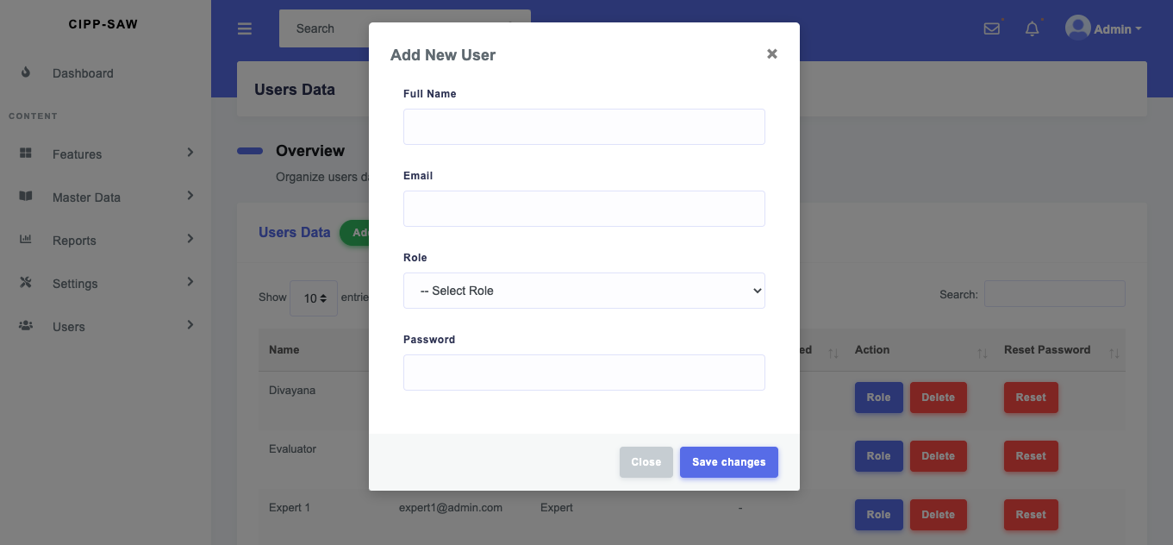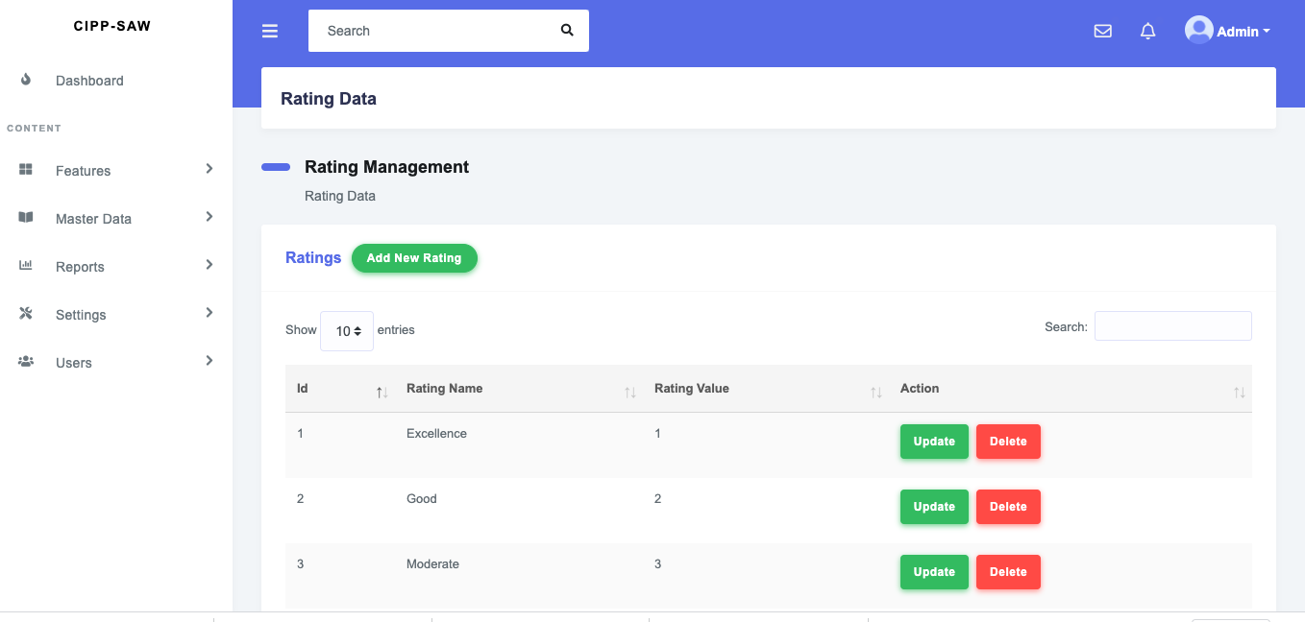

Fig. 8. Form of Rating Management Fig. 9. Form of Access Rights Setting

This research was able to provide answers to the limitations of the research were conducted by Rasouli et al.2, research by Setiawan and Munajah 3, research by Eze et al. 4, research by Barteit et al.5, and research by Chin et al.6 by showing the existence of usage tests toward the CIPP Model evaluation application that integrated with the SAW method to evaluate the e-learning effectiveness in view of the dimensions of functionality and accuracy of the formula calculations used in that application.

The novelty of this research is to show the existence of formula testing and the effectiveness tests of the evaluation application. Testing of the evaluation tool is usually only limited to testing the validity and reliability of the instruments. However, this research carried out further testing of functionality and the accuracy of the formula calculations used in the evaluation tool.

Besides has the advantage, this research also has the limitation. A limitation is the weights equalization process of the experts has not been shown to ensure the principle of fairness in providing recommendations and making decisions.

# Conclusions

In general, the results of the usage tests toward the *CIPP* evaluation application which was integrated with the *SAW* showed that the evaluation application had entered the good category and feasible to be disseminated and applied to a wider scale. This was evidenced from the results of the effectiveness percentage obtained from the usage tests of evaluation applications by experts, lecturers, and students, respectively which were 90.67%, 90.47%, and 90.49%. Besides, the results of usage tests of the *SAW* method formula had also shown an accurate calculation process in determining the dominant aspects that need to be maintained and need to be improved to support the e-learning effectiveness. Future work that needs to be done to overcome the limitation in this research is to improve the experts’ weights by adopting one of the concepts of *Balinese* local wisdom, namely *Tat Twam Asi* as the basis for determining weights equality.

# Acknowledgment

The authors express their gratitude to the Directorate General of Research and Development, Ministry of Education, Culture, Research and Technology of the Republic of Indonesia to provide funding and a chance to completion this research.

# references

1. Ariawan, I.P.W., Giri, M.K.W., & Divayana, D.G.H. 2020. Simulation of SAW-based CIPP evaluation model calculation in determining improvement priority for e-learning services. In: *2020 4th International Conference on Vocational Education and Training (ICOVET)*, Malang, Indonesia, 2020; 1–6.
2. Rasouli, A., Rahbania, Z., & Attaran, M. Students’ readiness for e-learning application in higher education. *Malaysian Online Journal of Educational Technology* 2016; 4(3): 51–64.
3. Setiawan, R., & Munajah, R. 2020. Evaluation of the application of online learning in Indonesian universities. *TEM Journal* 2020; 9(3): 1194–1199.
4. Eze, S.C., Chinedu-Eze, V.C.A., Okike, C.K., & Bello, A.O. Factors influencing the use of e-learning facilities by students in a private Higher Education Institution (HEI) in a developing economy. *Humanities and Social Sciences Communications* 2020; 7, 1–15.
5. Barteit, S., Guzek, D., Jahn, A., Bärnighausen, T., Jorge, M.M., & Neuhann, F. Evaluation of e-learning for medical education in low- and middle-income countries: A systematic review. *Computers & Education* 2020; 145, 1–18.
6. Chin, R.Y.K, Tjahjono, R., Rutledge, M.J.R., Lambert, T., & Deboever, N. The evaluation of e-learning resources as an adjunct to otolaryngology teaching: a pilot study. *BMC Medical Education* 2019; 19, 1–9.
7. Divayana, D.G.H., Suyasa, P.W.A., & Abadi, I.B.G.S. Digital library evaluation application based on combination of CSE-UCLA with weighted product. *Journal of Engineering and Applied Sciences* 2019; 14(4), 1318–1330.
8. Said, A., & Syarif, E. The development of online tutorial program design using problem-based learning in open distance learning system. *Journal of Education and Practice* 2016; 7(18), 222–229.
9. Martaningsih, S.T., Soenarto, & Istiyono, E. Evaluation model of career counseling program in vocational high school. *International Journal of Evaluation and Research in Education* 2019; 8(2), 318–329.
10. Setiadi, G., Joyoatmojo, S., & Sajidan. The development of blended learning-based self-learning on classroom action research training material to improve teachers professionalism. *International Journal of Education and Research* 2016; 4(9), 213–224.
11. Muslihudin, M., Trisnawati, Mukodimah, S., Hashim, W., Ayshwarya, B., Nguyen, P.T., Shankar, K., Peteraitis, S.K., & Maseleno, A. Performance of SAW and WP method in determining the feasibility of motorcycle engineering workshop for competency test of vocational high school student. *International Journal of Recent Technology and Engineering* 2019; 8(2S2), 348–353.
12. Setyani, R.E., & Saputra, R. Flood-prone areas mapping at Semarang city by using simple additive weighting method. *Procedia - Social and Behavioral Sciences* 2016; 227, 378–386.
13. Aminudin, N., Huda, M., Kilani, A., Embong, W.H.W., Mohamed, A.M., Basiron, B., Ihwani, S.S., Noor, S.S.M., Jasmi, K.A., Safar, J., Ivanova, N.L., Maseleno, A., Triono, A., & Nungsiati. Higher education selection using simple additive weighting. *International Journal of Engineering & Technology* 2018; 7(2.27), 211–217.
14. Aliyev, R.R. Multi-attribute decision making based on z-valuation. *Procedia - Computer Science* 2016; 102, 218–222.
15. Anggraeni, E.Y., Andewi, W., & Oktafianto. Simple additive weighting for modeling dss to determine the best college in Pringsewu. *International Journal of Information System and Computer Science* 2017; 1(1), 8–16.
16. Meri, R. Simple additive weighting (SAW) method on the selection of new teacher candidates at integrated islamic elementary school. *International Journal of Information System & Technology* 2020; 4(1), 428–435.
17. Myint, K.K., Soe, T.T., & Toe, M.M. Grant selection process using simple additive weighting approach. *International Journal of Trend in Scientific Research and Development* 2019; 3(4), 1681–1686.
18. Ibrohim, M., & Sumiati. Decision support system for determining the scholarship recipients using simple additive weighting (SAW). *International Journal of Computer Applications* 2016; 151(2), 10–13.
19. Situmeang, I.J.T., Hummairoh, S., Harahap, S.M., & Mesran. Application of SAW (simple additive weighting) for the selection of campus ambassadors. *International Journal of Informatics and Computer Science* 2021; 5(1), 21–28.
20. Warnars, H.L.H.S., Fahrudin, A., & Utomo, W.H. Student performance prediction using simple additive weighting method. IAES International Journal of Artificial Intelligence 2020; 9(4), 630–637.
21. Sari, S.A., & Rezeki, Y.S. The development of an ingenious circuit based on chemo-edutainment learning. *International Journal of Educational Research Review* 2019; 4(1), 15–25.
22. Sutirna. Subject teachers’ perceptions of academic mentoring and counseling services. *COUNS-EDU:* *The International Journal of Counseling and Education* 2019; 4(4), 129–133.
23. Dalimunte, M., & Salmiah, M. Students’ ability at changing direct into indirect speech and indirect into direct speech. *Budapest International Research and Critics Institute-Journal* 2019; 2(2), 178–185.
24. Agung, A.A.G., Sudiarta, I.G.P., Divayana, D.G.H. The quality evaluation of school management model based on Balinese local wisdom using weighted product calculation. *Journal of Theoretical and Applied Information Technology* 2018; 96(19), 6570–6579.
25. Divayana, D.G.H., Ariawan, I.P.W., & Adiarta, A. Development of countenance application oriented on combining ANEKA-Tri Hita Karana as a mobile web to evaluate the computer knowledge and morality. *International Journal of Interactive Mobile Technologies* 2019; 13(12), 81–103.