Gamification on Chatbot-based Learning Media:   
A Platform Perspective

Indra Hidayatulloh a), Totok Sukardiyono, Herman Dwi Surjono, Sigit Pambudi

Department of Electronics and Informatics Education, Universitas Negeri Yogyakarta, Indonesia

a) Corresponding author: [indra.hidayatulloh@uny.ac.id](mailto:indra.hidayatulloh@uny.ac.id)

**Abstract.** Moodle, being one of the most widely used Learning Management Systems in Indonesian educational institutions, has a plethora of capabilities that support continuous assessment and remote learning in general. However, this conventional one-way learning medium has some disadvantages, including a lack of mobility and a monotonous engagement with the learning path. On the other hand, the rapid growth of chatbots as educational media enables more mobility and a more customized learning path. Additionally, one of the most significant challenges of distance learning is motivating students. Therefore, a gamification technique is commonly chosen to cope with this challenge. In Moodle, gamification can be easily implemented with additional plugins like LevelUp. Nevertheless, the development of gamification on chatbots for learning media is still limited. Hence, this article presents the realization of an interactive chatbot with gamification to support the Digital Transformation course during distance learning. The chatbot features developed in this research are an announcement menu, course information, class registration, course materials, quizzes, learning progress, a leaderboard, and a final test.

# INTRODUCTION

Moodle claims more than 184000 sites over 240 countries use their Learning Management Systems (LMS) service [1][2], including Indonesia. In Indonesia 6605 sites powered their distance learning system using Moodle [1]. This is reasonable because Moodle has a plethora of capabilities that support continuous assessment and remote learning in general. Furthermore, Moodle also bring the notion of collaborating whiteboard, conference and social media in one place [3] make it more attractive for student. However, this conventional one-way learning medium has some disadvantages, including a lack of mobility [4] and a monotonous engagement with the learning path [4].

On the other hand, the rapid growth of chatbots as educational media enables more mobility and a more customized learning path. The chatbot itself is well-known for its mobility benefit when it comes to educational tools. For instance, the usage of a chatbot as a rapid information provider attempts to offer catastrophe-related information to foreign visitors in disaster areas[5]. The use of chatbots to leverage learning mobility, also demonstrated by [6] in their eHealth system and [7] in their e-commerce chatbot. Furthermore, chatbots for specific educational purposes are also implemented by [8]–[11].

While chatbots may help with mobility, there are still major challenges associated with distant learning, such as sustaining student motivation. As a result, gamification is often used to overcome this obstacle [12]. The application of a game's design, in whole or in part, to real-world problems is known as gamification [13]. The features can be points, badges, leaderboards, awards, and punishments systems [14]. Furthermore, gamification is effectively reduce 10% of dropout rate in distance learning [15], which make it strong evidence as a proper tools for maintaining student’s learning motivation as cited in [12].

In Moodle, gamification can be easily implemented with additional plugins like LevelUp. Nevertheless, the development of gamification on chatbots for learning media is still limited. Hence, this article presents the realization of an interactive chatbot with gamification to support the Digital Transformation course in Universitas Negeri Yogyakarta during distance learning. The chatbot features developed in this research are an announcement menu, course information, class registration, course materials, quizzes, learning progress, a leaderboard, and a final test.

# PROPOSED SYSTEM

Universitas Negeri Yogyakarta (UNY) has a web-based e-Learning platform called Besmart which was developed using Moodle. Many lecture activities at UNY are held online through Bestmart. One of them is the Digital Transformation course, which is a course related to the field of Information Technology that held in all study programs at UNY. This condition is considered suitable for a case study in the development of chatbots as learning media and online exams equipped with gamification features.

In this study, we transformed the Digital Transformation course, which previously had a web-based interface using Moodle, into a conversational interface in the form of a telegram chatbot. This chatbot application was developed by following the menu structure and content of the Transformation Digital course at Besmart. However, this chatbot has had gamification features such as level (in the form of learning progress), leaderboard, score and countdown that has been implemented in quiz. We named this chatbot TransformasiDigitalUNY_bot.

## System Architecture

The architecture of the proposed system currently consists of three main components, namely Telegram Client, Telegram Server, and Bot Server. Telegram provides three types of official client applications including Desktop Apps (Windows, Mac, Linux), Mobile Apps (Android, Iphone, Ipad), and Web Apps. Meanwhile, Telegram Server has the @BotFather service, which is the only bot that manages all other bots. Inside the Bot Server there is a chatbot application that was built as a learning medium and online exam for Digital Transformation courses that are connected to a database server and file server. The system architecture design can be seen in Figure 1.

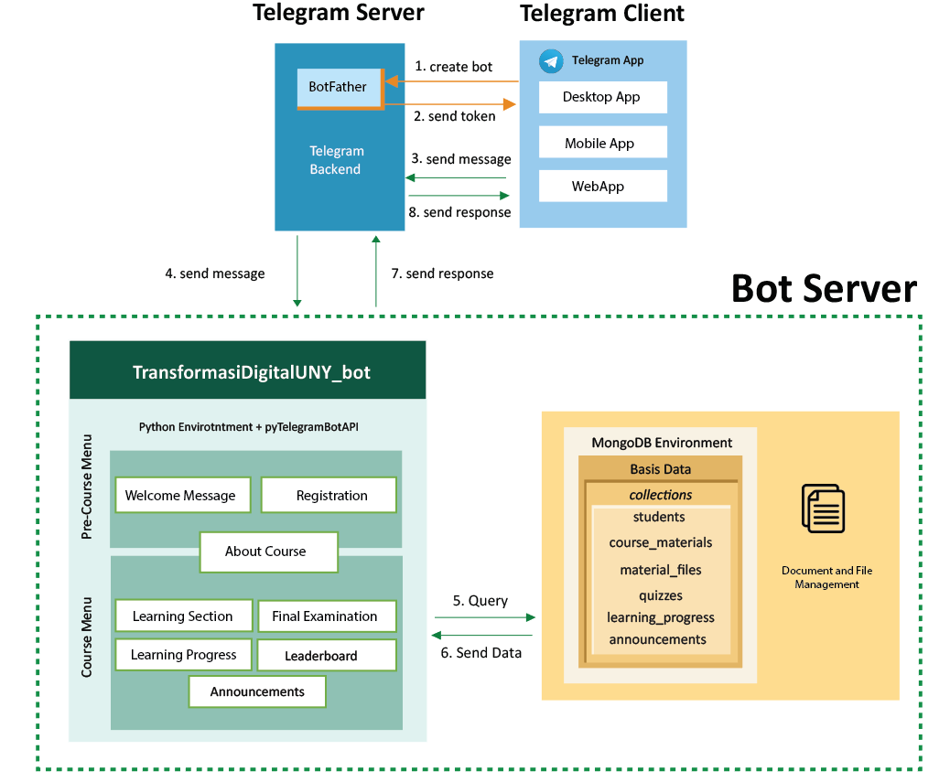

**Figure 1.** System Architecture

The creation of Telegram Bot is done through the Telegram Client application by accessing the @BotFather account and sending a message containing /newbot command. Then, @BotFather will ask the user to enter the name and username of the bot. After that, @BotFather send a token which will be used by the chatbot application to access the Telegram Server via the Bot API. Users can also add description, about info, and profile photo of the bot, as well as edit and delete the bot.

To use the chatbot application (say it has been created), users can access the bot via the search menu. Furthermore, users can interact with bots via private chat on the Telegram Client application. In this case the user can send text messages or commands using a regular keyboard, buttons on a custom keyboard, or buttons on an inline-keyboard. Users can interact with bot via inline queries straight from the text input field in any chat. All they need to do is start a message with bot's username and then type a query. The message or command is sent by the user from the Telegram Client to the Telegram Server. Then, the message is passed through the Bot API and received by the chatbot application. Next, the chatbot application will identify the message and determine the appropriate response.

This chatbot application, TransformasiDigitalUNY_bot, is built using the Python Programming Language by implementing the pyTelegramBotAPI module to be able to communicate with the Bot API. There are two main menus in the chatbot application, namely the Pre-Course menu and the Course menu. The Pre-Course menu consists of the Welcome and Class Registration submenus. The Course menu includes the Course Materials submenu (containing materials and quizzes), Final Examination, Learning Progress, Leaderboard, and Announcements. Meanwhile, the About Course submenu is found in the two menus above. To be able to receive messages and process responses at any time, the chatbot application must always be running.

If processing the response requires data, the chatbot application will query the data to the database on the database server and/or documents on the file server. The database server used is MongoDB. There are several collections to store data in the database, including students collection, course_materials, material_files, quizzes, learning progress, and announcements. Meanwhile, the file server is used to store lecture material data, such as lecture modules in pdf format and presentation slides in power point format. Query results are sent from the database server and/or file server to the chatbot application. After all stages of response processing have been completed, then the response is sent from the chatbot application to the Telegram Server via the Bot API. Next, the response is forwarded to the Telegram Client to be displayed to the user.

## Chatbot Conversation Flow

As mentioned earlier, the TransformasiDigitalUNY_bot has two main menus, namely Pre-Course and Course menu. The user will be directed to the Pre-Course menu if the bot detects that the user has not been registered as a student in the Digital Transformation course. If the user's status is an active student, the bot will suggest the user to do learning activities on the Course menu. The flow of conversation between users and bots on the two menus is represented in a chatbot conversational flow diagram which can be seen in Figure 2 and Figure 3. A chatbot conversational flow is a decision tree that shows a comprehensive list of decisions, events, and outcomes.

In a chatboat conversation flow diagram, each color has its own meaning. The green color indicates the action of sending messages by the user to TransformDigitalUNY_bot. Green messages starting with the / symbol (e.g. /start) are commands that users can use to start certain conversations with bots. While the green message without the / sign means the action taken by the user to respond to the conversation with the bot. Furthermore, the blue color indicates the message sent by the bot and the orange color means the special action taken by the bot other than displaying the message. These actions include storing and updating data in the database, setting up quizzes, sending files, grading, and so on.

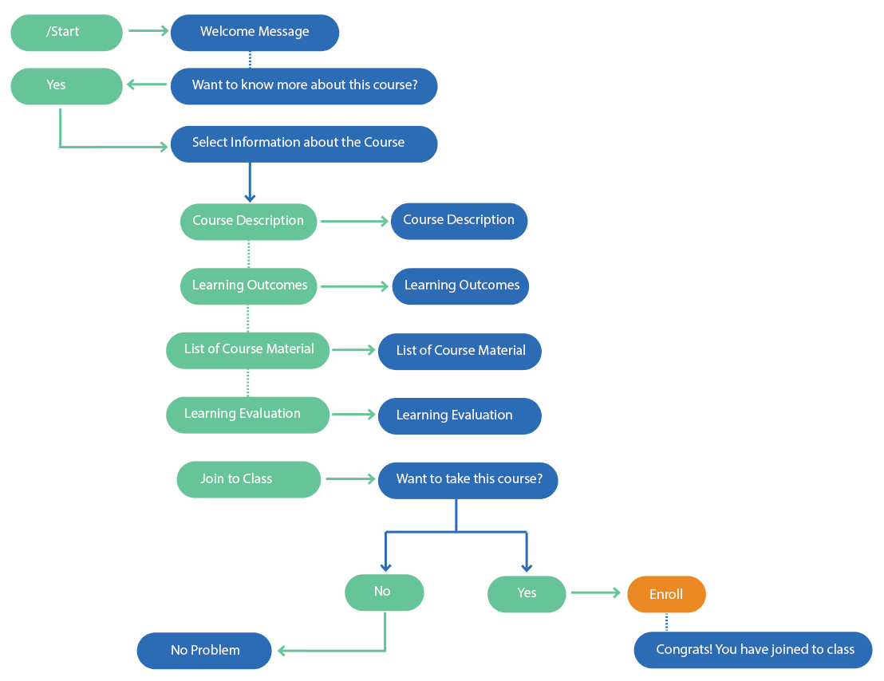

**Figure 2.** Chatbot Conversation Flow of Pre-Course Menu

When a user accesses TransformasiDigitalUNY_bot via private chat for the first time, a message containing the command /start is automatically sent from the Telegram Client to the Bot Server. The bot will respond with a Welcome Message and ask the user if they are interested in more detailed information about the Digital Transformation course. If the user answers yes, the bot will send a message containing several information choices, including descriptions, learning achievements, a list of course materials, and learning evaluations. In addition, there is also the option to join the Digital Transformation class. If the user chooses to join, the bot will register the user's telegram account. Then, the bot will record user accounts in the student collections in the database and make user learning progress data in the learning_progress collections. At this stage, the learning progress data does not contain user learning activities because no learning activities are carried out. After the two processes are completed, the bot will send a congratulations message for registering and ask the student to access the course menu. On the other hand, if the user does not want to join or know more details about the course, the bot will respond with a message that shows it does not matter.

Students can access the Course menu by sending the /studying command. As a response, The bot will send a message containing a choice of learning activities, such as learn Course Materials, take the Final Examination, check Learning Progress, view Leaderboards, read Announcements, and info About the Course. The choice of learning activities can be accessed through commands or inline-keyboard buttons. For example, suppose some users are not active students trying to access the Lecture menu or learning activity options. In that case, the bot will ask the user to register for the Digital Transformation course first.

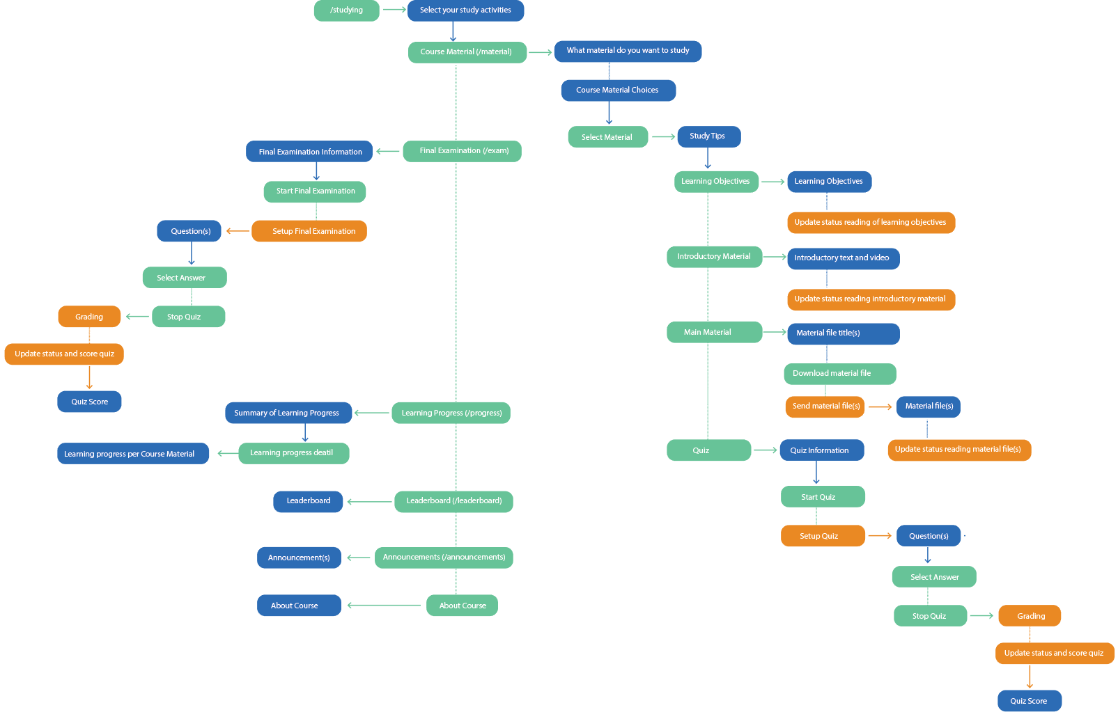

**Figure 3.** Chatbot Conversation Flow of Course Menu

If a student chooses to study course material, the bot will send a list of course material choices. Students can choose one of the materials. The bot will respond with a message containing study tips and a choice of learning activities, including studying the learning objectives, introduction to the material, the main material, and taking quizzes. Suppose the student chooses to study the learning objectives or introductory material. In that case, the bot will send a message containing the material for these two things and update the status from previously unstudied (0) to already learned (1). In contrast, the learning status for the main material would be said complete if the student has downloaded the material file. Furthermore, quizzes have a slightly longer conversational flow. If a student chooses a quiz, the bot will display important information related to the quiz settings, and the bot prepares the quiz according to the existing settings. After the student chooses to start doing the quiz, the quiz questions will be displayed one by one, and the student can choose the correct answer. Students can stop in the middle of taking the quiz if they do not want to continue the quiz. In this case, the student is still considered completed the quiz even though not all questions have been answered. The bot will do grading to determine student quiz scores. Another learning activity, namely the Final Exam, has a conversational flow like a quiz.

Students can see their learning progress by selecting the learning progress submenu. The bot will send a message containing a summary of learning progress related to how much material (learning objectives, introduction to material, main material, and quizzes) has been completed from the total available material and the final exam status. Furthermore, TransformasiDigitalUNY_bot also provides a leaderboard that displays student rankings based on the grades obtained. Every time a student completes and gets a quiz or final exam score, the ranking order on the leaderboard will be updated directly. In addition, students can also read announcements related to lectures through the announcements submenu. If students want to re-learn information about courses, students can also select the About the Course submenu.

# References

1. Moodle, “Moodle statistics.” https://stats.moodle.org/ (accessed Oct. 04, 2021).
2. IBL News, “Moodle Says It Accounts for Over 200 Million Users and 151,000 Websites | IBL News.” https://iblnews.org/moodle-says-it-accounts-for-over-200-million-users-and-151000-websites/ (accessed Oct. 04, 2021).
3. B. Mourad, A. Tarik, A. Karim, and E. Pascal, “System Interactive Cyber Presence for E learning to Break Down Learner Isolation,” Int. J. Comput. Appl., vol. 111, no. 16, pp. 35–40, 2015, doi: 10.5120/19626-1544.
4. J. Pereira, “Leveraging chatbots to improve self-guided learning through conversational quizzes,” ACM Int. Conf. Proceeding Ser., vol. 02-04-Nove, no. October, pp. 911–918, 2016, doi: 10.1145/3012430.3012625.
5. S. E. Ahmady and O. Uchida, “Telegram-based chatbot application for foreign people in Japan to share disaster-related information in real-time,” 2020 5th Int. Conf. Comput. Commun. Syst. ICCCS 2020, pp. 177–181, 2020, doi: 10.1109/ICCCS49078.2020.9118510.
6. F. Amato, S. Marrone, V. Moscato, G. Piantadosi, A. Picariello, and C. Sansone, “Chatbots meet ehealth: Automatizing healthcare,” CEUR Workshop Proc., vol. 1982, pp. 40–49, 2017.
7. M. M. Khan, “Development of An e-commerce Sales Chatbot,” HONET 2020 - IEEE 17th Int. Conf. Smart Communities Improv. Qual. Life using ICT, IoT AI, pp. 173–176, 2020, doi: 10.1109/HONET50430.2020.9322667.
8. P. Smutny and P. Schreiberova, “Chatbots for learning: A review of educational chatbots for the Facebook Messenger,” Comput. Educ., vol. 151, no. February, p. 103862, 2020, doi: 10.1016/j.compedu.2020.103862.
9. M. Kowsher, F. S. Tithi, M. Ashraful Alam, M. N. Huda, M. Md Moheuddin, and M. G. Rosul, “Doly: Bengali Chatbot for Bengali Education,” 1st Int. Conf. Adv. Sci. Eng. Robot. Technol. 2019, ICASERT 2019, vol. 2019, no. Icasert, pp. 1–6, 2019, doi: 10.1109/ICASERT.2019.8934592.
10. O. Zahour, E. H. Benlahmar, A. Eddaoui, H. Ouchra, and O. Hourrane, “A system for educational and vocational guidance in Morocco: Chatbot e-orientation,” Procedia Comput. Sci., vol. 175, pp. 554–559, 2020, doi: 10.1016/j.procs.2020.07.079.
11. S. Jang, J. J. Kim, S. J. Kim, J. Hong, S. Kim, and E. Kim, “Mobile app-based chatbot to deliver cognitive behavioral therapy and psychoeducation for adults with attention deficit: A development and feasibility/usability study,” Int. J. Med. Inform., vol. 150, no. January, p. 104440, 2021, doi: 10.1016/j.ijmedinf.2021.104440.
12. I. Hidayatulloh, H. D. Surjono, T. Sukardiyono, and S. Pambudi, “Gamification on Chatbot-Based Learning Media : a Review and Challenges,” ELINVO (Electronics, Informatics, Vocat. Educ., vol. 6424, doi: 10.21831/elinvo.
13. J. Brito, V. Vieira, and A. Duran, “Towards a Framework for Gamification Design on Crowdsourcing Systems: The G.A.M.E. Approach,” Proc. - 12th Int. Conf. Inf. Technol. New Gener. ITNG 2015, pp. 445–450, 2015, doi: 10.1109/ITNG.2015.78.
14. B. Morschheuser, K. Werder, J. Hamari, and J. Abe, “How to Gamify? A Method for Designing Gamification,” Proc. 50th Hawaii Int. Conf. Syst. Sci. (HICSS 2017), pp. 1298–1307, 2017, doi: http://hdl.handle.net/10125/41308.
15. D. de la Peña, D. Lizcano, and I. Martínez-Álvarez, “Learning through play: Gamification model in university-level distance learning,” Entertain. Comput., vol. 39, no. March, 2021, doi: 10.1016/j.entcom.2021.100430.