Effect of Cylinder Length on The Ratio of Safety Factor and Weight of Rocket Motor Tube Using Thin-Walled Cylinder

Lasinta Ari Nendra Wibawa 1, a)* Tuswan 2, b)

1National Research and Innovation Agency (BRIN), Indonesia.

2Department of Naval Architecture, Institut Teknologi Sepuluh Nopember, Indonesia

a) Corresponding author: [lasinta.ari@lapan.go.id](mailto:lasinta.ari@lapan.go.id)

b) tuswan.18041@mhs.its.ac.id

**Abstract.** The paper examines the effect of cylinder length on the rocket motor tube's safety factor and weight ratio using a thin-walled cylinder. The outer diameter, wall thickness, cap thickness, and cylinder fillet radius were 550, 8, 50, and 100 mm, respectively. The length of the cylinder was varied 3, 3.5, 4, 4.5, and 5 meters. The internal pressure used is fixed, which is 12 MPa. The materials used are Aluminium 7068-T6 and Aluminium 7034-T6. Stress analysis using the finite element method with Ansys Workbench software to select the optimal length of the rocket motor tube in terms of the safety factors and tube weight ratio. The simulation results show that the longer the rocket tube, the lower the safety factor ratio and the weight of the rocket tube both when using Al 7068-T6 and Al 7034-T6 materials.The highest ratio value is when the rocket tube has a length of 3 meters using Al 7034-T6 material.

# INTRODUCTION

In previous studies, the maximum von Mises stress, which is the leading cause of failure of rocket motor tubes, can be minimized by increasing the wall thickness, cap thickness, and fillet radius 1–3. It is just that this method can increase the weight of the tube. The most optimal method is to increase the fillet radius because it does not significantly increase the tube's weight.

Rocket motor tubes that use thin-walled cylinders have the advantage of being lighter in weight. It dramatically affects the longer range of the rocket for the same thrust. However, It can fail if careful calculations are not carried out because it works in high temperature and pressure conditions 4.

One way to increase the rocket's propulsion is to extend the rocket motor tube so that it can accommodate more fuel. However, increasing the rocket tube's length would also increase the tube's weight and affect the maximum von Mises stress. This study examines the effect of the length of the rocket motor tube on the ratio of the safety factor and the tube's weight so that the rocket motor tube's optimum length can be obtained.

The cylinder length is not a factor affecting maximum hoop, longitudinal and radial stresses in thin-walled cylinders. In the thin-walled cylinder equation, the factors that influence the three stresses are internal pressure, internal diameter, and wall thickness. However, several previous studies have demonstrated that the failure of rocket tubes occurs due to the maximum von Mises stress, which is greater than the three stresses.

In this paper, the wall thickness, cap thickness, fillet radius, and internal pressure were constant, namely 8 mm, 50 mm, 100 mm, and 12 MPa, respectively. The values of wall thickness, cap thickness, and fillet radius were based on previous research 5. The outer diameter of the cylinder is 550 mm. The cylinder length was varied 3, 3.5, 4, 4.5, and 5 m. The material used is Al 7068-T6 and Al 7034-T6. Aluminium series 7000 (Al-Zn-Mg) was chosen as the rocket tube material because of its good formability and high specific strength, so it is widely used for aircraft structures 6.

The stress analysis used the finite element method with Ansys software to select the rocket motor tube's optimal length in terms of the safety factor ratio and its weight. The software is often used to analyze rocket motor tubes from various materials such as composites and metals 7,8.

# MATERIAL AND METHOD

*2.1. Material*

The material used for the rocket motor tube is Al 7068-T6 and Al 7034-T6. Its advantages include very high tensile strength, good formability, corrosion resistance, and lightweight. Table 1 shows the mechanical properties of Aluminium 7068-T6 and Al 7034-T6.

**TABLE 1.** Mechanical properties of Aluminium alloy 7068-T6 and Al 7034-T6.

|  |  |  |  |  |
| --- | --- | --- | --- | --- |
| **Material** | **Density (g/cm³)** | **Yield Strength (MPa)** | **Tensile Strength (MPa)** | **Young Modulus (GPa)** |
| Al 7068-T6 | 2.85 | 683 | 710 | 71 |
| Al 7034-T6 | 2.89 | 730 | 750 | 71 |

*2.2. Finite element analysis*

The pressure vessels, based on their dimensions, are divided into thin-walled and thick-walled. The thin-walled cylinder has a wall thickness smaller than 1/20 inner diameter (*Di*), while the thick-walled cylinder has a wall thickness greater than 1/20 inner diameter (*Di*).

The thin-walled cylinder stress will occur in three directions: hoop (circumferential), longitudinal (axial), and radial. The maximum stress equation for thin-walled cylinders in the hoop, longitudinal and radial directions is:

${\left(σ_{h}\right)}_{max}=\left(\frac{P_{i}D_{i}}{2t}\right)$ (1)

${{(σ}_{l})}_{max}=\left(\frac{P_{i}D_{i}}{4t}\right)$ (2)

${{(σ}_{r})}_{max}=- p_{i}$ (3)

Where *pi* = internal pressure (MPa), *Di*= inner diameter of cylinder (mm), and *t*= wall thickness of cylinder (mm).

The von Mises stress analysis of the rocket motor tube was carried out using the finite element method with the help of Ansys software. Ansys is one of the most popular software used in finite element analysis 9,10. Ansys is also widely used to measure the stress concentration in thick-walled and thin-walled cylinders 11.

The finite element method (FEM) is one of the most common methods used to calculate any physical phenomenon, such as structural or fluid behaviour, heat transfer, and electromagnetic component engineering 12,13. This method allows each product design to be analyzed in detail and reduces the number of physical prototypes, making it easier to develop better products faster.

The FEM procedure allows the continuum to be discretized into a limited number of parts (elements) and emphasizes that the continuous domain's characteristics can be estimated by assembling the same properties of discrete elements per node. This process is known as discretization. The values between nodes are determined from polynomial interpolation using the computational matrix method. The accuracy of the results depends on discretization, the accuracy of the assumed interpolation form, and the accuracy of the computational solution method 14–16. The FEM is very popular because of its ability to model many numerical problems regardless of geometry, boundary conditions, and loading.

Figure 1 depicts a thin-walled cylinder design with a length of 3000 mm, a wall thickness of 8 mm, a cap thickness of 50 mm, and a fillet radius of 100 mm. Because the cylinder shows symmetry in the longitudinal (axial) direction, it can be modelled with its upper half 17.

**Figure 2.**demonstrates the one-eighth part of a cylinder with a length of 3000 mm, the wall thickness of 8 mm, cap thickness of 50 mm, and fillet radius of 100 mm. This section is quite representative of the finite element simulation because the pressure applied to the fluid in the cylinder is closed. The pressure will be continued equally and evenly 18.

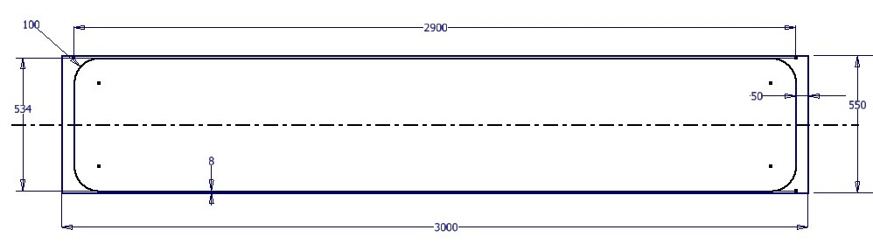

**Fig. 1.** The thin-walled cylinder design with a length of 3000 mm, a wall thickness of 8 mm, a cap thickness of 50 mm, and a fillet radius of 100 mm.

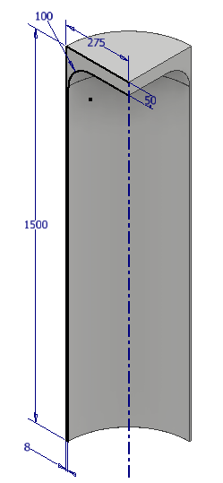

**Fig. 2.**The one-eighth part of a cylinder with a length of 3000 mm, a wall thickness of 8 mm, a cap thickness of 50 mm, and a fillet radius of 100 mm.

Figure 3 explains the boundary conditions of the finite element analysis, namely the type of constraint (left) and loading condition (right). Table 2 shows the finite element analysis assumptions and their parameters using Ansys Workbench.

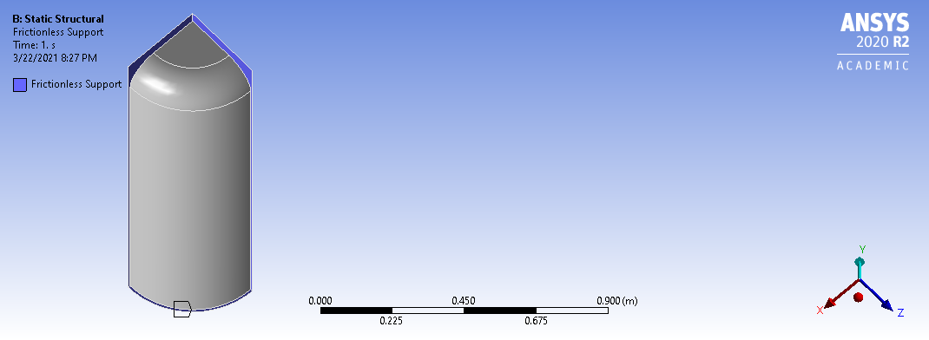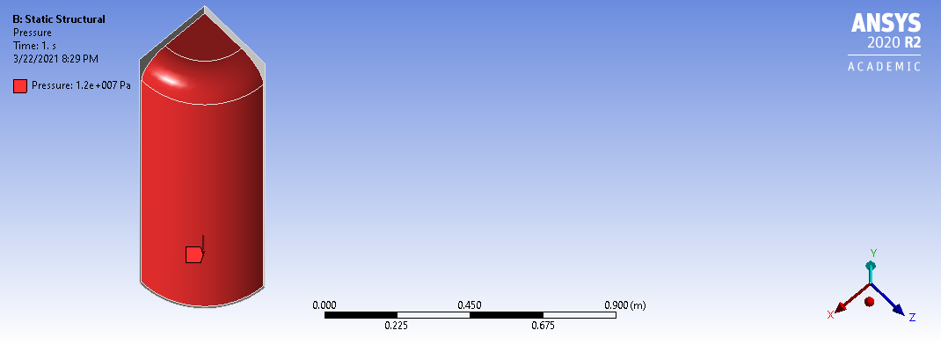

**Fig. 3.** The constraint type (left) and loading condition (right).

**TABLE 2.** The finite element analysis assumptions and parameters using Ansys Workbench.

|  |  |
| --- | --- |
| **Parameters** | **Value** |
| Length of cylinder | 3, 3.5, 4, 4.5, and 5 m |
| Outer diameter of cylinder | 550 mm |
| Wall thickness, cap thickness, fillet radius | 8 mm, 50 mm, 100 mm |
| Internal pressure | 12 MPa |
| Size of element | 15 mm |

# RESULT AND DISCUSSION

In this section, Figure 4 displays the maximum von Mises stress for a rocket tube length of 3 meters (left) and 3.5 meters (right). The simulation results show that the maximum von Mises stress increases when using a rocket tube from 3 meters to 3.5 meters long but then decreases when the tube is 4 meters and 4.5 meters (Table 3). The condition means that an increase in the length of the rocket tube can result in a fluctuating increase or decrease in the maximum von Mises stress. The increase and decrease in maximum von Mises stress are not significant. All values for the maximum von Mises stress are still below the yield strength of the material, both Al 7068-T6 and Al 7034-T6. That is, the rocket motor tube is safe for all length variations because yielding is one of the rocket industry's reported failure criteria, apart from fractures 19–22.

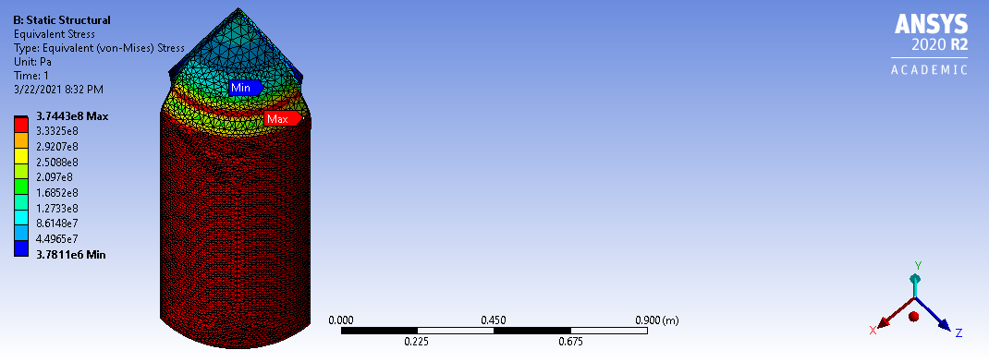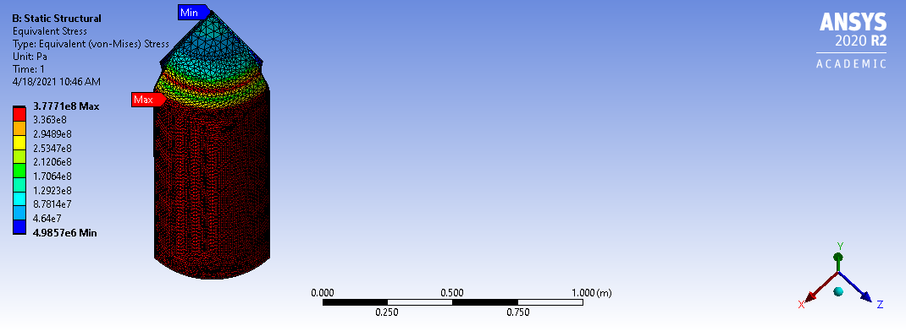

**Fig. 4.** The von Mises stress for a rocket tube length of 3 meters (left) and 3.5 meters (right).

**TABLE 3.** Effect of rocket tube length on the maximum von Mises stress using Al 7068-T6 and Al 7034-T6.

|  |  |  |  |  |
| --- | --- | --- | --- | --- |
| **Material** | **Length**  **(m)** | **Number of nodes** | **Number of elements** | **Maximum von Mises stress (MPa)** |
| Al 7068-T6 | 3 | 35680 | 17872 | 374.43 |
| Al 7068-T6 | 3.5 | 41310 | 20652 | 377.71 |
| Al 7068-T6 | 4 | 47502 | 23703 | 375.02 |
| Al 7068-T6 | 4.5 | 52609 | 26267 | 374.48 |
| Al 7068-T6 | 5 | 57666 | 28794 | 376.74 |
| Al 7034-T6 | 3 | 35680 | 17872 | 374.43 |
| Al 7034-T6 | 3.5 | 41310 | 20652 | 377.71 |
| Al 7034-T6 | 4 | 47502 | 23703 | 375.02 |
| Al 7034-T6 | 4.5 | 52609 | 26267 | 374.48 |
| Al 7034-T6 | 5 | 57666 | 28794 | 376.74 |

The fluctuating increase and decrease in von Mises stress certainly affect the safety factor of the rocket motor tube, which also fluctuates as well. It can be seen in Table 4. The fact makes us think that choosing the length of the rocket tube is something specific, depending on the design we want. Moreover, the maximum von Mises stress value for a rocket tube length of 3 meters and 4.5 meters is almost the same. It's just that the selection of a rocket tube with a length of 4.5 meters certainly has consequences for the additional weight of the rocket itself. The condition will affect the ratio between the safety factor and the weight of the rocket tube.

Moreover, Table 4 illustrates the effect of the length of the rocket tube on the ratio of the safety factor and the weight of the tube. The safety factor in this study is calculated using the maximum strength of the material because the rocket motor tube is a single-use component. The simulation results show that the longer the rocket tube is, the lower the safety factor ratio and the weight of the rocket tube both when using Al 7068-T6 and Al 7034-T6 materials. The highest ratio value is when the rocket tube has a length of 3 meters using Al 7034-T6 material. The safety factor in this variation is 2, the value of the minimum safety factor for a component that can withstand dynamic loads 23.

It can be summarized that the results of this study prove that although the length of the rocket tube does not have a significant effect on the maximum von Mises stress and the safety factor, the longer the length of the rocket motor tube actually decreases the safety factor ratio and the weight of the rocket tube itself. It means that the increase in the length of the rocket tube must be considered proportionally to obtain optimal performance.

TABLE 4. Effect of the length of the rocket tube on the ratio of the safety factor and the weight of the tube.

|  |  |  |  |  |
| --- | --- | --- | --- | --- |
| **Material** | **Length**  **(m)** | **Safety factor** | **Rocket tube weight**  **(kg)** | **Ratio** |
| Al 7068-T6 | 3 | 1.90 | 99.55 | 0.019 |
| Al 7068-T6 | 3.5 | 1.88 | 109.26 | 0.017 |
| Al 7068-T6 | 4 | 1.89 | 118.96 | 0.016 |
| Al 7068-T6 | 4.5 | 1.90 | 128.67 | 0.015 |
| Al 7068-T6 | 5 | 1.88 | 138.37 | 0.014 |
| Al 7034-T6 | 3 | 2.00 | 100.95 | 0.020 |
| Al 7034-T6 | 3.5 | 1.99 | 110.79 | 0.018 |
| Al 7034-T6 | 4 | 2.00 | 120.63 | 0.017 |
| Al 7034-T6 | 4.5 | 2.00 | 130.47 | 0.015 |
| Al 7034-T6 | 5 | 1.99 | 140.32 | 0.014 |

# conclusion

The effect of cylinder length on the rocket motor tube's safety factor and weight ratio using a thin-walled cylinder is analyzed using finite element software. The simulation results reveal that the longer the rocket tube, the lower the ratio of safety factor and the weight of the rocket tube both when using Al 7068-T6 and Al 7034-T6 materials. The highest ratio value is when the rocket tube has a length of 3 meters using Al 7034-T6 material.

# Acknowledgments

The author would thank the Indonesian National Research and Innovation Agency (BRIN) for supporting this research.

# References

1. Wibawa, L. A. N., Diharjo, K., Raharjo, W. W. & Jihad, B. H. Stress Analysis of Thick-Walled Cylinder for Rocket Motor Case under Internal Pressure. *J. Adv. Res. Fluid Mech. Therm. Sci.* **70**, 106–115 (2020).

2. Wibawa, L. A. N., Diharjo, K., Raharjo, W. & Jihad, B. H. The Effect of Fillet Radius and Length of The Thick-Walled Cylinder on Von Mises Stress and Safety Factor for Rocket Motor Case. *AIP Conf. Proc.* **2296**, (2020).

3. Wibawa, L. A. N. *et al.* Effect of Overlap Length and Surface Roughness on Adhesive Joint Strength of Composite Rocket Motor Case (GFRP) and Cap (Al 6061). *J. Phys. Conf. Ser.* (2021).

4. Emrich, W. Rocket Engine Fundamentals. in *Principles of Nuclear Rocket Propulsion* 11–20 (2016). doi:10.1016/b978-0-12-804474-2.00002-3

5. Wibawa, L. A. N. & Tuswan. Finite element analysis and lightweight optimization design of rocket motor tube using a thin-walled cylinder. *AIP Conf. Proc.* (2022).

6. Yamada, R., Itoh, G., Kurumada, A. & Nakai, M. Further study on the effect of environment on fatigue crack growth behavior of 2000 and 7000 series aluminum alloys. *Mater. Sci. Forum* **879**, 2153–2157 (2017).

7. Choi, Y. G., Shin, K. B. & Kim, W. H. A study on size optimization of rocket motor case using the modified 2D axisymmetric finite element model. *Int. J. Precis. Eng. Manuf.* **11**, 901–907 (2010).

8. Ramanjaneyulu, V., Balakrishna Murthy, V., Chandra Mohan, R. & Naga Raju, C. Analysis of Composite Rocket Motor Case using Finite Element Method. *Mater. Today Proc.* **5**, 4920–4929 (2018).

9. Wibawa, L. A. N. Effect of Fillet Radius of UAV Main Landing Gear on Static Stress and Fatigue Life using Finite Element Method. *J. Phys. Conf. Ser.* **1811**, (2021).

10. Wibawa, L. A. N. Effect of Bolt Hole Size on Static Stress and Fatigue Life of UAV Main Landing Gear Using Numerical Simulation. *J. Phys. Conf. Ser.* **1811**, (2021).

11. Mohamed, A. F. Finite Element Analysis for Stresses in Thin-Walled Pressurized Steel Cylinders. *Int. J. Sci. Eng. Res.* **9**, 201–204 (2018).

12. Tuswan, T., Abdullah, K., Zubaydi, A. & Budipriyanto, A. Finite-element analysis for structural strength assessment of marine sandwich material on ship side-shell structure. *Mater. Today Proc.* **13**, 109–114 (2019).

13. Tuswan, T., Zubaydi, A., Piscesa, B., Ismail, A. & Ilham, M. F. Free Vibration Analysis of Interfacial Debonded Sandwich of Ferry Ro-Ro’s Stern Ramp Door. *Procedia Struct. Integr.* **27**, 22–29 (2020).

14. Ismail, A., Zubaydi, A., Piscesa, B., Ariesta, R. C. & others. Vibration-based damage identification for ship sandwich plate using finite element method. *Open Eng.* **10**, 744–752 (2020).

15. Zubaydi, A., Piscesa, B., Ismail, A. & others. Dynamic characteristic of partially debonded sandwich of ferry ro-ro’s car deck: a numerical modeling. *Open Eng.* **10**, 424–433 (2020).

16. Tuswan, T. *et al.* Influence of application of sandwich panel on static and dynamic behaviour of ferry ro-ro ramp door. *J. Appl. Eng. Sci.* **19**, 208–216 (2021).

17. Dadkhah, F. & Zecher, J. *ANSYS Workbench Software Tutorial with Multimedia CD Release 11*. (Schroff Development Corporation, 2008).

18. Lawrence, K. L. *Ansys Workbench Tutorial Release 14*. (Schroff Development Corporation, 2012).

19. Williams, F. A., Barrère, M. & Huang, N. C. *Fundamental aspects of solid propellant rockets*. (1969).

20. James, B. H. Structural integrity analysis of solid rocket motors. in *Conference on Stress and Strain in Engineering (National Committee on Applied Mechanics, The Institution of Engineers, Australia, Brisbane, 1973)* (1973).

21. Rao, B. N. Fracture of solid rocket propellant grains. *Eng. Fract. Mech.* **43**, 455–459 (1992).

22. Rao, A. S., Rao, G. V. & Rao, B. N. Effect of long-seam mismatch on the burst pressure of maraging steel rocket motor cases. *Eng. Fail. Anal.* **12**, 325–336 (2005).

23. Dobrovolsky, V. & Zablonsky, K. *Machine elements : a textbook*. (Peace Publisher, 1978).