The Effect of Load Variations and Thread Types on the Joint Strength of the Rocket Cap and Tube Using Finite Element Method

Lasinta Ari Nendra Wibawa1, a)*,Setiadi1, b)

1National Research and Innovation Agency (BRIN), Indonesia.

a) Corresponding author: [lasinta.ari@lapan.go.id](mailto:lasinta.ari@lapan.go.id)

b) setiadi@lapan.go.id

**Abstract.** The thread joints are often used to connect a rocket tube to a cap and a rocket tube to a nozzle. The connection of two components using a thread joint needs to be considered carefully. The joint is the part that most often fails because it is the location of the stress concentration. The study aims to examine the effect of load variations and thread types on the joint strength between the cap and rocket tube using the finite element method. The analysis was carried out with the help of the Ansys Workbench software. Loads of thread joint was varied 70, 80, 90, 100, and 110 kN. The rocket cap and tube material are Al 6061-T6. Static stress simulation results show that the thread joints both square thread and trapezoidal threads can withstand static loads of up to 100 kN because it has a safety factor of more than 1.25. The trapezoidal thread has a better safety factor than the square thread.

# INTRODUCTION

The rocket motor is a very important part of the rocket, and it often fails at the joints. The failure can occur in the joining of the rocket tube with the cap or nozzle. The joint is the location where stress is concentrated due to the internal pressure of the rocket engine. Previous studies' static stress analysis of the rocket motor shows that the maximum von Mises stress is always at the joint 1–3.

Several studies have discussed the rocket tubes with a diameter of 122 mm which is assumed by the pressure vessel principle. The study used variations in wall thickness, cap thickness, fillet radius, tube length, and internal pressure 1–5. However, studies that discuss the joining of rocket tubes with other components such as caps and nozzles are still few. The critical point of von Mises stress occurs in the joint. It is the reason why research on the effect of variation in load and thread type on the strength of the joint of rocket caps and tubes is important to do.

The thread joint is often used to join cylinders and pipes, especially those with a diameter not too large. The joint is also used to connect a rocket tube to a cap and a rocket tube to a nozzle. The joining of two components using a thread joint needs to be considered carefully to avoid unwanted failures. There are several types of threads, each of which has different characteristics. The choice of thread type is very dependent on the type of use. Therefore, the research on the effect of the type of thread and the maximum load it can withstand needs to be done to produce a connection design that is as expected. In addition, the strength of the joint greatly determines the results of the rocket tube hydrostatic test 6.

The study aims to examine the effect of load variations and thread types on the joint strength between the cap and rocket tube using the finite element method. Loads of thread joint was varied 70, 80, 90, 100, and 110 kN. The type of threads used is the square thread and trapezoidal thread. The material of the rocket cap and tube is Al 6061-T6. The cap acts as an external thread, while the rocket tube acts as an internal thread. In some studies, the cap acts as a pinned thread, while the rocket tube acts as a box thread 7–14.

The thread joint analysis was carried out with the help of the Ansys Workbench software. Ansys is a CAE type software that is widely used for analysis in the field of aviation and space, including rocket technology 15–31. Ansys, especially Ansys Mechanical, is widely used to simulate computer models of structures or machine components to analyze their strength and toughness to withstand loads in their working environment.

# MATERIAL AND METHOD

The material used for the cap and tube rocket is Al 6061-T6. Its advantages include medium tensile strength, good formability, corrosion resistance, and lightweight. Table 1 shows the mechanical properties of Al 6061-T6. The outer diameter of the cap and rocket tube is 122 mm. The friction coefficient of the cap (Al 6061-T6) and rocket tube (Al 6061-T6) was assumed 0.3.

**TABLE 1.** Mechanical properties of Al 6061-T6.

|  |  |  |  |  |  |
| --- | --- | --- | --- | --- | --- |
| **Material** | **Density (g/cm³)** | **Yield Strength (MPa)** | **Tensile Strength (MPa)** | **Young Modulus (GPa)** | **Poisson’s ratio** |
| Al 6061-T6 | 2.70 | 276 | 310 | 68.9 | 0.33 |

Static stress analysis of threaded joints using numerical methods. The numerical methods commonly used to simulate engineering problems are the finite element method (FEM) and the finite difference method (FDM). FEM is a numerical mathematical technique to facilitate solving partial differential equations in engineering. FEM solves the equation by setting the domain discretization with the selected form elements and combining them into the whole system so that the process takes longer than FDM. FDM solves the equation by setting direct differentiation along each rectangular coordinate axis so that it can run faster than FEM. FDM is generally used to solve fluid mechanics and heat transfer problems that are often stationary at the boundary, but it is impossible to solve problems with large strains or deformations. FEM is more advantageous for solving problems with large deformations and can be used for almost all types of engineering problems with complex geometries and material combinations. Therefore, solving the threaded joint case using the finite element method is quite appropriate.

The simulation of the thread joint between the cap and the rocket tube is modelled using a 2D symmetrical axis. The 2D axisymmetric model has the special advantage of saving computational time because it requires fewer elements than the 3D model so that the meshing process is faster. In addition, the convergence error will be reduced so that very accurate results will be obtained. The model also offers a complete solution compared to solutions in 3D models that are only visible on the surface.

Figure 1 describes the cap and rocket tube in 3D which is the object of the joint. The model simulation using the 2D axisymmetric. The rocket cap has an outer diameter of 122 mm and a length of 45 mm. The rocket tube has an outside diameter of 122 mm, an inside diameter of 109.5 mm, and a length of 40 mm.

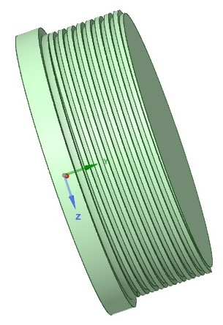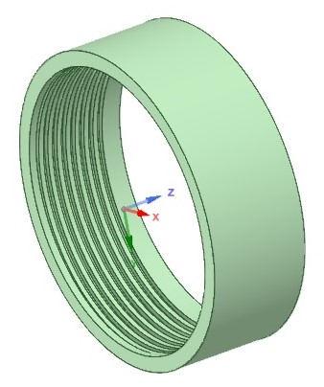

**Fig. 1.** The cap (left) and rocket tube (right).

The boundary conditions of the thread joint, namely the frictionless supports (left) and loading condition (right) of the square thread joint is fixed (Fig. 2). The meshing process of square threaded joints using element sizes 0.3 and 0.1 mm (Fig. 3). Table 2 explains the thread parameters using Ansys Workbench.

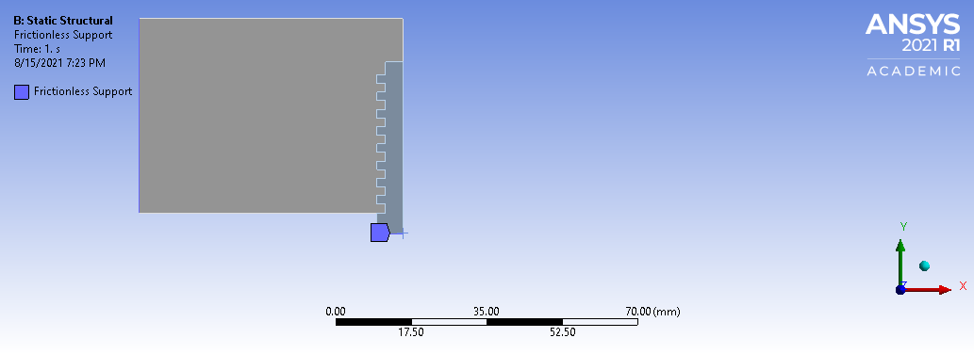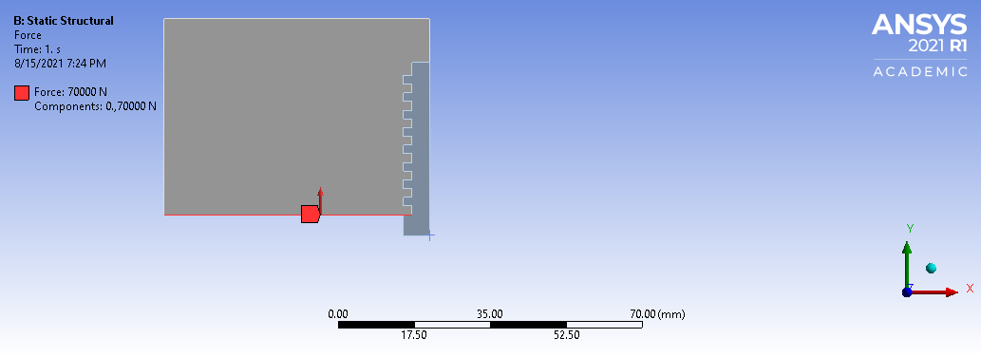

**Fig. 2.** The frictionless supports (left) and loading condition (right) of the square thread joint.

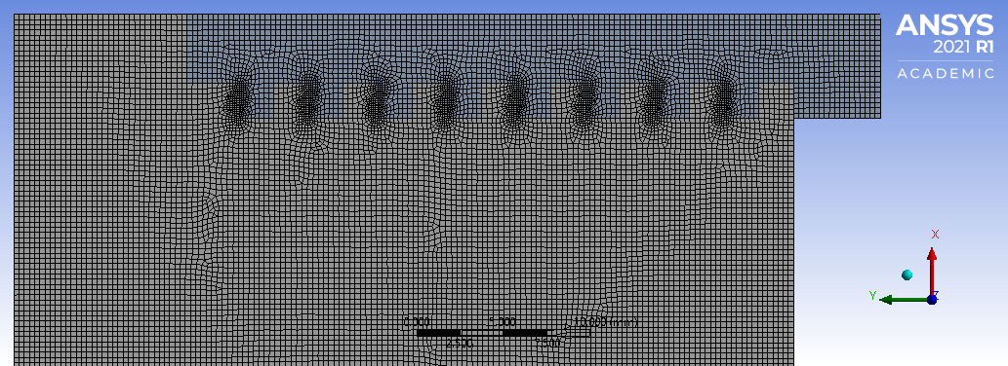

**Fig. 3.** The meshing process of the square thread joint.

**TABLE 2.** The thread parameters using Ansys Workbench.

|  |  |  |
| --- | --- | --- |
| **Parameters** | **Square thread** | **Trapezoidal thread** |
| Pitch size  Major diameter  Minor diameter  Pitch diameter  Thread number  Thread length  Element size and edge sizing  Number of nodes  Number of elements | 4 mm  114 mm  109.5 mm  111.9 mm  8  320 mm  0.3 mm and 0.1 mm  100005  32835 | 4 mm  114 mm  109.5 mm  111.9 mm  8  320 mm  0.3 mm and 0.1 mm  100197  32913 |

# RESULT AND DISCUSSION

The results of the von Mises stress in the joint of a square thread and a trapezoidal thread for a load of 70 kN is shown in Figure 4. It shows that the maximum von Mises stresses in the joint of square threads and trapezoidal threads are 148.63 MPa and 146.37 MPa. The maximum von Mises stress in both square and trapezoidal threads increases with increasing loading (Table 3). The simulation results show that the stress concentration in the square thread is higher than that of the trapezoidal thread. Square threads are slightly less thick in core diameter than trapezoidal threads thereby reducing load-carrying capacity. The thickness of the thread core diameter is one of the factors that affect the strength of the threaded joint. The maximum von Mises stress occurs in the first thread in both the square and trapezoidal threads. The results of this study are following the research conducted by Cojocaru, et al. 32.

Figure 5 describes the safety factor for the connection of a square thread and a trapezoidal thread at a loading of 70 kN whose values are 1.86 and 1.89, respectively. The safety factor decreases as the load increases (Table 3). The safety factor is the ratio of the yield strength of the material to the maximum von Mises stress. Therefore, the factor of safety is inversely proportional to the maximum von Mises stress. The higher the maximum von Mises stress, the lower the safety factor of the structure or component.

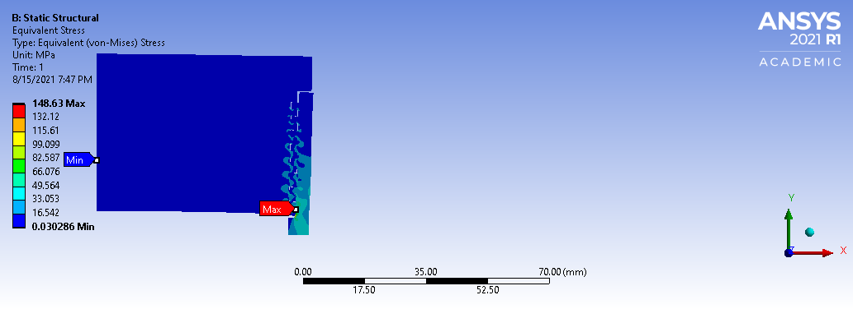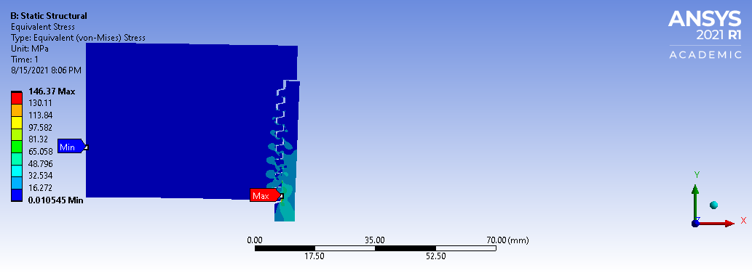

**Fig. 4.** The von Mises stress of thread joint: square thread (left) and trapezoidal thread (right) for a load of 70 kN.

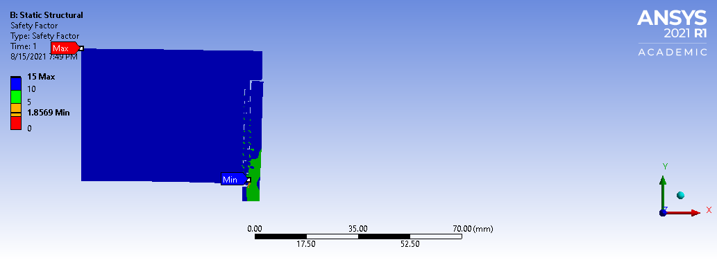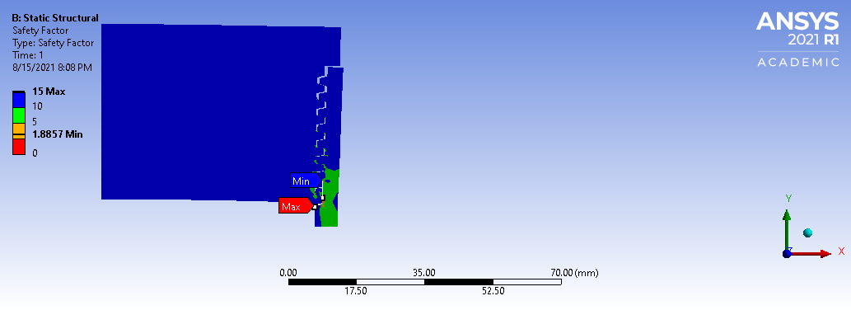

**Fig. 5.** The safety factor of thread joint: square thread (left) and trapezoidal thread (right) for a load of 70 kN.

Static stress simulation results show that the thread joints both square thread and trapezoidal threads can withstand static loads of up to 100 kN because it has a safety factor of more than 1.25 (Table 3). The minimum safety factor for a component that can withstand static loads is 1.25-2.00 33. The trapezoidal thread has a better safety factor than the square thread.

Trapezoidal and square threads have a sufficient safety factor to withstand static loads. However, it is recommended to use trapezoidal threads for the joint between the cap and the rocket tube. In addition to having a better safety factor, trapezoidal threads are also easier to manufacture than square threads.

**TABLE 3.** The results of static stress analysis of thread joint using Ansys Workbench.

|  |  |  |  |
| --- | --- | --- | --- |
| **Thread type** | **Load (kN)** | **Maximum von Mises stress (MPa)** | **Factor of safety** |
| Square | 70 | 148.63 | 1.86 |
|  | 80 | 169.87 | 1.62 |
|  | 90 | 191.10 | 1.44 |
|  | 100 | 212.34 | 1.30 |
|  | 110 | 233.57 | 1.18 |
| Trapezoidal | 70 | 146.37 | 1.89 |
|  | 80 | 167.28 | 1.65 |
|  | 90 | 188.19 | 1.47 |
|  | 100 | 209.10 | 1.32 |
|  | 110 | 230.01 | 1.20 |

# concluSION

Research about the effect of load variations and thread types on the strength of the rocket tube joint with the cap has been carried out using Ansys Workbench. Static stress simulation results show that the thread joints both square thread and trapezoidal threads can withstand static loads of up to 100 kN because it has a safety factor of more than 1.25. The trapezoidal thread has a better safety factor than the square thread.

# Acknowledgments

The authors would like to thank the National Research and Innovation Agency (BRIN) of the Republic of Indonesia for supporting this research.

# References

1. Wibawa, L. A. N., Diharjo, K., Raharjo, W. W. & Jihad, B. H. Stress Analysis of Thick-Walled Cylinder for Rocket Motor Case under Internal Pressure. *J. Adv. Res. Fluid Mech. Therm. Sci.* **70**, 106–115 (2020).

2. Wibawa, L. A. N., Diharjo, K., Raharjo, W. & Jihad, B. H. The Effect of Fillet Radius and Length of The Thick-Walled Cylinder on Von Mises Stress and Safety Factor for Rocket Motor Case. *AIP Conf. Proc.* **2296**, (2020).

3. Wibawa, L. A. N. *et al.* Effect of Overlap Length and Surface Roughness on Adhesive Joint Strength of Composite Rocket Motor Case (GFRP) and Cap (Al 6061). *J. Phys. Conf. Ser.* (2021).

4. Wibawa, L. A. N., Diharjo, K., Raharjo, W. W. & Jihad, B. H. Pengaruh Ketebalan Cap dan Tekanan Internal terhadap Tegangan Von Mises Silinder Berdinding Tebal untuk Tabung Motor Roket. *Teknik* **41**, 111–118 (2020).

5. Wibawa, L. A. N. Numerical Study of The Effect of Wall Thickness and Internal Pressure on Von Mises Stress and Safety Factor of Thin-Walled Cylinder for Rocket Motor Case. *JST (Jurnal Sains dan Teknol.* **9**, 30–38 (2020).

6. Setiadi, Sanjaya, A. B. & Fitroh, A. J. Optimization of Threaded Joint Design on Motor Rocket Tube of RX1220 Rocket and Its Correlation to Hydrostatic Test Result. in *Seminar Nasional Iptek Penerbangan dan Antariksa XXIII-2019* (2019).

7. Wang, Y., Qian, C., Kong, L., Zhou, Q. & Gong, J. Design optimization for the thin-walled joint thread of a coring tool used for deep boreholes. *Appl. Sci.* **10**, (2020).

8. Wang, Y., Xia, B., Wang, Z. & Chai, C. Model of a new joint thread for a drilling tool and its stress analysis used in a slim borehole. *Mech. Sci.* **7**, 189–200 (2016).

9. Shi, C., Tan, L., Zhu, X., Chen, K. & Cheng, F. Fracture Failure analysis and research on Solid expandable tubular with joint thread. *Eng. Fail. Anal.* **129**, 105658 (2021).

10. Zheng, J. & Yang, J. Random fatigue analysis of drill-pipe threaded connection. *Int. J. Mater. Struct. Integr.* **10**, 34–51 (2016).

11. Porcaro, R. R., Cândido, L. C., Trindade, V. B., De Faria, G. L. & Godefroid, L. B. Evaluation of standard API casing connections and parametric API Buttress improvement by finite element analysis. *Mater. Res.* **20**, 130–137 (2017).

12. Xu, S. *et al.* Experimental study of mechanical properties and residual stresses of expandable tubulars with a thread joint. *Thin-Walled Struct.* **115**, 247–254 (2017).

13. Dong, L., Zhu, X. & Yang, D. Study on mechanical behaviors of double shoulder drill pipe joint thread. *Petroleum* **5**, 102–112 (2019).

14. Shahani, A. R. & Sharifi, S. M. H. Contact stress analysis and calculation of stress concentration factors at the tool joint of a drill pipe. *Mater. Des.* **30**, 3615–3621 (2009).

15. Ramanjaneyulu, V., Balakrishna Murthy, V., Chandra Mohan, R. & Naga Raju, C. Analysis of Composite Rocket Motor Case using Finite Element Method. *Mater. Today Proc.* **5**, 4920–4929 (2018).

16. Wang, Z., Han, Q., Nash, D. H., Fan, H. & Xia, L. Thermal buckling of cylindrical shell with temperature-dependent material properties: Conventional theoretical solution and new numerical method. *Mech. Res. Commun.* **92**, 74–80 (2018).

17. Eswara Kumar, A., Somanadha Sastry, K., Manideep, K. & Priyanka, M. Dynamic Analysis of Flex Seal of Solid Rocket Motor Nozzle. *Mater. Today Proc.* **4**, 1590–1597 (2017).

18. Guo, X. *et al.* Effects of liner properties on the stress and strain along liner/propellant interface in solid rocket motor. *Aerosp. Sci. Technol.* **58**, 594–600 (2016).

19. Asraff, A. K., Sheela, S., Paul, A., Mathew, A. & Savithri, S. Cyclic Stress Analysis of a Rocket Engine Thrust Chamber Using Chaboche, Voce and Creep Constitutive Models. *Trans. Indian Inst. Met.* **69**, 495–500 (2016).

20. Wibawa, L. A. N. & Tuswan. Finite element analysis and lightweight optimization design of rocket motor tube using a thin-walled cylinder. *AIP Conf. Proc.* (2022).

21. Eswara Kumar, A., Balakrishna Murthy, V. & Chandra Mohan, R. Effect of Shim Percentage on Non-Linear Static Behavior of Flex Seal of Rocket Nozzle. *Mater. Today Proc.* **2**, 1427–1434 (2015).

22. Eswara Kumar, A., Balakrishna Murthy, V., Chandra Mohan, R. & Prakash, D. Study of Non-Linear Static Behavior of Flex Seal of Rocket Nozzle byt Varying Number of Shims. *Mater. Today Proc.* **2**, 1613–1621 (2015).

23. Wibawa, L. A. N. & Tuswan. Effect of Cylinder Length on The Ratio of Safety Factor and Weight of Rocket Motor Tube Using Thin-Walled Cylinder. *AIP Conf. Proc.* (2022).

24. Asraff, A. K., Sunil, S., Muthukumar, R. & Ramanathan, T. J. Stress analysis & life prediction of a cryogenic rocket engine thrust chamber considering low cycle fatigue, creep and thermal ratchetting. *Trans. Indian Inst. Met.* **63**, 601–606 (2010).

25. Harikrishnan, R. & Lokavarapu, B. R. Design and analysis of rocket nozzle. *Mater. Today Proc.* **38**, 3365–3371 (2020).

26. Wibawa, L. A. N. Effect of Fillet Radius of UAV Main Landing Gear on Static Stress and Fatigue Life using Finite Element Method. *J. Phys. Conf. Ser.* **1811**, (2021).

27. Asraff, A. K., Aparna, R., Kumaresan, D. & Muthukumar, R. Comparison of creep properties of four copper alloys and creep based stress analysis of a rocket engine combustion chamber. *Procedia Eng.* **55**, 45–50 (2013).

28. Degtyarev, M. A. & Avramov, K. V. Numerical Simulation of the Stress-Strain State of the Rocket Retention Module. *Strength Mater.* **51**, 707–714 (2019).

29. Ropia, B., Shekhar, H. K. & Thakur, D. G. Study of Initial Pressure Rise in Multi Grain Solid Propellant Rocket Motor. *Propellants, Explos. Pyrotech.* **45**, 741–750 (2020).

30. Sai Teja, P., Sudhakar, B., Dhass, A. D., Krishna, R. & Sreenivasan, M. Numerical and experimental analysis of hydroxyl-terminated poly-butadiene solid rocket motor by using ANSYS. *Mater. Today Proc.* **33**, 308–314 (2020).

31. Wibawa, L. A. N. Effect of Bolt Hole Size on Static Stress and Fatigue Life of UAV Main Landing Gear Using Numerical Simulation. *J. Phys. Conf. Ser.* **1811**, (2021).

32. Cojocaru, V., Miclosina, C. O. & Korka, Z. I. Fatigue analysis of large diameter threaded connections subjected to dynamic axial loads. *Appl. Mech. Mater.* **658**, 177–182 (2014).

33. Dobrovolsky, V. & Zablonsky, K. *Machine elements : a textbook*. (Peace Publisher, 1978).