**THE EFFECTS OF TEMPERATURE CHANGES ON RESILIENT MODULUS OF ACWC, ACBC AND AC BASE**

Luki Caroles 1)

Siegfried 2)

1. University of Papua, Manokwari

[Luckycaroles1977@gmail.com](mailto:Luckycaroles1977@gmail.com)0

1. Institute of Road Engineering, Bandung

**Abstract**

Temperature is the main factor influencing the performance of asphaltic mixtures of pavement layers such as ACWC (Asphaltic Concrete of Wearing Course), ACBC (Asphaltic Concrete of Binder Course) as well as AC Base (Asphaltic Concrete of Base Course). At low temperature such kinds of mixture would be stiff and brittle while at high temperature they would be soft and follow the viscoelastic behavior. At low temperature these mixtures have high crack susceptibility, while at high temperature they are easy to experience of permanent deformation. This research is to learn further the effects of temperature changes on resilient modulus of ACWC, ACBC and AC Base mixtures. The research was carried out in laboratory by using an equipment called Universal Material Testing Apparatus (Umatta). This sort of equipment purposes to test the resilient modulus of a mixture sample. The results show that the increase of testing temperature will decrease the resilient modulus of the mixtures significantly as 76.44% for ACWC, 78.20% for ACBC and 76.20% for AC Base.

Key words : Universal Material Testing Apparatus, Resilient Modulus, ACWC, ACBC, AC Base.

# Introduction

Temperature is the main factor influencing the performance of upper layers of pavement system such as surface and base courses, especially the ones made of asphalt mixtures. At low temperature, the pavement layers tend to brittle and fatigue, while at high temperature it seems easy to experience of permanent deformation.

Temperature distribution both daily and seasoning has an important influences on pavement system (Dickinson, 1981). This influence should be taken into consideration in the stage of pavement design. For instance, the heavy loaded vehicles are allowed to pass the road link during the night days for avoiding the traffic jam, but this will affect the road defect especially fatigue because during the night days the temperature decreases and the pavement system will be brittle and tends to crack. While during the daytime, the temperature increases and this will contribute to pavement defect due to increasing stresses under surface layer.

The effect of temperature changes also has significant influence on material aging through oxidation process on the upper pavement surface and resulting brittle and defects (Qin *et al.*, 2014).

This paper details about the influences of temperature changes on resilient modulus of asphaltic concrete mixtures as well as to obtain the values related for each type of asphaltic concrete mixture such as ACWC, ACBC, and AC Base.

# Literature Review

## Material of Pavement Surface

Surface course is upper layer of a pavement system that has roles of: (1) to retain vertical load of a vehicle passing (2) as a wearing course (3) impermeable layer and (4) to distribute load to the lower layers.

Materials of bituminous surface layer course usually contains of mixing between asphalt and aggregates which fulfills certain standard and requirement. These standard and requirements should cover some issues such as stability, durability, retain to fatigue, workability, retain to shear, and impermeable. The choice of surface material type depends on design life, road classification as well as construction staging chosen.

One of well knowns surface course is asphaltic concrete. This sort of mixture consists of well gradation for heavy loaded traffic. There are several types of asphaltic concrete available i.e. AC for foundation layer and AC for surface layer. AC for surface layer consists of wearing course (Asphalt Concrete Wearing Course, ACWC) with minimum thickness of 40 mm and maximum diameter of 19 mm. Minimum typical modulus required is 1100 MPa (Umum and Marga, 2013).The ACWC and ACBC have minimum thickness of 60 mm and typical modulus is 1200 MPa. The third classification is foundation layer such as AC Base with minimum thickness 75 mm, maximum aggregate of 37.5 mm and minimum thickness of 75 mm while the typical modulus is 1600 MPa.

## Universal Material Testing Apparatus (Umatta)

Universal Material Testing Apparatus (Umatta) is an equipment to measure modulus of asphalt mix within repeated load as well as Indirect Tensile Strength testing using Universal Testing System (UTS) developed by Industrial Control Process (IPC Global) Limited. Modulus testing purposes to determine relative performance of asphalt mix for pavement design. This sort of equipment is able to measure the modulus in the range between 500 – 20,000 MPa.

The modulus value is obtained using the following formula.

$E=Fp x (µ+0.27)$/ h *Drh ………………..1

Where : E is Resilient Modulus in MPa)

Fp is repeated load in N

µ is Poisson’s ratio

h is specimen thickess in mm

Drh is horizontal recovery deformation in mm.

During the testing, the diametral cyclic compressive load is acted at the vertical axis of the specimen and the total diametral deformation at horizontal axis is assumed as horizontal deformation. This equipment does not measure the vertical deformation. Figure 1 shows an unit of Umatta.

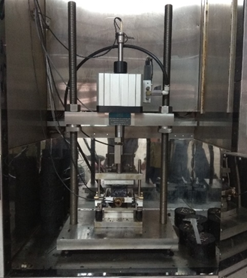

Figure 1. An unit of Umatta

## Resilient Modulus of Asphaltic Mix

Resilient Modulus of an asphaltic mix is defined as the ratio between stress and strain at specific loading time and temperature. Asphaltic mix does not follow full elastic behavior. Because of that, the term of elastic modulus does not suit and this should be replaced by Resilient Modulus (Sukirman, 1999).

Likes modulus of mix, the asphalt mix (Sbit) is also influenced by time loading and temperature. This sort of modulus is one of the input on calculation of resilient modulus of asphalt mix. To determine the resilient modulus of asphalt mix, it can be tested in laboratory using Umatta. The resilient modulus of asphalt mix also can be predicted theoretically through the analytical formulas available such as Shell (Heukelom and Klomp, 1964) and Nottingham method (BROWN, 1980)

# Methodology

There are some steps available namely properties testing, mix testing, and finally data analysis.

## Material properties test

Asphalt mix of pavement surface layer consists of mix of aggregates and asphalt. That is the main reason to carry out testing for both asphalt and aggregates in order to fulfill the requirement of Indonesian DG General Specification 2018 2nd Revised.

## Resilient Modulus Testing

The resilient modulus test is carry out in laboratory using Umatta. The tests were done for 3 types of asphaltic mixes. Figure 2 shows the test in progress.

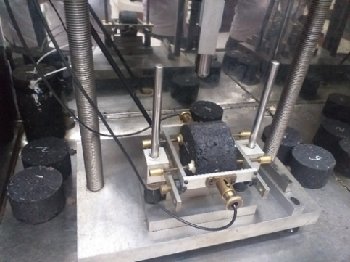

Figure 2. Testing Asphalt mixes using Umatta

# Data and Analysis

For 15 samples of three types asphaltic mix, the results are as follows.

## Material properties

Properties test was carried out for both aggregates and asphalt. The results are shown in Table 1 and Table 2.





From Tables 1 and 2, it is shown that both coarse and fine aggregates fulfilled the Indonesian DG General Specification 2018 2nd Revised.

## Results of Optimum Asphalt Content Test

All of the results of test on optimum asphalt content are described below.

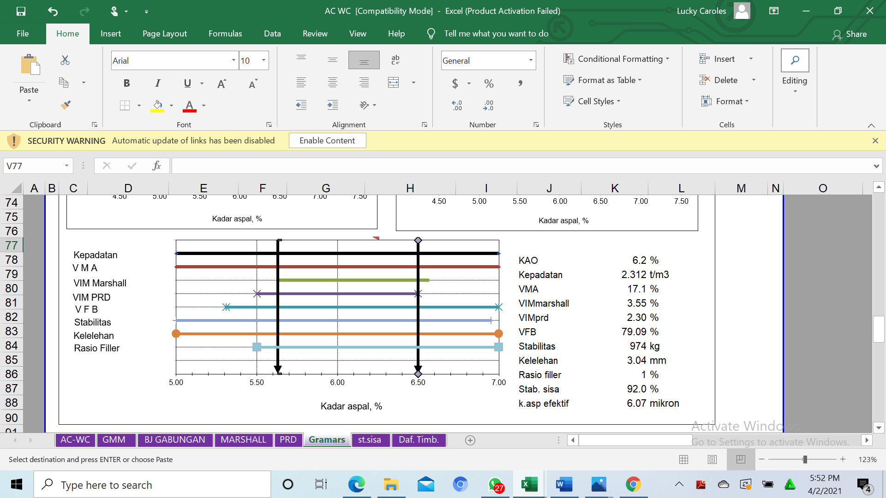

Figure 3. Optimum of Asphalt Content ACWC 6.2%



**REFERENCES**

Figure 4. Optimum of Asphalt Content ACBC 5.8%



Figure 5. Optimum of Asphalt Content AC Base 5.6%

It can be said that from Figures 3, 4, and 5 the optimum asphalt contents for each type of mixes, ACWC – ACBC – AC Base, are 6.2%, 5.8%, and 5.6% respectively.

## Results of Resilient Modulus Test

Resilient Modulus Test which was carried out in the laboratory for 15 samples and three types mixes i.e. ACWC, ACBC and AC Base within optimum asphalt content 6.2%, 5.8%, and 5.6%. The testing utilizes Universal Material Testing Apparatus (Umatta).

There are two different temperatures taken i.e. 26 oC and 41 oC. There were two steps taken that is the first step all samples were tested at 26 oC, and one day afterward the second testing were done at temperature 41 oC. The results in term of Resilient Modulus (MPa) for all three sample are shown in Table 3 and Table 4, while Table 5 shows the comparison of each other.







## Analysis of Resilient Modulus Test

Some information obtained from Table 3 that is the average Resilient Modulus of ACWC, ACBC and AC Base at temperature 26 oC are 2157 MPa, 2503 MPa, and 2494.8 MPa. All of these modulus are above the required typical modulus as mentioned in Pavement Design Manual (Umum and Marga, 2013). When they were tested at temperature 41 oC the modulus values decrease sharply as shown in Table 4. The values of Resilient Modulus for each type of mix ACWC, ACBC, and AC Base are 508.2 MPa, 544.6 MPa, and 592.8 MPa. When it is calculated mathematically, it can be said that the changes of resilient modulus due to temperature increament from 26 oC to 41 oC are 76.44%, 78.20% and 76.20% for ACWCm ACBC, and AC Base respectively.

# Conclusion

The increase of testing temperature from 26 oC to 41 oC will decrease significantly the Resilient Modulus of three types of mixes. Resilient modulus of ACWC decrease with the amount 76.44%, ACBC decreases in the number of 78.20% and AC Base decreases 76.20%. That is all for temperature changes from 26 oC to 41 oC.

This finding comes to a conclusion that the temperature changes affect significantly the values of resilient modulus. This is due to the characteristics of asphalt which follows viscoelastic where at the low temperature they behave viscous and at high temperature they will behave elastic.

**REFERENCES**

BROWN, S. F. (1980) *An introduction to the analytical design of bituminous pavements*.

Dickinson, E. (1981) *Pavement Temperature Regimes in Australia: Their Effect on the Performance of Bituminous Constructions and Their Relationship With Average Climate Indicators*, *Australian Road Research*.

Heukelom, W. and Klomp, A. J. (1964) ‘Road design and dynamic loading’, in *Assoc Asphalt Paving Technol Proc*.

Qin, Q. *et al.* (2014) ‘Field aging effect on chemistry and rheology of asphalt binders and rheological predictions for field aging’, *Fuel*, 121, pp. 86–94.

Sukirman, S. (1999) ‘Perkerasan lentur jalan raya’, *Nova, Bandung*, 2.

Umum, K. P. and Marga, D. J. B. (2013) ‘Manual Desain Perkerasan Jalan’. Nomor 02/M/BM/2013.