Analysis of seawater intrusion into groundwater in the coastal area of Durung Village, Aceh Besar Regency, Aceh Province, Indonesia
M Arfah¹ and M Tanjung¹

¹Ship Engineering Department, Malahayati Merchant Marine Polytechnic, Aceh Besar, Aceh, Indonesia

E-mail: mahbubarfah555@gmail.com
Abstract. Durung Village is a region consisting mostly of coastal and hilly areas. Utilization of groundwater in the coastal zone has been increased these recent years for all purposes of life, from drinking to sanitation and from industry to agriculture. It results new environmental problem, such as seawater intrusion that caused negative impact on groundwater resources. This research aims to analyze the effect of seawater intrusion into the groundwater in the study area. Total Dissolved Solids (TDS) was used in this research as approximation of groundwater salinity value. The spatial distribution of seawater intrusion had been prepared by using Geographic Information System (GIS) spatial interpolation technique for TDS parameter. The results revealed that seawater intrusion presented more obviously near the coastal line and its northern part was the most affected area by this contamination indicated by the highest TDS value of 2.947 mg l⁻¹, whereas the farther location from the coastline were free of seawater intrusion indicated by low TDS values between 181 – 579 mg l⁻¹.

- Introduction
Durung Village is a coastal region in Mesjid Raya Sub-district, Aceh Besar Regency, Aceh Province, Indonesia. This area is directly adjacent to the ocean so that it is prone to natural disaster especially seawater intrusion. The increasing of global population in Durung Village affects their needs of clean water for households, offices, trade, hotels, agriculture, animal husbandry, home industry, etc. The source of drinking water for the community in Durung Village is a bore well or a pump [1].
In addition, the need for clean water has reduced the flow of fresh groundwater towards the sea. Thus the sea water would flow into wells on the ground [2]. It is indicated by the higher Total Dissolved Solids (TDS) values of some resident’s wells in this village. This will cause the environmental problems in freshwater aquifer. Cleaning takes years [3]. It is important to monitor and to prevent the adverse effect of seawater intrusion.
Seawater intrusion is a process causes the suppressed in groundwater by seawater on aquifers in coastal areas [4]. It is the process of infiltration of seawater into the pores of rocks and contaminate its groundwater quality. Seawater intrusion occurs naturally in most coastal aquifers which is caused by hydraulic connections and density differences between groundwater and seawater. On the other hand, seawater intrusion can also occur in coastal areas due to excessive groundwater exploitation as population growth in the areas [5].
The prediction of seawater intrusion can be determined by several groundwater parameter, including Total Dissolved Solids (TDS). The amount of dissolved salt which influenced the groundwater salinity can be assumed as the indicators of seawater intrusion [6], [7]. TDS is the physical parameter which delineates both organic and inorganic compounds in a solution [8]. TDS includes the amount of some materials in the water, such as carbonate, bicarbonate, chloride, magnesium, calcium, sodium, organics ions, etc. According to [8], the content of TDS can also effect the taste of the water becomes salty.
In recent years, many studies have carried out to analyze seawater intrusion phenomenon and its impact to the environment and coastal areas particularly. Various methods have been done by the researchers to estimate and evaluate the seawater intrusion and its impact to the groundwater. The resistivity method using Schlumberger electrode configuration is able to detect and investigate the seawater intrusion in the coastal regions [9], [10], [11]. Meanwhile, the measurement of groundwater parameter is the most common method which is used by many researchers around the globe [5], [6], [7], [12], [13]. Based on the electrical conductivity (EC) and TDS values, a contour map can be created to generate seawater zones distribution in the coastal areas [11], [14]. A spatial distribution of seawater intrusion can be obtained by combining the Geographic Information System (GIS) technique and in-situ measurement of groundwater parameters [15]. In addition, the approach of TDS measurement in wells is an efficient method for the study of seawater intrusion in a coastal aquifer [5], [6], [7], [8]. Despite a good amount of study in this field, there was no previous research about seawater intrusion in the coastal area of Durung Village.
Because of the impact of seawater intrusion has been found in the coastal area of Durung Village, it is necessary to investigate and monitor regularly to prevent the natural disaster and clean water crisis problems in the future.
In this study, Total Dissolved Solids (TDS) was used as an approximation to identify the salinity value of groundwater. A Geographic Information System (GIS) based method to generate the spatial distribution of seawater intrusion in the research location was developed using Inverse Distance Weighting (IDW) interpolation method.
The main objectives of this research are to analyse the seawater intrusion to groundwater in the coastal area and to yield a spatial distribution of seawater intrusion in the coastal area of Durung Village.

- Research Method
  - Study area
Durung Village is located at latitude of 5º38’49’’ to 5º39’18’’and longitude 95º26’12’’ to 95º26’51’’. It spreads to an area of 834 Ha, which is situated in Mesjid Raya Sub-district, Aceh Besar Regency, Aceh Province, Indonesia. It is directly adjacent to the ocean. The main livelihood of the community is in the agriculture and animal husbandry sector. Several home industries are also developed significantly in this recent years [1]. The map of Mesjid Raya Sub-district, Aceh Besar Regency can be seen in Figure 1.

  - Data collection
Generally, this study applied a quantitative descriptive method. However, the purposive sampling method was used to select the sampling sites. This method was chosen because of the difference topography of the research location. The difference of elevations in the study area ranges from 6 m to 35 m. A set of TDS observed data was obtained by doing in-situ measurement on November 2020. There were 10 resident’s wells as the groundwater resource in Durung Village. A TDS meter was used to measure the TDS value, while the coordinates of each sample sites were collected by using a portable Global Positioning system (GPS).

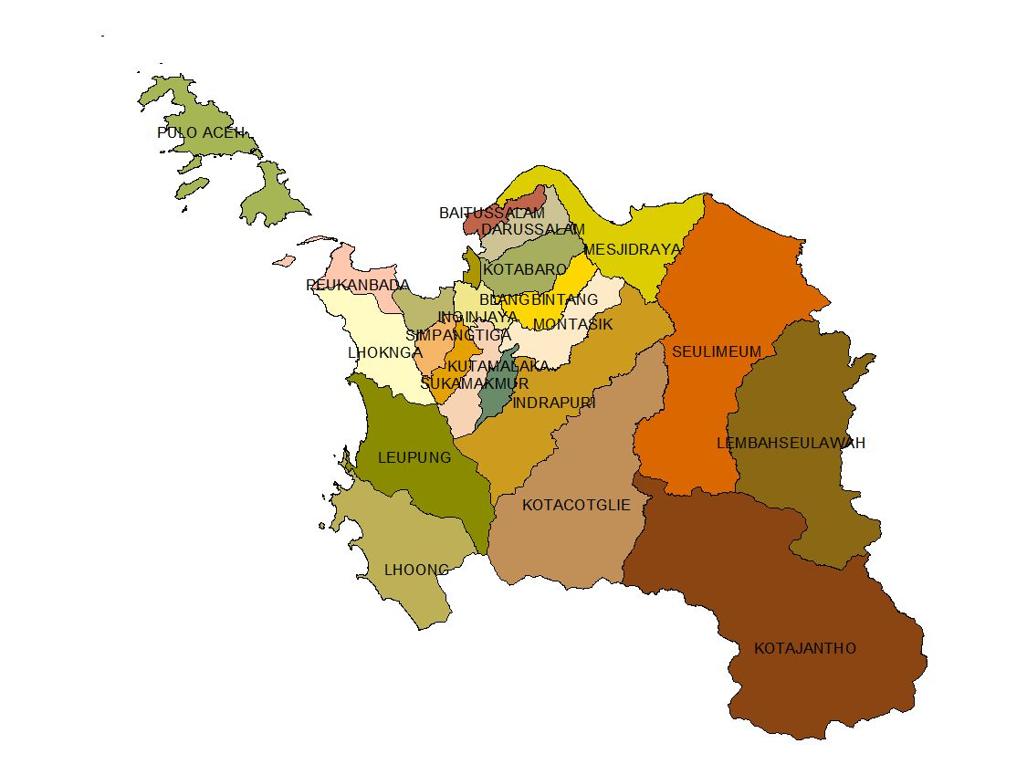
Figure 1. The map of Mesjid Raya Sub-district, Aceh Besar Regency

  - Interpolation Method
The field data was analyzed by using geo-statistical analysis method based on Geographic Information System (GIS). Therefore, using geostatistical analyst tools, surface variation of the TDS values was created by using Inverse Distance Weighting (IDW) interpolation method. IDW is one of the most optimal deterministic interpolation method in estimating the groundwater TDS values at un-sampled location [15], [16]. It works by assuming that each point has a local influence that reduced by the distance [15], [17], [18].

- Results and Discussion
  - Total Dissolved Solids (TDS)
The purpose of TDS measurement is to obtain the TDS values in the coastal area of Durung Village. The measurement was conducted at 10 sampling locations. The result showed that the TDS observed values in the groundwater samples varies widely in this region. The TDS values at some sample points was much more than standard value. The highest TDS value was 2.947 mg l⁻¹, whereas the farther location from the coastline were free of seawater intrusion indicated by low TDS values between 181 – 579 mg l⁻¹. It indicated that the seawater intrusion occurred in several coastal areas of Durung Village, especially at the closer distance to the coast.

  - Spatial Distribution of TDS
Prediction of seawater intrusion in a coastal area can be established based on the spatial distribution pattern of the TDS in the groundwater through interpolation method based on Geographic Information System (GIS). Geo-statistical analysis results based on GIS interpolation method (IDW interpolation method) showed the indications of seawater intrusion in seawater intrusion presented more obviously near the coastal line and its northern part was the most affected area by this contamination indicated by the highest TDS value of 2.947 mg l⁻¹, whereas the farther areas from the coastline were free of seawater intrusion indicated by low TDS values between 181 – 579 mg l⁻¹. The map of IDW interpolation results from the groundwater TDS in Durung Village is shown at Figure 2.

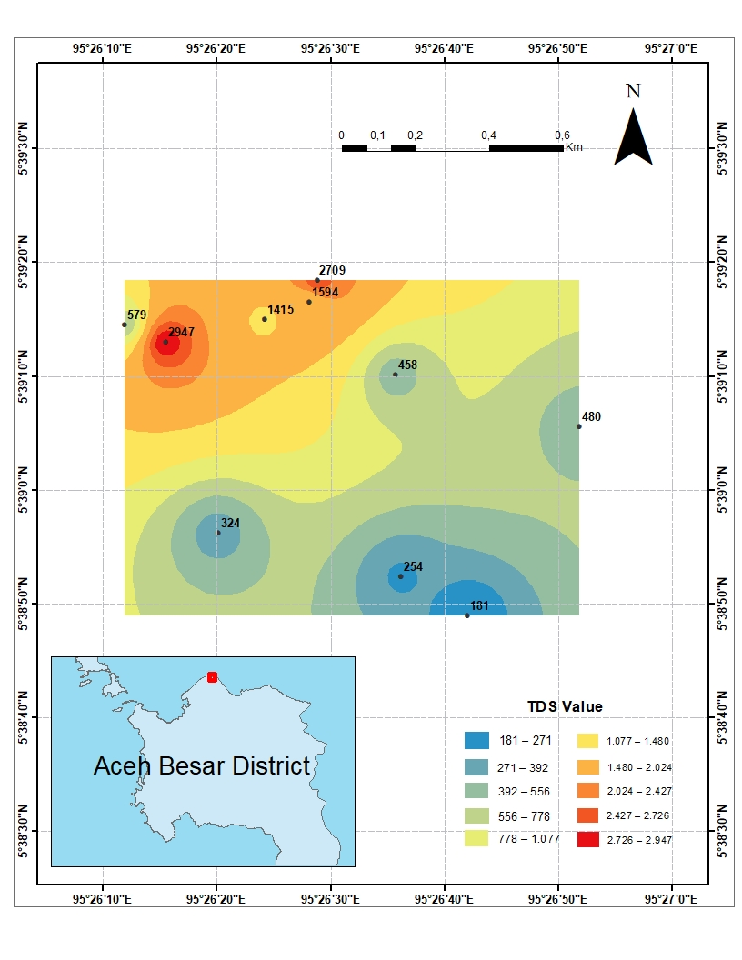
Figure 2. Map of IDW interpolation results from TDS

- Conclusion
In this study, we had undertaken an analysis of seawater intrusion into groundwater in the coastal area of Durung Village, Mesjid Raya Sub-district, Aceh Besar Regency, Aceh Province, Indonesia. Based on the results of TDS measurement that had been carried out on 10 groundwater samples from resident’s wells, it can be concluded that seawater intrusion had reached the research location. The impact of seawater intrusion was found at several sampling locations near the coastal line and its northern part was the most affected area by this contamination indicated by the highest TDS value of 2.947 mg l⁻¹, whereas the farther sampling locations from the coastline were free of seawater intrusion indicated by low TDS values between 181 – 579 mg l⁻¹. In addition, further study needs to be done regularly in this area. Due to the importance of monitoring the effect of seawater intrusion into the groundwater in order to protect the groundwater resource in the long term and also to safe our coastal environment in the future.

Acknowledgments
The authors would like to extend their appreciation to Malahayati Merchant Marine Polytechnic, Aceh, Indonesia for funding and providing necessary facilities in making this research possible. The authors also wish to acknowledge the constructive comments from the guest editor and reviewers.

- References
[1] Muliandari 2018 Kecamatan Mesjid Raya dalam Angka 2018 (Aceh Besar: BPS Kabupaten Aceh Besar)
[2] Lanbo L 2016 Encyclopedia of Life Support Systems, Natural and Human Induced Hazards vol 2 (USA: US Army Cold Regions Research and Engineering Laboratory) p 1 – 7
[3] Kingshuk R, Katsuhiro S and Eiichi K 2014 International Soil and water Conservation Research vol 2 p 40 – 42
[4] Gaaloul N, Pliakas F, Kallioras A, Schuth C and Marinos P 2012 Open Hydrology Journal vol 6 p 31 – 44
[5] Cheruvathoor V G and Krishnalah C 2015 International Journal of Geology and Earth Sciences vol 1 p 21 – 25
[6] Ahmad H M K Z 2012 Sebaran TDS, DHL, Penurunan Muka Air Tanah dan Prediksi Intrusi Air Laut di Kota Tangerang Selatan (Bogor: IPB Press)
[7] Abdurrachman, Rosmaiti and Iswahyudi 2019 ARGOSAMUDRA, Jurnal Penelitian vol 6 p 1 – 6
[8] Reri A, Tifany E and Aroiya A 2017 Jurnal Teknik Lingkungan UNAND vol 14 p 62 – 71
[9] Muhammad U N ABA, Agus S and Jatmiko E S 2017 International Journal of Innovative Research in Advanced Engineering (IJIRAE) vol 3 p 76
[10] Rizky R W, Dwa D W and Amien W 2017 Jurnal Teknik ITS vol 6 p C81 – C83
[11] Khoirun N, Tony Y and Sugeng W 2012 Berkala Fisika vol 15 p 7 – 14
[12] Nico A P, Wahyudi and Suntoyo 2013 Jurnal Teknik POMITS vol 1 p 1 – 3
[13] Subin K J, Rajan R V and Kumar R S 2016 IOSR Journal of Environmental Science, Toxicology and Food Technology (IOSR – JESTFT) vol 10 p 51 – 53
[14] Ahmad C, Tjahyo N A, Muh A M, Sembodo N and Romza F A 2017 Majalah Geografi Indonesia vol 31(Yogyakarta: UGM Press) p 61 – 66
[15] Maulina T, Saumi S and Muhammad R 2020 Jurnal Natural vol 20 p 24 – 26
[16] Balakrishnan P, Abdul S and Mallikarjun N D 2011 African Journal of Environmental Science and Technology vol 5 p 1069 – 1074
[17] Gouri S B, Pravat K S and Ramkrishna M 2018 Journal of The Saudi Society of Agricultural sciences vol 17 p 116
[18] Wang S, Huang H, Lin Q G, Zhang H and Fan Y R 2014 International Journal of Climatology vol 34 p 3746

