Calibration The Travel Resolution Stepper Motor Machines of CNC-Based Batik Robot Running GRBL Firmware

Marsono1, a); Yoto2, b); Annisau Nafiah3, c); and Riana Nurmalasari4, d)

Author Affiliations

1,2,3,4Malang State University  
Jl. Semarang 5, Malang, Indonesia

Author Emails

*a) Corresponding author: marsono.ft@um.ac.id  
b)*[*yoto.ft@um.ac.id*](mailto:yoto.ft@um.ac.id)

*c)*[*annisau.nafiah.ft@um.ac.id*](mailto:annisau.nafiah.ft@um.ac.id)

*d)riana.nurmalasari.ft@um.ac.id*

**Abstract.** The level of accuracy for the movement of the motor used determines the movement of a robot. If the motor and GRBL do not match, the robot's movement will endanger both the product and the machine operator. The goal of this research is to find the quickest way to calibrate the travel resolution stepper motor machine of a CNC-based Batik robot running GRBL firmware. The method used in this study is Parallel Throwaway Prototyping, which consists of several direct experiments with the machine made. The outcomes were as follows: 1. The basic movement of the robot has three types of travel resolution: radial, axial, and rotary. 2. In radial and axial types, the number of travel resolutions is calculated by dividing the number of steps by the value of the shift distance of one revolution; 3. In rotary types, it is calculated by dividing the number of steps of one rotation by the degree of rotation angle. The findings of this study suggest that we should pay attention to the error of the stepper motor or the belt and lead screw because it can affect the precision of the stepper motor movement.

# BACKGROUND

Batik is an ancestral tradition of the Indonesian people. Batik has a high value because of its distinctive patterns and colors, which can show the identity of each region in Indonesia. This is supported by UNESCO's recognition, which states that batik is a patent by Indonesia among dozens of cultural heritages worldwide. Thus, batik must be preserved at all times so that it does not disappear from Indonesian culture. Furthermore, the popularity of batik is growing. This is due to a government program promoting the use of batik to preserve culture and the development of batik fashion, which is becoming more popular among the younger generation. Batik fashion indicates that batik does not only belong to the old class, thus making batik increasingly known in the community.

This condition, in fact, provides an opportunity for batik business owners to increase their production capacity. On the other hand, the employees who work in the written batik business, where the majority of the employees are dominated by the elderly because they are thought to have patience in making batik, are the factors that affect the batik industry's production capacity each month. Many batik entrepreneurs lament the fact that there is little interest among young people in learning to be batik makers' employees because they believe that making batik is a tedious job.

Another issue that batik entrepreneurs face is that the traditional manufacturing process takes a long time and has several stages. According to one of the batik entrepreneurs, the coloring process takes a long time when done manually, beginning with making models/patterns on paper and then transferring them to cloth, nglowong, ngiseni. In one month, one employee can only produce an average of one batik layer.

Robot technology will continue to evolve, resulting in a variety of robots with varying abilities [1]. As a result, various types of robots have been designed in this modern era (Fig 1).

**Figure 1.** Robot Type Classification

Source: Budiharto (2010)

Humans invented robot technology as tools or machines to make work easier, safer, and less boring [2]. The following are the functions of robot development in human life and industrial development [3]:

1. Replacing humans in work that has a high risk of danger and difficult terrain.

2. Improve a company's productivity, accuracy, and durability in performing a task so that errors caused by human factors can be reduced.

3. Assisting humans in carrying out their daily tasks.

4. Make students want to learn about technological advancements.

5. Can be used for human entertainment and interesting shows.

The presence of robot technology in the midst of human life is becoming increasingly felt as a result of its benefits and applications. Robots are designed to adapt to the type of work or activity to be performed, so humans are becoming increasingly innovative in designing robots that can interact directly in everyday life [4]. Human-robot interaction is classified into three levels: (a) humans as fully robot controllers; (b) humans as managers of robot operations; and (c) humans and robots are equal.

Interaction between humans and robots is critical in the industrial world. The degree to which robots rely on humans will have an impact on the level of automation. The lower robot's reliance on humans, the higher level of automation. This will enable the robot to perform a task automatically, reducing the amount of human labor and costs that must be incurred.

There are numerous components and tools that will be used in the design of a robot. The components and tools used in the design of the robot are tailored to the type, benefits, and functions of the robot itself [5]. Several components are used in the robot design technique, including the mechanical structure, power transmission, and the use of sensors, controllers, and actuators (Fig 2).

**Controller System**

**Actuator System**

Wheel System

Foot System

Hand System

**censor**

**Actuator**

**Robot Mechanic**

**Figure 2.** Principles of Robot Design

Source: Supriyanto, et al (2010)

The function and type of robot are critical factors to consider in robot design techniques. The function is used as a reference to determine how the robot will operate. A robot generates an output in the form of mechanical movement in response to the commands of the given program, and the given movement can take any form. Robot Mechanics refers to a mechanical system made up of several motion systems in the field of robotics [6;7].

The number of movements that the robot can perform is referred to as the principle of degrees of freedom. A DOF is a joint that is represented by an actuator motion. The robot arm has three degrees of freedom (DOF), allowing it to move up and down, left and right, and front and back. The robot's movement is organized into four configurations: cartesian robot, cylindrical robot, spherical robot, SCARA and articulated robot. Configuration refers to how each manipulator link is connected to the next at each joint. Each link will be connected to the next link via a linear joint denoted as P or a revolute joint denoted as R [8,9].

Cartesian Configuration (Cartesian Robot)

This configuration is made up of three mutually perpendicular linear axes [7]. The robot's work area is on the Cartesian XYZ axis in this configuration (Fig 3).

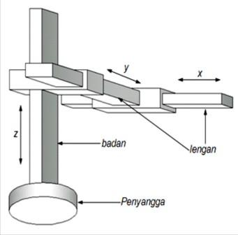

**Figure 3.** Cartesian Configuration

Source: Pitowarno (2006)

The advantage of this configuration is that it is simple to calculate the robot's equations of motion. This is due to the fact that the Cartesian axis is influenced by a single actuator, making its movement easier to program. The robot's control system is a robot movement control system that uses pulse width modulation (PWM) to control a servo motor. There are two types of control in a robot: open control and closed control. Each control system on the robot is explained in detail below [11;12].

Open-loop control system

An open control system, also known as feedforward control, is one in which the controller does not recalculate the output. This control is commonly used in robotic systems that employ actuators with logical feed-based configurations of steps in a sequence. Figure 4 depicts a block diagram of an open control system.

Controller

Process

Input

Output

Signal

mover

**Figure 4.** Open Control System Block Diagram

In the block diagram of the open control system shown above, the output produced or carried out by the robot has no effect on the input processing because there is no feedback provided by the output to provide a reference to the controller to perform the next output. A stepper motor is an example of an actuator whose operating system is based on a logic feed with a step-by-step configuration [13].

The specific goal of this research is to obtain the calibration parameters of the stepper motor movement in accordance with the mechanics of the machine used so that the CNC-based 3 DOF batik robot can work optimally.

## METHOD

The Parallel Throwaway Prototyping model is used in this type of study. With this model (Fig 5), it will be possible to carry out the stages of creating a machine consisting of several main components that are then assembled into a single system. The research takes place in the State University of Malang's mechatronics laboratory, with the research subject being travel resolution stepper motors with radial, axial, and rotary models.

**Figure 5.** Parallel prototype research approach

## FINDING AND DISCUSSION

GRBL is a firmware that is widely used in CNC-based programs. GRBL was chosen because it is open source and has a simple and easy to use interface. Several parameters must be synchronized between hardware and software during the travel resolution calibration of this CNC-based 3 DOF batik robot so that the movement of the stepper motor matches the image to be worked on and does not endanger the machine or its operators.

There are three types of travel resolutions for which we will calculate the turn ratio as follows:

1. Belt or radial type, with the axis of rotation perpendicular to the movement

2. Axial type with a lead screw that moves in the direction of the axis of rotation

3. Rotary Type

A. Belt Type (Radial)

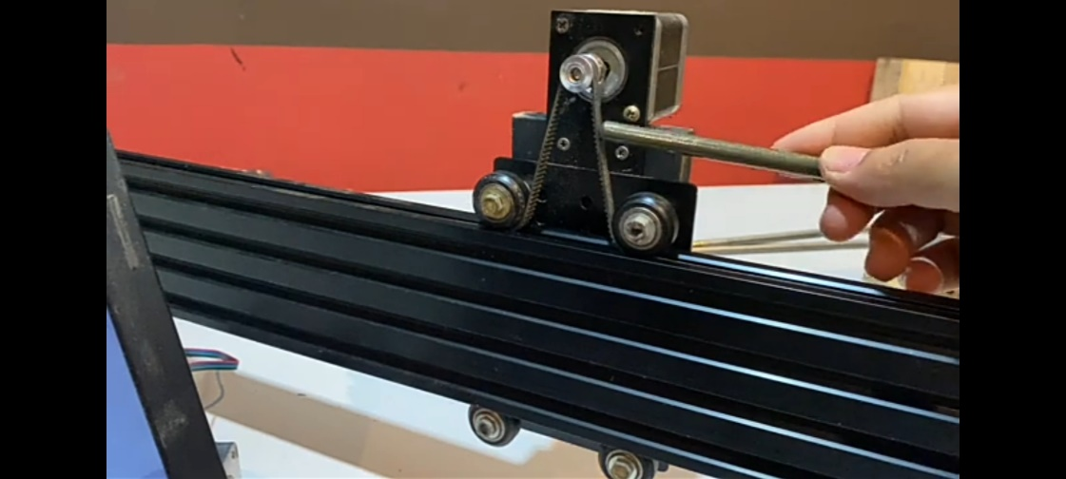

**Figure 6.** Radial type stepper motor movement

The radial rotation ratio can be calculated as follows:

1. The number of steps divided by the distance. Where the distance can be calculated by the number of gears passed, and then a number is taken for the number of steps in one round. For a distance of one pulley rotation where the number of gears times the distance of the gear.

2. Things that determine the number of round steps are as follows:

a. Stepper specifications

b. Jumper formation setting

3. In the specification's parameters, we can see one parameter, which is the step angle. This step angle denotes the stepper movement's resolution in the angle. At 1.80, for example, one turn of the stepper's step will move the stepper 1.8 degrees. So, for one rotation or 360°, the motor requires 200 steps (200 steps per revolution), which can be calculated by multiplying 360 by 1.8.

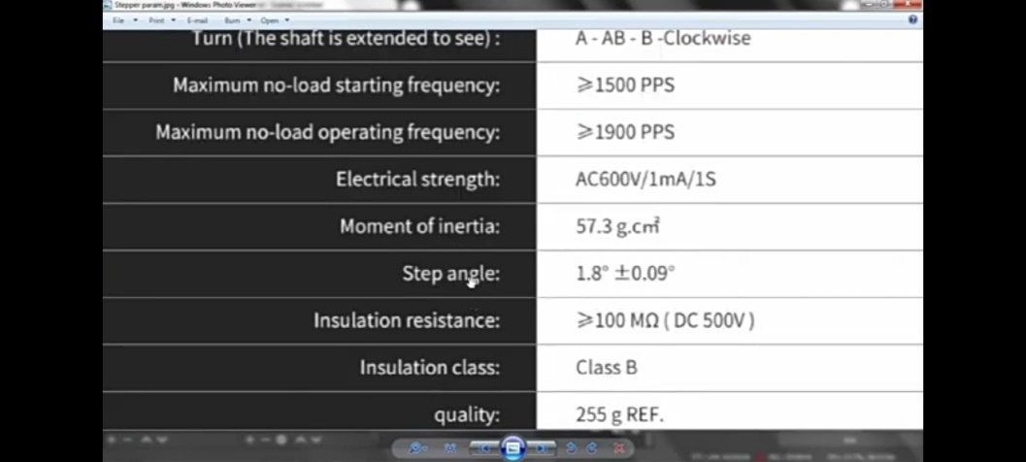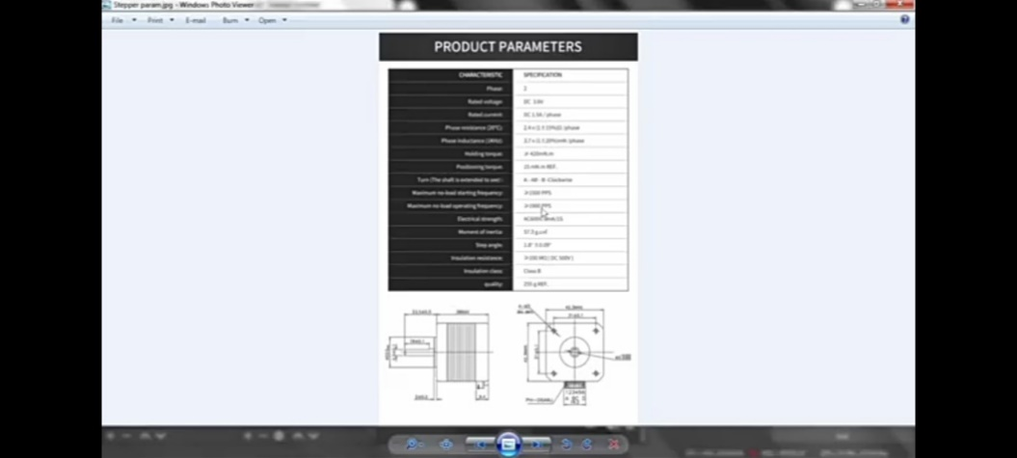

**Figure 7.** Stepper motor parameters

4. Based on the step angle, there are two types of steppers: 0.90 and 1.80. For a 0.90 stepper motor, one revolution requires 400 steps (400 steps/rev). If the information is not contained in the stepper body, we must look for it on the internet using the series attached to the stepper motor. However, if it is not found, we can assume that the stepper motor has 1.80 because, unless otherwise stated, that type is the most commonly used.

5. This jumper configuration determines the micro static mode (driver mechanism) to regulate the current in the stepper's direction so that the stepper can move less than the factory default angl

**Figure 8.** Stepper motor jumper code

The factory default motor resolution will be 200 steps/rev in full step options M0, M1, M2 without jumper (LLL). If it is set to 1/2 step resolution with a jumper position (HLL), the motor requires 400 steps per rotation, and so on, depending on the jumpers installed in the stepper motor driver (M0, M1, M2).

SAMPLE APPLICATION

1. In the figure below, we use a 1.80 stepper with a 16-tooth motor pulley and a belt pitch of 2 mm.

**Figure 9.** Installation of stepper motor with radial travel type

2. Formation jumper with HLL. As a result, the jumper only has M0. As shown in the data table, the rotation step is 400 with a resolution of ½ step.

**Figure 10.** HLL mode jumper installation

3. Once you've determined the number of rotational steps, simply compute the displacement distance. There are 16 teeth in one round, and the distance between them is 2 mm, so there are 16 X 2 = 32 mm in one round. So, based on the motor data (400 steps/rev) and the 32 mm step calculation, 400/32 = 12.5 can be calculated.

4. The number 12.5 is entered into the GRBL settings at parameter number $100 because it uses the x-axis and is saved. Then try to move.

**Figure 11.** Setting GRBL X-axis resolution

5. If the movement is slow, the $110 parameter is set to the maximum limit of 15000, and the acceleration is set to the $120 parameter, for example, 500.

**Figure 12.** Setting X-axis maximum rate

**Figure 13.** Setting x-axis acceleration

6. If the movement is felt strongly enough, we can determine whether it is in accordance with the order.

**Figure 14.** Gantry movement test

B. Axial type with lead screw

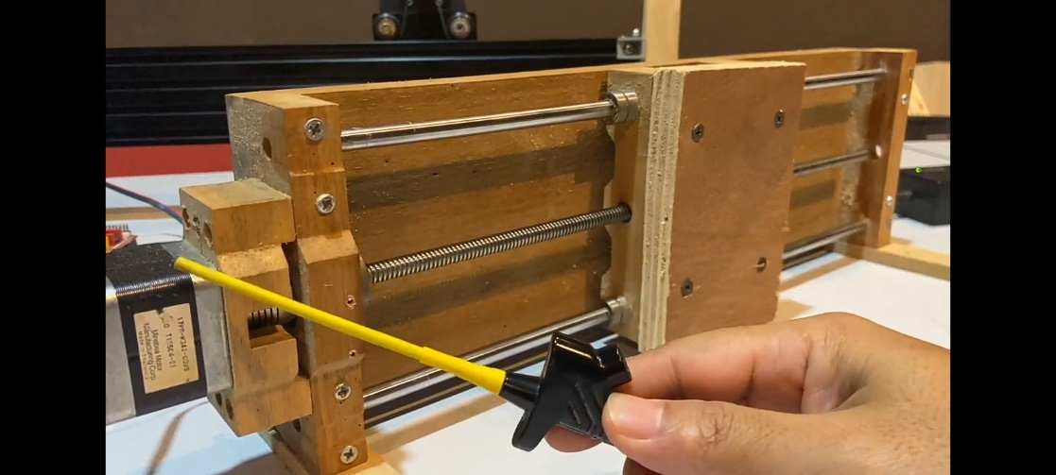

**Figure 15.** Stepper motor axial type mounting model with lead screw

The method of calculating the rotation ratio is the same as the previous type, namely the number of steps in one round divided by the distance in one round, with more details as follows:

1. In the diagram, we're using a 400-stepper, and all we need to do is figure out the divisor or distance.

2. Depending on the lead screw specifications, the distance can be determined by two parameters:

• Pitch distance / distance between adjacent lead screw tooth paths / number of paths

• The number of paths on the lead screw can be of several types, including:

a. 4 lane lead screw: where 1 lane is a multiple of 4, so that for one turn with 4 lanes and a pitch distance of 2 mm, you get 8 mm (2 x 4 = 8 mm), or in other words, one full turn of this lead screw will shift as far as 8 mm.

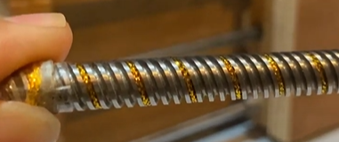

**Figure 16.** 4 lane lead screw

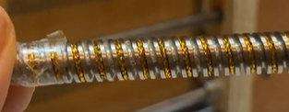b. 2 lane lead screw: where 1 lane is a multiple of 2, so that for one turn with 2 lanes and a pitch distance of 2 mm, you get 4 mm (2 x 2 = 4 mm), or in other words, one full turn of this lead screw will shift as far as 4 mm.

**Figure 17.** 2 lane lead screw

c. 1 lane lead screw: a lead screw with only one lane, so that for one turn it has one lane with a pitch distance of 2 mm, then 2 mm is obtained (1 x 2 = 2 mm), or in other words, one full turn of this lead screw will shift 2 mm).

3. The number of steppers/ distance can be calculated using the previous parameters (turnover step = 400 and divisor number or path distance = 2), which is 400/2 = 200.

4. Then, in the parameter number $100, enter the number 200 in GBRL, which is 200 on the x-axis (if it is installed on the y / y-axis, it is replaced at number $ 101; z-axis number $ 102, then save.Graphical user interface, text, application

**Figure 18.** Axial type travel resolution setting

5. The final step is to test the movement and determine whether it conforms to the desired parameters.

**Figure 19.** Axial type movement experiment

C. Rotari Type (A Axis)

**Figure 20.** Rotary type mounting stepper motor

The rotation ratio is calculated in the same way as the previous type, which is as follows:

1. The number of steps in one round divided by the distance traveled in one round (only the distance traveled in one round is expressed in degrees of angle because it rotates).

2. For example, the stepper motor used has 400 steps per revolution divided by the distance of one revolution in the angle (3600 degrees), yielding 400/360 = 1.111.

3. There is a transmission ratio factor because of differences in the use of pulleys, where the stepper uses a small pulley and the rotary axis uses a large pulley. As a result, the result is multiplied by the transmission ratio.

4. The small pulley has 16 teeth, while the large pulley has 60. As a result, the transmission ratio is 60/16. To calculate the travel resolution, do the following:

1.111 x 3.75 = 4.167 (400/360) X (60/16) = 1.111 x 3.75 = 4.167

5. Then, on the A axis, enter the number (4,167) obtained in GBRL.

**Figure 21.** Travel resolution setting on rotary type

6. The final step is to try to move with the reference line, then measure whether the movement is consistent with the command for one round. If it is appropriate, the reference line will return to its original position in one turn.

Garis referensi

**Figure 22.** Test movement on rotary type

# CONCLUSION

According to the findings of this study, there are three types of stepper motor installation on a CNC-based 3 DOF robot machine with GRBL firmware: radial, axial, and rotary types. The GRBL software is widely used in CNC-based machines because it is user-friendly. The number of teeth on the pulley is 16, the pitch belt is 2 mm, the formation of the HLL jumper installation is 400 steps/revolution, the x-axis travel resolution is 12.5 with a maximum rate of 15000, and the acceleration is 500 in the radial type using a 1.80 stepper motor. The travel resolution value in the axial type with a lead screw on the same motor parameters and using a 1-way lead screw is 200. The angle degree in the rotary type is 3600, the transmission ratio of the small pully is 16 teeth, and the transmission ratio of the large pully is 60 teeth, with a stepper motor parameter of 400 steps/revolution. The travel resolution value is 4.167.

# Acknowledgments

We would like to express our gratitude to the Directorate of Research and Community Service (DRPM) of the Ministry of Education, Culture, Research, and Technology of the Republic of Indonesia for their financial support for our research. The research team would like to express their heartfelt gratitude to everyone who assisted with this study, as well as to Malang State University's Research Institute and Community Engagement for their assistance.

# References

1. W. Budiharto, *Robotics: Theory & Implementation* (Andi Offset, Yogyakarta, 2010).
2. S. Arifin, and A. Wicaksono, “Design of Loy Krathong Automatic Robot Based on Atmega 128 Microcontroller in KRI 2011 Case”. (ASIA Scientific Journal of Technology and Information, 8(1), 2014).
3. A. Jalil, “Humanoid Robot Design”, (Konferensi Nasional Ilmu Komputer (KONIK), Pascasarjana Magister Sistem Komputer STMIK Handayani, Makassar, 2016).
4. W. Jatmiko, P. Mursanto, P. Tawakal, S. Alvisalim, and A. Hafidth, *Robotics: Theory and Application*, (Universitas Indonesia, Depok, 2012).
5. R. Supriyanto, Hustinawati, W. Nugraini, A. Kurniawan, Y. Permadi, and S. Abdurrachman. *Robotika*. (Universitas Gunadarma, Jakarta, 2010).
6. S. Muis, *Basic Principles of How Robots Work*, (Graha Ilmu, Yogyakarta, 2011).
7. E. Pitowarno, *Design, Control and Artificial Intelligence Robotics,* (Andi Publisher, Yogyakarta, 2006).
8. A. Ibrahim, R. Alexander, M. Sanghar, and R. D’souza, “Control Systems in Robotics: A Review”, (International Journal of Engineering Inventions, 5(5), 29-38, ISSN: 2319-6491, 2016).
9. H. Jaya, *Microcontroller-Based Robotics System Design and Implementation*, (Mitra Grafika, Makassar, 2016).
10. M. Mustar, I. Santosa, and R. Hartanto, “Designing Human and Robot Interaction Models in the Form of Visual Displays on Computers” (Seminar Nasional Teknologi Informasi dan Multimedia 2014, STMIK AMIKOM Yogyakarta, 19 Februari 2014).
11. A. Yulianto and E. Ramadan, “Moving Manipulator Robot Control System With Visual Feedback”, (Microtech Scientific Journal, 1(2), 2014).
12. T. Suyadhi, *Robotics Smart Book*, (Andi Offset, Yogyakarta, 2010).
13. I. Wahyudi, *Arduino Platform Microcontroller. Module*, (Politeknik Negeri Malang, Malang, 2017).