Development Electrical Technician Competency Test Using Adaptive Test

1Muhamad Ali, 2 Thomas Koehler 3 Bruri Triyono

1 Electrical Engineering Department Faculty of EngineeringUniversitas Negeri Yogyakarta, Indonesia  
[muhal@uny.ac.id](mailto:muhal@uny.ac.id)

**Abstract**. Electrical engineering jobs require a competent workforce. For this reason, it is necessary to have the means to conduct a competency test for electricians. One of the important aspects in the competency test is the knowledge aspect which in the test takes a long time so that it saturates the test participants. This article will discuss the design and implementation of an electrician's competency test on the knowledge aspect by using an adaptive test. The development method consists of 4 stages, namely 1) needs analysis, 2) system design, 3) adaptive competency test system development, and 4) system testing. The results showed that the competency test of electricians in the knowledge aspect could be done with an adaptive test. Adaptive tests are able to produce up to 98% accuracy compared to manual tests, so they are feasible to be developed and implemented.

**Keyword**: electrical technician, adaptive, test, competency

1. Introduction

Computer-based adaptive testing (CAT) has become one of the methods in conducting assessments in schools, universities, and competency tests. Assessment using CAT provides many advantages in terms of speed of the test and accuracy to determine whether the test taker has met the passing criteria or not. This is because CAT uses questions that have been selected and adjusted to the level of difficulty [1, 2, 3]. The test process with CAT will be more structured because the first item that will be given to test takers usually has a moderate level of difficulty. If the first question is not answered correctly, then the easier question will be given, and if answered correctly, the next more difficult question will be given. The selection of these items and the termination conditions were based on a specific computer algorithm, and Item Response Theory was applied to the initial item analysis to determine the item difficulty of each item [2, 4].

Computerized testing, in general, benefits many areas of testing including individuality and time dependence [3, 4]. In addition, CAT has the great advantage of eliminating test items of inappropriate difficulty and saving testing time [5]. However, it is necessary to understand the underlying testing model, Item Response Theory (IRT), to avoid abuse and to maximize the benefits of CAT.

To ensure that electrical work can be carried out reliably, safely, and economically, competent technicians are needed [6,7]. For this reason, an electrician's competency test is needed. One of the aspects tested in the competency test activity is knowledge. To measure this aspect, it is necessary to test with a large number of questions given. The weakness of the knowledge test is that it takes a long time and makes the test participants experience boredom so that the test results are often not in accordance with their actual abilities [8,9]. For this reason, this article will review competency tests on cognitive aspects with adaptive tests conducted online.

1. Method

Adaptive tests were developed using a research and development ADDIE model approach. The development steps of this Trainer consist of five stages, namely 1) Needs analysis, 2) Adaptive Test System design, 3) Adaptive Test System development, and 4) Testing to electrical technician and data analysis, and 5) Conclution.

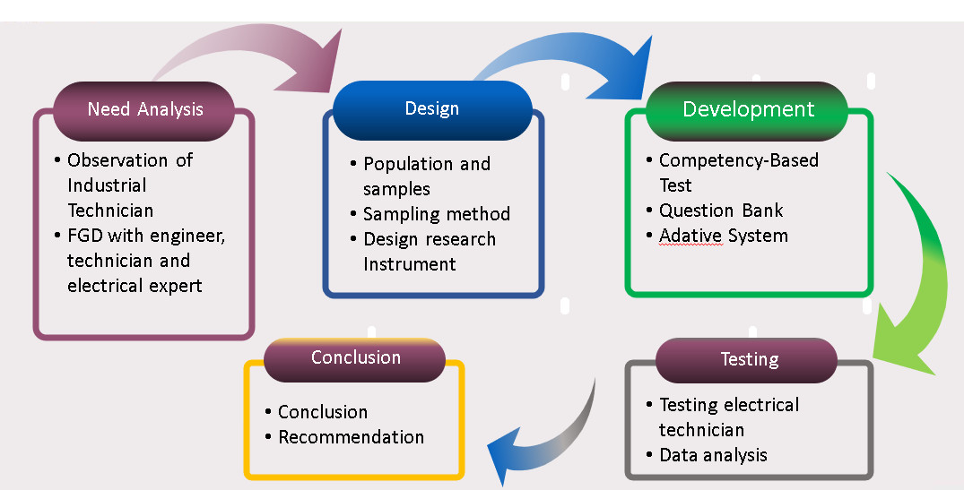

Figure1. Development stage of the system

Needs analysis aims to identify the need for competency testing on cognitive aspects according to the job profile of electricians. The analysis was carried out through observation and Focus Group Discussions with technicians in the industry, electrical engineering practitioners and experts in the electrical field. The results of the analysis are used as the basis for designing the adaptive test system. The design consists of questions, databases and software. The next stage of development is to develop an adaptive test system according to the design results. The last stage is to test the adaptive system on technicians in the industry. There were 30 people involved in the trial, namely technicians from 5 industries in Indonesia (PT Indonesia Power, PT Bukit Asam, PT PLN, PT PJB, PT Cogindo and PT Petro Kimia)

1. Results and Discussion

Based on the test results of 30 electrician competency test participants, it was found that the total number of items answered ranged from about 15 to 32 unless there was one participant who completed a large number of items. The average time needed to complete the adaptive test is 28,24 minutes. The completion time of this question is much faster than the regular competency test with an allocation of up to 75 minutes to answer 50 questions.

1. Conclusion

Moodle sudah digunakan di banyak institusi di Indonesia, termasuk sekolah, perguruan tinggi dan Lembaga Pendidikan dan pelatihan di industry. Selain itu, kebutuhan uji kompetensi yang efisien, murah dan dapat diandalkan karena kemampuan teknisi yang beragam. Banyak teknisi adalah lulusan SMA, SMK, D3, D4 dan S1 dari berbagai latar belakang Pendidikan. Dengan adaptive tes, para teknisi dapat dipetakan dengan cepat dan mudah untuk selanjutnya dikembangkan melalui program Pendidikan dan pelatihan di industri sesuai dengan kebutuhan. Hasil uji coba adaptive tes menunjukkan bahwa adaptive tes yang dikembangkan mampu meningkatkan efisiensi uji kompetensi dan ketepatan hasil uji kompetensi teknisi listrik.

References

1. Akiyama, M. (2008). Trial version of adaptive test module using Moodle. *Proceedings of JART 2008.*
2. Brown, J. D. (1997). Computers in language testing: Present research and some future directions. *Language* *Learning & Technology,* 1, 44-59.
3. Downing, S.M. & Haladyna,T.M. (ed.). (2006) *Handbook of Test Development,* Lawrence Erlbaum Associates Publishers.
4. Dunkel, P.A. (1999). Considerations in developing and using computer-adaptive tests to assess second language proficiency, Language Learning & Technology, 2, 2, 77-93.
5. Ohtomo, K., Nakamura, Y. & Akiyama M. (2006) TDAP 2.02 ___http://e-learning.ac/moodle-resources/
6. Magis, D., Yan, D. & von Davier, A.A. (2017). Computerized adaptive and multistage testing with R. Switzerland: Springer International Publishing.
7. Magno, C. (2019). What happens to educational assessment in the 4th industrial revolution. Diambil dari https://www.pemea.org/single-post/2019/02/03/What-Happens-to-Educational-Assessment-in-the-4th-Industrial-Revolution pada tanggal 19 Juli 2019.
8. Michael Furr, R. M. (2011). Scale Construction and Psychometrics for Social and Personality Psychology. London: SAGE Publications Ltd.