**Alternatives to Preventing Corrosion of Vehicle Components during a Pandemic**

**Nani Mulyaningsih1 and Yusuf Nurul2**

1 Teknik Mesin Universitas Tidar, Jl. Kapten Suparman 39 Magelang, Indonesia

2 Teknik Mesin Universitas Tidar, Jl. Kapten Suparman 39 Magelang, Indonesia

E-mail: nani_mulyaningsih@untidar.ac.id

**Abstract.** Motorized vehicle components, especially those that operate at high temperatures, are often prone to corrosion. This can result in the appearance of the product being less attractive, noise pollution and damage to the vehicle engine. Therefore, it is necessary to control corrosion on these components with the right method and affordable costs that can save expenses, especially during a pandemic. One of the methods is by using nickel-chrom metal plating. Previous research has discussed about nickel-chrom plating on steel but the corrosion rate is still relatively high. Therefore, this research aims to reduce the corrosion rate of vehicle components using real ambient temperature conditions. This study used a variation of the coating time of 30, 40.50 minutes. The coating specimens were given heating treatment and then tested for corrosion using the potentiodynamic method. The results showed that the use of nickel-chrom plating on motorized vehicle components could prevent corrosion. Nickel-chrom plating with a time of 50 minutes produces the most optimal corrosion behavior, namely 0.0000909 mmpy at a cost of IDR 20,000-30,000 per component. The results of this study will later be useful for the community to take advantage of this alternative to protect vehicle components at low prices during a pandemic.

1. **Introduction**

The use of a motorized vehicle for a long period of time will cause the components to be damaged. Damage that occurs to metal-based components is indicated by the occurrence of corrosion. Corrosion or rusting is a chemical phenomenon in metal materials which is basically a reaction of metals into ions on metal surfaces which are in direct contact with a water and oxygen environment (Asadikiya, Zhong, & Ghorbani, 2019).

In motorized vehicles, the metal component that is prone to corrosion is the exhaust. There are many factors that cause corrosion in the exhaust to occur such as the length of use, the pH of the acidic environment, the temperature difference between the outer and inner exhaust, etc. The losses incurred are quite a lot such as increased fuel consumption, noise pollution, and can also cause damage to the engine itself. Corrosion to metal exhaust materials cannot be avoided, but there is another way to inhibit the corrosion rate of the exhaust, namely metal plating.

Electroplating method of metal plating is one way to protect a metal to limit it from interaction with the outside environment. The interactions that are intended include, among others, the age of the vehicle, the hot sun, the interaction with rainwater, air, heat, and chemical substances in the environment (Hegazy, 2018). Besides, electroplating can also be used to beautify the appearance, this can be done on the exhaust of a motorized vehicle that has been corroded. 2. Research on metal plating has been carried out previously by (Putri & Handani, 2015) nickel-chrome plating against the corrosion rate of motorcycle exhausts. In his research using a voltage variation of 2 volts, 3 volts, and currents of 3 amperes, 4 amperes, 5 amperes. The slowest corrosion rate results are 118,904 mmpy at a voltage variation of 3 volts with a current of 5 amperes. While the fastest corrosion rate occurred at a voltage variation of 2 volts with a strong current of 3 amperes, the result was 424.047 mmpy in seawater media.

(Darmawan, 2015) in a chromium nickel plating research using time variations of 5, 10, 15, and 20 minutes on AISI 4340 steel material. The lowest corrosion rate results are 0.040 mm / a at 20 minutes, and the highest corrosion rates occur at time variations 5 minutes corrosion rate is 0.271 mm / a. From the above problems, it can be seen that previous research on nickel chromium plating has been carried out, but the corrosion rate is still high. Therefore, the aim of this research is to reduce the corrosion rate again with the same method, namely chromium nickel plating but with different parameters. Using variations of nickel-chrom plating time of 30, 40, and 50 minutes, then the specimens were given a heating treatment, after which they were tested for corrosion using the potentiodynamic method.

**Research methodology**

**1**.1. Data Retrieval Procedure

The data collection procedure begins with the preparation of tools and materials, testing the composition of the vehicle specimen (exhaust), nickel-chrom plating, heating treatment and then corrosion testing. Potentiodynamic polarization testing was carried out using three electrodes consisting of a working electrode in the form of a test specimen (pipe), a counter electrode in the form of platinum and a reference electrode using Ag / AgCl. Previously, specimens from nickel chromium plating were preheated at 250 0C for 20 minutes. After that, the calculation of the rate of corrosion that occurs, performs an analysis and compares the results with previous studies and calculates the amount of costs for the process.

2.1. Tools and Materials

The equipment used in this study consisted of: grinder, vise, flat table, coarse file, fine file, measuring cup, measuring flask, breaker glass, sample container, funnel, pipette, glass bottle, blender, scissors, calipers, ruler, plastic bottle containers, fine sieves, drop pipettes, elbows, scales, aluminum foil, polishing tools, chemical composition testing kits, potentiodynamic polarization method corrosion testers. The material used is exhaust (Mahendra, 2018)

2.3. Specimen preparation

The vehicle exhaust is cut into a test specimen measuring 20x 20x1mm, carried out at the Untidar Mechanical Engineering Laboratory as shown in Figure 1.The following:

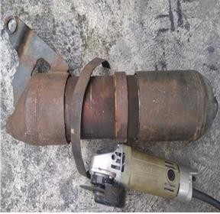 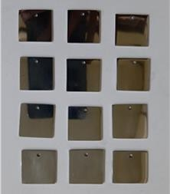

Figure 1. Specimens before cutting Figure 2. After cutting specimens

*2.4. Chromium Nickel Plating*

Chrome nickel plating on the exhaust is carried out using the electroplating method. Variations in nickel plating process time, namely: 30, 40, and 50 minutes with a current of 5 amperes, a voltage of 6 volts, and a temperature of 50 ℃ 4.The variations of the chromium plating process time were: 30, 40, and 50 minutes with a current of 5 amperes, voltage 6 volts, and temperature 50 ℃

The process is carried out at the Laboratory of Mechanical Engineering Materials, Tidar University.

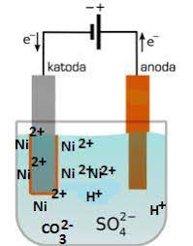

Figure 3. Electroplating Installation Series

2.5. Composition Test

The chemical composition test is carried out to determine the content of chemical elements contained in the test specimens used. Using The Thermoscientific ARL 3460 series Spectrometer test equipment

2.6. Corrosion Rate Testing

According to (Hegazy, 2018), the determination of the corrosion rate can be expressed by equation 2.

r = 0.129 (a x I_corr) / (n x D) (2)

Where :

r = Corrosion rate (mpy)

a = atomic mass number

Icorr = Corrosion current density (μ A / cm2)

0.129 = Constant for mpy

n = Atomic Valence

D = specific gravity of the specimen (gr / cm3)

3. Results and Discussion

3.1. Chemical Composition Test

From the results of chemical composition testing conducted at PT. Itokoh Ceperindo, Klaten, Central Java, the results show that the element of Carbon is 0.0178%, Silica 0.0345%, Manganese 0.0958% y

From the results of chemical composition testing conducted at PT. Itokoh Ceperindo, Klaten, Central Java, the results show that the element of Carbon is 0.0178%, Silica 0.0345%, Manganese 0.0958% y

ang indicates that the specimen is classified as a low carbon steel type.

|  |  |
| --- | --- |
|  |  |
|  |  |

Figure 4. Specimens of chromium nickel plating results

3.3. Corrosion Test

From the test results obtained the following graph:

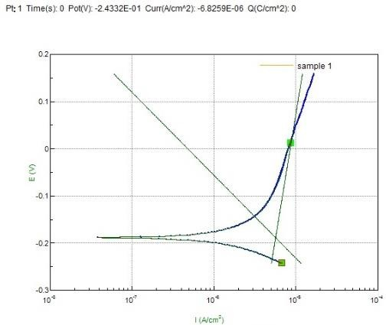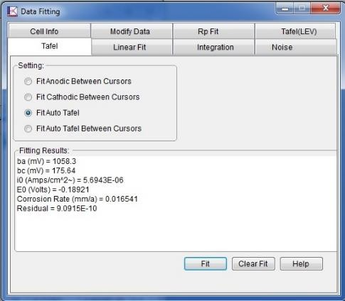

Figure 5.Results of the Icorr Value of Specimen Corrosion Test 1

Figure 5 is one of the Icorr results of the corrosion test on specimen 1, which occurs in the vehicle component (raw material) before being given the nickel-chrom coating. From this figure, the Icorr value is obtained to calculate the magnitude of the corrosion rate using the formula in equation 2. Then the results of the corrosion rate are graphed as shown in Figure 6.

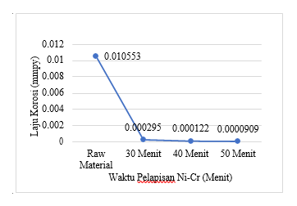

Figure 5. Effect of Ni-Cr Coating Time on Corrosion Rate

Figure 5 shows the relationship between the Ni-Cr coating time and the corrosion rate. From this figure, it can be seen that the longer the Ni-Cr coating time, the lower the corrosion rate value on the surface of the vehicle components and conversely, if the Ni-Cr coating time is faster, the corrosion rate will be higher. It is proven by the corrosion rate of 0.010553 mmpy of raw material, decreasing to 0.00000909 mmpy at 50 minutes of coating time at 40 minutes of coating time, and of 0.000122 mmpy. This is in accordance with previous research conducted by (Mahendra , 2018) and (Darmawan, 2015) Based on the data from the calculation of the corrosion rate, it is known that the longer the electroplating process time is used, the value of the corrosion rate in the specimen decreases. This occurs because the increasing of plating time results in a large number of nickel-chrome ions that coat the surface so that the surface density of the specimen increases. The longer the electroplating process is used, the lower the corrosion rate of the specimen will be.

Conclusion

1. Based on the objectives, research results and data obtained, the results of alternative research on the prevention of corrosion of vehicle components during a pandemic, the chemical composition of vehicle component specimens including low carbon steel

2. The corrosion rate of vehicle components is 0.000000909 mmpy on vehicle components after being coated with nickel-chromium for a coating time of 50 minutes.

Acknowledgments

The author would like to thank the support and facilities from the Laboratory of the Department of Mechanical Engineering, Tidar University

**Acknowledgments**

Penulis mengucapkan terimakasih atas dukungan dan fasilitas dari Laboratorium Jurusan Teknik Mesin Universitas Tidar

1. **References**

Asadikiya, M., Zhong, Y., & Ghorbani, M. (2019). Corrosion Study of Aluminum Alloy 3303 in Water-Ethylene Glycol Mixture: Effect of Inhibitors and Thermal Shocking. *International Journal of Corrosion*, *2019*. https://doi.org/10.1155/2019/9020489

Darmawan, S. (2015). PENGARUH VARIASI KUAT ARUS LISTRIK DAN WAKTU PROSES ELECTROPLATING TERHADAP KEKUATAN TARIK, KEKERASAN DAN KETEBALAN LAPISAN PADA BAJA KARBON RENDAH DENGAN KROM The Influence Variation of Strong Electric Current Time and Process Electroplating Power of Att. *Dinamika Teknik Mesin*, *5*(2), 66–71.

Hegazy, et all. (2018). Corrosion inhibition performance of a novel cationic surfactant for protection of carbon steel pipeline in acidic media. *International Journal of Electrochemical Science*, *13*(7), 6824–6842. https://doi.org/10.20964/2018.07.53

Mahendra. (2018). Analisis Pelapisan Nikel-Krom Terhadap Laju Korosi Pada Knalpot Sepeda Motor. *Jurnal Pendidikan Teknik Mesin*, *6*(03), 207–214.

Putri, A., & Handani, S. (2015). Karakterisasi Sifat Mekanik Hasil Elektroplating Nikel Karbonat (NiCO 3) Pada Tembaga (Cu). *Jurnal Fisika*, *4*(1), 83–90.