**Utilization Of Digital Application "Webtoon:Lazy Cooking" An Alternative Vocational Learning Media Cullinary Art**

**Nurul Ridhi Utami1* , Endang Mulyatiningsih2 and Nurul Ridha Utami3**

1.2 Family Welfare Education Postgraduate, Yogyakarta State University Program

Karangmalang Campus, Caturtunggal, Depok, Sleman, Yogyakartan Indonesia

3 Yogyakarta State University Art Education Postgraduate

Karangmalang Campus, Caturtunggal, Depok, Sleman, Yogyakarta, Indonesia

E-mail: [*nurulridhiutami@gmail.com*](mailto:nurulridhiutami@gmail.com)

**Abstract.** *This study aims to reveal the benefits of digital applications, namely webtoon: lazy cooking as an alternative to vocational learning media for culinary majors. This research is a journal study research model, which describes some of the research findings and then implements the results. The results show that in the current digital era, digital comic applications, one of which is the webtoon, provides an attractive cooking comic appearance and clear material exposure. This can be an alternative learning media, especially in the culinary department. In the use of digital webtoon applications: lazy cooing required socialization, namely the introduction and preparation of educators so that they can use the digital webtoon application optimally. The digital application, namely webtoon: lazy cooking, can be used well as a vocational learning medium for the culinary department. So that the learning process becomes more effective and efficient for educators and students. And can provide solutions in overcoming problems in the teaching and learning process. This research is expected to be a reference and alternative in learning that can be applied to students.*

1. **Introduction**

In the current era of globalization, Indonesia is facing quite fierce competition between every special human resource (HR) at the global level. In fact, in the education sector, Indonesia has lagged behind up to 128 years. Iman Usman, Alumni of American Field Service and Co-Founder of Indonesia Future Leader and Co-Founder of Ruangguru.com, in Jakarta, Edunews.Id said that “Indonesia has experienced 128 years of backwardness in terms of education, but when we live in Indonesia it seems there are no problems , but when we go abroad we are very far behind "(Editors et al., 2021). In improving and supporting the government to prepare a qualified and globally competitive young generation, it is necessary to have a strategy from every educator. Supported by Damansyah stated "Only a country with superior and intelligent human resources can win global competition and survive in the future"(Darmansyah, 2006). So it takes a good and appropriate strategy to produce high quality intellectual human resources.

Strategies that can be carried out include: making educators prepare good learning media, exchanging students at international companies, conducting training in the international world of work, providing international education. Various learning strategies carried out by educators as solutions and innovations in teaching and learning activities in the vocational field(Darmansyah, 2006);(Fatkhurrohkhman et al., 2017);(Tegeh, 2016); (Wahjusaputri et al., 2020). This is done to be able to prepare young people who are skilled, intelligent in thinking, attitudes, actions and culture, and have global competitiveness with "fulfillment of basic competencies, namely: knowledge, attitudes and skills"(Sunarmi & Jaedun, 2015). In addition to learning media, other internal problems are an obstacle to getting good quality and quality for educators for students who have 21st century skills, namely 4C (critical, creative, communicative and collaborative).

The current development of information and communication technology is supported by the internet which is easily accessible in the community as an activity to interact and exchange information. Various kinds of websites have developed in the community, one of which is the webtoon. The webtoon actively promotes itself to spoil the public, especially comic fans, which are made more attractive, namely online. According to research conducted by Harmoko et al, it was found that "the percentage value of the total feasibility of webtoon media is 79.5%. Meanwhile, the results of the response analysis have a total percentage of 85.24%. So that based on the percentage of achievement, this value is included in the interpretation of 76% - 100% "(Harmoko & Sumbawati, 2017).

Teenagers, especially students who love comics, are of course very familiar with the term "webtoon". Jang explained "Webtoon is a digital comic application that presents various genres of comics online"(Jang & Song, 2017);(Wulandari & Lestari, 2019). In it there are various types of comics that can entertain, provide the readers with the latest knowledge and information. In addition, as a vocational learning medium, especially in the culinary / culinary department. Therefore, this application can be used as a learning medium for educators and students to support students in having 21st century skills so that later they can compete globally. In addition, according to Kim et al, "webtoon and other digital comics also have an impact on every individual, namely creativity in thinking."(Kim & Yu, 2019);(Lee, 2013);(Sunarmi & Jaedun, 2015).

*Webtoon*"Lazy cooking" tells of a woman who likes to cook. In the storyline, this comic from Thailand provides tips on cooking. This helps students, especially vocational cooking, understand the processing and presentation of dishes in a more enjoyable way.

In the teaching and learning process, several problems were found in the field, seen from the preparation of educators to provide information or knowledge to students who were deemed to be “not keeping up with the times that were starting to develop. Due to the less optimal use of the learning media used "(Wahjusaputri et al., 2020). Many people view mobile devices / smartphones as "a tool that can only be used as a means of entertainment and communication, even though it really helps the learning process from an educational perspective"(Hadi & Marpanaji, 2019);(Lesmono et al., 2018);(Majid & Ridwan, 2019). One of them is simulation-based learning media and virtualization technology. It is hoped that when faced with the problem of limited tools, materials, time (learning time in class / lab / workplace), and learning systems that must take turns and groups, it will be very helpful to overcome student learning difficulties, "effective and efficient for the cost of advice and infrastructure. between students and educators "(Mahnun, 2019);(Putri & Lubis, 2018);(Wahyu et al., 2017);(Witarti & Puspitasari, 2018). Besides that it can be used as a reference and "alternative media in student learning"(Lestari & Kusrini, 2012)

Based on the description that has been conveyed, the purpose of this study is to reveal the benefits of digital applications, namely webtoon: lazy cooking as an alternative to vocational learning media for culinary majors. With the hope that webtoon: lazy cooking can be an alternative learning media that is effective and efficient for educators and students. As well as solutions that can help overcome problems in the teaching and learning process.

1. **Research Method**

This study uses a secondary literacy study, a non-interactive qualitative approach that is "starting from the data and ending with the conclusions of the research results from the researchers."(Hutagalung & Utomo, 2017; Nurhayati, 2018; sudrajat & Moha, 2019).

1. **Results And Discussion**

Supported by research(Harmoko & Sumbawati, 2017);(Harmoko & Sumbawati, 2017)"Learning media is anything that is used to transmit messages and can stimulate students' thoughts, feelings, attention and willingness" so as to encourage a deliberate, purposeful and controlled learning process. In the learning process the media has a function as a carrier of information from the suber (teacher) to the receiver (student). Media is part of the learning component, the benefits and functions of media in learning are greatly felt by both educators and students. The success of the media in improving the quality of student learning is determined by how the teacher's ability to choose the media to be used.

According to the meaning, there are several considerations that need to be made by the teacher to choose the media, namely: "a. Student considerations, b. Consideration of learning objectives, c. Consideration of learning strategies, d. Consideration of ability in designing and using media, e. Cost considerations, f. Consideration of facilities and infrastructure, and g. Efficiency and effectiveness considerations "(Mahnun, 2019).

The webtoon industry emerged at the turn of the century as a new genre in the Korean culture industry through the increase in web users in the Internet age. “Webtoons can be created and shared by anyone, and they don't need to be trained first. They can freely upload webtoon episodes consisting of stories and graphics on their own blog. The webtoon was created by amateurs in 1999 as illustrated notebooks or visual essays. Webtoons are published online free of cost because they are not designed to be commercially oriented. "(Jang & Song, 2017);(Lee, 2013)

“The term webtoon, a combination of the words web and cartoon, was coined when Korea created webcomics or manhwa published online. Webtoons are also known as mobile cartoons, digital comics, web manhwa in Korean, and keitai manga in Japanese "(Jang & Song, 2017);(Wulandari & Lestari, 2019)The term webtoon, a combination of the words web and cartoon, was coined when Koreans created webcomics or manhwa that were published online. Webtoons are also known as mobile cartoons, digital comics, web manhwa in Korean, and keitai manga in Japanese. Supported by research conducted by Ji-Hyeon Kim et al "provide a place for creative workers to process and serve food"(Kim & Yu, 2019).

Webtoon writers have created great content and have welcomed its golden age. "The term webtoon is used to differentiate it from comic books that are published as the purpose the webtoon was created for is viewed on the web"(Jang & Song, 2017).

The results of research conducted by Wulandari et al. Show that students have a stronger interest and motivation towards online cartoons, these results indicate that students have a stronger interest and motivation towards online cartoons.(Wulandari & Lestari, 2019);(Wahjusaputri et al., 2020);(Putri & Lubis, 2018). So that in this research, it is expected that lazy cooking webtoon can generate positive interest and motivation to be more creative and facilitate understanding for students.

Research conducted by Witarti found that "online media has an effect on adolescent preparedness although it is still not optimal"(Witarti & Puspitasari, 2018). Supporting this research, that the webtoon is expected to increase preparedness in processing and serving dishes. In addition, "online learning also opens opportunities for students to learn independently and adds a variety of experiences, knowledge and skills"(Czerkawski, 2016).

In this study, lazy cooking webtoon can effectively and efficiently help provide solutions to learning media problems. At a minimum, it can be used as an alternative in digital learning media. The research conducted by Wahyu revealed that "the development of digital learning media is actually effective in improving learning outcomes"(Wahyu et al., 2017);(Czerkawski, 2016);(Lestari & Kusrini, 2012);(Radovan & Perdih, 2016). Also supported by research conducted by Sunarmi "The development of multimedia learning outcomes in Patiseri is suitable for learning media and effectively improves student learning outcomes."(Sunarmi & Jaedun, 2015);(Lesmono et al., 2018). Other research conducted by Majid suggests that digital applications have a good effect and deserve to be a good solution as an alternative to learning innovation(Majid & Ridwan, 2019);(Mahnun, 2019); (Harmoko & Sumbawati, 2017).

*Webtoon* One of which can be used as a learning media for vocational culinary learning is lazy cooking. From the explanation of previous research, digital applications, namely webtoon: lazy cooking, can be used well as an alternative to vocational learning media for the culinary department. So that the learning process becomes more effective and efficient for educators and students. And can provide solutions in overcoming problems in the teaching and learning process.

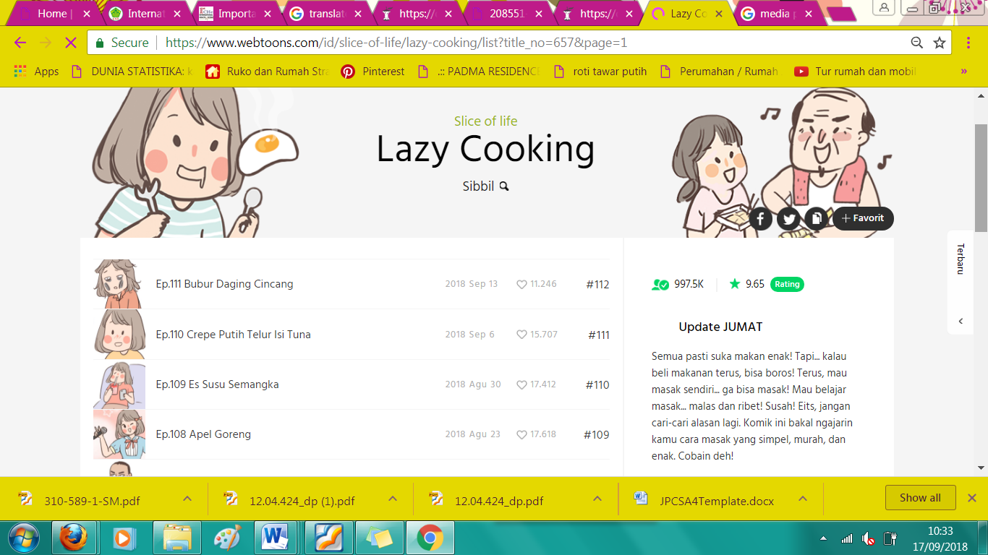

**Figure 1 Webtoon Lazy Cooking**

1. **Conclusion**

The digital application, namely webtoon: lazy cooking, can be used well as an alternative to vocational learning media for the culinary department. So that the learning process becomes more effective and efficient for educators and students. And can provide solutions in overcoming problems in the teaching and learning process.

**Acknowledgments**

Our gratitude goes to Prof. Dr. Endang Mulyatiningsih, M.Pd. who has directed the completion of this article and the team that drafted the ICTVT 2021 writing manual which is the basis for the preparation of this writing layout.

1. **References**
2. Czerkawski, Bc (2016). Blending Formal And Informal Learning Networks For Online Learning. International Review Of Research In Open And Distance Learning, 17 (3), 138–156. Https://Doi.Org/10.19173/Irrodl.V17i3.2344
3. Darmansyah. (2006). Learning Strategies With Humor. Industrial Engineering Scientific Journal, 4 (3), 147–154.
4. Fatkhurrohkhman, M., Permata, E., Ekawati, R., & Rizal, Su (2017). Development Of Digital Engineering Learning Tools Based On Project Based Learning The Teaching Devices Development Of Digital Engineering Using Project Based Learning In. Vocational Education, 7 (1), 101–109.
5. Hadi, Tr, & Marpanaji, E. (2019). Designing And Quality Testing Of "Digichip" Virtual Simulation Software Of Android Platform For Mobile-Virtual Learning Supporting Vocational Mechatronics Engineering. Journal Of Vocational Education, 9 (2), 105–118. Https://Doi.Org/10.21831/Jpv.V9i2.23570
6. Harmoko, Db, & Sumbawati, Ms (2017). Mobile Webtoon Development In The Course Of Game Programming At The State University Of Surabaya. Journal Of It-Edu., 02, 102–109.
7. Hutagalung, T., & Utomo, D. (2017). Meta-Analysis Of Research Variations From Accounting Researchers In Indonesia. Diponegoro Journal Of Accounting, 6 (4), 352–362.
8. Jang, W., & Song, Je (2017). Webtoon As A New Korean Wave In The Process Of Glocalization. Kritika Kultura, 2017 (29), 168–187. Https://Doi.Org/10.13185/Kk2017.02908
9. Kim, Jh, & Yu, J. (2019). Platformizing Webtoons: The Impact On Creative And Digital Labor In South Korea. Social Media And Society, 5 (4). Https://Doi.Org/10.1177/2056305119880174
10. Lee, S. (2013). A Study On Strategic Modeling To Develop Comics Content With Smart Device Platform. International Journal Of Smart Home, 7 (6), 1–10. Https://Doi.Org/10.14257/Ijsh.2013.7.6.01
11. Lesmono, Ad, Bachtiar, Rw, Maryani, & Muzdalifah, A. (2018). The Instructional-Based Andro-Web Comics On Work And Energy Topic For Senior High School Students. Journal Of Indonesian Science Education, 7 (2), 147–153. Https://Doi.Org/10.15294/Jpii.V7i2.14245
12. Lestari, Sy, & Kusrini, K. (2012). Developing A Mobile Application "Asian Recipes (Indonesian, Chinese, Japanese)" Based On Android. Management Data And Information Technology (Dasi), 13 (1), 36.
13. Mahnun, N. (2019). Learning Media (Study Of The Steps For Selecting Media And Their Implementation In Learning For Elementary School Children). Journal Of Islamic Studies, 14 (1), 87–99.
14. Majid, Nwa, & Ridwan, T. (2019). Development Of The Traditional Digital Games For Strengthening Childhood's Verbal Skills. Journal Of Vocational Education, 9 (1), 75–82. Https://Doi.Org/10.21831/Jpv.V9i1.22802
15. Nurhayati, S. (2018). Performance Of Intake At Annual Report: Case Study For 2016 Report On Library Center For Social Economic Research And Marine. Pari Journal, 4, 1–10.
16. Putri, Dm, & Lubis, Ee (2018). The Influence Of Social Media Line Webtoon On Comic Reading Interest In Riau University Students. Student Online Journal Of The Faculty Of Social And Political Sciences, 5 (1), 1–15.
17. Radovan, M., & Perdih, M. (2016). Developing Guidelines For Evaluating The Adaptation Of Accessible Web-Based Learning Materials. International Review Of Research In Open And Distance Learning, 17 (4), 166–181. Https://Doi.Org/10.19173/Irrodl.V17i4.2463
18. Editors, B., Galau, K., & Lemos, Dr (2021). Indonesian Educators 128 Years Old. Edunews.Id. Https://Www.Edunews.Id/Edunews/Pend Pendidikan/Pend Pendidikan-Indonesia-Tertatuh-128-Tahun
19. Sudrajat, D., & Moha, I. (2019). Variety Of Qualitative Research. Equilibrium, 5 (9), 1–8. Https://Doi.Org/10.31227/Osf.Io/Jaxbf
20. Sunarmi, T., & Jaedun, A. (2015). Development Of Multimedia Learning Patiseri Developing Patisserie Teaching Multimedia For. Journal Of Vocational Education, 5 (1), 132–144.
21. Tegeh, Im (2016). Implementation Of Innovative Learning Models For Vocational Education. National Seminar On Vocational And Technology (Semnasvoktek), 225–234.
22. Wahjusaputri, S., Marlina, E., & Latifah, S. (2020). Developing The Teaching Factory Learning Media In A Public Vocational High School. Journal Of Vocational Education, 10 (1), 69–79. Https://Doi.Org/10.21831/Jpv.V10i1.30222
23. Wahyu, A., Wirawan, Dyah, C., Indrawati, S., & Rahmanto, An (2017). The Development Of Learning Media Archives To Improve Student Learning Outcomes Smk Negeri 3 Surakarta. Journal Of Vocational Education February, 7 (2017), 78–86. Http://Journal.Uny.Ac.Id/Index.Php/Jpv
24. Witarti, Di, & Puspitasari, A. (2018). The Effect Of Disaster Information In Online Media Tirton. Defense Journal, 4 (1), 61–75. Http://Jurnal.Idu.Ac.Id/Index.Php/Defensejournal/Article/View/253/Pdf4
25. Wulandari, Ra, & Lestari, Re (2019). The Effectivness Of Webtoon For Efl Student In Mastering Vocabulary. Cell- Conference Of English Language And Literature. Https://Semnas.Untidar.Ac.Id/Wp-Content/Uploads/2019/07/Rizqi-Ayu-Wulandari-Rodhiana-Eka-Lestari-Siti-Laras-Utami-The-Effectivness-Of-Webtoon-For- Student-In-Mastering-Vocabulary.Pdf