SPATIAL PATTERN ANALYSIS OF THE COVID-19 PANDEMIC IN BALIKPAPAN CITY

Purris Rachelina Girsang1,a),Nur Anggraeni2, Nava Chairunisa Nabila3 and Achmad Ghozali 4)

Author Affiliations

1Institut Teknologi Kalimantan,Balikpapan,Indonesia   
2Institut Teknologi Kalimantan,Balikpapan,Indonesia

3Institut Teknologi Kalimantan,Balikpapan,Indonesia

4Institut Teknologi Kalimantan,Balikpapan,Indonesia

Author Emails  
a)Corresponding author: purris.girsang@gmail.com

**Abstract.** The spread of the COVID-19 pandemic in Indonesia was recorded since March 2020 and continued to increase until this research was conducted. The process of transmission caused this pandemic outbreak to spread widely to various regions. The spread of the COVID-19 pandemic has had an impact on various aspects of human life. Based on data from the Balikpapan City COVID-19 Task Force, it was identified a significant increase in cases of the COVID-19 pandemic, where at the beginning of the pandemic there were 6 cases on March 23, 2020 and on February 26, 2021 there were 8,990 positive cases of COVID-19 in Balikpapan City. These conditions indicate that the spread of infectious diseases can be viewed geographically. Therefore, a geospatial-based analysis needs to be carried out to analyze and understand the transmission of COVID-19, as well as detect areas at risk of exposure to COVID-19 in Balikpapan City. The purpose of this study was to determine the spatial distribution pattern of the COVID-19 pandemic in Balikpapan City in the period March 2020 – February 2021. The analytical method used in this study was spatial analysis using a hot spot analysis tool with ord gi* statistics. The results showed that Balikpapan City has a varied distribution pattern for the COVID-19 pandemic, namely 4 sub-districts units in the hot spot category and 1 sub-districts unit in the cold spot category. This grouping occurs because it is influenced by neighborhood aspects.

# Introduction

A pandemic or disease outbreak is a non-natural disaster that can be transmitted within the community with a number of sufferers that exceeds the usual situation at a certain time and place (Gwitira, et. al., 2021), and has an alarming level of spread and severity (Irwan, 2017). The spread of infectious diseases is influenced by the interaction between two main factors, namely the ability of a disease to transmit the pathogen that infects the host and the characteristics of the human population that is the host in the proliferation of the pathogen at a certain time (Dangisso, et. al., 2020). Based on WHO statement, the COVID-19 pandemic is a new type of infectious disease caused by the SARS-Cov virus whose transmission process is from human to human. The spread of the COVID-19 pandemic in Indonesia was recorded since March 2020 with the first positive cases of 10 cases and continued to increase until this research was conducted. The process of transmission caused this pandemic outbreak to spread widely to various regions. The number of positive cases of COVID-19, which continues to increase rapidly, has led the Government to define COVID-19 as a type of disease that causes a Public Health Emergency (KKM) and establish the KKM COVID-19 in Indonesia. The high spread of the COVID-19 pandemic has had an impact on various aspects of human life such as the increasing number of fatalities, expanding the coverage area of the affected area, and having implications for broad socio-economic aspects in Indonesia. The process of transmission caused this pandemic outbreak to spread widely to various regions (Shariati, 2020). The number of positive cases of COVID-19, which continues to increase rapidly, has led the Government to define COVID-19 as a type of disease that causes a Public Health Emergency (KKM) and establish the KKM COVID-19 in Indonesia. The high spread of the COVID-19 pandemic has had an impact on various aspects of human life such as the increasing number of fatalities, expanding the coverage area of the affected area, and having implications for broad socio-economic aspects in Indonesia. The process of transmission caused this pandemic outbreak to spread widely to various regions. The number of positive cases of COVID-19, which continues to increase rapidly, has led the Government to define COVID-19 as a type of disease that causes a Public Health Emergency (KKM) and establish the KKM COVID-19 in Indonesia. The high spread of the COVID-19 pandemic has had an impact on various aspects of human life such as the increasing number of fatalities, expanding the coverage area of the affected area, and having implications for broad socio-economic aspects in Indonesia.

A disease outbreak can also be transmitted by the population in an area by looking at the incidence of cases from contact of infected individuals with other individuals which will eventually form a pattern of transmission and spread of disease (Suprihadi & Rudy, 2013). The challenge of the COVID-19 pandemic is also being faced by the City of Balikpapan, as one of the cities with the second highest cases in East Kalimantan Province. Based on data from the Balikpapan City COVID-19 Task Force, it was identified a significant increase in COVID-19 pandemic cases, where at the beginning of the pandemic there were 6 cases on March 23, 2020 and on February 26 2021 there were 8,990 positive cases of COVID-19. 19 in Balikpapan City. To suppress the spread of the COVID-19 pandemic, apart from the methods that have been used so far, need to emphasize the spatial aspect. This aspect is needed because the spread of disease can experience changes in the pattern of events due to an epidemiological transition which is strongly influenced by the demographic, socio-cultural, and socio-economic conditions of the community in an area (Rahajeng, 2012; Kondo, et. al., 2016). These conditions indicate that the spread of infectious diseases can be viewed geographically. Therefore, a geospatial-based analysis needs to be carried out to analyze and understand the transmission of COVID-19 (Islam, et.al., 2021), as well as detect areas at risk of exposure to COVID-19 in Balikpapan City. and socio-economic community in an area (Wardani, et. al., 2013). These conditions indicate that the spread of infectious diseases can be viewed geographically. Therefore, a geospatial-based analysis needs to be carried out to analyze and understand the transmission of COVID-19, as well as detect areas at risk of exposure to COVID-19 in Balikpapan City. and socio-economic community in an area (Meyers, 2012). These conditions indicate that the spread of infectious diseases can be viewed geographically. Therefore, a geospatial-based analysis needs to be carried out to analyze and understand the transmission of COVID-19, as well as detect areas at risk of exposure to COVID-19 in Balikpapan City.

# DATA AND METHOD

## Data Collection Method

This study uses the documentation study method which is a data collection technique that is indirectly addressed to the research subject in order to obtain information related to the object of research (Hamdi, 2020). The data needs obtained by documentation study activities include data on population data by age, population based on gender, population based on livelihood, number of positive cases of COVID-19 in Balikpapan City.

## Data Analysis Method

The data analysis method used in this study is spatial analysis using a hot spot analysis tool with getis ord gi* statistics. Hot spot analysis is used to determine the spatial distribution pattern of the COVID-19 pandemic in the period from March 2020 to February 2021 in every urban sub-districts in Balikpapan City. This method was carried out to detect the spatial clusters that were formed and were able to identify statistically significant spatial concentrations (Getis and Ord, 1992 in Kurniawan, et al., 2018). The initial hypothesis of this analysis is that there is no spatial autocorrelation between features. The Z-score and P-value generated in this analysis indicate whether the initial hypothesis can be rejected or accepted. P-value is the probability that is formed from a random process of spatial patterns, where the smaller p-value indicates the smaller the probability found in the spatial pattern (Getis and Ord, 1992 in Kurniawan, et al., 2018). The limit value of the P-value can be seen in the Z-score value, where the P-value and Z-score are related to the standard normal distribution which can be seen in Figure 1.

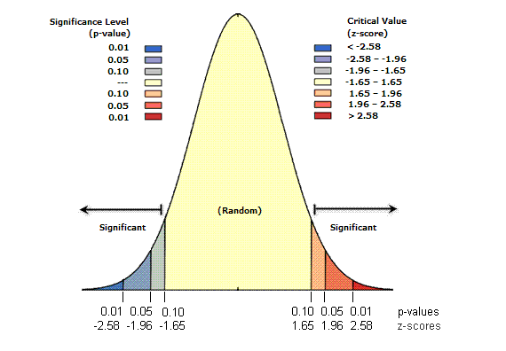

FIGURE 1. Normal Distribution Standard (Getis and Ord, 1992 in Kurniawan, et al., 2018)

1. Testing spatial autocorrelation with the Getis-Ord Gi* statistical approach. The statistical formulation of Getis-Ord G according to (Getis and Ord, 1992 in Sukarna, et al., 2017) is as follows

 (1)

Information :

$G \left(d\right)$ = Value Getis-Ord G

$X_{i}$*

= Feature value i

$X_{j}$ = Feature value i

$w_{ij}$ = Spatial weight between features i and j

1. Performing Getis-Ord G* statistical calculations using ArcGIS Software Performing statistical calculations on Getis-Ord G* using ArcGIS 10.3 software with hot spot analysis on spatial statistical analysis tools.
2. Interpreting the Z-score that has been obtained from the emerging Hot Spot analysis process in ArcGis software. This is done to provide an overview where spatial clusters are formed with features of high values ​​or low values. The interpretation of the results of the Z-score calculation according to (Getis and Ord, 1992 in Kurniawan, et al., 2018) is as follows

* If the Z-score is positive, it means that the larger the Z-score is positive, the more intense the grouping is to form a Hot Spot.
* If the Z-score is negative, it means that the smaller the Z-score is negative, the more intense the grouping is to form a Cold Spot.

# Result and discussion

## Overview of Balikpapan City Area

Balikpapan City is one of three cities in East Kalimantan Province. Balikpapan City is located between 116.5o East Longitude – 117.0o East Longitude and 1.0o South Latitudeg – 1.5o South Latitude. Balikpapan City has a land area of ​​503.3 km2 and has a marine management area of ​​160.10 km2. Balikpapan City has a hilly morphology of 85% and is located at an altitude of 0-100 masl. Balikpapan City consists of 6 (six) sub-districts, namely West Balikpapan District, North Balikpapan District, Central Balikpapan District, City Balikpapan District, South Balikpapan District, and East Balikpapan District, and has 34 (thirty four) urban sub-districtss. The administrative map of Balikpapan City can be seen in Figure 2.

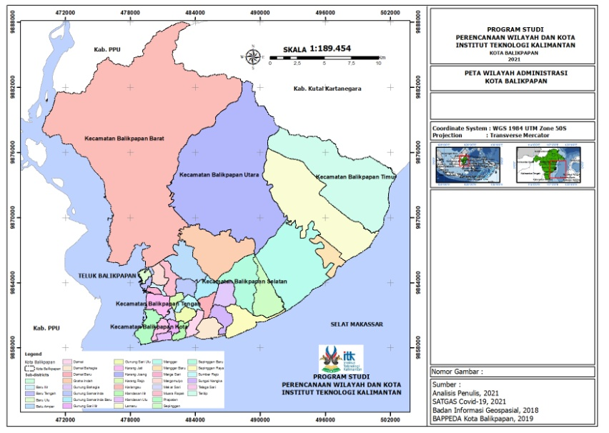

FIGURE 2. The Map of Balikpapan City (Analysis, 2021)

## Overview of the COVID-19 Pandemic in Balikpapan City

Balikpapan City is located in East Kalimantan Province and is the gateway to East Kalimantan and North Kalimantan provinces. This position makes Balikpapan City the epicenter of the distribution process of food, clothing and human movement. In early 2020, Balikpapan City experienced an increase in positive COVID-19 patients with red zone status. Positive cases continued to grow until this research was carried out, namely in February 2021 and again placing Balikpapan City as a red zone in East Kalimantan.

### Number of Positive Cases of COVID-19 for the Period March 2020-February 2021

The condition of the COVID-19 pandemic continued to increase significantly until the time this research was carried out, namely in February 2021. This was evidenced by the number of positive cases in Balikpapan City which previously in March 2020 had a total of 192 positive COVID-19 cases up to February 2021 reached a total of 15,035 positive COVID-19 cases. According to the Balikpapan City Health Office in 2021, Balikpapan City ranks second out of ten districts/cities in East Kalimantan Province with the highest total COVID-19 cases for one year). The following is the spatial distribution pattern of the COVID-19 COVID-19 pandemic at the beginning of the study, from March 2020 to February 2021, which can be seen in Figure 3. Positive cases of COVID-19 in Balikpapan City.



FIGURE 3. Graphic of the COVID-19 Development on March 2020 – February 2021 in Balikpapan City (Analysis, 2021).

The graph in 3. is an illustration of the total development of positive COVID-19 cases in the city of Balikpapan per sub-district from March 2020 to February 2021. In general, the growth of total positive cases has accelerated throughout the year, with the highest acceleration seen in June-August 2020. Sub-districts South Balikpapan and North Balikpapan experienced an increase in total positive cases, much higher than the other 4 sub-districts, with each of them being above 20,000 positive cases in February 2021. On the other hand, Balikpapan Kota, Central Balikpapan, West Balikpapan, and East Balikpapan sub-districts respectively -each recorded positive cases under 15,000 people in February 2021.The data also shows that only the West Balikpapan sub-district has experienced a slowdown in the growth of total positive cases, namely in September-December 2020, although not significantly.

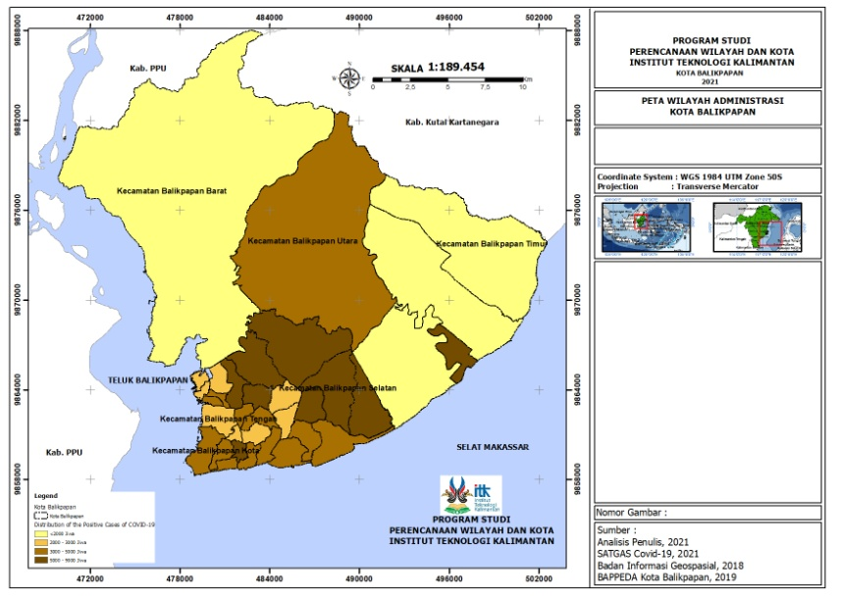

FIGURE 4. The Map of COVID-19 Case Distribution (Analysis, 2021)

Data on the distribution of positive COVID-19 cases can be displayed on the map in Figure 4. It can be interpreted spatially that positive cases of COVID-19 have spread throughout the Balikpapan City area. Where the highest spread of COVID-19 positive cases is indicated by dark brown in 8 sub-districts units, namely Gunung Sari Ilir Sub-districts, Graha Indah Sub-districts, Batu Ampar Sub-districts, Gunung Bahagia Sub-districts, Muara Rapak Sub-districts, Sepinggan Sub-districts, Sepinggan Baru Sub-districts, and Manggar Sub-districts. New. Based on the data on Positive Cases of COVID-19 for the City of Balikpapan in Appendix C., it can be seen that the Sepinggan Baru Sub-districts has the most total positive cases of COVID-19 for one City of Balikpapan, but if you look at its development, North Balikpapan District has contributed greatly to the addition of positive COVID-19 cases in Balikpapan City since the beginning of the pandemic. On the other hand, the Teritip Sub-districts has the lowest distribution of cases in Balikpapan City which is shown in light yellow on the map, this shows the total number of positive COVID-19 cases in the Teritip Sub-districts is less than 2000 people.

### Number of Positive Cases of COVID-19 by Age Group on March 2020-February 2021

The number of COVID-19 in Balikpapan City can also be described by age group. Based on data collected from the Balikpapan City Health Office, the results of the recapitulation of data on the number of positive COVID-19 cases based on age groups in the period March 2020 - February 2021 in Balikpapan City were obtained. The data can be displayed in the graph in Figure 5.



FIGURE 5. Number of Positif Case of COVID-19 by Age Group on March 2020 – February 2021 in Balikpapan City (Analysis, 2021)

The following graph shows the total number of positive COVID-19 cases in the city of Balikpapan per age group from March 2020 to February 2021. In general, each category has a variety of total positive cases, with the highest number being in the 25-29 year age group and 55-59 years, accounted for 1977 cases and 1812 cases, respectively. The relatively low number of positive cases (under 1,000 cases) was seen in the elderly (over 60 years) and young (under 19 years) age groups, with the lowest number of positive cases recorded in the under-five age group, which was 321 cases.



FIGURE 6. Percentage of Positif Case of COVID-19 by Age Group on March 2020 – February 2021 in Balikpapan City (Analysis, 2021)

The diagram in Figure 6. shows the percentage of the number of positive COVID-19 cases in the city of Balikpapan in 2 age groups, namely productive age (15-64 years) and non-productive age (under 15 years and above 64 years) in March 2020 to February 2021. The two age groups recorded a very disparate difference in the number of positive cases, where people of productive age accounted for up to 90% of the total positive cases of COVID-19 in the city of Balikpapan. Meanwhile, people of non-productive age only accounted for 10% of the total positive cases.

## Analysis of the Spatial Distribution Pattern of the COVID-19 Pandemic in Balikpapan City

Hot Spot Analysis (Getis-Ord G*) uses the concept of spatial relationships (neighborhood) Contiguity Edges Only, it is intended because the data owned is data in the form of polygons. Based on the analysis carried out using the Hot Spot Analysis (Getis-Ord G*) analysis technique on aggregate data of positive COVID-19 cases in the period March 2020 - February 2021, the ZScore and PValue values ​​were obtained which describe the significance value of the data held. The results of the analysis can be displayed in table 1.

TABLE 1. The Result of Hot Spot Analysis (Analysis, 2021)

| **Sub-districts** | ***ZScore*** | ***PValue*** | **Keterangan** |
| --- | --- | --- | --- |
| **Balikpapan Barat** | | | |
| Baru Ilir | -0,30 | 0,76 | Not Significant |
| Baru Tengah | -1 | 0,27 | Not Significant |
| Baru Ulu | -0,90 | 0,31 | Not Significant |
| Kariangau | 1,21 | 0,22 | Not Significant |
| Margo Mulyo | -0,52 | 0,60 | Not Significant |
| Marga Sari | -0,80 | 0,41 | Not Significant |
| **Balikpapan Utara** | | | |
| Batu Ampar | 1,88 | 0,05 | Significant 90% |
| Gunung samarinda | 1,69 | 0,08 | Significant 90% |
| Karang Joang | -0,26 | 0,79 | Not Significant |
| Muara Rapak | 0,92 | 0,35 | Not Significant |
| Gunung samarinda Baru | 2,17 | 0,02 | Significant 95% |
| Graha Indah | 1,36 | 0,17 | Not Significant |
| **Balikpapan Kota** | | | |
| Prapatan | -0,75 | 0,45 | Not Significant |
| Telaga Sari | -0,22 | 0,82 | Not Significant |
| Klandasan Ulu | 0,22 | 0,81 | Not Significant |
| Klandasan Ilir | 0,04 | 0,96 | Not Significant |
| Damai | -0,82 | 0,41 | Not Significant |
| **Balikpapan Tengah** | | | |
| Gunungsari Ulu | -0,48 | 0,62 | Not Significant |
| Gunungsari Ilir | -0,32 | 0,74 | Not Significant |
| Karang Rejo | 0,53 | 0,59 | Not Significant |
| Karang Jati | 0,01 | 0,98 | Not Significant |
| Mekar Sari | -0,86 | 0,38 | Not Significant |
| Sumber Rejo | -0,69 | 0,48 | Not Significant |
| **Balikpapan Selatan** | | | |
| Sepinggan | 0,71 | 0,47 | Not Significant |
| Gunung bahagia | 0,19 | 0,84 | Not Significant |
| Sepinggan Baru | 2,03 | 0,04 | Significant 95% |
| Sepinggan Raya | 0,95 | 0,33 | Not Significant |
| Sungai nangka | -0,40 | 0,68 | Not Significant |
| Damai Baru | -0,56 | 0,57 | Not Significant |
| Damai Bahagia | -0,75 | 0,45 | Not Significant |
| **Balikpapan Timur** | | | |
| Manggar | -0,07 | 0,93 | Not Significant |
| Lamaru | -1,49 | 0,13 | Not Significant |
| Teritip | -1,81 | 0,06 | Significant 90% |
| Manggar Baru | -0,81 | 0,41 | Not Significant |

This is done to provide an overview where spatial clusters are formed with features of high values ​​or low values. It was found that 3 sub-districts units had a statistically significant value of 90%, namely the Teritip Sub-districts, Gunung Samarinda Sub-districts and Batu Ampar Sub-districts. Two sub-districts units were found that had a statistically significant value of 95%, namely Sepinggan Baru Sub-districts and Gunung Samarinda Baru Sub-districts. The calculation results using Hot Spot Analysis (Getis-Ord G*) can be displayed on the map in Figure 7.

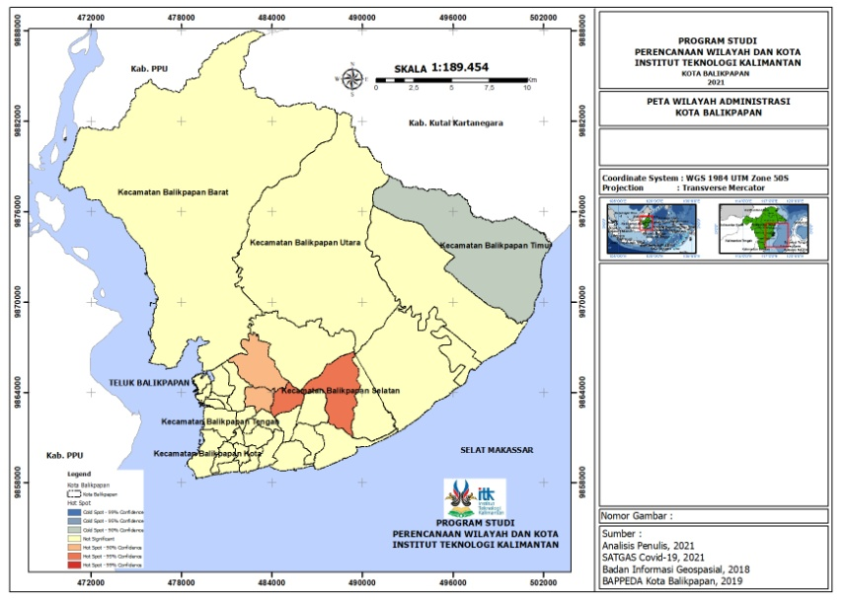

FIGURE 7. Results of Hot Spot Analysis (Analysis, 2021)

Based on Figure 7. it can be seen that Batu Ampar Sub-districts and Gunung Samarinda Sub-districts have large Zscore values, namely 1.884 and 1.69, respectively, which means that the larger the Zscore, positive, the more intense the grouping so as to form a Hot Spot with a significance of 90%. . It was also found that Gunung Samarinda Baru Sub-districts and Sepinggan Baru Sub-districts had Zscore values ​​of 2.17 and 2.03, respectively, resulting in intense grouping and forming Hot Spots with a significance of 90%. While the Teritip Sub-districts has the smallest Zscore value, which is -1.81 which means that the smaller the negative Z-score, the more intense the grouping to form a Cold Spot. On the other hand, there are 29 sub-districts units that have insignificant information, This is because the 29 sub-districts units are not included in either the Hot Spot or Cold Spot patterns. Furthermore, it can be shown in table 2. to see the sub-districts with the highest number of positive COVID-19 cases in Balikpapan City.

TABLE 2. Number of the Positive Cases of COVID-19 Based on the Most Cases (Analysis, 2021)

| **Sub-districts** | ***Number of COVID-19 Positif Cases (case)*** |
| --- | --- |
| Sepinggan Baru | 8076 |
| Gn. Samarinda Baru | 7691 |
| Batu Ampar | 7415 |
| Gn. Samarinda | 7306 |
| Manggar | 7252 |
| Muara Rapak | 7020 |
| Gn. Bahagia | 6024 |
| Gn. Sari Ilir | 5124 |
| Klandasan Ilir | 4893 |
| Karang Rejo | 4792 |
| Baru ilir | 4536 |
| Damai | 4460 |
| Klandasan Ulu | 4204 |
| Telaga Sari | 4059 |
| Damai Bahagia | 4045 |
| Sungai Nangka | 3934 |
| Prapatan | 3902 |
| Graha Indah | 3838 |
| Margomulyo | 3395 |
| Sumber Rejo | 3046 |
| Sepinggan Raya | 3044 |
| Baru tengah | 2939 |
| Sepinggan | 2937 |
| Mekar Sari | 2879 |
| Karang Jati | 2788 |
| Gn. Sari Ulu | 2688 |
| Baru ulu | 2587 |
| Damai Baru | 2328 |
| Manggar Baru | 1740 |
| Lamaru | 1526 |
| Margasari | 1418 |
| Kariangau | 1074 |
| Karang Joang | 1074 |
| Teritip | 879 |

If you look at the highest number of positive cases by sub-districts, it is known that the top 4 sub-districts units are sub-districts with the Hot Spot category, namely Gunung Samarinda Baru Sub-districts, Sepinggan Sub-districts, Gunung Samarinda Sub-districts, and Batu Ampar. If we look at the Z Score of neighbors from each sub-districts, it is found that 4 sub-districts with the Hot Spot category are influenced by neighboring sub-districts with a positive ZScore value. Likewise, if viewed from the lowest number of positive cases based on the sub-districts, then 1 unit of sub-districts is obtained with the Cold Spot category which is influenced by the neighborhood sub-districts with a negative ZScore value so as to form a Cold Spot.

# Conclusion

The spatial distribution pattern of the COVID-19 pandemic in Balikpapan City has a statistically significant value of 90%, so that 4 sub-districts units are included in the Hot Spot development, 27 sub-districts units are included in the not significant, and 1 sub-districts unit is included in the Cold Spot development. The formation of hot spots and cold spots is also influenced by elements of regional neighbourhood, where in this study the boundaries of the area used are the sub-districts level. So that a sub-districts with a hot spot category is the formation of a sub-districts that has a high Zscore value as well. By understanding the distribution pattern of the COVID-19 pandemic, it is hoped that this can be a recommendation for the government of Balikpapan City in making policies to control COVID-19.

# acknowledgements

The researchers sincerely thank Balikpapan COVID-19 Task Force and Health Agency of Balikpapan City for the availability of free-access data. The author's thanks go to the United States Geological Survey (USGS) for the ease of access and availability of free-access data. The researchers also extend their gratitude to those who in one way helped in the completion of this research study.

# references

1. Badan Pusat Statistik Kota Balikpapan. (12 July 2021). <https://balikpapankota.bps.go.id/>.
2. Dangisso, Mesay Hailu, Daniel Gemechu Datiko, Bernt Lindtjorn, *Identifying Geographical Heterogeneity of Pulmonary Tubercolosis in Southern Ethiopia: A Method to Identify Clustering for Targeted Interventions.* (Global Health Action, Swansea, 2020) 13(1):1785737. <https://dx.doi.org/10.1080%2F16549716.2020.1785737>
3. Gugus Tugas COVID-19 Balikpapan. (13 July 2021). <http://covid19.balikpapan.go.id/>.
4. Gwitira, Isaiah, Norbert Karumazondo, Munyaradzi Davis Shekede, Charles Sandy, Nicolas Siziba, Joconiah Chirenda, *Spatial Patterns of Pulmonary Tubercolosis (TB) Cases in Zimbabwe from 2015 to 2018*.( PLoS ONE, San Fransisco 2021) 16(4): e0249523. https://doi.org/10.1371/journal.pone.0249523.
5. Hafner, Christian M. *The Spread of the COVID-19 Pandemic in Time and Space*. (Int. Journal of Enviromental Research and Public Health, Basel 2021) 17(11). <https://dx.doi.org/10.3390%2Fijerph17113827>.
6. Irwan, SKM., M.Kes*. Epidemologi Penyakit Menular.* (Yogyakarta: CV. Absolute Media, 2017)
7. Islam, Ariful, Md. Abu Sayeed, Md. Kaisar Rahman, Jinnat Ferdous, Shariful Islam, Md. Mahmudul Hassan. *Geospatial Dynamics of COVID-19 Clusters and Hotspots in Bangladesh.* (Willey, 2021) 00:1-15.

https://doi.org/10.1111/tbed.13973.

1. Kondo, Keisuke. *Hot and Cold Spot Analysis Using Stata* (The Stata Journal,2016),pp 16(3): 613-631. https://doi.org/10.1177/1536867X1601600304.
2. Kurniawan, A., Sadali. *Pemanfaatan Analisis Spasial Hot Spot (Getis Ord Gi*) untuk Pemetaan Klaster Industri di Pulau Jawa dengan Memanfaatkan Sistem Informasi Geografis* (Universitas Gadjah Mada,2016)
3. Meyers, David. *A Spatial Cluster Analysis of Massachusetts Infection Disease Mortality, 2002-2011* (Thesis, Public Health Program. Tufts University, 2014)
4. Qamilah, Nurul, Agel Vidian Krama. *Difusi dan Pola Spasial Sebaran Penyakit Demam Berdarah Dengue (DBD) di Kota Bandar Lampung* (Jurnal KesMARS, 2018) ,pp.1 (1) : 87-95
5. Rahajeng, E. *Upaya Pengendalian Penyakit Tidak Menular di Indonesia*. Jurnal Informasi Kesehatan vol 2. (Direktorat PPTM, P2PL Kementrian Kesehatan RI, 2012)
6. Saifudin, Nanang. *Analisis Spasial dan Permodelan Faktor Risiko Kejadian Difteri di Kabupaten Blitar Tahun 2015* (Thesis, Faculty of Public Health, Universitas Surabaya, 2016)
7. Wardani, Dyah Wulan Sumekar Rengganis, Lutfan Lazuardi, Yodi Mahendradhata, Hari Kusmanto. *Pentingnya Analisis Closter Berbasis Spasial dalam Penanggulangan Tuberkolosis di Indonesia (*Jurnal Kesehatan Masyarakat, 2013) Vol. 8 No. 4. <https://doi.org/10.23960/jk%20unila.v1i2.1641>.
8. Shariati, Mohsen, Tahoora Mesgari, Mahboobeh Kasraee, Mahsa Jahangiri-rad. *Spatiotemporal Analysis and Hotspots Detection of COVID-19 Using Geographic Information System (March and April, 2020)* (Journal of environmental Health Science & Engineering, 2020), pp.18(2): 1499-1570. https://dx.doi.org/10.1007%2Fs40201-020-00565-x.
9. Sukarna, Wahidah Sanusi, HAfilah H. *Analisis Autokorelasi Moran’s I, Geary’s C, Getis-Ord G, dan LISA serta Penerapannya pada Penderita Kusta di Kabupaten Gowa*. Makassar: Universitas Negeri Makassar, 2017
10. Suprihadi, Rudy Latuperissa. *Pembuatan Model Transmisi dan Dinamika Persebaran Virus H5N1 Sebagai Sistem Manajemen Bencana Endemik Flu Burung di Kabupaten Semarang Provinsi Jawa Tengah dengan Pendekatan Statistik.* (Semarang: Universitas Semarang, 2013)
11. World Health Organization. *Infection Prevention and Control During Health Care When nCov (COVID-19) Infection is Suspected*. (Geneva: *World Health Organization*, 2020)