**Smart Air Pollution Monitoring System Planning Design in Manokwari**

Rio Octovinary Pramanagara1, a), Christian Dwi Suhendra2,b  and Duaitd Kolibongso 3,c)

1*University of Papua, Department of Electrical Engineering, Jl. Gn. Salju. Amban, Manokwari, West Papua Indonesia*

2 *University of Papua, Department of Informatics Engineering, Jl. Gn. Salju. Amban, Manokwari, West Papua, Indonesia*

3 *University of Papua, Department of Marine Science, Jl. Gn. Salju. Amban, Manokwari, West Papua Indonesia.*

a) Corresponding author: r.pramanagara@unipa.ac.idb) Corresponding author :[c.suhendra@unipa.ac.id](mailto:c.suhendra@unipa.ac.id)

c) [d.kolibongso@unipa.ac.id](mailto:d.kolibongso@unipa.ac.id)

**Abstract.** Air pollution is one of important factors that affecting on health. The increasing of populations and the activities of human in every sector has caused the air pollution. Polluting gases such as carbon monoxide (CO), nitrogen dioxide (NO2), and sulphur dioxide (SO2) are often the result of human activities specifically from the vehicles in the street. In Manokwari city, there are several points, especially during start of working hours and end of working hours has caused increase in traffic and contributing to pollution. To monitor the air quality in Manokwari, the Internet of Things (IoT) approach could be used to determine the air quality using sensors. Smart air pollution monitoring system design in Manokwari will be used on Raspberry Pi as IoT devices, Sensor MQ 135, MQ2 and dust particles sensor GPY2Y1014AU to determine the polluting gases. GPS module also be used in the system design, so that the user can see the air quality map in the smartphone, but if the users are not using a smartphone, Raspberry Pi 4 will also be used as BTS with YateBTS so that the user will receive the text message.

**Keywords:** polluting gases, carbon monoxide, nitrogen dioxide, sulphur dioxide, Raspberry Pi 4, Manokwari

**INTRODUCTION**

The government of the Republic of Indonesia regulates “Air Pollution Control” according to Government Ordinance Number 41 of 1999. The definition of air pollution based on article 1 of Government Ordinance Number 41 of 1999 is intake of substances, energy and/or other components into ambient air by human activities, thereby decreasing the ambient air quality to a level such that c ambient air will not be able to meet needs. Polluting gases such as carbon monoxide (CO), nitrogen dioxide (NO2), and sulphur dioxide (SO2) are often the result of human activities (Achmadi, 2014). Air pollution is an important factor affecting health. A number of epidemiology studies have shown that the impact of air pollution on health is detrimental to the public society, ranging from subclinical impact to untimely death (Samet et al, 2000).

Currently, countries all over the world experience high air pollution. According to WHO data in 2018 showed that 9 out 10 people breathe air with high pollutants and approximately 7 million die every year as result of air pollution (WHO, 2018). Manokwari Regency located in West Papua province is one of the largest cities on Papua Island with an area 1.556, 94 km2. According to the Statistic Agency in 2015, the population of Manokwari Regency is 201.218 (BPS, 2015). The increasing populations has caused an increase of activities in every sector. The increase of these activities has caused increases in traffic, particularly concentrated in some areas. In Manokwari city, there are several places and times, especially during start of working hours and end of working hours where contribution to pollution is particularly high. The source is from the mixed flow of private vehicles, public transportation and motor cycles. Some of the traffic points that have been identified are the T- intersection at Jl. Merdeka, intersection at Sanggeng, the intersection at Wosi and Jl. Baru. The traffic points have become places of high human activity where the street vendors and pedestrians are potentially exposed to the air pollution from the vehicles. Those polluting gases include carbon monoxide (CO), nitrogen dioxide (NO2) and sulphur dioxide (SO2).

Carbon monoxide is an odorless, colourless and toxic gas that is produced by fossil fuels burning gasoline resulting in emission from cars and trucks. Nitrogen dioxide is a combustion gas that has a pungent odor, brown, highly corrosive and is one of the main air pollutants. Sulphur dioxide is a gas formed when fossil fuel is burned and contains sulphur, odor, colourless and soluble in the water. The toxicity of carbon monoxide is often neglected because the gas is colourless and odorless, even though this gas is harmful if inhaled by humans because it can attach the oxygen in the blood. Carbon monoxide can have an impact on health, namely physiological pressure especially to people with heart disease and blood poisoning (Soedomo, 2011). At a certain concentration level, nitrogen oxide can react with haemoglobin having a similar impact to carbon monoxide which is to block the normal function of haemoglobin. The impacts are eye irritation and respiratory problems. High nitrogen dioxide gas concentration affects the environment and causes the air colour to turn brownish. This generates the production of photochemical smog compounds (ozone, aldehyde, peroxyacylnitrate) when it has reacted with the solar heat and hydrocarbons. The impact of these compounds on health are: infection of the respiratory system; eyes and lungs irritation, and contribution to health problems of other organs such as heart, liver and kidneys. Sulphur dioxide has been long known as a gas that causes irritation to the respiratory system, such as mucous membrane, larynx and trachea. This will cause pain in breathing, especially for vulnerable groups such as: people who have asthma; children, and elderly. When sulphur dioxide reacts with other chemical compounds it will form sulphate particles if inhaled and accumulate in the lungs and will cause pain in breathing; respiratory disease and even death (EPA, 2007).

The Internet of Things (IoT) approach could be used to monitor the air quality in Manokwari. IoT is used to measure the variables that determine the air quality using sensors to send data for processing. Smart air pollution has been developed before. The data collected through the sensor displays to an interface that has been designed to be accessible from the internet to any smartphone (Okokpujie et al, 2018). Another research project was also conducted by utilizing vehicles with sensors which collected the data and uploaded using smartphones to data centres allowing and to receive information on air quality (Okokpujie et al, 2018). This paper focuses on the application design of air quality monitoring in Manokwari so the people can have access to information based on IoT technology. The air quality parameters can be developed into air quality maps that can be accessed by smartphone. This paper will discuss the use of raspberry and gas sensors to collect the data which determines air quality and process that data so that the result can be displayed on the air quality map and updated periodically.

**EXISTING WORK**

Smart Air Pollution has been done in some previous research and its support to smart cities. Purwanto et, al (2019) have developed a monitoring system for sulphur dioxide level and the factors that affect air quality such as temperature, humidity, and wind speed using Wireless Sensor Network. In another study by Spanda & Shanmughasurandram (2018), IoT has been used to monitor carbon monoxide level, air quality, dust particles along with their coordinate points. The objective is that users can scan air pollution level by android smartphone, the result being displayed using google maps. The monitoring of air quality with the IoT approach has been done also by Campo et al (2019) where data is collected by network sensors and is displayed on websites and mobile phones. Besides being used as a tool to collect the data, Raspberry Pi is also used as Base Transmit Station (BTS) to perform communication such as making and receiving calls or sending and receiving messages. Soim et al, (2019) studied YateBTS based on BTS technology using Raspberry Pi which can be used as a solution for communication outside the BTS area coverage (rural area).

**PROPOSED WORK**

The IoT devices will be located at several potential crowding points in Manokwari.  The points are at Makelew intersection; Sanggeng intersection, Wosi intersection and T-intersection at Regent’s office.

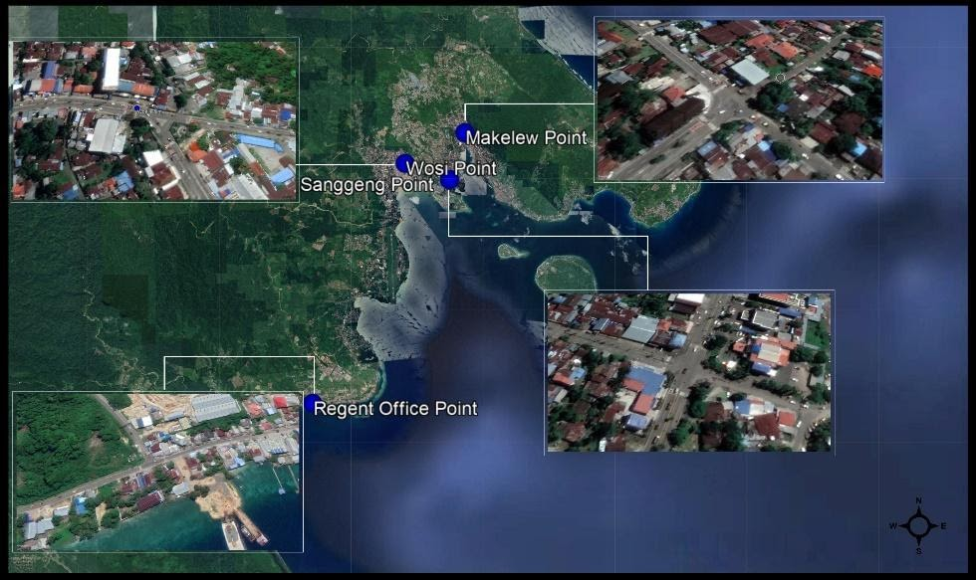

**FIGURE 1.** IoT Devices Location

The built system will collect the gas data using sensors and will upload the data to a web server which will periodically update air quality information on an air quality map. If someone is close to the coordinates of IoT devices or corresponds to the coverage area of YateBTS, they will automatically receive a short message that informs them of the air quality in the coverage area. It will also be displayed in an air quality monitoring application in Manokwari. People who do not have smart phones will receive air quality information by text message. Figure 2 below shows the design of the monitoring system as flowchart.

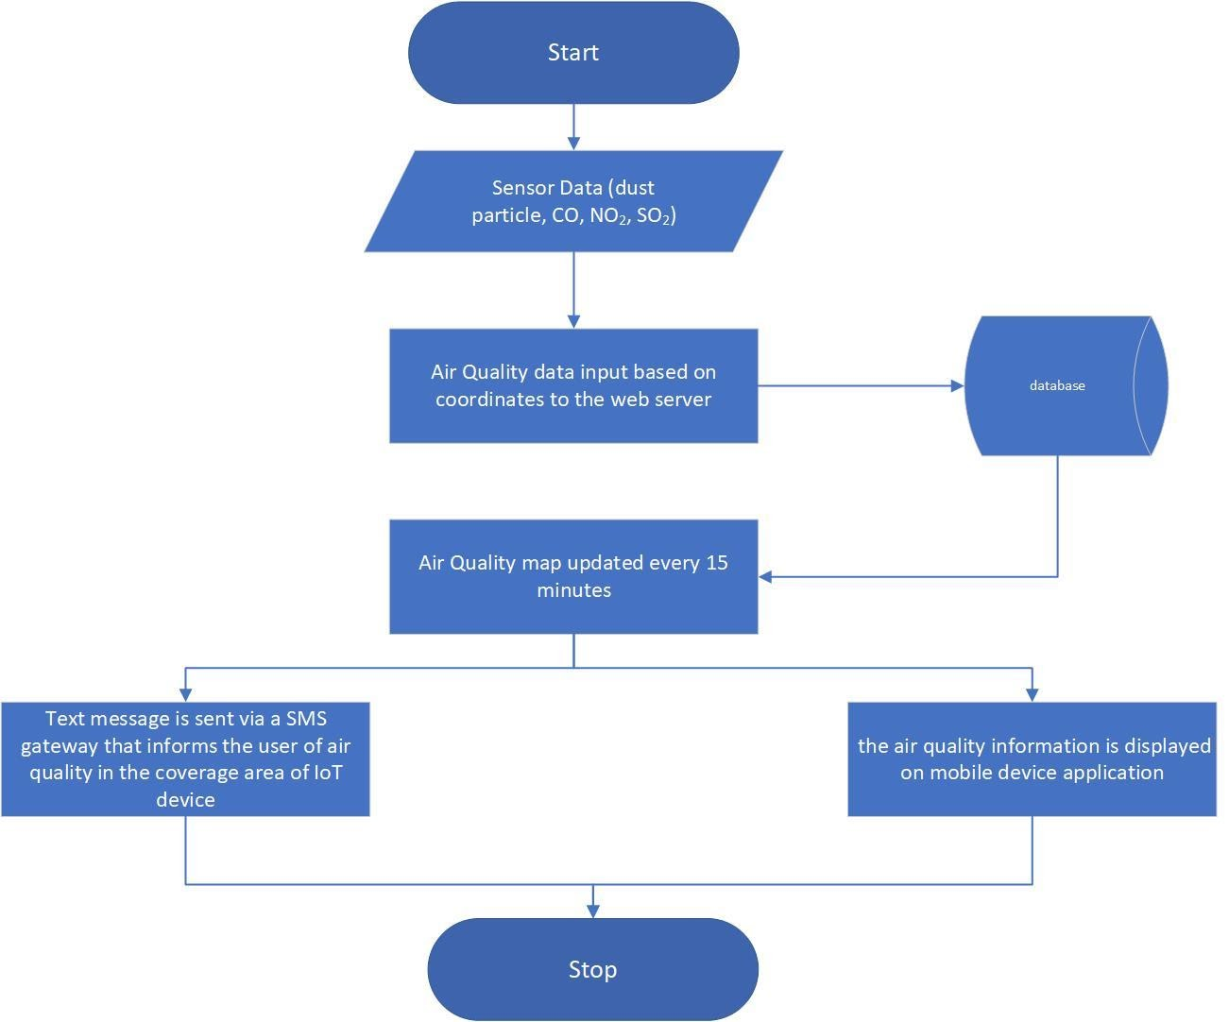

**FIGURE 2.** Design of Monitoring System Flowchart

The design of the air quality monitoring system will be based upon Raspberry Pi 5 processor, gas sensor MQ135, MQ2 and dust particles sensor GP2Y1014AU. GPS modules are also needed to collect location coordinates. To make the IoT devices as BTS a Quad band antenna is needed, bladeRF x40 as transmitter and receiver, and Yate BTS will make the device as private BTS to send the text message. The figure 2 below shows a block diagram design of air the quality monitoring system

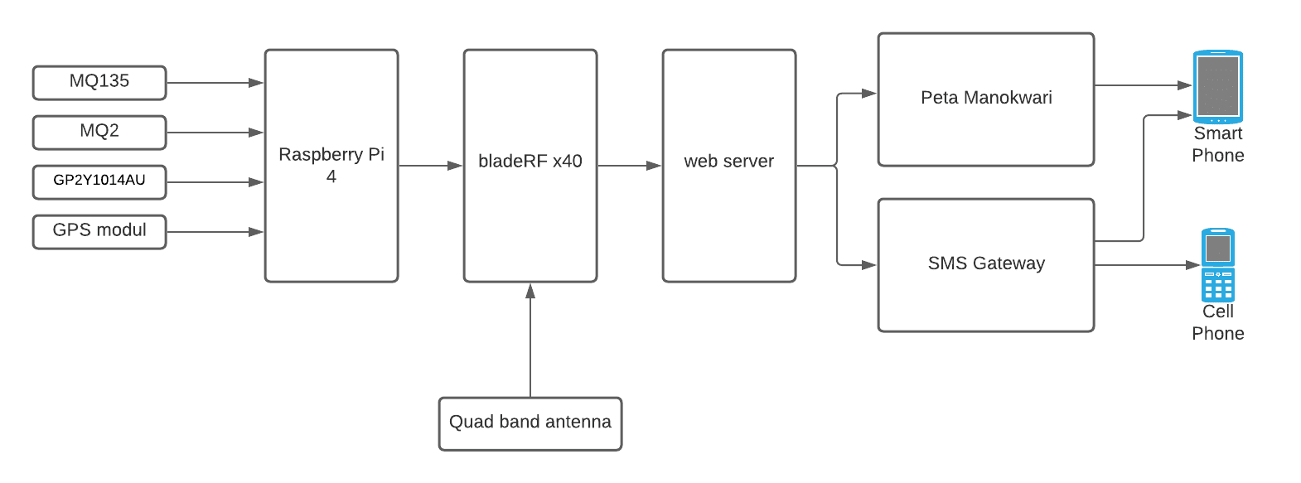

**FIGURE 3.** Block Diagram Design of Air Quality Monitoring System

**CONCLUSION**

The design of the air quality monitoring system will be used on Raspberry Pi 4 as IoT devices. Gas Sensor MQ135, MQ2 and dust particles sensor GP2Y1014AU used to collect the information that determines air quality. Those parameters will be mapped to each coordinate on the air quality map of Manokwari using a GPS module, so that the user can see the air quality in their smartphone. In this design Raspberry Pi will also be used as BTS with YateBTS. The function is to send the text message to the user if they are not using a smartphone.

**REFERENCES**

1. Achmadi, U . *Dasar-Dasar Penyakit Berbasis Lingkungan*. Rajawali Press, 2014.
2. Samet, Jonathan M, et al. “The National Morbidity, Mortality, and Air Pollution Study. Part II : Morbidity and Mortality from Air Pollution in the United States.” *Health Effects Institute*, vol. 94, ser. 3, June 2000. *3*.
3. WHO (World Health Organization) . 2018 . *Polusi Udara*
4. Badan Pusat Statistik Manokwari (2015)
5. Soedomo, M. *Kumpulan Karya Ilmiah Pencemaran Udara*. Bandung: Institut Teknologi Bandung, 2011.
6. EPA (Environmental Protection Agency) . 2007. *Air Pollution*
7. Kennedy Okokpujie, Etinosa Noma-Osaghae, Odusami Modupe, Samuel John and Oluga Oluwatosin, A Smart Air Pollution Monitoring System, International Journal of Civil Engineering and Technology, 9(9), 2018, pp. 799–809
8. Purwanto, P, et al. “Design of Air Quality Monitoring System Based On Web Using Wireless Sensor Network.” *Journal of Physics: Conference Series*, vol. 1295, 2019, p. 012043., doi:10.1088/1742-6596/1295/1/012043.
9. Spandana, G, and R Shanmughasundram. “Design and Development of Air Pollution Monitoring System for Smart Cities.” *2018 Second International Conference on Intelligent Computing and Control Systems (ICICCS)*, 2018, doi:10.1109/iccons.2018.8662932.
10. Gonzalez Campo, Maria Jose, et al. “A Proposal for An Air Quality Monitoring System for Cartagena De Indias.” *Proceedings of the 17th LACCEI International Multi-Conference for Engineering, Education, and Technology: “Industry, Innovation, and Infrastructure for Sustainable Cities and Communities,”* 2019, doi:10.18687/laccei2019.1.1.280.
11. Soim, Sopian, et al. “The Implementation of YateBTS Based GSM Using Raspberry Pi.” *Journal of Physics: Conference Series*, vol. 1500, 2020, p. 012005., doi:10.1088/1742-6596/1500/1/012005.