**Salt Iodization Technology To Improve Salt Quality**

**at IKM Sanolo Jaya Bima Regency**

Ruslan1,a), A Wiraningtyas1, A Sandi2, Ariyansyah3

*1Departement of Chemistry Education, STKIP Bima, West Nusa Tenggara, Indonesia*

*2Departement of Economic Education, STKIP Bima, West Nusa Tenggara, Indonesia*

*3Departement of Biology Education, STKIP Bima, West Nusa Tenggara, Indonesia*

a)Corresponding author: [ruslan_kim@stkipbima.ac.id](mailto:ruslan_kim@stkipbima.ac.id)

**Abstract**. The problems faced by salt farmers in Sanolo Village, Bolo District, Bima Regency, West Nusa Tenggara Province include the low quality of salt so that it does not meet the standards for use as consumption salt. In this activity, iodine fortification of salt has been carried out into iodized salt. The stages of activities carried out include salt drying, grinding, iodization and packaging. The result of this activity is that the application of salt iodization technology at IKM Sanolo Jaya can improve the quality of salt so that it can meet the standards as consumption salt. Processing of salt into iodized salt increases the selling value of salt by 500%. Changes in the behavior of partner groups in the use of science and technology to produce iodized salt.

**INTRODUCTION**

The salt commodity is the superior product of the Bima Regency which is the locomotive for the development of the fishery sector and a buffer for the salt industrialization in NTB. As a leading commodity that is a regional priority, salt management has been stated in the 2019-2024 NTB roadmap where Bima Regency is a salt industrialization area in NTB. In the next five years, the government has designed a salt industrialization scheme and in 2020 it will be focused on efforts to strengthen salt processing SMEs. In the context of developing the salt industry, the NTB Provincial Government has collaborated with the Bima Regency Government and the Ministry of Maritime Affairs and Fisheries. IKM Sanolo Jaya is a small and medium industry engaged in salt production. Some farmers have used the geomembrane method so that the salt produced has better quality or premium quality. However, the salt produced is still in the form of coarse salt so it must be further processed to be used as consumption salt. The price of krosok salt in Bima Regency tends to vary depending on the weather and salt season [1]. The high prices at the beginning of the season can only be enjoyed for a moment by some salt farmers who are very ready to prepare their production land before the dry season arrives. During the harvest season, the prevailing salt price at the farmer level does not provide incentives for salt farmers. From this fact, the income level of salt farmers is always very low. In general, smallholder salt farmers in Sanolo Village, Bima Regency, really hope for a salt industry that processes salt in Bima Regency, especially in Sanolo Village, Bolo District, Bima Regency. So that farmers can directly sell their salt products to the salt industry without having to go through traders or collectors who buy salt at low prices. Until now, there is only one company that buys salt in Bima Regency, namely PD Budiono Madura, so the opportunity to monopolize the price of salt is very wide open [2]. To avoid selling salt at low prices, farmers store salt, hoping that the price of salt at the salt farmer level will improve. Salt hoarding is a strategy that can be done to maintain business continuity as well as maintain salt demand in the market [3]. The low selling price of salt in IKM Sanolo Jaya is due to the low quality of salt. Therefore, with the existence of an iodized salt manufacturing industry, the selling price can reach Rp. 5,000 per kg or Rp. 150,000 per sack [4]. In this activity, the industrialization of salt products will be carried out so that salt from farmers is directly processed and then marketed in the form of iodized salt.

**EXPERIMENTAL PROCEDURE**

Processing of salt into iodized salt uses salt drying oven machines, salt grinding machines, iodization equipment and packaging. Coarse salt is dried in the oven for 30 minutes. The dried salt is then ground and then fortified with potassium iodate (KIO3) solution to produce iodized salt and packaged in plastic packaging.

**RESULT AND DISCUSSIONS**

Salt products produced by partner farmers at IKM Sanolo Jaya so far have been in the form of coarse salt. The salt cannot be used as consumption salt because it does not meet the standards. In this activity, iodine fortification of salt has been carried out into iodized salt. The stages of activities carried out include salt drying, grinding, iodization and packaging.

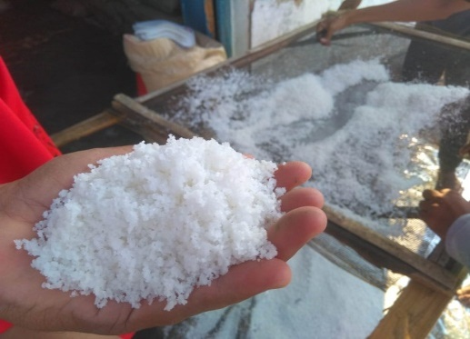

**FIGURE 1**. Salt as Raw Material

The salt used as raw material in this activity is a salt product using a geomembrane as shown in figure 1. Most of the farmers who join the Sanolo Jaya IKM group have used geomembrane plastic as a crystallization table, so that the resulting salt product has better quality than salt. produced using soil as a crystallization table [5]. Salt raw material in the form of coarse salt still contains water, so it needs to be dried to reduce the water content. In this activity, the drying process uses a gas-fueled oven. Salt drying was carried out for 30 minutes as shown in Figure 2.

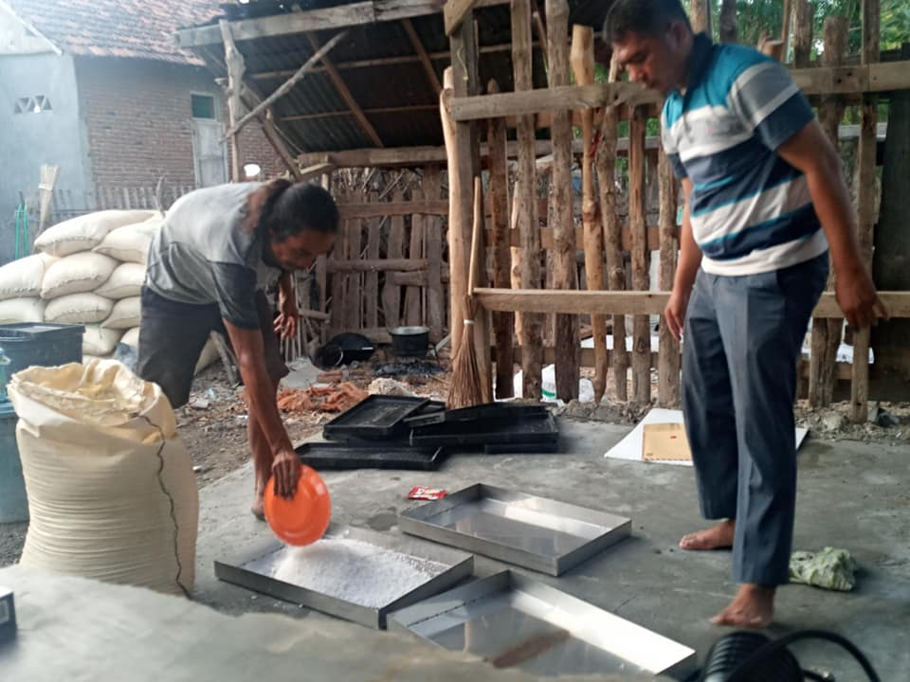

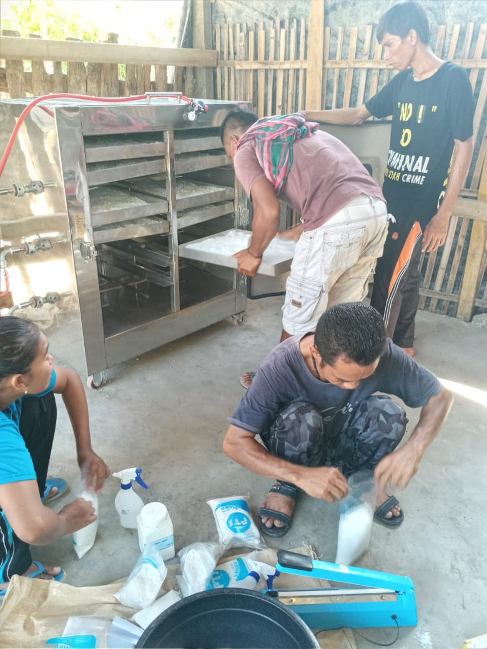

**FIGURE 2**. Drying Process

The coarse salt that has been dried is then subjected to a grinding process. Milling is done to smooth the salt crystals so that the iodine fortification process can be mixed evenly. The milling process is as shown in Figure 3.

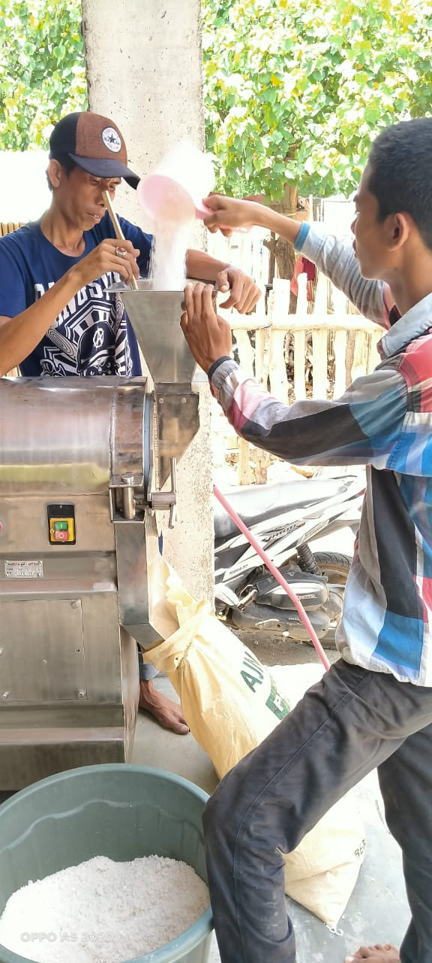

**FIGURE 3**. Milliing Process

The milling process uses a grinding machine with a capacity of 40-60 kg per hour. To produce fine salt crystals in the grinding process depending on the water content, the lower the water content in the salt, the finer the resulting crystals. The next stage is the process of fortification of iodine on salt that has been mashed. Iodine solution with levels of 30-80 ppm is sprayed on the salt crystals while stirring until evenly mixed. The process of iodine fortification and salt packaging is as shown in Figure 4.

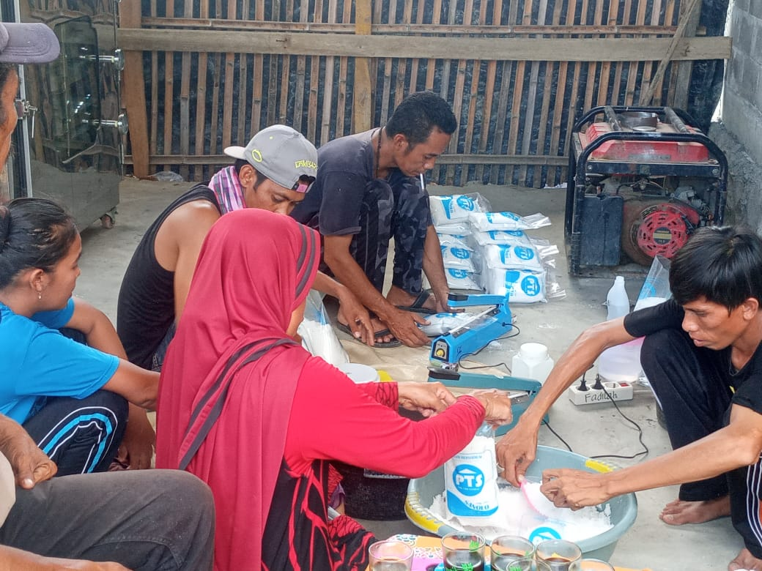

**FIGURE 4**. Process of iodine fortification and salt packaging

The production of iodized salt produces iodized salt products which are packaged in sizes of 1 kg and 250 grams. The selling price for the size of 1 kg is IDR. 5,000.00 This activity can increase the selling price of salt from IDR. 20,000.00 per sack measuring 60 kg to IDR. 150,000.00 per sack or an increase in price of about 500%.

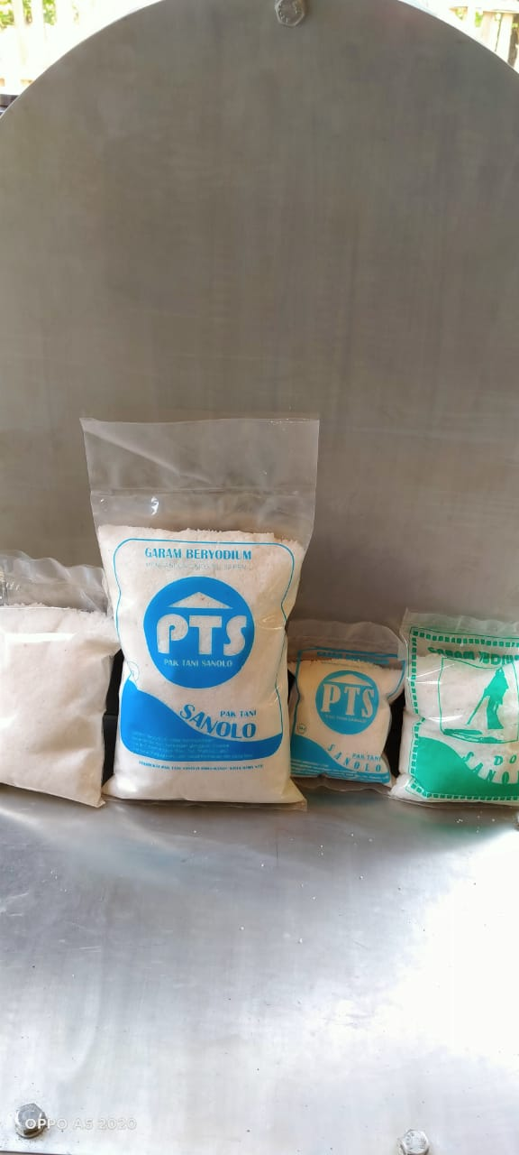

**FIGURE 5**. Iodized Salt Products

**CONCLUSIONS**

The application of salt iodization technology at IKM Sanolo Jaya can improve the quality of salt so that it can meet the standard as consumption salt. Processing of salt into iodized salt increases the selling value of salt by 500%. Changes in the behavior of partner groups in the use of science and technology to produce salt and process iodized salt.

**ACKNOLEDGMENTS**

The author would like to thank the Directorate of Research and Community Service, Directorate General of Research and Development Strengthening, Ministry of Research, Technology and Higher Education of the Republic of Indonesia who has funded this Community Service through the PPPUD scheme in 2021.

**REFERENCES**

1. Wiraningtyas, A. Sandi, A. Sowanto, Ruslan. *Jurnal Karya Abdi Masyarakat*. **1** (2), 138-145.  (2017).

<https://doi.org/10.22437/jkam.v1i2.4292>

1. Rahman, A., Raharja, S., Kadarisman, D. *Manajemen IKM*. **9** (1), 106-118. (2014).
2. Wiraningtyas, A., Sandi, A., & Ruslan, R. *MITRA: Jurnal Pemberdayaan Masyarakat*, **3**(1), 1-10. (2019). <https://doi.org/https://doi.org/10.25170/mitra.v3i1.494>
3. Rahayu, D. Awaliyah, N.S. Syahrimin. Busran. Afan, M. Wiraningtyas, A. Ruslan, Agustina, S. *Jurnal Redoks* **1** (1), 7 – 15. (2018). <https://doi.org/10.33627/re.v1i1.235>
4. Ruslan, Wiraningtyas, A., Sandi, A., Ariyansyah. Aptekmas : Jurnal Pengabdian Kepada Masyarakat **3** (4), 70-74. (2020). <https://doi.org/10.36257/apts.v3i4.2970>