**Optimization of Production Profit Using Genetic Algorithm**

**Rusmala1 , Suhardi2 and Heliawaty**3

1,2Universitas Cokroamin0to Palopo, Indonesia

3Universitas Sulawesi Barat, Majene, Indonesia

1. mail: [rusmala@uncp.ac.id](mailto:rusmala@uncp.ac.id)

**Abstract.** Based on the problems in each company, profit optimization the main problem in the production process, precise calculation and analysis is needed to get maximum profit. The purpose of this research is to apply genetic algorithms to optimize the profits from the production process of goods. The research method is based on a genetic algorithm which consists of the process of chromosome formation, fitness design, and reproduction. The variables needed are the type of production, size, production cost, selling price per item, profit per item, as well as the lowest demand and highest demand in one week. The lowest and highest limits are needed, that’s why, the optimization of the amount of production can be adjusted to market demand. Other data that must be taken into account is the maximum production cost per week. Maximum production cost and production capacity are needed so that the result of solution does not exceed the maximum limit of capital provided so constraint data is needed to obtain appropriate calculations based on constraint factors. The results showed that the greatest fitness value was in the population 75 a1 = 297, a2 = 122, a3 = 83, a4 = 464, a5 = 70, a6 = 90, a7 = 476, a8 = 83, a9 = 85 with the resulting fitness value was 64.59 with a total profit of 64,594,570. the results of the CR-MR calculation get the results of cr = 0.5 and mr = 0.5 and the average fitness obtained is 59.00.

1. **Introduction**

Every company, profit optimization was the main thing in the production process. Precise calculation and analysis is needed to support maximum profit achievement. High production will use a lot of capital, but if the low production the investors can not meet consumer needs. This requires proper production planning to prevent losses. Therefore, a precise calculation is needed to obtain an accurate and efficient maximum profit through the implementation of genetic algorithms. Genetic algorithms can be used for the calculation of production profit[1]. Genetic algorithms have the ability to solve various complex problems in facing optimization problems [2]. Several previous studies have discussed the problem of profit optimization, including research that discusses the application of genetic algorithms to maximize profit on goods production. The results of this research can be concluded that the value of the genetic algorithm parameter has an influence on the optimization results and the genetic algorithm is able to determine the combination of the production of goods to be produced in accordance with the capital and stock that is able to generate maximum profit[3]. The genetic algorithm requires testing to get the best parameters [4]. Testing is done to determine the size of the population, then testing the number of generations, then testing the combination of crossover rate and mutation rate.

1. **Method**

This research begins with data collection. The data that used, is the data from a factory that produces soap. The next stage was the analyzed data process following the genetic algorithm stage. Initialization carried out only once and produces an initial population with the number of chromosomes. The next process is to calculate the fitness value, crossover, and mutation of the chromosomes, that have been formed at the initialization stage. Python was used to calculate fitness, mutation and crossover values.

1. **Result and Discussion**

The data variables needed are the type of production, size, production cost, selling price per item, profit per item, lowest demand and highest demand in one week. The lowest and highest limits are needed so that the amount of production can be adjusted to market demand. The data is addressed in table 1.

**Table 1.** Data Production

|  |  |  |  |  |  |  |  |
| --- | --- | --- | --- | --- | --- | --- | --- |
| **No** | **items** | **Size** | **Cost Poduction**  **(Rp)** | **Price Selling  Per Item (Rp)** | **Profit  Per Item (Rp)** | **Lowest Demand (Pcs)** | **Highest demand**  **(Pcs)** |
|
| 1 | Sabun Cuci Piring | 5 liter | 47000 | 60000 | 13000 | 200 | 300 |
| 1.5 liter | 14400 | 25000 | 10600 | 100 | 150 |
| 600 ml | 5760 | 10000 | 4240 | 50 | 100 |
| 2 | Sabun Pakaian | 5 liter | 6350 | 75000 | 68650 | 200 | 500 |
| 1.5 liter | 19050 | 30000 | 10950 | 50 | 100 |
| 600 ml | 7620 | 15000 | 7380 | 50 | 100 |
| 3 | Parfum | 5 liter | 100000 | 150000 | 50000 | 200 | 500 |
| 1.5 liter | 40050 | 55000 | 14950 | 50 | 100 |
| 600 ml | 16020 | 25000 | 8980 | 50 | 100 |

Other data that must be taken into account is the maximum production cost per week. The maximum production cost and production capacity are needed so that the solution produced through the optimization process using genetic algorithms does not generate a production solution that exceeds the maximum limit of capital provided so that in this study constraint data is also needed to obtain appropriate calculations based on constraint factors. The data are shown in table 2.

**Table 2.** Constrain Data

|  |  |
| --- | --- |
| Constrain Data | |
| Production Capasity | 2.000 Liter |
| Maximum Production Cost | 782.900.000 |

1. Chromosome Formation

The number of samples used was 9 types of laundry soap. Then, this sample is used as a chromosome. The representational form of this chromosome is an integer. Each gene in a chromosome represents the number of items to be produced at one time (1 month). The chromosome length (StringLen) used is 9 which represents the items offered from each product. The chromosomes formed are shown in table 3.

**Table 3.** Chromosome Formation

|  |  |  |  |  |  |  |  |  |
| --- | --- | --- | --- | --- | --- | --- | --- | --- |
| a1 | a2 | a3 | a4 | a5 | a6 | a7 | a8 | a9 |

Based on the table above, there are 9 chromosomes that are formed based on the amount of data taken, namely 9, from which the data represents each item. Chromosome representations are shown in table 4

**Table 4.** Chromosome Representation

|  |  |  |
| --- | --- | --- |
| **Chromosome Representation** | | |
| a1 | Sabun cuci piring | 5 liter |
| a2 | Sabun cuci piring | 1.5 liter |
| a3 | Sabun cuci piring | 600 ml |
| a4 | Sabun pakaian | 5 liter |
| a5 | Sabun pakaian | 1.5 liter |
| a6 | Sabun pakaian | 600 ml |
| a7 | Parfum laundry | 5 liter |
| a8 | Parfum laundry | 1.5 liter |
| a9 | Parfum laundry | 1. ml |

1. Fitness Design

Determining the constraint function is done before calculating the fitness value. The constraint function used is the production capacity and the maximum production cost.

Obstacle 1 (C1):

Fund <78.290.000

47.000 + 14.400 + 5.760 + 63.500 + 19.050 + 7.620 + 133.500 + 40.050 + 16.020 ≤ 78.290.000

Obstacle 2 (C2):

Amount of Production <2000 liter

a1 + a2 + a3 + a4 + a5 + a6 + a7 + a8 + a9 ≤ 6000

Based on the effect of the constraint function on the fitness value, the fitness function can be searched by reducing the total profit by the total violation (penalty). The formula used is shown in Equation 1.

*Fitness(x1, x2) – M (c1+c2)......................................................................................(1)*

However, using the formula as shown in equation 3 has a drawback, namely the resulting fitness value is too large. Therefore, in this case, the researcher modifies equation 1 by dividing the results of the reduction in total profit and total penalties by a large number. In this case the denominator of 1,000,000 is used. The goal is that the range of fitness values is not too large. After modification, the fitness calculation formula is shown in equation 4.

$Fitness\left(x\right)=\frac{a1+a2+a3+a4+a5+a6+a7+a8+a9−\left(C1+C2\right)}{1.000.000}$*………....................(2)*

Fitness (x) is a function used to find fitness values. 47.000a1 + 14.400a2 + 5.760a3 + 63,500a4 + 19.050a5 + 7,620a6 + 133,500a7 + 40.050a8 + 16.020a9 is the formula used to find total profit if a1, a2, a3, a4, a5, a6, a7 are produced , a8, and a9. Meanwhile, C1 + C2 is the total number of violations committed by individuals. The values of C1 and C2 can be calculated through Equation 3 and Equation 4.

*C1 = $\left\{\begin{aligned}47.000a1 + 14.400a2 + 5.760a3 + 63.500a4 + 19.050a5 + 7.620a6 + 133.500a7 \\ + 40.050a8 + 16.020a9 ≤ 100.000.000 \\ 47.000a1 + 14.400a2 + 5.760a3 + 63.500a4 + 19.050a5 + 7.620a6 + \\ 133.500a7 + 40.050a8 + 16.020a9 ≤ 100.000.000; Selainnya\end{aligned}\right.$.....(3)*

*C2 = $\left\{\begin{aligned}a1 + a2 + a3 + a4 + a5 + a6 + a7 + a8 + a9 ≤ 2000 \\ a1 + a2 + a3 + a4 + a5 + a6 + a7 + a8 + a9 ≤ 6000; \end{aligned}\right.$ (4)*

Python programming language was used to apply genetic algorithms in optimizing the production value in this case study. The input data is shown in figure 1.

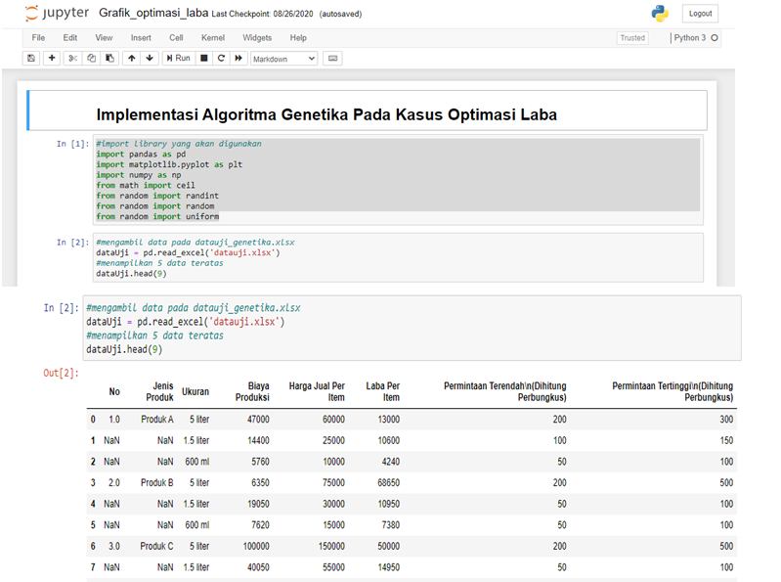

**Figure 1.** Data Input in Phyton

The calculation of the fitness, crossover and mutation values are shown in Figures 2, 3 and 4.

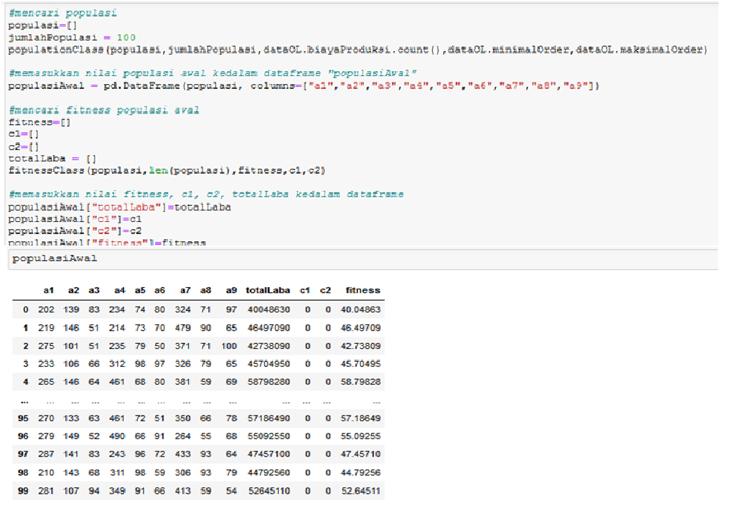

**Figure 2**. Fitness Value

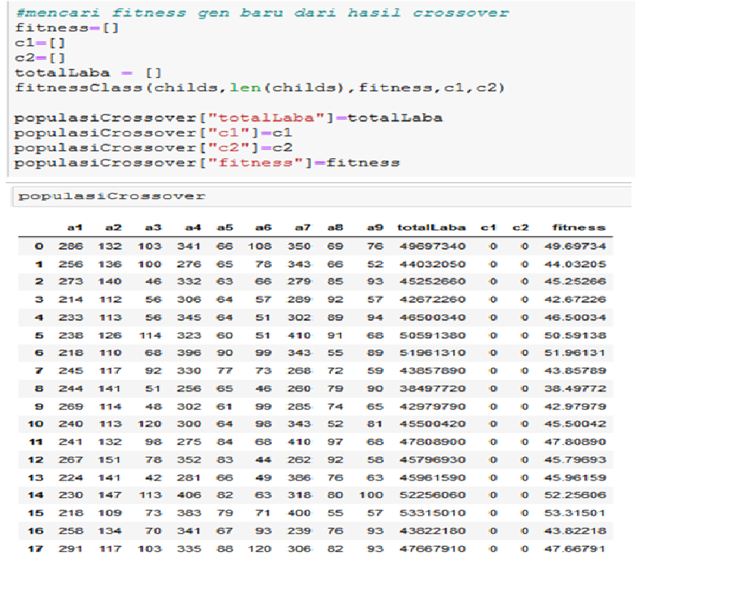

**Figure 3**. Crossover Process

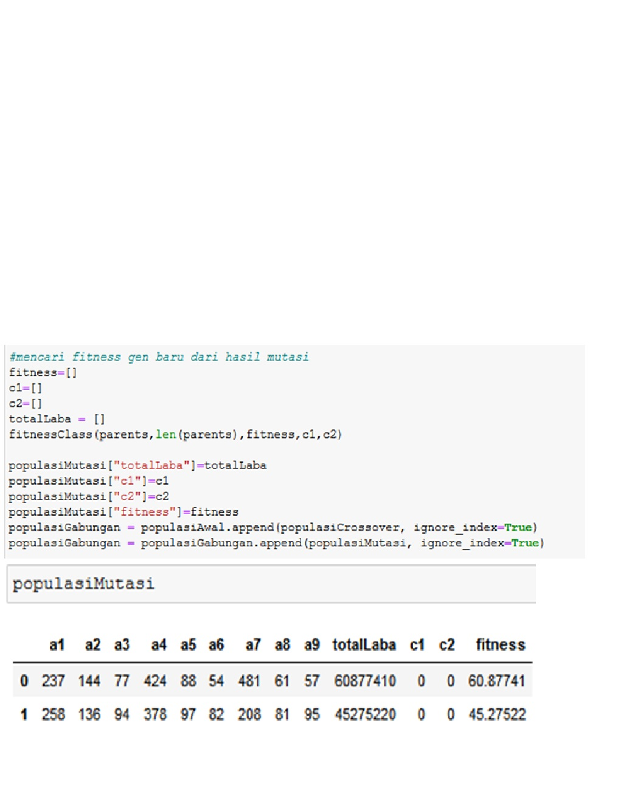

**Figure 4**. Mutation Process

After the process of calculating the fitness value, crossover and mutation, the next step is selection. At the selection stage, the best value or solution was searched for production profit. The best solution determined by the greatest fitness value from the population. Figure 5 shows the selection process.

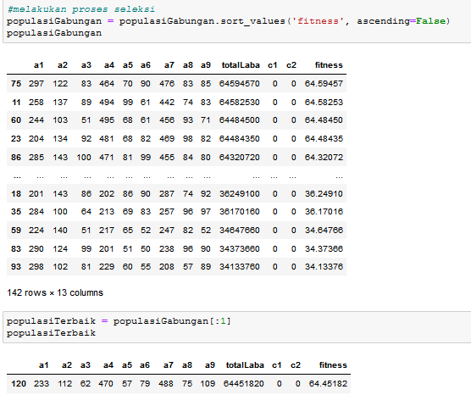

**Figure 5**. Selection Process

Based on Figure 5, the greatest fitness value is in population 75. The resulting fitness value is 64.59 with a total profit of Rp. 64,594,570. In this case, population testing is also carried out which aims to see the range of the population that has the best fitness. Figure 6 shows the results of the population test.

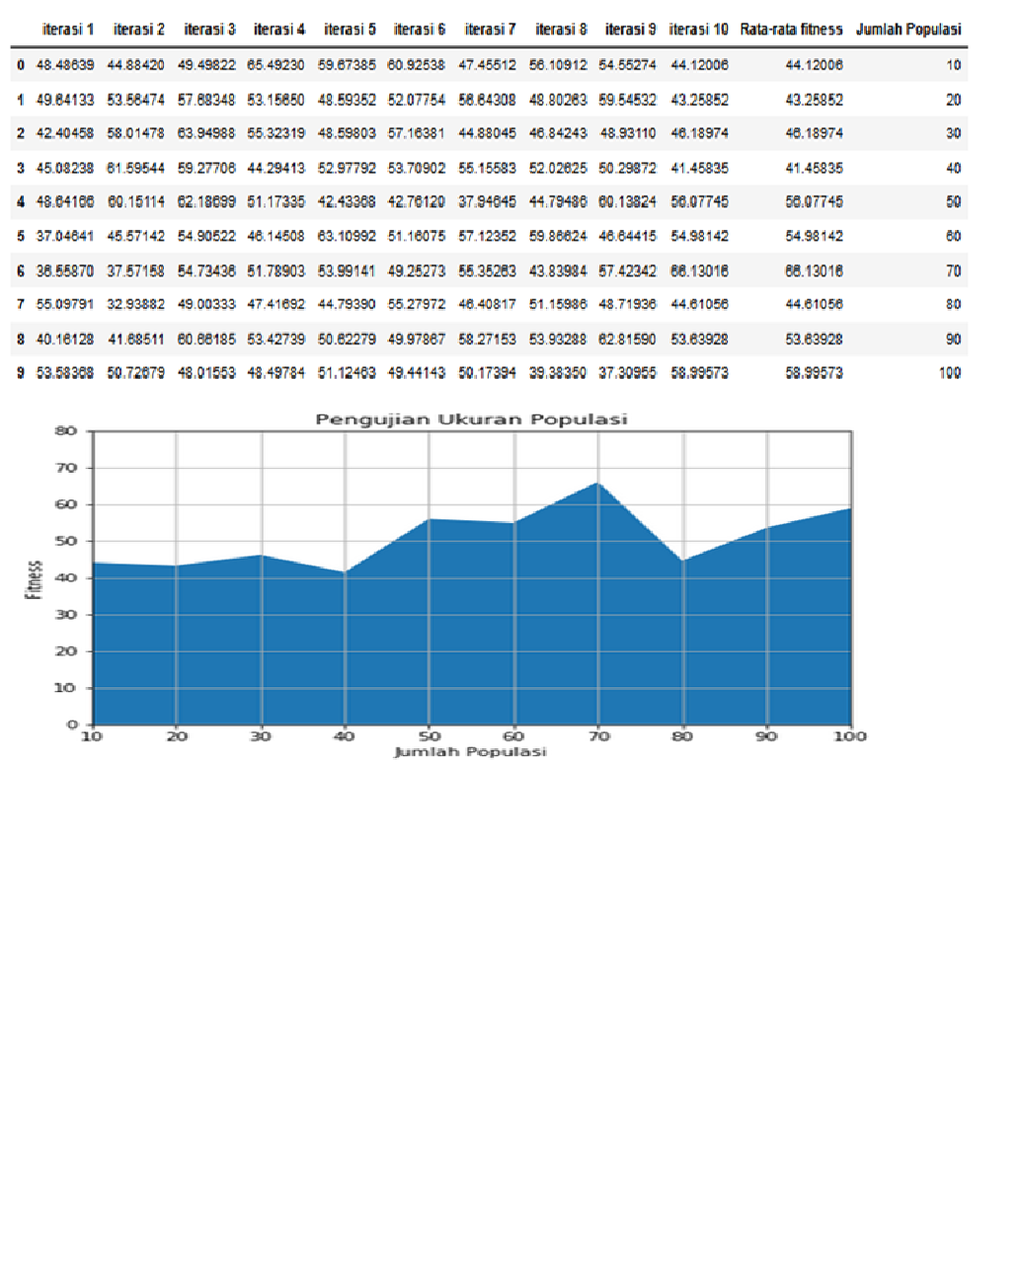

**Figure 6.** Testing population

Based on Figure 6, the best population test results are in population 70 with an average fitness value of 66.13.The population size used, it the population that produces the best fitness value in the population size trial. The number of generations used is 100. The CR and MR values used in the test range from 0 to 1. Each generation is tested 10 times and the average fitness value is calculated. From these trials, the optimal CR and MR values will be obtained to solve the problem. CR and MR test results are shown in Figure 7.

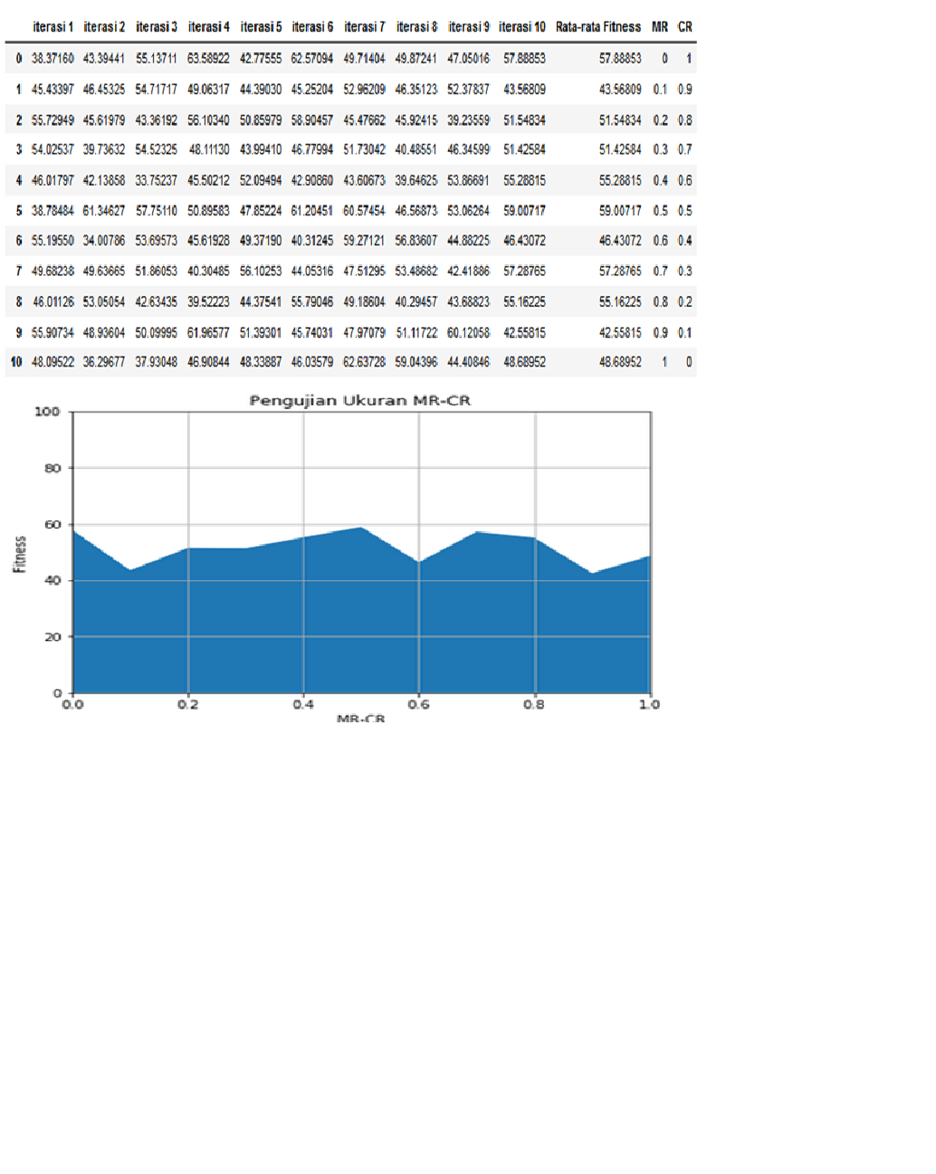

**Figure 7.** CR and MR Tersting Result

Based on the data in Figure 7, it shows that the greatest value of the average fitness is at CR = 0.5 and MR = 0.5 with the resulting average fitness of 59.00.

1. **Conclusion**

TThe results showed that the genetic algorithm and soap production data used in this study showed that the greatest fitness value was in population 75 at 64.59 and profit as much as 64,594,570. In test of the population size, the 70th population has the largest average fitness value, namely 66.13. Furthermore, testing the CR-MR value obtains the best CR-MR value, namely cr = 0.5 and mr = 0.5 and the average fitness value obtained is 59.00

**Acknowledgments**

Thank you to The Universitas Sulawesi Barat as an institution that has collaborated in this research.

1. **References**

[1] N. Metawal, M. Elhoseny, M. K. Hassan, and A. E. Hassanien, “Loan Portfolio Optimization using Genetic Algorithm : A case of credit constraints,” pp. 59–64, 2016, doi: 10.1109/ICENCO.2016.7856446.

[2] R. Iriany, A. W. Widodo, and W. F. Mahmudy, “Pemanfaatan Algoritma Genetika Untuk Optimasi 0 / 1 Multi-Dimensional Knapsack Problem Dalam Pendistribusian Produk ( Studi Kasus UD . TOSA ),” vol. 1, no. 4, pp. 257–269, 2017.

[3] W. F. Mahmudy, “PENERAPAN ALGORITMA GENETIKA UNTUK MEMAKSIMALKAN LABA,” vol. 02, no. 01, pp. 6–11, 2015.

[4] C. D. Harim Adi Saputro1, Wayan Firdaus Mahmudy2, “IMPLEMENTASI ALGORITMA GENETIKA UNTUK OPTIMASI PENGGUNAAN LAHAN PERTANIAN,” no. 12, 2015.