**The Effect of NaOH Loading on The Performance of The Vario 125 engine with a Biogas Fuel**

**Syamsuri1, Y W Mirzayanti2, A H Mukti3 and Yoniv Erdhianto4**

1,3Mechanical Engineering, Institute Technology Adhi Tama Surabaya

2Chemical Engineering, Institute Technology Adhi Tama Surabaya, Indonesia

4Industrial Engineering, Institute Technology Adhi Tama Surabaya, Indonesia

E-mail: syamsuri@itats.ac.id

**Abstract.** Humans greatly need transport facilities for their daily lives. Therefore, they are incredibly dependent on diesel/gasoline fuel. Some efforts are required to reduce the dependence on oil for transport. Biogas belongs to alternative biofuel, which is easy to find and renewable energy. Experimental research aims to investigate a motorcycle with an injection system and biogas fuel. The content of NaOH mixed in the slurry was varied from 0, 300, 500, and 700 grams. The result of research indicated that the more the nutrition NaOH was mixed in the slurry, the faster the biogas production was resulted, strictly within ten years. The mechanical power performance of the motorcycle could reach 3.32 hp. **Keywords:** Biogas, Motorcycle, Injection system, total nutrition NaOH variation.

1. **Introduction**

Energy is one of the basic human needs. As the population increases, the energy demand will also increase. The transportation sector dominates the energy needs of the human population. Currently, energy raw materials come from fossil fuels. In Indonesia, oil and gas are still the primary sources of energy. Fossil fuel is a non-renewable energy source, so its reserves will be depleted. Fossil fuel can lead to an energy crisis and have an impact on basic human needs. Therefore, it is necessary to develop related sources of fuel oil raw materials. Renewable energy is needed for the long term. The development of research related to alternative fuels such as biofuel and biogas is very much needed to solve the problem of the energy crisis. Biogas is a renewable energy source produced by the anaerobic fermentation of organic matter [1]. Biogas can be produced from market waste, animal waste, wastewater, and human waste [1-2]. Therefore, the development of biogas installations is very suitable to be carried out in areas with dense livestock populations, vegetable farming areas and in areas where there are many agricultural product processing industries.

Production of biogas from animal manure, such as cow is very potential and has an advantages, energy derived from it is very environmentally. The uses of biogas **can also** reduce atmospheric greenhouse gases and other emissions. Several factors that affect **the assembly** of biogas are the condition of the digester, pH, nutrients temperature, the ratio C/N, and the starter [1]. Depend on the source of raw biomass **and the** treatment process, the biogas composition typically lies within the ranges CH4 = 35–75%, CO2 = 25–65%, H2 = 1-5%, N2 = 0.3–3% **together with**traces of**vapour**, NH3, H2S, and mercaptans (e.g., CH3SH), halides and siloxanes. **The standard** of biogas, the digestion rate**, the method** stability, the richness in bacteria, and**the**eﬀectiveness in treating substrates containing lipids, proteins, and nonbiodegradable solid matter are parameters **in theory** inﬂuenced by both the pretreatment of the organic feedstocks, **and therefore, the** anaerobic digestion is operating temperature [3]. Biogas will provide lower exhaust emissionsfor motorized vehicles than fossil fuels and can help improve local air quality [4][5].

This study aims to determine the effect of adding variations in the amount of NaOH nutrients to the time of biogas formation and the performance of motorcycles using biogas fuel. The biogas process is carried out to obtained methane (CH4) gas. The validation process is carried out to determine

1. **Experimental methods**

This research was carried out at the KUD Farm in Bocek Village, Karangploso District, Malang Regency, East Java. This research aims to investigate a motorcycle with an injection system and biogas fuel. The research variable is the object that is the centre of attention in this study. The data used in this study are 1) Data validation with the water boiling test method. 2) Data on the performance of motorcycles using biogas with the variation of mass nutrition NaOH. The NaOH nutrition variation data in this study were 300, 500, and 700 gr. This research consists of four stages. The first stage is the design of biogas equipment. The second stage is the design of the kit conversion. The third stage is data collection using the water boiling test analysis. The fourth stage is data collection by applying biogas to motorcycle modifications based on variations in NaOH nutrients.

* 1. *Design of Biogas Equipmnet*

The reactor used in this study is a plastic tank with a thickness of 5 mm, a diameter of 58 cm, a height of 93 cm, there are two holes equipped with a cover measuring 73 mm, and the weight of the tank is 7.6 kg. The reactor volume capacity is 230 litres of manure plus four reservoirs. The reactor was modified by perforating the top side with a diameter of 3-inch and adding an outer and inner shock drat of the same size as the slurry inlet hole. The bottom of the drum was perforated for the exhaust section, then given a 2-inch pipe and connected to the L pipe.

The condensation trap bottle is made of a 2-litre refillable water bottle that functions as a condensation trap (condensation) in the pipe and a safety valve. In this installation, the trap bottle is placed before the reservoir. This is intended to make it easier for small water vapour from condensation from the pipeline to the reservoir (plastic gas reservoir) to descend and enter the bottle. If there is excessive water in the system, it can compress the biogas line. For the manufacture of this trap bottle, it is recommended that the water level be 15 to 25 cm high. Because if it is too low, the gas will come out of the water before it reaches the desired pressure. A reservoir is a place to store biogas. Reservoir created using plastic with a size of 1 m x 1 m and a thickness of 0.4 mm, attached to the pipe after the condensation trap bottle. In this research, biogas installations require two and three-inch pipes that are used for sewage in the digester, namely the inlet and outlet, as well as inch pipes, hoses, Naples and clamps are used as biogas flow from the reactor to the reservoir. This installation also uses several L and T connections to connect the biogas pipeline and uses a ball valve to open and close the biogas flow.

* 1. *Motorcycle Kit Conversion Design*

A prepared motorcycle requires a conversion kit as a fuel line. The injection system uses very high pressure to do the misting. The gap in the injector itself is minimal and almost invisible to the eye if you don't pay close attention. The fuel that we use today uses gas fluid, so the pressure does not need to be too high because the shape of the biogas itself is not visible, so there is no need to atomize it. Some modifications made to the motorcycle are as follows:

1. The fuel tank was changed with an air tube or a compressor tube, and in this study, it used a compressor tube with a capacity of 25 litres and a maximum pressure of 6 kgf/cm2. This is intended to accommodate more gas and minimize gas leakage if using a gas tank other than the small volume and the many holes in the tank that can cause gas leaks.
2. The fuel line uses an air pipe made of iron pipe material which aims not to leak easily and for easy and safe connection even at high pressure. The fuel line also uses a rubber hose to make it flexible and easy to install.
3. The addition of a T terminal and a regulator on the biogas line aims to regulate the gas pressure entering the engine as idle up and gas. Because of the biogas that enter the engine for the idle up rotation, the pressure is 0.5 kgf/cm2, and it is optionally regulated for the gas.
4. The original injector that came with the motorbike was replaced with an injector modification of brass shaped like an original injector and combined with the main jet carburettor placed at the end with a hole more significant than the original injector hole. Here, two main jets are used, namely for ignition of the idle up position with 1200-1700 rpm and the second main jet is used to increase the gas.
5. Replacing the gas alternator with a double gas shift due to increase the gas, we need to open the air throttle valve and the gas throttle simultaneously to balance the mix between air and fuel.
6. The throttle gas (biogas) uses a ball valve with modify the faucet handle that is perforated and attached to the throttle cable, and add a compression spring so that when raise the engine gas the gas throttle can close again automatically perfect on idle up.
   1. *The Water Boiling Test Analysis*

Testing this biogas fuel tool uses the Water Boiling Test (WBT) analysis. This analysis was carried out with several parameters: time (minutes) and temperature (oC). The time parameter is the time required for water cooking, while the temperature is the water surface temperature achieved during the water cooking process at a specific time [6].

* 1. *The Performance of Biogas-fuelled motorcycle*

The research methodology for motorcycle performance is as follows. The modified motorcycle is filled using biogas fuel. Furthermore, the measurement of the time used for fuel from full fuel to exhaust at idle gas to determine how long the biogas can be used. Motorcycle testing at the dyno test site to determine the performance produced from gasoline and biogas fuel. The test was carried out using biogas whose slurry has been varied with variations in NaOH nutrients of different amounts, namely: 300, 500 and 700 gr. While on a motorcycle, variations are taken from the engine rpm. The specifications of the machine used have been studied previously The specifications of the motorcycle engine used in the experiment are shown in Table 1 [6].

**Table 1.** Motorcycle engine specifications [6]

|  |  |
| --- | --- |
| Specification | Honda Vario 125 |
| Type of machine | 4 stroke, SOHC, eSP |
| Stroke Volume | 124.8 cc |
| Fuel Supply System | PGM-FI (Programmed Fuel Injection) |
| Diameter x Strokes | 52.4 x 57.9 mm |
| Transmission | Automatic Otomatic, V-matic |
| Maximum Power | 8.2 kW (10.8 HP) / 8,500 rpm |
| Minimum Torque | 10.8 Nm (1.1 kgf.m)/5,000 rpm |

1. **Results and Discussion**

In this study, variations of the addition of NaOH nutrients to the slurry to produce biogas and variations of rpm on a modified motorcycle engine using biogas are used. The loading variations are 300, 500, and 700 gr. The following is data on the results of biogas formation in the reactor from various variations of loading NaOH in Figure 1.

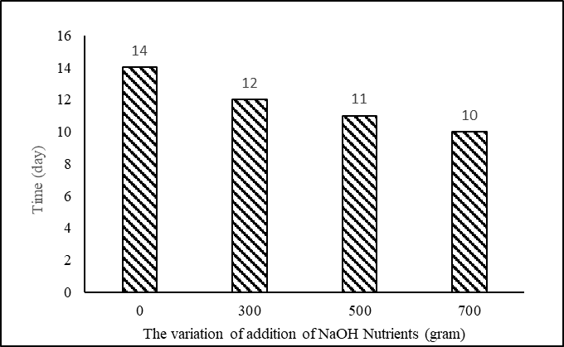

**Figure 1.** Relationship between Variation NaOH Nutrients and the Time of Biogas Formation

* 1. *Validation*

Validation was carried out using the Water Boiling Test (WBT) method. The test by heating the water until it boils is carried out to see whether the trend analysis is correct with previous research.

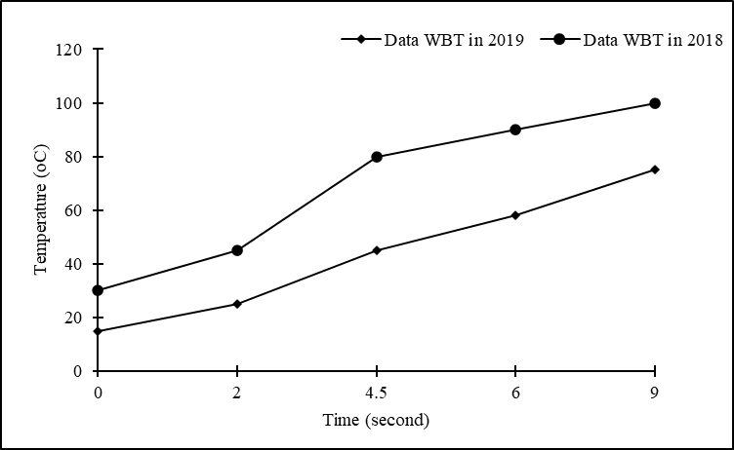

**Figure 2.** Relationship between temperature and water heating time and compared to previous studies

Figure 2 is a graph of the relationship between time (minutes) and temperature (oC) from the results of the validation data with [7] data. Based on Figure 2, it can be seen that the resulting temperature also increases with increasing time. This is in accordance with the theory of heat transfer, exceptionally sensible heat Q = M.Cp.∆T where the more significant Q, the more significant T automatically [7].

* 1. *The effect of engine speed on the power generated from variations in the number of nutrients*

Figure 3 shows the relationship between rpm and power for various amounts of NaOH added to the biogas slurry. In general, Figure 3 shows that as the rpm increases, the power also increases. Theoretically, The increase in power is the relationship between power and rpm is directly proportional. Based on this analysis, there is exciting information. Namely, the addition of 700 g of NaOH has greater power than the addition of 300 and 500 g. The NaOH compound has advantages when mixed with a biogas slurry. It can accelerate the fermentation process of the microbes contained in the slurry to form more methane gas and produce biogas with a higher methane gas content.

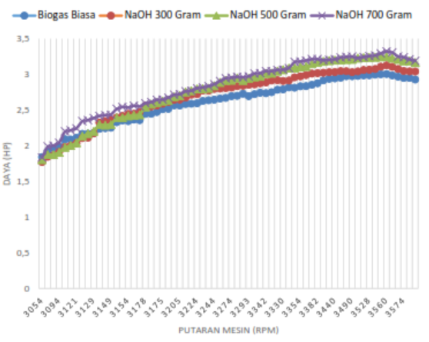

Engine Speed (rpm)

Power (Watt)

Figure 3. Relationship between rpm and power for various amounts of NaOH added to the biogas slurry

* 1. *The effect of engine speed on torque resulting from variations in the number of nutrients*

Figure 4 shows the relationship between rpm and torque for various amounts of NaOH added to the biogas slurry. In general, Figure 4 shows that when the rpm increases, the torque also increases. This phenomenon is due to theoretically the relationship between torque and rpm is directly proportional to Equation 1 [5]. In general, the 700 gr NaOH mixture has greater torque than the other NaOH mixtures.

$T= \frac{30Ne}{π.n}$........................................ [1]

Torque (N.M)

Engine Speed (rpm)

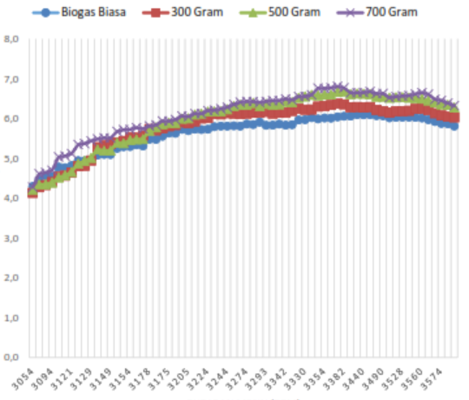

Figure 4. Relationship between rpm and torque for various amounts of NaOH added to the biogas slurry

* 1. *The effect of engine speed on the average effective power (B Mep) resulting from variations in the number of nutrients*

Figure 5 shows the relationship between rpm and the average effective power (Bmep) for various amounts of NaOH content added to the biogas slurry. Figure 5 shows that when the rpm is higher, the Bmep value gets bigger, then at 3272 rpm engine speed, the Bmep value will decrease. This phenomenon is caused by, theoretically, when the mechanical power increases, the Bmep also increases.

This is in accordance with Equation 2 as follows [7] :

$Bmep=\frac{120000 x Ne}{Vl. z.n.a }$......................................... [2]

Based on the analysis, the results obtained show an interesting phenomenon, namely for a 700 gr NaOH mixture with a higher Bmep value than other NaOH mixtures.

Engine Speed (rpm)

BMep (N/M3)

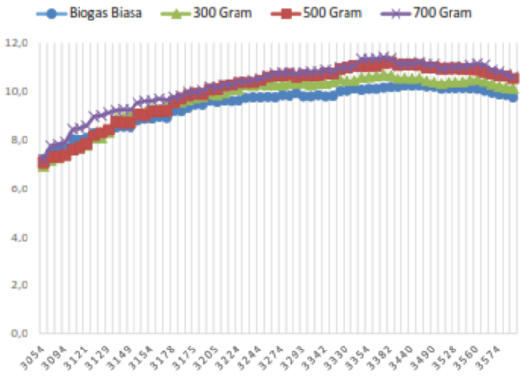

Figure 5. Relationship between rpm and the average effective power (Bmep) for various amounts of NaOH content added to the biogas slurry

* 1. *The Effect of Engine Speed on Specific Fuel Consumption (Sfc) Produced From Variations in the number of Nutrients*

Figure 6 shows the relationship between rpm and Specific Fuel Consumption (Sfc) for various amounts of NaOH content in biogas. In the picture in general, it can be seen that the Specific Fuel Consumption (Sfc) value has decreased to 3214 rpm, then Specific Fuel Consumption (Sfc) has a constant value to 3580 rotation and at a certain speed will rise again. According to the formula, this can be explained as follows: a decrease in Specific Fuel Consumption (Sfc) because at the beginning of the increase in rpm, it takes a significant fuel consumption. The fuel consumption is constant until a particular rotation. After the rpm exceeds 3580, Specific Fuel Consumption (Sfc) tends to increase because the high power is in line with the large fuel requirements.

Engine Speed (rpm)

Sfc (kg/h.watt)

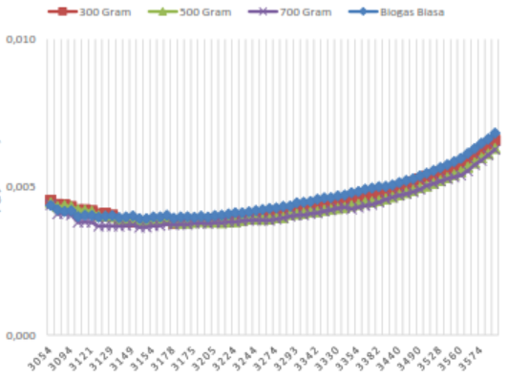

Figure 6. Relationship between rpm and Specific Fuel Consumption (Sfc) for various amounts of NaOH content in bioga

* 1. *The effect of engine speed on Thermal Efficiency resulting from variations in the number of nutrients*

Figure 7 shows the relationship between rpm and Thermal Efficiency for various amounts of NaOH content in biogas. In the picture in general, it can be seen that the Thermal Efficiency at 3074 to 3198 rpm has increased, then the efficiency has decreased up to 1870 rpm. This increase is because when the engine rpm increases, the fuel consumption also increases and when the rpm decreases, the efficiency also decreases. There is an interesting thing here that the 700 gr NaOH mixture has better efficiency than the mixture with less amount.

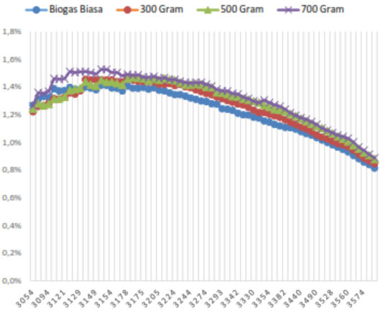

Thermal Efficiency, η (%) (kg/h.watt)

Engine Speed (rpm)

Figure 7. relationship between rpm and Thermal Efficiency for various amounts of NaOH content in biogas

1. **Conclusion**

The results show that the addition of 700 gr of NaOH nutrients can produce biogas with a specific capacity. The biogas production takes ten days faster when compared to variations in the other NaOH nutrients. In addition, the mechanical power of the modified biogas-fueled motorcycle with the addition of 700 g of NaOH nutrients reached 3.32 HP.

1. **References**

[1] D. A. Putri, R. R. Saputro, and Budiyono, 2012, “Biogas production from cow manure,” *Int. J. Renew. Energy Dev.*, vol. 1, no. 2, pp. 61–64.

[2] R. Naghavi, M. A. Abdoli, A. Karbasi, and M. Adl, 2020, “Improving the quantity and quality of biogas production in tehran anaerobic digestion power plant by application of materials recirculation technique,” *Int. J. Renew. Energy Dev.*, vol. 9, no. 2, pp. 167–175.

[3] I. V. Yentekakis and G. Goula, 2017, “Biogas management: Advanced utilization for production of renewable energy and added-value chemicals,” *Front. Environ. Sci.*, vol. 5, no. 7..

[4] Z. Lv *et al.*, 2018, “The effect of digested manure on biogas productivity and microstructure evolution of corn stalks in anaerobic cofermentation,” *Biomed Res. Int.*, vol.

[5] R. Riswanto and S. Sodikin, 2018, “Potential of Renewable Energy Biogas from Plant (Hyacinth),” *J. Phys. Theor. Appl.*, vol. 2, no. 2, p. 64.

[6] S. Syamsuri, Y. W. Mirzayanti, Z. Lillahulhaq, and A. B. Hidayat, 2021, “Implementation of packed column for biogas purification as fuel for motorcycle injection systems for performance improvement,” *Eastern-European J. Enterp. Technol.*, vol. 4, no. 1(112), pp. 86–93.

[7] Y. Syamsuri, W. Wulandari Mirzayanti, A. Widyo Widjajanti, and S. K. Bani, 2020, “Pengaruh Variasi Konsentrasi NaOH sebagai Nutrisi pada Performansi Biogas Tipe Portabel,” vol. VI, no. 2460, pp. 195–207.