**Design and Development of Web-Based Simulator for Container Vessel Handling**

**T Cahyadi1, T M H Hartanto1, U Widyaningsih1, A Mirianto1, Z Zuhri2, and**

**N V Harini3**

1Department of Nautics, Politeknik Pelayaran Surabaya, Surabaya 60294, East Java, Indonesia

2Department of Mathematics, Universitas Islam Negeri Sunan Ampel, Surabaya 60237, East Java, Indonesia

3Department of Mathematics education, Universitas Islam Negeri Sunan Ampel, Surabaya 60237, East Java, Indonesia

[novitavindriharini@gmail.com](mailto:novitavindriharini@gmail.com)

**Abstract.** The main factor causing congestion at the port is the long waiting time for ships to load and unload goods. The duration of loading and unloading of goods is influenced by the way the goods are arranged so that they can be easily picked up on time. Good arrangement can avoid Long Hatches or delays in loading and unloading of goods due to cargo that should be unloaded at a port being crushed by the cargo for the next port. The Stowage Plan is a description of information regarding the cargo arrangement plan on the ship which shows a side view (plan) and a top view (profile) of the location of the cargo, the amount of cargo, and the weight of the cargo in the hold according to the consignment mark for each destination port. The purpose of this research is to build a software design to determine the appropriate stowage plan for the arrangement of containers on the transport ship. The hope is that a stowage plan can be produced which will have an impact on the faster loading and unloading process of goods but will not disturb the stability of the transport ships.

1. **Introduction**

Indonesia is an archipelago country, located in the Southeast Asia region. Due to its strategic geographical location, Indonesia has the strength and opportunity to develop the economic sector. The spearhead of this economic development is to carry out commodity export-import activities between Indonesia and neighbouring countries. In this export-import activity, optimization of time and resources plays an important role to support and help increase work efficiency and effectiveness in order to increase profits. This optimization will lead to time efficiency which will affect cost savings [1].

Congestion often occurs at the port. So, are there still not enough ports? Do you need more? If the number of ports is increased, will congestion at the port be reduced drastically? Apparently not, because the main cause of congestion at the port is the loading and unloading process of goods on board. It takes a lot of space to put the cargo of the ship before being arranged on the carrier ship. So, if so, do we have to increase the capacity of the container stacking place for loading and unloading ships? There is another way, namely by optimizing the arrangement of goods in an existing place. If the arrangement is done properly, the ship's waiting time for loading and unloading of goods on board will be faster [2].

The duration of loading and unloading activities is influenced by the way the goods are arranged so that they can be easily picked up on time. This is done to avoid Long Hatches or delays in loading and unloading of goods due to cargo that should be unloaded at a port being crushed by the cargo for the next port; Over Hatched or the separation of a small part of the cargo on another ship, the group of goods, so that it will cause difficulties and increase the length of loading and unloading time at the port; and Long Distances or cargo carried that should have been unloaded at the previous port. The arrangement of goods must also pay attention to the stability of the ship so that it is always positive [3].

In the Container Terminal, there is a temporary storage for containers according to its type which is called Container yards. Container yards are divided into rectangular areas called blocks. Generally, container yards are divided into 3 main blocks according to the type of containers, namely export blocks, import blocks, and transhipment blocks [4] [5].

Several things that need to be considered in the arrangement of containers at container yards, including: Transport Ship Schedule, Port Destination, Container Size, and Container Weight. In the arrangement, 1 stack of containers (4 tiers) comes from the same group (port destination and size); In addition, the size of the containers must be the same. Heavy containers are placed at the bottom so as not to damage other containers. The same arrangement also applies to the placement of containers on board. Each container has its own loading and unloading schedule and containers can only be accessed from above. If the existing arrangement is not in line with the loading and unloading schedule, it is necessary to carry out the shifting process [8] [9].

Therefore, every loading activity requires a special calculation to determine the appropriate arrangement so that containers placed on a transport ship are in the loading and unloading order [10]. The second thing which is also important is the determination of the right place for the arrangement so that containers placed on a ship do not disturb the stability of the carrier vessel [11]. The process of determining the right setting place is referred to as a stowage plan [12].

The Stowage Plan is an information depiction of the cargo arrangement plan on the ship which shows a side view (plan) and a top view (profile) of the location of the cargo, the amount of cargo, and the weight of the cargo in the hold according to the consignment mark for each port of destination [13]. Things that need to be considered in making a stowage plan are Stability of the ship, condition and location of loading and unloading equipment, the strength of the deck, the volume of the cargo space and the carrying capacity of the ship, the port of destination of the cargo, the amount, weight, type and nature of the load on each hold and there are loads that are not ready for shipment and option loads [14].

The functions of making a Stowage Plan on container carriers, including can know the location of each load and the amount and weight, can plan the demolition activities to be carried out, can calculate the number of workers required, can calculate the length of time the unloading takes place and as a document of responsibility for cargo arrangements [15].

1. **Method**

There are three stages in making this simulator. The first stage is the search for ship data and container data. In this study, the containers used are ordinary containers measuring 20 ft with a maximum weight of 24 tons. The second step is storing data that has been inputted as a database in my SQL. The third stage is programming the simulator in PHP my Admin. At this stage, the researcher enters the formula of calculating ship stability. The stability of the ship can be determined using the following equation [16]:

1. The height of the metacentric point above the keel ($KM$)
$$KM=KB+BM$$

$$KM=The vertical distance from the keel of the ship to point M$$

$$KB= The sum of the distances from the keel to the floating point$$

$$BM= The distance of the floating point to the metacentric$$

2. Height of the Floating Point of the Keel ($KB$)

KB values can be found in the following ways:

$$For ship type plat bottom, KB = 0,50d$$

$$For ship type V bottom, KB = 0,67d$$

$$For ship type U bottom, KB = 0,53d$$

With $d=ship draft$

1. Distance from floating point to metacentric ($BM$) $BM =\frac{b^{2}}{10} d$

With:

$b$ = ship width (m)

$d$ = ship draft (m)

1. Height of Centroid of Keel ($KG$)

$$Total of KG =\frac{\sum{M}}{\sum{W}}$$

With:

$∑M=Number of Moments \left(ton\right)$

$$∑W=the sum of the multiplication of$$

$$the center of gravity and the object's weight (ton)$$

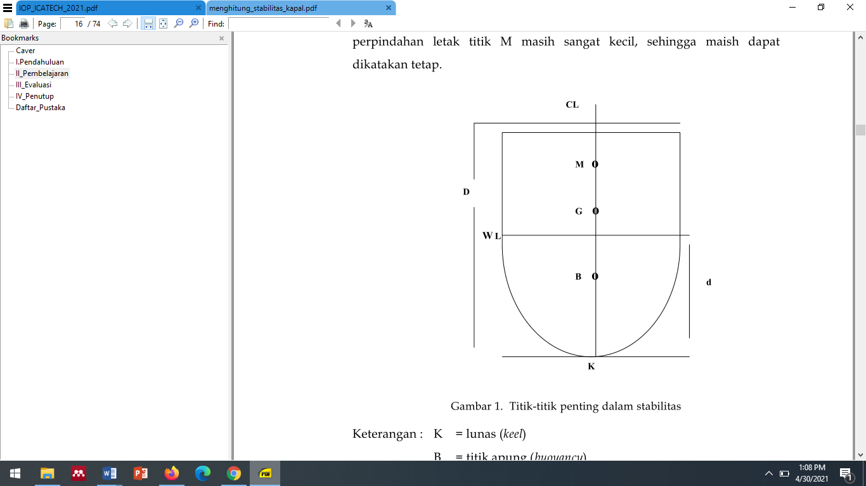

**Picture 1**. Key points in stability

1. **Results and Discussion**

Our discussion begins with the identification of the type of vessel. The type of ship used is a container ship, which is a ship used for container transportation between islands in Indonesia. The following is the ship data used in this study:

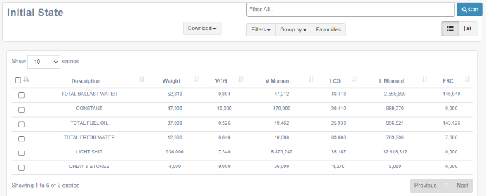

**Picture 2**. Ship Data

Figure 2 shows the display of ship data input, the inputted data includes total ballast water, constant, total fuel oil, total fresh water, light ship, crew and stores.

The containers used are ordinary containers measuring 20 feet with a maximum weight of 24 tonnes (according to the standards allowed by port operators in Indonesia). The following is the container data used in this study:

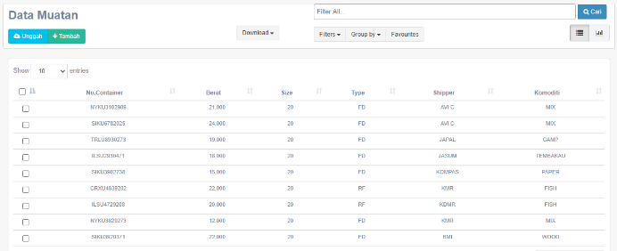

**Picture 3**. Container Data

Figure 3 shows a display of the container data input. The data inputted includes the container number, weight, size, type, shipper and commodity. Based on ship data and container data, it can be seen that the displacement is 1088.8.

The software used in the development of this simulator is PHP My Admin as a prototype / display and the database uses My SQL. The simulator design is made / designed in such a way as to make it easier for users to operate it. The following is a display of the simulator that has been designed in this study:

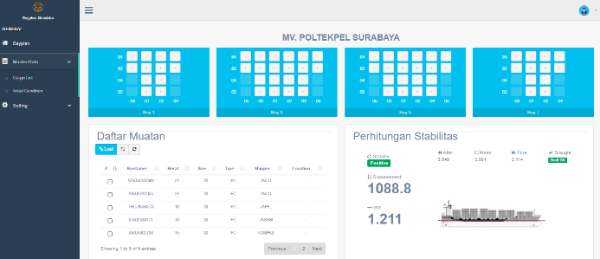

**Picture 4**. Display of the simulator

After the data input process is done, we can test the simulator three times. The first trial was carried out on November 2nd, 2020 to find out the calculation of the stability of the ship if 1st Bay is fully filled, 3rd Bay is filled with 4, and the other Bay is empty. The following results are obtained:

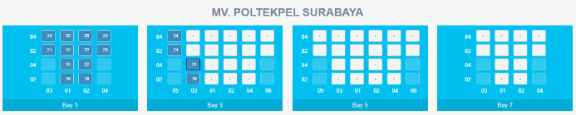

**Picture 5.** 1st trial (1st bay is fully filled)

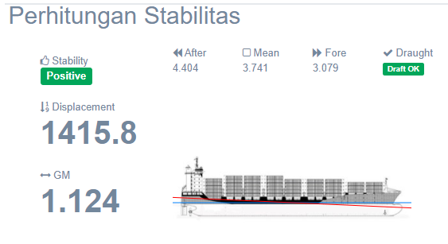

**Picture 6.** Calculations of stability at 1st trial

From the calculation of the stability of the ship in Figure 6, it can be seen that the displacement value is 1415.8, the GM value is 1.124, the after value is 4.404, the fore value is 3.079 and the mean value is 3.741. Because the after value is greater than the fore value, the ship is in a look up position.

The second trial was carried out on November 8th, 2020 to find out the calculation of the stability of the ship if 7th Bay is fully filled, 5th Bay is filled with 4, and the other Bay is empty. The following results are obtained:

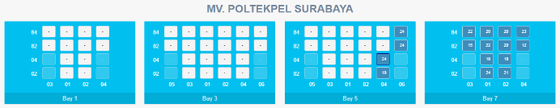

**Picture 7.** 2nd trial (7th bay is fully filled)

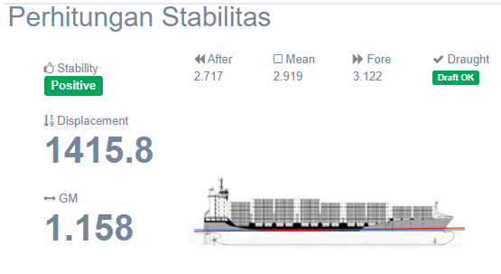

**Picture 8.** Calculations of stability at 2nd trial

From the calculation of the stability of the ship in Figure 8, it can be seen that the displacement value is 1415.8, the GM value is 1.158, the after value is 2.717, the fore value is 3.122 and the mean value is 2.919. Because the after value is greater than the fore value, the ship is in a look down position.

The third trial was carried out on November 13th , 2020 to find out the calculation of the stability of the ship if 1st Bay is filled with 2, 3rd Bay is filled with 4, 5th Bay is filled with 4, and 7th Bay is filled with 5. The following results are obtained:

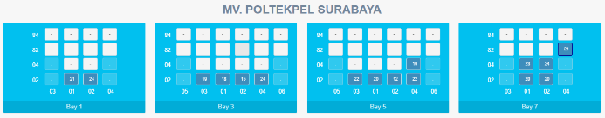

**Picture 9.** 3rd trial (all of Bay are filled)

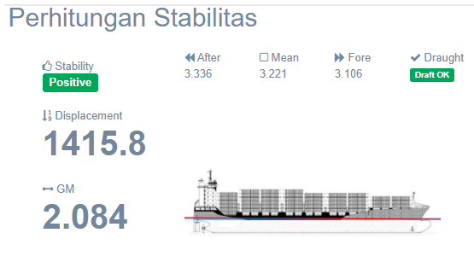

**Picture 10.** Calculations of stability at 3rd trial

From the calculation of the stability of the ship in Figure 10, it can be seen that the displacement value is 1415.8, the GM value is 2.084, the after value is 3.336, the fore value is 3.106 and the mean value is 3.221. Because the fore and after values are almost the same and still in the mean, the ship is in balance.

1. **Conclusion**

Based on the explanation of the results and discussion, it appears that the Simulator can display ship mileage, ship data, container data, arrangement of containers on ships, calculation of ship stability and displacement. From the above formulation, it can be seen that this simulator can help to speed up the loading and unloading process on ships so that congestion that often occurs at the port can be reduced.

1. **References**

[1] Elyta, H. A., & Saing, Z. (2019). National strength on construction of international freight terminal in entikong Indonesia. *Int. J. Sci. Technol. Res*, *8*(3), 10-15.

[2] Parreño, F., Pacino, D., & Alvarez-Valdes, R. (2016). A GRASP algorithm for the container stowage slot planning problem. *Transportation Research Part E: Logistics and Transportation Review*, *94*, 141-157.

[3] Stergiopoulos, G., Valvis, E., Mitrodimas, D., Lekkas, D., & Gritzalis, D. (2018). Analyzing congestion interdependencies of ports and container ship routes in the maritime network infrastructure. *IEEE Access*, *6*, 63823-63832

[4] Badino, A., Borelli, D., Gaggero, T., Rizzuto, E., & Schenone, C. (2016). Airborne noise emissions from ships: Experimental characterization of the source and propagation over land. *Applied Acoustics*, *104*, 158-171.

[5] Liu, W., Li, Y., Dai, Y., & Zhang, S. (2020, June). The layout strategy of container yard and comparative analysis under double cycling process. In *Journal of Physics: Conference Series* (Vol. 1549, No. 5, p. 052043). IOP Publishing.

[6] Kuzmicz, K. A., & Pesch, E. (2019). Approaches to empty container repositioning problems in the context of Eurasian intermodal transportation. *Omega*, *85*, 194-213.

[7] Shen, Y., Mi, W., & Zhang, Z. (2017). A positioning lockholes of container corner castings method based on image recognition. *Polish Maritime Research*.

[8] Peng, P., Cheng, S., Chen, J., Liao, M., Wu, L., Liu, X., & Lu, F. (2018). A fine-grained perspective on the robustness of global cargo ship transportation networks. *Journal of Geographical Sciences*, *28*(7), 881-889.

[9] Edirisinghe, L., Jin, Z., & Wijeratne, A. W. (2018). The reality of container exchange between shipping lines: Clearing the pathway to virtual container yard. *Transport Policy*, *72*, 55-66.

[10] Krile, S., & Mišković, D. (2018). Optimal use of container ships for servicing among small ports. *NAŠE MORE: znanstveni časopis za more i pomorstvo*, *65*(1), 18-23.

[11] Van Eeden, J. (2018). *A model for the translation of South African economic activity into shipping container demand* (Doctoral dissertation, Stellenbosch: Stellenbosch University).

[12] Li, J., Zhang, Y., Ji, S., Zheng, L., & Xu, J. (2020). Multi-stage hierarchical decomposition approach for stowage planning problem in inland container liner shipping. *Journal of the Operational Research Society*, *71*(3), 381-399

[13] Jovanovic, R., Tanaka, S., Nishi, T., & Voß, S. (2019). A GRASP approach for solving the Blocks Relocation Problem with Stowage Plan. *Flexible Services and Manufacturing Journal*, *31*(3), 702-729

[14] Roberti, R., & Pacino, D. (2018). A decomposition method for finding optimal container stowage plans. *Transportation Science*, *52*(6), 1444-1462.

[15] Chou, C. C., & Fang, P. Y. (2021). Applying expert knowledge to containership stowage planning: An empirical study. *Maritime Economics & Logistics*, *23*(1), 4-27.

[16] Wilson P.A. (2018) End on Launching and Launching Calculations. In: Basic Naval Architecture. Springer, Cham.