Use of Graphic Info-Based Poster as Work Safety Induction Media

Wahyu Noviansyah1, a) and Dian Puspita Eka Putri2,b) Adhan Efendi 3, Kundari Rahmawati4, Itok Dwi Kurniawan5

Author Affiliations

145Universitas Sebelas Maret Surakarta, Jl. Ir. Sutami No.36, Kentingan, Kec. Jebres, Kota Surakarta, Jawa Tengah 57126

2IAIN Syaikh Abdurrahman Bangka Belitung, Jl. Petaling No.Km.13, Petaling, Mendo Bar., Kabupaten Bangka, Kepulauan Bangka Belitung 33173.

3Politeknik Negeri Subang, l. Brigjen Katamso No. 37 (Belakang RSUD, Dangdeur, Kec. Subang, Kabupaten Subang, Jawa Barat 41211

Author Emails

Use superscript letters such as “a)” to indicate the author’s e-mail address below.   
Use b), c), etc. to indicate e-mail addresses for more than 1 author.   
a) Corresponding author: adhan@polsub.ac.idb)wahyunoviansyah@staff.uns.ac.id

c)dianpuspitaekap@iainsasbabel.ac.id

d)[kundariwahmawati@staff.uns.ac.id](mailto:kundariwahmawati@staff.uns.ac.id)

e)itokdwikurniawan@staff.uns.ac.id

**Abstract.** This study is a type of development research. Researchers develop the media based on the increasing number of work accidents in the vocational education laboratory of Universitas Sebelas Maret, especially in construction practice. The rate of work accidents can interfere with the practicum learning process. This study aims to make poster media education for students about occupational health and safety (OHS) in the workshop. Renewal of the research contained in the concept of an OHS poster according to the level of work accidents that often occur. Methods of data collection using observation and questionnaires. The data obtained was analyzed quantitatively and descriptively. The results of the study show that: (1) Material expert validation got a score of 84.85% is in the category valid; (2) Validation from media experts got a score of 90.2% is in the very feasible category; (3) small group trials, the percentage of the display aspect is 84.3%, the language aspect is 89.3%, and the usability aspect is 87.5%. The average percentage of eligibility obtained is 87.04%. The average percentage of the small group trial shows that the poster media from the user's perception is categorized as very feasible implemented in learning.

# INTRODUCTION

The Building Engineering Education Study Program carrying out its role as an Institution of Educators and Education Personnel needs to equip prospective teachers with work competencies in line with industry needs. It is a professional competence for students to carry out the teaching profession in the vocational engineering field. With industry-appropriate work competencies, prospective vocational teachers can educate and train vocational students with competencies in line with the industrial world. Education is substantial in supporting the progress of a country in terms of human resources [1]. Added by [2], education focused on the establishment of competencies that produce graduates who are ready to work. Students are required to participate in practical learning in workshops. Students' training is to carry out work tasks in the field of building construction. Skill development in the learning practice requires direct interaction between students and machine tools. Direct interaction between students and machines requires awareness and a correct understanding of work safety. The potential and risk of work accidents when using the machine will endanger and harm various parties. Therefore, students are required to take safe actions in carrying out practical work in the workshop.

The survey results from student respondents in 2019 showed that as many as 58.6% of the Building Engineering Education Study Program students had not implemented Occupational Health and Safety (OHS) standards correctly. In addition, as many as 27 cases of work accidents have occurred in the workshop environment from 2016-2019. The phenomenon of work accidents with this period shows an increasing trend and peaks in 2019 with the highest number of work accidents. As can be seen in the following data presentation

**TABLE 1.** Work Accident Rates in the Building Engineering Education Study Program

|  |  |  |  |  |
| --- | --- | --- | --- | --- |
| **No** | **Year** | **Work Safety Description** | | **Total** |
|  |  | **Type** | **Category** |  |
| 1 | 2016 | Scratched/sliced by tool | Medium | 1 |
| 2 | 2017 | Fell  Hit by a sharp object  Scratched/sliced by tool | Medium | 5 |
| 3 | 2018 | Hit by a sharp object  Crashed by object | Medium | 4 |
| 4 | 2019 | Hit by a sharp object  Scratched/sliced by tool  Crashed by objects  Mashed by objects  etc. | Medium | 17 |
|  | **Total** | | | **27** |

Exposure to the phenomenon of work accidents strengthens the assumption that the urgency of introducing OHS needs to be carried out as a corrective and preventive solution in responding to the phenomenon of work accidents. The selection of effective and efficient media is an option to increase understanding and awareness of safe preventive measures in protecting student work safety while working in workshops. The application of Occupational Health and Safety is very important in vocational institutions that have a high accident risk [3].

The introduction of work safety with the one-way briefing method has not been able to optimize this role. The selection of posters based on infographics is believed to be an effective and efficient media choice in overcoming these problems. The combination of the two will be an effective and efficient medium that can always be re-read. The installation of media posters in the workshop environment can continue to remind students so that awareness arises about the importance of workplace safety. Therefore, this study aims to develop an infographic-based poster as a medium for induction of work safety in the Building Engineering Education workshop. [4] state that technological advances are a challenge for teachers in developing learning media in the classroom. The use of media is expected to increase students' understanding in receiving the material presented by the teacher [5].

Media can be interpreted as an intermediary used to emphasize and clarify information or messages to be conveyed by the sender of the message. Media helps in constructing messages or information to be more concrete so that it is easily understood and captured by the recipient of the message (receiver). Added by [6], the media through the validity test is considered able to overcome the problems faced by students. In the context of learning, media is used as an intermediary in conveying learning messages. Media serves to clarify the messages conveyed through learning materials. [7] in their research argue that media that uses lots of pictures will be more attractive to students in the learning process.

Through the use of media, the learning process will be easily conveyed if the media is made attractively [8]. In other words, learning can be achieved by the objectives with minimal resources of time, effort, and cost. For example, if learning without media takes 2 to 3 meetings for students to become familiar with the material. By using learning media, students only need one learning meeting to understand the messages conveyed in the learning materials [9]. One of the media that can be used in learning is poster media. The poster is defined as a visual medium that displays a combination of images and text messages. The use of a combination of images, colors, and text in conveying a message aims to attract the attention of the reader who sees and instils the idea that contains the message in the reader's mind for a long time. While infographics have the meaning of a combination of information and graphics in the form of data visualization images. Infographics aim to convey complex information by displaying images to make it easier to understand. Thus, infographic-based posters are static visual media that present information by using a combination of images, colors and text to attract attention and instill ideas into the reader's mind.

The use of infographic-based poster media in work safety induction is expected to be effective and efficient in conveying messages about the application of work safety. Consumption of messages continuously through media that contains a combination of images, colors and text as well as data visualization will make it easier to instill knowledge construction about correct practice regarding work safety Thus, the embedded ideas help students to perform and minimize harmful actions while working in the workshop.

# mETHOD

This study aims to develop a learning media product in the form of infographic-based posters. The research approach used is the research and development. This research is carried out with reference to development research from Borg & Gall [10] where research and development procedures include: (1) research and data collection; (2) planning and developing products; (3) expert validation; (4) product revision; (5) limited trial; (6) product revision; (7) expanded trial; and (8) final product revision. Data collection techniques in the development of media products use interviews, observations and literature studies. Meanwhile, the data collection of the feasibility test and product trials used a questionnaire. The research subjects are students of the building engineering education study program. The data analysis uses descriptive statistical analysis to describe the infographic-based poster media products that have been developed and their feasibility level to be implemented in practical learning. To measure the feasibility of poster media, the following formula is used.

Percentage = $\frac{Result Score}{Expected Score}x 100\%$

The calculated score is then compared with the eligibility category, as shown in the following table.

**TABLE 2.** Eligibility Categorization

|  |  |
| --- | --- |
| Category | Percentage |
| Very Feasible | 76% - 100% | |
| Feasible | 56% - 75% | |
| Not Feasible | 40% - 55% | |
| Very Not feasible | 0% - 39% | |

# RESULT AND DISCUSSION

This study begins with an analysis of the rate of work accidents in the implementation of practical learning which tends to increase from year to year as seen in the following data.

**Figure 1.** Work Accident Rate in The Building Engineering Education Study Program

The data is reinforced by the average score of the knowledge test results on understanding the application of OHS to wood practice students in 2021, which is 64. As seen in the results of the following analysis.

**TABLE 3.** OHS Knowledge Test Result

|  |  |  |  |  |  |
| --- | --- | --- | --- | --- | --- |
| **Descriptive Statistics** | | | | | |
|  | N | Minimum | Maximum | Mean | Std. Deviation |
| OHS_Test_Result | 35 | 32.00 | 84.00 | 64.0000 | 12.11708 |
| Valid N (listwise) | 35 |  |  |  |  |

The number shows that it is necessary to increase the understanding of OHS for students during work practices in workshops. The results of this learning problem analysis become the basis for the need for a media development that can help provide an understanding of the application of OHS visually. On which practice, students need concrete examples that provide visualization of the application of OHS. Thus, the results of the needs analysis underlie the development of infographic-based posters. Added by [11] that there are many methods in identifying occupational safety and health. According to [12], the most appropriate point is classifying work hazards based on the hazard level caused. In line with the opinion above, according to [13], using two combined methods in identifying occupational accident hazards is powerful to conquer the number of work accidents. The development of infographic-based posters serves as a medium for induction of work safety. Through posters installed in the workshop, messages and work safety instructions will be properly internalized because they will be seen and read repeatedly when students practice in the workshop. The development of the substance of the poster material is based on the following competency requirements.

**TABLE 4.** Competency Mapping Results

|  |  |  |  |
| --- | --- | --- | --- |
| Competency | Sub Competency | Indicator | Learning Material |
| Implementing Occupational Health and Safety | * Implementing Environment Health and Safety principle on work situation | * Identify types and accidental work * Identify the occupational safety implementation in work situation * Carry out occupational safety induction in work situation * Apply the use of Personal Protective Equipment in work situation | * Types of work accident * Implementation of emergency response procedures * Implementation of machine operation safety in the workshop * Application of the use of Personal Protective Equipment |

Poster media was developed by Canva and Adobe Illustrator applications. Poster media making was done by paying attention to aspects of size, color contrast, images selection, and text types that are attractive and easy to read. The results of the infographic-based poster developed are as follows.

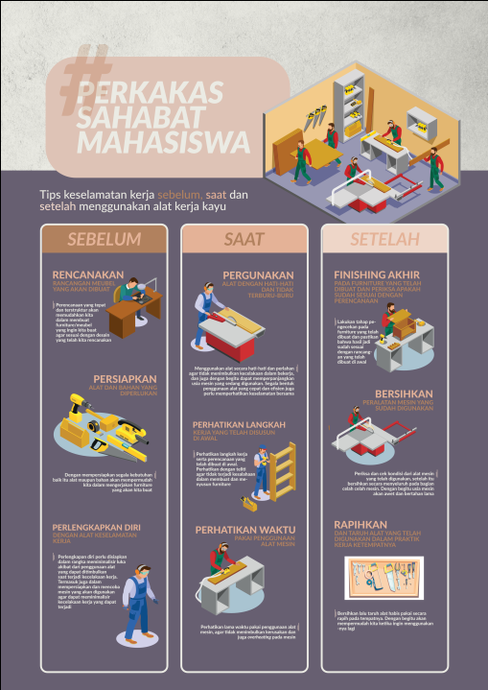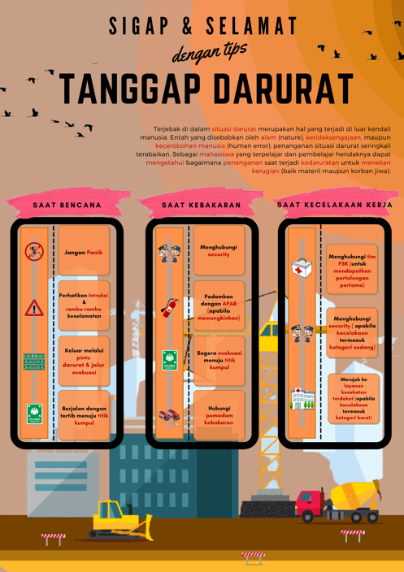

**FIGURE 2.** Operator OHS Poster

In an effort to test the feasibility of the poster media, a validation test was carried out using the Expert Judgment method with media experts and OHS materials. Validation done by the academics who are certified in the OHS competency of General Operators. The results of material expert validation are described in the following tables and graphs.

**TABLE 5.** Experts Judgement Validation Result Data

|  |  |  |  |  |  |  |  |  |
| --- | --- | --- | --- | --- | --- | --- | --- | --- |
| Aspect | Frequency | | | | Score Total | Point | Max Score | Percentage (%) |
|  | **1** | **2** | **3** | **4** |  |  |  |  |
| Quality | 0 | 0 | 7 | 5 | 41 | 12 | 48 | 85.4 |
| Benefit | 0 | 0 | 5 | 3 | 27 | 8 | 32 | 84.3 |
| Total |  | | | | 68 | 20 | 80 | **84.85** |

**FIGURE 3.** Material Expert Validation Results

Based on the presentation of the data, it is illustrated that the poster media developed from the aspect of material quality obtains a percentage of 85.4%. Meanwhile, from the aspect of benefit, the percentage is 84.3%. The average percentage of material feasibility is 84.85%. Thus, from the material side of the poster media, it meets the feasibility of being implemented in learning activities.

**TABLE 6.** Expert Judgement Validation Results Data

|  |  |  |  |  |  |  |  |  |
| --- | --- | --- | --- | --- | --- | --- | --- | --- |
| Aspect | | Frequency | | | Total Score | Total Point | Max Score | Percentage (%) |
|  | **1** | **2** | **3** | **4** |  |  |  |  |
| Display | 0 | 0 | 3 | 3 | 21 | 6 | 24 | 87.5 |
| Language | 0 | 0 | 2 | 4 | 22 | 6 | 24 | 91.6 |
| Layout | 0 | 0 | 1 | 2 | 11 | 3 | 12 | 91.6 |
| Total |  | | | | **54** | **15** | **60** | **90.2** |

**FIGURE 4.** Media Eligibility Results

Based on the results of the media expert validation test, the percentage of the display aspect is 87.5%, the language is 91.6%, and the layout aspect is 91.6%. The average percentage of eligibility obtained is 90.2%. The average percentage shows that the poster media from the media side is included in the very feasible category to be implemented in learning.

To see the feasibility of the media from user perceptions, a small group trial was conducted. The limited trial activity was carried out with 3 students of the Building Engineering Education Study Program. The data on the results of user trials can be seen in the following table.

**TABLE 7.** Limited Trial Results Data

|  |  |  |  |  |  |  |  |  |
| --- | --- | --- | --- | --- | --- | --- | --- | --- |
| Aspect | | Frequency | | | Total Score | Total Point | Max Score | Percentage (%) |
|  | **1** | **2** | **3** | **4** |  |  |  |  |
| Language | 0 | 0 | 3 | 4 | 25 | 7 | 28 | 89.3 |
| Display | 0 | 0 | 5 | 3 | 27 | 8 | 32 | 84.3 |
| Benefit | 0 | 0 | 3 | 3 | 21 | 6 | 24 | 87.5 |
| Total |  | | | | **73** | **31** | **84** | **87.03** |

**FIGURE 5. Small Group Trial Results**

Based on the results of small group trials, the percentage of the display aspect is 84.3%, the language is 89.3%, and the usability aspect is 87.5%. The average percentage of eligibility obtained is 87.04%. The average percentage of the small group trial shows that the poster media from the user's perception is categorized as very feasible to be implemented in learning.

# CONCLUSION

The results showed that: (1) The validation of the material experts got a score of 84.85 which was included in the valid category; (2) Validation from media experts gets a score of 90.2 which is included in the Very Eligible category; (3) small group trials, the percentage of the aspect of the display is 84.3%, the language is 89.3%, and the usability aspect is 87.5%. The average percentage of eligibility obtained is 87.04%. The average percentage of the small group trial shows that the poster media from the user's perception is categorized as very feasible to be implemented in learning. Further research on occupational safety and health posters using the Hazard, Identification, Risk, and Assessment (HIRA) method is also needed. It aims to deepen the results obtained in the prevention of work accidents in the Vocational Education laboratory.

# ACKNOWLEDGMENTS

Thank you to all the research team who helped with this research and the seminar committee who published the results of this research.

# References

1. Gusmida, R & Islami, N. *“The Development of Learning Media for the Kinetic Theory of Gases Using the ADDIE Model with Augmented Reality”*, Journal of Educational Science, Vol. 1, No. 1, pp.1-10, 2017.
2. Efendi, A dan Komarudin, D, *“Evaluation of the Application of Occupational Safety and Health (OSH) at the Subang State Polytechnic Laboratory”,* Journal Automotive Experience*,* Vol. 2 No. 1 pp. 9-14, 2019.
3. Efendi, A dan Sinung, Y,N , *“Has the Electrical Laboratory of Subang State Polytechnic Applied Occupational Safety and Health? Evaluation Report in 2019,* Journal Automotive Experience, Vol. 2 No. 2 pp. 47-52, 2019.
4. Supandi, M & Senam, S, *“Development of science learning media-based local wisdom Batui to improve critical thinking ability”* Jurnal Pendidikan dan Pengajaran*,* Vol. 52 No. 3, pp.163-171, 2020.
5. Pahmi & Syahfutra, W, *“Development of Learning Media Using VideoScribe for the Subject of Present Continuous Tense”* Lectura: Jurnal Pendidikan,Vol.10 No. 2, pp.184-197, 2019.
6. Aryati, L, Pujiastuti, H & Sudiana, R, *“Development of Learning Media with the STEM Approach on Materials of Sequences and Series”*, Formatif: Jurnal Ilmiah Pendidikan MIPA, Vol. 10 No.2, pp. 91-102, 2020.
7. Swi E, D, & Khairudin M, *“Development of an Interactive Learning Media to Improve Competencies”,* International Conference on Technology and Vocational Teachers (ICTVT 2017).
8. Hasan K, Zainal, Z & Suhadjerah, *“The Development of Learning Media of Pakakala Boardgame”,* Journal of Educational Science and Technology, Vol. 6 No. 1, pp.48-55, 2020.
9. Yushlihannisa, A, A, *“Developing Learning Media Mind-Mapping Accounting Based on Android for XI Ips Sma Students”,* Yogyakarta State University, Thesis, 2015.
10. Borg, W, R., Gall, M, D., & Gall, J, P, *“Educational Research”,* USA: Pearson Education Inc, 2003.
11. Isaac Kweku Adu, Hirpkazu Sugiyama, & Ulrich Fischer. *“Comparison of Methods for Assessing Environmental, Health, and Safety (EHS) Hazard in Early Phases of Chemical Process Design”.* Journal Process Safety and Enviromental Protection. Volume 86. Issue 2. 2008.
12. Sunaryo & Mochamad Aditya Hamka. *“Safety Risks Assesment on Container Terminal Using Hazard Identification and Risk Asssesment and Fault Tree Analysis Methods”.* Procedia Engineering. Volume 194. 2017.
13. Bambang Suhardi et al. *“ Analysis of the Potential Hazard Identification and Risk Assesment (HIRA) and Hazard Operability Study (Hazop): Case Study.* International Journal if Engineering and Tehcnology. Volume 7. Pp 1-7. 2018.