Arduino Based Automatic Disinfectant Sprayer For New Normal Classroom

Yanty Rumengan1, a), Abdul Zaid Patiran1,b) and Ernes Bevin1, c)

Author Affiliations

1Electrical Engineering Department, Engineering Faculty, Papua University, Indonesia

Author Emails  
a) y.rumengan@unipa.ac.id  
b)a.patiran@unipa.ac.id

c)ernesbevin32@gmail.com

**Abstract.** Covid-19 is an infectious disease that attacks the respiratory system caused by the corona virus found in 2019. It spread all over the world and declare as a pandemic by the WHO. Thus, also affect Indonesia. One way to prevent the spread of Covid-19, especially in the closed public area, is by spraying disinfectant. This study aims to design an automatic sprayer that could prevent Covid-19 spread in the classroom and used automatically. The system using an Arduino UNO microcontroller. The disinfectant sprayer design to work automatic that will reduce the need for an operator. The tool works well as the system can automatically spray disinfectant to the classroom. Moreover, the automatic sprayer arranges according to the class timetable. However, the system cannot work outside the class timetable, such as additional classes needed.

# Background

The Covid-19 pandemic affects many countries as well as Indonesia. In the pandemic time, people tried to create tools that can cut the spreading of the disease any further while thriving for living. Healthy lifestyles and technological innovation, especially in public facilities will prevent the spread of the disease. In the open area, one way to prevent the spread of the virus is by spray disinfectant, either continuously or on schedule. The problem that may arise will be the efficiency of spraying due to human resources, the large area to cover, and the population who take the service1. Optimization disinfectant spraying can reach by automatization of the spray system.

In the "New Normal" which means normal activities in pandemic time, people need to work outside and other activities. In term of study activities especially in the classroom, a system that can effectively spray disinfectant to the classroom automatically need to be made. This study aims to design a system that can spray disinfectant automatically based on Arduino UNO. The device will spray the classroom automatically following the class timetable. The problems that need to be solved are how to design an automatic disinfectant sprayer based on Arduino UNO, how it will work, and how much it will cost. This study will not include how to control the water pump, what kind of disinfectant is applied, how to use the Arduino UNO, and unscheduled class spray.

# Research procedure

The research procedure showed in flowchart as follow:

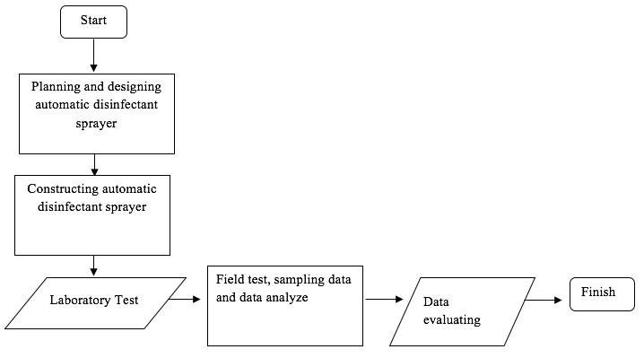

**FIGURE 1.** Research Procedure Flowchart

The first step is planning and designing the automatic disinfectant sprayer by reading related articles and journals. The second is constructing the tool. The third is a laboratory test before conducting a field test. The field test is to collect and analyze data. The last is evaluating the data acquired. The data taken are quantitative data using primary sources while conducting field test.

The automatic disinfectant sprayer system will be attached to the ceiling of the classroom. To assembly the system, additional tools are needed, such as a glue gun, cable ties, cable clamp, screwdriver, and scissors1. The automatization will need an Arduino UNO microcontroller and a classroom schedule to arrange the spraying time accordingly3. The water control from the tank to the misting system manage by relay module4,5. The design showed below:

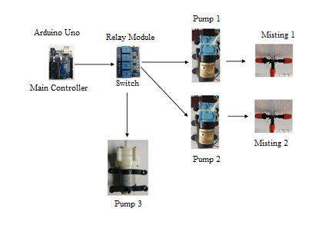

**FIGURE 2.** System Design

The list of tools and spareparts shows in TABLE 1.

**TABLE 1.** Tools and spareparts

|  |  |  |
| --- | --- | --- |
| **Name** | **Amount** | **Unit** |
| Arduino UNOR3 Atmega328 | 1 | piece |
| Relay module | 1 | piece |
| Sinleader 12V DC Pump | 2 | piece |
| 5/16 water pass hose | 23 | meter |
| RTC (*Real Time Clock*) DS3231 | 1 | piece |
| 30 cm Female to Female Jumper Cable | 25 | piece |
| 30 cm Male to Female Jumper Cable | 25 | piece |
| 30 cm Male to Male Jumper Cable | 25 | piece |
| Multimeter | 1 | piece |
| Bottle | 1 | piece |
| Misting orange | 10 | piece |
| Cable ties | 3 | bundle |
| Disinfectant | 30 | liter |
| Adaptor 12V 5A | 2 | piece |
| Adaptor 5V 1A | 1 | piece |

The tools specification as follow:

1. Arduino type UNO ( main controler)

**TABLE 2.** Specification of Arduino UNO

|  |  |
| --- | --- |
| **Specification** | **Value** |
| Voltage | 5V |
| Recommended input voltage | 7-12V |
| Input voltage range | 6-20V |
| Pin digital I/O | 14 (where 6 pin output PWM) |
| Pin analog input | 6 |
| DC current at I/O pin | 40 mA |
| DC current at pin | 3.3V 50mA |
| Flash memory | 32KB (ATmega328), at 0,5 KB use by bootloader |
| SRAM | 2 KB ( ATmega328) |
| EEPROM | 1 KB (ATmega328) |
| Clock | 16MHz |

1. Relay module ( as a switch)

**TABLE 3.** Specification of relay module

|  |  |
| --- | --- |
| **Specification** | **Value** |
| Input relay | 5V DC |
| Maximum load | 250VAC/10A 30VDC/10A |
| Opto-coupler isolation for board microcontroller protection of AC current | - |
| Indicator LED | - |
| Terminal Block | - |
| Maximal 4 channel output | 10A |

1. SINLEADER DC water pump (sprayer)

**TABLE 4.** Specification of water pump

|  |  |
| --- | --- |
| **Specification** | **Value** |
| Voltage | 12V Nom.(9-14.4V) |
| Current | 4.0A |
| Flow | 6.0 LPM |
| Pressure | 130 Psi (8.3 Bar Cut off) |

1. Orange type misting (range ± 1 meter depent on water pressure)

**TABLE 5.** Specification of misting

|  |  |
| --- | --- |
| **Specification** | **Value** |
| Type | Sprinklers |
| Color | Orange/Black |
| Capacity | 8-10 L/hour |
| Spray diameter | 0,7-0,9 meter |
| Conectore size | 6 mm |

1. 1.5L tank to store the disinfectant fluid

# Discussion

## System design

The system design can be divided into two parts; the first is a hardware design and the second is software design. Hardware design is electronics design as well as spare parts assembly. The electronics design of the system adjusts to the input requirement of each electronic component. FIGURE 3 shows the overall configuration of the system which connected the Arduino micro controller to RTC. FIGURE 4 shows the system installation diagram within the classroom with the assumption of 10.3m x 7.8m space.

The software used for Arduino UNO is Arduino IDE software. This software uses the C programming language. This Arduino listing program known as sketch, “void setup()” {} and “void loop()”. {} is a function of each sketch6. To design the Arduino program, its start with installing the pins for the system. FIGURE 5 shows a part of the program.

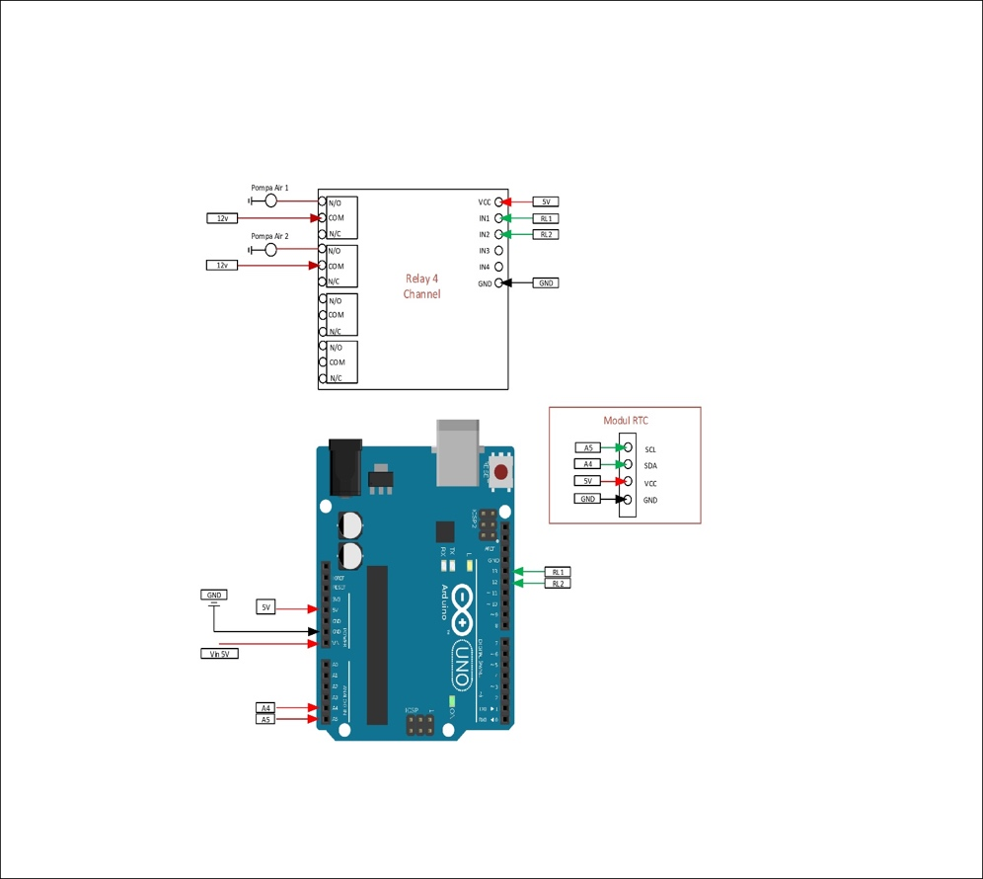

**FIGURE 3.** Electronic circuit of the system

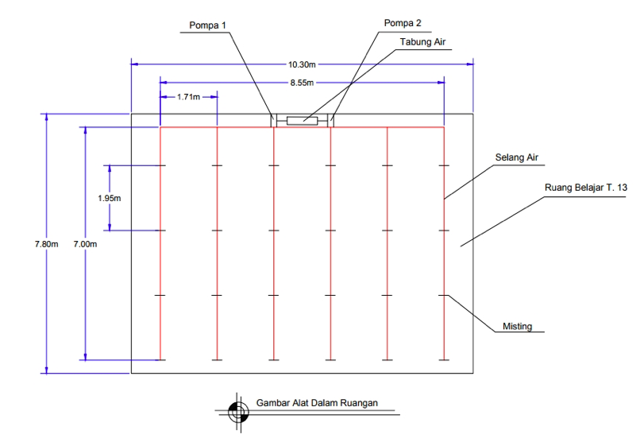

**FIGURE 4.** System installation

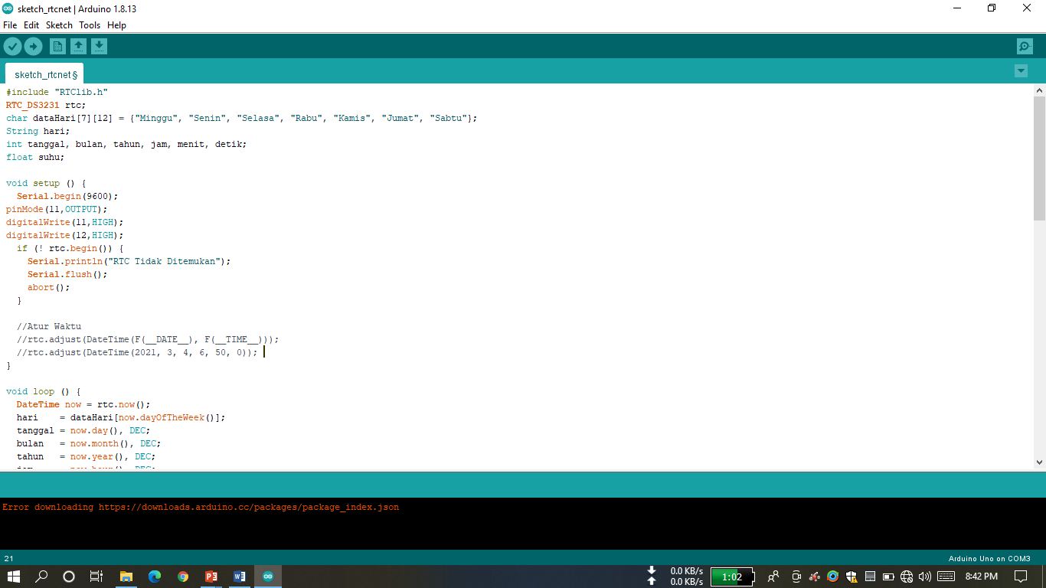

**FIGURE 5.** Arduino IDE Program

## System operation

The system will automatically work according to the class timetable2. For example, the first class on Monday (Senin in Bahasa) is "Sistem Kontrol" for the third-semester student that will perform at 07.30 – 09.10 Eastern Indonesia Time (EIT), the system will spray automatically 30 minutes before the class started (07.00 EIT). The 30 minutes’ time window can be set by the user according to the class timetable. The system will spray the classroom for 10 seconds. The rules will work for the other class on the day, but not for an unscheduled class. Although the system works automatically while spraying disinfectant, however, to refill the disinfectant tank still needs to do manually. The flowchart that use to explain the system workflow shows in FIGURE 6.

## System test

The test that runs aims to acquired data and the error rate of the system1. The test conduct on two functions, functional test and performance test. The functionality test completes by test the characteristics and functions of each part of the system. The test is to understand whether or not the system works properly. While the functionality test identifying whether or not the system works as it intended to.

The functional test conducts on the system and parts such as a microcontroller, relay, RTC, water pump, and power supply. The microcontroller used is Arduino UNO that tested with input the programmed codes to Arduino IDE software. The relay tested using the microcontroller with a digital input signal that works as a switch. At the test, the input signal is HIGH then the relay on N/O is connected and on N/C disconnected. On the other hand, while the input signal is LOW then the relay on N/O is disconnected and on N/C connected. This condition explained that the system works properly.

The RTC asses by input code to Arduino IDE and checks it can be read by the RTC. The water pump test achieves by using a 220V power supply. And last the power supply test accomplish by using a 12V 5A adaptor.

The performance test executes by operating the system and each part according to its purpose. The test performs at the controller part and management part. The test performs to make sure that the system can operate well. The tables below show the test result.

**TABLE 6.** System test

|  |  |  |  |  |
| --- | --- | --- | --- | --- |
| **DC voltage on RTC** | **DC voltage on Relay** | **DC voltage on Arduino** | **Total Power** | **Status** |
| 4.82 V | 3.82 V | 4.95 V | 1,08 Watt | Standby |
| 5.06 V | 4.55 V | 5.10 V | 1.19 Watt | Operate |

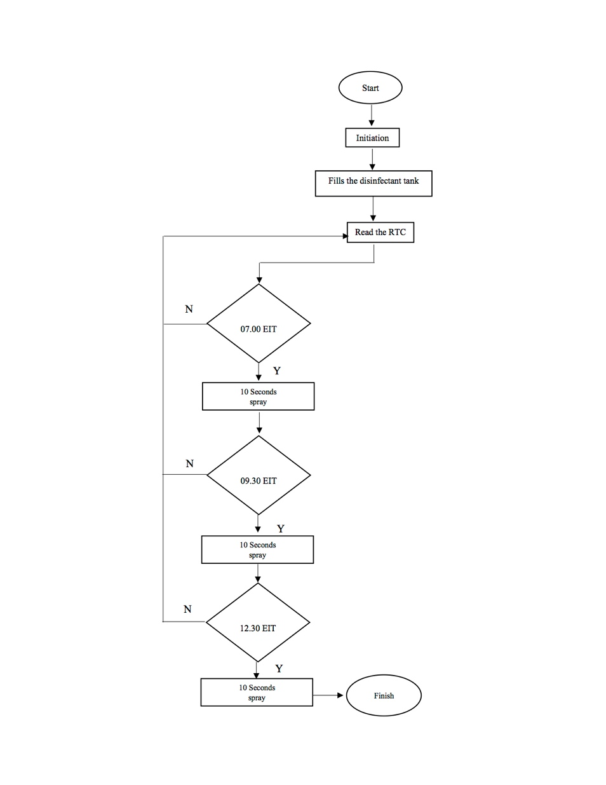

**FIGURE 6.** System Program Flowchart

**TABLE 7.** Water pump test on standby condition

|  |  |  |  |
| --- | --- | --- | --- |
| **DC voltage on Pump 1** | **DC voltage on Pump 2** | **Total Power** | **Status** |
| 0.78 A | 0.78A | 18.72 Watt | Standby |
| 2.36 A | 2.40 A | 57.12 Watt | Operate |

**TABLE 8.** Current on the system

|  |  |  |
| --- | --- | --- |
| **DC current on RTC** | **DC current on Relay** | **DC current on Arduino** |
| 0.54 mA | 123.4 mA | 117.3 mA |

## Block diagram

Block diagram of the automatic disinfectant sprayer consist of power supply block, input block, process block, and output block show in FIGURE 75.

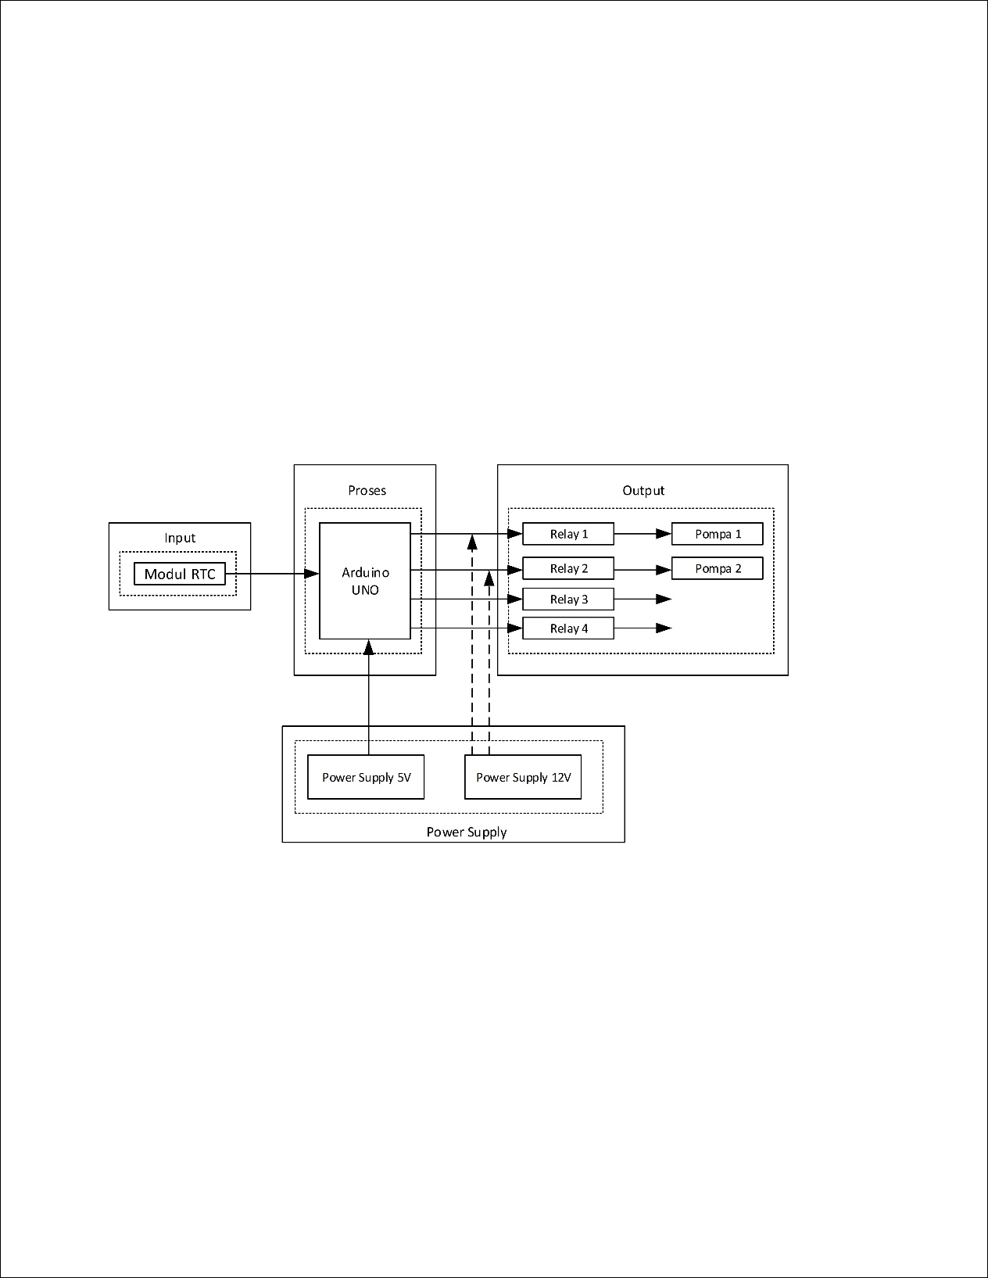

**FIGURE 7.** Block Diagram Circuit

The Power supply block is a block that have two adaptors which are 12V 5A adaptor that function as main power supply and 5V adaptor as Arduino UNO power supply. The input block consists of RTC module as time reader. The process block is the brain of the system that used Arduino UNO as its component. The output block is the controlled parts that consist of 4 relay channel function as water pump switch.

## System implementation

The prototype consists of parts as shown below, such as Arduino UNO and its software, relay, water pump, misting, water pass hose, power supply, and RTC.

1. Arduino UNO as controller

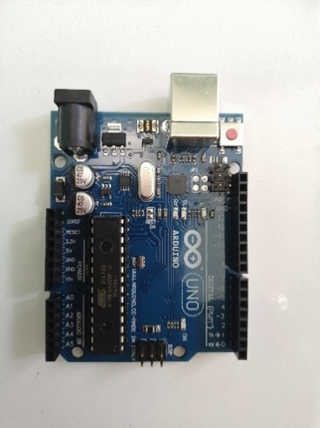

1. Relay as switch

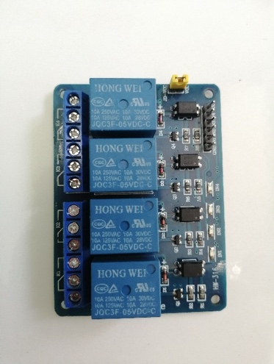

1. Water pump

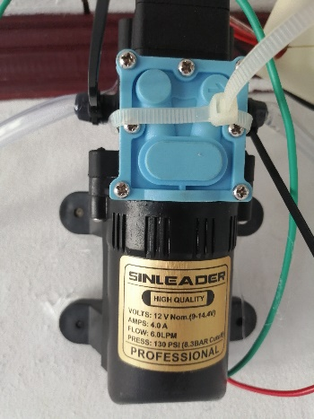

1. Misting

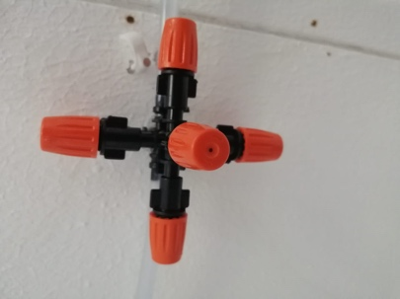

1. Water pass hose

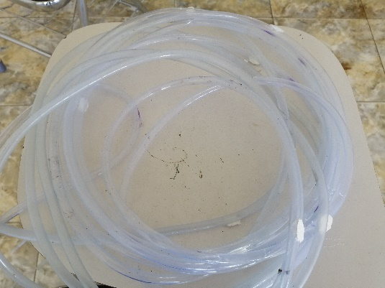

1. Power supply

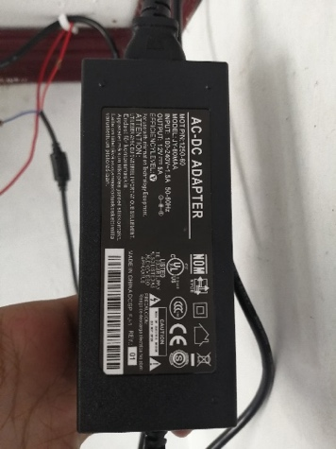

1. Arduino IDE software



1. RTC

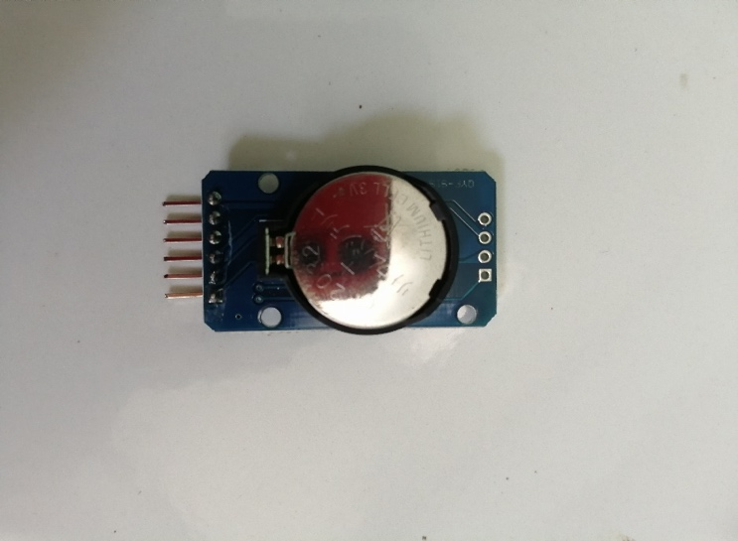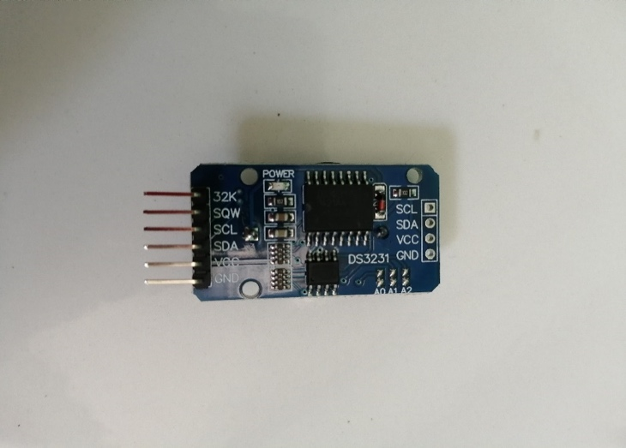

The system network in detail shows at FIGURE 8.

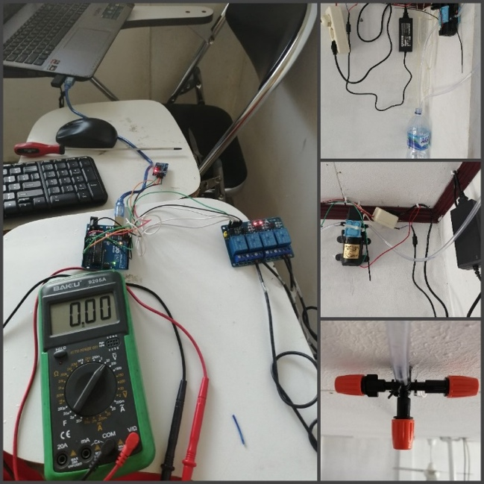

**FIGURE 8.** Detailed Overall System

## System assembly process

The assembly process of the system following several steps. The first step is preparing tools and spare parts. The process is according to the planning. The second step is constructing the hardware. The third is implementing the software into the system. And the last is testing the system, hardware, and software.

The total expenditure to build the system is Rp. 1,384,225.-. The price is affordable for the system that can accommodate a lot of people. The budget showed in TABLE 9 below.

**TABLE 9**. Budget expenditure

|  |  |  |
| --- | --- | --- |
| **Parts** | **Quantity** | **Price** |
| Arduino UNO R3 Atmega328 | 1 | Rp. 75,000.- |
| RTC (*Real Time Clock*) DS3231 | 1 | Rp. 22,500.- |
| 30 cm Male to Male Jumper Cable | 25 | Rp. 11.875.- |
| 30 cm Male to Female Jumper Cable | 25 | Rp. 11,875.- |
| 30 cm Female to Female Jumper Cable | 25 | Rp. 11,875.- |
| Sinleader 12V DC Pump | 2 | Rp. 264,100.- |
| Relay module | 1 | Rp. 43,000.- |
| Misting orange @Rp. 4,000.- | 150 | Rp. 600,000.- |
| Water pass hose | 23 meter | Rp. 69,000.- |
| Cable | 15 meter | Rp. 75.000 |
| Adaptor | 2 | Rp. 200,000.- |
| Total budget |  | Rp. 1,384,225.- |

## System operation

The automatic disinfectant sprayer operates by doing protocols. The first protocol is to make sure the system connects to 220V AC grid lines before turn on the system. Then, input the class timetable into the system. After that, the system will work as programmed. To turn off the system, unplug the power supply cord that connects to the 220V AC network.

# CONCLUSIONs

The design and assembly of automatic disinfectant sprayer have succeeded its purpose in 10.3 m x 7.8 m classroom. The sprayers outlet arranges at 30 places with five misting for each point. The spraying process works perfectly according to the class timetable programmed on the Arduino UNO microcontroller. The total budget for the system is affordable, thus applicable to many classrooms.

# References

1. A. N. Trisetyanto, *Rancang Bangun Alat Penyemprotan Disinfektan Otomatis untuk mencegah Penyebaran Virus Corona* (unpublished, Universitas IVET, Semarang), 2015.

2. F. R. Seke, *Sistem Kontrol Otomatis Misting Antiseptik Berbasis Microcontroller Untuk Meminimalisir Penyebaran Covid-19* (unpublished, Universitas Negeri Manado, Manado), 2020.

3. M. Novaria, *Rancang Bangun Alat Anti Kebisingan Suara Guna Mendukung Etika Berkunjung Ke Rumah Sakit Berbasis Arduino UNO* (unpublished, Politeknik Negeri Sriwijaya, Palembang), 2017.

4. M. Risal, *Sistem Kontrol Sirkulasi Air Dan Pemberian Pakan Pada Akuarium Ikan Hias* (unpublished., STMIK Handayani, Makassar), 2017.

5. M. Saleh & M. Haryanti, *Rancang Bangun Sistem Keamanan Rumah Menggunakan Relay* (unpublished., Universitas Suryadarma, Jakarta), 2017.

6. Zulkarnaen, *Smart Sprayer Disinsfektan Berbasis Mikrokontroler Atmega328* (unpublished, STMIK Syaikh Zainuddin NW, Anjani NTB), 2020.