**Learning Media of Mobile Augmented Reality Based Electrical Measurement Tools In Design and Testing**

**Yushanafi MN1 and Samsul Hadi2**

Electrical Engineering Education Department, Universitas Negeri Yogyakarta,  
Yogyakarta, Indonesia

E-mail: [yushanafi@gmail.com](mailto:yushanafi@gmail.com) , [samsul.hd@gmail.com](mailto:samsul.hd@gmail.com)

**Abstract.** Learning Media of mobile augmented reality-based electrical measurement tools is a technology that can help teacher and student work together in the learning process how to use electrical measurement tools correctly. As a learning aid, development of mobile AR-based electrical measurement tools helps a student to interact and make simulation use of tools virtually with phones that have been designed to resemble the actual form. AR technology can be used anywhere and anytime with the help of smartphones. This technology uses mobile phones or smartphones to enhance its utility such as cameras and sensors, so this AR-based does not use marker but using ground plane detection methods. This method will detect horizontal surfaces in the environment, such as floors and tabletops so virtual media can place it like real. Into the development of this application must go through several stages before it is ready for use. Functional testing becomes important to see the compatibility of the application against the hardware. The test results show that this application can run on almost all smartphone devices.

**Keyword :** *augmented reality, electric measurement, vocational education, multimeter*

1. **Introduction**

Electrical power installation engineering is one of the expertise programs held at vocational high schools. The purpose of this expertise program refers to the Law on the National Education System No. 20 of 2003 article 15 states that vocational education is secondary education that prepares students to continue their studies in the vocational field or to enter the world of work directly. Specifically, the Electrical Power Installation Engineering Skills Competency is that students are equipped with skills, knowledge, and competencies in the electricity sector in a professional manner.

The Indonesian National Work Competency Standards (SKKNI) as work competency standards in a field are used as reference competency standards in the development of the Electrical Power Installation Engineering Skills Competency curriculum. These competencies are built on the foundation of normative, adaptive, and productive basic competencies.The Indonesian National Work Competency Standards (SKKNI) as work competency standards in a field are used as reference competency standards in the development of the Electrical Power Installation Engineering Skills Competency curriculum. These competencies are built on the foundation of normative, adaptive, and productive basic competencies.

The electric measurement tools are the competency of expertise in electric power installation engineering in vocational high schools. In this competency, students learn about the introduction of electric measurement tools, work principles, measurement procedures, and analysis of measuring electrical quantities results. This competency used of a basic reference in developing learning media applications based on augmented reality mobile. The augmented reality-based was chosen because of several advantages, Augmented Reality (AR) is a technology that can change the way people learn and educate. Aside from that, the widespread adoption of mobile devices has sparked a surge of interest in combining the advantages of mobile learning and augmented reality applications[1]. Visual augmentation, in which computer graphics are combined with real-world imagery, is the most popular application of AR. AR blends graphics and video using a handheld computer such as a smartphone or tablet. This is referred to as "handheld camera see-through"[2]. Augmented Reality (AR) has the potential to be employed in the educational and education method in colleges[3]. AR as a mixed and enhanced reality has compelling features for educational purposes; its potential and affordances can be further extended when an AR system is designed by connecting multiple types of technologies [4].

Augmented reality as a learning medium can also overcome various obstacles in the teaching and learning process in vocational high school. Many studies have shown that Augmented Reality (AR) technologies have a positive effect on student motivation, learning benefits, communication, engagement, learning behaviors, and enjoyment in primary, secondary, and higher education. However, little research has been done on the advantages of AR applications in VET, as well as their effect on addressing a broad range of special educational needs, such as learning disabilities[5]. During the next few decades, multimedia will cause significant changes in the teaching process, particularly as smart students discover that they can go beyond the limitations of traditional teaching methods. There is a change in learning from the transmitting or passive-learner model to the experiential or active-learner model[6]. It is important to build a learning environment that can attract students' learning interest, enhance student visualization, and reduce the cognitive stress faced by students when developing learning media for AR technology in Vocational High School. Furthermore, the teaching and learning process is more engaging because of the teacher's teaching style. Furthermore, the teaching and learning process is more engaging due to the teacher's style of combining theory and practice at the same time. The use of augmented reality in education not only aids in the creation of a healthy teaching and learning atmosphere, but it also improves students' abstract visualization, which is beneficial when performing experiments. [7].

1. **Designing of Mobile Augmented Reality Based Electrical Measurement Tools**
   1. *Development Tools Introduction*

Unity3D is a multi-platform game development framework with a completely integrated professional game engine that includes rendering, physical engine, script engine, lighting mapping, and scene management capabilities. Unity3D is primarily used to construct immersive 3D and 2D environments such as training simulations, medical visualization, and structural visualization. A full Unity3D software is made up of several scenes, each of which contains a large number of models (GameObiect) and their actions, which is managed by scripts (such as JavaScript, C#, and others). The camera presents and controls what we see in the picture[8].

As a mobile application developer platform, Unity does not work alone. The are several development tools that can be used to create an augmented reality-based mobile applications, one of which is the Vuforia SDK. Vuforia is a mobile augmented reality software development kit (SDK) that allows developers to create augmented reality apps. It recognizes and tracks planar images and 3D objects in real time using computer vision technology. When virtual objects, such as 3D models and other media, are viewed through the camera of a mobile device, this image registration feature allows developers to place and orient them in relation to real-world objects [9].

* 1. *The Concept of Learning Media*

A study produced a mobile application based on Augmented Reality for electrical measurement tools in a vocational high school called ARAVO. The apps became a learning media that compiled using AR-based technology. A technology that overlays virtual objects (augmented components) into the physical world is known as augmented reality (AR). These virtual objects then tend to share the same space as real-world objects.[1]. Augmented Reality (AR) is a kind of Virtual Environment (VE), or Virtual Reality (VR), as it's also known. Virtual Reality systems completely immerse a user in a synthetic environment, and the user is oblivious to the physical world around him when submerged. Augmented Reality, on the other hand, takes digital or computer-generated content, such as pictures, audio, or video, and adds it to the real world.[10]. Augmented reality is a method of viewing the real world (either directly or through a system such as a camera that creates a visual representation of the real world) and enhancing the visual with computer-generated input such as still graphics image, audio, or videos. AR differs from VR in that it enhances (adds to) a real-world or current scene rather than making something entirely different.[11].

The apps is the Augmented Reality of Amperemeter, Ohmmeter, and Voltmeter. The ARAVO has made an interface and learning features designed to resemble the actual form of using electric measurement tools in a virtual object. The mobile AR system can strengthen the ubiquitous cooperative and scene learning with the helpof virtual objects in the real environment. All in real life can be used as a prop in augmented reality learning to achieve convenience, interactivity, situational awareness, accessibility, and personalization[8] The ARAVO had five main menus, namely the Home, Competency Standart(SKKD), Play AR, material, and information menu. To understand the work system of the Learning Media of mobile augmented reality-based electric measurement tools, figures 1 is presented below :

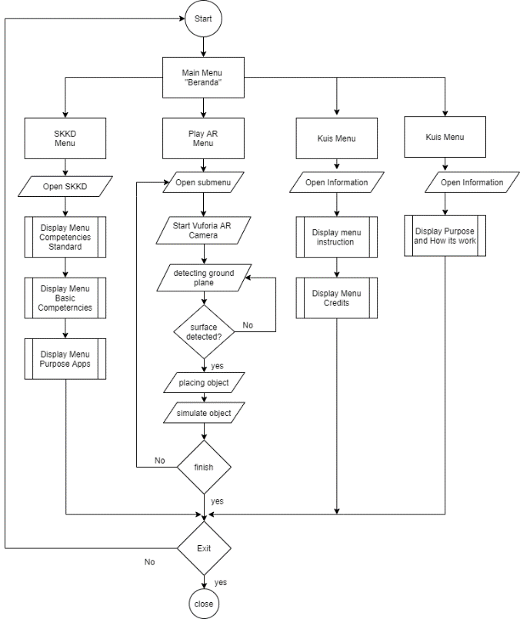

Figure 1. Flowchart of mobile Mobile Augmented Reality Based Electrical Measurement Tools

The Home menu consisted of the being this application purpose made and how to operate the Learning Media as learning media for electrical measurement tools. The information menu also can be found here. The information menu consisted of a detailed explanation of each button and function in apps. The credits menu shows sources of every part and component 3D model, icon, and pictures that exist inside apps. The competency standart menu is a list of Competencies standard, and Basic Competencies is part of the curriculum vocational high school major of electrical engineering. This menu helps a user understand that the application is part of competency standart in vocational high school.

The Play AR is the main menu for a Learning Media for electrical measurement tools with AR-based technology. There five sub-menus called Resistance measuring with Ohmmeter, DC electric current measuring with Amperemeter, DC voltage measuring with Voltmeter, AC voltage measuring with Voltmeter, and extras.

* 1. *Media Design Display*

Design of user interface is one of the most important things while developing mobile application.

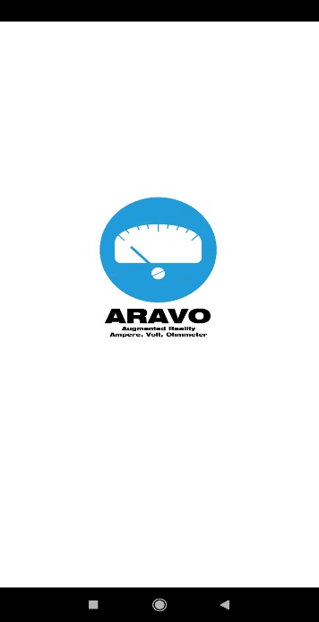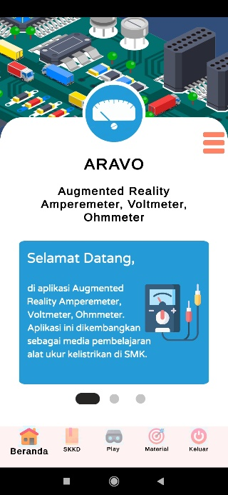

Figure 2. Main Menu Display

Figure 2 shows the initial view and face of the learning media for electric measuring instruments based on augmented reality. There are 5 main menus displayed, namely homepage, competency, AR play, materials, and information. The workflow for each menu is described in Figure 1 above.

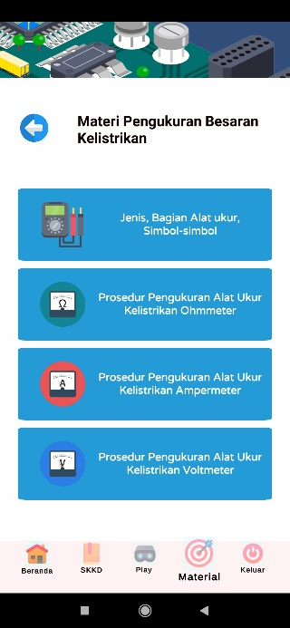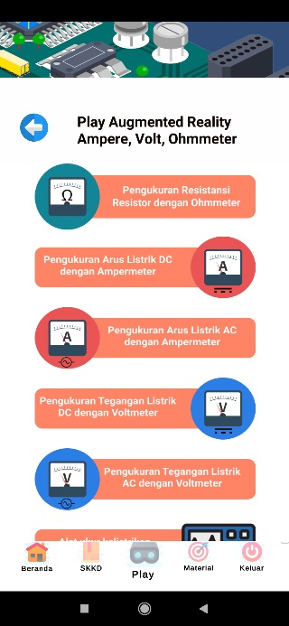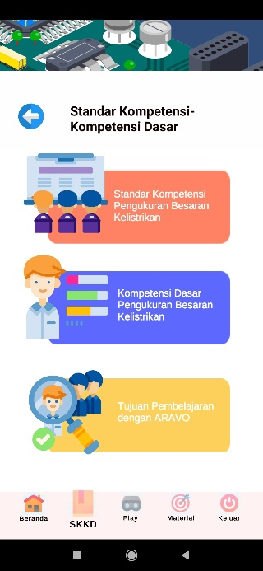

Fig.3 Display of sub-main menu

Figure 3 shows the content in each main sub-menu. Every sub-menus was directly connecting to the previously programmed AR-based technology in Unity3D. Vuforia AR platform used in this program. The augmented reality method is not marker detection but ground plane detection. The ground plane detection method combines a camera and sensor in smartphones to detect horizontal surfaces in the environment such as floors or tabletop. After that, an AR program will run and put the 3D model of the electric measurement tool top on it. The main 3D model virtually for electrical measurement tools is the multimeter.

A Multimeter is a measuring instrument that can measure multiple electrical properties. A user can use this menu to simulate how to operate measurement tools correctly. Multimeter hasSimulation can see in smartphones with camera-assisted. As an example measuring DC electric voltage with a voltmeter. As an example measuring DC electric voltage with a voltmeter can see how real it, the voltmeter in a virtual world can use to measure the DC electric voltage as in the physical world perspective.

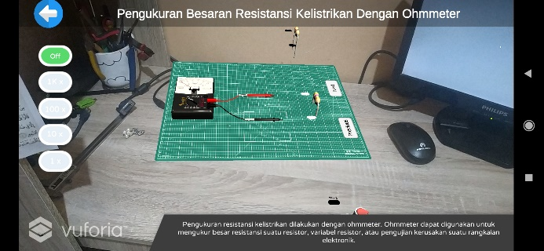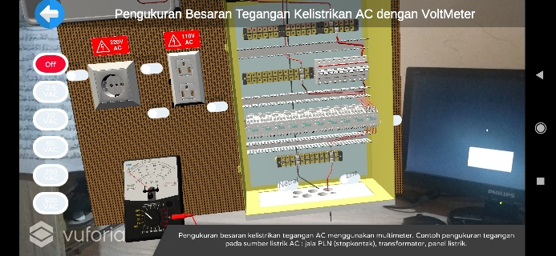

Figure 4. Display of multimeter and electric panel based on augmented reality

Figure 4 shows a simulation of using a multimeter to measure voltage with augmented reality technology. Vuforia Ground Plane enables digital content to be placed on horizontal surfaces in your environment, such as floors and tabletops. It supports the detection and tracking of horizontal surfaces, and also enables you to place content in mid-air using Anchor Points.[12]. . The detection technique does not use markers like AR applications in general but uses the ground plane detection method. The virtual model can access by pointing the camera at a flat area such as a table or floor. The multimeter acts as a 3d model is displayed on the table. The model is visible with the help of a smartphone camera. Each material is equipped with a virtual button that functions to simulate measurements of various electrical quantities

The multimeter has a selector knob to determine its function and measuring limits. For example, users take measurements of electrical voltage quantities, users define their own measuring limits. The UI button on the left side of the smartphone screen is used to control the selector knobs. The multimeter probe cable is moved by pressing a virtual button pin that is visible through the cellphone camera, so that the application will pinpoint the target point for measuring voltage. In addition to the virtual button pins, there are virtual prev and next buttons, used to replace the components to be measured.

1. **Results**

This research is still limited to the functional test. The functional test is installing the application on several android devices such as Xiaomi Redmi Note 8 and Xiaomi Redmi Note 7. The results obtained are that the Aravo application can run well on the Android Nougat platform and above. The further research step is to validate the appropriateness of this application by media and material experts to obtain feasibility, usability data and the readiness of learning media to be implemented in schools.

1. **Conclusion**

The goal of developing augmented reality-based mobile applications is to optimize learning with smartphones to make it more interesting. This application is a means to bridge the limitations of practical tools, especially in the competence of electrical measuring instruments. This competency student needs to master understanding and skills of electrical measuring instruments. Augmented reality learning media on this electric measuring instrument is expected to increase the efficiency of a teacher in delivering electrical measuring instrument material that is full of practical learning. Students can simulate the measurement of various electrical quantities such as voltage, resistance, and electric current virtually with the help of a smartphone, just as students practice using realistic measuring instrument tools. Hopefully that the application can run on various smartphone platforms for students and teachers well and smoothly.

1. **References**

[1] Nincarean, D., Ali, M. B., Abdul Hamid, N. D., & AR, M. M. (2013). Mobile Augmented Reality: the potential for education. *Procedia - Social and Behavioral Sciences 103* , 657 – 664

[2] Linowes, J., & Babilinski, K. (2017). *Augmented Reality for Developer: Build practical augmented reality applications with Unity,.* Birmingham: Packt Publishing.

[3] Akçayır, M., & Akçayir, G. (2016). Advantages and challenges associated with augmented reality for education: A Systemic review of the literature. *Educational Research Review*.

[4] Hsin, K. W., Silvia Wen, Y. L., Hsin, Y. C., & Jyh, C. L. (2013). Current status, opportunities and challenges of augmented reality in education. *Sciencedirect: Computer and Education Volume 62*.

[5 ] Acosta, J. B., Fabregat, R., Baldiris, S., & Graf, S. (2014). Augmented Reality Trends in Education: A Systematic Review of Research and Applications. *J. Educ. Technol. Soc.17 (4)*, 133–149.

[6] Vaughan, T. (2011). *Multimedia : Making It Work,eight edition.* McGraw-Hills.

[7] Ismail, M. E., Utami, P., Ismail, I. M., Khairudin, M., Amiruddin, M. H., Lastariwati, B., & Maneetien, N. (October 2018). The effect of an augmented reality teaching kit on visualization, cognitive load and teaching styles. *Jurnal Pendidikan Teknologi dan Kejuruan, Vol. 24, No. 2*, 178-184.

[8] Li, C. Y., & Tang, B. (2018). *Research on The Application of AR technology Based on Unity 3D in Education.* IOP Conf. Series: Journal of Physics: Conf. Series 1168 .

[9] Getting Started with Vuforia Engine in Unity: About Vuforia. Accessed April 30, 2021 [https://library.vuforia.com/articles/Training/getting-started-with-vuforia-in-unity.html#about](https://library.vuforia.com/articles/Training/getting-started-with-vuforia-in-unity.html%23about)

[10] Kipper, G., & Rampolla, J. (2013). *Augmented Reality: An Emerging Technologies Guide to AR.* 225 Wyman Street, Waltham, MA 02451, USA: Elsvier.

[11] Mealy, P. (2018). *VIrtual and Augmented Reality for Dummies.* New Jersey: John Wiley & Sons, Inc.

[12] Ground Plane Vuforia. Accessed April 30, 2021 <https://library.vuforia.com/features/environments/ground-plane-guide.html>