An Extended IoT System for Real Time Solar Power Monitoring
Adelhard Beni Rehiara^{1, a)}, Yanty Rumengan², Pandung Sarungallo³⁾
Author Affiliations
^{1,2,3}Electrical Engineering Department, University of Papua, Indonesia
Author Emails
^{a)} Corresponding author: a.rehiara@unipa.ac.id
Abstract. Industrial revolution 4.0 has been marked with the human needs of big data from all over devices, and it has been triggering the massive development of the Internet of Things (IoT). In this paper, an IoT system for solar power monitoring system is developed to measure voltage, current, temperature, and humidity using a voltage divider, ACS712, and DHT11 sensor. An ATMega328 microcontroller then processes data, and hereafter it is given to the ESP8266 module to be sent thru an internet connection via the TP-Link TL-MR3420 modem. The result of the running system shows that the proposed IoT system can well run to measure the system variables. As samples of the test measurement data on 4th April 2021, about 70%RH, 35⁰C, 13V and 0.25A for humidity, temperature, voltage and current respectively can be sensed. However, the data is sent to a cloud system and displayed in the LCD for local monitoring.

INTRODUCTION
Technology is created to help and reduce human work. Since the first industrial revolution, technology has developed to be more sophisticated, simple, and easy to use. In every industrial revolution, technology is focused on differently. Some points of the current industrial revolution 4.0 are the internet of things (IoT), networking, and cyber-physical system. An IoT allows a device to exchange data utilizing an internet network. The IoT application covers many technology areas, but it is mostly used to monitor and control devices [1-2].
Solar power is a kind of renewable energy that becomes popular to be developed. People are more intent to use this power together with the maturity of solar technology, the simplicity to be installed, and the attractive price of the solar power unit. On the other hand, the disadvantages are the dependency on weather, the effective time of solar radiation and the coverage area for the panel installation.
Many researches have been issued in solar power monitoring, i.e., 1) Gopal et al. have built an IoT based solar power monitoring to monitor voltage and current of a PV panel. It is not stated where the data is stored [1], 2) Husin et al. design a solar power monitoring device and the data is given in online mode. The device also does an algorithm to track the sun so that the power plant will produce maximum energy [3], 3) Li et al. develop an IoT technology to monitor, maintenance and performance of a solar PV. This device includes GPS and camera system connected to a raspberry PI[4], 4) Priharti et al. design a device for online monitoring a PV panel. This device include a light intensity sensor[5], and 5) Rehiara et al. implement a data logger for real time solar power monitoring where the data is stored on local drive[6]. From this point of view, many of them are focused on monitoring voltage, current, and generate energy, while solar power generation is very dependent on weather.
In this paper, an extended IoT system for solar power monitoring is proposed. A DHT 11 sensor is added to measure humidity and temperatur where is negletecd by previous researchers. Therefore the IoT system can measure more variables such as voltage, current, temperature, and humidity so that the given data is useful for monitoring, modeling, and forecasting both solar energy and weather.

Method

System Diagram
The block diagram of the proposed IoT system is given in Figure 1. It consists of a solar power system measured with current and voltage sensors, and temperature and humidity sensors are extended in this system to provide information about the weather. All of the data is processed by an ATMega328 microcontroller, and the output is sent to an LCD, serial monitor, and cloud storage.

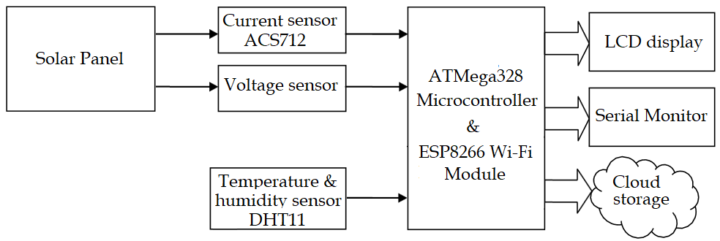
Figure 1. The proposed IoT system diagram

Voltage Divider
In this project, a voltage devider is used to reduce solar panel voltage so that the voltage can be sensed by the analog to digital (ADC) part of the microcontroller. The voltage divider is a simple but useful device to separate high voltage into some fraction in the output part. In general, this device is built using two or more resistors which are in pairs within series pair with input voltage shown in the Figure 2 [6-7].

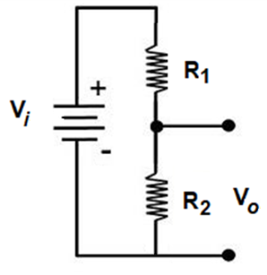
Figure 2. Voltage divider

According to Ohm's law, current I flow in the voltage divider is equal to the input voltage divider by total resistivity, R₁, and R₂. Then the output voltage V_{o} is the output resistance R₂ by current I. Therefore the voltage divider can be formulated as follows, where the current I is processed inside the bracket [6-9].

(

Cloud Storage
The sensing data is sent to cloud storage so that everyone worldwide can monitor solar power. Many free websites are provided, such as ThingSpeak[8][10], Blynk [11], Cayenne, etc. In our case, the ThingSpeak platform was selected due to its simplicity, but unfortunately, it has limited to 7 channels and 3 million data for a free user account. ThingSpeak gives a complete service for an IoT system, including aggregate, visualize, and analyze data streams in a cloud platform. In addition, it can send alerts while creates a data visualization instantly.

System Implementation

Hardware
Based on the proposed system shown in Figure 1, some hardwares are used to build the completed system where completed system are connected as shown in Figure 5. The hardwares are detailed as follows.
- Uno Wi-Fi Board
In this board, a microcontroller Atmel ATMega328, Wi-Fi module ESP8266 with 32 MB flash memory and CH340G USB-TTL converter are integrated on one board. The board has compatibility with Arduino Uno R3, and so it can be programmed with Arduino IDE. A DIP switch is provided for setting the configuration as specified and the physical of the board is given in Figure 5 [12].

- LCD Display
Liquid Crystal Display (LCD) is a media display that used liquid crystal for displaying any character. Some types of LCD are segment LCD, dot matrix character LCD, and graphic LCD. In this paper, a dot-matrix LCD that can display 16 X 2 characters. The LCD 16x2 has 16 pins which are categorized into three parts [13], i.e.:
- Data pins data which are used to send characters data to the LCD, D0 to D7. In an application using a micro-controller, only data pins from D4 to D7 are used.
- Setting pins that are used to set the LCD. The pins are RS (Register Select) pin for indication or set the type of incoming data as a data or command, R/W (Read Write) pin as an instruction for write or read data, E (Enable) pin to latch the data.
- Power pins are used for powering the LCD, which are A, K, VD, VSS, and VDD.

- ACS712 Current Sensor Module
This sensor module is a low price current sensor but powerful inaccuracy for sensing AC or DC current. The current is measured using a linear Hall circuit while providing low power loss due to small internal resistance. The ACS712 sensor has been factory-trimmed, and it has nearly zero magnetic hysteresis, so there is no need for calibration. This module and its schematic are figured in Figure 3, while its important features are given in Table 1 [14].
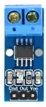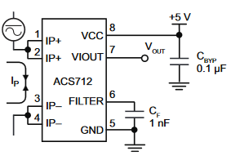

Figure 3. ACS712 current sensor module

TABLE 1. Features of ACS712
Description | Values
Internal conductor resistance | 1.2 mΩ
Output sensitivity | 66 to 185 mV/A
Zero current output voltage | VCC x 0.5 V
Total output error | 1.5% at 25°C
Internal conductor resistance | 1.2 mΩ

- DHT 11 Sensor Module
DHT11 is a temperature and humidity sensor offering excellent quality, long-term stability, fast response, anti-interference ability, and cost-effectiveness. The sensors measure humidity using the resistive-type humidity measurement component while using NTC for sensing the temperature. The output of both temperature and humidity data are 40-bit data, and those are sent together simultaneously and on the same wire. The 5KW pull-up resistor is needed to latch the data within a 20m distance, and it is inside the module, as shown in Figure 4 [15].

.
.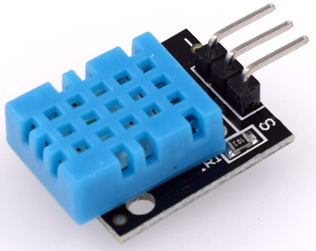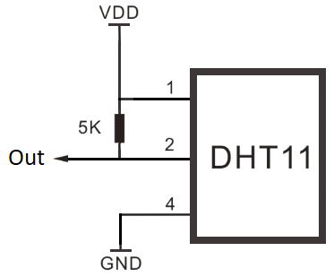

Figure 4. DHT11 sensor module

- Solar Panel
The solar panel is also called a photovoltaic panel or solar cells. The term "cells" means that this panel contains some independent solar cells built by mixing some semiconductor elements like silicon, phosphorus, and boron layers [1][16]. These cells are structured in a grid-like pattern on the solar panel's superficies. Most solar panels are built from crystalline silicon solar cells due to their durability to high temperatures. However, some solar panels are designed from a thin film that converts solar radiance spectrum into electric energy. This thin film may not be lasting in high temperatures, and so it is mainly used in a place with low temperatures.

Firmware
This project used ATMega328 microcontroller in an Uno Wi-Fi board. The microcontroller needs firmware as the primary instruction to be executed along the hardware process. Due to the compatibility of the Uni Wi-Fi mainboard with an Arduino, it can be programmed in Arduino IDE. This IDE provides a simple way to program a microcontroller than the other IDE, such as WinAVR, BASCOM AVR, etc.

System Design
The completed system design with the wiring data is provided in Figure 5. DHT 11 sensor module will send the data through port 2 of the main board, while ACS 712 sensor module and voltage divider are connected to ADC port A1 and A2, respectively. The voltage divider designs so that the solar panel voltage is divided into six parts, and the mainboard will sense 1/6 of the solar panel voltage. Therefore the maximum sensing is about 30 VDC.
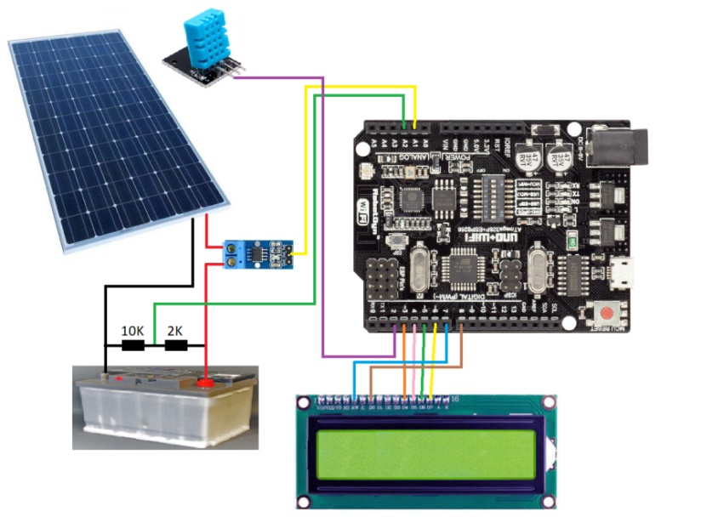
Figure 5. Wiring diagram

RESULT

Connection Testing
The connection to the internet is made via a Wi-Fi connection provided by the TP-Link TL-MR3420 modem. Figure 6 shows the connection test of the implemented system, namely ESP_05FF7B, which is captured from the modem traffic monitor list. The figure also shows that the IoT system actively sends the data to the cloud website.

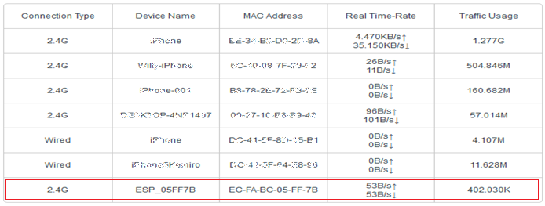
Figure 6. Connection test

Logging Data
In this project, about 4 channel data have been used to save the data from the IoT system where each channel is used to collect data from each sensor. The IoT system is designed to send data every 20 seconds, and Figure 7 shows the collected data on 4th April 2021 started from 15:14 to 15:34. For each channel, 180 samples of actual data were collected for about 60 minutes. However, in the cloud service platform, only 60 samples (20 minutes) will show.

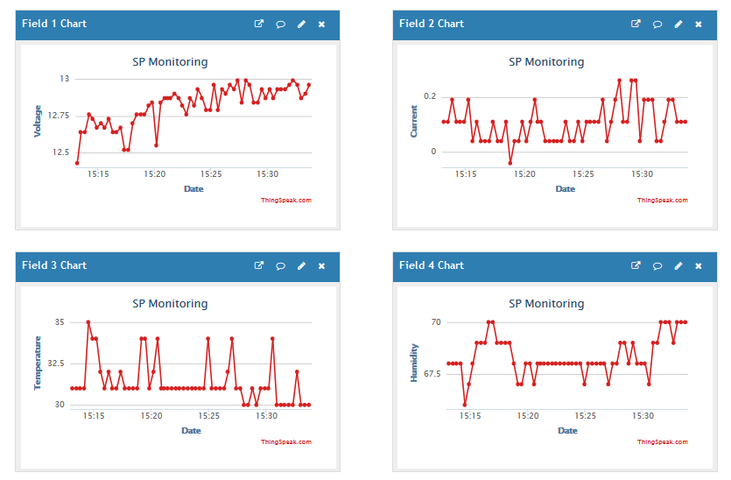
Figure 7. Logging data

At the time of logging data, the weather is slightly cloudy after heavy rain, where the humidity and temperature are high, about 70%RH for humidity and 35⁰C for temperature. On the other hand, the voltage is measured at about 13V while the battery is almost full, as shown in a little current flow of about 0.25A. This IoT system can provide some parts of weather system data; therefore, it can be used to monitor solar power and for modelling and forecasting the weather.
Based on observation, there are some delays between sending data and displaying data to the ThingSpeak. These delays cause by a slower internet connection between the device and the cloud service. However, all of the data was sent successfully. The duration of about 20 seconds is more than enough for the device to resend the data before new data arrives.

Conclusion
In this article, a solar power monitoring device has been designed and developed. The mainboard consists of an ATMega328 microcontroller and Wi-Fi module ESP 8266. The monitoring system can run well to sense the voltage, current, temperature, and humidity of a solar power generation system. A current sensor ACS712 is occupied in getting the current data while the voltage data is given using a voltage divider. The temperature and humidity sensors are added to extend a conventional monitoring system using the DHT 11 sensor module to develop a device that can also be used to monitor, model, and forecast the weather. The sensing data are displayed in LCD and sent to ThingSpeak.com as a cloud website. The developed IoT system is connected to the cloud service via internet connection by TP-Link TL-MR3420 modem. The measurement data test on 4th April 2021 shows that the IoT system can work as expected. The measured data are 70%RH, 35⁰C, 13V, and 0.25A for humidity, temperature, voltage, and current, respectively.

Acknowledgments
Authors wishing to acknowledge the Electrical Engineering Department as well as Engineering Faculty of Papua University for supporting this research and publication.

References
- M. Gopal, T. C. Prakash, N. V. Ramakrishna, and B. P. Yadav, “IoT Based Solar Power Monitoring System,” IOP Conf. Ser. Mater. Sci. Eng., vol. 981, p. 032037, Dec. 2020, doi: 10.1088/1757-899x/981/3/032037.
- D. D. P. Rani, D. Suresh, P. R. Kapula, C.H. M. Akram, N. Hemalatha, and P. K. Soni, “IoT based smart solar energy monitoring systems”, Materials Today: Proceedings, 2021.
- K. A. K. Husin, N. M. Adenam, M. Y. A. M. Yunin, K. N. S. W. S. Wong, S. Z. M. Hashim, and H. K. Adli, “Monitoring and Optimizing Solar Power Generation of Flat-Fixed and Auto-Tracking Solar Panels with IoT System,” IOP Conf. Ser. Mater. Sci. Eng., vol. 1062, no. 1, p. 012011, Feb. 2021, doi: 10.1088/1757-899x/1062/1/012011.
- Y. F. Li et al., “On-line monitoring system of PV array based on internet of things technology,” IOP Conf. Ser. Earth Environ. Sci., vol. 93, p. 012078, Nov. 2017, doi: 10.1088/1755-1315/93/1/012078.
- W. Priharti, A. F. K. Rosmawati, and I. P. D. Wibawa, “IoT based photovoltaic monitoring system application,” J. Phys. Conf. Ser., vol. 1367, p. 012069, Nov. 2019, doi: 10.1088/1742-6596/1367/1/012069.
- A. B. Rehiara, P. Hendri P., and P. Grace, “Implementation of ATMega8 Microcontroller for Data Logger of Solar Irradiation,” Int. J. Appl. Math. Model., vol. 3, no. 1, pp. 1–8, Jan. 2015.
- A. B. Rehiara, Y. Rumengan, “Arduino-based PLTS and PLN Hybrid Controller Design,” Procedia of Engineering and Life Science, Vol. 1, No.1 March 2021.
- J. Kandimalla, D. Ravi Kishore, “Web Based Monitoring of Solar Power Plant UsingOpen Source IOT Platform Thingspeak and Arduino,” International Journal for Modern Trends in Science and Technology, Vol.3, Issue 4, pp. 16-21, April 2017.
- K.Tamilselvi, E.Jananandhini, N.Vijayakumar, “Design and Implementation of IOT Enabled Smart Solar Power Monitoring System,” International Journal of Advanced Research Trends in Engineering and Technology(IJARTET), Vol. 6, Issue 12, pp. 14-19, December 2019.
- K.G.Srinivasan, K.Vimaladevi, S.Chakravarthi, “Solar Energy Monitoring System by IOT,” Int. Jnl. of Advanced Networking & Applications (IJANA), Special Issue, pp. 46-51
- M. P. Tellawar, N. Chamat, “An IOT based Smart Solar Photovoltaic Remote Monitoring System,“ International Journal of Engineering Research & Technology (IJERT), Vol. 8, Issue 9, pp. 235-240, September-2019.
- Anonymous, UNO+WiFi R3 ATmega328P+ESP8266, 32Mb flash, USB-TTL CH340G, Micro-USB, [Online], https://robotdyn.com/uno-wifi-r3-atmega328p-esp8266-32mb-flash-usb-ttl-ch340g-micro-usb.html (accessed Apr. 06, 2021).
- A. A. Saputra, D. Notosudjono, and B. B. Rijadi, “Smart Grid Hybrid System (Fotovoltaik-PT. PLN) Berbasis IoT (Internet of Things),” J. Online Mhs., vol. 1, no. 1, pp. 1–14, 2019.
- Anonymous, ACS712: Hall-Effect-Based Linear Current Sensor IC, [Online], https://www.allegromicro.com/en/products/sense/current-sensor-ics/zero-to-fifty-amp-integrated-conductor-sensor-ics/acs712 (accessed Apr. 06, 2021).
- Anonymous, DHT11 Humidity & Temperature Sensor, [Online], Available: https://www.mouser.com/datasheet/2/758/DHT11-Technical-Data-Sheet-Translated-Version-1143054.pdf.
- S.Padma, P.U.Ilavarasi, B. Amith Infant, K. Anusan, “Monitoring of Solar Energy using IOT,” Indian Journal of Emerging Electronics in Computer Communications, Vol.4, Issue 1 (2017), pp.596- 601.

