System Dynamics Modeling for Estimating the Electrical Energy Demand of West Papua Province

Adelhard Beni Rehiara1,a), Bibiana Rosalina Wihyawari2) and Fourys Yudo Setiawan Paisey3)

Author Affiliations

1,2,3 Electrical Engineering Department, University of Papua, Indonesia  
  
Author Emails

a) Corresponding author: a.rehiara@unipa.ac.id

**Abstract.** As one of the new provinces in Indonesia, West Papua Province needs the infrastructures for supporting its development, including electrical infrastructures. In this paper, system dynamics modeling has been built to investigate the readiness of electrical infrastructure, especially electricity generation, in facing the energy demand by the growth of population and other sectors in West Papua Province. The models have met the absolute mean error (AME) standard of validation. The simulation of the Business as Usual (BAU) model shows that the generation units are supported well in normal condition until 2050. In case no additional installed capacity for the generation units, the existing units may not support the population and energy growth by 2043 and 2047 in the designed scenarios simulation. The lack of capacity is due to the upwards of energy demand in 2050, about 5012.09 GWh in scenario 1 and 7406.98 GWh in scenario 2, which is significantly increasing from 5012.09 GWh in BAU.

# Introduction

West Papua province is a province on the eastern side of Indonesia which is expanded in 2000. The province has twelve residences and a municipality with 218 districts. The total cover area of this province is about 138.385 km2, where about 97.239 km2 areas are covered by rain forests [1]. As a province in the "child age," this province is actively under development; therefore, it is necessary to ensure infrastructure availability to support its development.

Electrical energy becomes a kind of necessary energy in human life since this energy usage tends to increase by the year; therefore, the electrical infrastructure as the public facilities must be present in developing an area. Social and economic activities may not run in case of the lack and absence of this infrastructure, and then there is no profit to develop the area. This condition is applicable in every area with no exception to the West Papua Province.

System dynamics modeling represents the dynamic and the complexity of a system into a model by the concept of system thinking. Unlike the other software used in the energy management system, such as Long-range Energy Alternatives Planning (LEAP), Hybrid Optimization of Multiple Energy Resources (HOMER), etc., the system dynamic gives more independence, accessibility, and flexibility in designing a system model. Some researchers have done researches about system dynamic modeling for low carbon development in West Papua province, in the aspect of forestry [2], energy [3], sustainable human development index [4], eco-industrial development [5], and solid waste management [6].

The low carbon energy model in [3] is used to identify the carbon-producing in the energy sector of West Papua province, while the energy itself is general for energy used in the activity of the entire industrial and electricity and gas sector. Therefore in this paper, an approach to determine energy supply and demand is modeled through system dynamics. Some scenarios have been created to investigate the readiness of the province to deal with the dynamics of population growth.

# Method

## Model Description

In this modeling, the demand for electrical energy in West Papua province is influenced by population or customer growth with an indicator of electricity consumption which states the level of industrialization that has been achieved. In general, electrical energy customers can be grouped into four sectors, i.e., household, industrial, commercial, and public/social sectors. Fulfillment of electricity needs depends on the ability and capacity of each available power plant. The power and generating capacity are related to the installed capacity in 2021.

The final result of the modeling of electrical energy demand is how the existing electricity infrastructures can support electricity demand in this province. The estimation of electricity demand is related to the trend (behavior) of electricity consumption in each sector. Then the model is made based on historical data to optimize the electricity demand forecast so that it can produce more accurate and reliable results.

## System Modeling

The system model was modeled in PowerSim 10 software, and the model is implemented into a stock-flow diagram (SFD). Inside the SFD, the dynamic model is modeled into two variables, namely stock (level) and flow (rate). The effect of time on the relationship between variables is taken into account in SFD.

In order to know the ability of the electrical infrastructure in West Papua Province to serve the electricity demand, the population growth and energy growth scenarios are designed based on Business as Usual (BAU) model. The models are detailed as follows.

1. BAU model

This model will connect the population and the sectors of society, business, and government to the electrification ratio, energy usage, and excess generation capacity. By this model, the energy usage can be simulated for future years. This BAU model is the base model to design the following scenario.

1. Scenario 1 model (Population growth)

Based on data from the central bureau of statistics, West Papua Province is the second province in Indonesia to be the migration destination; therefore, in this scenario, the population growth by the migration is assumed to be 200% from the BAU model. The energy usage from other sectors stays at its rate.

1. Scenario 2 model (Energy growth)

In this scenario, energy usage from both the population and other sectors is assumed to be increased. The population rate is set to reach 200%, while the energy rate from other sectors also increases about 150% from the BAU model.

## Model validation

In order to avoid any potential errors that arise after running the modeling scenario of the SFD, the designed model must be validated. By doing the validation process, the errors will be eliminated, then the model will be accurate enough, and the simulation will be in lined with the realities as expected. The absolute mean error (AME) is chosen to validate the model, and it can be formulated as follows[2]–[6].

 (

Where *A* is the actual value and *S* is the value of simulation while subscription *i* represents number of data sequences. The AME limit value about 30% is considered strong enough to support the validation model process.

# Result and discussion

## Model development

The system dynamics modeling for energy demand is implemented in PowerSim 10 software, and its stock-flow diagram (SFD) is given in Figure 1. Data for the model is taken from West Papua in Number 2010 to 2021 by [7], Electricity Statistic 2010 to 2021 [8], and PLN Statistic 2021 [9]. Some initial values used in the simulation are given in Table 1.

|  |  |  |
| --- | --- | --- |
| **Variables** | **Baseline value** | **Unit** |
| Installed generation capacity | 459.55 | MW |
| Maximum support generation units | 396.98 | MW |
| Average household energy sell | 1,544.12 | KWh |
| Energy sell from non-household sector | 146.14 | GWh |

In system dynamics modeling, the designed model will be made upon the natural world, and then the availability of data becomes a crucial issue. For this condition, several assumptions will play essential roles in overcoming the lack of data in modeling. The list of assumptions made for the energy demand model is given as follows.

1. The excess generation capacity is the unused capacity of the system.
2. Others energy rate sale is the energy sell from the household sector, industrial sector, commercial sector, and public/social sector.
3. Electrification ratio is the ratio between the number of households and the number of electricity customers.
4. Average energy usage is the average of energy usage in households in a year.
5. Installing generation capacity is remain constant about 459.55 MW in 2021.

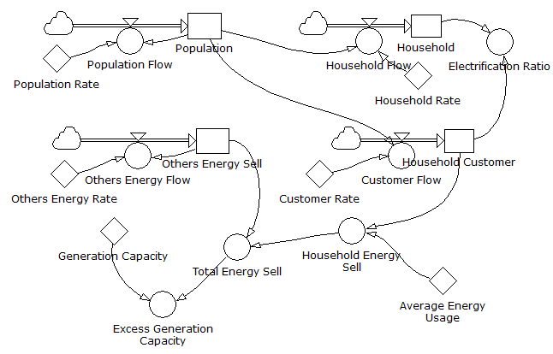

**Figure 1.** Stock-flow diagram

## Model validation

An appropriate simulation result can be reached by providing a precise model is required. Therefore to ensure that the model is accurate enough, the model has to be validated. Table 2 provides the number of simulations and collected data for validating the model.

|  |  |  |  |  |  |  |  |  |
| --- | --- | --- | --- | --- | --- | --- | --- | --- |
| **TABLE 2.** Model validation | | | | | | | | |
| **Year** | **Population** | | **Household Customer** | | **Sum of Household** | | **Energy Usage** | |
| **Simulation** | **Data** | **Simulation** | **Data** | **Simulation** | **Data** | **Simulation** | **Data** |
| 2010 | 757,700 | 757,700 | 77,333 | 77,333 | 184,600 | 184,600 | 146.14 | 146.14 |
| 2011 | 783,159 | 789,300 | 95,896 | 89,842 | 189,727 | 165,500 | 156.09 | 160.60 |
| 2012 | 809,473 | 816,300 | 114,914 | 108,640 | 195,027 | 176,800 | 166.72 | 174.43 |
| 2013 | 836,671 | 828,300 | 134,404 | 136,893 | 200,504 | 188,000 | 178.08 | 183.81 |
| 2014 | 864,783 | 849,800 | 154,380 | 156,505 | 206,166 | 195,200 | 190.21 | 202.39 |
| 2015 | 893,840 | 871,500 | 174,860 | 173,991 | 212,017 | 192,600 | 203.16 | 218.35 |
| 2016 | 923,873 | 893,400 | 195,860 | 188,599 | 218,066 | 197,500 | 216.99 | 236.84 |
| 2017 | 954,915 | 915,400 | 217,397 | 205,035 | 224,317 | 203,400 | 231.77 | 213.93 |
| 2018 | 987,000 | 952,400 | 239,490 | 221,940 | 230,779 | 210,300 | 247.56 | 236.84 |
| 2019 | 1,020,164 | 974,760 | 262,157 | 202,332 | 237,457 | 238,350 | 264.42 | 213.95 |
| 2020 | 1,054,441 | 1,134,068 | 285,418 | 217,135 | 244,360 | 250,880 | 282.42 | 212.18 |
| Avg. | 898,729 | 889,357 | 177,465 | 161,659 | 213,002 | 200,285 | 213,002 | 199.95 |
| AME | 0.0978 | | 0.0105 | | 0.0635 | | 0.0382 | |

From Table 2, AME values for population, household, total household, and energy usage from other sectors are 9.78%, 1.05%, 6.35%, and 3.82%, respectively. Based on our target to use 30% AME standard values, it is shown that the model has met the goal accurately. Therefore the simulation result may be valid in the nearest future.

## Simulation and analysis

Base on the model shown in Figure 1, the simulation is running under scenarios designed previously. The result is shown in Figure 2-4.

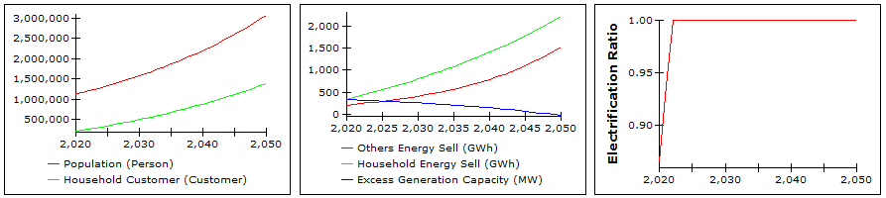

**Figure 2.** BAU simulation

It can be seen from Figure 2 that typically, in Business as Usual (BAU), the increase of population is also followed by the number of customers from the household sector. It is also shown that energy usage from other sectors, including industrial, commercial, and public sectors, is growing, but the household sector has dominated it. On the other hand, the total energy demand in 2050 is about 3741.87 GWh, supplied by 427.15 MW installed generation units. Therefore the excess generation capacity is still available for all sectors in West Papua Province, which are degraded from 381.15 MW in 2020 to 17.60 in 2050.

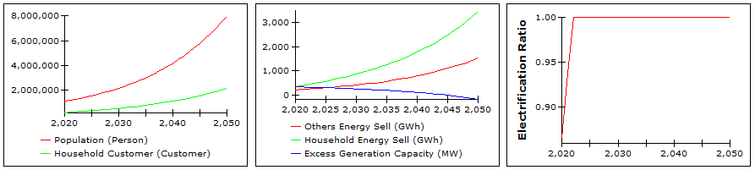

**Figure 3.** Scenario 1 simulation

Under scenario 1, the population is assumed to grow twice faster than the rate in the BAU condition, and its simulation result is plotted in Figure 3. Figure 3 shows that although the population increases, the costumer from the household sector only a little higher compared to the BAU, which is 1391249 of BAU and 2190731 of scenario 1 in 2050. As the population increased, the energy usage in the household sector is far leading the other sector. Therefore the generator capacity may not be enough for the people in this province in 2047. This lack is due to the increasing energy demand, which is reached 5012.09 GWh.

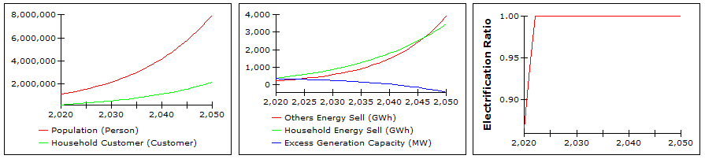

**Figure 4.** Scenario 2 simulation

In scenario 2, it is assumed that the population is growing 200%, as same as scenario 1. Additionally, the energy from other sectors is supposed to increase by 150%. The result of the simulation is given in Figure 4. In this figure, energy usage from other sectors is within the close of the household sector; then, it becomes the forefront in 2047. On the other hand, this scenario shows that people in this province may not get enough electricity by 2043. The generation may not support the demand because of the lack of generation capacity. It is seen from the energy demand, which is reached 7406.98 GWh in 2050. Therefore installing generation capacities has to be risen to fulfill the demand. Overall simulation shows that the electrification ratio may be reached in 2022 as it now reaches 99.98% in actual condition.

# Conclusion

System dynamics modeling has been used in this research for estimating the energy demand of West Papua Province. Later two scenarios were given to investigate the ability of generation units in supporting the demand. The simulation result shows that for the BAU model, the generation capacity is fulfilled the demand. The province needs new generation units to bear the demand since the existing generation units may not sufficient in 2043 or 2047, as simulated in scenarios 2 and 1. It is seen from the energy demand that upwards from 3741.87 GWh to 5012.09 GWh and 7406.98 GWh in 2050 simulated in BAU, scenarios 1 and 2. On the other hand, the electrification ratio is reached in 2022 in every simulation, which means that the province satisfies its population with enough electricity supply in that year.

# Acknowledgments

Authors wishing to acknowledge the Electrical Engineering Department as well as Engineering Faculty of Papua University for supporting this research and publication.

# References

1. Badan Perencanaan Pembangunan Daerah, *Rencana Pembangunan Jangka Menengah Provinsi Papua Barat 2017-2022*. West Papua Province, 2017.
2. Hendri, M. Karuniasa, S. Prabawardhani, K. Syamsudin, and W. S. Pradafitri, “Scenario for West Papua contribution for NDC from forestry sector,” *IOP Conf. Ser. Earth Environ. Sci*., vol. 716, no. 1, pp. 012017, Mar. 2021, doi: 10.1088/1755-1315/716/1/012017.
3. F. Wehantouw, M. Karuniasa, R. N. Wurarah, A. Tuharea, C. Maharani, H. Shalilah, and P. A. Pambudi, “Low carbon energy model in West Papua,” *IOP Conf. Ser. Earth Environ. Sci.*, vol. 716, no. 1, p. 012015, Mar. 2021, doi: 10.1088/1755-1315/716/1/012015.
4. I. Tjolli, M. Karuniasa, A. B. Rehiara, S. Jance, and I. Lestari, “Development of the sustainable human development index model in West Papua,” *IOP Conf. Ser. Earth Environ. Sci.*, vol. 716, no. 1, pp. 012106, Mar. 2021, doi: 10.1088/1755-1315/716/1/012106.
5. R. N. Wurarah, M. Karuniasa, F. Wehantouw, A. Tuharea, and M. Muhsin, “Towards an eco-industrial development in West Papua economy,” *IOP Conf. Ser. Earth Environ. Sci.*, vol. 716, no. 1, pp. 012104, Mar. 2021.
6. S. Prabawardani, Hendri, M. Karuniasa, K. Syamsudin, C. Maharani, and F. Munichputranto, “Towards a low carbon solid waste management in West Papua,” *IOP Conf. Ser. Earth Environ. Sci.,* vol. 716, no. 1, pp. 012016, Mar. 2021, doi: 10.1088/1755-1315/716/1/012016.
7. Anonymous, *Papua Barat Dalam Angka*. Central Bureau of Statistics, 2010.
8. Anonymous, *Statistik Ketenagalistrikan*. Ministry of Energy and Mineral Resources, 2010.
9. Anonymous, *Statistik PLN*. State Electricity Company, 2021.