CsI(Tl) Scintillation Detector for Planar Scintigraphy Technique

Ayu Jati Puspitasari1, a), Lukman Mubarak1, b), and Halim Hamadi 1, c)

1Polytechnic Institute of Nuclear Technology, Babarsari Street PO BOX 6101 YKBB, Sleman, Yogyakarta, Indonesia (55281)

a) Corresponding author: ayu.puspitasari@batan.go.idb) lukmanmubarak@gmail.com

c) halim.hamadi@batan.go.id

**Abstract.** This study focuses on using a CsI(Tl) detector for imaging in the planar scintigraphy imaging technique. CsI(Tl) detectors offer affordable, power-efficient, compact, and portable measurements because they use compact electronic components. In this study, the radiation beam is captured by a CsI(Tl) scintillation detector given a lead (Pb) collimator with a thickness of 2 mm and a collimator hole with a diameter of 2 mm. The result of testing the efficiency value is 2.07%. This detector is stable based on the chi-square test value on 10 measurements. The chi-square value is 6.919 (in the range of 3.325 – 16.919). The ideal measurement distance between the detector and the test object is less than 2 cm. For planar imaging, the Cs-137 source was placed on an acrylic phantom measuring 70×70 mm2. From the imaging results, the average percentage error on the x-axis center, y-axis center, and area of ​​the source is 3.73%, 3.23%, and 4.71%, respectively, with an overall average error percentage of 3.89%.

# INTRODUCTION

Applying nuclear technology in the medical area, including diagnostic, therapeutic, or nuclear medicine, uses image processing technology [1]. The diagnostic examination uses an external radiation source that generates transmission processes. In diagnostic nuclear medicine, the internal radiation source generates emission events. Diagnostic nuclear medicine utilizes a gamma camera or Anger scintillation camera [2], [3]. Gamma camera applies scintigraphy technique. The 2 types of gamma cameras are planar and SPECT (Single Photon Emission Computed Tomography). The planar gamma camera displays a 2D image, while SPECT generates a 3D image [4]–[6].

Planar scintigraphy images the distribution of radioactive material in a 2D image used for whole-body screening for tumors, metastatic tumors, and particularly bone [7]. A fit radioactive material concentrates on a specific target organ after being compounded with another chemical into radiopharmaceutical, a chemical compound that contains radioactive atoms in its structure. It is used in the field of nuclear medicine for diagnosis or therapy. After applying radiopharmaceutical to the patient, the target organ is imaged using a gamma camera [8].

In the past decades, NaI(Tl) has been used as a scintillating crystal in almost all gamma cameras [9]. NaI(Tl) is a crystal with a reasonable price, a proper luminance efficiency, and an acceptable energy range. It makes a standard crystal for use in most nuclear medicine imaging equipment [10]. One alternative crystal that can be applied as a scintillation detector is Csi(Tl) or Thallium doped Cesium Iodide. CsI(Tl) scintillator has high density, high luminous efficiency, high radiation-hardness [11].

The CsI(Tl) detector, one of the most efficient detectors on SPECT, offers affordable, power-efficient, compact, and portable measurements because it uses compact electronic components. CsI(Tl) is an inorganic scintillator that is very suitable for coupling with photodiodes because it has the highest light yield, quantum efficiency of 69% along the spectrum compared to 49% in NaI(Tl) [12], [13]. Based on spectrum shape and resolution, NaI(Tl) and CsI(Tl) detectors have nearly the same properties and performance. In terms of efficiency, considering the correction factor, the CsI(Tl) detector is superior to the NaI(Tl) detector. From several aspects, the CsI(Tl) detector also has advantages over the NaI(Tl) detector, including being more economical and more practical because this detector is small and compact. The CsI(Tl) detector is more energy-efficient, which requires ± 24 Volts, while the NaI(Tl) detector requires 500 -1200 Volts of electrical power [13]. The CsI(Tl) detector has currently been used on a prototype collar therapy indicator (COTI) which is a thyroid uptake therapy device with an output in the form of a count value [14].

The CsI(Tl) detector used in this study is the Atom Fast Scintillation 8*8*50 Crystal Radiation Detector, which is a small device consisting of an ionizing radiation detector (a scintillation detector in the form of a cesium iodide / CsI(Tl) crystal of size 4*7*35 mm, or 8*8*50 mm). The detector can detect a 60 keV - 10 MeV power spectrum, with 130 cps per Sv/hr detection sensitivity. Display and storage of sensor data via an application on the iOS or Android operating system. This detector is equipped with a multiplier in the form of a solid-state photomultiplier (SSPM) inside [15].

SSPM is a silicon device capable of detecting single photons in the wavelength range from 0.4 to 28 m. SSPM is an essential part of a CsI(Tl) scintillation detector, where its role is as a substitute for PMT. SSPM is also known as a multi-pixel photon counter (MPPC). MPPC is defined as a solid-state photodetector made of hundreds or thousands of integrated single-photon avalanche diodes (SPADs) called microcells or pixels. In other words, SPAD is the smallest block or microcell of an SSPM. After detecting photons, SPAD generates electrical output signal [16]–[18].

For the imaging process, PMT on gamma cameras can be replaced with SSPM (Solid State Photomultiplier), which can reduce the Anger dimensions of gamma cameras and determine the exact location of the gamma radiation beam. The solid-state technology allows the detection of lower radiation levels in the imaging process. It has the advantage of fast attenuation correction detection when using two detectors for transmission and emission [19].

This research is a preliminary study on using a CsI(Tl) detector for imaging in a planar scintigraphy technique with a Cs-137 gamma source. The detector performance test was conducted using an efficiency and stability test using the chi-square test. Furthermore, using an acrylic phantom containing Cs-137, counting was carried out using a CsI(Tl) detector. The radiation count data were formed into a digital image using Python.

# METHOD

The detector used is Atom Fast Scintillation which consists of an ionizing radiation detector (scintillation detector: crystal cesium iodide / CsI(Tl)) with size 8*8*50 mm. The source used is Cs-137, with a diameter of which is placed on an acrylic phantom measuring 70 × 70 mm2. The Cs-137 source data used are shown in table 1.

**TABLE 1**. Cs-137 source specification

|  |  |
| --- | --- |
| **Parameter** | **Values** |
| Half-life (T1/2) | 30.1 years |
| Initial activity (A0) | 0,25µ Ci = 9250 Bq |
| Current activity | 0,23 µ𝐶𝑖 = 8511,02 Bq |
| Diameter | 25 mm |
| Luas | 490,63 mm2 |

The radiation beam is captured by a CsI(Tl) scintillation detector provided with a lead (Pb) collimator with a thickness of 2 mm and a collimator hole with a diameter of 2 mm. The output of the signal processing circuit system is a result of the count from the source in the test object.

## Detector to Source Ideal Distance

This test aims to determine the ability of the detector used to produce a sound (non-uniform) distribution of count values to produce a clear image. The test is carried out by determining the detection limit and quantization limit. The block diagram of the test is shown in Figure 1.

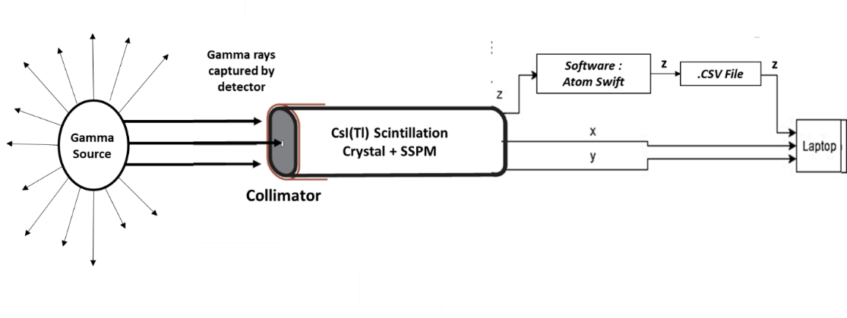

**FIGURE 1.** Block diagram of detector testing

The detection limit is a limit value used to find out whether a “detected” radioactive substance is present in the sample being measured or not. The detection limit value is determined by the deviation of the background measurement with a confidence level of 3 sigmas. Determination of detection limit using equation (1)

$LOD=3σ=3\sqrt{R_{B}}$ (1)

where $R_{B}$ is the background count rate.

While the limit of quantization is a limit value used to determine whether the value of the measurement results can be expressed quantitatively or not. The quantization limit value must be determined by convention, from one country or laboratory to another country or laboratory with a different value. The most widely used quantization limit value is the background measurement deviation with a confidence level of 7 sigmas (2) [20].

$LOQ=7σ=7\sqrt{R_{B}}$ (2)

In addition to the limit of detection and limit of quantization, an alternative method can be used to measure the accuracy of the estimated results of a mode, namely the Root Mean Square Error (RMSE). A low RMSE value indicates that the variation in the value produced by a forecast model is close to the variation in the observed value. The RMSE value is obtained through equation (3) [21].

$RMSE=\sqrt{\frac{\sum_{i=1}^{n}{(C_{i}-\overline{C}}}{n}}$ (3)

where $C_{i}$ is the i-th radiation count, $\overline{C}$ is the average radiation count and $n$ is the number of data.

## Detector Performance Test

The detector performance test is carried out to determine the efficiency and stability of the detector. The detector’s efficiency is the ratio between measured radiation count and the absolute activity of the source, i.e., the amount of radiation emitted by the source in all directions (4π) [13]. The test technique takes the radiation source’s dose rate value, which is carried out with the distance between the radiation source and the detector being 1 cm, which is repeated 30 times. The test diagram is shown in Figure 1. The efficiency of the detector can be determined by equation (4),

$η (\%)=\frac{(\sum{C_{t}}-\sum{C_{b}})}{t}×\frac{1}{A_{t}fΩ}×100$ (4)

$η$ is detector efficiency, $C_{t}$ is total count, $C_{b}$ is background count, $t$ is counting time, $A_{t}$ is source activity during testing, $f$ is gamma decay fraction (%), and $Ω$ is a geometric factor. This geometric factor can be calculated through equation (5),

$Ω=2π\left(1-\frac{d}{{\left(d^{2}+R^{2}\right)}^{\frac{1}{2}}}\right)$ (5)

$d$ is the distance from the source to the detector, and $R$ is the radius of the detector. If $Ω$ = 1, the spread is 4π because the detector receives all radiation from the source. If $Ω$ = 0.5, the spread is 2π, i.e., the detector only receives half of the radiation coming from the source [13].

Another performance test is the chi-square test. The Chi-square test determines the stability of a tool, or the measurement results follow the Gaussian distribution. Collecting count data 10 times is based on Figure 2 at a detector-source distance of 1.5 cm and calculating the chi-square value with the equation (6).

$χ^{2}=\frac{\sum{{(C_{i}-\overline{C})}^{2}}}{\overline{C}}$ (6)

where $C_{i}$ is the i-th radiation count and $\overline{C}$ is the average radiation count [22].

## Digital Image Viewer

The image is the reconstruction of the gamma radiation counting matrix. The scintillation detector is placed in front of the source 1 cm apart, as shown in Figure 2. The source Cs-137 was placed in a 7×7 cm acrylic phantom with three different positions (40,30; 20,50; and 13.5,13.5; in mm) based on the coordinates in Figure 3. The position of the Cs-137 in the phantom is shown in Figure 4. These positions represent the location of Cs-137 in the middle and at the edge of the observation object.

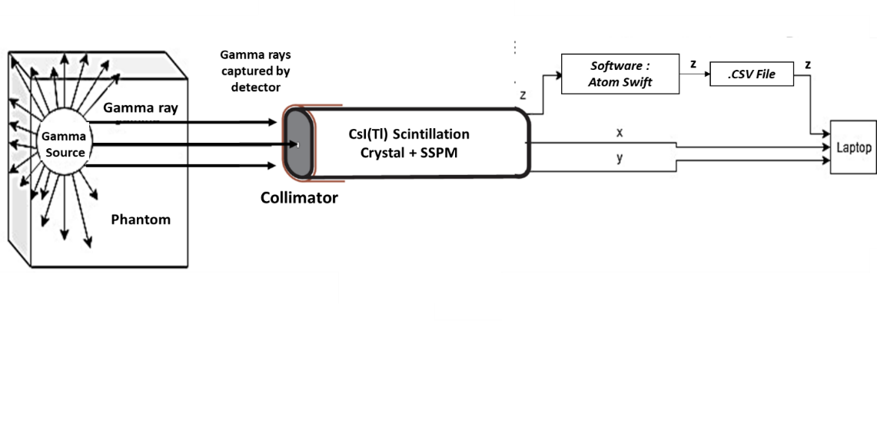

**FIGURE 2.** Block diagram of radiation count image data retrieval

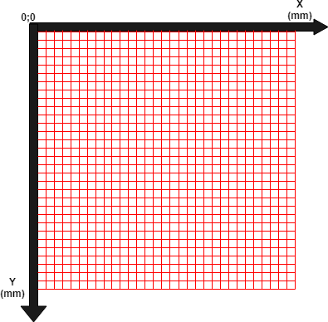

**FIGURE 3.** Data collection coordinate

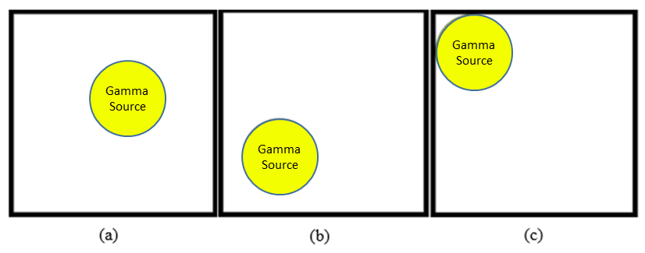

**FIGURE 4.** The position of Gamma source, (a) first coordinate 40;30, (b) second coordinate 20;50, (c) third coordinate 13.5;13.5

Gamma radiation is counted using a CsI(Tl) detector which has been given a lead (Pb) collimator. The collimator is used to focus the beam and to limit the catching area of the detector. The beam that escapes from the collimator will go to the detector, hit the scintillation crystal inside the detector, turn into a light spark captured by the photocathode, and then forward to the SSPM (Solid-State Photomultiplier) in the CsI(Tl) detector. This SSPM produces a z signal which is the emission from a gamma source (radioisotope). The measurement results are automatically sent via Bluetooth and displayed on the screen of the Android-based Atom Fast application. The stored data is transferred to a computer for processing. The x and y coordinates representing the position of the test object image are obtained from the shift of the CsI(Tl) detector with the x, y coordinates determined based on Figure 3.

The results of the radiation count values are used as discrete values, which are then represented as the position of an image position of the phantom/test object using Python software. This image formation was carried out to determine the performance of the CsI(Tl) detector in planar scintigraphy imaging techniques.

Data collection was done every 5 mm, so we have 15 points of measurement on each axis. The 225 count data is formed into a 15×15 matrix. Furthermore, it is used as an image with a resolution of 15×15 pixels. Then the image resolution is enlarged to 70×70 pixels (following the 70×70 mm phantom size) because the image is coarse and difficult to observe visually. After the count value is converted into grayscale with a value ranging from 0 to 255, the next step is the thresholding process to convert it into a binary image (black and white). Thresholding is done with the condition that the gray color of the image has an intensity between the lower limit (min) and the upper limit (max), ranging from 0 to 255. The upper and lower limit values are between 0 to 1. In this study, the thresholding limit value is 0.71-0.88. Digital image processing is shown in Figure 4.



**FIGURE 4.** Digital image processing’s flowchart

# result and discussion

## Test Result of Detector to Source Ideal Distance

The distance between the source and detector being tested is from 1 cm to 4 cm with an interval of 0.5 cm. For each distance variation, the total and background were counted 10 times, then averaged and calculated limit of detection (LOD) and limit of quantization (LOQ) based on equations (1) and (2). If the net radiation count result is more excellent than the LOD and LOQ, it is passed. The test results are presented in Table 2.

**Table 2.** The test results of LOD dan LOQ

|  |  |  |  |  |  |  |
| --- | --- | --- | --- | --- | --- | --- |
| **Distance (cm)** | **Average total radiation count (cps)** | **Average background radiation count (cps)** | **Average net radiation count (cps)** | **LOD 3σ** | **LOQ 7σ** | **Result** |
| 4.0 | 10.23 | 6.66 | 3.57 | 7.74 | 18.07 | LOD and LOQ didn’t pass |
| 3.5 | 11.73 | 7.44 | 4.29 | 8.18 | 19.10 | LOD and LOQ didn’t pass |
| 3.0 | 13.29 | 8.22 | 5.07 | 8.60 | 20.07 | LOD and LOQ didn’t pass |
| 2.5 | 20.73 | 9.00 | 11.73 | 9.00 | 21.00 | LOD passed, LOQ didn’t |
| 2.0 | 32.34 | 9.78 | 22.56 | 9.38 | 21.90 | LOD and LOQ passed |
| 1.5 | 45.94 | 10.56 | 35.37 | 9.75 | 22.75 | LOD and LOQ passed |
| 1.0 | 78.12 | 11.34 | 66.78 | 10.10 | 23.58 | LOD and LOQ passed |

Using the same data, the RMSE calculation is then carried out using equation (3). RMSE calculation results are presented in Table 3.

**Table 3.** Calculation of RMSE

| **Distance (cm)** | **RMSE value** |
| --- | --- |
| 4.0 | 388.95 |
| 3.5 | 367.56 |
| 3.0 | 352.90 |
| 2.5 | 334.35 |
| 2.0 | 288.78 |
| 1.5 | 2.35 |
| 1.0 | 1.21 |

The test results in Table 2 show that the net radiation count at a distance of less than 2 cm is greater than the LOD and LOQ. Detector-source distance of 2 cm means the net radiation count can be distinguished from the background count or detected by the detector, and its value can be expressed quantitatively.

Then, looking at the RMSE, the value of the count distribution data is said to be good if the calculated RMSE value is getting smaller. A low RMSE value indicates that the variation in the value produced by a forecast model is close to the variation in the observed value [21]. Thus, a low RMSE value at a distance below 2 cm indicates that the detector is able to distinguish the presence of radiation sources significantly.

Thus, the type of CsI(Tl) Atom Fast Scintillation 8*8*50 Crystal Radiation detector used is capable of producing good phantom count distribution values at an ideal distance of less than 2 cm from the test object or phantom.

## The Efficiency of CsI(Tl) Detector

The average yield of 30 source count rate data is 67.37 cps. The data is taken with the distance from the source to the detector is 1 cm, and the radius of the detector used is 0.4 cm. The result of calculating the value of the geometry factor (Ω) based on equation (2) is 0.45, and the detector efficiency based on equation (1) is 2.07%.

From the results of the efficiency determination, it is known that the efficiency of the CsI(Tl) Atomfast type used is better than the CsI(Tl) detector type W556 7699 made by Hilger in the research of Sumanto et al. (2011) [23]. Using the Cs-137 source, the efficiency of the detector used in this study was 1.73%.

The detector’s efficiency is the ratio between the number of counts and the absolute activity of the source, namely the number of radiation emitted by the source in all directions (4π). The geometric factor is 0.45 (close to 0.5 or 2π), which shows that the detector can receive almost half of the radiation originating from the radiation source. The detector’s ability to measure radiation can be affected by the distance from the radiation source to the detector, the medium between the detector and the radiation source, and the detector’s active volume (scintillator). The greater the active volume, the more the number of radiation counts that a detector can receive. [13].

## The Stability of CsI(Tl)

This stability test uses the chi-square test. The radiation count was measured 10 times, then the chi-square was calculated based on equation (6). The calculation results are presented in Table 4.

**Table 4.** The chi-square test

|  |  |  |
| --- | --- | --- |
| **Data** | $$C_{i}$$ | ${(C_{i}-\overline{C})}^{2}$ |
| 1 | 73 | 0 |
| 2 | 75 | 6 |
| 3 | 73 | 0 |
| 4 | 70 | 8 |
| 5 | 73 | 0 |
| 6 | 77 | 14 |
| 7 | 78 | 25 |
| 8 | 55 | 339 |
| 9 | 83 | 104 |
| 10 | 70 | 8 |
|  | $\overline{C}=$ 73 | $\sum{{(C_{i}-\overline{C})}^{2}}=$ 503 |
|  |  | $$χ^{2}=6.919$$ |

In a set of 10 measurements with confidence levels of 0.05 to 0.95, the Chi-Square test results should be within 3.325 and 16.919, as stated in the IAEA-TECDOC-602 [22]–[24]. The results of the chi-square test detector CsI(Tl) used are in this range, and these are 3.325 < 6.919 < 16.919. Thus, the CsI(Tl) detector is stable, and the measurements follow a Gaussian distribution.

## Digital Planar Scintigraphy Image

The 15×15 count matrix data is imaged as shown in Figure 5, which is a greyscale image. The image is still difficult to observe visually, so it is necessary to increase the number of pixels. Image resolution is enlarged to 70×70 pixels. Because the phantom size is 70×70 mm2, so 1-pixel image represents a 1 mm2 phantom. The 70×70 pixel greyscale image is shown in figure 6.

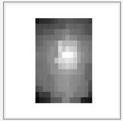

**FIGURE 5.** Initial image 15×15 pixel

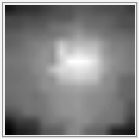

**FIGURE 6.** The image resulting from an increase in the number of pixels 70×70

For identifying the radiation source’s location, which is the center point and the area of the source, the grayscale image is converted into a binary image. Global thresholding is done manually. The contrast range obtained is 0.71 to 0.88. The result of the optimal thresholding value is that image pixel data < 0.71 is valued at 0 (black), and image pixel data > 0.88 is valued at 1 (white). The binary image resulting from the contrast sharpening process is shown in Figure 7.



**FIGURE 7.** Binary image result of thresholding process

The following process is determining the center point, as shown in Figure 8. The image result in Figure 8 is also used to calculate the diameter of the object or source. The value of the area of the source is determined by counting the number of white pixels in pixel units. This planar scintigraphy image was tested using a phantom with a different CsI(Tl) source position.



**FIGURE 8.** Determination of the center point of the source in the binary image

The size and the center point of the Cs-137 source of the system results are compared with the actual state. These results are presented in Figure 9-11 and Table 5-7.

|  |  |  |  |  |
| --- | --- | --- | --- | --- |
|  | |  | | |
| **FIGURE 9**. Position A (40;30)  **Table 5**. Test results in position A (40;30) | | | | |
| **Parameter** | | **Actual condition** | | **Viewer system** | **Error (%)** | |
| Center point (x ; y) | | 40 ; 30 | | 39.00 ; 30.00 | x = 2.50  y = 0.00 | |
| Area (mm2) | | 490.63 | | 477.00 | 2.78 | |

|  |  |  |  |
| --- | --- | --- | --- |
|  | |  | |
| **FIGURE 10**. Position B (20;50)  **Table 6**. Test results in position B (20;50) | | | |
| **Parameter** | **Actual condition** | **Viewer system** | **Error (%)** |
| Center point (x ; y) | 20.00 ; 50.00 | 21.00 ; 47.00 | x = 5.00  y = 6.00 |
| Area (mm2) | 490.63 | 519.00 | 5.78 |

|  |  |  |  |
| --- | --- | --- | --- |
|  | |  | |
| **FIGURE 11**. Position C (13.5;13.5)  **Table 7**. Test results Position C (13.5;13.5) | | | |
| **Parameter** | **Actual condition** | **Viewer system** | **Error (%)** |
| Center point (x ; y) | 13.50 ; 13.50 | 14.00 ; 13.00 | x = 3.70  y = 3.70 |
| Area (mm2) | 490.63 | 518.00 | 5.58 |

The average test results for diameter and area with 3 positions are as follows.

• Area of source : 504.59 mm2

The average percentage of errors, i.e.

• x-axis center : 3.73 %

• y-axis center : 3.23 %

• Area of source : 4.71 %

The difference between the image viewer created with the actual conditions can be due to the random nature of radiation and the lack of dense data collection. The result of this study indicates 504.59 mm2 for the area. Therefore, a digital image viewer and a measure of the size of the source of the gamma transmitter in the digital image created can be appropriately used with an overall error percentage of 3.89%.

# CONCLUSION

The CsI(Tl) detector type Atom Fast Scintillation 8*8*50 Crystal Radiation used in this study has a reasonably good efficiency value of 2.07%. The chi-square test value is 6.919, so this detector is stable because it is in the range between 3.325 and 16.919 (10 measurements). However, this detector cannot display the gamma energy spectrum, so the resolution value of the detector cannot be known. The ideal measurement distance between the detector and the test object is less than 2 cm. From the imaging results, the average percentage of errors in the x-axis center, y-axis center, and area of ​​the source is 3.73%, 3.23%, and 4.71%, respectively, with an average percentage error overall that is 3.89%. Based on the test results above, the CsI(Tl) detector can be an alternative in planar scintigraphy imaging techniques. By considering the ideal distance between the detector and the source, this detector should be used in in-vitro nuclear medicine applications.

# Acknowledgments

The authors wished to acknowledge assistance or encouragement from the Electronics Instrumentation Study Program and Research and Community Service Unit, Polytechnic Institute of Nuclear Technology.

# References

[1] Y. Sasaki and K. Kusakabe, “Nuclear medicine for diagnosis and treatment,” *IAEA Off. Public Inf. Commun.*, vol. 17, no. 1, pp. 7–8, 2017.

[2] F. Kharfi, “Principles and Applications of Nuclear Medical Imaging: A Survey on Recent Developments,” *Imaging Radioanal. Tech. Interdiscip. Res. - Fundam. Cut. Edge Appl.*, no. March 2013, 2013, doi: 10.5772/54884.

[3] Y. Wang, “Nuclear Medicine : Physics and Imaging Methods ( SPECT and PET ),” Polytechnic Institute of NYU, Brooklyn, NY 11201, 2017.

[4] D. H. Skuldt, “Nuclear medicine,” *Minim. Invasive Med. Technol.*, no. x, pp. 59–66, 2016, doi: 10.1055/s-0038-1625324.

[5] T. Lewellen, “The Scintillation Camera : Planar and SPECT List of Nuclear Medicine ʻSingle Photonʼ Radionuclides,” 2007.

[6] D. . Bailey, J. . Humm, A. Todd-Pokropek, and A. van Aswegen, *Nuclear Medicine Physics: A Handbook for Teachers and Students*. Vienna: International Atomic Energy Agency, 2014.

[7] N. B. Smith and A. Webb, *Introduction to Medical Imaging*. Cambridge University Press, 2010.

[8] J. L. Prince and J. M. Links, *Medical Imaging Signals and Systems*, 2nd ed. Pearson, 2014.

[9] W. J. C. Koppert, M. M. A. Dietze, S. Van Der Velden, J. H. L. Steenbergen, and H. W. A. M. De Jong, “A comparative study of NaI(Tl), CeBr3, and CZT for use in a real-time simultaneous nuclear and fluoroscopic dual-layer detector,” *Phys. Med. Biol.*, vol. 64, no. 13, 2019, doi: 10.1088/1361-6560/ab267c.

[10] M. Khoshakhlagh, J. P. Islamian, S. M. Abedi, and B. Mahmoudian, “Development of Scintillators in Nuclear Medicine,” *World J. Nucl. Med.*, vol. 14, no. 3, pp. 156–159, 2015, doi: 10.4103/1450-1147.163241.

[11] G. Z. Shi *et al.*, “Development of a position sensitive CsI(Tl) crystal array,” *Nuclear Engineering and Technology*, vol. 52, no. 4. pp. 835–840, 2020, doi: 10.1016/j.net.2019.09.003.

[12] N. Bhusal, “Third Generation Gamma Camera SPECT System,” no. December, 2020, [Online]. Available: http://arxiv.org/abs/2002.10707.

[13] S. Bahri, “Perbandingan Kinerja Detektor NaI(Tl) Dengan Detektor CsI(Tl) Pada Spektroskopi Radiasi Gamma,” *J. Gradien*, vol. 3, no. 1, pp. 204–209, 2007.

[14] M. Abuqbeitah, M. Demir, N. Yeyin, S. Sager, and D. Gray, “Thyroid uptake test with portable device (COTI) after 131I tracer administration: proof of concept,” *Radiat. Environ. Biophys.*, vol. 59, no. 3, pp. 553–558, 2020, doi: 10.1007/s00411-020-00849-8.

[15] KBRADAR, “Instructions and specifications to the bluetooth radiation dosimeter Atom Fast for smartphone and tablet,” *kbradar.org*, 2017. https://kbradar.org/a190925-instructions-and-specifications.html.

[16] M. D. Petroff and M. G. Stapelbroek, “Photon-Counting Solid-STate Photomultiplier,” *IEEE Trans. Nucl. Sci.*, vol. 36, no. 1, pp. 158–162, 1989, doi: 10.1016/s0168-8278(02)00155-1.

[17] S. Gundacker and A. Heering, “The silicon photomultiplier: Fundamentals and applications of a modern solid-state photon detector,” *Phys. Med. Biol.*, vol. 65, no. 17, 2020, doi: 10.1088/1361-6560/ab7b2d.

[18] D. S. C. Putranto, “Design and simulation nanoscale-based single photon avalanche diode on silicon,” Universitas Indonesia, 2011.

[19] J. Zhang, P. Maniawski, and M. V. Knopp, “Performance evaluation of the next generation solid-state digital photon counting PET/CT system,” *EJNMMI Res.*, vol. 8, 2018, doi: 10.1186/s13550-018-0448-7.

[20] Anonym, “Statistik Pencacahan Radiasi,” pp. 1–15, 2017.

[21] S. Makridakis, M. Hibon, and C. Moser, “Accuracy of Extrapolation (Time Series) Methods: Results of a Forecasting Competition,” *J. R. Stat. Soc. Ser. A*, vol. 1, no. 2, pp. 111–153, 1982, doi: 10.2307/2345077.

[22] IAEA, “Quality Control Procedures Applied to Nuclear Instruments,” *Iaea-Tecdoc*, vol. 1599, no. August 2007, p. 69, 2008.

[23] J. Sumanto, S. Bachtiar, and A. Jalil, “Kajian Ki Nerja Sistem Deteksi Antara Detektor Nai(Tl) Dan Csi(Tl) Untuk Perangkat Renograf Portabel Jinjing,” *PRIMA - Apl. dan Rekayasa dalam Bid. Iptek Nukl.*, vol. 8, no. 2, pp. 63–72, 2011.