Radial Power Flow Analysis of Rajawali Feeder in Manokwari Power Grid
Bibiana Rosalina Wihyawari^{1,a)}
Author Affiliations
¹Electrical Engineering Department, University of Papua, Indonesia
Author Emails
^{a)} Corresponding author: rosalina.wihyawari@gmail.com
Abstract. Power flow analysis is an important analysis of power system to investigate the ability of the system to anticipate the change of load demand. Forward backward sweep method is a powerfull method to analize power flow in a power distribution network that mostly in radial topology. In this paper, the forward backward sweep method has been applied to calculate the power flow of Rajawali feeder in the power grid of Manokwari. Result denotes that this feeder has good voltage regulation which is shown in a little percentage drop about 0.41% in the outer bus. It also represents that power loss is increase from 167.0575kW in lower demand to 196.6048 kW in peak demand.

INTRODUCTION
A distribution network is a component in electrical power system to deliver the power from a power generator or a substation to the load. Standard voltage of a distribution network in Indonesia is 20kV and so a transformer is needed to step down this voltage to before use by consumers. Due to its functions, the constructions of this network are a simple and inexpensive; therefore reliability of this network is relatively low and also it has a large voltage drop, especially for the load at the end of the lines.
Generally the structure of a distribution network is a radial type which has a main line and the load directly tapped to the line. The merits of this topology are uncomplicated, inexpensive and simple to be installed. On the other hand its reliability is poor because the continuity of the supply to the load will be end until disturbances resolved.
In the distribution network the classical problem is how the quantity and quality are given properly in whole of time. Therefore power flow analysis is important to obtain information about the power flow and voltage of the system. This information is needed to evaluate the performance of the power system and analyze the conditions of generation and loading.
Manokwari is the capital city of West Papua provincethat has its own local grid which is consisted of six feeders. This power grid is operated by An the electricalgovernment company namely PT. PLN P2B has the authority to operate this grid(1).In this paper, the power flow analysis of the Rajawali Feeder of Manokwari power grid is investigated by calculating the voltage profile and losses of each branch node of the distribution network.

method
The method of forward and backward is used in this paper to calculate voltage, power and power loss in a radial distribution network. This method is developed by which is presented in their paper. This method is extended from the Distflow method by determining three basic calculations to complete the analysis of power flow in distribution systems. The calculations are used to obtain active power, reactive power, and voltage magnitude.
Consider a balance three phase, radial distribution feeder with n branches/nodes and n_{c} shunt capacitors as shown in Figure 1(2). The method of DistFlow can be explain without any branch V_{k} to V_{kn} on the figure(3). Base on this figure, power and voltage on each node from V₀ to V_{n} can be calculated by the following equations(4).
(
(
(

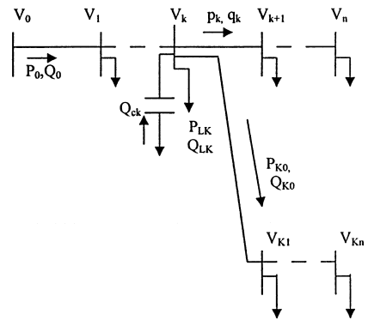
Figure 1.Single line diagram of a general distribution system

The above equationsare called the forward equation and each process is called a forward update. The Distflow's other calculation procedures and sequences are called backward update andbackward equations.In this approximation method, the initial values of P₀ and Q₀ are determined through the summation process of active and reactive power of loads. V₀ is the initial voltage which is also used as the base voltage of the system in the calculation process of the approach method which uses units per unit. Assuming a balanced phase, a picture of a radial distribution network can be seen in the following figure(2).
(
(
(

By including complex number elements, the voltage magnitude and voltage angle of each bus are obtained from the equation (5):
(
At the end of the feeder, the following conditions must be met:
(
(
Where :
r_{i} = resistance of the line leading to bus i
x_{i} = capacitance of the line leading to bus i
P_{i} = real power flowing from bus i
Q_{i} = reactive power flowing from bus i
V_{i} = voltage magnitude on bus i
Qc_{i} = additional reactive power of the capacitor on the bus i
P_{n} = active power on the last bus of the main branch
Q_{n}= reactive power on the last bus of the main branch
P_{kn}= active power on the last bus branching
Q_{kn}= reactive power at the last bus branching

Voltage at nodes k (branching bus) and ko (branching bus connected to the main branch):
(
Power losses on the line connecting the two buses(5).
(
(

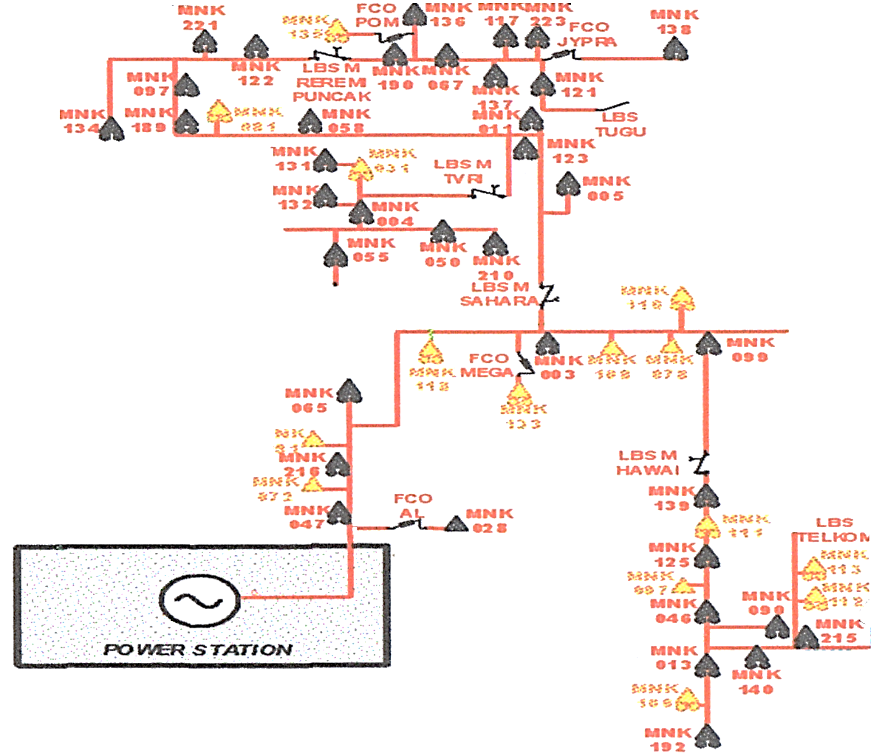
Figure 2.Single line diagram of Rajawali feeder

result and discussion

Data of Rajawali Feeder
The main object of this research is Rajawali feeder of the power grid of Manokwari which has six feeders, namely Rajawali, Mambruk, Kasuari, Nuri, Merpati, and Maleo.The feeder is used to service the load in the center area of Manokwari city. Total system configuration is shown in Figure 2. The Rajawali feeder is represent in red line of this figure.
The feeder of Rajawali has 53 lines to connect 54 load buses. All of the lines supported by 70mm² AAAC cable with impedances are given in Table 1. The load buses are used to supply the load in the nearest place of the buses while some buses are only used to make the brach network. Data from the electical company (PLN) shows that total load of lower demand in Rajawali feeder is 2677 kVA and 2838 kVA in peak demand(6). The detail of load buses is given in Table 2.

TABLE 1. Data of Lines
No | From | To | R | jX | No | From | To | R | jX
1 | 1 | 2 | 0.044 | 0.038 | 28 | 28 | 29 | 0.088 | 0.076
2 | 2 | 3 | 0.153 | 0.133 | 29 | 29 | 30 | 0.109 | 0.096
3 | 3 | 4 | 0.022 | 0.019 | 30 | 29 | 46 | 0.132 | 0.114
4 | 4 | 5 | 0.022 | 0.019 | 31 | 30 | 31 | 0.372 | 0.325
5 | 5 | 6 | 0.109 | 0.096 | 32 | 31 | 32 | 0.022 | 0.019
6 | 6 | 7 | 0.263 | 0.229 | 33 | 32 | 33 | 0.088 | 0.076
7 | 7 | 8 | 0.153 | 0.133 | 34 | 33 | 34 | 0.175 | 0.153
8 | 7 | 27 | 0.022 | 0.019 | 35 | 34 | 35 | 0.088 | 0.076
9 | 8 | 9 | 0.044 | 0.038 | 36 | 35 | 36 | 0.131 | 0.115
10 | 9 | 10 | 0.066 | 0.057 | 37 | 36 | 37 | 0.088 | 0.076
11 | 9 | 11 | 0.022 | 0.019 | 38 | 37 | 38 | 0.24 | 0.211
12 | 11 | 12 | 0.022 | 0.019 | 39 | 38 | 39 | 0.066 | 0.057
13 | 12 | 13 | 0.197 | 0.171 | 40 | 39 | 40 | 0.219 | 0.191
14 | 13 | 14 | 0.022 | 0.019 | 41 | 39 | 41 | 0.044 | 0.038
15 | 14 | 15 | 0.044 | 0.038 | 42 | 41 | 42 | 0.066 | 0.057
16 | 15 | 16 | 0.153 | 0.133 | 43 | 42 | 43 | 0.131 | 0.115
17 | 16 | 17 | 0.022 | 0.019 | 44 | 43 | 44 | 0.088 | 0.076
18 | 17 | 18 | 0.066 | 0.057 | 45 | 43 | 45 | 0.199 | 0.174
19 | 18 | 19 | 0.131 | 0.115 | 46 | 46 | 47 | 0.022 | 0.019
20 | 19 | 20 | 0.066 | 0.057 | 47 | 47 | 48 | 0.131 | 0.115
21 | 19 | 21 | 0.008 | 0.076 | 48 | 46 | 49 | 0.044 | 0.038
22 | 21 | 22 | 0.044 | 0.038 | 49 | 49 | 50 | 0.219 | 0.191
23 | 21 | 23 | 0.056 | 0.096 | 50 | 49 | 51 | 0.088 | 0.076
24 | 20 | 24 | 0.131 | 0.115 | 51 | 51 | 52 | 0.131 | 0.115
25 | 24 | 25 | 0.109 | 0.096 | 52 | 51 | 54 | 0.196 | 0.171
26 | 25 | 26 | 0.022 | 0.019 | 53 | 52 | 53 | 0.068 | 0.115
27 | 27 | 28 | 0.153 | 0.133

TABLE 2. Bus Data of Load
Bus  No. | Lower |  | Peak |  | Bus  No. | Lower |  | Peak
 | P | jQ | P | jQ |  | P | jQ | P | jQ
1 | - | - | - | - | 28 | 56.99 | 0.85 | 68.99 | 1.02
2 | 66.99 | 0.99 | 34.00 | 0.50 | 29 | 27.00 | 0.40 | 40.00 | 0.59
3 | 88.99 | 1.32 | 82.99 | 1.23 | 30 | 52.99 | 0.79 | 65.99 | 0.98
4 | 43.00 | 0.64 | 23.00 | 0.34 | 31 | 63.99 | 0.95 | 81.99 | 1.22
5 | 35.00 | 0.52 | 23.00 | 0.34 | 32 | 53.99 | 0.80 | 23.00 | 0.34
6 | 51.99 | 0.77 | 28.00 | 0.42 | 33 | 48.99 | 0.73 | 46.99 | 0.70
7 | 23.00 | 0.34 | 18.00 | 0.27 | 34 | 32.00 | 0.47 | 35.00 | 0.52
8 | - | - | - | - | 35 | 56.99 | 0.85 | 61.99 | 0.92
9 | 56.99 | 0.85 | 74.99 | 1.11 | 36 | 70.99 | 1.05 | 87.99 | 1.31
10 | 49.99 | 0.74 | 73.99 | 1.10 | 37 | 63.99 | 0.95 | 81.99 | 1.22
11 | 34.00 | 0.50 | 23.00 | 0.34 | 38 | 75.99 | 1.13 | 81.99 | 1.22
12 | 71.99 | 1.07 | 86.99 | 1.29 | 39 | - | - | - | -
13 | 59.99 | 0.89 | 73.99 | 1.10 | 40 | 34.00 | 0.50 | 75.99 | 1.13
14 | 34.00 | 0.50 | 32.00 | 0.47 | 41 | 67.99 | 1.01 | 58.99 | 0.88
15 | 70.99 | 1.05 | 87.99 | 1.31 | 42 | 34.00 | 0.50 | 75.99 | 1.13
16 | 34.00 | 0.50 | 32.00 | 0.47 | 43 | 31.00 | 0.46 | 31.00 | 0.46
17 | 63.99 | 0.95 | 79.99 | 1.19 | 44 | 61.99 | 0.92 | 71.99 | 1.07
18 | 95.99 | 1.42 | 91.99 | 1.36 | 45 | 31.00 | 0.46 | 31.00 | 0.46
19 | 72.99 | 1.08 | 73.99 | 1.10 | 46 | - | - | - | -
20 | 61.99 | 0.92 | 74.99 | 1.11 | 47 | 32.00 | 0.47 | 36.00 | 0.53
21 | - | - | - | - | 48 | 59.99 | 0.89 | 59.99 | 0.89
22 | 53.99 | 0.80 | 34.00 | 0.50 | 49 | 66.99 | 0.99 | 63.99 | 0.95
23 | 53.99 | 0.80 | 34.00 | 0.50 | 50 | 6.00 | 0.09 | 6.00 | 0.09
24 | 61.99 | 0.92 | 74.99 | 1.11 | 51 | - | - | - | -
25 | 84.99 | 1.26 | 84.99 | 1.26 | 52 | 59.99 | 0.89 | 83.99 | 1.25
26 | 84.99 | 1.26 | 84.99 | 1.26 | 53 | 70.99 | 1.05 | 87.99 | 1.31
27 | 48.99 | 0.73 | 61.99 | 0.92 | 54 | 111.99 | 1.66 | 88.99 | 1.32

Simulation Result
The simulation is done using a Matlab script in a m-file using Matlab 2021 edition under Windows 10 environment. Results of the simulation about voltages and the voltage drop in each bus are given in Table 3 and also figured in Figure 3. Simulation of lower demand has elapsed time about 0.204046 seconds while the peak demand simulation takes 0.048908 seconds to complete it. Total power losses of this feeder are about 167.0575+j237.2724 and 196.6048+j276.4539 for lower and peak demand respectivelly.
Figure 3 shows the voltage profile and percentage drop of the Rajawali feeder. It is represented from the figure that buses of 6 to 20 and 27-54 are the buses that mostly affected by the peak demand. The location of the buses are in the centre of the city and the most affected buses are buses of 43-45 which are located in the area of high population density.The maximum voltage drop in busses 43-45 has persentage about 0.4%.
The figure also indicates that the high voltage bus and the lower voltage bus are buses of 2 and 45 that are 0.9997 and 0.9959 pu respectivelly. The outer bus is bus of 21 which has voltage about 0.999 pu that is droped about 0.1%.

TABLE 3. Bus Voltage Profile
Bus  No. | Voltage of lower demand |  |  | Voltage of peak demand |  |  | Bus  No. | Voltage of lower demand |  |  | Voltage of peak demand
 | V (Re) | V (Im) | %_{drop} | V (Re) | V (Im) | %_{drop} |  | V (Re) | V (Im) | %_{drop} | V (Re) | V (Im) | %_{drop}
1 | 1 | 0 |  | 1 | 0 | 0 | 28 | 0.9983 | -0.0015 | 0.17 | 0.9982 | -0.0016 | 0.18
2 | 0.9997 | -0.0003 | 0 | 0.9997 | -0.0003 | 0.03 | 29 | 0.9981 | -0.0017 | 0.19 | 0.9979 | -0.0019 | 0.21
3 | 0.9987 | -0.0011 | 0.03 | 0.9986 | -0.0012 | 0.14 | 30 | 0.9978 | -0.0019 | 0.22 | 0.9976 | -0.0021 | 0.24
4 | 0.9985 | -0.0012 | 0.13 | 0.9984 | -0.0013 | 0.16 | 31 | 0.9976 | -0.0021 | 0.24 | 0.9973 | -0.0023 | 0.27
5 | 0.9984 | -0.0013 | 0.15 | 0.9983 | -0.0014 | 0.17 | 32 | 0.997 | -0.0026 | 0.3 | 0.9966 | -0.0029 | 0.34
6 | 0.9977 | -0.0019 | 0.16 | 0.9976 | -0.0021 | 0.24 | 33 | 0.9969 | -0.0026 | 0.31 | 0.9966 | -0.003 | 0.34
7 | 0.9961 | -0.0033 | 0.23 | 0.9958 | -0.0036 | 0.42 | 34 | 0.9968 | -0.0028 | 0.32 | 0.9964 | -0.0031 | 0.36
8 | 0.9957 | -0.0036 | 0.39 | 0.9954 | -0.004 | 0.46 | 35 | 0.9966 | -0.003 | 0.34 | 0.9961 | -0.0034 | 0.39
9 | 0.9957 | -0.0037 | 0.43 | 0.9953 | -0.004 | 0.47 | 36 | 0.9965 | -0.003 | 0.35 | 0.996 | -0.0035 | 0.4
10 | 0.9957 | -0.0037 | 0.43 | 0.9953 | -0.004 | 0.47 | 37 | 0.9963 | -0.0032 | 0.37 | 0.9958 | -0.0036 | 0.42
11 | 0.9955 | -0.0038 | 0.43 | 0.9951 | -0.0042 | 0.49 | 38 | 0.9963 | -0.0032 | 0.37 | 0.9957 | -0.0037 | 0.43
12 | 0.9955 | -0.0039 | 0.45 | 0.9951 | -0.0042 | 0.49 | 39 | 0.9961 | -0.0034 | 0.39 | 0.9955 | -0.0039 | 0.45
13 | 0.9954 | -0.0039 | 0.45 | 0.995 | -0.0042 | 0.5 | 40 | 0.9961 | -0.0034 | 0.39 | 0.9955 | -0.0039 | 0.45
14 | 0.995 | -0.0042 | 0.46 | 0.9946 | -0.0046 | 0.54 | 41 | 0.996 | -0.0035 | 0.4 | 0.9954 | -0.004 | 0.46
15 | 0.995 | -0.0043 | 0.5 | 0.9946 | -0.0046 | 0.54 | 42 | 0.996 | -0.0035 | 0.4 | 0.9953 | -0.004 | 0.47
16 | 0.9949 | -0.0043 | 0.5 | 0.9945 | -0.0047 | 0.55 | 43 | 0.9959 | -0.0035 | 0.41 | 0.9953 | -0.004 | 0.47
17 | 0.9947 | -0.0045 | 0.51 | 0.9943 | -0.0049 | 0.57 | 44 | 0.9959 | -0.0035 | 0.41 | 0.9953 | -0.0041 | 0.47
18 | 0.9947 | -0.0046 | 0.53 | 0.9943 | -0.0049 | 0.57 | 45 | 0.9959 | -0.0035 | 0.41 | 0.9953 | -0.004 | 0.47
19 | 0.9946 | -0.0046 | 0.53 | 0.9942 | -0.005 | 0.58 | 46 | 0.9978 | -0.0019 | 0.22 | 0.9976 | -0.002 | 0.24
20 | 0.999 | -0.0008 | 0.54 | 0.9989 | -0.0009 | 0.11 | 47 | 0.9978 | -0.0019 | 0.22 | 0.9976 | -0.002 | 0.24
21 | 0.999 | -0.0008 | 0.1 | 0.9989 | -0.0009 | 0.11 | 48 | 0.9978 | -0.0019 | 0.22 | 0.9976 | -0.0021 | 0.24
22 | 0.999 | -0.0009 | 0.1 | 0.9989 | -0.0009 | 0.11 | 49 | 0.9978 | -0.0019 | 0.22 | 0.9976 | -0.0021 | 0.24
23 | 0.999 | -0.0009 | 0.1 | 0.9989 | -0.0009 | 0.11 | 50 | 0.9978 | -0.0019 | 0.22 | 0.9976 | -0.0021 | 0.24
24 | 0.999 | -0.0009 | 0.1 | 0.9989 | -0.001 | 0.11 | 51 | 0.9978 | -0.0019 | 0.22 | 0.9975 | -0.0021 | 0.25
25 | 0.9989 | -0.001 | 0.1 | 0.9988 | -0.001 | 0.12 | 52 | 0.9977 | -0.002 | 0.23 | 0.9975 | -0.0022 | 0.25
26 | 0.9989 | -0.001 | 0.11 | 0.9988 | -0.001 | 0.12 | 53 | 0.9977 | -0.002 | 0.23 | 0.9974 | -0.0022 | 0.26
27 | 0.9988 | -0.001 | 0.11 | 0.9987 | -0.0011 | 0.13 | 54 | 0.9977 | -0.002 | 0.23 | 0.9975 | -0.0021 | 0.25

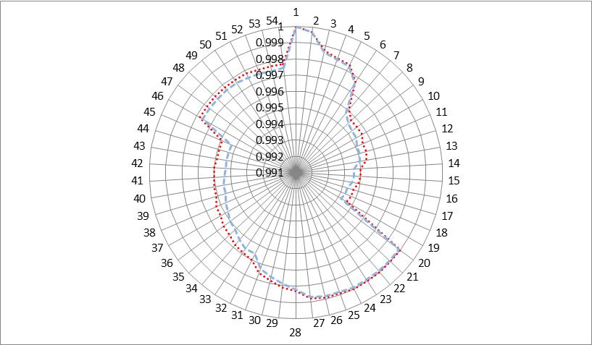 | 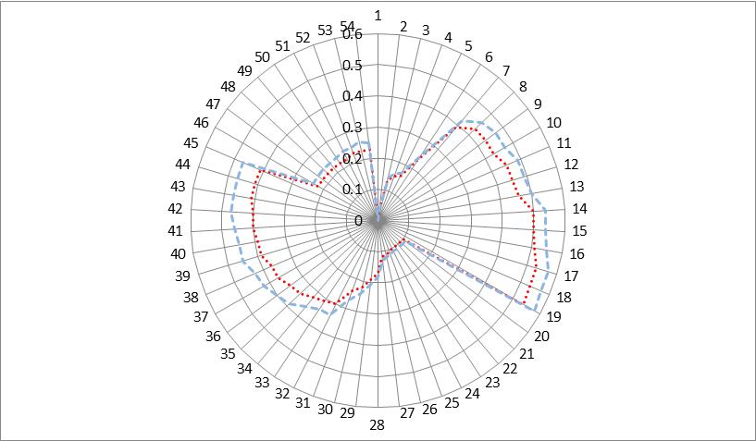
(a)Bus voltage profile | (b) Percentage drop
Figure 3.Bus voltage profile and percentage voltage drop of lower (red curve) and peak (blue curve) load

conclussION
In this paper, a forward backward sweep method is used to analize radial power flow in the feeder of Rajawali of Manokwari power grid. Simulations were done in Matlab 2021 under Windows 10 environment. Time alapsed for running this simulations are about 0.204046 seconds and 0.048908 for lower and peak demand.
Base on the simulation results, it can be concluded that Rajawali feeder has a feasible quality and quantity of energy supply that is denoted in voltage drop of the outer load bus which is only dropped about 0.1%. Although power losses is increase from 167.0575+j237.2724 in lower demand to 196.6048+j276.4539 in peak demand, the maximum voltage drop is about 0.41% in the load buses of 43-45.

Acknowledgments
Author wishing to acknowledge the Electrical Engineering Department as well as Engineering Faculty of Papua University for supporting this research and publication.

References
1. Rehiara AB. Optimal Power Flow of the Manokwari Power Grid Regarding Penetration of 20 MW Combined Cycle Power Plant. In: 2019 International Conference on Advanced Mechatronics, Intelligent Manufacture and Industrial Automation (ICAMIMIA). 2019. p. 53–7.
2. Mekhamer SF, Soliman SA, Mostafa MA, El-Hawary ME. Load flow solution of radial distribution feeders: a new approach. In: 2001 IEEE Porto Power Tech Proceedings (Cat No01EX502). 2001. p. 5 pp. vol.3-.
3. Baran M, Wu FF. Optimal sizing of capacitors placed on a radial distribution system. IEEE Transactions on Power Delivery. 1989;4(1):735–43.
4. Khedkar M, Dhole G. Optimal Load Transfer: Strategy for Loss Reduction of Distribution Network. 2003 Dec 1;84.
5. Setiawan INS. Studi Aliran Daya Jaringan Distribusi 20 KV di Bali dengan Metode yang Lebih Cepat. Jurnal Teknologi Elektro. 2007;6(1).
6. Cahyo JRDB. Analisa Pengaruh Interkoneksi Pembangkit Listrik Tenaga Mikrohidro dan Simulasi Rekonfigurasi Penyulang Terhadap Profil Tegangan dan Rugi Daya pada Sistem 20kV Manokwari. University of Papua; 2016.

