Gamification on Chatbot-based Learning Media:   
A Platform Perspective

Indra Hidayatulloh a), Totok Sukardiyono, Herman Dwi Surjono, Sigit Pambudi

Department of Electronics and Informatics Education, Universitas Negeri Yogyakarta, Indonesia

a) Corresponding author: [indra.hidayatulloh@uny.ac.id](mailto:indra.hidayatulloh@uny.ac.id)

**Abstract.** As a popular Learning Management System in Indonesian educational institutions, Moodle has some drawbacks, including a lack of mobility and a monotonous engagement with the learning path. While chatbots may assist with mobility and a more personalised learning path, there are still substantial issues with distance learning, such as keeping students motivated. On the other hand, gamification, which is often used to solve this problem, can be easily applied in Moodle but is still limited to chatbot-based learning media. Therefore, this study aims to build a chatbot for learning media and online exams with gamification features. This study aims to build a chatbot for learning media and online exams with gamification features. Learning and exam features include course information, registration, learning course materials, quizzes, final exams, learning progress, leaderboard, and announcements. Meanwhile, the gamification consists of rules and rewards, levels, quests, scores, countdown, timer, progress, badges, and leaderboard. We conducted BlackBox testing and focus group discussions on testing the chatbot. As a result, the functionality of the learning features, online exams, and gamification on the chatbot has been running well. Furthermore, several areas of improvement have been identified for future development, including completeness of features, safety concerns, and variations in testing.

# INTRODUCTION

Moodle claims more than 184000 sites in over 240 countries use their Learning Management Systems (LMS) service [1][2], including Indonesia. In Indonesia, 6605 sites powered their distance learning system using Moodle [1]. This claim is reasonable because Moodle has a plethora of capabilities that support continuous assessment and remote learning in general. Furthermore, Moodle also brings the notion of collaborating whiteboard, conference and social media in one place [3] make it more attractive for the student. However, this conventional one-way learning media has some disadvantages, including a lack of mobility [4] and a monotonous engagement with the learning path [4].

On the other hand, the rapid growth of chatbots as educational media enables more mobility and a more customized learning path. The chatbot itself is well-known for its mobility benefit when it comes to educational tools. For instance, the usage of a chatbot as a rapid information provider attempts to offer catastrophe-related information to foreign visitors in disaster areas[5]. The use of chatbots to leverage learning mobility, also demonstrated by [6] in their eHealth system and [7] in their e-commerce chatbot. Furthermore, chatbots for specific educational purposes are also implemented by [8]–[11].

While chatbots may help with mobility, there are still significant challenges associated with distant learning, such as sustaining student motivation. As a result, gamification is often used to overcome this obstacle [12]. The application of a game's design, in whole or in part, to real-world problems is known as gamification [13]. The features can be points, badges, leaderboards, awards, and punishments systems [14]. Furthermore, games are widely considered as an exciting learning media [15] and gamification effectively reduces 10% of the dropout rate in distance learning [16], which make it strong evidence as a proper tool for maintaining students' learning motivation, as cited in [12].

In Moodle, gamification can be easily implemented with additional plugins like LevelUp. Nevertheless, the development of gamification on chatbots for learning media is still limited. Hence, this article presents the realization of an interactive chatbot with gamification for online learning and examination media.

# PROPOSED SYSTEM

Universitas Negeri Yogyakarta (UNY) has a web-based e-Learning platform called Besmart which was developed using Moodle. Previously, Besmart has been used to support blended learning lectures at UNY [17][18]. However, since the Covid-19 pandemic, many lectures have been held entirely online through Besmart. One of them is the Digital Transformation course, which is related to the field of Information Technology held in all study programs at UNY. This condition is considered suitable for a case study in developing chatbots as learning media and online exams equipped with gamification features.

In this study, we transformed the Digital Transformation course, which previously had a web-based interface using Moodle, into a conversational interface in the form of a telegram chatbot. This chatbot application was developed by following the menu structure and content of the Digital Transformation course at Besmart. However, this chatbot is equipped with gamification features such as rules and rewards, levels, quests, scores, countdown, timer, progress, badges, and leaderboard. We named this chatbot TransformasiDigitalUNY_bot.

## System Architecture

The architecture of the proposed system currently consists of three main components, namely Telegram Client, Telegram Server, and Bot Server. Telegram Client is a telegram instant messaging application usually used for chatting. Meanwhile, Telegram Server has the @BotFather service, the only bot that manages all other Telegram bots. The chatbot that we built, TransformasiDigitalUNY_bot, is located in Bot Server. The chatbot connects to a database server and file server. The system architecture design can be seen in Fig. 1.

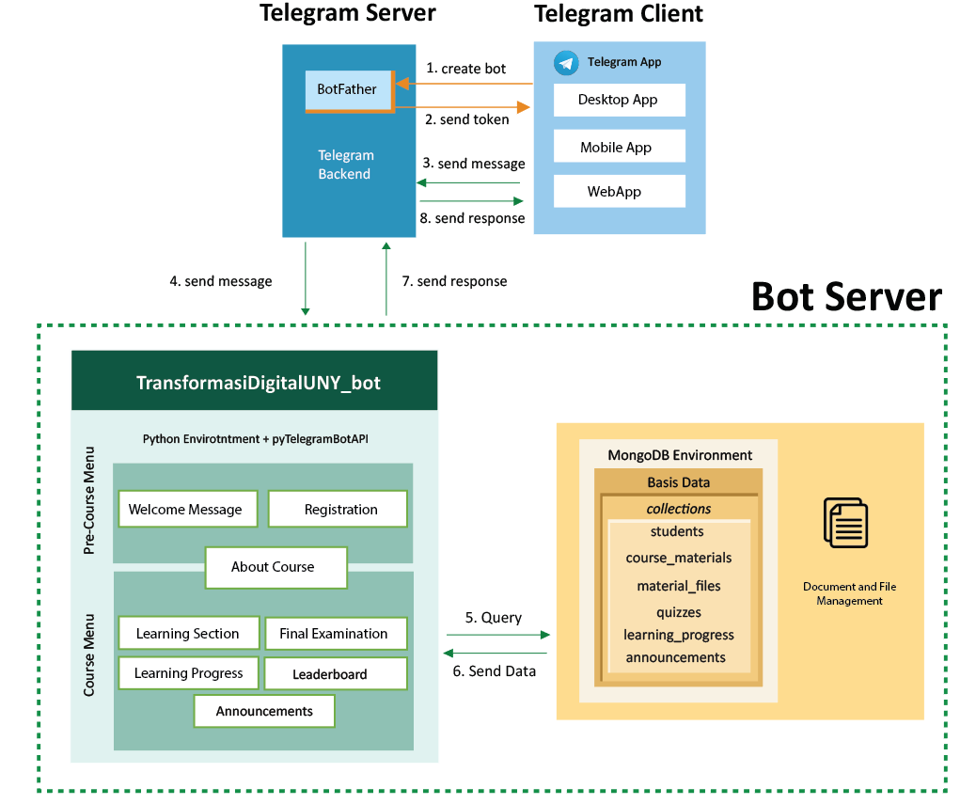

**FIGURE 1.** System Architecture

In the system architecture, Telegram Client has two primary functions. First, we (developer) used it to access @BotFather to create and manage a Telegram bot, namely TransformasiDigitalUNY_bot, connected to the chatbot application in Bot Server. Second, it is used by the users to access the chatbot, like sending requests and receiving responses to complete the Transformation Digital course. In this case, the request and response messages are forwarded by Telegram Server through Bot API. The users can send text messages or commands using a regular keyboard, buttons on a custom keyboard or an inline keyboard, and inline query.

Regarding the chatbot application itself, TransformasiDigitalUNY_bot is built using the Python Programming Language by implementing the pyTelegramBotAPI module to communicate with the Bot API. The chatbot has two menu categories: the Pre-Course menu and the Course menu. The Pre-Course menu consists of the Welcome Message and Registration. The Course menu includes Learning Section (Course Materials and Quizzes), Final Examination, Learning Progress, Leaderboard, and Announcements. Meanwhile, the About Course or Course Information menu is available in both categories. Guests or non-registered users can only access the Pre-Course menu, while students or registered users will be directed to the Course menu. Furthermore, the chatbot uses a MongoDB database server to store students' data, course materials, quizzes, learning progress, and announcements. Besides, the chatbot also connects to the file server to access material course files in pdf and PowerPoint format.

## Chatbot Conversation Flow

The flow of conversation between users and the chatbot is represented in the chatbot conversational flow diagram, as shown in Fig. 2 and Fig. 3. A chatbot conversation flow is a decision tree that shows a comprehensive list of decisions, events, and outcomes.



**FIGURE 2.** Chatbot Conversation Flow Diagram of Pre-Course Menu

In the chatbot conversational flow diagram, each colour has its own meaning. The green colour indicates the action of sending a message by a user to the chatbot. For example, a green message starting with the slash symbol (e.g. /start) is a command that the users can use to start a specific conversation with the chatbot. In comparison, a green message without the slash sign means the user's response to a specific chatbot's message. Furthermore, the blue colour indicates the message sent by the chatbot, and the orange colour means the particular action taken by the chatbot other than displaying messages. These particular actions include storing and updating data in the database, grading, and many more. Messages are connected with the dotted line means one message. Meanwhile, actions are linked with the dotted line means menu options.



**FIGURE 3.** Chatbot Conversation Flow Diagram of Course Menu

# Results and Discussion

The implementation results of TransformasiDigitalUNY_bot interface are as follows:

* Start Menu and Welcome Message

The start menu interface contains short information about the TrasnformasiDigitalUNY_bot description, including who the users are and what they can do and get by using this chatbot. Users can push the START button to start using the chatbot for the first time or type and send /start command on a regular keyboard. This interface can be seen in Fig. 4 (Start Menu).

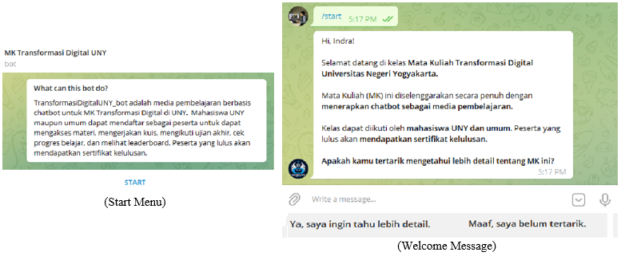

**FIGURE 4.** Start Menu and Welcome Message Interface

For a welcome message, the TransformasiDigitalUNY_bot start making a conversation by reading the first name of the telegram user to say Hi. Besides, it also asks whether the user is interested in knowing more about the Digital Transformation course. This interface provides two buttons on a custom keyboard that the user can use it to answer the question. This interface is shown in Fig. 4 (Welcome Message).

* Course Information Menu

Suppose the users want to know more about the course. In that case, the chatbot will display a course information menu, as shown in Fig. 5. There are five menus in the form of buttons on the inline keyboard, including Course Description (Deskripsi MK), Learning Objectives (Capaian Pembelajaran), List of Course Materials (Daftar Materi Kuliah), Learning Evaluation (Evaluasi Pembelajaran), and Join the Class (Bergabung ke Kelas MK Transformasi Digital UNY) if the user is not registered yet in this course. We implemented a gamification feature in this menu, namely rules and rewards. So the user must open (read) the first four menus before being able to register as a student of the course. Thus, every student is expected to understand the rules of the course.

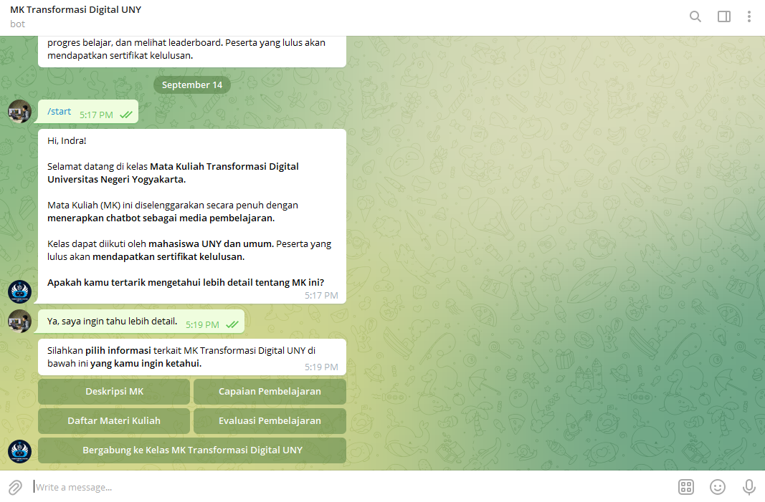

**FIGURE 5.** Course Information Menu Interface

Figure 6 shows the interface of each course information menu. The course description menu contains the course type, course weight, and a short description of the course materials. Learning outcome displays every objective that users will achieve if they can complete the course. The list of materials consists of every topic title that the user will learn. Learning evaluation informs what type of evaluation is used in this course, scoring scale, scoring calculation, and a passing grade. The users have to read all of that information before they decide to join the class. The join to the class submenu gives options to the users whether they will join or not by choosing the buttons on the custom keyboard. The chatbot will display a congratulatory message to the users and give them directions to send commands (/kuliah or /studying) to be able to access the learning activities menu if they successfully join the class.

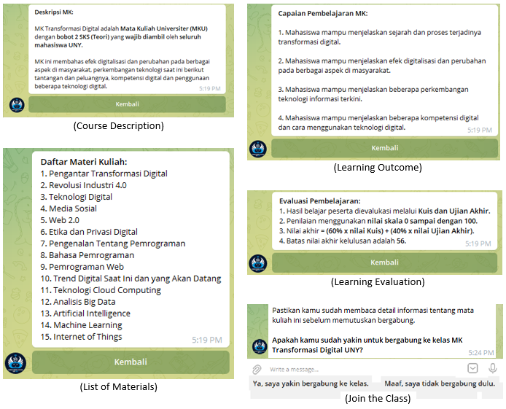

**FIGURE 6.** Interface of Every Course Information Menu

* Learning Activities Menu

This interface contains six menus in the form of buttons on inline-keyboard, namely Learning Section (Pelajari Materi), Final Examination (Ikut Ujian Akhir), Learning Progress (Cek Progres Belajar), Leaderboard (Lihat Leaderboard), Announcements (Baca Pengumuman), and Course Information or About Course Menu (Ketahui Tentang MK). The learning activities menu can be shown in Fig. 7.

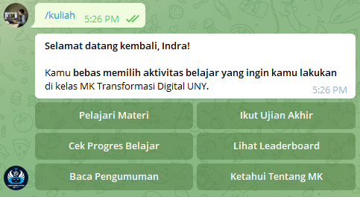

**FIGURE 7.** Learning Activities Menu Interface

* Learning Section Menu

If the users choose Learning Section menu, the chatbot will send a message containing a list of materials in the form of buttons on the inline keyboard. We arranged the course materials based on the level of difficulty. The leveling itself is part of gamification feature. Then, suppose the users select one of the topics, for instance, Introduction to Digital Transformation (Pengantar Transformasi Digital) or Industrial Revolution 4.0 (Revolusi Industri 4.0). In that case, the chatbot will display some submenus as shown in Fig. 8, including Learning Objectives (Tujuan Pembelajaran), Introductory Material (Materi Pengantar), and Main Materials (Materi Utama). Introductory material consists of introduction text and video in the form of a youtube video, while the main materials can be documents like pdf or PowerPoint. User has to download the document before they can read it.

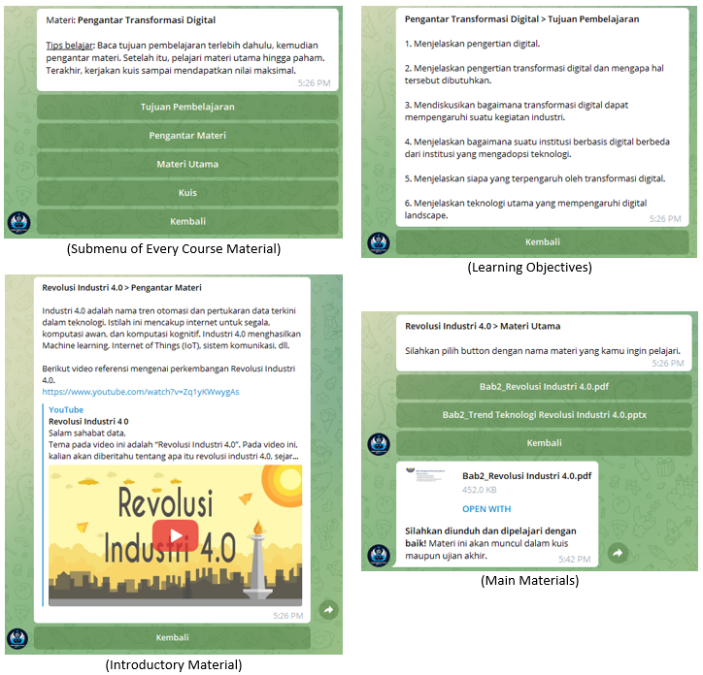

**FIGURE 8.** Learning Section Menu Interfaces include Submenu Interface of Every Course Material, Learning Objectives, Introductory Material, and Main Materials

Another necessary submenu in Learning Section menu is Quiz (Kuis). There is a quiz in every course material topic that the users should complete. The quiz interfaces are shown in Fig. 9. If the users choose the Quiz submenu, the chatbot will send a quiz information menu message. The information includes remaining chances to take the quiz, deadline, number of questions, and grading method. Users can select the Start Quiz (Mulai Kuis) button on the inline-keyboard when ready to take the quiz.

Chatbot starts the quiz by displaying the countdown so the users can be more prepared and information on how to quit the quiz before it is finished. Then, the chatbot will show the question one by one in a limited time. Every question can have different types (single or multiple answer questions), number of answer options, grading weight, and time duration. The previous question will be replaced with the following question after the users answer it or the time duration of the question is up. Besides, the chatbot also does not show the correct answer to the users. These two things are done to minimize cheating in online exams. The chatbot will send a quiz results message containing the grading result, congratulation and motivation message after the users finish or quit the quiz. Interfaces and rules in the quiz menu are similar to the final exams menu. The difference is final exams has more questions that are generated randomly from all the quizzes. Both quiz and final exams applied some gamification features such as quests, scores, countdown, and timer.

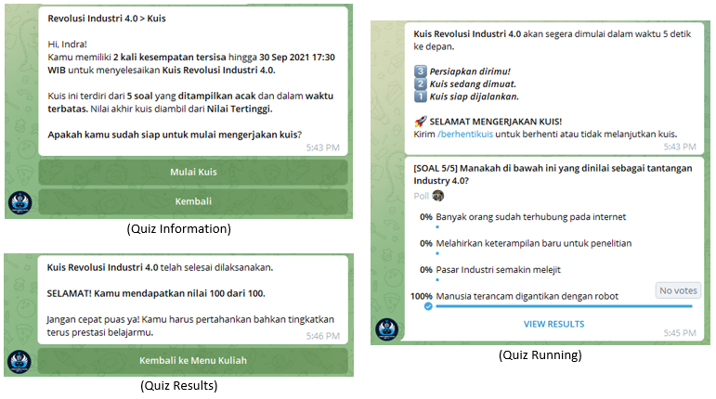

**FIGURE 9.** Learn Materials Menu Interfaces include Quiz Information, Quiz Running, and Quiz Results

* Learning Progress Menu

This menu embodies one of the gamification features, namely progress. There are two types of interfaces related to the learning progress menu: summary of learning progress and learning progress detail. The summary consists of ranking, total score, number of finished course materials including learning objectives, introductory material, and main materials that have been finished, final exams status and score. Learning progress detail shows the status of every content of learning materials, whether it has been finished or not. Learning progress information is always updated every time a user completes a learning activity. The interfaces of learning progress menu can be seen in Fig. 10.

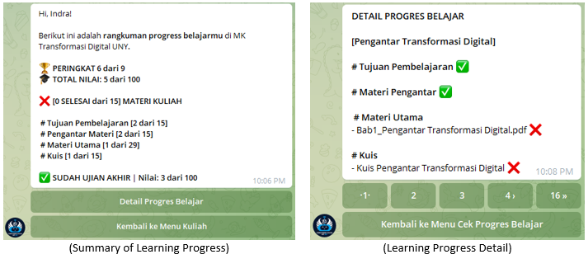

**FIGURE 10.** Learning Progress Menu Interface

* Leaderboard and Announcements Menu

The leaderboard interface displays ranking information of all users on multiple pages, including the rating number, full name, username, and total score. For example, the first page shows rank 1 to 3 displayed with medal and trophy icons as badges, and the following ranks are shown on the next pages. Badges and leaderboards are also forms of implementing gamification features. For the announcement interface, newest information is displayed on a smaller page number. Both the leaderboard and announcements interfaces are shown in Fig. 11.

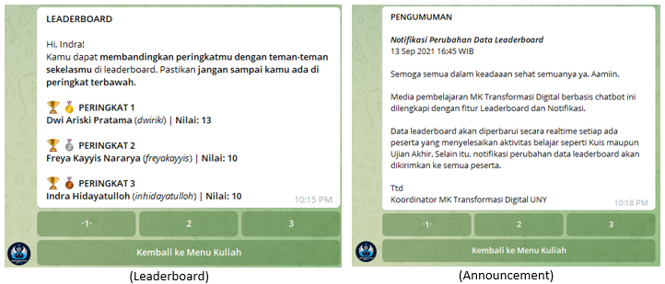

**FIGURE 11.** Leaderboard and Announcements Menu Interface

For the testing, we performed BlackBox testing to examine the functionality of TransformasiDigitalUNY_bot. Five testers used the chatbot simultaneously and tried every feature to check whether it worked or not. All the features have been tested and the results are running well.

In addition, we also conducted a Focus Group Discussion (FGD) with a limited number of participants. The participants are the same people who did blackbox testing. All of them are lecturer with more than five years teaching experience using Moodle. They also have expertise and research experience in the field of e-learning. We discussed the shortcomings of the Digital TransformasiUNY_bot that may be useful for developing this chatbot in the future. The results of the FGD are as follows:

* Course benefits information needs to be added to the course information menu. It will help the users to understand what the benefits they will get if they take and complete the course.
* Digital Transformation courses are also held online through video conferencing by using BigBlueButton feature of Moodle, Google Meet, or Zoom. In this case, the chatbot should provide a feature that facilitates the users to join video conferences.
* Another Moodle’s features should be available in this chatbot are Assignments and Discussions features. Users should be able to submit assignments and do discussion with all the users or specific group of users.
* The Quiz and Final Examination only have multiple-choice questions. The chatbot should provide other questions like short and long essay questions with an automatic essay scoring system [19][20].
* Ensuring that users read the learning materials, preventing users from cheating, and avoiding security attacks like SQL injection [21] are essential aspects of security that need to be in a chatbot.
* Moodle has proven to be reliable in helping organize online lectures. Many organizations are already very familiar with using Moodle. It is better to analyze the best potential of chatbots as independent learning media or to be integrated with Moodle. It is also necessary to test the usability and effectiveness of the chatbot as a learning media and compare it with Moodle.

# Conclusion

We presented a telegram chatbot named TransformasiDigitalUNY_bot as online learning and examination media for Digital Transformation Course. The chatbot was built by transforming a web-based Moodle interface into a conversational interface. There are two menu categories in the chatbot: the Pre-Course and Course menu. The pre-course menu includes Welcome Message, Course Information or About Course (Course Description, Learning Outcome, List of Materials, Learning Evaluation), and Join the Class or Registration. In contrast, the Course menu consists of Learning Section (Learning Objectives, Introductory Material, Main Materials, Quiz), Final Examination, Learning Progress, Leaderboard, Announcements, and About Course as in the Pre-Course menu. In addition, the chatbot has gamification features such as rules and rewards in the About Course and Registration menu, levels in the list of course materials, quests; scores; countdown; timer in the quiz and final exams, progress in the learning progress menu, badges and leaderboard in the leaderboard menu. We performed BlackBox testing with a limited number of testers to test the chatbot's functionality, and the result is that all the features work well. However, this research is still early in realising chatbot-based learning media with gamification features. So there are many areas for improvement and future directions. We conducted a Focus Group Discussion and noted that further chatbot development needs focus on the completeness of features, security aspects, and testing.

# References

1. Moodle, “Moodle statistics.” https://stats.moodle.org/ (accessed Oct. 04, 2021).
2. IBL News, “Moodle Says It Accounts for Over 200 Million Users and 151,000 Websites | IBL News.” https://iblnews.org/moodle-says-it-accounts-for-over-200-million-users-and-151000-websites/ (accessed Oct. 04, 2021).
3. B. Mourad, A. Tarik, A. Karim, and E. Pascal, “System Interactive Cyber Presence for E learning to Break Down Learner Isolation,” Int. J. Comput. Appl., vol. 111, no. 16, pp. 35–40, 2015, doi: 10.5120/19626-1544.
4. J. Pereira, “Leveraging chatbots to improve self-guided learning through conversational quizzes,” ACM Int. Conf. Proceeding Ser., vol. 02-04-Nove, no. October, pp. 911–918, 2016, doi: 10.1145/3012430.3012625.
5. S. E. Ahmady and O. Uchida, “Telegram-based chatbot application for foreign people in Japan to share disaster-related information in real-time,” 2020 5th Int. Conf. Comput. Commun. Syst. ICCCS 2020, pp. 177–181, 2020, doi: 10.1109/ICCCS49078.2020.9118510.
6. F. Amato, S. Marrone, V. Moscato, G. Piantadosi, A. Picariello, and C. Sansone, “Chatbots meet ehealth: Automatizing healthcare,” CEUR Workshop Proc., vol. 1982, pp. 40–49, 2017.
7. M. M. Khan, “Development of An e-commerce Sales Chatbot,” HONET 2020 - IEEE 17th Int. Conf. Smart Communities Improv. Qual. Life using ICT, IoT AI, pp. 173–176, 2020, doi: 10.1109/HONET50430.2020.9322667.
8. P. Smutny and P. Schreiberova, “Chatbots for learning: A review of educational chatbots for the Facebook Messenger,” Comput. Educ., vol. 151, no. February, p. 103862, 2020, doi: 10.1016/j.compedu.2020.103862.
9. M. Kowsher, F. S. Tithi, M. Ashraful Alam, M. N. Huda, M. Md Moheuddin, and M. G. Rosul, “Doly: Bengali Chatbot for Bengali Education,” 1st Int. Conf. Adv. Sci. Eng. Robot. Technol. 2019, ICASERT 2019, vol. 2019, no. Icasert, pp. 1–6, 2019, doi: 10.1109/ICASERT.2019.8934592.
10. O. Zahour, E. H. Benlahmar, A. Eddaoui, H. Ouchra, and O. Hourrane, “A system for educational and vocational guidance in Morocco: Chatbot e-orientation,” Procedia Comput. Sci., vol. 175, pp. 554–559, 2020, doi: 10.1016/j.procs.2020.07.079.
11. S. Jang, J. J. Kim, S. J. Kim, J. Hong, S. Kim, and E. Kim, “Mobile app-based chatbot to deliver cognitive behavioral therapy and psychoeducation for adults with attention deficit: A development and feasibility/usability study,” Int. J. Med. Inform., vol. 150, no. January, p. 104440, 2021, doi: 10.1016/j.ijmedinf.2021.104440.
12. I. Hidayatulloh, S. Pambudi, H. D. Surjono, and T. Sukardiyono, “Gamification on Chatbot-Based Learning Media : a Review and Challenges,” ELINVO (Electronics, Informatics, Vocat. Educ., vol. 6424, doi: 10.21831/elinvo.
13. J. Brito, V. Vieira, and A. Duran, “Towards a Framework for Gamification Design on Crowdsourcing Systems: The G.A.M.E. Approach,” Proc. - 12th Int. Conf. Inf. Technol. New Gener. ITNG 2015, pp. 445–450, 2015, doi: 10.1109/ITNG.2015.78.
14. B. Morschheuser, K. Werder, J. Hamari, and J. Abe, “How to Gamify? A Method for Designing Gamification,” Proc. 50th Hawaii Int. Conf. Syst. Sci. (HICSS 2017), pp. 1298–1307, 2017, doi: http://hdl.handle.net/10125/41308.
15. V. P. P. Setyadharma, E. Iryanti, I. Hidayatulloh, and N. A. S. Nugraha, “Designing of english challenge mobile game application as the media of english language learning,” J. Eng. Appl. Technol., vol. 1, no. 1, pp. 30–42, 2020, doi: 10.21831/jeatech.v1i1.34756.
16. D. de la Peña, D. Lizcano, and I. Martínez-Álvarez, “Learning through play: Gamification model in university-level distance learning,” Entertain. Comput., vol. 39, no. March, 2021, doi: 10.1016/j.entcom.2021.100430.
17. S. Pambudi, H. D. Surjono, T. Sukardiyono, and I. Hidayatulloh, “Video-Based Blended Course for Computer Network Learning,” J. Phys. Conf. Ser., vol. 1413, no. 1, 2019, doi: 10.1088/1742-6596/1413/1/012025.
18. S. Pambudi, I. Hidayatulloh, H. D. Surjono, and T. Sukardiyono, “Development of Instructional Videos for the Principles of 3D Computer Animation,” J. Phys. Conf. Ser., vol. 1737, no. 1, 2021, doi: 10.1088/1742-6596/1737/1/012022.
19. G. B. Herwanto, Y. Sari, B. N. Prastowo, M. Riasetiawan, I. A. Bustoni, and I. Hidayatulloh, “UKARA: A Fast and Simple Automatic Short Answer Scoring System for Bahasa Indonesia,” vol. 2, pp. 48–53, 2018, doi: 10.26499/iceap.v2i1.95.
20. B. N. Prastowo et al., “A Proposed Framework for Essay Answer Processing based on Computational,” no. December, pp. 54–58, 2018, doi: 10.26499/iceap.v2i1.96.
21. F. Y. Hernawan, I. Hidayatulloh, and I. F. Adam, “Hybrid method integrating SQL-IF and Naïve Bayes for SQL injection attack avoidance,” J. Eng. Appl. Technol., vol. 1, no. 2, pp. 85–96, 2021, doi: 10.21831/jeatech.v1i2.35497.