**The Public Acceptance of BPS Website of West Papua Province Using the Unified Theory of Acceptance and Use of Technology Model**

**Kristia Yuliawan1 and Marlinda Sanglise2**

1,2 Informatics Engineering Department, Faculty of Engineering, University of Papua, Manokwari, Indonesia

e-mail: k.yuliawan@unipa.ac.id

**Abstract.** Local government websites should be able to provide quick access to reliable data on population census to the public. This study aims at revealing the public acceptance and use of the BPS (Statistics) website in the West Papua province by utilizing the Unified Theory of Acceptance and Use of Technology (UTAUT) model. The survey data were analyzed using the Evaluation of Measurement Model and Evaluation of Structural Model. The test results show that, respectively, the Effort Expectancy and Social Influence variable has a positive and significant effect on Behavioral Intention, the Performance Expectancy variable shows a positive but non-significant effect on Behavioral Intention, the Behavioral Intention variable gives a positive and significant effect on Use Behavior, and the Facilitating Condition variable provides positive but non-significant effect to the use Behavior variable.

Keywords: *statistics, census, public acceptance, UTAUT*

1. **Introduction**

A population census refers to an entire process for collecting, processing, compiling, and publishing the demographic, economic, and social data of all residents in a country or region at a certain time (1). BPS is a Central Bureau of Statistics instituted by Law No. 6/1960 on the Census and Law No. 7/1960 on statistics. These two laws have been amended with Law No. 16 of 1997 concerning statistics. To implement this law, BPS is obliged to provide the needed data for the public. Provincial BPS is the representative of BPS who carries out their duties and authorities on statistical activities according to the applicable law and regulations in the regions.

To provide data for the public, the Provincial BPS perform both offline and online service. In the offline model, the users must directly come to the office to obtain data. This service is considered ineffective because of its time-consuming. For the online service, the public can easily access census data anywhere and anytime by visiting the Provincial BPS website and downloading the needed data. The problem in obtaining online data is internet access and computer literacy, especially in rural and remote areas like West Papua. The public access to the BPS website in West Papua is relatively low and unstable where it can be seen from the traffic overview of the website visitors.

The implementation of information technology must be related to users’ acceptance. So, it is crucial to know the extent to which users can accept a particular technology to measure the success of the technology use (2). UTAUT is one way to know the factors that can affect the intention in using a certain technology as adoption from previous models such as TPB, TRA, and TAM (3). This research aimed at providing information on the public acceptance towards information technology, i.e., the BPS website of West Papua Province. Furthermore, it can be taken into consideration among other government agencies for providing public services with the use of information technology.

1. **Research Methods**

UTAUT is the latest technology acceptance model developed by Venkatesh, et al (4) that combine eight theories of technology acceptance consisting of Theory of Reasoned Action (TRA), Technology Acceptance Model (TAM), Motivational Model (MM), Theory of Planned Behavior (TPB), Combined TAM and TPB, Model of PC Utilization (MPTU), Innovation Diffusion Theory (IDT), and Social Cognitive Theory (SCT). From these eight theories, Vankatesh et al., emphasize that there are 4 constructs with a direct influence on user behavior. They consist of Performance Expectancy (PE) on the extent to which a person believes that the system can benefit their work, Effort Expectancy (EE) on the ease level of the system use, Social Influence (SI) on the extent to which someone believes the use of the new system and Facilitating Conditions (FC) on the extent to which ones believes the organizational infrastructure that supports the use of the system.

The Likert scale questionnaire was used to determine Performance Expectancy (PE), Effort Expectancy (EE), Social Influence (SI), and Facilitating Conditions (FC) with the categories of Strongly Disagree (SD), Disagree (D), Agree (A), and Strongly Agree (SA) (5). The research procedure is presented below.

1. Sample size determination

2. Research models and hypotheses making

3. Questionnaires distribution and data collection

4. Data Processing

5. Analysis of UTAUT model using SmartPLS

6. Hypothesis Testing

7. Formulating the Results

1. Sample size determination

The data type in this research was quantitative in which the information was related to the problem of census data on the website. The quantitative data were in the form of people's behavior in obtaining online census data. The population in this research was those who had downloaded the census data on the BPS website of West Papua. This study employed a survey method by distributing a set of questions and a written statement to 50 research respondents as the samples (6).

1. Research models and hypotheses making

This research employed the UTAUT model (Unified Theory of Acceptance and Use of Technology) model to find out the effectiveness of the BPS website of West Papua to provide reliable information on census data. This study also measured the users’ ability to adapt to the system, and the system's ability to give a quick response towards user commands. The application of this model was to know the extent to which the Quality of the System meets the desired characteristic of the information system.

1. Questionnaires distribution and data collection

The questionnaire distribution was done online using Google Forms that was shared through WhatsApp. After the questionnaire responses were collected, it was extracted in Microsoft Excel to the further data process.

1. Data Processing

The data in the Excel program were saved with the extension of *comma-delimited* (.csv) to be analyzed using smartPLS.

1. UTAUT Analysis Model with SmartPLS

The research measurement model was carried out in two stages of evaluation, the Evaluation of Measurement Model and the Evaluation of Structural Model.

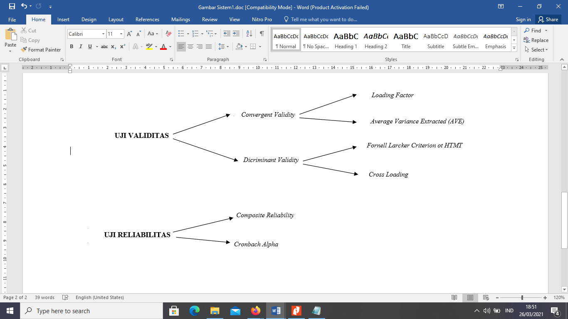

Figure 1. Evaluation of Measurement Model



Figure 2. Evaluation of Structural Model

1. **Results and Discussion** 
   1. Sample Determination

The respondents were categorized based on their experience accessing the website, age, and gender.

* 1. Model and Hypothesis Making

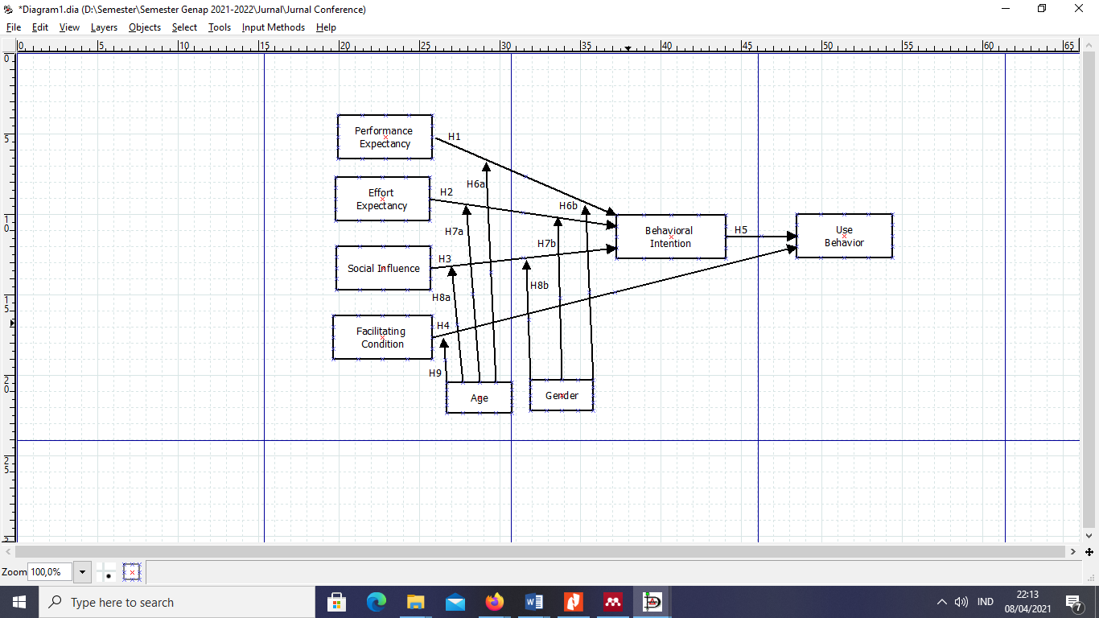

Figure 3. Research scheme with UTAUT model

Based on the research model above, the hypothesis can be formulated as follows:

**Table 2**. Research hypothesis

|  |  |
| --- | --- |
| HYPOTHESIS | Explanation |
| H1 | The positive effect of Performance Expectancy towards Behavioral Intention on the BPS website of West Papua Province |
| H2 | The positive effect of Effort Expectancy towards Behavioral Intention on the BPS website of West Papua Province |
| H3 | The positive effect of Social Influence towards Behavioral Intention on the BPS website of West Papua Province |
| H4 | The positive effect of Facilitating Condition towards Use Behavioral I on the BPS website of West Papua Province |
| H5 | The positive effect of Behavioral Intention towards Use Behavioral on the BPS website of West Papua Province |
| H6 | The positive effect of Performance Expectancy towards Behavioral Intention the BPS website of West Papua Province based on (a) age and (b) gender |
| H7 | The positive effect of Effort Expectancy towards Behavioral Intention on the BPS website of West Papua Province based on (a) age and (b) gender |
| H8 | The positive effect of Social Influence towards Behavioral Intention on the BPS website of West Papua Province based on (a) age and (b) gender |
| H9 | The positive effect of Facilitating Conditions towards Use Behavioral on the BPS website of West Papua Province based on age |

* 1. Questionnaire Distribution and Data Collection

The research was done among 50 respondents by completing questionnaires in a google form. The respondent's gender can be seen in Table 3 below.

**Tabel 3**. Respondent Characteristics

|  |  |  |  |  |
| --- | --- | --- | --- | --- |
| No | Variable | Classification | Number | Percentage |
| 1 | Gender | Male | 32 | 64 % |
| 2 | Female | 18 | 36 % |

* 1. Data Processing

Data processing was carried out by presenting the research data and the response trend was clarified from the respondents’ answers. The results were then tabulated employing data processing based on their age and gender.

* 1. Analysis of UTAUT model with SmartPLS
     1. Validity Test of Factor Loading

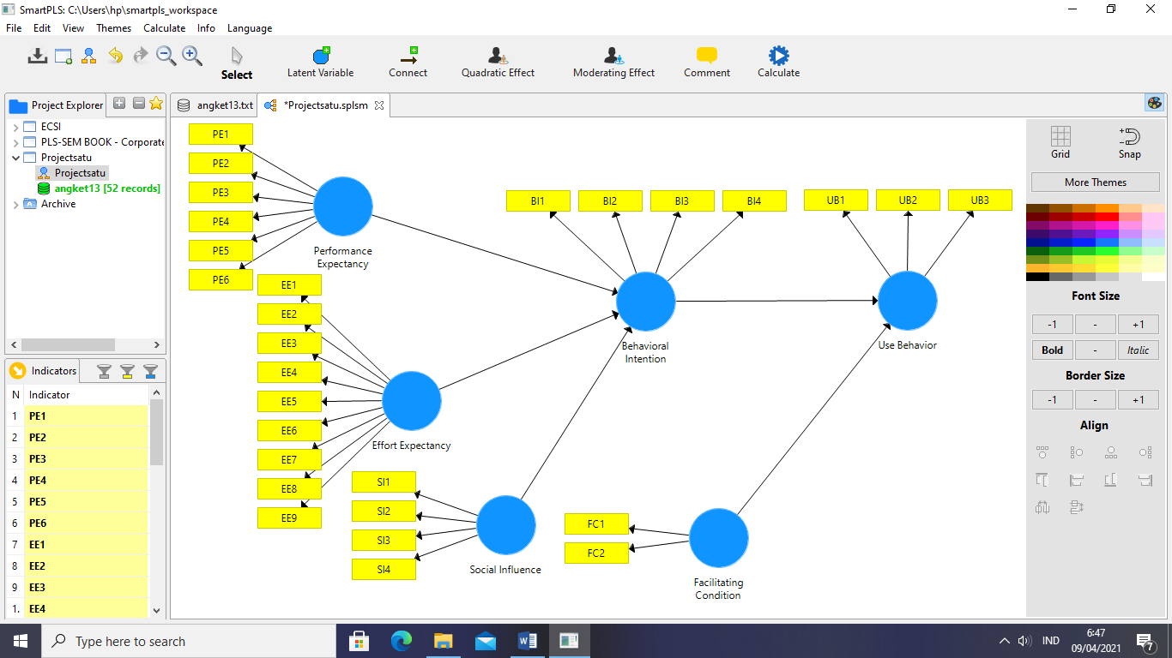

Figure 4. Factor Loading

Figure 4 shows the output diagram of the overall correlation. The correlation is invalid because it contains a loading factor of 0.70. Based on the PLS-SEM assessment, an invalid indicator is eliminated from the output diagram because it is unable to measure its construction or indicator. Meanwhile, Figure 5 displays a path diagram of the results of the re-estimation model with a validity score above 0.70.

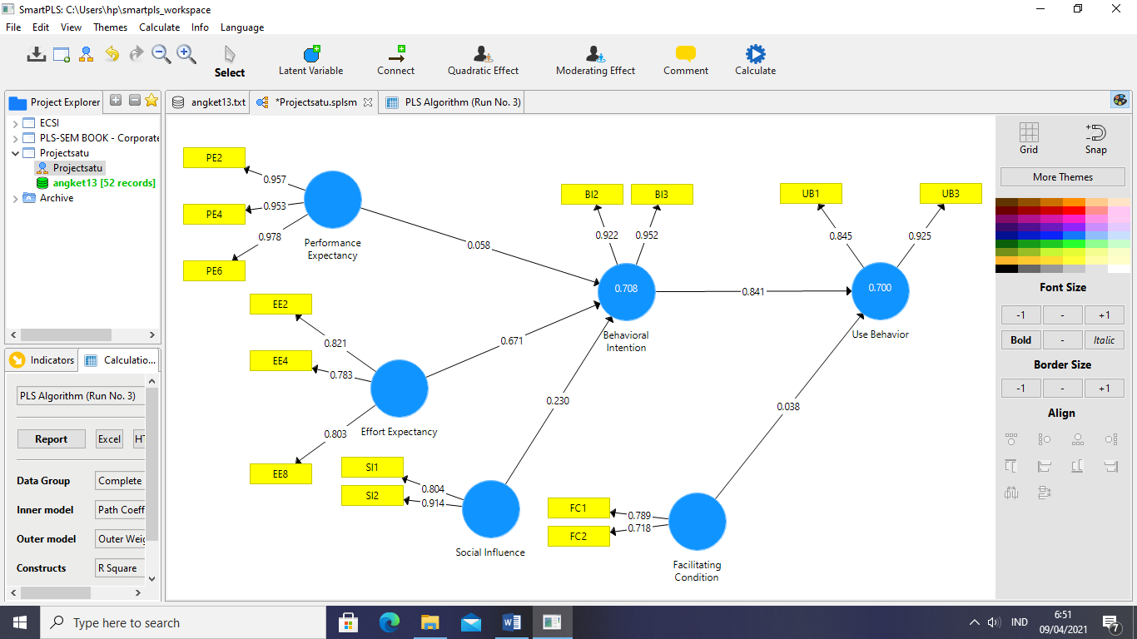

Figure 5. Diagram Output of Re-Estimasi Results Model

* + 1. Validity Test of Average Variance Extracted(AVE).

The AVE indicator is to measures the number of variables that can be captured by the construct compared to the variables caused by measurement error. AVE value must be bigger than 0.5 and if an indicator is below 0.5, it declares as an invalid indicator.

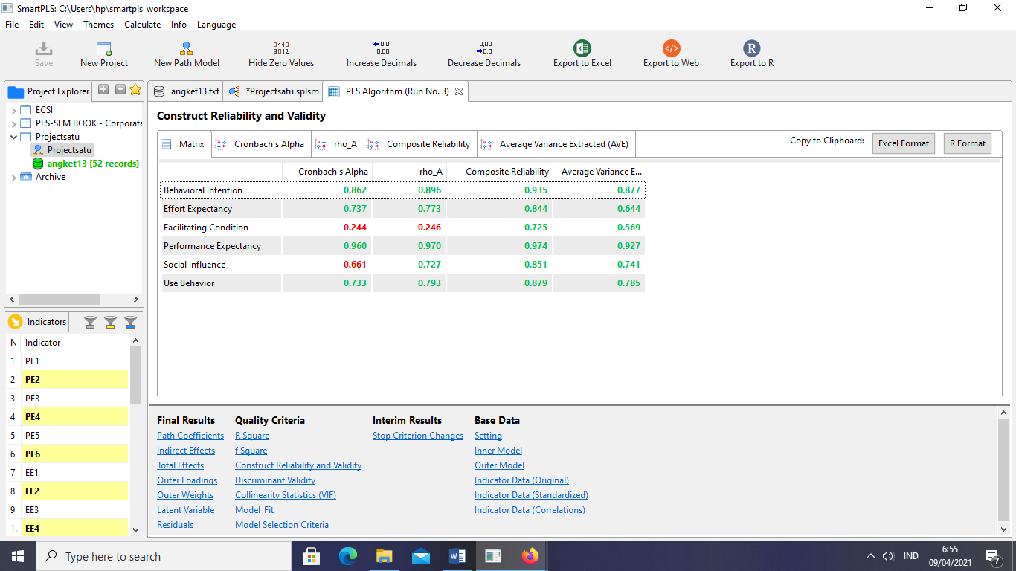

Figure 5. Results of AVE Test

Figure 5 shows that all composite reliability is acceptable because each construct is above 0.7 meaning that all construct values have good reliability for further test except the Facilitating Condition and Social Influence variables which are below 0.7 or bad reliability value.

* + 1. Validity Test of Fornell Larcker Criterion

The Fornell Larcker Criterion is an approach that assesses the Discriminant Validity of the correlation value among variables, the variable itself, and variable with other variables. The way to assess the Fornell Larcker Criterion is by analyzing the correlation of the variable with the variable itself which should not be smaller than the correlation of the variable with other variables.

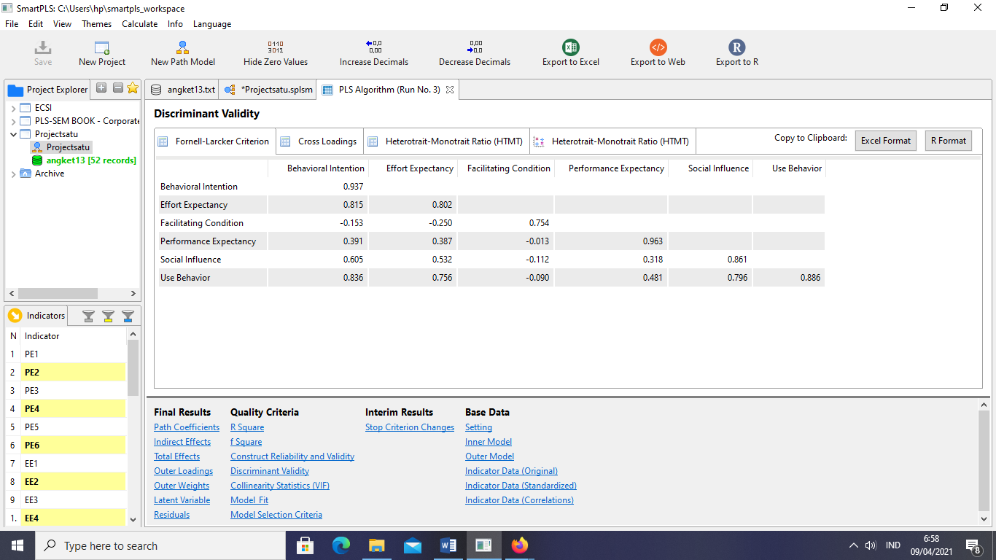

Figure 6. Fornell Larcker Criterion

Based on Figure 6, it can be seen that the Behavioral Intention variable is 0.937 while the highest correlation value between the Behavioral Intention variable and other variables is 0.836. It means that the Behavioral Intention variable is bigger than the other variables likewise with other variables.

* + 1. Validity Test of Cross Loading

Cross Loading is the correlation between the indicators towards other constructs compared to the correlation coefficient with other constructs.

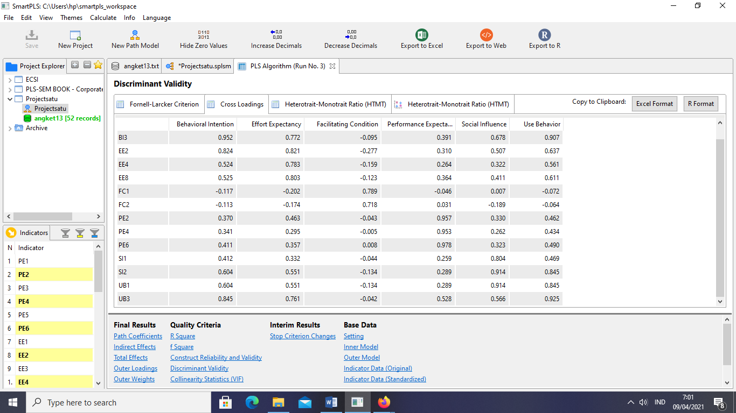

Figure 7. Cross Loading

* + 1. Reliability Composite Testing

In the composite Reliability test, a construct is declared reliable if composite reliability has a value> 0.70. Figure 7 shows that all constructs have valid reliability because they have passed the required minimum criteria.

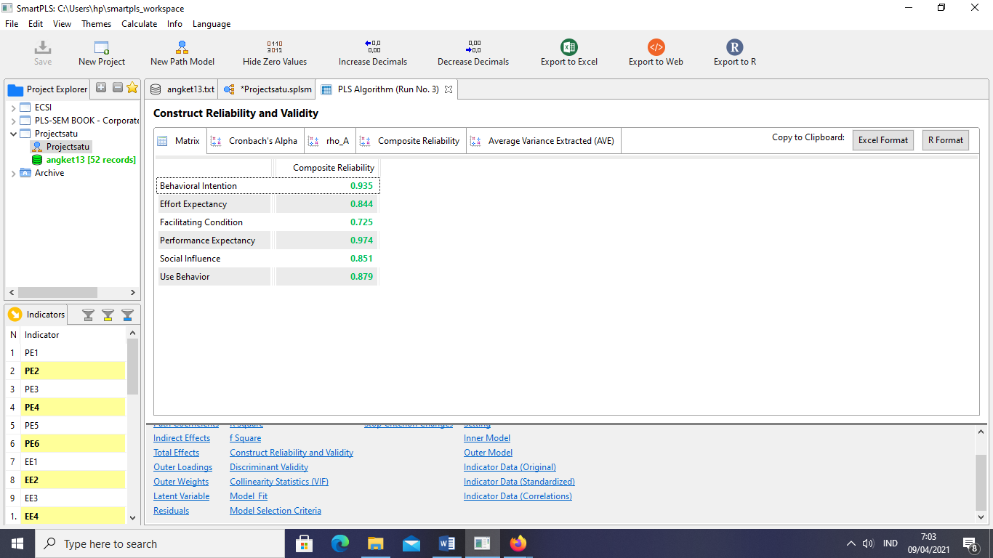

Figure 7. Composite Reliability

* + 1. Cronbach AlphaReliability

In the Cronbach Alpha test, a construct is declared reliable if the composite reliability has a value> 0.70. Figure 8 below shows that all Behavioral Intention, Effort Expectancy, Performance Expectancy, Use Behavior variables have valid reliability since they have passed the required minimum criteria excluding the variable of Facilitating Condition and Social Influence which are invalid with the value <0.70.

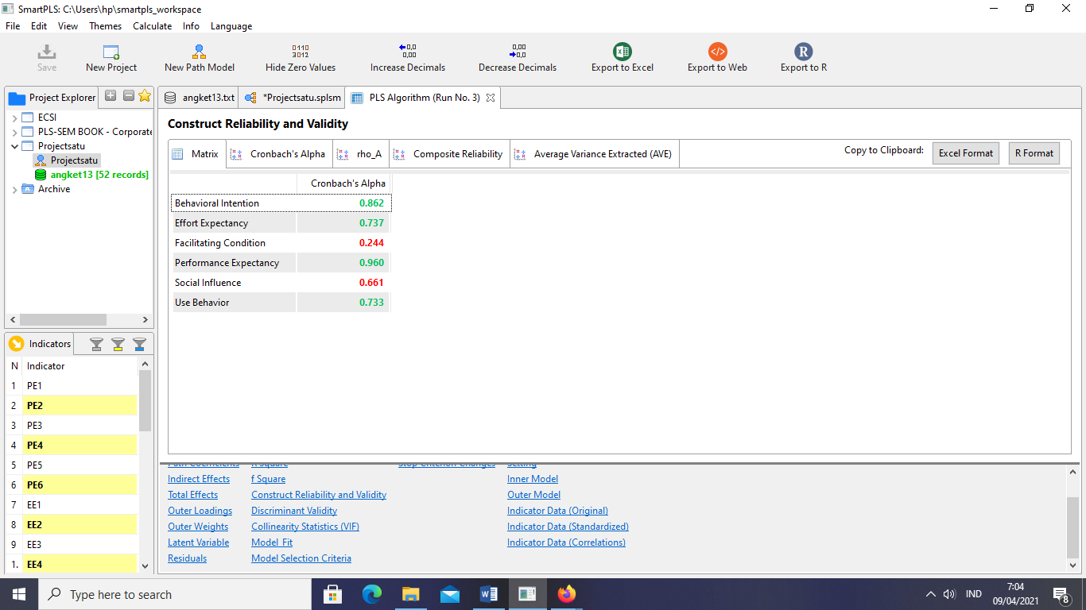

Figure 8. Cronbach Alpha

* + 1. R-SquareStructural Model

The R-Square test is a test used to explain exogenous variables towards endogenous variables.

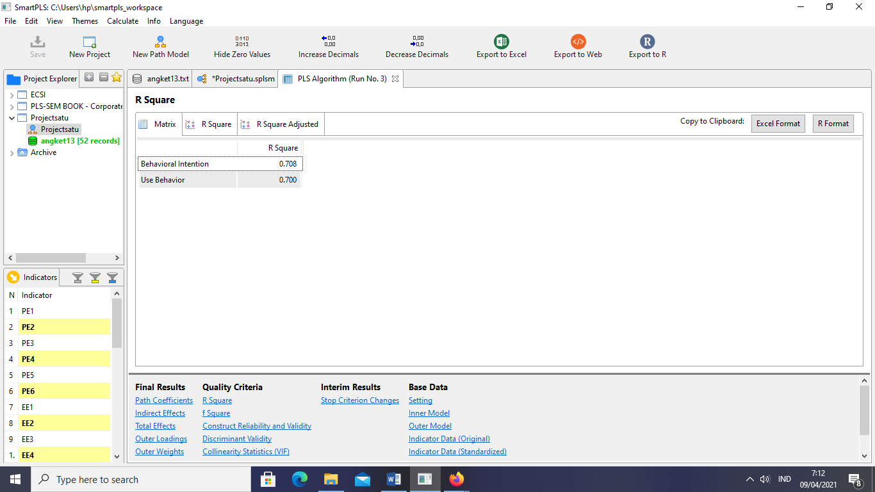

Figure 9. *R-Square*

The R-Square value of the Behavioral Intention variable is 0.708 which means that the Behavioral Intention variable is influenced by 70.8% due to the Performance Expectancy, Effort Expectancy, and Social Influence variables. Meanwhile, the Use Behavior variable is 70% influenced by the Facilitating Influence and Behavioral Intention variables.

* + 1. Path Coefficient Structural Model

Path Coefficient is used to know the extent to which the influence of the independent variable towards the dependent variable. The value is analyzed to indicate the direction of the variable relationship whether the variable leads to positive or negative. The Path Coefficients are in the range of -1 to 1.

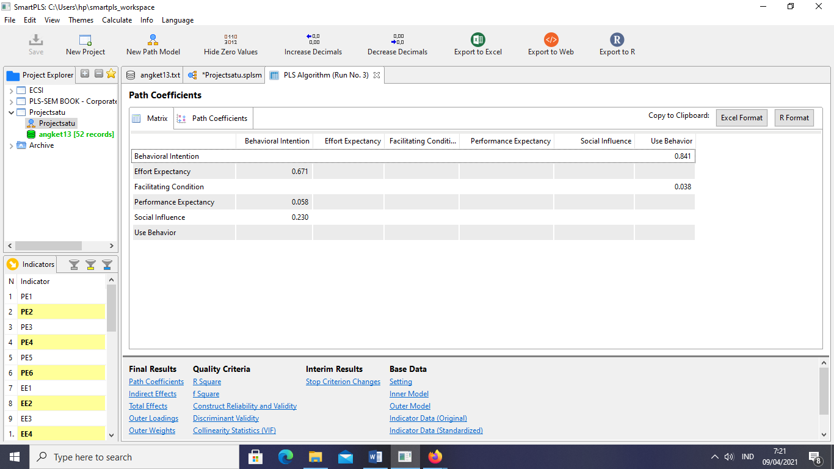

Figure 10. Path Coefficient

Figure 10 above indicates that the Behavioral Intention and Facilitating Condition variables show a positive relationship with Use Behavior, while the Effort Expectancy, Performance Expectancy, Social Influence variables have a positive relationship to Behavioral Intention.

* + 1. T-Statistic Test

The T-Statistic test is used to know the significance among constructs in which if the value is bigger than 1.96. It means that the T-Statistic is significant on the contrary if it is smaller than 1.96, it is not significant.

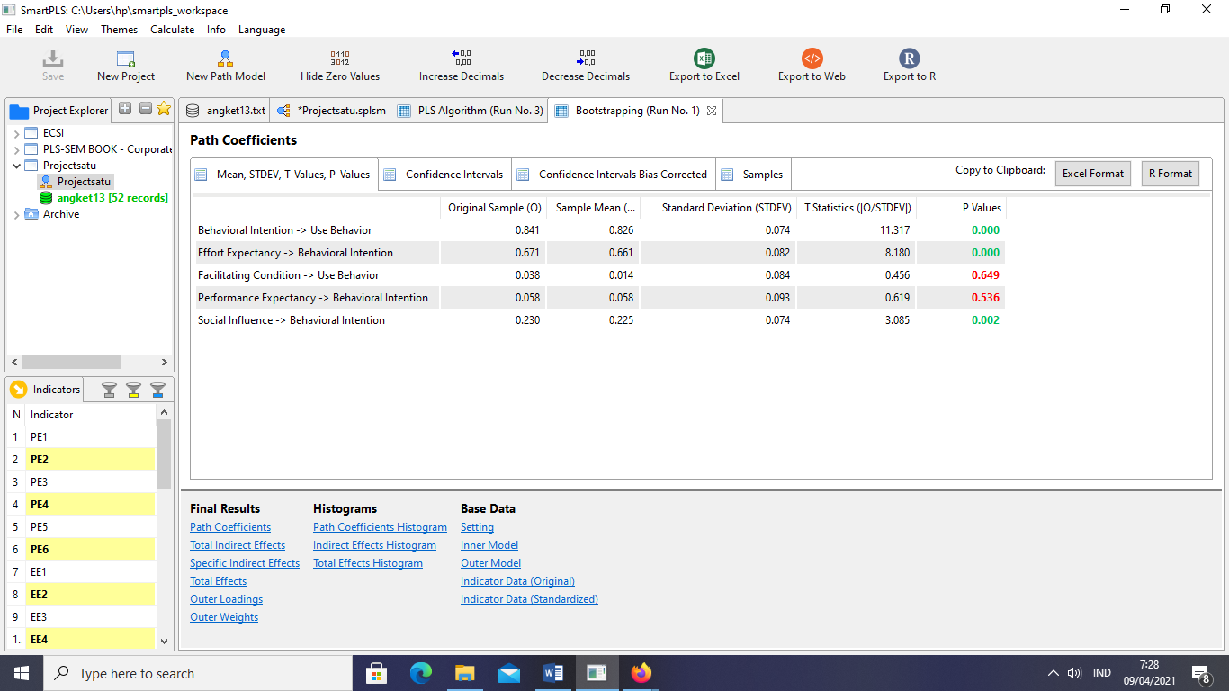

Figure 11. T-Statistic

The relationship of Behavioral Intention shows a significant relationship with Use Behavior while Facilitating Condition is not significant towards Use Behavior. The relationship between the Effort Expectancy and Social Influence variables has a significant relationship with Behavioral Intention, but Performance Expectancy is not significant towards the relationship with the Behavioral Intention variable.

* + 1. Predictive Relevance Test

Predictive Relevance is a value that shows the extent of the observation result. The observation value is good if the Predictive Relevance value is above 0.

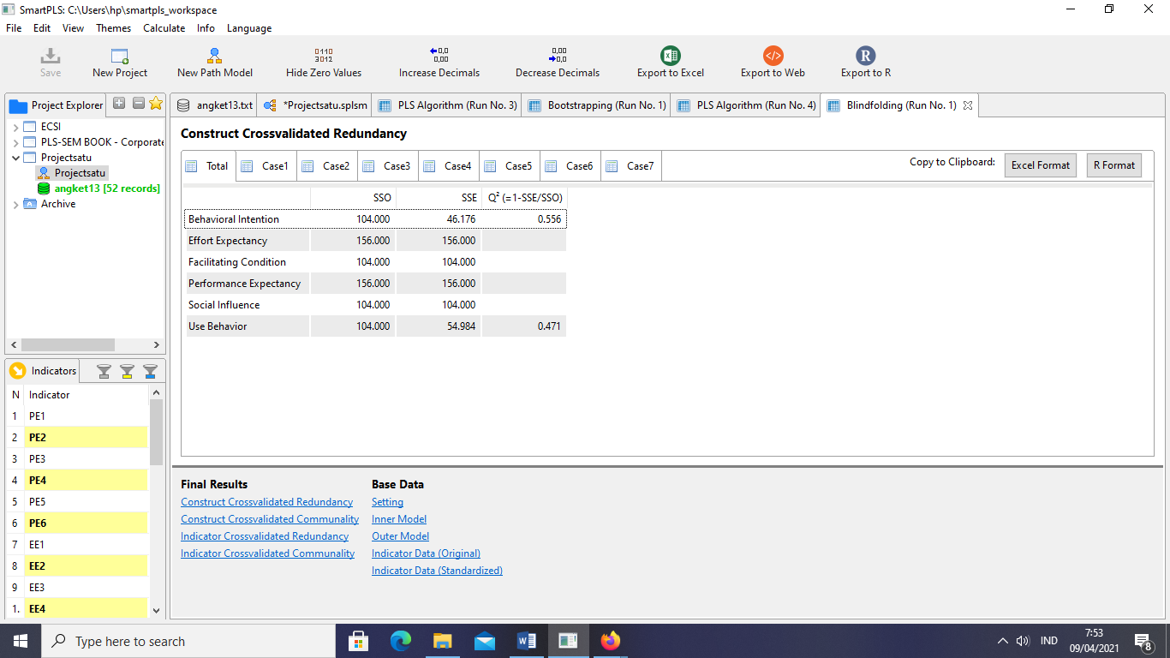

Figure 11. Predictive Relevance

Based on the picture above, the Predictive Relevance value is 0.556 indicating the good observation value of Behavioral Intention. Meanwhile, Predictive Relevance gains 0.471 meaning that the observation value of Use Behavior is considered good.

1. **Conclusion**
2. The variables of Effort Expectancy and Social Influencer have a positive and significant effect on Behavioral Intention, while the Performance Expectancy variable shows a positive but not significant effect towards Behavioral Intention.
3. The variables of Behavioral Intention give a positive and significant effect on the Use Behavior, while the Facilitating Condition variable has a positive but not significant effect on the use Behavior variable.
4. The variables of Performance Expectancy, Effort Expectancy, and Social Influencer affect 70% towards Behavioral Intention variables, while 30% are influenced by other variables.
5. The variables of Facilitating Condition and the Behavioral Intention variable affect 70% towards the Use Behavior.

1. **References**

1. BPS. Buku 4A. Pedoman Teknis BPS Provinsi dan Kabupaten/Kota Uji Coba PES SP2020 [*Technical Guidelines for Provincial and District / City BPS Testing PES SP2020*] | i. 2020;

2. Nasir M. Evaluasi Penerimaan Teknologi Informasi Mahasiswa di Palembang Menggunakan Model UTAUT [*Evaluation of Student Information Technology Acceptance in Palembang Using the UTAUT Model*]. Semin Nas Apl Teknol Inf [Internet]. 2013;1(1):15–2013. Available from: https://journal.uii.ac.id/Snati/article/view/3006

3. Hakim MM, Nurkamid M. Model Adopsi Ukm Di Kudus Terhadap E-Commerce [*SME Adoption Model in Kudus Towards E-Commerce*]. Simetris J Tek Mesin, Elektro dan Ilmu Komput. 2017;8(1):339–44.

4. Dillon A. Human Acceptance of Information Technology. Int Encycl Ergon Hum Factors, Second Ed - 3 Vol Set. 2006;27(3):425–78.

5. Marchewka J, Liu C, Kostiwa K. An Application of the UTAUT Model for Understanding Student Perceptions Using Course Management Software. Commun IIMA. 2007;7(2):93.

6. Prof. Dr. Sugiyono. Metode Penelitian Kuantitatif, Kualitatif, dan R&D *[Quantitative & Qualitative Research Methods, and R & D*]. 1st ed. Bandung: Alfabeta; 2019.