Using Innovative Technology and land Game in Vocational Education Design to Revive the Kaxabu's Tribal Culture

Li-Hsun Peng 1,a, Adam B. Cheng 1,b and Ibnu Siswanto,2,c

Author Affiliations

1 Department of Creative Design, National Yunlin University of Science and Technology. 123, University Road, Section 3, Douliou, Yunlin 64002. (Taiwan)

2 Automotive Engineering Education Department, Faculty of Engineering, Universitas Negeri Yogyakarta.

3You would list an author’s second affiliation here.

Author Emails  
a) penglh@gemail.yuntech.edu.tw,  
b)m11036002@gemail.yuntech.edu.tw  
c)ibnusiswanto@uny.ac.id

**Abstract.** Through innovative technology education, this research seeks to integrate Taiwan's local culture and history and explores the aboriginal swords and weapons that have declined with the change of the times. Researchers restore their traditional value and revitalize it again through digital and vocational technology and craft design techniques. Taiwan recognizes as the birthplace of Austronesian culture. In recent years, the aboriginal culture there has gradually received international attention and has an opportunity for recovery; however, the design and reproduction of weapons, especially knives, are limited. The law defines it as an offensive weapon, so it is difficult to promote. Because of this, this research is looking forward to real-life role-playing. Starting from the local history and legends of the Kaxabu tribe, we will use soft foam as the material to make non-lethal model weapons. We hope that through cultural education, the purpose of promoting the New Reality Movement. Therefore, the team used lightweight, innovative foam and glass fiber materials to produce weapons with full visual design effects. Allow young people in the vocational and technical education field to absorb and understand knowledge in a newer way while being exposed to traditional culture.

# Introduction

## 1.1 Research Background and Motivations

In the past, cultural and creative applications mostly use in fashion products such as backpacks or clothing accessories [1]. Knives are a link that cannot ignore in the development of various cultures. Taiwan's special terrain has produced aboriginal cultures of various ethnic groups, making handicrafts somewhat different. In terms of knives, although the aboriginal tribes have their unique knives and crafts, the knives and weapons of the aboriginal peoples have gradually become less important as the aboriginal culture fades, new manufacturing methods and unusual crafts have the value that is more commercial and other issues. The large-scale interactive game LARP has had a great cultural and creative output in the land game. These parts of creation could serve in the vocational and technical education field as a part of creativity, from traditional clothing and craft items [2] to the development of knives. This research has allowed some weapons that cannot reproduce due to regulations to be safe and entertaining.

The Creative Life Design Department of Yunlin University of Science and Technology initiated this research and invited the Kaohsiung Arc smith Workshop to collaborate, using foam and glass fiber as raw materials. After purchasing the materials, the manuscript produces by 3D modeling, printed, and cut in reality. Later, try to develop the possibility of innovative design.

People can obtain various knife production methods in modern society and use modern technology to produce them. Still, the chances of integrating them into entertainment projects are not high. Therefore, this research puts forward the idea of making knives and artistic decoration and writes a novel display method of the memory of the Kaxabu tribe and the history of knives. The tribe's knife represents the lifestyle sought in the history of the tribe and is another way of telling the story of the tribe.

We look forward to turning the self-defense reaction known as human instinct into a way of life that integrates culture, education, and entertainment and could fit in the vocational and technical education field.

## 1.2 Research Purposes

It is not difficult to buy the knives advertised as aboriginal knives on the market. Still, they are safe for children and the only handful of weapons they use to practice the martial arts without wearing appropriate equipment. Few products use weapons as a medium to tell history. In the literature discussion, the team used unique aboriginal knives as the subject matter and foam knives as the form of expression to reproduce the knives. Combining the interactive method of the land game let the public understand the history and culture of the knife in the ethnic group and integrate it into cultural education. Therefore, the objectives of this study are as follows:

1. Construct weapons that could truck based on aboriginal knives and weapons

The team decided to use aboriginal knives and weapons as prototypes, make them with drawing software, and use laser engraving to add details to restore the shape and texture as much as possible.

1. Using laser engraving technology

Here will be mainly thunder carving, adding some tribal storylines on the knife lines.

1. Promotion of land games

Promote the land game that allows the actual use of weapons and belongs to the tribe.

# Literature Reviews

The main axis of this chapter is to discuss the respective characteristics of tribes, knives, and land games, and the classification and similarities and differences of knives and weapons between the Kaxabu and other indigenous peoples. Finally, it analyzes the types of materials frequently used in foam weapons. Finally, analyze the tool-making process and type, and understand the materials of the tools on the market.

## Kaxabu

Finally, he moved because of the Han nationality and lived in Puli, Nantou. The Kaxabu people are distributed in Puli Township, Nantou County, with Niumian to the northwest and Centipede Lun to the southeast, with Shoucheng and Daan in the middle. They collectively call the "four villages" because there are four tribes, and the distance between the four tribes is about one kilometer. Although traditionally classified as the Banzai tribe of the Pingpu tribe, everyone in the tribe knows that their ancestors call themselves Kaxabu. UNESCO currently classifies the Kaxabu language as one of the eighteen endangered languages [3].

## Tales of the Kaxabu tribe-Fanpo Ghost

If you understand the legends and stories of the aborigines of Taiwan, it could be mainly through oral histories [4]. The Kaxabu myth passes down to this day. It says that the ghosts are the witches of Kaxabu. They will use witchcraft to harm people. They will ride on banana leaves and fly in the air. They can also transform or fetch things from the air. However, they are unbeatable. When injuring by a specific weapon or wearing an item representing authority, one can be injured or killed. Such legends can become cultural codes with local cultural characteristics, and it expects that they could promote local cultural education and scientific and in the vocational and technical education field.

## Analysis of Aboriginal Knives

This section mainly discusses the knife types of the Kaxabu witch and its shape. In terms of fish-shaped [5], snake-shaped [6], and Tao Tribal knife [7]. The sheaths and fish-shaped scabbards are flat [6], and the artisanship is displaying on a flat surface. Snake knives usually show artisanship at the end of the sheath, as shown in **TABLE 1** [8].

The advantages and disadvantages of choosing fish-shaped knives in this design are as follows. Advantages: The scabbard with a flat surface is suitable for laser engraving, coloring, and digging. Disadvantages: Compared with the serpentine scabbard, it lacks the three-dimensional sense of the angle.

**TABLE 1.** The general classification of aboriginal weapons and knives.

|  |  |  |
| --- | --- | --- |
| **Types of knives** | **Picture** | **Features and Common Points** |
| Fish-shaped knives |  | Totem creation on the sheath, less deformation, high fluency, and the end caudal fin focus on artisanship. |
| Snake knife |  | Totem creation on the sheath, there are many shapes and decorations, and the artisanship and patterns of each tribe are different. In the end, it will look like a snake's tail. |
| Tao’s Tribal knife |  | Totem creation on the sheath, straight knives mainly used, and the tip upturns are different from other tribes. |

## Knife Selection: Pan Hua of the Kaxabu Tribe

Because of the high altitude, the Kaxabu tribe people need to break the weeds and chaotic leaves for a long time to move forward. The Kaxabu witches are typical aboriginal knives and weapons, and aboriginal knives can roughly divide into fish-shaped knives and snake-shaped knives. Therefore, the shape is mainly a scimitar, which is similar in shape to a fish-shaped knife. The team will present the three-dimensional rendering using modeling technology and produce it. The shape of the entire knife will have a profound impact on the transmission of tribal stories.

## LARP

At first, LARP (Live Action Role Playing) bases on TRPG for table games. However, more people want to exercise. Therefore, we choose LARP with higher dynamics. Abandon the static desktop game system, and use actual foam weapons to combat. It was originally a small group game in Europe and the United States, but now it has evolved into a large-scale event held by thousands of people at the same time [9]. As of the high altitude, the Kaxabu tribe people need to break the weeds and chaotic leaves for a long time to move forward. The Kaxabu witches are typical aboriginal knives and weapons, and aboriginal knives can roughly divide into fish-shaped knives and snake-shaped knives. Therefore, the shape is mainly a scimitar, which is similar in shape to a fish-shaped knife. The team will present the three-dimensional rendering using modeling technology and produce it. The shape of the entire knife will have a profound impact on the transmission of tribal stories.

## LARP Weapon

This section mainly discusses why we should use foam weapons as a medium for developing cultural creativity.

Regarding the commercially available functional knives, iron knives use for cutting, felling, and other functions that generate output value. In contrast, foam knives are mostly martial arts exercises and toys, as shown in **TABLE 2**.

The advantages and disadvantages of choosing the foam knife in this design are as follows. Advantages: convenient for cutting and coloring, suitable for creation. Disadvantages: It still cannot replace the visual reality of traditional knives and machinery. It is not easy to injure when playing, and laws and regulations do not restrict it.

**TABLE 2.** The difference between ordinary weapons and LARP foam weapons.

|  |  |  |  |
| --- | --- | --- | --- |
| **Types of knives** | **Picture** | **Material** | **Features and Common Points** |
| Iron Knife |  | Iron | It makes by forging using ironmaking and other techniques. The items are hard and durable and symbolize human progress from the Bronze Age to the Iron Age. Suitable for use at work. |
| Foam knife |  | Foam, fiberglass | The human body does not cause the tears caused by ordinary knives due to factors such as sharpness. This research using a shock-resistant structure made of foam and glass fiber. Suitable for playing or role-playing. |

## Materials on the market for making LARP weapons

The current mainstream choice of material is EVA foam, an environmentally friendly material used for cushioning, earthquake resistance, heat insulation, and waterproofing. Fiberglass core has lightweight, has high toughness, heat resistance, and does not expand when exposed to heat. Polyethylene pipes are easy to shape after heating at high temperatures. They commonly use long-handled weapons or grips that will not attack others, but they will not use them in this production [10].

# Research Methods

This research will divide into three stages to interpret the Kaxabu tribe and recognize the relevant ethnic groups. In the first stage, choose weapons and stories representing the Kaxabu tribe, and confirm the product shape and color matching for development. To better shape the work and show the value of its totem and artisanship. In the second stage, choose a tool material medium suitable for conveying this design, collect and analyze the production process of foam knives, find the best practices, and choose a balance between education and fun. Based on modern digital design tools, the third stage reduces design difficulty and preserves culture for a long time. This outcome could also serve in the vocational and technical education field.

# Research Analysis

## 4.1 Theme: Kaxabu Cultural and Creative Sacrificial Knife

How to make the prop weapon made of foam material make the user feel realistic? In addition, the use of technology at the same time has cultural and creative significance. In addition to knowing the culture and story of Kaxabu, you also need to know the types of knives and look for specific knives. Understand the material analysis of foam weapons, and find suitable media for cutting and coloring. The last out of the cultural and creative ceremony knife can add many different ways of cultural inheritance in the past.

## 4.2 Outcome Designs

In this research and design, using innovative technology, the team tried to present the production of game weapons with innovative procedures and methods, show the meaning of culture, and design education. **FIGURE 1** shows how to cut the foam for the first time to make a uniform template. **FIGURE 2**. It shows how 3D design and laser engraving technology cut the foam material to achieve the cultural and creative purpose to convey. **FIGURE** **3** shows the standard coloring method. Totems concretize Kaxabu's totems and stories in multiple continuous and modern silhouette expressions in pattern design. We incorporate artistic elements into the sheath and integrate the traditional stories of the tribe with modern media and modern technology to get close to our daily lives.

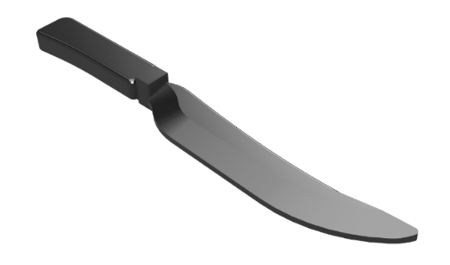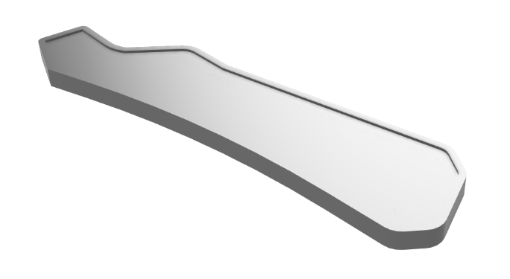

**Figure 1.** Knife 3D modeling.

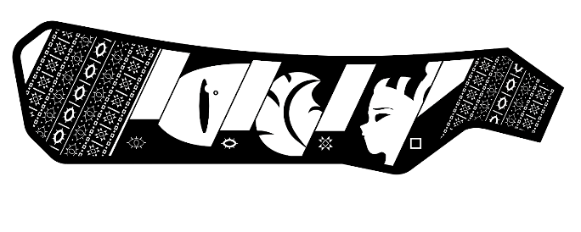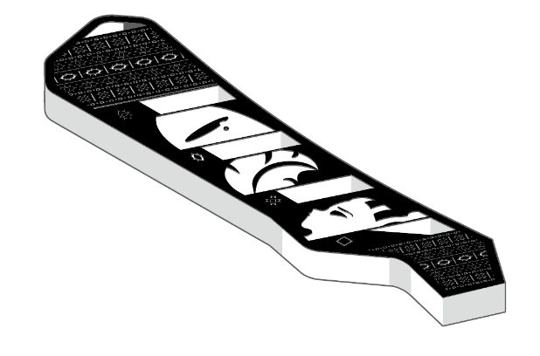

**Figure 2.** Laser engraving design draft and rendering.

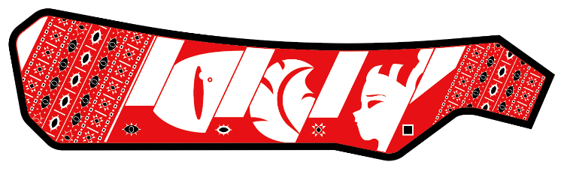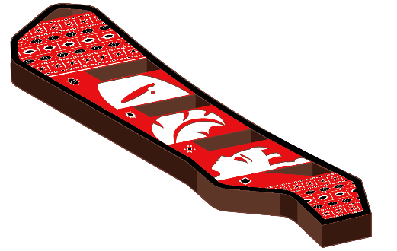

**Figure 3.** Color matching and rendering.

# Conclusion

The theme of this time can show that when props and weapons transform into cultural and creative products through technology, they transform their cultural connotations, incorporate traditional story content, and enhance the value of entertainment. It does not have to be a paper talk. In this research, we engraved the story on the product, constructing cultural and creative products with technology so that the craft can tell itself and convey the story of the tribe. Through this occasion, we would like to thank Fox Artisan's Workshop for providing the workshop venue and the technical support related to mine carving and weapon production. The study uses software modeling software, laser engraving, and other modern technologies to hardware glass fiber and high-density foam and could serve in the vocational technology and educational fields. The appearance and pattern used with advanced artisanship, such as blacksmiths, present the power of technology. Traditional industries focus on designing low energy consumption and recyclable products, so EVA Foam and glass fiber also select the material [11]. At the same time, fortunately, the tool's appearance has not been lost; we can still find the relevant pictures in the related papers and research, and Internet information. Although the practicality of iron knives is more dangerous in terms of cultural heritage, real knives will not disappear with the torrent of history. However, iron knives cannot entertain in education, so the team used general-purpose foam and glass fiber to break through the obstacles. We use the traditional Kaxabu totem on the knife surface and draw the story of Kaxabu on the sheath. Use harder lines to illuminate the sense of traditional artisanship. It expects that this type of foam weapon can shock people's hearts in the future, inherit unique stories and tribal history, and extend its meaning to vocational science and technology education.

# References

1. L. H. Peng, P. S. Chung, and and M. K. Tran Thi, J. Phys.: Conf. Ser. 1700 012102 (2020).
2. L. H. Peng, Y. H. Lin, and I. Siswanto, J. Phys.: Conf. Ser. 1833 012051 (2021).
3. H. C. Huang, “A Study of Kaxabu Phonology,” MS. thesis, National Tsing Hua University, 2016, pp. 2.
4. L. H. Peng and C. Y. Pan, ICEEPSY 2013, 357-364 (2014).
5. Kaxabu Budza sheath, Retrieved from https://catalog.digitalarchives.tw/item/00/5e/3b/67.html Accessed August 22, 2021.
6. Tukuzan, Laiyi-Tribal Culture, and Art Creative Marketing Experience Camp. Retrieved from https://ed.arte.gov.tw/CCDA/page_paiwan.aspx Accessed August 22, 2021.
7. Tao Tribe's Long Knife, National Museum of Taiwan History, Retrieved from https://collections.nmth.gov.tw/CollectionContent.aspx?a=132&rno=2003.012.0005 Accessed August 22, 2021
8. J. W. Jhang, “A Study of Aborigine Knife Craft,” MS. Thesis, National Taiwan University of Arts, New Taipei City, 2011, pp.80-81
9. C. C. Kao, “How Do Players Immerse Themselves in Games? Exploring Social Factors Influence Role-playing in Non-digital Role-playing Games,” MS. Thesis, National Taipei University, Taipei, 2020.
10. Build Your Own Live-Action Role-Play (LARP) Weapons and Equipment With Custom Foam From Foam Factory!, Retrieved from https://www.foambymail.com/blog/build-your-own-live-action-role-play-larp-weapons-and-equipment-with-custom-foam-from-foam-factory /Accessed August 22, 2021
11. S. C. Yang, L. H. Peng and L. C. Hsu, Sustainability 11(24), 6895 (2019)