The Use of Spell Reunion in Technology Education and Digital Design
Li-Hsun Peng ^{1, a}, Cheng-Chu Lin ^{1, b} Ibnu Siswanto,^{2, c}
Author Affiliations
¹ Department of Creative Design, National Yunlin University of Science and Technology. 123, University Road, Section 3, Douliou, Yunlin 64002. (Taiwan)
² Automotive Engineering Education Department, Faculty of Engineering, Universitas Negeri Yogyakarta.
³You would list an author’s second affiliation here.
Author Emails
^{a)} penglh@gemail.yuntech.edu.tw,
^{b)}m11036012@gemail.yuntech.edu.tw
^{c)}ibnusiswanto@uny.ac.id

Abstract. This research is to study the customs of the Chinese society during New Year’s Eve, the "Night Dinner" of the Reunion Encirclement [1]. The study analyzes its colors, shapes, and materials through education, digital design and combines them with traditional customs and culture. The agreed slang and allegory stories summarized the meanings of ten auspicious dishes. To classify and give existing products, from the application of environmentally friendly materials and image analysis, use the scientific classification to classify the meaning of food, then the scientific and technological educational application with the aid of digital drawing design, systematic editing, rearrangement, and combination, both traditional value and technological innovation, to produce aesthetic education, vocational technology value, and distinctive totem designs with the meaning of auspicious dishes.

1. INTRODUCTION

1.1. Motivation
New Year's Eve is a day when the whole family reunites and has the New Year's Eve dinner together in Chinese society; reunion is the most important annual event, called "enclosed furnace" in Taiwanese [2]. In our contemporary society where interpersonal relationships are gradually estranged. In addition, under the influence of COVID-19, passing on the custom of reunion encircling furnaces through technical education and digital design is more important and urgent. This research takes the "New Year's Eve Dinner" of the reunion furnace in Chinese society as the research's starting point. The study finds that design direction and strategy from the existing products, environmentally friendly materials, and image analysis have the development potential. Vocational-technical education and digital design distinguish the story meaning of dishes and present the implicit meanings. The dinner plate design used by more than one person incorporates the cross-border attempts of technology and art design, hoping to create an atmosphere and situation of family reunion.

1.2 Research Purposes
Taiwan's traditional handmade ceramic art has been facing a gradual decline in the process of cultural inheritance. In document research, this study selected ten auspicious dishes for the New Year's reunion after collecting and analyzing through documents analysis. With visual image analysis as the theme, the study aims to eliminate the shackles of traditional shapes and introduce technologically innovative, environmentally friendly materials. This research adopts the interactive education of science and vocational technology education. The purpose is to convey a positive message so that the public can easily understand the meaning of each dish. The design goals of this study are as follows:

1.2.1 Innovative presentation of catering packaging design:
In contemporary society, many families will choose take-out gift boxes for New Year dishes. Therefore, we have researched and designed environmentally friendly packaging boxes that are easy to carry and reuse to replace paper containers (PE coating and beeswax), plastics, and other toxic products. New Year’s Eve is an important issue to educate the consumers to understand in the practical application of science and vocational technology education.

1.2.2 Features both offering sacrifices to the gods and visual enjoyment:
The most abundant dishes will be prepared to honor the ancestors and the gods on New Year's Eve. Ten kinds of meaningful design symbolize perfection [3]. The cultural meaning, the tablecloth design with cultural, creative, and educational characteristics.

1.2.3 The shape and pattern design of the decorated porcelain bowl:
Porcelain bowls are to hold New Year's Eve dishes [3]. Given this, the plate's design is shaped with a round bottom, supplemented by auspicious images aimed at presenting the atmosphere of the New Year and exploring Taiwan’s value simultaneously. Under the development trend of environmental protection technology, the porcelain clay material has been recycled, reused, filtered, and mixed with innovative materials. During the New Year period, the bottom of the porcelain bowl with auspicious patterns meets the people's expectations in traditional culture and has vocational technology’s value.

2. Literature Review
This study summarizes the traditional textual meanings of ten auspicious dishes from the literature collection and analysis method, including the beginning of eating chicken, surplus every year, family reunion, encouraging and safe, rich and blessed, good luck, long life Prosperity in the year, a good harvest of grains, and prosperity of the family are full of positive meanings such as good luck. [3]. [4]. [5].TABLE1. [6]. [7].TABLE2.

TABLE 1. Analysis and Comparison of Perfect Dishes [3] [4] [5].
Titles | Pictures | Features and Common points
chick | 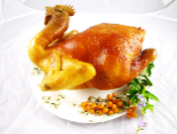 | Eating chicken in New Year dishes means that "starting" New Year dishes must have a chicken on the table.
fish | 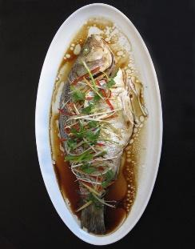 | Fish is an indispensable delicacy in the New Year dishes. The tradition is to ask all dishes should be eaten on that day except the fish, because you have to stay to have a "surplus".
hot pot | 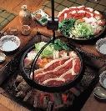 | It means "reunion". When eating hot pot, everyone gathered around the stove.
luck cake | 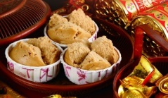 | It looks like a flower, and the word "fa" means "get rich". At the same time, the cracks in the cake are opening, symbolizing more wealth in the coming year.
Steamed stuffed bun | 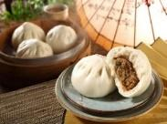 | There are two types of fillings: salty and sweet, which represent "salty gold and sweet silver."
Radish | 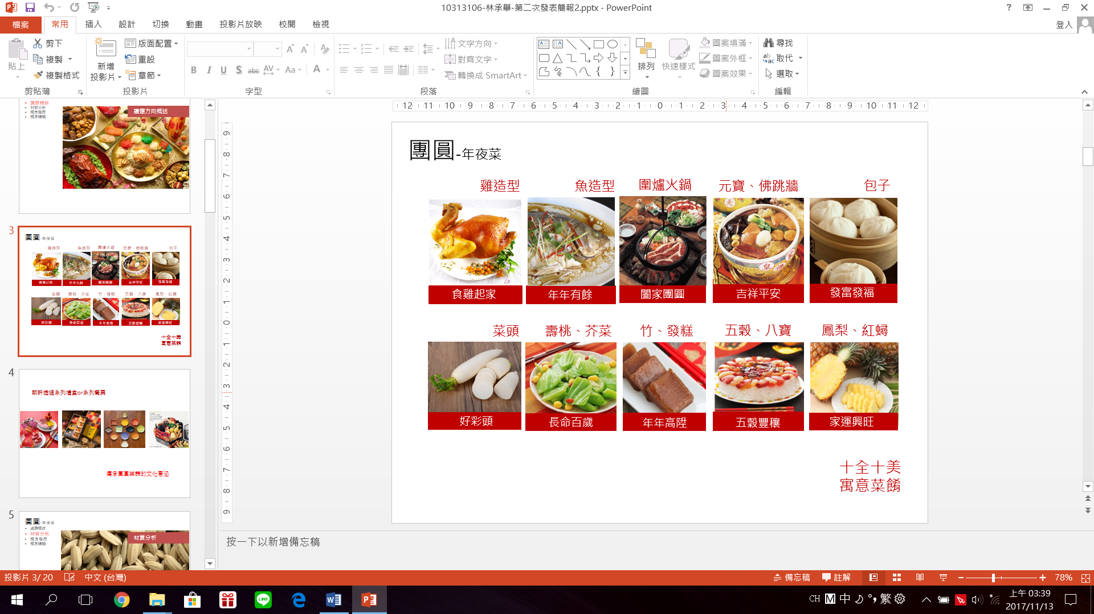 | It is made by mixing radish and steaming rice because "Caitou" stands for "Colorful Fortune.
Long year dishes | 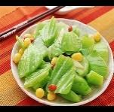 | Originally, the long-term meaning of "long year dishes" refers to the meaning of long-term work. Later, it is also a rare dish to eat once a year during reunion during the Lunar New Year.
Grains | 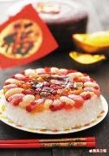 | A good agricultural harvest is a "good year", and the first day of the first month is "year". The word "year" means a good year and a good harvest.
Rice cake | 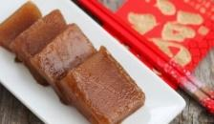 | There are square white and yellow rice cakes, which symbolize gold and silver, and have the auspicious meaning of making a fortune in the new year.
Pineapple | 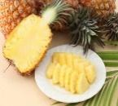 | The pineapple symbolizes good luck and is a symbol of auspiciousness and prosperity.

TABLE 2. Comparative analysis of the materials of existing products on the market [6] [7].
Material | Carton container | Melamine | Pottery bowl | Porcelain
Patterns | 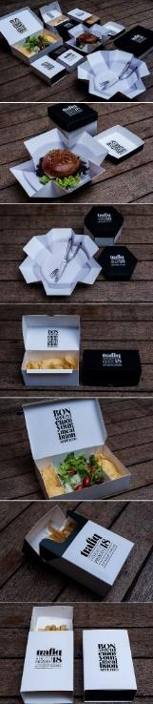 | 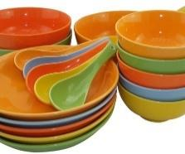 | 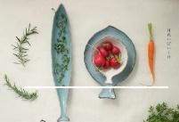 | 
Function | Catering gift box | Dressed dishes | Dressed dishes | Dressed dishes
Advantage | Take away convenient disposable products | Resistant to drop and easy to clean | Beautiful shape and reusable | Beautiful shape, reusable, and easy to use
Disadvantage | There are toxic containers such as PE coating and beeswax in the carton container, which is easy to produce garbage. | Do not install high-temperature hot food, do not microwave. The hotter, the more poisonous | Not easy to store, bulky, and fragile | Not easy to store, bulky, and fragile

3. Research Methods
In the first phase of the literature analysis, the investigation records the origin of the New Year's reunion and dinner story. In the second stage, the New Year reunion imagery summarizes ten kinds of auspicious dishes， which inherits from their cooking methods and vocational technology education significance. In the third stage, analyzed the materials of existing products in the market. After comparing various materials, they retained the advantages, improved the shortcomings, and replaced them with environmentally friendly materials. This research bases on the above four steps to achieve the research, analyze the cost research purpose and present the final product design.

4. Research Analysis

4.1.1 Chowder Box
The packaging box uses the characteristics of wood material, which is breathable, environmentally friendly, reusable, and suitable for vocational-technical education. The structure imitates the appearance of a traditional Chinese temple building. Four-piece modules done technologically. The two sides imitate the characteristic parts of the traditional wooden structure of the temple-the bucket, which is crisscrossed and stacked [8]. Three packaging boxes are stacked and tied with a rope to form a group for easy delivery; the box uses digital mine cutting technology on all sides to depict and record different totems: Such as FIGURE 3.
- The front of the box-educating consumers that reunion is the most important annual activity on New Year's Eve [2]. Over time, it is gradually being forgotten and disappeared. How to prepare New Year dishes?
- Behind the box-depict historical allusions [2] [9-18]. From the Archaean period, Sui and Tang Dynasties, Western Jin, Southern Dynasties, Song Dynasty, to Taiwan-related documents and records.

4.1.2 Sacrificial tablecloth
Before eating the "New Year's Eve Dinner" in the reunion furnace, people who worship the god first, so the design of the tablecloth with inheriting vocational and technological education significances, and innovative craftsmanship: Such as FIGURE 4.
- The color presents in auspicious red for the New Year.
- The tablecloth size is 100x100 cm based on the turntable diameter in the middle of the traditional household table, which is 70~90 cm.
- Ten trays place in corresponding seats with the tablecloths, and the dishes totems are presented in a hand-painted style.

4.1.3 Science, technology, and environmental protection back to porcelain
After comparing and analyzing the materials of existing products on the market according to Table2, they can divide into two types: family and catering. In this study, the concept of a catering box plus household tableware set is combined: Such as FIGURE 5.
- The shape combines with the shape features of ten representative foods, and the shapes on both sides extend to allow users to prevent scalding and be easy to handle. The encouraging words
- Corresponding to each representative engrave on the bottom of the plate. The product base on a round bottom. After use, it is easy to clean, store, and stack without taking up space.
- The use of technologically environmentally-friendly recycled and reused porcelain clay mixes to solve the health concerns that paper containers and melamine are likely to produce drugs and improve the weight of general traditional pottery.
- The product size needs a larger capacity of 20x20cm in the shape of a hot pot, and the rest design in 18x18cm, which does not exceed the size of the table.
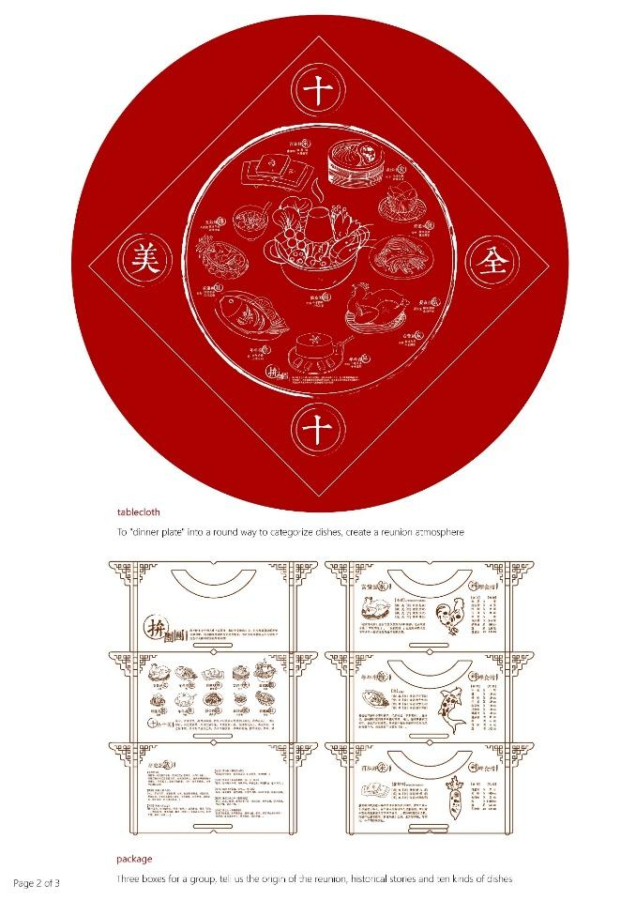 |  | 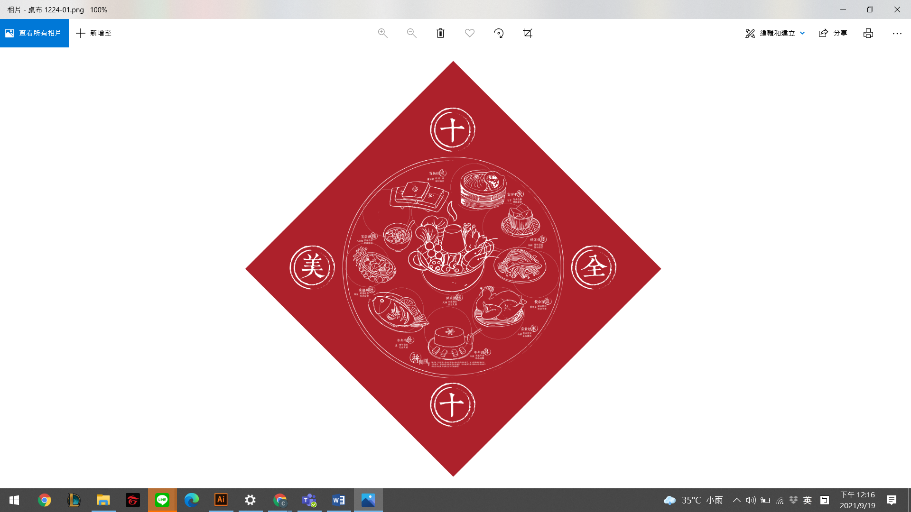
Figure 3. Catering box design |  | Figure 4. Sacrificial tablecloth
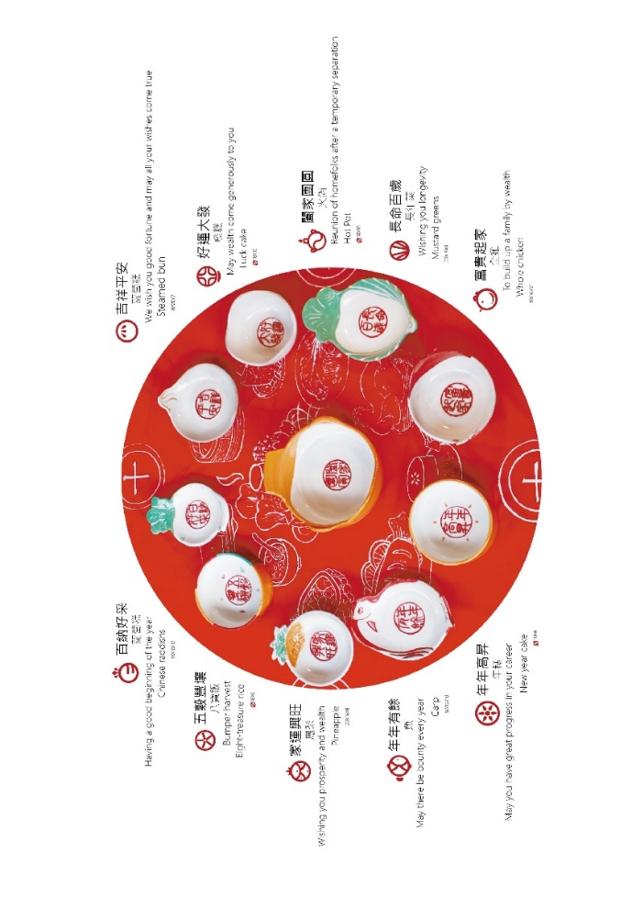
Figure 5. Science and technology environmental protection porcelain design

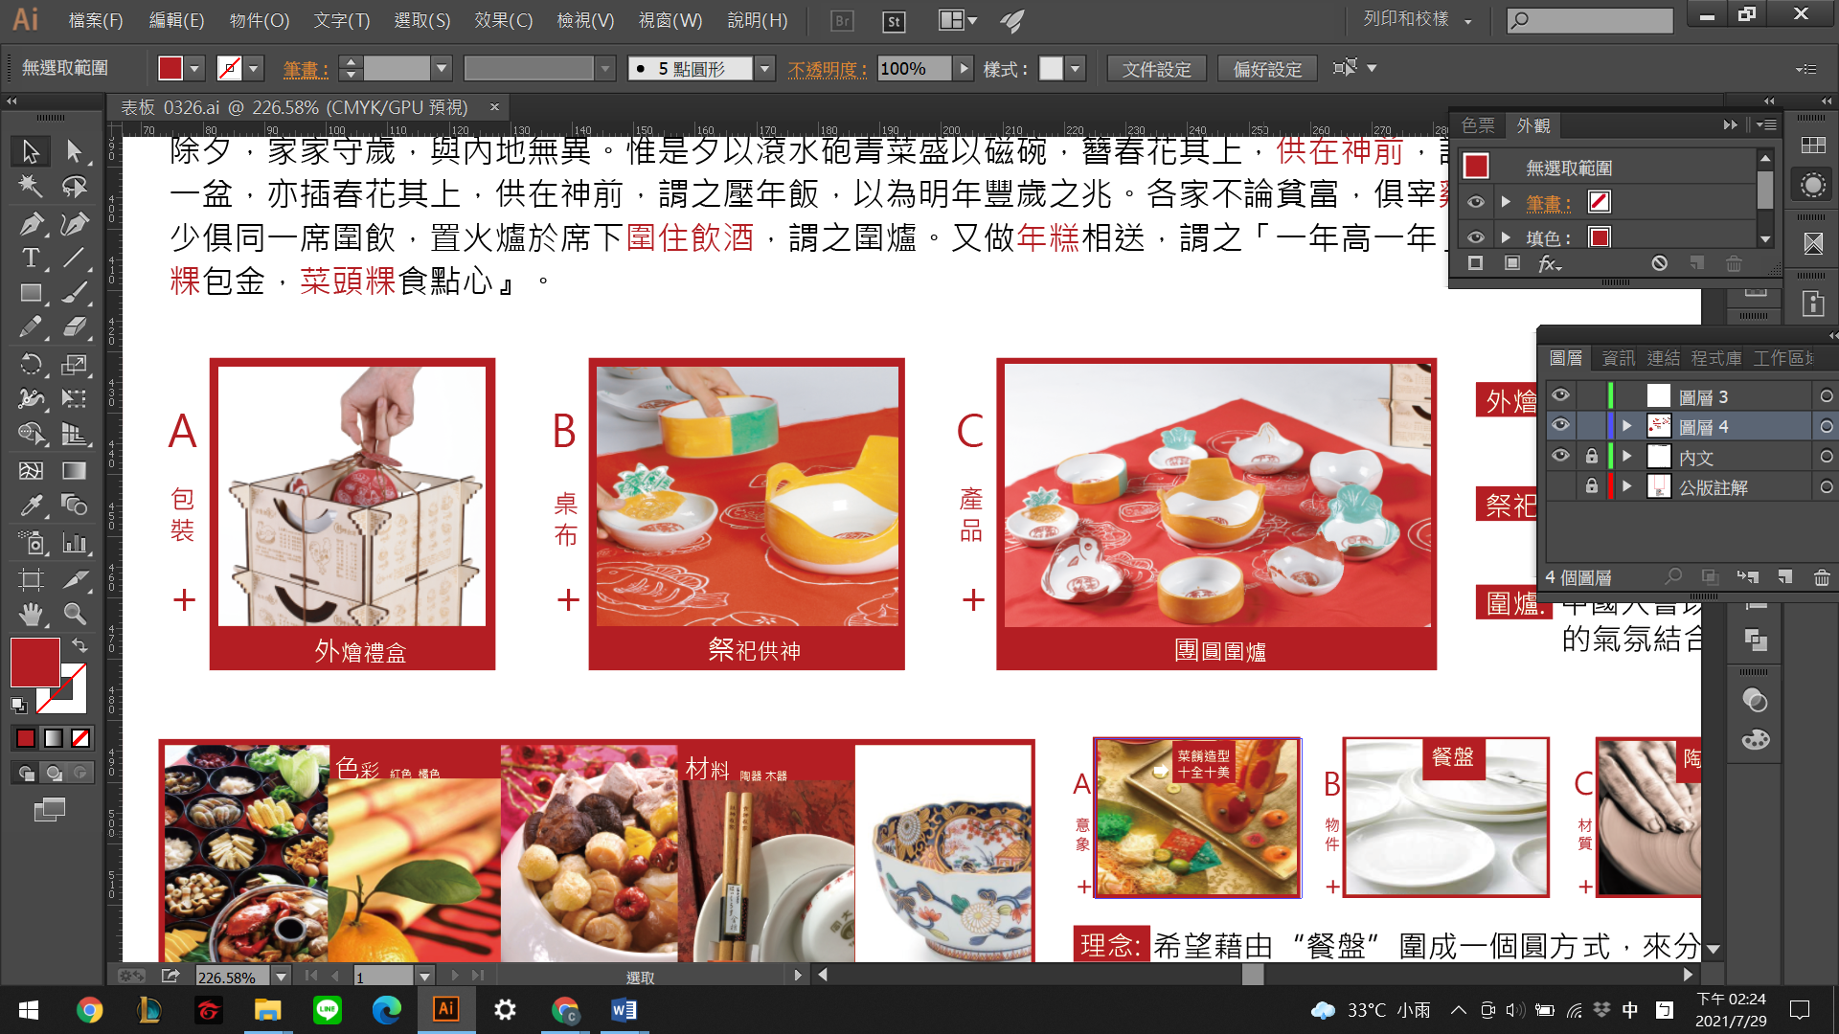
Figure 6. Chowder | Figure 7. Sacrifice |  | Figure 8. Reunion Dinner Plate

5. Conclusion
After literature analysis and investigation, the research and analysis results found improved utensils' material and characteristics through scientific, technological education, and digital design. The study summarized the New Year reunion dinner story records and the New Year reunion image. The ten kinds of auspicious dishes have a different meanings. (Figure 6. and Figure 7.) Computer graphics are used on the wooden boxes of the packaging to assist the design and planning, after analyzing and comparing the current product materials, retaining the advantages, and improving the disadvantages. Recycled porcelain clay with environmental protection and technological characteristics is mixed with some new clay to replace the traditional form of pottery production, to create non-toxic materials, and reduce the weight of the finished product based on environmental requirements and forms suitable for vocational and technological education use. Figure 8.

6. References
- Z. M. Chen, Taiwanese folk songs folk proverbs and culture (2019)
- M. X. Lin, Talking about Taiwan's New Year Customs from the Legend of "Sinking Land", "Taiwan Studies Newsletter", National Published by the Central Library Taiwan Branch, Issue 24 (2009)
- T. X. Lai, 2010 the meaning of the origin of the New Year dishes Retrieved from https://blog.xuite.net/tina20130 526/twblog/113152376 Accessed August 22, 2021
- T. Y. Zhang, P. X. Huang and M. C. Huang, reunion to celebrate the New Year-Discussing the marketing of New Year dishes, National North Mennong Engineering Research Report (2015)
- X. E. Li, Taiwan Folklore Festival: The folklore meaning and sacrificial culture of seasonal customs, Taichung City (2004)
- L. H. Peng, A. Y. Lin, and Indarti, Design of seed paper coaster for sustainable engineering and environmental education in kaxabu niumian community, J. Phys.: Conf. Ser. 1700 012088 (2020)
- S. C. Yang, L. H. Peng and L. C. Hsu, The Influence of Teacup Shape on the Cognitive Perception of Tea, and the Sustainability Value of the Aesthetic and Practical Design of a Teacup. Sustainability, 11 (2019)
- Shenlu Enterprise Co., Ltd., common decoration and configuration of temples Retrieved from https://www.
shenlu.com.tw/news_detail/59.htm Accessed August 22, 2021
- Y. H. Jiang, Happy Chinese New Year, Taiwan Monthly Bimonthly newsletter (2008)
- K. Z. Li, Have a Happy Song Dynasty New Year, Times Culture, Taipei City (2016)
- S. Z. Wang, National Festivals and Customs, Starlight, Taipei City (1991)
- C. Z. Zhang, Spring Festival Story, Taipei City (2012)
- Z. Zhuan, Han river’s Chaolu "Inner Chapter Xiaoyaoyou"
- B. Zong, (Lian Dynasty) G. Du, Jingchu Suishiji, (Secret Book of Bao Yan Tang), "Rite • Nei Ze"
- Y. Meng, (Western Jin Dynasty), "Tokyo Dream Hualu. Volume One. Lunar New Year's eve."
- L. Gou, (Western Jin Dynasty), "Qing Jia Lu. Volume twelve. New Year's Eve Dinner
- Z. Jiang, Z. Gao Z. Zhou, Z, Liu Z. Fan and Z. Yu, "Taiwan House Chronicles" (1964)
- Taiwan Historical Committee, The Chronicles of Taiwan in the Qing Dynasty Volume 7 (2004)

