Strategic Planning of Renewable Energy Utilization in Manokwari to Support West Papua as a Conservation Province

Lion Ferdinand Marini1,a, Bambang Syairudin2,b

1)Electrical Engineering Department, University of Papua, West Papua, Indonesia  
2)Magister Management Technology Department, Institut Teknologi Sepuluh Nopember Surabaya. Indonesia

a) l.marini@unipa.ac.idb) [bambangsyairudin@gmail.com](mailto:bambangsyairudin@gmail.com)

**Abstract.** Based on the Government Regulation number 79/2014 on the National Energy Policy about realization of the use of renewable energy in the national energy mix is ​​targeted to reach at least 23% by 2025. To fulfill the government's target, good renewable energy strategy plan from each region is required. In this research, the forecasting of electrical needs and strategic planning in Manokwari focusing on energy sources derived from solar or sunlight and hydro. This research used time series analysis and linear regression to forecast electricity needs is around 405 Giga Watt (GW) until 2025 with an average increase of electricity load per year from 2018 is 0.07%, therefore the target of renewable energy in 2025 in Manokwari is 93 GW. Strategic planning is made through SWOT analysis on the utilization of Solar Power Plant and Micro hydro Power Plant by weighted to get score using AHP (Analytic Hierarchy Process) method. The scoring results (6.94; 7.18) where SWOT quadrant charts enter the strength-opportunity strategy (SO) quadrant, which prioritizing the studies on renewable energy based on potential energy sources in the region and monitoring budget usage for renewable energy utilization which is contained in the RPJMD and APBD in Manokwari Regency.

# INTRODUCTION

Utilization of renewable energy in the world very rapidly lately, given the global issue of global warming makes almost all countries vying to develop renewable energy based on energy potential in each country. Indonesia is one of the countries committed to the development of renewable energy. Referring to National Energy Policy contained in Government Regulation No.79/ 2014 [1], the realization of the use of renewable energy in the national energy mix is targeted to reach at least 23% by 2025 and 31.2% by 2050. General Plan National Energy is a derivative of national energy policy which has been established by Presidential Decree no. 22/2017 [2].

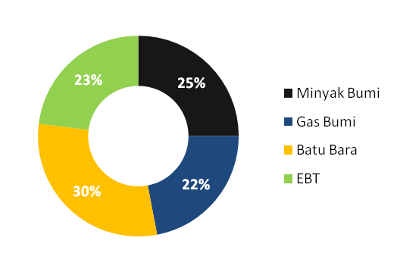

**FIGURE 1**. National Energy Mix 2025

As the capital city of West Papua Province, the progress of Manokwari city quite rapidly along with the development of office infrastructure, ports, government buildings including housing and business areas. Manokwari Regency has great renewable energy potential. Topographically Manokwari is surrounded by hills and rivers and also the location close to the equator line. This research only focuses on renewable energy potential that sourced from water and solar, because the technology that related to those energy sources has developed rapidly in the world, and it has been specially applied recent years in Manokwari. Therefore, it is deemed necessary to have strategic energy planning in Manokwari Regency 2018-2025 and more exploration of renewable energy from water (microhydro) and solar (solar power plant).

## Population and Economic

Based on data from BPS Manokwari the population increased from year to year. The number of population in 2010 amounted to 139,860 increased to 160,258 (2015), 164,586 (2016) and 169,639 (2017). The number of unemployed 3,507 people (3.45%) in 2013 and increased in 2016 to 4,837 people (6.58%). The economic growth of Gross Regional Domestic Product (GRDP) of Manokwari at current prices in the period 2010-2016 shows the trend continues to increase in line with the improving economic conditions. In 2011 the Sectoral GDP of Manokwari was Rp 4.6 billion, 2012 (Rp 4,7 billion), 2013 (Rp 5,4 billion), 2014 (Rp 6,3 billion), 2015 (Rp 6,9 billion) and 2016 (Rp 7,6 billion).

(a) (b)

**FIGURE 2**. (a) Population 2010-2017; (b) GRDP 2010-2017 (Billion Rupiah)

Source: BPS Manokwari, 2017 [3]

## Electricity in Manokwari

Electricity in Manokwari is still dependent on diesel power plant. However, in recent years alternative energy sourced from solar and water has been used gradually from two centralized Solar Power Plant and a Micro Hydro Power Plant. The capacity of Arfai solar plant has 1 megawatt (MW), Bumi Marina solar plant has 2 MW and Prafi Micro Hydro has 2.5 MW. Although the use of alternative energy in manokwari has not been optimal but this is a good start for the renewable energy development in considering the electricity demand increases every year. In 2007 the peak load was 9 MW and then became 31 MW in 2017 with 48 MW engine power installed and 37 MW engine capabilities.

## Renewable Energy Potential

a. Solar Energy Potential

Manokwari is located in the northern island of Papua. It is indirectly close to the equator so the sunlight intensity relatively stable everyday. The average solar light potential in the manokwari can reach 5.4 KWh/m2/day[4]. In Manokwari there have been several centralized Solar Power Plants (PLTS) which have been operating from 2014. Until 2018 there are only 3 centralized Solar Power Plants spread in several places, namely PLTS Mansinam (50 Kw), PLTS Arfai (1 MW) and PLTS Bumi Marina (2 MW).

b. Hydro Energy Potential

Topographically Manokwari has a hilly area so that the potential of water energy is very large that is by utilizing ground elevation, irrigation channel or waterfall. There are 7 big rivers that flow even in the dry season. Has a great potential but until today only one Micro Hydro Power Plant, the Prafi Micro hydro which operated since 5 November 2015. If those rivers can be utilized properly, it will be great for help reduce the use of unfriendly oil fuel.

# METHODOLOGY

## Forecasting methods

Forecasting methods are grouped into 2 (two) main categories: (a). Quantitative methods. Some quantitative forecasting techniques: moving average method, exponential smoothing method, winter method, Box-Jenkins method and regression analysis and time series analysis; (b). Qualitative methods (qualitative techniques or judgment forecasting). Expert opinions and forecasts are used as a basis for determining future demand.

Forecasting techniques that will be used in this study is divided into 2 stages; First stage predicted using time series analysis by looking at past data patterns. After all the forecasting data is resumed in the second stage the forecasting data is reordered with the population and GRDP that serves as the independent variable that affects the electricity needs each year.

An example of a mathematical model form which assumes a definite or deterministic relationship between two variables:

|  |  |
| --- | --- |
| **Yt = b1 + b2X** | (1) |

Whereas:

*Yt* = dependen variable

b1 = linear function parameter

b2 = linear function parameter

X= independent variable

* 1. *Planning And Management Strategic*

This chapter will discuss about the definition of the strategy management, strategic planning and renewable energy. Definition of Strategic management by Fred R. David [5] is art and science of formulating, implementing, and evaluating cross-functional decisions that enable an organization to achieve its objectives. It is to achieve and maintain competitive advantage, strategic management synonymous with strategic planning. Strategic planning only focused on formulation strategy, looking for internal and external analysis, creating long term objective, making alternative strategic and choosing the best strategy for implementation. Position on Strategic planning is on top management, so it means this function for making decision for a better organization or business.

## Analytical Hierarchy Process (AHP)

The AHP methods approach by developed from measurement theory related to quantitative non-quantitative (tangible/intangible) decision. It was developed by Thomas Saaty [6] to support decision-making problems with multiple criteria. Amongst the existing methods, the analytic hierarchy process (AHP), is possibly the most well known and used in criteria for decision models containing conflict resolution.

The principle of this approach seeks to accommodate the cognitive, subjective and subjective aspects of knowledge. The AHP principle begins by decomposing complex decision problems and then classifying the subject matter into matrix elements (decisions) in pairs within a given hierarchy. At the same hierarchical level, these elements can be compared (pairwise comparison) by incorporating considerations of qualitative and quantitative factors.

# RESULTS

## Forecasting Electricity Needs

The forecasting process is done in two stages. First all the data needs of electricity and electricity users are plotted to see past graphs of data patterns for later forecast based on time series. Graphs obtained from the total electrical load and the number of electrical users based on past data form a trend pattern as it increases annually, with an average annual increase of 0.11% for electrical load and 0.12% for the number of electric users [7].

(a) (b)

**FIGURE 3**. Data Pattern of Electricity Expenses and Electricity Users 2013-2017

After the pattern of past data is found, data is forecasted until 2025 using trend analysis on Minitab 17 software. The obtained data then regreated into population and GRDP. The results are written below:

|  |  |  |  |  |  |  |  |
| --- | --- | --- | --- | --- | --- | --- | --- |
| **TABLE 1.** Forecasting Electrical Needs Result (KWh) in Manokwari 2018-2025 | | | | | | | |
| No | Year | Household | Business | Public | Industry | Social |
| 1 | 2018 | 159,399,614 | 64,770,484 | 24,287,856 | 2,881,597 | 11,016,444 |
| 2 | 2019 | 173,383,958 | 68,101,424 | 26,648,277 | 3,417,634 | 11,773,663 |
| 3 | 2020 | 187,368,302 | 71,432,364 | 29,008,699 | 3,953,672 | 12,530,883 |
| 4 | 2021 | 201,352,646 | 74,763,303 | 31,369,121 | 4,489,710 | 13,288,102 |
| 5 | 2022 | 215,336,990 | 78,094,243 | 33,729,542 | 5,025,747 | 14,045,321 |
| 6 | 2023 | 229,321,334 | 81,425,182 | 36,089,964 | 5,561,785 | 14,802,541 |
| 7 | 2024 | 243,305,678 | 84,756,122 | 38,450,386 | 6,097,822 | 15,559,760 |
| 8 | 2025 | 257,290,022 | 88,087,062 | 40,810,807 | 6,633,860 | 16,316,980 |

**TABLE 2**. Forecasting Electricity Users in Manokwari 2018-2025

|  |  |  |  |  |  |  |
| --- | --- | --- | --- | --- | --- | --- |
| No | Year | Household | Business | Public | Industry | Social |
| 1 | 2018 | 109,034 | 12,010 | 1,987 | 12 | 3,210 |
| 2 | 2019 | 119,357 | 12,492 | 2,220 | 14 | 3,127 |
| 3 | 2020 | 129,679 | 12,974 | 2,452 | 15 | 3,044 |
| 4 | 2021 | 140,002 | 13,456 | 2,685 | 17 | 2,961 |
| 5 | 2022 | 150,324 | 13,938 | 2,917 | 18 | 2,879 |
| 6 | 2023 | 160,647 | 14,420 | 3,150 | 19 | 2,796 |
| 7 | 2024 | 170,969 | 14,902 | 3,382 | 21 | 2,713 |
| 8 | 2025 | 181,292 | 15,383 | 3,615 | 22 | 2,630 |

Based on PLN electrical data, in the last five years total electricity consumption in Manokwari until the end of 2017 is 240 GigaWatt (GW) with 114,501 numbers of users from the five sectors. There are household sector, business sector, public sector, industry sector and social sector. While forecasting electricity consumption in all sectors in Manokwari from 2017 to 2025 is estimated to increase to 405 GW with 198.693 number of users and an average increase of electricity burden 0,07% per year.

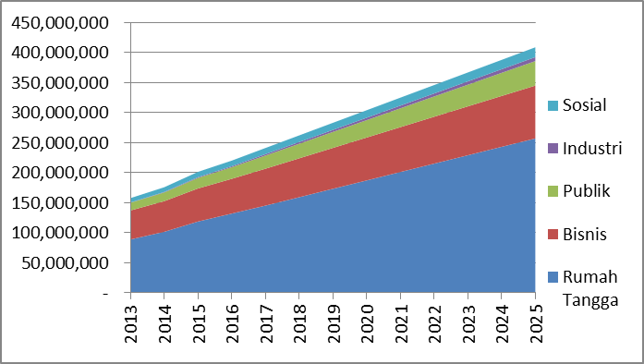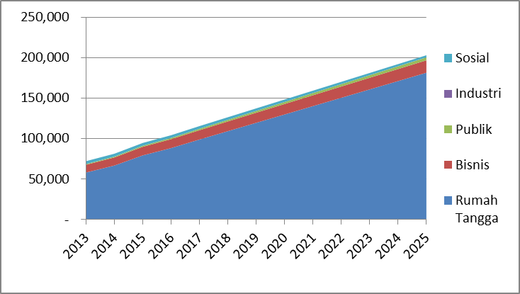

(a) (b)

**FIGURE 4**. Profile of Users (a) dan Electricity Needs (b) in Manokwari Regency 2013-2017 and the Forecasting 2018-2025

## Formulating Strategy Plan Renewable energy in Manokwari

Strategy formulation uses SWOT analysis, covering three important stages. There are input stage, matching stage and decision stage [8]. Input stage is obtained through discussion with experts and academics in electro, energy and planning. Phase matching and decision phase using SWOT matrix and AHP method with the help of MiniTab Software.

**TABLE 3.** SWOT Analysis Matrix

|  |  |  |
| --- | --- | --- |
| **Strategic Planning of Renewable Energy Utilization in Manokwari to Support West Papua as a Conservation Province** | **STRENGHTS (S)**   1. Special Autonomy Law in Papua 2. Supportive local Univeristy 3. RE development is included in the RPJMD as one of the priority program plans. 4. Solar Panel and mycrohidro have been used in recent years. 5. Source of ET is abundant and free. | **WEAKNESSES (W)**   1. Customary communal land rights 2. Local governments have not been able to maximize local universities. 3. Lack of regional infrastructure. 4. Lack of regional information on ET. 5. Inadequate human resources. 6. Diesel power plant has not been able to meet electricity demand. 7. Unequal distribution of human population. |
| **OPPRTUNITIES(O)**   1. Government Regulation No.79/2014 on National Energy Policy. 2. The Ministry of Energy and Mineral Resources is aggressively building RE-based power plants. 3. RE technology is developing rapidly today. 4. Eco-friendly. | **STRATEGY SO**   1. Prioritize the studies on renewable energy based on potential energy sources in the region. (S2, S3, S4, S5, O1, O2, O4) 2. Monitoring the use of budgets for renewable energy development contained in the RPJMD and APBD. (S1, S3, S4, O1, O2, O4) | **STRATEGY WO**   1. To socialize the use of renewable energy as an alternative energy by utilizing environmentally friendly energy sources.(W1, W2, W4, W5, O1, O2, O3, O4) |
| **THREATS (T)**   1. RE technology being developed is still expensive. 2. High level of migration 3. Sudden change of RE policy 4. Security. | **STRATEGY ST**   1. Conducting training for vocational schools in the field of renewable energy. (S2, O1) 2. Optimizing the role of regional-owned enterprise as managers and supervisors of power plants sourced from renewable energy. (S1,S3, S4, O1, O4) | **STRATEGY WT**   1. Create a pilot project "Kampung Mandiri Energi" by involving local universities. (W1, W2, W3, W4, W6, O1, O4) 2. Enhance socialization of eco-friendly renewable energy. (W2, W4, O1, O3, O4) |

The weighting results presented are the average results of four resource persons who are experts in their respective fields, namely from the Development Planning Agency at Sub-National Level of West Papua Province (R1), the West Papua Energy and Mineral Resources (R2), State Electricity Enterprise Manokwari Area (R3) and academics from the Department of Electrical Engineering, University of Papua (R4).

**TABLE** **4**. Ranking and Weighting from Respondents

|  |  |  |  |  |  |  |  |  |  |
| --- | --- | --- | --- | --- | --- | --- | --- | --- | --- |
| Internal Factors | Attribute | R 1 | | R 2 | | R 3 | | R 4 | |
|  |  | Rank | Weight | Rank | Weight | Rank | Weight | Rank | Weight |
| Strengths | (S1) | 4 | 0,111 | 1 | 0,058 | 4 | 0,174 | 1 | 0,039 |
| (S2) | 5 | 0,138 | 2 | 0,071 | 3 | 0,236 | 2 | 0,553 |
| (S3) | 5 | 0,28 | 5 | 0,315 | 2 | 0,464 | 3 | 0,133 |
| (S4) | 5 | 0,288 | 5 | 0,243 | 4 | 0,082 | 2 | 0,082 |
| (S5) | 5 | 0,184 | 5 | 0,315 | 5 | 0,044 | 3 | 0,192 |
| Weaknesses | (W1) | 3 | 0,11 | 4 | 0,097 | 4 | 0,174 | 5 | 0,435 |
| (W2) | 5 | 0,213 | 1 | 0,032 | 3 | 0,236 | 4 | 0,077 |
| (W3) | 3 | 0,147 | 2 | 0,123 | 2 | 0,464 | 4 | 0,1 |
| (W4) | 4 | 0,175 | 2 | 0,135 | 4 | 0,082 | 3 | 0,072 |
| (W5) | 4 | 0,122 | 3 | 0,283 | 5 | 0,044 | 2 | 0,078 |
| (W6) | 2 | 0,122 | 4 | 0,209 | 4 | 0,174 | 2 | 0,2 |
| (W7 | 3 | 0,111 | 5 | 0,121 | 3 | 0,236 | 1 | 0,039 |
| External Factors | Attribute |  |  |  |  |  |  |  |  |
| Opportunities | (O1) | 5 | 0,383 | 5 | 0,365 | 5 | 0,057 | 4 | 0,385 |
| (O2) | 5 | 0,203 | 4 | 0,264 | 4 | 0,241 | 5 | 0,28 |
| (O3) | 5 | 0,086 | 4 | 0,08 | 3 | 0,268 | 4 | 0,197 |
| (O4) | 5 | 0,328 | 4 | 0,292 | 2 | 0,198 | 5 | 0,138 |
| Threats | (T1) | 4 | 0,098 | 2 | 0,161 | 2 | 0,125 | 5 | 0,436 |
| (T2) | 4 | 0,243 | 1 | 0,058 | 5 | 0,078 | 1 | 0,153 |
| (T3) | 4 | 0,064 | 1 | 0,499 | 4 | 0,033 | 2 | 0,199 |
| (T4) | 3 | 0,595 | 2 | 0,282 | 5 | 0,057 | 4 | 0,212 |

**TABLE 5**. Average Score Results

|  |  |  |  |
| --- | --- | --- | --- |
| Internal Factors | No | Attribute | Score |
| Strengths | 1 | Special Autonomy Law in Papua (S1) | 0,3095 |
| 2 | Supportive local Univeristy (S2) | 0,6614 |
| 3 | RE development is included in the RPJMD as one of the priority program plans. (S3) | 1,0746 |
| 4 | Solar Panel and mycrohidro have been used in recent years. (S4) | 0,7858 |
| 5 | Source of ET is abundant and free. (S5) | 0,8219 |
| Weaknesses | 1 | Customary communal land rights (W1) | 0,7946 |
| 2 | Local governments have not been able to maximize local universities. (W2) | 0,592 |
| 3 | Lack of regional infrastructure. (W3) | 0,4725 |
| 4 | Lack of regional information on ET. (W4) | 0,3958 |
| 5 | Inadequate human resources. (W5) | 0,4353 |
| 6 | Diesel power plant has not been able to meet electricity demand. (W6) | 0,4664 |
| 7 | Unequal distribution of human population. (W7 | 0,2777 |
|  | Total Score Strength-weakness | | **7,0876** |
| External Factors | No | Attribute |  |
| Opportunities | 1 | Government Regulation No.79/2014 on National Energy Policy. (O1) | 1,5813 |
| 2 | The Ministry of Energy and Mineral Resources is aggressively building RE-based power plants. (O2) | 1,0871 |
| 3 | RE technology is developing rapidly today. (03 | 0,6197 |
| 4 | Eco-friendly. (04 | 0,9127 |
| Threats | 1 | RE technology being developed is still expensive. (T1) | 0,7543 |
| 2 | High level of migration(T2) | 0,4723 |
| 3 | Sudden change of RE policy (T3) | 0,5868 |
| 4 | Security. (T4) | 0,8456 |
|  | Total Score Opportunity Threat | | **6,8598** |

After the weight of each element is obtained then the weight will be multiplied by the rating to get a score for each element. From the last table, Table 4.7 is the result of the average score of each questionnaire from the experts. The value obtained for internal factors (Strength-Weakness) is 7.087 and the value for external factors (Opportunities-Threats) is 6,859. This value will be entered into the quadrant of the SWOT matrix to see which strategy will be the priority of the four (4) strategy formulations.

# CONSLUSION

Based on the results of the research, it is concluded that Forecasting the needs of electricity and electricity users based on statistical methods using data Growth of population and growth of GRDP value. Forecasting electricity consumption in all sectors in Manokwari District from 2017 to 2025 is expected to increase to 405 GW with an average increase of 0.07% per year. Forecasting electricity consumption in all sectors in Manokwari District from 2017 to 2025 is estimated to increase to 198,693 with an average increase of 0.08% per year. SWOT Analysis offers a future renewable energy development formula that includes the main strategies using the main forces to take advantage of opportunities (SO) and other alternative strategies.

My advance for this research, only focuses on renewable energy sourced from water and solar/sunshine, therefore it is expected that further research can discuss about the potential of other sources. Renewable energy data is still very limited because it was only used in 2014 in Manokwari, so the forecasting result has a high bias/error rate then it is expected that the next research can maximize the forecasting of electrical energy needs from renewable energy with more past data.

# REFERENCES

1. Presiden Republik Indonesia. 1989, Peraturan Pemerintah Republik Indonesia No 79 Tahun 2014 Tentang Kebijakan Energi Nasional, Jakarta.
2. Presiden Republik Indonesia. 2006, Peraturan Presiden No 22 Tahun 2017 Tentang Rencana Umum Energi Nasional, Jakarta.
3. Badan Pusat Statistik Manokwari dan Bappeda Manokwari. 2012, 2013, 2014, 2015, 2016 Manokwari Dalam Angka.
4. Mantoro, Ari. 2017. Prediksi Konsumsi Listrik 2016-2035 dan Rencana Pemenuhan Energi Listrik Berbasis Energi Baru Terbarukan di Kabupaten Manokwari. Tesis, Universitas Gajah Mada.
5. David, Fred, R. 2011. Strategic Management Concept and Cases, 13th Edition, Francis Marion University, South Caroline. United States.
6. Saaty, TL. The Analytic Hierarquic Process. New York: McGraw Hill; 1980.
7. Annual Report PLN X Area Manokwari. 2017.
8. Leonardo Budi Hasiholan, Dheasey Amboningtyas. Role of SWOT Analysis in Improving Competitiveness in Sambal Special Stall (SS). Jurnal Mantik. Volume 4, Number 4, Feb 2021, pp. 2436-244