Teachers Professional Identity in Vocational Education: A Review of Literature

Muhammad Nurtanto1, a) Putu Sudira2, b) Herminarto Sofyan3, c) Nur Kholifah4, d) and Pardjono5, e)

Author Affiliations

1Department of Mechanical Engineering Education, Universitas Sultan Ageng Tirtayasa, Banten, Indonesia

2Departmenet of Postgraduate Program, Yogyakarta State University, Yogyakarta, Indonesia

3Departmenet of Postgraduate Program, Yogyakarta State University, Yogyakarta, Indonesia

4Department of Clothing and Food Engineering, Yogyakarta State University, Indonesia

5Departmenet of Postgraduate Program, Yogyakarta State University, Yogyakarta, Indonesia

a) Corresponding author: [mnurtanto23@untirta.ac.id](mailto:mnurtanto23@untirta.ac.id)   
b) [putupanji@uny.ac.id](mailto:putupanji@uny.ac.id)

c) [hermin@uny.ac.id](mailto:hermin@uny.ac.id)

d) [nur.kholifah@uny.ac.id](mailto:nur.kholifah@uny.ac.id)

e) [pardjono@uny.ac.id](mailto:pardjono@uny.ac.id)

**Abstract.** The identity of vocational teachers is the main study in the development of teacher careers and acts in a professional manner that is oriented to the achievement of graduate competencies and graduates' recognition of the world of work. There are still very limited literature studies that focus on the identity of vocational teachers, most of which describe the identity of teachers in general, while vocational teachers have different functions and roles. Thus, the identity of vocational teachers is important to study and explore based on the findings that researchers have revealed and support the performance of future vocational teachers. Thirty-five research articles were analyzed to identify the professional identities of vocational teachers in the last decade which were reconstructed into their professional identities. Thus, this construction contributes to decision-making on the acceptance of new teachers, professionals, awards, or evaluating the status of teachers to be more stable in various changes and future challenges. The findings show that professional identity consists of seven components, namely a commitment to teaching, motivation to become a teacher, self-efficacy beliefs, job satisfaction, and sense of responsibility and orientation or competency in practical work. The commitment attributes are a priority aspect that is widely discussed and affects the career path of future teachers.

# INTRODUCTION

Teachers of vocational have a different role from general teachers. In a general context, the teacher's role is to guide, teach, and support student activities, as well as being involved in the administrative evaluation and even curriculum development, [1]. However, the context of vocational teachers has a specific goal, namely how the quality of graduates and how graduates are accepted and work in an industrial environment. So, the teacher has an important meaning in the survival of students and the determinants of the future [2]. Given the importance of the role, meaning, and significance of SMK teachers in the last few decades, very few have been adapted and become standard references in the teacher career system.

Various cases in developing countries, such as Indonesia, related to vocational teachers include low educational qualifications, low-income levels, low subject, and pedagogical relevant competencies, low teaching motivation and commitment, and less than an optimal certification or professional recognition [3], loss of teaching commitment, professional orientation, task orientation and self-efficacy [4], even limited teaching skills [5]. The root of this phenomenon is the ability to apply the professional identity of teachers as a standard for acceptance and development of teacher career paths.

Focus on the quality of vocational teachers or vocational teachers who are good, professional, manifested in the concept of teacher identity. Various perspectives describe identity as a self-concept that is influenced by several factors, including individual, social, cultural, and even previous backgrounds, current experiences, and future views, [6]. The identity of the teacher formed in zoning is strengthened as there is interaction from within and from outside or called social relations. However, the identity of the teacher will seem slow or not change if the interaction is limited or internal factors limit themselves and choose to be safe, [7]. Generally, this occurs when there is no control from the management system in work punishment. So, the identity of a vocational teacher has a point of view from the concept of self-behavior, social relations, orientation to community and professional organizations, teaching skills that focus on nothing but the formation of student competencies. The interaction between individuals, social strengthens professional skills and the interaction of the three aspects strengthens pedagogical competence.

In this review, the tensions that exist in vocational education can be overcome by identifying the aspects or components that make up the identity, work area, and experience of teachers. Thus, this study aims to show what influences teacher performance in improving the quality of learning in vocational education. Thus, research becomes the basis for the acceptance of new teachers and the development of professional programs in vocational education. The results of the review allow future researchers to understand complex professional identities and stabilize the status of future teachers. The research objective is (RQ1) What are the professional identities of teachers in vocational education? (RQ2) How is the work area related to the teacher's previous experience? and (RQ3) How are the relationships formed from the constructs found?

# THE REVIEW METHOD

This study is a Systematic Literature Review or SLR which refers to Kitchenham, (2007) [8], with the aim of completing studies based on certain research questions through data sets in the form of research literature used. Its primary purpose is to collect, summarize, and evaluate evidence about a predefined research arena. The main reason is to find gaps in the study and recommend future research, so that understanding of the phenomenon currently being studied is more focused [9]. The guidelines used in the SLR follow Kitchenham and Charters, with three phases including planning, implementation, and reporting. Systematically the sub-elements of each stage are (1) identifying questions; (2) formulating a protocol; (3) identifying inclusion and exclusion criteria (4) review selection procedures and strategies; (5) study quality assessment; and (6) data extraction and evidence synthesis tailored to the research question.

## Journal Research Methodology

A systematic review using the search tools from several electronic databases and search engines for scientific literature, including “Open Knowledge Maps”; “Publish or Perish” tool; and ScienceDirect. The credibility and integrity of the study were used by considering articles published in reputable journals and authors in the field of vocational studies. The search string adjusted for the database search is “Teacher professional identity in vocational” at https://openknowledgemaps.org/; (“teacher identity” OR “professional identity”) AND (“Vocational Education”) in 2008-2021 Publish or Perish search where the search source selected was Scopus. The researcher confirmed the search data through the Google Scholar Profile that appeared in the previous search article [10], and obtained profile data including Katja Vähäsantanen; Predrag Živković; Ly Thi Tran; Meidi Sirk; Susanne Köpsén; Bernd Zinn, and others, as authors who consistently conduct research related to the professional identity of teachers in the vocational field. The findings on the Google Scholar Profile are taken and added as a database for identification, screening, eligible and inclusion.

## Inclusion and Exclusion Criteria

This study considers specific criteria that aim to screen the study variances, select and decide which are relevant to the research topic. It further excludes studies that do not meet the criteria. The inclusion criteria stipulate that studies must be empirical in a vocational field; articles were published from 2008-2020 and in 2000 there was a study void. Exclusion criteria included studies outside of English found and not selected, studies registered in other databases, and incomplete studies

## Review Process

Initial search results across all databases yielded 43 articles (**FIGURE 1.**). Based on the exclusion criteria, namely duplicate, relevance, title review, and review abstract the articles were excluded from the list. However, further searches were also carried out by considering the author's name as many as 11 articles, bringing the final total to 54 articles. After the exclusion criteria were carefully applied and thoroughly reviewed, 35 articles remained. During this process, thematic analysis procedures were run, [11]. The approach using the PRISMA method follows in FIGURE 2.

Identification

Screening

Eligibility

Included

Review Protocol

Literature Review using Open Knowledge Map, Publish or Perish, Scopus

Literature Search Result (OKM: 23, PP: 20, GSP: 11) → (N:54)

Screening (Title and Abstract)

Include (OKM: 10; PP: 20, GSP: 11) → (N:41)

Excluded

Assessing for eligibility (full text papers)

Included (OKM: 8; PP: 17, GSP: 10)

Study included in quantitative synthesis (meta-analysis) → (N: 35)

(N:6)

(N:13)

**Figure 1.** PRISMA review process

## Data Extraction and Analysis

A total of 35 articles was further analyzed to provide data findings regarding the research question. The process of triangulating different sources [12], is followed by considering trends in teacher professional studies, identities, and work areas. The analysis process uses NVivo 12 software. The grouping is displayed using a percentage and frequency chart, and concept maps.

# RESULT AND DISCUSSION

Before analysing the main research objectives, we extracted the keywords of professional identity in 35 studies to describe the main themes. Preliminary findings suggest that professional identity is influenced by roles, decisions to become teachers, competencies, and work areas.

## Distribution of Data by Years, Journals, Publishers, Country and Research Context

Grouping in the years between 2008-2021, it can be seen that the top two percentages, namely 2015 (17.14%), and 2014, 2016, 2018, and 2019 have the same percentage of 11.43%. While there was a decline in the following years, namely 2020 and 2021. This situation explains that the topic of TPI in the field of vocational education or VET is still limited. Of the 35 articles grouped into four publishers, namely Taylor and Francis, Springer, Elsevier, and Academic Publishers. This explains the validity and credibility of the analyzed data (see **FIGURE 2**.).

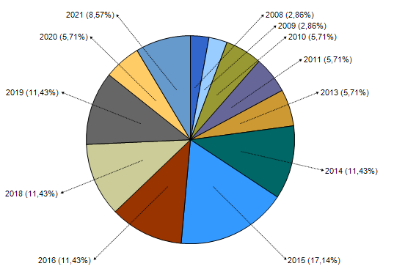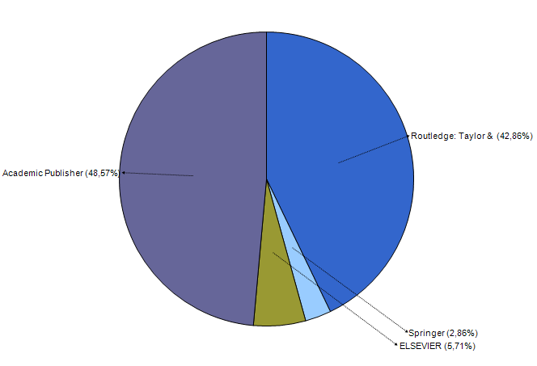

**Figure 2.** Percentage of data collection origin in studies

Based on the distribution of journal names, 27 journals were found (see **FIGURE 3**.). Journals found with the most contributions include Teachers and Teaching: Theory and Practice (TTTP), Teaching and Teacher Education (TTE), Educational Studies (ES), European Journal of Teacher Education (EJTE), Journal of Education and Work (JEW), and Research in Post-Compulsory Education (RPCE). We found the research method in two approaches, namely qualitative (74.29%) and quantitative (25.71%). The data show that the perspective analysis of phenomena in the field is influenced by various characteristics, including political, social, and state psychology.

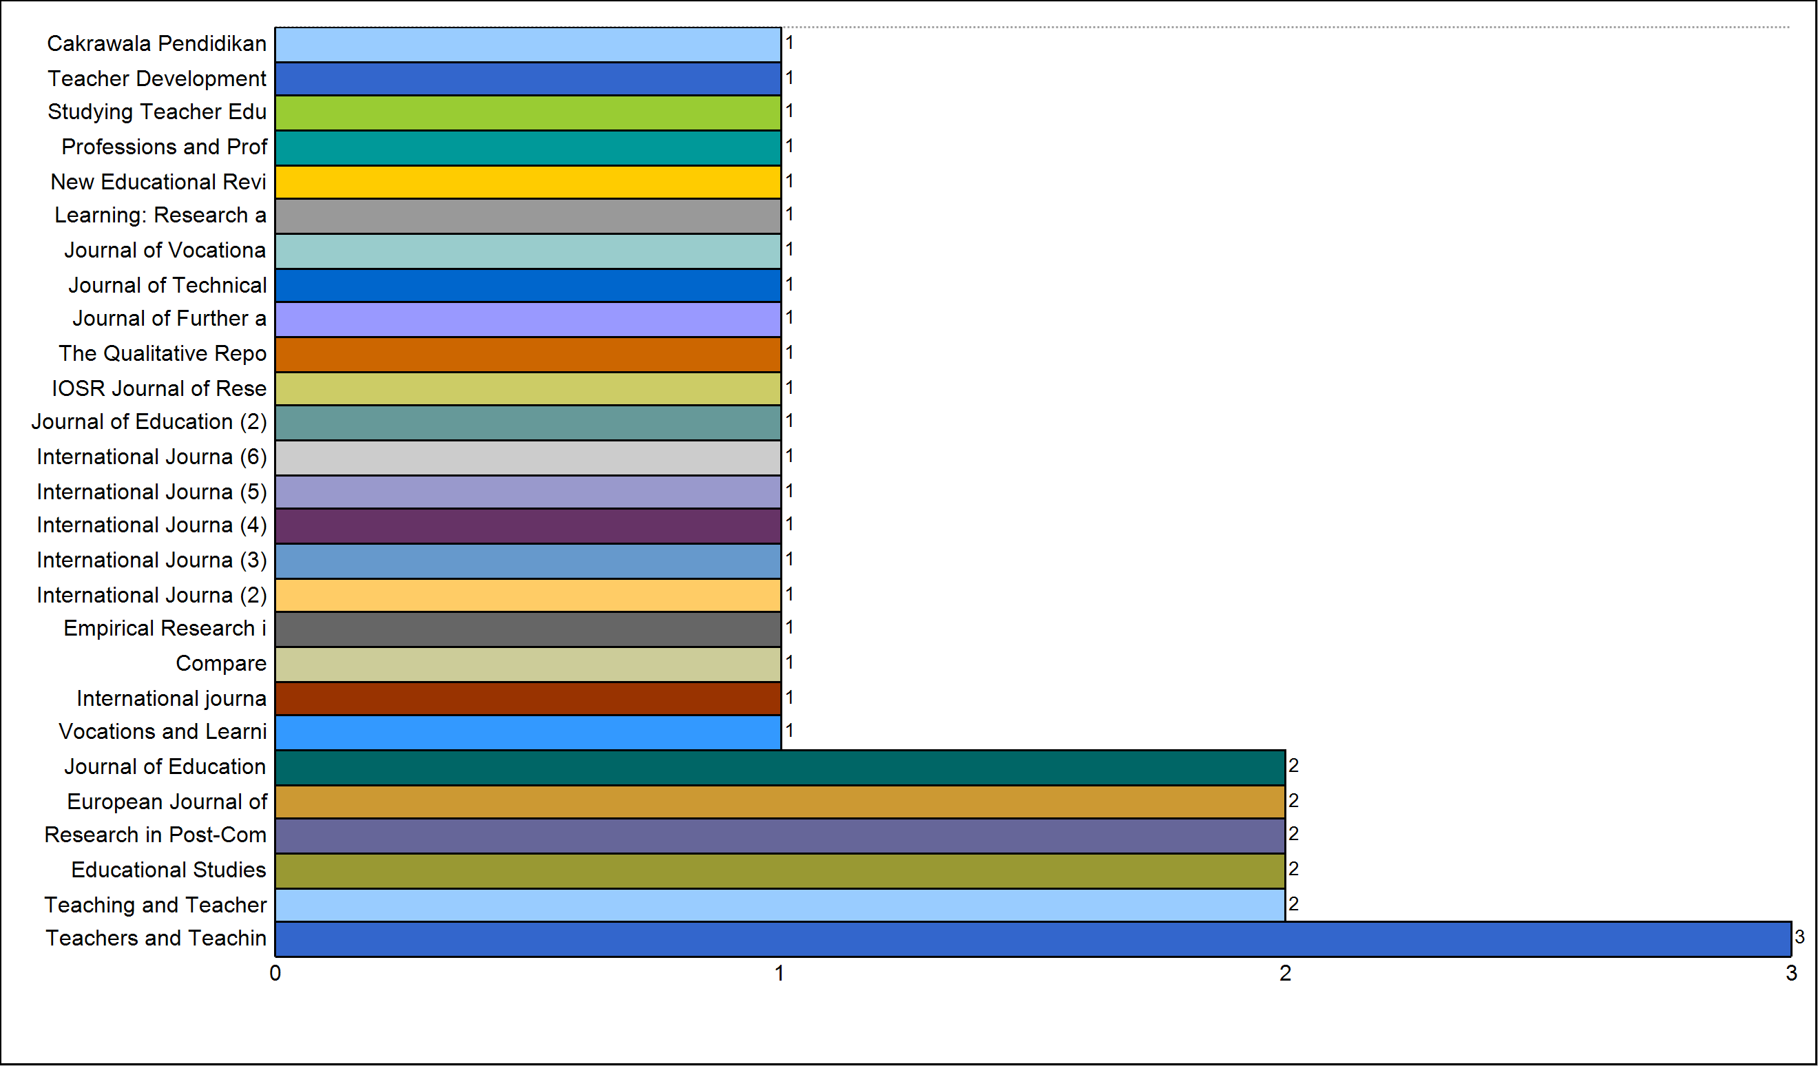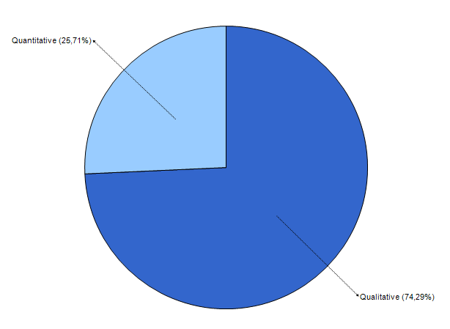

**Figure 3.** The frequency of data collection techniques in studies

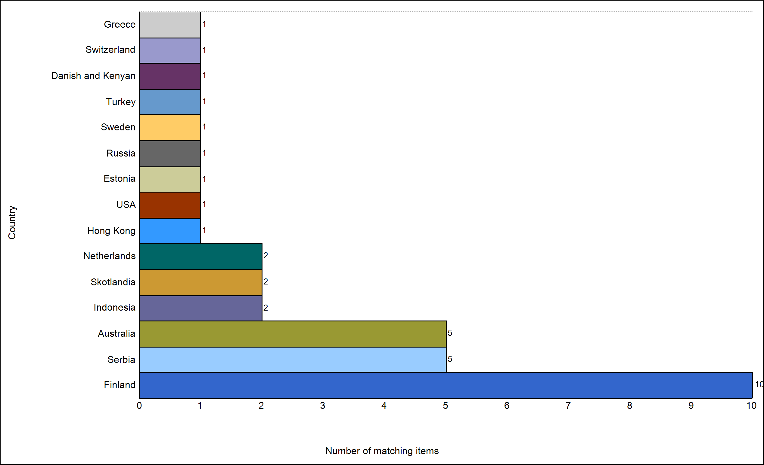

**Figure 4.** The frequency of data collection country in studies

A total of 15 countries from the distribution of 35 articles and Finland contributed the most with ten articles [13–17], followed by Serbia [18–20], and Australia [21–25]. Other countries include Indonesia, Scotland, Netherlands, Hong Kong, USA, Estonia, Russia, Sweden, Turkey, Danish and Kenyan, Switzerland, and Greece

## Teacher Professional Identity and Works Area in Vocational Education

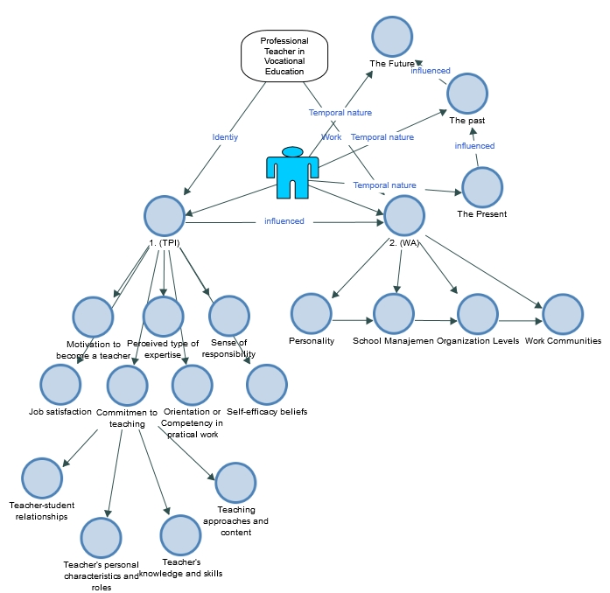

**Figure 5.** Conceptual framework for teacher professional identity in vocational education

The results of the analysis found the characteristics of professional teachers from the point of view of behavior personality. At least the TPI component consists of a commitment to teaching, motivation to become a teacher, self-efficacy beliefs, job satisfaction, and sense of responsibility and orientation or competency in practical work as additional attributes (see **FIGURE 5**.). Commitment is a serious concern, especially in learning. Several indicators have been described, namely teacher's knowledge and skills, teachers' personal characteristics and roles, teacher-student relationship, and teaching approaches and content. The concept of learning in vocational education has been discussed specifically compared to general teachers. In addition, pedagogic content knowledge (PCK) as an approach model has been improved with a higher level, namely a reconstruction model called TAWOCK [26, 27]. In terms of learning skills in vocational education, there are at least two skills that are mastered, namely learning methodologies and learning techniques that can be obtained through industry experience, competency certification tests, and training [28, 29].

Professional identity is formed during the process and there is a construction between personality behavior and social competency. Social interaction is connected with the work area as a teacher who is independent of the tasks in the classroom, but is also involved in school management, professional organizations, and the work community or industrial community, [30, 31]. The positive relationship of the work area strengthens professional competence and is indirectly connected to pedagogical competence. Several studies explain that teachers feel more meaningful in their work due to organizational and personality support, [32], age and work experience [33, 34], satisfaction based on psychological and social needs [35], and performance recognition [36]. At the same time, TPI is also influenced by past experiences, current experiences, and future views, [37].

Finally, the study explains the relationship between personality, social, and environment which is influenced by identity, a sense of calling or mission, capacity, and beliefs at a professional level. TPI as a good teacher or expertise teacher is constructed from personal behavior and social competency, [38, 39]. Positive aspects and high interest increase professional competence, but in limited aspects, professional competence is formed not optimally, or performance is limited. These two aspects directly affect pedagogical competence and simultaneously through professional competence affects pedagogical competence (See **FIGURE 6**.). The main goal is the development of students with high standards oriented to work standards. In the TPI study, starting to connect with the role of technology in various competencies, according to the findings of Vähäsantanen, (2019), [13] and digital skills in learning [40],it is important to research and produce a professional identity in vocational education that is stable to change.

(+)

(-)

Professional

Competency

Social

Competency

Personal

Behavior

Pedagogical

Competency

Positive Active

Negative Passive

(+)

(-)

Uninterested

STUDENT DEVELOPMENT

Technology

Technology

Technology

Technology

**Figure 6.** Relations of personal behavior, social, professional, and pedagogical competence in vocational education

# CONCLUSION

The results of the study of teacher professional identity in the field of vocational education are influenced by the identity, work area, and teacher background. Professional identity consists of seven components, namely a commitment to teaching, motivation to become a teacher, self-efficacy beliefs, job satisfaction and sense of responsibility, and orientation or competency in practical work. The commitment attributes are a priority aspect that is widely discussed and affects the career path of future teachers. Commitment is also discussed in the learning context, including teachers' knowledge and skills, teachers' personal characteristics and roles, teacher-student relationships, and teaching approaches and content. Finally, the findings of this study are conceptually formed from the role of professional identity, namely personal behavior and social competence which have a positive impact on professional competence and increase pedagogical competence on student orientation. At this level, professional teachers have achieved job satisfaction.

# Acknowledgments

The research reported in this publication is supported by the Ministry of Research and Technology/National Research and Innovation Agency, Indonesia through the Research of Doctoral Dissertation (PDD) Grant Program.

# References

1. B. Koster, M. Brekelmans, F. Korthagen, and T. Wubbels, “Quality requirements for teacher educators,” *Teach. Teach. Educ.*, vol. 21, no. 2, pp. 157–176, Feb. 2005, doi: 10.1016/J.TATE.2004.12.004.
2. K. Vloet and J. van Swet, “‘I can only learn in dialogue!’ Exploring professional identities in teacher education,” *Prof. Dev. Educ.*, vol. 36, no. 1–2, pp. 149–168, Jul. 2010, doi: 10.1080/19415250903457083.
3. M. C. Chang, S. Shaeffer, S. Al-Samarrai, A. B. Ragatz, J. de Ree, and R. Stevenson, *Teacher Reform in Indonesia:The Role of Politics and Evidence in Policy Making*. Washington DC, 2014.
4. C. Lamote and N. Engels, “The development of student teachers’ professional identity,” *Eur. J. Teach. Educ.*, vol. 33, no. 1, pp. 3–18, Jul. 2010, doi: 10.1080/02619760903457735.
5. A. Rosser, “Beyond access: Making Indonesia’s education system work,” 2018. [Online]. Available: https://think-asia.org/handle/11540/8034.
6. F. McKeon and J. Harrison, “Developing pedagogical practice and professional identities of beginning teacher educators,” *Prof. Dev. Educ.*, vol. 36, no. 1–2, pp. 25–44, 2010, doi: 10.1080/19415250903454783.
7. K. Livingston, “Developing teachers’ and teacher educators’ professional identity in changing contexts,” *Eur. J. Teach. Educ.*, vol. 39, no. 4, pp. 401–402, 2016, doi: 10.1080/02619768.2016.1235822.
8. B. Kitchenham and S. Charters, “Guidelines for performing Systematic Literature Reviews in Software Engineering,” 2007.
9. M. Unterkalmsteiner, T. Gorschek, A. K. M. M. Islam, C. K. Cheng, R. B. Permadi, and R. Feldt, “Evaluation and measurement of software process improvement-A systematic literature review,” *IEEE Trans. Softw. Eng.*, vol. 38, no. 2, pp. 398–424, 2012, doi: 10.1109/TSE.2011.26.
10. M. Gusenbauer, “Google Scholar to overshadow them all? Comparing the sizes of 12 academic search engines and bibliographic databases,” *Scientometrics*, vol. 118, no. 1, pp. 177–214, Jan. 2019, doi: 10.1007/S11192-018-2958-5/TABLES/4.
11. V. Braun and V. Clarke, “Using thematic analysis in psychology,” *Qual. Res. Psychol.*, vol. 3, no. 2, pp. 77–101, 2006, doi: 10.1191/1478088706QP063OA.
12. F. G. Kern, “The Trials and Tribulations of Applied Triangulation: Weighing Different Data Sources:,” *https://doi.org/10.1177/1558689816651032*, vol. 12, no. 2, pp. 166–181, May 2016, doi: 10.1177/1558689816651032.
13. K. Vähäsantanen and R. Hämäläinen, “Professional identity in relation to vocational teachers’ work: an identity-centred approach to professional development,” *Learn. Res. Pract.*, vol. 5, no. 1, pp. 48–66, 2019, doi: 10.1080/23735082.2018.1487573.
14. K. Vähäsantanen, “Professional agency in the stream of change: Understanding educational change and teachers’ professional identities,” *Teach. Teach. Educ.*, vol. 47, pp. 1–12, 2015, doi: 10.1016/j.tate.2014.11.006.
15. K. Vähäsantanen, P. Hökkä, A. Eteläpelto, H. Rasku-Puttonen, and K. Littleton, “Teachers’ Professional Identity Negotiations in Two Different Work Organisations,” *Vocat. Learn.*, vol. 1, no. 2, pp. 131–148, 2008, doi: 10.1007/s12186-008-9008-z.
16. K. Vähäsantanen and A. Eteläpelto, “Vocational teachers in the face of a major educational reform: individual ways of negotiating professional identities,” *J. Educ. Work*, vol. 22, no. 1, pp. 15–33, Jul. 2009, doi: 10.1080/13639080802709620.
17. J. Ursin, K. Vähäsantanen, L. McAlpine, and P. Hökkä, “Emotionally loaded identity and agency in Finnish academic work,” *J. Furth. High. Educ.*, vol. 44, no. 3, pp. 311–325, 2020, doi: 10.1080/0309877X.2018.1541971.
18. P. Živković, “Finding Connections : The Nexus between Teacher Professional Identity and Some Aspects of Teacher Quality in Republic of Serbia,” *IOSR J. Res. Method Educ.*, vol. 6, no. 6, pp. 74–77, 2016, doi: 10.9790/7388-0606037477.
19. P. Živković, B. Stojanović, and D. Ristanović, “Student teachers’ professional identity: Research in the Republic of Serbia,” *New Educ. Rev.*, vol. 51, no. 1, pp. 221–231, 2018, doi: 10.15804/tner.2018.51.1.18.
20. P. Živković, “Professional Development and Teachers Professional Identity: Self- Assessment in Republic of Serbia,” *J. Educ. Instr. Stud. World*, vol. 3, no. 1, pp. 150–158, 2013.
21. T. Schmidt, “Industry currency and vocational teachers in Australia: what is the impact of contemporary policy and practice on their professional development?,” *Res. Post-Compulsory Educ.*, vol. 24, no. 1, pp. 1–19, 2019, doi: 10.1080/13596748.2019.1584431.
22. L. Thi and N. Thi, “Mediating teacher professional identity : The emergence of humanness and ethical identity,” *Int. J. Train. Res.*, vol. 11, no. 3, pp. 199–212, 2013, [Online]. Available: http://hdl.handle.net/10536/DRO/DU:30059439.
23. L. T. Tran and N. T. Nguyen, “Negotiation of Professional Identities in the ‘Contact Zone’: Contradictions and possibilities in the time of international student mobility,” Sense Publishers, 2014.
24. M. A. Tyler and D. Dymock, “Constructing a professional identity in VET: teacher perspectives,” *Res. Post-Compulsory Educ.*, vol. 26, no. 1, pp. 1–18, 2021, doi: 10.1080/13596748.2021.1873404.
25. L. T. Tran and N. T. Nguyen, “Re-imagining teachers identity and professionalism under the condition of international education,” *Teach. Teach. Theory Pract.*, vol. 21, no. 8, pp. 958–973, 2015, doi: 10.1080/13540602.2015.1005866.
26. Z. Arifin, M. Nurtanto, W. Warju, R. Rabiman, and N. Kholifah, “The tawock conceptual model at content knowledge for professional teaching in vocational education,” *Int. J. Eval. Res. Educ.*, vol. 9, no. 3, pp. 697–703, 2020, doi: 10.11591/ijere.v9i3.20561.
27. Z. Arifin, M. Nurtanto, A. Priatna, N. Kholifah, and M. Fawaid, “Technology andragogy work content knowledge model as a new framework in vocational education: Revised technology pedagogy content knowledge model,” *TEM J.*, vol. 9, no. 2, pp. 786–791, 2020, doi: 10.18421/TEM92-48.
28. M. Nurtanto, Z. Arifin, H. Sofyan, W. Warju, and S. Nurhaji, “Development of model for professional competency assessment (Pca) in vocational education: Study of the engine tune-up injection system assessment scheme,” *J. Tech. Educ. Train.*, vol. 12, no. 2, pp. 34–45, 2020, doi: 10.30880/jtet.2020.12.02.004.
29. M. Nurtanto, H. Sofyan, P. Pardjono, and S. Suyitno, “Development model for competency improvement and national vocational qualification support frames in automotive technology,” *Int. J. Eval. Res. Educ.*, vol. 9, no. 1, pp. 168–176, 2020, doi: 10.11591/ijere.v9i1.20447.
30. S. Suyatno, E. Hasanah, W. Wantini, D. I. Pambudi, and S. Supardi, “Meaning in Work of Indonesian Teachers : A Phenomenological Meaning in Work of Indonesian Teachers : A Phenomenological Research,” *Qual. Rep.*, vol. 26, no. 10, pp. 3189–3213, 2021, doi: https://doi.org/ 10.46743/2160-3715/2021.4970.
31. A. Eteläpelto, K. Vähäsantanen, and P. Hökkä, “How do novice teachers in Finland perceive their professional agency?,” *Teach. Teach. Theory Pract.*, vol. 21, no. 6, pp. 660–680, 2015, doi: 10.1080/13540602.2015.1044327.
32. Y. Akgunduz, C. Alkan, and Ö. A. Gök, “Perceived organizational support, employee creativity and proactive personality: The mediating effect of meaning of work,” *J. Hosp. Tour. Manag.*, vol. 34, pp. 105–114, Mar. 2018, doi: 10.1016/J.JHTM.2018.01.004.
33. K. S. Anthun and S. T. Innstrand, “The predictive value of job demands and resources on the meaning of work and organisational commitment across different age groups in the higher education sector,” *http://dx.doi.org/10.1080/1360080X.2015.1126890*, vol. 38, no. 1, pp. 53–67, Jan. 2015, doi: 10.1080/1360080X.2015.1126890.
34. N. Kholifah, H. Sofyan, P. Pardjono, P. Sudira, and M. Nurtanto, “Explicating the Experience of Beginner Vocational Teachers,” *TEM J.*, vol. 10, no. 2, pp. 719–723, 2021, doi: 10.18421/TEM102-28.
35. T. Clausen and V. Borg, “Job demands, job resources and meaning at work,” *J. Manag. Psychol.*, vol. 26, no. 8, pp. 665–681, Nov. 2011, doi: 10.1108/02683941111181761/FULL/XML.
36. C. Pavlish and R. Hunt, “An exploratory study about meaningful work in acute care nursing,” *Nurs. Forum*, vol. 47, no. 2, pp. 113–122, Apr. 2012, doi: 10.1111/J.1744-6198.2012.00261.X.
37. A. Malle and A. Yehualawork, “Professional agency in the stream of change: understanding educational change and teachers’ professional identities,” *Teach. Teach. Educ.*, vol. 47, no. (April 2015), pp. 1–12, 2015, doi: https://doi.org/10.1016/j.tate.2014.11.006.
38. J. L. Berger and K. Lê Van, “Teacher professional identity as multidimensional: mapping its components and examining their associations with general pedagogical beliefs,” *Educ. Stud.*, vol. 45, no. 2, pp. 163–181, 2019, doi: 10.1080/03055698.2018.1446324.
39. S. F. Shodiq and Syamsudin, “Teacher identity reconstruction: Socio-anthropological study of javanese society,” *Cakrawala Pendidik.*, vol. 38, no. 3, pp. 477–489, 2019, doi: 10.21831/cp.v38i3.26098.
40. F. Mutohhari, S. Sutiman, M. Nurtanto, N. Kholifah, and A. Samsudin, “Difficulties in implementing 21st century skills competence in vocational education learning,” *Int. J. Eval. Res. Educ.*, vol. 10, no. 4, pp. 1229–1236, 2021, doi: 10.11591/ijere.v10i4.22028.