**Building Work-Skills Through On-The Job Training During The Covid-19 Pandemic**

Peni Handayani1 and Siswoyo2

Author Affiliations

*Politeknik Negeri Bandung, Jl. Gegerkalong Hilir, Ds Ciwaruga, Bandung Indonesia*

*Author Emails*

Email : [penihan@polban.ac.id](mailto:penihan@polban.ac.id)

**Abstract.** The tradition of On-the Job Training (OJT) that has been carried out in industry is very difficult to realize during a pandemic because most of industries limit the number of employee while the student’s work skills must be built. This research aims to propose an OJT model that can build student’s work competencies and drive microeconomics in order to realize the government’s program to build a village economy. Qualitative method has been used in this research. Data collected by observation to assess the student’s skills, and interviews people who involved in this project. This research involved the 4th semester of electrical engineering students that have to achieve six competency units at the end of this project. The OJT carried out in the villages where students live by doing a small project to automate the part of production process in the microenterprise. This research revealed that all students are competent in creating an automation equipment for production process so that productivity increases more than 900%. In the student’s point of view, they feel happy to be part of community’s problem solver. This OJT has motivated and inspired them to create more innovative equipment To format your abstract, use the Microsoft Word template style: *Abstract* or Use Times New Roman Font: 9 pt, Indent: left 0.2", Right: 0.2", Justified. Each paper *must* include an abstract. Begin the abstract with the word “Abstract” followed by a period in bold font, and then continue with a normal 9-point font.

# INTRODUCTION

On-the Job Training is a student’s learning activity that normally conducted in industry for 3-6 months. This activity is an important thing for polytechnic students or vocational students. It aims to give students the opportunity to implement their knowledge and skills or to learn practical knowledge from the workplace. The problem now is very difficult to conduct this activity during covid 19 pandemic, because most of industries limit the production and number of employee due to crisis of pandemic. This mean that industrial capacity is reduced. Representative of the Ministry of Manpower in a webinar (May, 2020) revealed that under normal condition, the capacity of industry to meet the need of internship students is only 14% of the total needs. It is a signal that polytechnic and vocational institution have to find a new strategy in building skills and identify the new trend of market-driven. G4.0 technology has disrupted various sectors include vocational education. Many businesses are missing, but many new businesses opportunities that were unimaginable before have sprung up. This condition is exacerbated by the covid 19 pandemic. The learning process is more than 80% carried out online. This makes students bored so that learning is no longer effective. The most difficult is to build students’ work skills through the online learning process. Lecturers have to find a strategy to develop learning methods to build and develop the students’ work skills as long as the campus or laboratory is closed for offline learning.

**Literature Review and Theory**

Nawa Cita are nine dreams that Indonesia wants to achieve. Three of them are strong related to this topic. There are: 1) developing Indonesia from the periphery by strengthening regions and villages, 2) Improve the quality of Indonesian people through improving the quality of education and training, 3) increase people’s productivity and competitiveness in the international market, 3) Realizing economic independence by moving strategic sector of the domestic economy [1]. This policy is translated into West Java Masagi or Jawa Barat Masagi (Jabar Masagi) program. This program is focused on educational character based on Sunda philosophy, namely building: 1) cultivate of feeling (surti, olah rasa): a sense of sympathy, 2) cultivate of understanding (harti, memahami): understand other people, understand how to manage the environment and oneself, 3) show evidence (bukti): show the contribution to society with caring and smart working, and 4) loyalty (bakti): being devoted by good services to the community [2]. Technical Vocational Education and Training (TVET) in India and other countries play a vital role in the process of economic development by expanding skills required for small and medium enterprises [3]. Vocational education and training (VET) have specific curriculum and learning method. It is a combination between education and work training. The learning outcomes can be measured and tangible or can be demonstrated [4]. VET in the G4.0 era must flexible in method, learning time and place, and choice of courses [5]. Curriculum design should be flexible so that students have many choices of subjects to develop themselves according to their talents [6]. Engineering students could choose courses outside of engineering subject, for example business, economy, or Information Technology (IT), etc. Therefore, the modular course is the best choice for learning method. The Massive Open Online Courses (MOOC) model which has been developed by many Universities in South Africa is a new innovation model of learning in this country. It is an appropriate model of educations in pandemic era [7]. In the future, in the G5.0 era, accountability of learning in the MOOC model could be distributed to everyone. It means that everyone could contribute in the content, mentor, tutor, coach, and counsellor. It is a characteristic of learning in the G5.0, while learning characteristic in the G4.0 is collaborative [8]. Learning process is focused on students’ need. Knowledge, skills and attitudes can build on the workplace. Boud and Solomon proposed a learning model which they called Work Based Learning (WBL). In this model, the Higher Education, Professional Organization, and industries must build good cooperation to create new opportunities for learning and curriculum development [9]. The learning outcomes or competencies achievement are selected and measured based-on National Work Standard or SKKNI (Standar Kompetensi Kerja Nasional Indonesia) for Industrial Automation. This standard issued by Indonesian Labour Ministry (Kepemnakertrans) [10]. According to these literature review and theory, the OJT model proposed should fulfill with the Nasional Qualification Framework, the higher education standard, and independent learning method as mention on these regulations [11], [12].

**Aims and Method**

On the job training has been perceived as a job training in large industry. Under the normal condition, industrial capacity to accommodate OJT students much smaller than the number of students who have to OJT. This capacity decreased sharply during the pandemic. This research aims to find a breakthrough on how to build work skills without relying on large industries but still provide added value for students, community, and the local economy. This research conducted in 4 steps as shown in Figure-1.

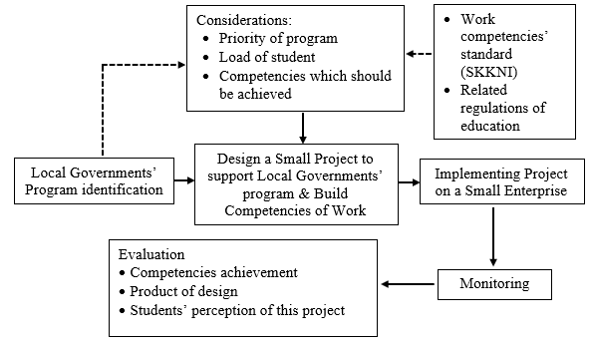

Figure.1. Research Steps for Work Skills Development

Step 1) identify the local or village government’s program. Step 2) Design the small project to support local governments’ program by considering the load of students, competencies which should be achieved, and the priority of program. Step 3) implementing project on a small enterprise. Step 4) evaluate the result of project and assess the students’ competencies achievement. It also needs to know the student’s perception after they finish this project. Qualitative approach was used in this research. Data collected by interviewing the community in a field where students work their job, evaluate the students’ portfolio during do this project, and evaluate their product design.

**RESULT AND DISCUSSION**

This section discusses about the strategy of on-the job training, selection and determination of projects, setting standard of learning outcomes, project implementation, evaluation of learning outcomes, and evaluation of project. The lack of practicum activities in the campus due to the pandemic has created a real Project Based Learning model to solves problems in the community and support government to move economic in the village. These activities can be conducted in the village where students live

**On-the Job Training (OJT) Strategy and Design**

The first thing to consider when choosing a learning strategy in a pandemic situation is safety and health. Student must be made aware of compliance with health protocols. The second, this learning must be able to develop students’ work skills include hard and soft skills. The third, the learning outcomes must be able to have positive impact on society. The fourth, this activity must be able to expand networking between polytechnic and stakeholders. The fifth, this activity must be able to encourage small economy growth. The selection and determination of projects must be considering the level of student competency, learning load or credit semester, time or duration of learning, and work area must be in the same city or village as the students’ domicile so that they do not have to go out of town. In addition, the project must be selected based on the priority scale of the local or village development programs. Competencies that have to be achieved by students refer to the National Work Competency Standard (SKKNI) for the Industrial Automation field. Learning outcomes (LOs) standard can be selected from this SKKNI. According to the competency certification scheme which is determined by Nasional Professional Certification Board, 6 – 8 competency units can be selected as the work competencies that should be achieved by students on the end of OJT. The sixth, the assessment involves professional associations in the industrial automation field namely Perkumpulan Masyarakat Ahli Teknik Otomasi Industri Indonesia (PMATOII). The object chosen in this research is a micro enterprise. Targeted job for students is automate parts of the production process in order to increase productivity. The process of forming work competencies is shown in Figure-2. In this research, students already have basic skills such as mathematics and its applications, electronics engineering, instrumentation, and basic programming. Work competencies already introduced through the laboratory activities in the first until forth semesters [13]

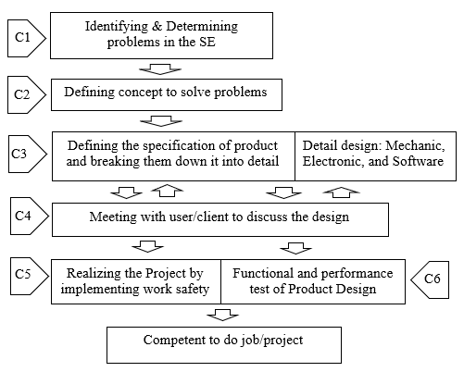

Figure 2. Building Work Competencies

**Project Implementation**

Safety and healthy standard are the first consideration in the implementation of OJT and the design of product or equipment. The main aim of this project is to automate the process of packaging liquid (milk) in plastic. The design of this simple machine includes mechanical part, electronics part, and programming part. Mechanical part work to fill the liquid and seal it. The electronics part work to control the mechanic arm of robot, sense of liquid volume in the plastic and temperature of heater for sealing, counts packaged and sealed plastics, displays seal temperature, the number of packaged, and activate an alarm in the case of disturbance. Block diagram of this equipment is shown in Figure-3.

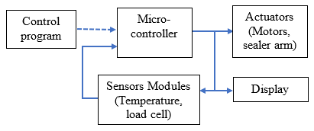

Figure 3. Block Diagram of Equipment

The equipment will start to work by filling some plastic packaging until it reaches a certain weight. Then the sealer will start to seal all packages in one time. The sealed plastic will be transferred to the storage and counter will calculate how many packages are entered in the storage. The calculation result will be displayed on the LCD. Plastic packaging with a capacity of 14 can be filled and sealed in 50 seconds. This process time is calculated from filling the milk into plastics until the sealing process is complete. It is faster than the manual process which it needs 8,5 minutes for same capacity of production. This equipment increase productivity about 920 %.

**The Preparation and Works Competencies Assessment**

The obstacles to implementing this project was poor coordination between team members at the beginning because each of them had difference perception of the user’s expectation. This stage has trained their communication skills and learn the abilities of each other’s. After 3 weeks they have good coordination and shown the good progress of work. Awareness of work responsibilities has also been well developed. Work competencies which must be achieve by students include soft skills and hard skills. Soft skills which are to be assessed consist of communications skills, responsibility, discipline, consistency in implementing healthy and safety standard during works. The technical skills which are to be assessed include design ability based on the main problem on enterprise, assembly electronic components, develop program for automation, and functional or quality test of product or commissioning ability. These competencies are covered in the 6 (six) competencies units. The assessment has been carried out by assessors of PMATOII members. The assessment has been carried out through 3 (three) method namely reviewing the work process via video conference every week, interviews with users, and testing functional of product. The assessment result is shown in Figure-4.

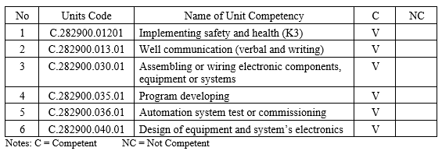

Figure-4. Competencies Assessment Results

**Student’s Perception**

This OJT model needs to be evaluated from student’s point of view. Interviews with the students involved in this project revealed that the practical learning from field was inspiring and made them motivated to learn more. They feel happy as a part of community’s problem solver. They aware that the technical knowledge is not enough to implement it in the society or industry.

**CONCLUSION**

Work-skills can be built not only in medium or big industry, but also can be built through on-the job training on the micro enterprises or home industries. “The curriculum” of the OJT must be carefully designed according to the field needs. The learning outcomes must refer to the National Work Competencies Standard (SKKNI) in an appropriate field of work. Selected competency Units must be agreed with the professional association so that work competencies are measured according to industry standard. Students have been motivated to learn from field. Interactive with the community in village have inspired students to create more machine or equipment that can be used to move small enterprises. Students need challenge to develop their creativity. Whatever the reason, basic skills such as etic, basic technical skills, and language must be strongly built first in the campus.

**ACKNOWLEDGMENTS**

I would like to thank the ICTVT UNY 2021 team for giving me the opportunity to contribute to this event. I also to thank students who have participated in this project, and also to thanks very much to industrial automation association that supported this project to improve the quality of human resource and move village economic

# REFERENCES

References should be numbered using Arabic numerals followed by a period (.) as shown below and should follow the format in the below examples.

1. Inggried Dwi Wedhaswar, *Nawacita. 9 Agenda Prioritas Jokowi-JK* (Kompas, Jakarta, 2014)
2. Trie Utami. “Panca Niti- Lima Tahapan Mengenal Diri” (Dialog Positif, 20 Agustus 2020)
3. Naresh Kumar & Tabassum Jamal, Productivity. Vol 58 no 4 pp410-420 (2018)
4. Finch & Krunkilton, *Curriculum Development in Vocational and Technical Education*. *5th* *Edition* (Boston: Allyn and Bacon, 1999) pp. 3-14
5. M. Samani, “Vocational Education in the Era of Industry 4.0: an Indonesian Case” – 2018 Atlantis Conference Proceeding (Atlantis Press,Surabaya, 2018), pp 45-47.
6. J. Kehinde, “*Talent Management: Effect on Organizational Performance*” (Macrothink Institute, 2012), pp 178-186.
7. Patient_Rambe and Mamello_Moeti, “Disrupting and Democratising Higher Education Provision or Entreching Academic Elitism: toward a model of MOOCs Adoption at African Universities*”* (Springer, Bloemfontein, South Africa, 2016).
8. A_Denni_Triaji_Prio_P, *Learning 5.1*. *Duluan Tiba di Masa Depan* (Gramedia, Jakarta, 2020), pp. 55-106
9. David_Boud & Nicky_Solomon, *Work-based Learning. A New Higher Education*?, (SRHE and Open University Press, Philadelphia, USA, 2001), pp 18-57
10. Kemenakertrans, *Kepmenakertrans Nomor 631 tahun 2016, tentang* *SKKNI bidang Otomasi Industri* (Kemenakertrans, Jakarta, 2016)
11. Kemendikbud, *PERPRES Nomor 8 tahun 2012*  *tentang KKNI* (Kemendikbud,Jakarta, 2012)
12. Kemendikbud, *Kepmendikbud nomor 3 tahun 2020* *tentang Standar Nasional Pendidikan* *Tinggi (SNPT)* (Kemendikbud, Jakarta, 2020)
13. P.Handayani & T.Y.Putro, Materials Science and Engineering. Letters **830,**  042081 (2020)