The Analysis of Liquefaction Potential in Balaroa Area, Palu City, Central Sulawesi
Suci Amalia Namira^{1, a)}, Teuku Faisal Fathani¹ & Agus Darmawan Adi¹
¹Department of Civil and Environmental Engineering, Universitas Gadjah Mada, Yogyakarta
^{a)} Corresponding author: suci.a.n@mail.ugm.ac.id
Abstract. On September 28, 2018, Mw 7.5 earthquake in Central Sulawesi caused the shift that occurred in the Palu Koro fault triggered several disasters. It includes tsunamis on the coast of Palu City and liquefaction in several areas including Petobo, Balaroa, and Jono Oge Village. The liquefaction phenomenon is the loss of soil strength during earthquake higher than 0.1 g which generally occurs in loose sandy soil with high groundwater levels. This study aims to determine the liquefaction potential in Balaroa, Palu City, Central Sulawesi. The analysis of liquefaction potential was carried out using the Settle3 software with N-SPT (Standard Penetration Test) and PGA (peak ground acceleration) data of 0.33 g. Each analysis produced a safety factor value based on the review point. Furthermore, the Liquefaction Potential Index (LPI) as well as Liquefaction Severity Index (LSI) were calculated. Based on the analysis carried out through two review points of the soil test, the results of this study showed that the drilling point of BH 01 (at the top part of the area) had liquefaction potential with high damage potential. Meanwhile, the drilling point of BH 02 (at the un-liquified area) had liquefaction potential.

INTRODUCTION
Central Sulawesi is an area traversed by the intersection of three of the world's major tectonic plates, the Indo- Australian Plate, the Pacific Plate, and the Eurasian Plate. This makes the area vulnerable to natural disasters, especially the occurrence of a shift in the Palu Koro Fault caused by plate movement. This also caused an earthquake on September 28, 2018 with a 7.5 magnitude which destroyed the coast of Palu Bay. This earthquake also triggered a tsunami and liquefaction causing severe damages and the death of approximately 2000 people. The earthquake triggered liquefaction in Palu City, namely in Balaroa, Petobo, Sibalaya, Jono Oge, and Lolu Village areas [15].
[22] carried out a study related to liquefaction potential in Palu City and developed a liquefaction hazard map. In the map, some places were categorized as liquefaction hazards with very high potential which was acceptable. However, based on the earthquake in Palu which resulted in liquefaction, it is the largest event in world history with infrastructure losses reaching 85% and causing many fatalities. Figure 1 shows a satellite photos from Google Earth and some photos of damage the Balaroa area, Palu City. The yellow arrow in the figure indicates the direction of the large ground flow that occurred from south-west to north-east. Large ground settlements and large tension cracks appeared at the upper side of the flow and collapsed houses were piled up and many houses were buried in the flowed soil at the lower side [11]
[14] identified topographical conditions at the time of earthquake and liquefaction, the results of the resistivity test at lane 1 (Balaroa) showed the occurrence of the phenomenon of a distressed aquifer that broke, causing an increase in water content in the soil layers above. This phenomenon is one indicator causing the occurrence of liquefaction in Balaroa.
[5] explored the causing factors of the massive mudflow, several areas including Balaroa, Petobo, and Jono Oge have high liquefaction potential in large-scale at a depth of 16 meters below the ground surface based on analysis using semi-empirical method. Liquefaction will turn soil into a massive amount of mud, this can happen if an area has a loose soil grain with high water content. In addition, other thing that can trigger the occurance of mudflows is a ground slopes and ground vibration due to the earthquake. Also, [3] conducted an analysis to determine the mechanism and level of geotechnical damage due to the earthquake in Palu City on September 28, 2018 using a Dynamic Cone Penetration Test (D-CPT). The results showed that in Petobo and Balaroa areas there some spots of freshwater imundation even two weeks after the disaster, and the affected area had a loose soil compared to the non- affected areas. In this study, an analysis of the liquefaction potential was carry out based on the Standard Penetration Test (SPT) data in the field using the Settle3 software. The results of the analysis are expected to be a reference in the spatial development of the area prone to liquefaction and its related impacts.
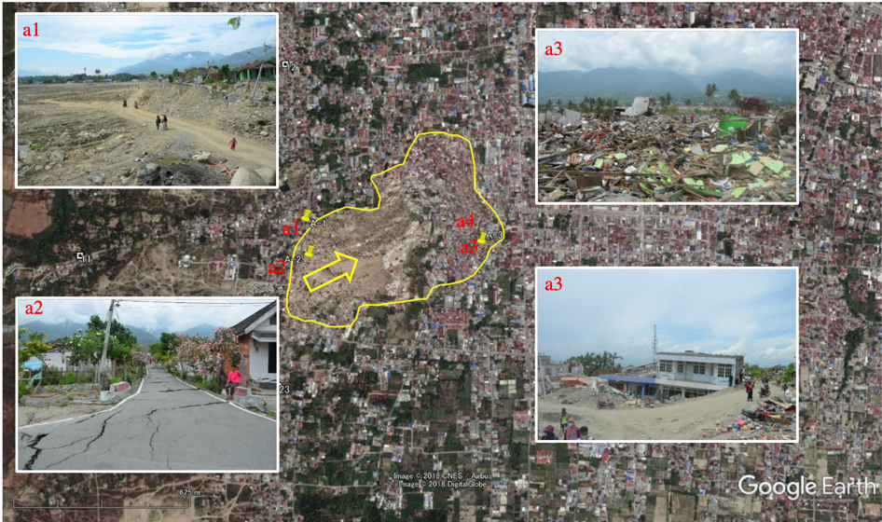
FIGURE 1. Satellite photo by Google Earth and some photos of damage in Balaroa district in Palu city [11]

RESEARCH METHODS
The Mw 7.5 earthquake in Palu City, Central Sulawesi triggered another disaster, namely liquefaction at several points of the City, which led to the change in the soil properties of the affected area. This study was carried out using the Settle3 software to analyze an earthquake with a magnitude of 7.5 Mw. The liquefaction potential was analyzed using the Liquefaction Potential Index (LPI) and the Liquefaction Severity Index (LSI) methods.

Data Collection
The data obtained was soil investigation in the form of the SPT test results and laboratory testing carried out in Balaroa Village, Palu City, Central Sulawesi. The earthquake data used in the analysis had a magnitude of 7.5 Mw and peak ground acceleration in the study area is 0.33 g. Furthermore, the SPT test results at the review points are shown in Table 1. BH 01 is located at the top part of the liquefaction area, whereas BH 02 is located at the north-side of the area and remained un-liquified during the 2018 earthquake.
TABLE 1. SPT test results of BH 01 and BH 02 point
 | BH 01 |  | BH 02
z (m) | N-SPT | Soil type | N-SPT | Soil type
0 | 0 | loose sand | 0 | loose sand
2 | 7 |  | 50
4 | 5 |  | 6
6 | 10 |  | 5
8 | 68 | very dense sand | 41 | dense sand
10 | 16 | medium sand | 50
12 | 21 |  | 49
14 | 33 |  | 36
16 | 12 | silt | 65 | very dense sand
18 | 51 | dense sand | 50
20 | 26 |  | 72

The location of study area is shown in Figure 2.
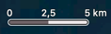

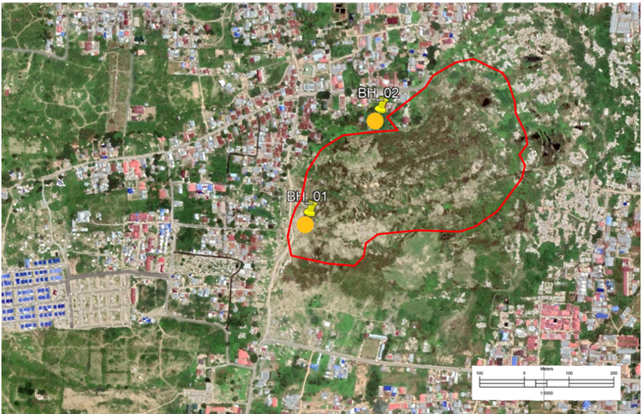
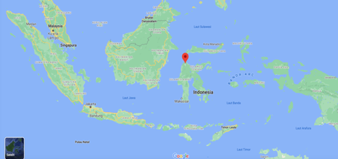
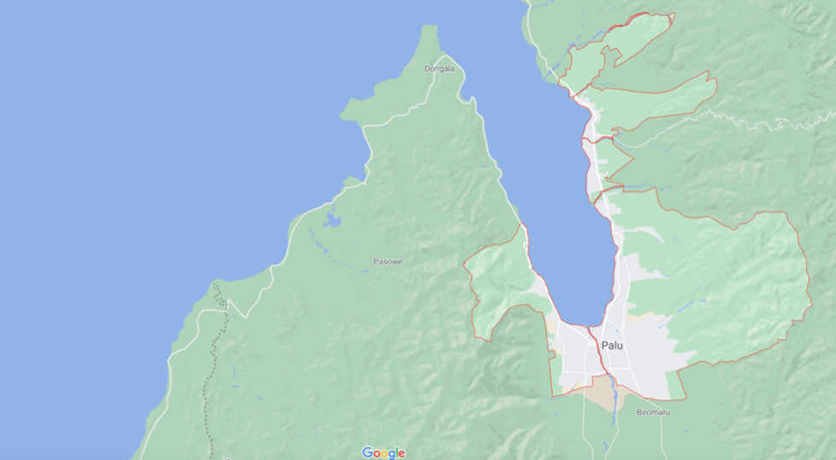
N
N
Palu City
Balaroa, West Palu

FIGURE 2. Research location (Google Maps and Mason et al., 2019)

Seismic Design Analysis
To carry out a liquefaction analysis at a location, there is a necessity to determine the peak ground acceleration (a_{max}) at the area. This data was obtained using a probabilistic method with reference to Indonesian seismic code of SNI 1726-2019 concerning procedures for earthquake resistant building and non-building structures design. The code states that the planned earthquake is an earthquake with an occurrence probability of 10 percent within 50 years. [12] which refers to AASHTO (2012) states that the potential for liquefaction and loss of soil strength is evaluated against the peak ground acceleration at the surface, magnitude, earthquake, and source characteristics consistent with the consideration of the maximum earthquake peak acceleration. The peak ground acceleration (PGA) distribution classification can be seen in Table 2.
TABLE 2. PGA distribution classification system [2]
No. | PGA (g) | Class | Risk Level
1 | a_{max} < 0.10 | 1 | Very low
2 | 0.10 < a_{max} < 0.20 | 2 | Low
3 | 0.20 < a_{max} < 0.30 | 3 | Medium
4 | 0.30 < a_{max} < 0.40 | 4 | High
5 | a_{max} > 0.40 | 5 | Very high

The peak ground surface acceleration value of the bedrock needs to be corrected. This is because the lower the strength of the soil, the higher the acceleration of the peak of the soil at the base of the building. Furthermore, the determination of the a_{max} peak ground surface acceleration is formulated in Equation (1).
a_{max} = PGA . F_{PGA} | (1)

where,
a_{max} = Peak ground acceleration at the surface (g)
PGA = Peak ground acceleration (g)
F_{PGA} = The coefficients determined by Table 3
TABLE 3. Coefficient of F_{PGA} [12]
Site Class | PGA
 | 0.1 | 0.2 | 0.3 | 0.4 | 0.5 | > 0.6
SA | 0.8 | 0.8 | 0.8 | 0.8 | 0.8 | 0.8
SB | 0.9 | 0.9 | 0.9 | 0.9 | 0.9 | 0.9
SC | 1.3 | 1.2 | 1.2 | 1.2 | 1.2 | 1.2
SD | 1.6 | 1.4 | 1.3 | 1.2 | 1.1 | 1.1
SE | 2.4 | 1.9 | 1.6 | 1.4 | 1.2 | 1.1
SF | A special evaluation is required at each location

Analysis of Liquefaction Potential Using Settle3 Software
The Settle3 software is a 3-dimensional program for the analysis of consolidation settlement under foundations, embankments, excavations on the surface. Furthermore, it also has an analysis program for liquefaction using several methods, which include Standard Penetration Test (SPT), Cone Penetration Test (CPT), and Shear Wave Velocity (VST) with analysis results related to safety factors with liquefaction resistance. The Settle3 analysis program is generally used to analyze soil consolidation and subsidence. However, in determining project settings, the liquefaction model can be activated with a choice of several methods implemented to determine the liquefaction potential.

Software Settle3 Modelling
Based on the SPT, the Liquefaction analysis has several options in determining soil parameters. The output can be selected automatically from the software or determined based on the desired method. Several factors were determined manually in the Settle3 liquefaction analysis as follows.
- N-SPT Correction Factor
Before calculating the CRR, the N value from the field needs to be corrected based on the following factors.
- Overburden pressure (C_{N}) correction factor is based on the Liao and Whitman (1986a) method.
- The hammer energy (C_{E}) correction factor is based on the Skempton (1986) method.
- The borehole diameter (C_{B}) correction factor is based on the Skempton (1986) method.
- Rod Length (C_{R}) correction factor is based on Cetin et al., (2004) method.
- Sample (C_{S}) correction factor is based on the NCEER (1997) method.
- Cyclic Stress Ratio (CSR)
The Liquefaction analysis with Settle3 used the ratio of cyclic shear stress according to the method [18], and the CSR in Settle3 was the same as that used in the manual method. The calculation of the CSR value can be seen in Equation (2).
$$\text{CSR=}\left(\frac{{\text{τ}}_{\text{cyc}}}{{\text{σ}\text{'}}_{\text{vo}}}\right)\text{ = 0.65 }\text{r}\text{d} \left(\frac{{\text{σ}}_{\text{vo}}}{{\text{σ}\text{'}}_{\text{vo}}}\right)\left(\frac{{\text{a}}_{\text{max}}}{\text{g}}\right)$$ | (2)
where,
CSR = Cyclic Stress Ratio (dimensionless)
σ_{vo} = Total vertical stress of the ground (kN/m²)
$σ_{\text{vo}}^{'}$ = Effective vertical stress of soil (kN/m²)
a_{max} = Maximum ground surface acceleration during an earthquake (m/s²)
g = Gravitational acceleration (9.81 m/s²)

- Stress Reduction Factor (r_{d})
The stress reduction factor was used to determine the maximum shear stress at different depths in the soil. Values generally range from 1 to lower values at ground level to greater depths, respectively. The value (r_{d}) in the analysis used the formula from [6], as seen in Equation (3).
r_{d} = 1 – 0.012 z | (3)
where,
r_{d} = Depth reduction factor
z = Depth of a soil layer (m)
- Magnitude Scaling Factor (MSF)
The magnitude scaling factor value was obtained using the formula from [21], as seen in Equation (4).
MSF = 2.5 – 0.2 M | (4)
- Cyclic Resistance Ratio (CRR)
The calculation for the cyclic resistance ratio according to the method [17]. The implementation of CRR calculation in Settle3 is shown in Equation (5).
$${\text{CRR}}_{\text{7,5}}\text{ =}\frac{\text{1}}{\text{34 - (}{\text{N}}_{\text{1}}{\text{)}}_{\text{60cs}}}\text{+}\frac{\text{(}{\text{N}}_{\text{1}}{\text{)}}_{\text{60cs}}}{\text{135}}\text{+}\frac{\text{50}}{\text{[10 (}{\text{N}}_{\text{1}}{\text{)}}_{\text{60cs}}\text{+ }\text{45}{\text{]}}^{\text{2}} }-\frac{\text{1}}{\text{200}}$$ | (5)
- Relative Density (D_{R})
The calculation of the relative density was implemented by [19] method.

Evaluation of Liquefaction Potential Index (LPI)
The liquefaction potential index is a method developed by [4] to determine the level of potential damage due to liquefaction. This is on the assumption that the depth of the soil which in case of liquefaction has the potential to cause observable manifestations from the soil surface that is up to a depth of 20 m. Furthermore, the analysis with this method can be carried out in conjunction with a simplified liquefaction analysis procedure. The classification of LPI values is shown in Table 4.
The LPI formula was proposed by [4] in Equation (6).
$$\text{LPI}\text{ =}\int_{\text{0}}^{\text{20}}{\text{F . w(z) . dz }}$$ | (6)
where,
LPI = Liquefaction Potential Index
F = The damage level of a layer in the liquefaction analysis is determined by equations: F = (1 – SF) to SF < 1, F = 0 to SF > 1
w = Depth weight factor, w = 10 – 0.5z
z = Depth analysis, maximum up to 20 meters
TABLE 4. Category of liquefaction potential based on LPI value
LPI Value | Iwasaki et al., (1984) | (Luna & Frost, 1998) | MERM (2003)
LPI = 0 | Very low | Little to none | None
0 < LPI < 5 | Low | Minor | Low
5 < LPI < 15 | High | Moderate | Medium
LPI > 15 | Very high | Major | High

Evaluation of Liquefaction Severity Index (LSI)
The liquefaction Severity Index is a method to estimate the damage level due to liquefaction. It is a development of the previous method proposed by [4]. The damage level due to liquefaction using LSI is classified into six categories as listed in Table 5 below.
TABLE 5. Categories of liquefaction potential based on LSI values [20]
LSI value | Level
85 < LSI < 100 | Very high
65 < LSI < 85 | High
35 < LSI < 65 | Medium
15 < LSI < 35 | Low
0 < LSI < 15 | Very low
LSI = 0 | Not liquefied

The determination of the liquefaction probability value used the formula in Equation (7).
$${\text{P}}_{\text{L}}\text{(}\text{z}\text{) = }\frac{\text{1}}{\text{1 + }{\left(\frac{\text{SF}}{\text{0}\text{.}\text{96}}\right)}^{\text{4.5}}}$$ | For SF < 1.411 | (7)
To determine the LSI value, the formula in equation (8) is used.
$$\text{LSI}\text{ =}\int_{\text{0}}^{\text{20}}{{\text{P}}_{\text{L}}\text{(}\text{z}\text{)}\text{ . }\text{w}\text{(}\text{z}\text{) . }\text{dz} }$$ | (8)
where,
LSI = Liquefaction Severity Index
P_{L}(z) = Liquefaction probability value based on depth function
z = Soil depth (m)

RESULTS AND DISCUSSION
The interpretation of the soil layers based on the conditions in the field is divided into two categories, whereas the drilling point of BH 01 is located at the top part of the liquefaction area, and the drilling point of BH 02 is at the north-side of the area and remained un-liquified during the 2018 earthquake. From the data interpretation, in BH 01 it was generally discovered that most of the soil layers are sand with an average N-SPT < 50. Furthermore, there is a layer of silt as deep as 2 meters at a depth of 16 meters. Meanwhile, in BH 02 it was discovered that the soil layer consists of loose sand with N-SPT < 10 at a depth of 0 – 6 meters and a hard soil layer at 2, 8 – 20 meters with N-SPT > 30.

Seismic Design Analysis
Based on the USGS seismic hazard map in the study area, the Peak Ground Acceleration value was 3.2 m/s², this value was converted to PGA by dividing it by 9.80665, the result was 0.33 g. From the results of the seismic design analysis, the maximum peak ground surface acceleration value a_{max} was 3.56 m/s².

Analysis of Liquefaction Potential Using Settle3 Software
The analysis results using [17] method in Settle3 show that the safety factor of BH 01 has a different value from each type of soil layer analyzed. The layer which is a type of loose sand that has an N-SPT value < 30 indicates a safety factor < 1 at a depth of 2 – 6, 10 – 12, 16, and 10 meters. However, the safety factor obtained at the depth of 8, 14, and 18 meters is > 1. This indicates that there is no liquefaction potential at that point. The analysis results using the Settle3 software at BH 01 can be seen in Figure 3.
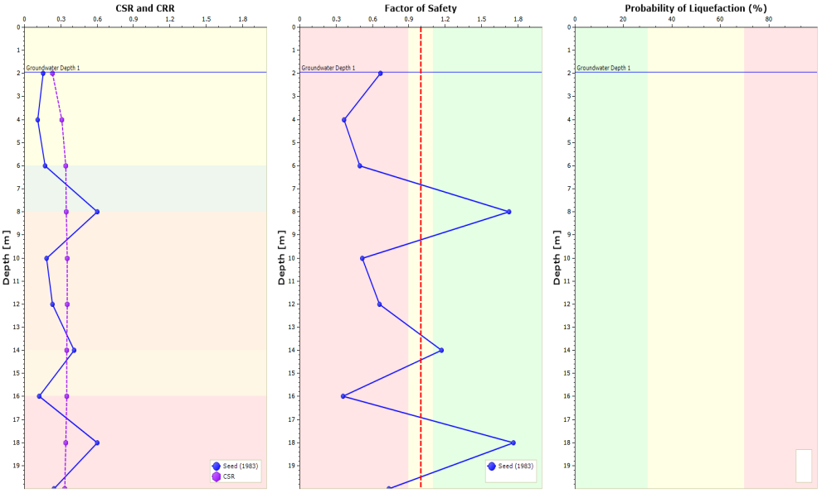
FIGURE 3. Graph of safety factor analysis results using Settle3 at BH 01

The analysis results using the Settle3 software of BH 02 can be seen in Figure 4.
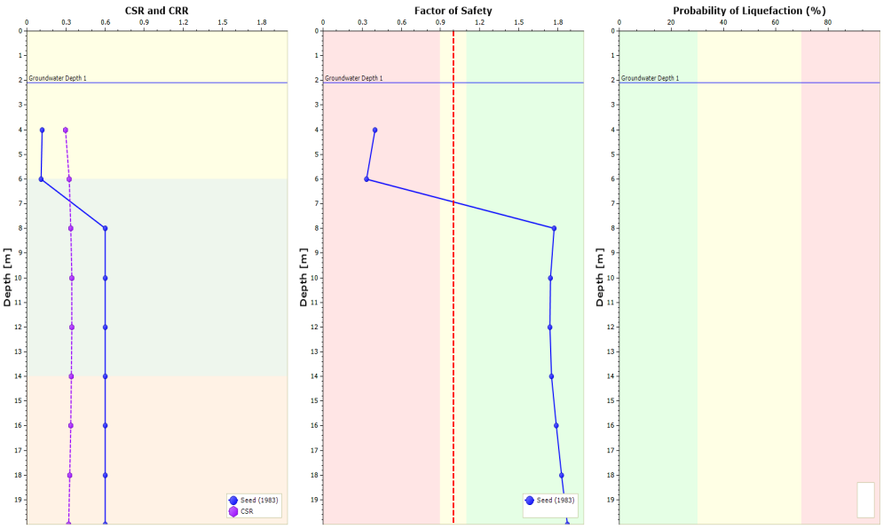
FIGURE 4. Graph of SF analysis results using Settle3 at BH 02 point
The analysis results of BH 02 using [17] method in Settle3 show that safety factor at a depth of 4 – 6 meters is < 1. Meanwhile, at 8 – 20 meters, the safety factor obtained is > 1. At a depth of 4 – 6 meters, the safety factor is very small as the type of soil at that depth is loose sand. In addition, at a depth of 8 – 20 meters, the safety factor is > 1 as the type of soil is dense sand.

Liquefaction Analysis with Liquefaction Potential Index Method
Based on the analysis results, the liquefaction potential index (LPI) value was obtained by integrating the value of F.w(z) at each depth. This is described by the area bounded by the function F.w(z) as the x-axis, and depth as the y-axis. The calculation of the integral function used the trapezoidal area method, therefore the LPI value of BH 01 has a larger area of 17.191 and BH 02 has an area of 7.546. The calculation results show that BH 01 has a very high category of damage potential according to [4], major category or large according to [8], and according to [10], it is a high category in which the LPI value obtained is > 15. Meanwhile, BH 02 has LPI value ranging from 5 – 15 which is a high category according to [4], moderate category according to [8], and according to [10], it is a medium category.
The liquefaction Severity Index is a method to estimate the damage level due to liquefaction. It is a development of the previous method proposed by [4]. Furthermore, the damage level due to liquefaction using LSI is classified into six categories as listed in Table 5 below.

Liquefaction Analysis with Liquefaction Severity Index Method
Based on the analysis results, the liquefaction severity index (LSI) value was obtained by integrating the PL(z).w value at each depth. This is described by the area bounded by the PL(z).w function as the x-axis, and depth as the y-axis. The calculation of the integral function implemented the trapezoidal area method. Therefore, the LSI value of BH 01 has a larger area of 32.823. It shows that the LSI value is in the range of 15 < LSI < 35. As a result, the damage level that can be caused by liquefaction is in a low category. Meanwhile, BH 02 has an area of 11.368, the LSI value obtained is in the range of 0 < LSI < 15 which is a very low category.
Mitigation Efforts on Liquefaction Potential
Based on field conditions, BH 01 was an area affected by liquefaction. Therefore, the area is not recommended for rebuilding but can be used as green open spaces. This is based on soil improvement by compacting at ground level and making drainage to control pore water in the soil.
The BH 02 an area not affected by liquefaction in the September 28, 2018 earthquake. The soil interpretation results show that this point is a type of loose sand at a depth of 4 – 6 meters, dense sand soil at a depth of 8 – 20 meters and a shallow groundwater level at 2.10 meters. The results of the liquefaction potential analysis show that the point has liquefaction potential at a depth of 4 – 6 meters, with the value of the damage level based on LPI being a medium category and the damage level caused by liquefaction based on the LSI being a very low category. Meanwhile, BH 02 can be stated to have no liquefaction potential. This is due to the analysis results at a depth below the very dense soil. Therefore, liquefaction at a depth of 4 – 6 does not affect the soil above it and causes no damage.

CONCLUSION
The analysis of potential liquefaction used [17] method in Settle3 software and the results show that BH 01 has a high liquefaction potential with safety factor < 1 at a certain depth. Meanwhile, BH 02 has liquefaction potential that only occurs at a depth of 4 – 6 meters.
The analysis of the damage level due to liquefaction was carried out using the Liquefaction Potential Index (LPI) and Liquefaction Severity Index (LSI) methods, the results show that BH 01 has a very high level of potential damage with the degree of damage due to liquefaction being categorized as low. Meanwhile, for BH 02, the level of potential damage due to liquefaction is in the medium category and the degree of damage that can be caused by liquefaction is categorized as very low.
Based on the analysis results, it is concluded that BH 01 which has the potential for liquefaction as deep as 20 meters with a very high level of potential damage, is not recommended for rebuilding because it is located at the liquefaction area and instead, can be used as a green open space. Meanwhile, the analysis results of BH 02 shows that it has the liquefaction potential but only at a depth of 4 – 6 meters. Therefore, there is no need for repairs because the liquefaction potential is at a depth below the ground surface which is very dense soil and it does not cause damage to the structure above it.

References
- Cetin K.O., Seed R.B., Der Kiureghian A., Tokimatsu K., Harder L.F. Jr, Kayen R.E., MossR.E.S. Journal of Geotechnical and Geoenvironmental Engineering, (ASCE, 130(12), 2004), pp. 1314-1340.
- Fathani, T. F., Adi, A. D., Pramumijoyo, S., & Karnawati, D. “The Determination of Peak Ground Acceleration at Bantul Regency , Yogyakarta Province , Indonesia”, in The Yogyakarta Earthquake of May 27, 2006, pp. 1–15, 2008.
- Hidayat, R. F., Kiyota, T., Tada, N., Hayakawa, J., & Nawir, H. “Reconnaissance on Liquefaction-induced Flow Failure caused by The 2018 Mw 7.5 Sulawesi Earthquake, Palu, Indonesia”. Journal of Engineering and Technological Sciences, 52(1), 2020, pp. 51–65.
- Iwasaki, T., Arakawa, T., & Tokida, K. “Simplified Procedures for Assessing Soil Liquefaction during Earthquakes”, 3(1), 1984, pp. 49–58.
- Jalil, A., Fathani, T. F., Satyarno, I., & Wilopo, W. “Liquefaction in Palu : The Cause of Massive Mudflows”, in Journal of Geoenvironmental Disasters (2020).
- Kayen, R. E, Mitchell, J. K., Seed, R. B.’ Lodge, A., Nishio, S., and Coutinho, R. “Evaluation of SPT-, CPT-, and shear wave-based methods for liquefaction potential assessment using Loma Prieta data”, ini Proc., 4th Japan-U.S. Workshop on Earthquake-Resistant Des. Of Lifeline Fac. And Counterneasures for Soil Liquefaction, 1, 1992, pp. 177-204.
- Liao, S.S.C. and Whitman, R.V. “Overburden Correction Factors for SPT in Sand”, in Journal of Geotechnical Engineering, 112(3), 1986, pp. 373 – 377.
- Luna, R., & Frost, J. D. “Spatial liquefaction analysis system”, in Journal Comput. Civil Engineering – 1998, 12, pp. 48–56.
- Mason, B., Hutabarat, D., & Prakoso, W. “Geotechnical Extreme Events Reconnaissance”, in Report of Geotechnical Extreme Events Reconnaissance, The Geotechnical Extreme Events Reconnaissance (GEER) Association (2019)
- Microzonation for Earthquake Risk Mitigation (MERM). "Microzonation Manual", in World Institute for Disaster Risk Management (2003)
- Miyajima, M., Setiawan, H., Yoshida, M., Ono, Y., Kosa, K., Oktaviana, I. S., Irdhiani. “Geotechnical damage in the 2018 Sulawesi earthquake, Indonesia”, in Geoenvironmental Disasters, 2019, 6(1), pp. 2–9.
- National Standardization Agency of Indonesia. “National standard for designing earthquake resistance buildings”, SNI-1726-2019, 2019.
- NCEER. "Proceedings of the NCEER Workshop on Evaluation of Liquefaction Resistance of Soils", Edited by Youd, T. L., Idriss, I. M., (Technical Report No. NCEER-97-0022, 1997).
- Nurdin, S., Harianto, T., Aswad, S., Arsyad, A., & Alexsander, S. “Liquefaction Disaster Mitigation and Geohydrology Conditions, Lessons from the Palu Earthquake Magnitude 7,4 Mw 28 September 2018” in 23rd Annual National Conference on Geotechnical Engineering. Jakarta, Indonesia, 2019.
- Parura, T. C., & Rahardyan, B. “Evaluation of Post-Earthquake, Tsunami, and Liquefaction Disaster Waste Management in Palu”, in E3S Web of Conferences, 148 (2020)
- Seed, H. B., Tokimatsu, K., Harder, L. F., Chung, R. M. "The Influence of SPT Procedures in Soil Liquefaction Resistance Evaluations", in Earthquake Engineering Research Center Report. (University of California at Berkeley, October, 1984).
- Seed, H. B., Idriss, I. A., & Arango, I. Closure to “Evaluation of Liquefaction Potential Using Field Performance Data”, in Journal of Geotechnical Engineering, 111(11), 1985.
- Seed, H., & Booker, J. “Stabilization of Potential Liquefiable Sand Deposits Using Gravel Drains”, in Journal of Geotechnical and Environmental Engineering, 104 (GT12), 1977.
- Skempton, A.W. “Standard penetration test procedures and the effects in sands of overburden pressure, relative density, particle size, ageing and overconsolidation”, Geotechnique 36(3), 1986, pp. 425-447.
- Sonmez, H., & Gokceoglu, C. “A Liquefaction Severity Index Suggested for Engineering Practice”, 2005, pp. 81–99.
- Tokimatsu, K., and Seed, H. B. “Evaluation of settlements in sands due to earthquake shaking”, in Journal Geotechnical Eng., (ASCE 113(GT8), 1987) pp. 61-78.
- Widyaningrum, R. “Penyelidikan Geologi Teknik Potensi Liquifaksi Daerah Palu, Provinsi Sulawesi Tengah” Bandung, 2012.

