Lightweight Optimization Design of Thin-Walled Cylindrical Rocket Motor Tube Using FEA

Lasinta Ari Nendra Wibawa 1, a) Tuswan Tuswan 2,3 b) *

1National Research and Innovation Agency (BRIN), Indonesia

2Department of Naval Architecture, Institut Teknologi Sepuluh Nopember, Surabaya

3Department of Naval Architecture, Universitas Diponegoro, Semarang

a) [lasinta.ari@lapan.go.id](mailto:lasinta.ari@lapan.go.id)

b) Corresponding author: tuswan.18041@mhs.its.ac.id

**Abstract.** The development of a rocket motor tube structure is a primary demand to enhance mission performance in the aerospace field. The work investigated the influence of wall thickness, cap thickness, and fillet radius on the structural strength and weight optimization of rocket motor tube using finite element Ansys software. A total of 12 finite elements developed models using Aluminium 7001-T6 subjected to internal operation pressure load were developed. In this work, the developed models using the wall thickness of 8 and 10 mm, the cap thickness of 50 and 75 mm, and the fillet radius of 50, 75, and 100 mm were comprehensively compared. The selection of the most optimum developed model was based on the minimum required safety factor with the lightest structural weight. It can be concluded that the finite element optimization simulation revealed that the increase in fillet radius is more recommended than the increase in wall thickness and cap thickness. It can be found that model code 0850100 was the most optimum developed rocket motor case using wall thickness, cap thickness, and fillet radius of 8, 50, and 100 mm, respectively.

# INTRODUCTION

The rapid progress in the challenge and development of rocket motor tube design in the aerospace field aims to improve mission performance. Rocket motor tube is considered as the essential element that influences the flight performance of the missiles. Its design should have enough strength to weight ratio to withstand working in environments with high pressure and temperature 1. One of the advantages of applying a thin-walled cylinder to a thick-walled cylinder in motor tube design with low internal pressure has lower structural weight. It dramatically impacts the rocket's longer range of the rocket for the same thrust. However, if the design performance is not analyzed more thoroughly, dramatic failure and safety issues can occur. It can happen when the stress exceeds the strength of the rocket motor tube material. In previous works, the maximum von Mises stress, which is the leading cause of failure of rocket motor tubes, can be minimized by increasing the wall thickness, cap thickness, and fillet radius of the rocket motor tube 2–4. However, these studies have not discussed the effect of increasing these variables on tube weight. Therefore, this paper aims to optimize these parameter changes to obtain the minimum required safety factor with the lightest tube weight.

In this work, the stress analysis is conducted using the finite element method with Ansys software to choose the most optimal rocket motor tube in terms of the minimum required safety factor with the lightest model. Ansys is commonly used to analyze rocket motor tubes made from metal and composite materials 5,6. Engineers generally use Ansys to solve numerical differential equations that are often found in engineering so that analysis can be carried out more quickly and accurately 7,8. In this study, a total of 12 developed models with different geometry of wall thickness, cap thickness, and fillet radius are compared. The minimum safety factor required is 2 because it can withstand dynamic loads 9. The research is expected to be a reference for interested parties in the process of designing an optimal rocket motor tube, especially for solid rocket motors. A good design will certainly increase the desired flight performance in terms of cost efficiency and the range of the rocket itself.

# MATERIAL AND METHOD

*2.1. Reference model and material*

The reference model used in this work is a thin-walled cylinder of a rocket motor tube with an outer diameter of 550 mm. In this model, the dimensions of the cylinder length are 2000 mm with a wall thickness of 8 and 10 mm. The cap thickness was varied 50 and 75 mm, while the fillet radius was varied 50, 75, and 100 mm. Geometry variation of developed rocket motor tube is depicted in Table 1, and the geometry of thin-walled cylinder design is illustrated in Figure 1.

**TABLE 1.** Geometry variation of developed thin-walled cylinder design of rocket motor tube.

|  |  |
| --- | --- |
| **Parameters** | **Value** |
| Length of cylinder (*L*) | 2000 mm |
| The outer diameter of the cylinder (*DO*) | 550 mm |
| Wall thickness (*tw*) | 8 and 10 mm |
| Cap thickness (*tc*) | 50 and 75 mm |
| Fillet radius (*R*) | 50, 75, and 100 mm |
| Element size | 10 mm |

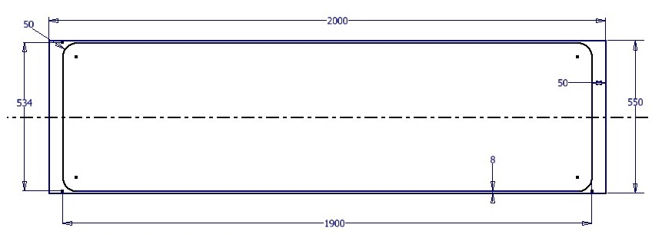

**Fig. 1.** Thin-walled cylinder design with a wall thickness of 8 mm, cap thickness of 50 mm, and fillet radius of 50 mm.

As the material is the most critical challenge, the selected material must have superior properties to satisfy performance requirements based on strength to weight ratio, specific stiffness, machining ability of the material, availability, cost, etc. The rocket motor tube uses Aluminium 7001-T6 because of its high tensile strength, good formability, corrosion resistance, and lightweight. Aluminium series 7000 (Al-Zn-Mg) was chosen as the rocket tube material because of its good formability and high specific strength 10. Table 2 shows the mechanical properties of Aluminium 7001-T6.

**TABLE 2.** Mechanical properties of Aluminium alloy 7001-T6.

|  |  |  |  |  |
| --- | --- | --- | --- | --- |
| **Material** | **Density (g/cm³)** | **Yield Strength (MPa)** | **Tensile Strength (MPa)** | **Young Modulus (GPa)** |
| Al 7001-T6 | 2.84 | 625 | 675 | 71 |

*2.2. 3D finite element model of rocket motor tube*

In this investigation, simulations are implemented numerically using the finite element software Ansys Workbench. Ansys software is widely used to measure stress concentrations in the thick-walled and thin-walled cylinders 11. The pressure vessels, based on their dimensions, are divided into thin-walled and thick-walled. The thin-walled cylinder has a wall thickness smaller than 1/20 inner diameter (*Di*), while the thick-walled cylinder has a wall thickness greater than 1/20 inner diameter (*Di*). Thin-walled cylinder stress will occur in three directions: hoop (circumferential), longitudinal (axial), and radial. The maximum stress equation for thin-walled cylinders in the hoop, longitudinal and radial directions is as follow:

${\left(σ_{h}\right)}_{max}=\left(\frac{P_{i}D_{i}}{2t}\right)$ (1)

${{(σ}_{l})}_{max}=\left(\frac{P_{i}D_{i}}{4t}\right)$ (2)

${{(σ}_{r})}_{max}=- p_{i}$ (3)

where *pi* is internal pressure (MPa), *Di*is the inner diameter of the cylinder (mm), and *t* is the wall thickness of the cylinder (mm).

The thin-walled cylinder can be divided into 8 exactly equal parts so that the finite element simulation process can be represented using 1/8 of the parts. The condition is due to the pressure applied to the fluid in a closed cylinder, and then the pressure will be continued equally and evenly in all directions 12. Figure 2 displays the one-eighth part of a thin-walled cylinder of a rocket motor tube, boundary conditions, and loading conditions, respectively. Load cases and corresponding design safety factors are the criteria used to judge the suitability of a design. It is defined as the ratio between the strength of the material and the maximum stress in part. In this work, the internal design pressure of the model is considered as a high loaded structure which is calculated based on the configuration model, is calculated as:

$P_{i}=\left(1.1:1.3\right)p_{c} e\frac{45K_{T}}{1-n}$ (4)

where *pc* is the working pressure, *KT* is the temperature sensitivity of propellant, *n* is the pressure index. In this study, the internal cylinder pressure was constant at 10 MPa.

Mesh convergence study is an important issue to obtain accurate results with reasonable computational time 13–17. The use of coarse mesh can yield a less stiff response of structures and higher stress. Therefore, several mesh sizes are used to get the optimum mesh sizes. The mesh convergence study is carried out by investigating static analysis to obtain the stress that occurred in the model. Good agreement demonstrating successful modelling of static analysis can be achieved using mesh element size 10 mm. Therefore, it validates the correctness of the model used in this work. Finite element analysis uses a fixed element size, which is 10 mm. There are differences in the number of nodes and elements for each variable, but not too significant. The meshing process uses standard mechanical.

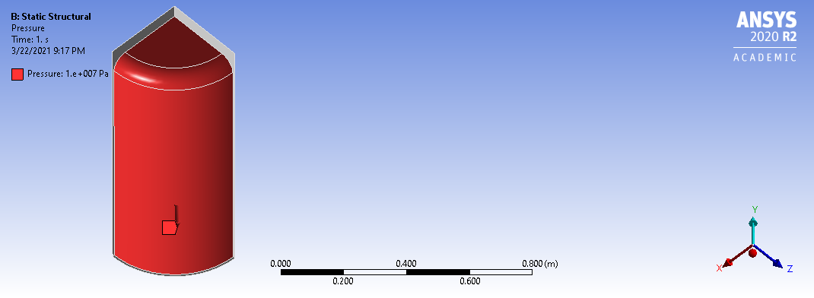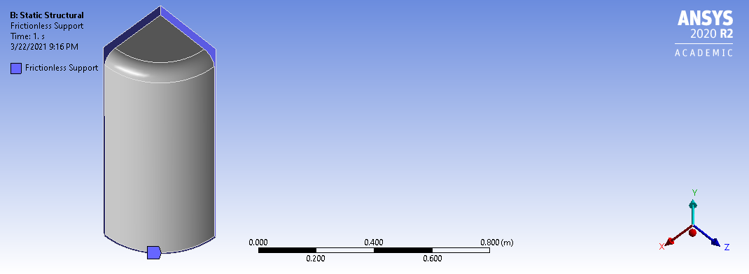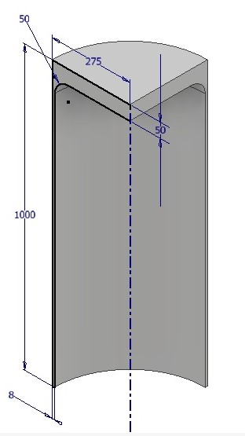

a b c

**Fig. 2.** a) the one-eighth part of a cylinder, b) type of constraint c) loading condition

# RESULT AND DISCUSSION

The static analysis is substantially vital as a thorough advance check to investigate the performance of the design. In this section, the finite element result was displayed to entirely analyze a comparison of structural strength and design safety factor between all investigated parameters. Figure 3 demonstrates the maximum von Mises stress (left) and design safety factor (right) of model code 0850050 with a wall thickness of 8 mm, cap thickness of 50 mm, and fillet radius of 50 mm. The effect of wall thickness, cap thickness, and fillet radius on the maximum von Mises stress of all evaluated models is presented in Table 3. An increase in wall thickness, cap thickness, and fillet radius affects the maximum von Mises stress reduction. The study is in agreement with previous studies 2,3,18,19. However, the increase in all three variations increased the rocket tube's overall weight (Table 4). All the maximum von Mises stress values are still below the yield strength of the Al 7001-T6 material, which is 625 MPa. It means that rocket motor tubes are safe for all length variations because yielding is one of the rocket industry's reported failure criteria, apart from cracking 20–23.

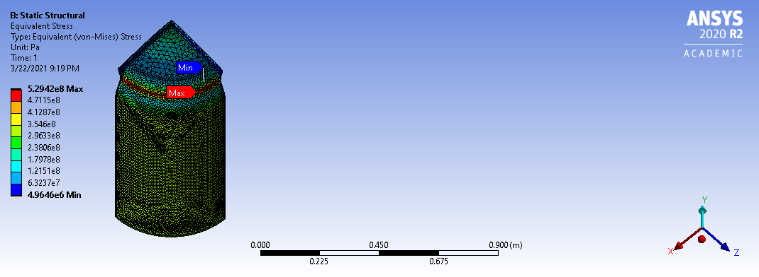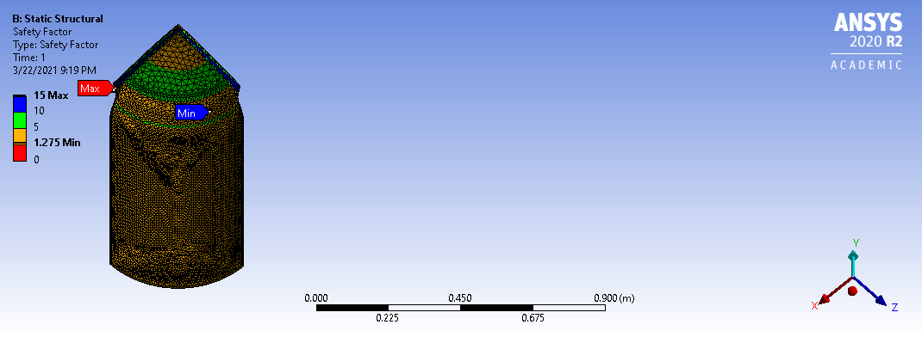

**Fig. 3.** The maximum von Mises stress (left) and safety factor (right) of rocket motor tube with a wall thickness of 8 mm, cap thickness of 50 mm, and fillet radius of 50 mm.

**Further, Table 4** demonstrates the effect of wall thickness, cap thickness, and fillet radius on the design safety factor and structural weight.  The design safety factor increases with increasing wall thickness, cap thickness, and fillet radius. The results are not different from previous studies 2–4,18,19. However, this increase is not necessarily beneficial because it increases the weight of the rocket motor tube. By providing a safety factor limitation of at least 2 for the design of rocket tubes, the lightest rocket tube uses variations in wall thickness, cap thickness, and fillet radius, namely 8 mm, 50 mm, and 100 mm, respectively. In this variation, the weight of the rocket tube appears the lightest, which is 78.96 kg. The weight of the next lightest rocket tube is 88.80 kg. The rocket tube weight is obtained when the wall thickness, cap thickness, and fillet radius are 10, 50, and 100 mm, respectively.

It can be summarized that the most optimum model has the largest fillet radius (100 mm), the smallest cap thickness (50 mm), and the smallest wall thickness (8 mm). It can be found that increasing the fillet radius is much better than increasing the wall thickness and cap thickness. The change in geometric shape creates additional stress beyond the calculated stress, known as the stress concentration. The higher the fillet radius will reduce the effect of stress concentration in the critical stress area. The pressure applied to the closed cylinder's fluid will continue the pressure evenly and equally in all directions. Stress concentration can be avoided in the spherical type pressure vessel because there is no sudden change in geometry. Theoretically, a spherical pressure vessel has better strength than a cylindrical pressure vessel with the same wall thickness and is the ideal shape to withstand internal stresses. However, this is different for cylindrical type vessels, both thin and thick-walled cylinders. In-cylinder-type pressure vessels, geometric changes in the fillet radius result in uneven stress distribution on the rocket tube walls. Consequently, if the fillet's radius is small, then the deformation will occur more suddenly so that internal stress is insufficient space to be evenly redistributed. As a result, the actual stress becomes more than the theoretical stress at the fillet base on the smaller side.

**TABLE 3.** Effect of wall thickness, cap thickness, and fillet radius on the maximum von Mises stress.

|  |  |  |  |  |  |  |  |
| --- | --- | --- | --- | --- | --- | --- | --- |
| **No** | **Model Code** | **Wall thickness**  **(mm)** | **Cap thickness (mm)** | **Fillet radius (mm)** | **Number of**  **nodes** | **Number of elements** | **Maximum von Mises stress (MPa)** |
| 1 | 1050050 | 10 | 50 | 50 | 52587 | 26615 | 459.97 |
| 2 | 1050075 | 10 | 50 | 75 | 52128 | 26569 | 338.58 |
| 3 | 1050100 | 10 | 50 | 100 | 53916 | 27583 | 263.38 |
| 4 | 1075050 | 10 | 75 | 50 | 51369 | 26141 | 338.76 |
| 5 | 1075075 | 10 | 75 | 75 | 53124 | 27135 | 273.58 |
| 6 | 1075100 | 10 | 75 | 100 | 51873 | 26553 | 247.94 |
| 7 | 0850050 | 8 | 50 | 50 | 52035 | 26282 | 529.42 |
| 8 | 0850075 | 8 | 50 | 75 | 53081 | 26895 | 405.79 |
| 9 | 0850100 | 8 | 50 | 100 | 53048 | 27031 | 312.65 |
| 10 | 0875050 | 8 | 75 | 50 | 52079 | 26294 | 406.86 |
| 11 | 0875075 | 8 | 75 | 75 | 52434 | 26676 | 334.25 |
| 12 | 0875100 | 8 | 75 | 100 | 52988 | 27012 | 309.24 |

**TABLE 4.** Effect of wall thickness, cap thickness, and fillet radius on the design safety factor and weight.

|  |  |  |  |  |
| --- | --- | --- | --- | --- |
| **No** | **Model Code** | **Safety factor** | **Weight (kg)** | **Description** |
| 1 | 1050050 | 1.47 | 81.94 | Failed |
| 2 | 1050075 | 1.99 | 84.85 | Failed |
| 3 | 1050100 | 2.56 | 88.80 | Passed |
| 4 | 1075050 | 1.99 | 97.60 | Failed |
| 5 | 1075075 | 2.47 | 100.52 | Passed |
| 6 | 1075100 | 2.72 | 104.46 | Passed |
| 7 | 0850050 | 1.28 | 72.94 | Failed |
| 8 | 0850075 | 1.66 | 75.88 | Failed |
| 9 | 0850100 | 2.16 | 79.86 | Passed |
| 10 | 0875050 | 1.66 | 88.84 | Failed |
| 11 | 0875075 | 2.02 | 91.78 | Passed |
| 12 | 0875100 | 2.18 | 95.76 | Passed |

# conclusion

The research has discussed the influence of wall thickness, cap thickness, and fillet radius on the structural strength and weight optimization of rocket motor tubes using Ansys software. A total of 12 models has been developed. The finite element simulation results reveal that the increase in fillet radius is much better than the increase in wall thickness and cap thickness. The lightest rocket model can be found using wall thickness, cap thickness, and fillet radius of 8, 50, and 100 mm, respectively.

# Acknowledgments

The author would thank the National Research and Innovation Agency (BRIN), Indonesia, which supports this research.

# References

1. Emrich, W. Rocket Engine Fundamentals. in *Principles of Nuclear Rocket Propulsion* 11–20 (2016).

2. Wibawa, L. A. N., Diharjo, K., Raharjo, W. W. & Jihad, B. H. Stress Analysis of Thick-Walled Cylinder for Rocket Motor Case under Internal Pressure. *J. Adv. Res. Fluid Mech. Therm. Sci.* **70**, 106–115 (2020).

3. Wibawa, L. A. N., Diharjo, K., Raharjo, W. & Jihad, B. H. The Effect of Fillet Radius and Length of The Thick-Walled Cylinder on Von Mises Stress and Safety Factor for Rocket Motor Case. *AIP Conf. Proc.* **2296**, (2020).

4. Wibawa, L. A. N. *et al.* Effect of Overlap Length and Surface Roughness on Adhesive Joint Strength of Composite Rocket Motor Case (GFRP) and Cap (Al 6061). *J. Phys. Conf. Ser.* (2021).

5. Choi, Y. G., Shin, K. B. & Kim, W. H. A study on size optimization of rocket motor case using the modified 2D axisymmetric finite element model. *Int. J. Precis. Eng. Manuf.* **11**, 901–907 (2010).

6. Ramanjaneyulu, V., Balakrishna Murthy, V., Chandra Mohan, R. & Naga Raju, C. Analysis of Composite Rocket Motor Case using Finite Element Method. *Mater. Today Proc.* **5**, 4920–4929 (2018).

7. Wibawa, L. A. N. Effect of Fillet Radius of UAV Main Landing Gear on Static Stress and Fatigue Life using Finite Element Method. *J. Phys. Conf. Ser.* **1811**, (2021).

8. Wibawa, L. A. N. Effect of Bolt Hole Size on Static Stress and Fatigue Life of UAV Main Landing Gear Using Numerical Simulation. *J. Phys. Conf. Ser.* **1811**, (2021).

9. Dobrovolsky, V. & Zablonsky, K. *Machine elements : a textbook*. (Peace Publisher, 1978).

10. Yamada, R., Itoh, G., Kurumada, A. & Nakai, M. Further study on the effect of environment on fatigue crack growth behavior of 2000 and 7000 series aluminum alloys. *Mater. Sci. Forum* **879**, 2153–2157 (2017).

11. Mohamed, A. F. Finite Element Analysis for Stresses in Thin-Walled Pressurized Steel Cylinders. *Int. J. Sci. Eng. Res.* **9**, 201–204 (2018).

12. Lawrence, K. L. *Ansys Workbench Tutorial Release 14*. (SDC Publications, 2012).

13. Tuswan, T., Abdullah, K., Zubaydi, A. & Budipriyanto, A. Finite-element analysis for structural strength assessment of marine sandwich material on ship side-shell structure. *Mater. Today Proc.* **13**, 109–114 (2019).

14. Tuswan, T., Zubaydi, A., Piscesa, B., Ismail, A. & Ilham, M. F. Free Vibration Analysis of Interfacial Debonded Sandwich of Ferry Ro-Ro’s Stern Ramp Door. *Procedia Struct. Integr.* **27**, 22–29 (2020).

15. Ismail, A., Zubaydi, A., Piscesa, B., Ariesta, R. C. & others. Vibration-based damage identification for ship sandwich plate using finite element method. *Open Eng.* **10**, 744–752 (2020).

16. Zubaydi, A., Piscesa, B., Ismail, A. & others. Dynamic characteristic of partially debonded sandwich of ferry ro-ro’s car deck: a numerical modeling. *Open Eng.* **10**, 424–433 (2020).

17. Tuswan, T. *et al.* Influence of application of sandwich panel on static and dynamic behaviour of ferry ro-ro ramp door. *J. Appl. Eng. Sci.* **19**, 208–216 (2021).

18. Wibawa, L. A. N., Diharjo, K., Raharjo, W. W. & Jihad, B. H. Pengaruh Ketebalan Cap dan Tekanan Internal terhadap Tegangan Von Mises Silinder Berdinding Tebal untuk Tabung Motor Roket. *Teknik* **41**, 111–118 (2020).

19. Wibawa, L. A. N. Numerical Study of The Effect of Wall Thickness and Internal Pressure on Von Mises Stress and Safety Factor of Thin-Walled Cylinder for Rocket Motor Case. *JST (Jurnal Sains dan Teknol.* **9**, 30–38 (2020).

20. Williams, F. A., Barrère, M. & Huang, N. C. *Fundamental aspects of solid propellant rockets*. (1969).

21. James, B. H. Structural integrity analysis of solid rocket motors. in *Conference on Stress and Strain in Engineering (National Committee on Applied Mechanics, The Institution of Engineers, Australia, Brisbane, 1973)* (1973).

22. Rao, B. N. Fracture of solid rocket propellant grains. *Eng. Fract. Mech.* **43**, 455–459 (1992).

23. Rao, A. S., Rao, G. V. & Rao, B. N. Effect of long-seam mismatch on the burst pressure of maraging steel rocket motor cases. *Eng. Fail. Anal.* **12**, 325–336 (2005).